
Order Decision
Papers on file
By Harry Wood BA (Hons) MA PhD MIPROW
an Inspector appointed by the Secretary of State for Environment, Food and Rural Affairs
Decision date: 11 May 2026

Order Reference: ROW/3368908

- This Order is made under Section 53(2)(b) of the Wildlife and Countryside Act 1981 and is known as the Borough of Telford & Wrekin Definitive Map and Statement of Public Rights of Way Footpath 85 Upgrade to Bridleway (Orchard Lane to Woodlands Road) Modification Order 2025.
- The Order is dated 10 April 2025 and proposes to modify the Definitive Map and Statement for the area by upgrading Footpath 85 to a bridleway, as shown on the Order Plan and described in the Order Schedule.
- There were three objections outstanding when Telford & Wrekin Council submitted the Order to the Secretary of State for Environment, Food and Rural Affairs for confirmation.

Summary of Decision: The Order is not confirmed.

Procedural Matters
- I am satisfied that I can make my decision based upon the documents submitted by the OMA, and I have therefore not undertaken a site visit. I have found it convenient to refer to locations marked on the Order Plan and have attached a copy of it to this decision, for reference.
Main Issues
- The Order has been made under section 53(2)(b) of the Wildlife and Countryside Act 1981 (the 1981 Act) in consequence of the occurrence of an event specified in section 53(3)(c)(ii), namely that a highway shown in the map and statement as a highway of a particular description ought to be there shown as a highway of a different description. The legal test I am required to deploy is the balance of probability test. This is a higher test than the reasonably alleged to subsist test used to determine if an order should be made.
- The evidence submitted in support of the Order relies on the presumption of dedication as set out in section 31 of the Highways Act 1980 (the 1980 Act). I must establish the date when the public’s right to use the Order route was brought into question. The evidence can then be examined to determine whether use by the public has been as of right and without interruption for a period of not less than 20 years. It is also necessary to consider whether there is sufficient evidence that there was no intention on the part of the landowners to dedicate public footpath rights during the relevant 20-year period.
- Under common law, an inference that a way has been dedicated for public use may be drawn when the actions of the landowners (or lack of action) indicate that they intended a way to be dedicated as a highway and where the public have accepted that dedication.
- Use by the public can be evidence of the intention to dedicate. For an inference of dedication, this use should be as of right without force, secrecy, or permission. There is no fixed period of use at common law and use may range from a few years to several decades, based on the facts of the case. The more intensive and open the use, the shorter the period required to raise the inference of dedication. The burden of proof lies with the claimant to demonstrate that the evidence is sufficient to indicate an intention of dedication.

Reasons

User Evidence

When use of the claimed route was brought into question
- The order making authority (OMA) have not specified when they believe bridleway rights over the Order route were brought into question. There is also no reference made in any of the user evidence forms (UEFs) to something that called public rights into question, such as a locked gate, a notice denying the existence of a right of way, or a challenge from a landowner.
- In the absence of evidence of overt acts bringing the right of the public to use the route into question, section 31(7a) and (7b) of the 1980 Act provides that a definitive map modification order application made to the surveying authority can serve as a challenge to use for the purposes of section 31(2) of the 1980 Act. An application was made to the Council on 23 October 2007. I therefore consider this to be the date of challenge and the relevant twenty-year period of use to be 23 October 1987 to 23 October 2007.

Whether the claimed route was used by the public as of right and without interruption
- Six user evidence forms have been completed, recording use of the Order route on horseback between 1979 and 2007. Four people claimed use for the full 20-year relevant period, while two others used the Order route for 19 years and 13 years.
- Claimed use was primarily for leisure, with users citing the route as a safer option for exercising their horses away from surrounding carriageways. Users were typically using the Order route as part of an extended ride, such as between Woodside and Ironbridge or Madeley and Rough Park.
- The frequency of use varied significantly. The most regular user rode the route two times per week. This is followed by 75 times per year (approximately 1.5 times per week), 30 times per year, “at least 20 times per year”, monthly, and “once or twice per year”. All of the respondents recall seeing other people on the route, including pedestrians, cyclists, and horse riders.
- I have seen no evidence that indicates this use was by force or by stealth, nor is there any suggestion that the use was interrupted during the 20-year period. None of the users recall asking for permission to use the Order route, and I have seen no evidence to suggest that any of the users enjoyed private rights on horseback over the Order route.
- Although the volume of use described is fairly regular in nature, it does not appear consistent with a bridleway link between a market town (Madeley) and a riverside village (Ironbridge). This is reinforced by the evidence of an interested party opposed to the Order. In an email to the OMA, he asserted: “As a daily user of this footpath, I have never seem [sic] a horserider on it”. This statement suggests that the use described in the UEFs was not of a sufficient volume to bring it to the attention of a regular user on foot. The OMA assert that there is “sufficient evidence” of use on horseback to reasonably allege that public rights subsist, but they do not elaborate on this position in any detail.

Whether there was no intention to dedicate a public right of way
- The OMA have not provided detail regarding the landownership of the Order route and its surrounding area, though they have explained that a Land Registry search identified one registered owner and other areas of unregistered land. The OMA followed the relevant statutory protocols in such circumstances (where landowners are unknown), seeking dispensation from the Secretary of State to advertise the Order on site. Neither the pre-order consultation process nor the making of the Order have elicited any response from relevant landowners.
- I have seen no evidence to suggest that any landowner took actions during the relevant period that successfully communicated a lack of intention to dedicate bridleway rights over the Order route.

Conclusions on the Section 31 tests
- I have concluded that the relevant period is 1987 to 2007. There is no evidence before me to suggest that this use was anything other than as of right, and there is no indication of interruption prior to 2018. There is no evidence of any actions by or on behalf of the landowner sufficient to convey to the public that there was no intention to dedicate a public right of way over the Order route. While the user evidence is credible, the number of UEFs submitted is low and they lack detail. I am not satisfied that use on horseback was of sufficient volume to have come to the attention of the relevant landowners. Accordingly, I conclude that the tests are not met and that public bridleway rights do not subsist over the Order route.

Common Law
- Dedication of a highway can also be inferred through common law. This would require evidence both that the relevant landowners intended to dedicate a public right of way and that the public accepted said route. Unlike the Section 31 tests, there is no minimum qualifying period of use. Case law has established that the burden of proof lies with those attempting to show that dedication has taken place.
- There is no evidence before me to suggest that the relevant landowners were aware of public use of the Order route on horseback. There is also insufficient evidence of use to demonstrate acceptance by the public. I am therefore not satisfied that public bridleway rights have been dedicated over the Order route.

Other Matters
- The three objections to the made Order primarily relate to issues of safety. They point in particular to the narrow width of the southern section of the Order route and raise concerns about the dangers pedestrians may face sharing such a route with horse riders. While these concerns are understandable, they cannot influence the issue of whether or not public bridleway rights exist over the Order route. Confirming the Order would not create any new public rights of way, but would instead record those already in existence in accordance with the OMA’s duty to keep the DMS up-to-date.
- The majority of the UEFs refer to seeing signs for Ironbridge Way on the Order route. This is a long distance route between Leegomery and Ironbridge, the majority of which appears to be along public footpaths. No evidence has been put before me concerning the significance of these signs. As such, they have not had a bearing on my decision.

Overall Conclusion
- Based on all of the evidence before me I am not satisfied, on the balance of probability, that a public bridleway subsists along the Order route.

Formal Decision
- I do not confirm the Order.

Harry Wood

INSPECTOR

Order Plan

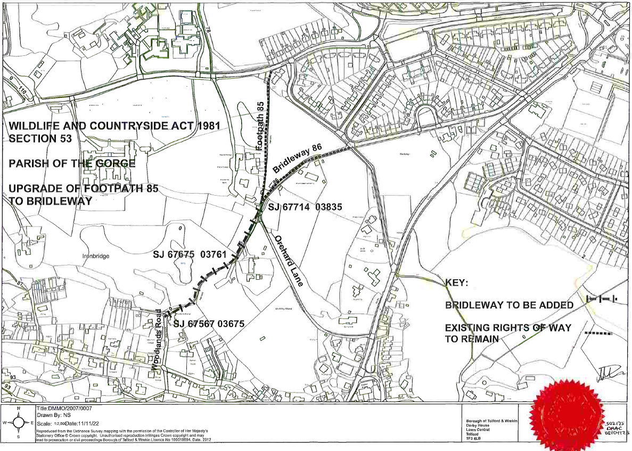
Not to scale

