

Order Decision
Site visit made on 23 March 2026
by Laura Renaudon LLM LARTPI Solicitor
An Inspector appointed by the Secretary of State for Environment, Food and Rural Affairs
Decision date: 12 May 2026

Order Ref: ROW/3360275
- This Order is made under Section 26 of the Highways Act 1980 (‘the 1980 Act’) and section 53A(2) of the Wildlife and Countryside Act 1981 (‘the 1981 Act’) and is known as the Cumberland Council (Parishes of St Bees (formerly Rottington) and Whitehaven) Public Path Creation and Definitive Map and Statement Modification Order 2024.
- The Order is dated 7 February 2024 and proposes to create public footpaths as shown on the Order Plan and described in the Order Schedule.
- There were six objections outstanding when the Cumberland Council submitted the Order to the Secretary of State for Environment, Food and Rural Affairs for confirmation.
Summary of Decision: The Order is not confirmed.

Preliminary Matters
- I have been appointed by the Secretary of State to determine whether to confirm the Order in the light of the unresolved objections that have been made to it.

Notices
- The Council have sent certificates confirming that the relevant consultation and publicity requirements have been met. The officer’s report on the Order (before making it) is a little unclear as to the extent to which the land ownership of the Order routes is known. It reports of two known landowners, and that notices had been posted at numerous points requesting that anyone owning relevant land come forward, but that no additional landowners had been identified.
- In the case of unknown landowners, the 1980 Act prescribes a specific process of obtaining a dispensation from the Secretary of State which would require a copy of a prescribed notice giving information about the Order to be displayed on the land. From the information before me it does not appear that any such dispensation has been sought or given.
- In answer to some of the objections raised, the Council assert that the use of some of the Order routes will have been permissive. This is in particular reference to the car park at Tarn Flatt Hall farm. However, from the information given I am unable to see that the farmer (or Trinity House, who are responsible for the lighthouse) is identified as a landowner capable of giving permission to use the Order routes.
- In the face of such uncertainty it was incumbent upon the Council to seek the necessary dispensation from the Secretary of State. I am not satisfied that the prescribed procedures have been followed, and cannot be confident that no prejudice arises as a result. I would thus decline to confirm the Order for this reason, although there are others.

The paths
- In this decision I will refer to the points on the Order route as shown on the Order Maps 1 and 2, copies of which are appended to this decision. No grid references are given on the maps, but the grid references are given for the particular points of reference annotated on the maps that are referred to in the Order.
- I undertook an unaccompanied site inspection on Monday 23 March 2026 when I travelled the proposed paths and some of the surrounding network with which the proposed paths would interlink. A sign indicating the closure of FP 422005 ahead to the south towards Fleswick Bay was in place at a point beyond Point A on Map 1 so I was unable to complete that particular loop.
- Several road closures were also in place in the area, but I was able to access Sandwith from the south, giving access to the Order routes starting at Point H. I witnessed domestic and agricultural vehicles using the routes as well as walkers (but no horseriders or cyclists) during my inspection.

The Order
- A number of potential infelicities arise with the Order as presented to me. These mainly concern the cited basis on which the Order is made, and the absence of information as to the current Definitive Statement.
- The Order recites that it is made under section 53A(2) of the 1981 Act because of an event specified in section 53(3)(a)(i) of the 1981 Act. Section 53(3)(a)(i) would relate to an event authorising the stopping up, diversion, widening or extension of a highway.
- Although the effect of the Order is to ‘extend’ the existing footpaths 422005, 422006 and 431039, no continuation of FP 431073 is shown on the Order Maps, or on the extract of the Definitive Map supplied to me, and that appears entirely new. (It is this section that I understand to form part of the Coast to Coast National Trail.) In any event, in all cases the power relied upon is that found in section 26 of the 1980 which is the power to create public paths, and the substantive part of the Order describes the addition of new paths rather than extensions to existing ones.
- Regulation 5 of the Public Rights of Way (Combined Orders) (England) Regulations 2008 (SI 2008/442) requires that the relevant part of a combined order relating to modifications to the DMS must be in the form prescribed or in a form substantially to the like effect, with such insertions or omissions as are necessary in any particular case. The prescribed form is found in the Schedule to the Public Rights of Way (Combined Orders) (England) (Amendment) Regulations 2010 (SI 2010/2127).
- That form provides that the preamble to the Order shall include that the event specified in section 53(3)(a)(iii) is ‘the creation (as authorised by this order) of a new right of way over land in the area to which the map relates, being a right of way such that the land over which the right subsists is a public path’. This specifically corresponds to the creation power in section 26 of the 1980 Act, rather than to any ‘extension’ or other event specified in section 53(3)(3)(a)(i), to which the Order makes reference. This prescribed preamble is rather different from the recital found in the present Order which, after citing paragraph (i) of section 53(3)(a), states that the relevant event is ‘the creation (as authorised by this Order) of highways hitherto shown or required to be shown in the map and statement’.
- Paragraph 1 of the substantive Order, after setting out what footpaths are to be created, provides that ‘thereupon the Cumberland Definitive Map shall be modified by adding to it that public right (sic) of way’. Paragraph 3 then sets out that the Definitive Statement shall be modified as described in Part 3 of the Schedule.
- The prescribed form set out in the 2010 Amendment Regulations requires the Order to state that ‘thereupon the [Cumberland] definitive map shall be modified by adding that path to it, and the definitive statement shall be modified as described in… the Schedule to this order’. The principal difference here is that the Order describes the addition of ‘those public right of way’ to the Definitive Map, whereas the prescribed form requires the addition of ‘paths’.
- Crucially, the Council have not provided a copy of the existing Definitive Statement, saying that ‘as this is a creation there is no definitive statement’. Yet parts of Part 3 to the Schedule to the Order clearly incorporate elements that are already (presumably, from the appearance of the Definitive Map) included in the Definitive Statement. Path number 422005, for example, is described as being from Feswick (sic) Bay and 1751 metres in length. Yet Point A, which is at the southern extremity of the Order routes, is considerably short of Fleswick Bay, and the route described in Part 1 of the Schedule relating to FP 422005 is slightly less than 700m long.
- It is not clear what is an ‘addition’ and what is an ‘amendment’, or whether the description of the width of the route, as 2.5 metres wide, amounts to any modification of the majority part of the route that is already on the Definitive Map and Statement (‘DMS’). I do not know if the matters stated in Part 3 of the Order Schedule such as the starting grid reference, length or description of the part of the route already on the DMS correspond with what is already on the Definitive Statement.
- The only limitation noted on the entire path number 422005 in Part 3 of the Order Schedule is a kissing gate at a grid reference corresponding to Point B on Map 1. On inspecting the route, I encountered additional limitations including ladder stiles at or beyond Point A, on one of which a notice stating that the footpath ahead was closed was affixed. Without sight of the existing Definitive Statement I do not know whether these limitations are recorded and therefore if changes (by omission or otherwise) are being made.
- Part 3 of the Order does not specifically amend any part of the existing Definitive Statement. It provides descriptions of each of the ‘extended’ routes (and the new one) but does not say what is to happen to the existing entries for the existing shorter routes. This appears to have the effect of providing for new routes without omitting the existing ones. A literal application would mean that for those parts on the existing DMS there would then be two footpaths recorded on the same route.
- Thus the question arises whether the Order is made in a form substantially to the like effect of that prescribed by the relevant Regulations. I do not seriously think that anyone will be materially misled by the reference to ‘those public right of way’ rather than to the ‘paths’ that are required by the prescribed form. The erroneous or incomplete reference to paragraph section 53(3)(a) of the 1981 Act and the failure to refer to a ‘new right of way’ in the preamble is a little more problematic, but not insurmountable.
- The main concern however is that Part 3 of the Schedule is not sufficiently clear about how the existing particulars of the Definitive Statement are to be modified or, in the absence of a copy of the existing Definitive Statement, whether the modifications set out are limited to giving effect only to the matters stated in the Creation Order. The Part simply states the description of the entire lengths of the relevant paths, which include parts that already exist on the DMS and whose recorded lengths, widths and limitations or conditions are unknown to me. In the absence of having been provided with the relevant extracts of the Definitive Statement I cannot be satisfied that the modifications made by Part 3 of the Schedule are limited, as they must be, to those arising out of the Creation Order or do not result in the duplication of routes.
- Therefore the ‘legal event’ elements of the Order would need to be severed, if I were to confirm the Creation Order itself.

The Creation Order: Main Issues
- Under Section 26 of the 1980 Act, if I am to confirm the (remainder of the) Order, I need to be satisfied that there is a need for the public footpaths, and that it is expedient that they should be created. In determining the need for the footpaths, I must have regard to:
- the extent to which the footpaths would add to the convenience or enjoyment of a substantial section of the public, or the convenience of persons resident in the area; and
- the effect which the creation of the footpaths would have on the rights of the persons with an interest in the land, account being taken of the provisions for compensation.

Reasons

The need for the proposed footpaths
- The Creation Order, if confirmed, would essentially complete the DMS’s record of a network of paths in the vicinity of St Bees Lighthouse, situated on a promontory a little south of Whitehaven harbour. I understand the impetus for the Order to have come from a desire to complete a further Coast to Coast walk, from St Bees to Robin Hood’s Bay, and the Order is promoted by Natural England. At the time of my site inspection, guideposts had already been erected, directing users from Sandwith to the ‘Coast to Coast path’ and at other points to the links to the England Coast Path. Those posts were each marked with the ‘acorn’ insignia used on National Trails.
- All the proposed footpaths are existing metalled ways or (in the case of Hannah Moor Lane, Points A to C) a clearly defined farm track. The existing footpaths linking to the Order paths are all presently culs-de-sac, if no public rights exist over the Order paths. They mostly form dead-end links inland from the coastal path around the headland of St Bees Head.
- Some of those objecting are highly sceptical of the need for any Creation Order, because of the inference that some or all of the Order paths are already subject to public rights and should be recorded on either the List of Streets (being the list of highways maintainable at the public’s expense, required to be kept by the Local Highway Authority pursuant to section 36 of the 1980 Act) or the DMS by reason of apparent dedication and acceptance by the public. Reference is made to Bell’s Map of 1892, which was a survey of the main and district roads and County bridges by the County Surveyor in 1892. The section of the Order route towards Tarn Flatt Hall Farm is clearly depicted on that map as a district road, implying the public’s right to use it even if not with a concomitant liability to maintain it.
- It was also shown on the Greenwood’s Map of Cumberland of 1823, the year after the lighthouse was built, as was what appears to be the section of Hannah Moor Lane that is the subject of the present Order. St Bees Head is described as being accessible by road from Sandwith (which can only mean by the Order route, having regard to contemporaneous maps) in 1905 in a published guidebook to the English Lakes that discusses public access to the lighthouse.
- I saw on my site inspection that the paths are already walked by users. There appears no need for the sign warning of the closure of FP 422005, at or close to its existing northern terminus but displayed to anyone having walked south from Point C, if this is not already the case in respect of that path. As to the others, walkers were seen on various parts of the proposed additional routes, and other recreational users were parked in the car park at the farm (for which payment is required) as well as in the verge at the Hannah Moor Lane junction (for which it is not). The present extent of use apparent during that relatively short inspection, on a weekday and at a time of fairly inclement weather, demonstrates the need for the routes.
- However, whilst in one sense there is a clear need for the paths shown on the Order route, in order to complete the Coast to Coast route and to access the lighthouse and other parts of the promontory, it is at least questionable whether there is any need to create them by way of this Order, given the apparent likelihood or at least credible possibility that user rights already exist.

The extent to which the paths would add to the convenience or enjoyment of a substantial section of the public or the convenience of residents
- Confirming the Order would complete the local network of paths in the area and resolve the existing ‘dead-ends’ of the linking paths. That would formally allow for a number of shorter circular walks to take place as well as, significantly, the complete Coast to Coast route.
- As well as adding to the general enjoyment of walking the Hannah Moor area by recording those routes, the proposed paths would add to the safe enjoyment of the network by providing a shortcut away from St Bees Head itself that could attract some users as an alternative route to the coastal path around the headland, especially in times of particularly windy weather. The existing coastal path around the promontory is at points immediately adjacent to the cliff edge on ground about 80 metres above datum. Whilst spectacular, the path is not suitable for all, and the wide and in part metalled ways of the Order routes would provide a safer alternative to rounding the point. The Order routes would therefore add to the convenience and enjoyment of those generally wishing to pursue the coastal path without having to wait for a suitable weather window to round the point, or for whom the coastal path is anyway unsuitable around the headland.
- If the objectors are right that the Order is unnecessary because public rights already exist along the routes, the confirmation of the Creation Order would amount to a ‘legal event’ allowing the Council to modify the DMS for the area and thus put the public rights on a formal footing. The recording of the routes would constitute prima facie evidence to users that they are not trespassing when using them as footpaths. Thus the confirmation of the Order would potentially add to the convenience or enjoyment of the public merely by the comfort of their being recorded on the DMS. However if those rights do already exist, then the substantive advantages to users from the routes I have described in the preceding paragraphs cannot be said to be a consequence of the Order.
- Given the apparent strength of the case to record existing user rights, in the absence of the Council having reviewed the DMS in this regard and come to any conclusion about whether modifications should be made to it on an evidential basis, on this issue I conclude that the formal recording of the routes would give rise only to some marginal public enjoyment.

The effect on persons with an interest in the land
- It appears that the Order route is not wholly registered with the Land Registry although two landowners have been identified. As noted above, the Council have been unable to identify any additional landowners after posting notices along the routes. They report that both known landowners are supportive of the Order. Neither has objected to it. The position of any other landowners is unknown.
- The Order routes follow established metalled ways or farm tracks and accordingly the recording of them as public footpaths would not require any fundamental change in their existing surfacing or appearance. The routes are bounded against livestock and would not unreasonably interfere with any farming practices.
- A Creation Order gives rise to the possibility of claims for compensation by the relevant landowner/s. Any such claims would need to evidence that the value of any interest in land has depreciated or that disturbance to the enjoyment of land has occurred as a result of the Order coming into operation. Thus the Upper Tribunal (Lands Chamber) may need to decide the question of compensation.
- The user history of the Order routes would no doubt be part of the relevant factual matrix in that regard, but the Lands Chamber of the Upper Tribunal could not ordinarily be expected to ascertain the extent of any pre-existing user rights when assessing the amount of compensation due arising from a Creation Order. In the absence of the Council having reviewed the DMS on evidential grounds, there appears to me a real risk that the public purse could be exposed to an unnecessary claim for compensation. I acknowledge that Natural England have indicated a willingness to underwrite all the costs of the Order, so it would be at no cost to the Council, but it is public money nonetheless. This would be a significant disadvantage of confirming the Order. It appears to me appropriate for the Council to review the DMS to determine what user rights already exist before promoting any Creation Order, if one is in fact needed.

Rights of Way Improvement Plan (‘ROWIP’)
- The Council indicate that the relevant provisions of the ROWIP are incorporated into their Countryside Access Strategy. A copy of the Strategy for 2019 – 2024 has been provided. No particular provisions of it have been identified by the Council as relevant, although it does refer to the Yorkshire Dales National Park Authority’s ambition to achieve the Coast to Coast route as a National Trail, which the Creation Order helps facilitate, and it identifies as a key strategic action the continued development of improved access and recreation opportunities especially to the Cumbrian coastline. This is stated in the light of the Marine and Coastal Access Act 2009 provisions to establish the England Coast Path, but nonetheless the linking of the Order routes to that path (or the ‘dead-ends’ presently linking from it) would facilitate this objective. Confirmation of the Order would be consistent with the objectives of the Strategy.
- However, the Strategy contains the statement that “the new strategy doesn’t include the ROWIP” and so it is not at all clear that the Strategy, which was scheduled to expire some time ago, does ‘incorporate’ the ROWIP as the Council advise. A number of those making representations contend for the Order to go ‘further’ and facilitate higher rights. Although there is no general objection that expanding the rights of way network would fail to accord with any material provision of any ROWIP for the area, I am not satisfied in the light of those representations, and in the absence of any information from the Council about it, that creating ‘only’ a footpath is commensurate with the area’s ROWIP. I do not give this any weight, however, because confirming the present Order would not prejudice the position on creating higher rights at a later stage. My role here is to determine whether or not to confirm the Order that the Council have made, rather than to consider re-writing the Order to give rise to a different set of user rights that are not contemplated by it.

Conclusions on whether it is expedient to confirm the Creation Order
- The Creation Order routes are needed for public use and there appears a credible case that such public user is already established as of right. There has been no evidential review by the Council. Some benefit to the public would result from the formal recording of footpath rights, and expanding the network is generally consistent with the Countryside Access Strategy. There appear no adverse effects on any landowner. However, in view of the potential cost to the public purse arising from the compensation provisions of the 1980 Act, it does not appear to me expedient to confirm the Order where there is a realistic possibility that it is unnecessary to do so. That compensation risk outweighs the benefits of the Order.

Overall Conclusions
- Having regard to the above, and all matters raised in the written representations, I conclude that the Order should not be confirmed.

Formal Decision
- I do not confirm the Order.

Laura Renaudon

INSPECTOR
ORDER MAP 1 (DO NOT SCALE)
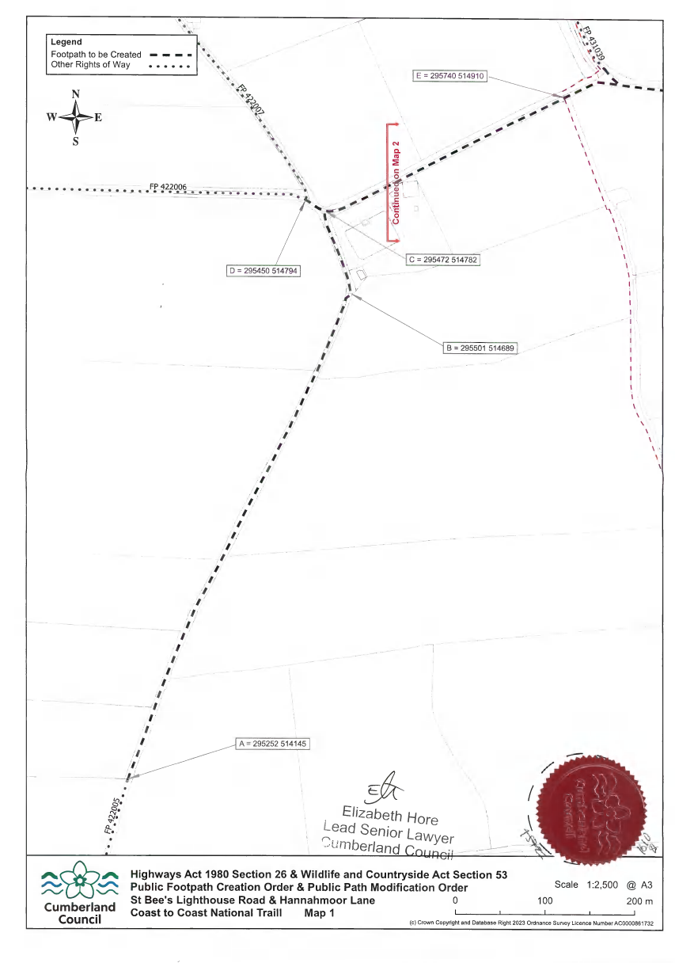

ORDER MAP 2 (DO NOT SCALE)

