Order Decision
Site Visit made on 19 January 2026

by G D Jones BSc(Hons) DipTP DMS MA MRTPI
an Inspector appointed by the Secretary of State for Environment, Food and Rural Affairs
Decision date: 27 April 2026

Order Ref: ROW/3347504
- This Order is made under Section 53(2)(b) of the Wildlife and Countryside Act 1981. It is known as the Lincolnshire County Council Claypole - Upgrade Bridleway 8 to Restricted Byway Westborough & Dry Doddington - Addition of Restricted Byway from Stubton Restricted Byway 6 to Clensey Lane Definitive Map Modification Order 2022.
- The Order is dated 5 January 2022 and proposes to modify the definitive map and statement for the area by upgrading Claypole Public Bridleway 8 between points A-B-C and D-E-F to restricted byway status and adding a restricted byway between points G and H shown on the Order map and described in the Order schedule.
- There were three objections when Lincolnshire County Council submitted the Order for confirmation to the Secretary of State for Environment, Food & Rural Affairs.
Summary of Decision: The Order is confirmed subject to the modifications set out below in the Formal Decision.

Procedural Matters
- An application was made to Lincolnshire County Council (the Council) in March 2006 for a Definitive Map Modification Order (DMMO) to upgrade Claypole Public Bridleway 8 and Stubton Restricted Byways 5 and 6 to byways open to all traffic and to add a byway open to all traffic between the southeasternmost end of Stubton Restricted Byway 6 and Clensey Lane to the Definitive Map and Statement (DMS).
- Following research and the collection of evidence, the Council concluded that a DMMO should be made as there was sufficient evidence to demonstrate:
- A restricted byway exists along Claypole Public Bridleway 8 either side of the East Coast Main Line railway (the railway);
- A restricted byway exists between Stubton Restricted Byway 6 and Clensey Lane; and
- The ‘widths recorded in the documentary evidence’ in respect to the two aforementioned routes.
- The Order was made by the Council on 5 January 2022 to upgrade the Claypole Public Bridleway 8 between points A-C and points D-F, either side of the railway, to a restricted byway and add a restricted byway between points G-H to the southeast of Stubton Restricted Byway 6 linking to Clensey Lane, as shown on the Order map. The Order route, therefore, comprises three connected, but discrete sections: A-C, D-F and G-H.
- Taking into account the existing right of way between points F-G, the effect of the Order is to create an almost continuous length of restricted byway between points A-H. The one exception is the section between points C-D where the right of way crosses the rail corridor, which would remain a bridleway.
- Three objections were submitted by landowners in respect to the made Order.
- Although the Order refers to ‘Clensey Road’, in the banner heading above and elsewhere herein I use ‘Clensey Lane’ on the basis that that appears to be its correct name. This and other matters are the subject of a number of modifications to the Order requested by the Council, as discussed toward the end of my decision.
The Main Issues
- The Council has relied upon Section 53(3)(c) (i), (ii) and (iii) of the Wildlife and Countryside Act 1981. Accordingly, the main issues relate to whether or not, on the balance of probabilities, the evidence shows that:

(i) A restricted byway subsists or is reasonably alleged to subsist between Stubton Restricted Byway 6 and Clensey Lane as identified in the Order (G-H);

(ii) The sections of Claypole Public Bridleway 8 either side of the railway as identified in the Order ought to be shown as a restricted byway in the DMS (A-C and D-F); and

(iii) Particulars contained in the DMS require modification in respect to width.

Reasons

Documentary Evidence
- Although no plan accompanied the 1771 Inclosure Award for Claypole, there is a 1770 Plan of the Inclosure of the Claypole Lordship that the Council maintains would have originally accompanied the Inclosure Award. It shows a road which appears to closely align with the Order route between points A-F. At its eastern end it is labelled ‘Road to Hough’. I note that the road to the south of Main Street at point A that extends along part of the Order route towards point B is now known as Hough Lane. I also note that, a little to the east of Claypole, Main Street becomes Stubton Road.
- The Inclosure Award records a public highway which the commissioners had admeasured and set out was ‘Hough Road’. It is described as branching south out of the Stubton Road to the north corner of allotment number 23 and then southeast to the Lordship of Stubton. This is consistent with the 1770 Plan referred to above. The Inclosure Award also records that Hough Road was admeasured and set out with a width of at least 60 feet between the ditches and fences in line with the relevant provisions of the 1769 Inclosure Act, for all persons to pass and repass on foot, horseback, and with cattle and carriages. This strongly supports the existence of a 60-foot-wide public vehicular right of way between points A-F.
- The 1771 Plan of the Inclosure of the Westborough and Doddington Lordship accompanied the 1771 Inclosure Award for Westborough cum Doddington. However, part of the Plan where the Order route is located is missing. What is now known as Clensey Lane, to the south at point H, is shown on the Plan as ‘Stubton Road’. The Council’s approach of using the descriptions of allotment 31, Stubton Road and a drain, to identify the sequence of the parcels and roads in the missing part of the Plan appears logical. Moreover, its conclusions are consistent with the photograph of the Plan from the National Archives, which shows a road that appears to closely align with the Order route between points G-H. To the west it is labelled ‘from Newark’.
- The 1771 Inclosure Award for Westborough cum Doddington records that the Road from Hough to Newark was admeasured and staked out with a width of 60 feet, in line with the relevant provisions of the 1769 Inclosure Act, for all persons to pass and repass on foot, horseback, and with cattle and carriages. This strongly supports the existence of a 60-foot-wide public vehicular right of way between points G-H.
- The 1806 ‘King’s Map’ shows a ‘public carriage road’ on what appears to be the alignment of the Order route between points A-H. The Ordnance Survey (OS) maps from 1814, 1824 and 1856, the 1828 ‘Bryant’s Map’ and the 1830 ‘Greenwood’s Map’ all show a route of similar length and alignment to the Order route.
- The Plan accompanying the 1837 Apportionment of the rent-charge in lieu of Tithes in the Parish of Stubton in the County of Lincoln shows a route broadly consistent with the Stubton Restricted Byways 5 and 6, which ran between points F-G of the Order route. To the western end there is the caption ‘From Claypole’ and to the eastern end ‘To Hough’, suggesting it formed part of a longer route linking Claypole and Hough. The ‘from’ and ‘to’ also suggest it to be an important route joining these settlements and support a vehicular status. It is depicted in the same manner as the ‘private carriage road’ which runs southwest-northeast and crosses the route in question. That part of the ‘private carriage road’ running southwest from that route is currently recorded in the DMS as Stubton Public Footpaths 2 and 3.
- The 1845 Plan of the Boston, Newark & Sheffield Railway shows a route broadly in the location of the Order route. The section between points A-F is labelled ‘Public Road’. All of the sections are numbered. When cross-referenced with the associated Book of Reference each of these sections are listed as ‘public highways’ in part or full ownership of the surveyors of highways of each respective parish or township. The 1846 Great Northern Railway Act also refers to a road crossing the railway at level, consistent with the aforementioned Plan and Book of Reference. While less comprehensive, the extracts of the 1845 Plan of an intended Railway to be called the Boston, Newark & Sheffield Railway are also consistent with the 1845 Plan of the Boston, Newark & Sheffield Railway. Collectively, this railway related evidence supports the existence of a highway along the Order route between points A-H.
- The 1857 Plan of an estate in the parish of Claypole, Lincolnshire – The Property of the Executors of J S Lee Esquire (1857 Estate Plan) shows a road, consistent with the Order route between points A-B, labelled ‘Hough Lane’. To the east, it narrows and runs parallel to the railway before crossing it at level, broadly consistent with the Order route between points B-E. A broad road, similar to the section labelled Hough Lane is shown continuing to the east of the railway roughly between points E-F.
- There are numerous further OS maps from 1886 to 1923 which post-date the arrival of the railway. They show a route broadly consistent with the Order route between points A-H with arrangements shown for the railway level crossing comparable to those shown on the 1857 Estate Plan. Although there can be no confidence that any such route had public use rights, the OS maps collectively build a strong picture of continued physical existence on the ground over many years.
- The draft valuation plan prepared for the 1910 Finance Act valuation shows the proposed route as uncoloured roughly between points A-F and thus exempt from charge. While not proof of a route’s status, land held on behalf of the rating authority would be left uncoloured on valuation maps, including public highway. The route may, though, have been left uncoloured for another reason, for instance because it was an occupation road.
- While the annotation on this part of the draft valuation plan is rather faint, the Order route between points G-H appears to cross hereditament 293. The associated valuation book records no deduction for ‘public rights of way or user’ against the entry for this hereditament. Nonetheless, it does not necessarily follow that there was no public right of way across this land at that time. For instance, if there was a public vehicular right of way present in the terms suggested by the 1771 Inclosure Award for Westborough cum Doddington, it may have been forgotten and become unused over the intervening years.
- It is also conceivable that the landowner may have opted not to declare a public right of way for some reason, for instance because the associated compensation may not have been considered sufficient to outweigh a consequential reduction in the land’s value. Moreover, the valuation books were not fully updated with the findings of the surveys that were undertaken over the period 1910-15 due to the disruption caused by World War I and the subsequent abolishment of the Incremental Value Duty by the Finance Act 1920.
- The 1930 OS map generally shows details comparable to the various OS maps from 1886 to 1923. Nonetheless, I note the section of the Order route between points A-F is depicted in the category ‘Roads under 14’ wide’ ‘Bad’. The 1947 OS map is similar albeit that the section A-F is depicted in the category ‘Other Motor Roads, narrow’ ‘Bad’.
- The 1930 Highways Handover map shows the entire Order route. Only the section between point A-F is shown as being publicly maintainable highway at the time of handover on 1 April 1930, thus indicating that, at that time, the section between point F-H was not considered to be publicly maintainable highway. There is also a handwritten note relating to the section between points D-H which reads ‘12’ Bridleway retain (Oct/70 minutes)’.
- The 1935-36 Plan and Sections of the London and North Eastern Railway (General Powers) show the Order route between points B-F. The associated section is annotated ‘Public Road to be crossed on the level’ at the point where the route crosses the railway. The route is recorded in the associated reference book as a ’road’ in the ownership of the Kesteven County. This further supports the status of the route between points A-F as a public road.
- The circa 1949 OS map shows the Order route in a similar manner to the 1930 and 1947 OS maps albeit that there is no key. The route is also shown on the 1050 OS map, depicted as a ‘Minor Road’.
- The map of the 1950 Claypole Parish Path Survey shows the order route between points A-F marked as ‘CBR 8’. CBR seems likely to be a misspelling of CRB, which is likely to mean a public carriage or cart road or unmetalled green lane used as bridleway. The associated survey note for ‘Path No. 8 Hough Lane’ says, ‘C.R.B. This is a Cart Road used mainly as a Bridle Way from there the main street to the Railway Crossing, and from there used mainly as a footpath.’ It goes on to record that the first 250 yards was in a fairly good, metalled condition, then continued as a green lane up to the level crossing where it became a footpath.
- The map of the 1950 Stubton Parish Path Survey shows the Order route between point F and roughly the mid-point between points G-H, presumably at the point it met the Parish boundary, as ‘5CRF’ and ‘6CRF’. CRF seems likely to mean a public carriage or cart road or unmetalled green lane used as footpath. The associated survey notes indicate that ‘(5)’ was a continuation of Hough Lane, clearly defined on the ground and a gate was difficult, and that ‘(6)’ was a continuation of ‘Path No. 5’ running to a field gate before continuing across a ploughed field to another field gate, the path was not defined on the ground, and a gate was difficult.
- The associated summary, under the heading ‘Position and nature of means of passage’ for 6CRF refers to ‘F.P.2. to Doddington Lane’. This suggests that the route formed part of a longer route that met with Doddington Lane. Doddington Lane is likely to be what is now known as Clensey Lane, as it is the only road which runs to the village of Dry Doddington. Nonetheless, the remaining portion of the Order route is not recorded in the parish path survey for Westborough and Dry Doddington Parish, which suggests that that Parish Council had not discovered or claimed it to be a public right of way.
- The 1953 Statement accompanying the Draft Map for Claypole and Stubton Parishes is consistent with the 1950 Survey information outlined above, albeit that some of the detail is missing due to a tear in one of the two papers. There is no equivalent Statement available for Westborough and Dry Doddington Parish.
- The 1954 and circa 1956 OS maps show the Order route between points A-C. It is depicted as ‘Roads Under 14ft of Metalling. Untarred (not including Truck, Class 1 and 2)’ or ‘Minor roads in towns, Drives and Unmetalled Roads’. The Order route between points D-F is not shown on these maps. The 1956 OS map shows the Order route in a similar manner to these other 1950s OS maps albeit that there is no key / legend and the route can be seen to extend a short distance beyond the railway but is largely not shown between points E-H.
- The Provisional Map and Statement for the area of the then West Kesteven Rural District were prepared in 1957 pursuant to the 1953 Draft Map for Claypole and Stubton Parishes and associated Statement referred to above. Although the 1957 map has not survived, the Provisional Statements have. The relevant entries are consistent with the 1950 Survey and 1953 Statement information outlined above.
- The 1959 Definitive Map for the area of the West Kesteven Rural District shows the Order route up to the parish boundary. However, it does not show a public right of way along the section of the Order route within Westborough and Dry Doddington Parish linking to Clensey Lane. Its depiction is broadly consistent with the 1950 Survey, 1953 Statement and 1957 Provisional Statements information referred to above. No 8 is shown as a public bridleway and Nos 5 and 6 are shown as restricted byways. The associated Statement is also broadly consistent with the foregoing 1950, 1953 and 1957 material.
- The 1963 and 1968 OS maps show parts of the Order route. Both show the section between point A-C as ‘untarred road under 14ft of metalling’ or a ‘minor road, drive or unmetalled road’. This section of the route is also shown as a public bridleway on both maps. The maps differ to the east of the railway. The 1963 map shows a path running along the Order route from the railway to what is now footpath No 2. The 1968 map shows a ‘road used as public bridleway’ from the railway to the Stubton / Westborough and Dry Doddington parish boundary.
- The draft revised map and draft statements associated with the abandoned 1968 First review of the Definitive Map and Statement shows similar details to the 1959 definitive map and relevant statements for the area, as outlined above.
- The minutes of the meeting of Kesteven County Council’s Highways Committee of 6 October 1970 record that ‘it was resolved that the Clerk be authorise to apply to the Magistrates’ Court for an Order under section 108 of the Highways Act 1959 in respect to Hough Lane, Claypole, which extends from the eastern side of the main railway line to Clensey Lane, on the grounds that it is unnecessary for public use, subject to the reservation of a bridle road with a width of 12 feet.’ There is, however, no evidence before me to suggest that this matter was taken any further.
- The plan that accompanied the 1972 Conveyance of freehold land at Claypole in the County of Lincoln and release of rights in level crossing no. 147 shows a small section of the Order route either side of the railway.
- Part of the Order route appears on a number of OS maps from 1985 and 2002 similar to the 1963 and 1968 OS maps. There are also a number of undated other maps which show the presence of a route, fully or in part, on a similar alignment to the Order route.

Assessment
- None of the documentary evidence is conclusive individually. Nonetheless, the evidence associated with the 1771 Inclosure Award for Claypole and the 1771 Inclosure Award for Westborough cum Doddington is particularly weighty and strongly supports the existence of 60-foot-wide public vehicular rights of way between points A-F and points G-H. Subsequent documentary evidence largely supports the existence of such routes. Some of the evidence, such as the 1910 Finance Act valuation documentation, does not support the presence of a public right of way between points G-H. However, as outlined above, this does not necessarily imply that there was / is no such right of way, and does not rebut the 1771 Inclosure Award evidence.
- While public use rights for mechanically propelled vehicles may have existed along the Order route, for the reasons identified by the Council there is good reason to believe that that would no longer be the case. Therefore, when taken together the documentary evidence, on the balance of probabilities, indicates that restricted byways subsist along the routes identified in the Order between points A-C, points D-F and points G-H. Furthermore, the Council’s reasons for omitting the section between points C-D, at the level crossing also appear appropriate based on the information before me.
- In coming to this view I have taken into account all the representations made, including those of the objectors. In particular, I note the submissions regarding a drain that runs across the Order route between points G-H. Nonetheless, there is a drain shown in this location on the 1771 Plan of the Inclosure of the Westborough and Doddington Lordship apparently passing under the route. Moreover, the 1771 Inclosure Award for Westborough cum Doddington records that the Commissioners had authorised a drain (the ‘Acredale Drain’) and a bridge (to carry the road from Hough to Newark over the drain) to be made. It seems likely that this was the ditch in question.
- I also note that the route and a drain in this location appear to be present together on some of the subsequent maps, such as the 1845 Plan of an intended Railway. Consequently, it seems very likely that the respective presence and function of the drain and route were mutually compatible across many years.
- There is also reference to an agricultural building that may have stood on the Order route between points G-H. Nonetheless, beyond the anecdotal comments of the objectors, there is no substantive evidence before me that indicates such a building has ever been present in this location. No such building is apparent on any of the numerous maps of this part of the route that span many years. Even if there had been such a building in the vicinity, there is no evidence that it stood directly on the route. Indeed, given the evidence associated with the 1771 Inclosure Award, it seems most likely that it did not.
- Other considerations have been raised, including the effect the Order route would have on land productivity and on biodiversity and that it might be subject to misuse. I have no doubt that these are genuine concerns. However, as outlined above, there is good reason to include the whole of the route in the Order and none of these considerations or any other points raised affect that.
- A number of modifications to the Order are sought by the Council:
- The various erroneous references to ‘Clensey Road’ to be changed to ‘Clensey Lane’;
- In Part I of the Schedule, changes to the wording to be more precise, including under the heading ‘Claypole’ in respect to Claypole Public Bridleway 8 to make it clearer that it is not already a restricted byway and the omission of reference to widths as that is a matter for Part II of the Schedule, and under the heading ‘Westborough & Dry Doddington’ to add ‘Restricted Byway No. 1189’ and to make the width consistent with that of the 1771 Inclosure Award for Westborough cum Doddington;
- In Part II of the Schedule, changes to the wording to correct errors and to reflect that the width of the route between points B-C and points D-E differ to the rest of the Order route due to it having been diverted here to enable the construction of the railway; and
- A correction to the title box and legend to the Order drawing to replace ‘Claypole Public Bridleway 7’ with ‘Claypole Public Bridleway 8’.
- These modifications all appear to be appropriate for the reasons identified by the Council, including in respect to the width of the sections between points B-C and points D-E being 8 metres due to the route’s diversion as a consequence of the introduction of the railway. The evidence indicates that the width of the rest of the Order route - between points A-B, points E-F and points G-H – should be 18.29 metres, equivalent to the 60 feet associated with the 1771 Inclosure Award for Claypole and the 1771 Inclosure Award for Westborough cum Doddington.
Conclusion
- For the reasons outlined above I am satisfied, on the balance of probabilities, that:

(i) A restricted byway subsists between points G-H of the Order route;

(ii) The sections of Claypole Public Bridleway 8 either side of the railway between points A-C and points D-F of the Order route should be upgraded to restricted byways; and

(iii) Between points A-B, points E-F and points G-H the width of the Order route should be recorded as 18.29 metres, and between points B-C and points D-E its width should be recorded as 8 metres.
- Accordingly, having regard to the above and all other matters raised in the representations, I conclude the Order should be confirmed with modifications.

Formal Decision
- I confirm the Order subject to the following modifications, which would not affect the Order such as to require advertising:
- In the Order, in the title on the first and final pages and in Article 3 on the second page replace ‘Clensey Road’ with ‘Clensey Lane’;
- In Part I of the Schedule to the Order under the heading ‘Modification of the Definitive Map’:
- Replace the text from and including ‘Description of path or way to be upgraded’ to ‘plan reference 2021/026/DMMO307/A4’ with:

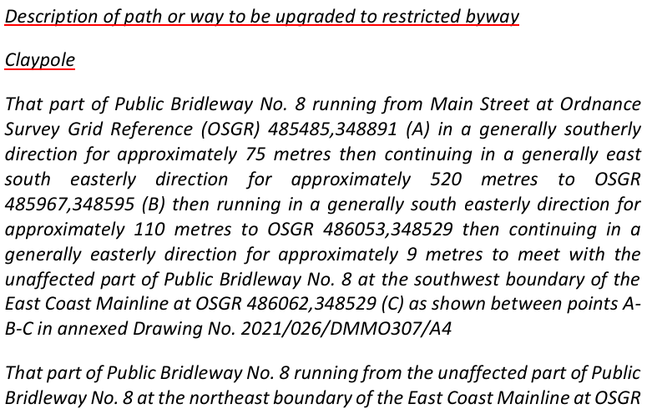

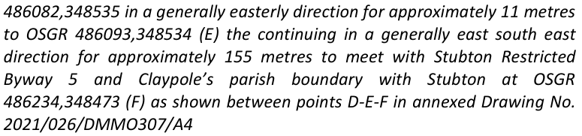
- In the description of path or way to be added, add ‘Restricted Byway No. 1189’ under ‘Westborough & Dry Doddington’, replace ‘south south easterly’ with ‘south easterly’, and replace ‘3 metres’ with ‘18.29 metres (equivalent to 60 feet)’;
- In Part II of the Schedule to the Order: below the heading ‘Modification of Definitive Statement’, replace all of the text with:

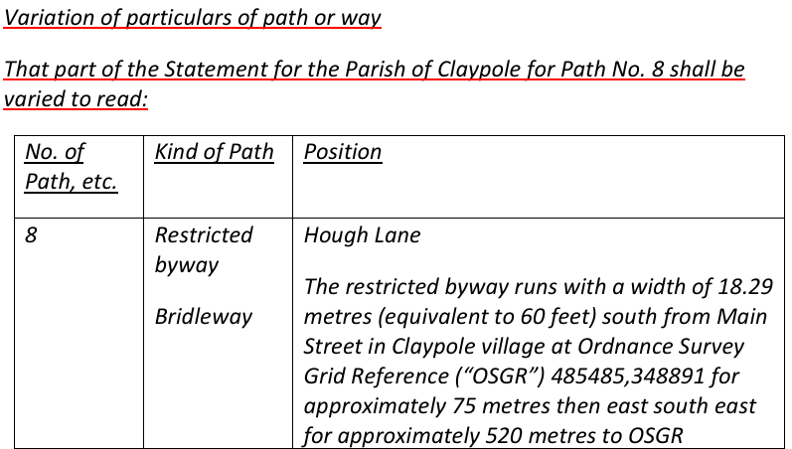

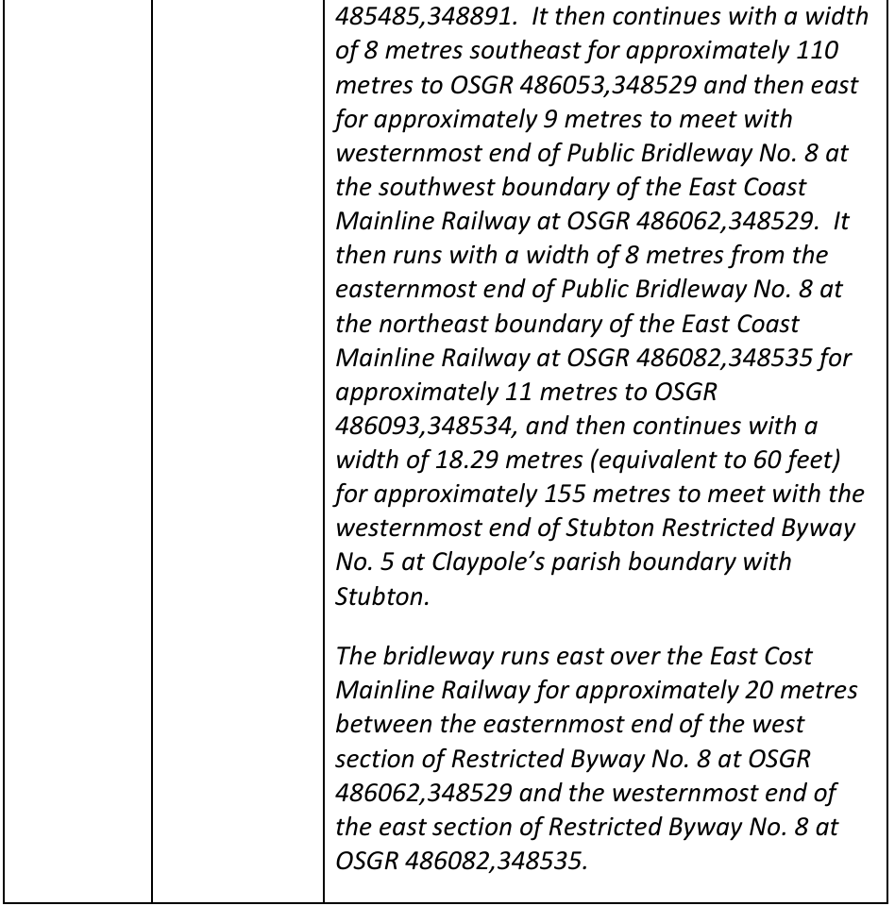

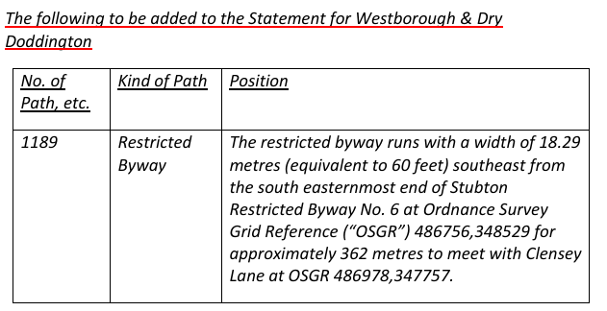
- In the Map, in the title of the Map and in the legend replace ‘Claypole Public Bridleway 7’ with ‘Claypole Public Bridleway 8’.

G D Jones

INSPECTOR

- 