

Application Decision
by Dominic Dobbs
Appointed by the Secretary of State for Environment, Food and Rural Affairs
Decision date: 14 May 2026

Application Ref: COM 3371151
Newton Common, Northumberland, NE66 3EA
Register Unit Number: CL 26
Commons Registration Authority: Northumberland County Council

- The application, dated 14 August 2025, is made under Section 38 of the Commons Act 2006 (the 2006 Act) for consent to carry out restricted works on common land.
- The application is made by Form Properties Limited.
- The works comprise:
- The re-surfacing of an existing accessway and footpath with a hard standing surface with associated laying of utilities, kerbs and drainage works covering approximately 167m²
- The laying of new hard surfaced area totalling approximately 30m² adjoining the existing access way.
- The laying of a new hard surfaced area totalling approximately 53m² to extend the existing vehicular way.
- The conversion of an approximately 7m² existing track to new verge.
- The use of temporary fencing to enclose the working area for the duration of the works.

Decision
- Consent is granted for the works described at i), ii), iv) and v) in accordance with the application dated 14 August 2025 and the plans submitted with it subject to the following conditions set out below. Consent is not granted for the works described at iii) above:

- the works shall begin no later than three years from the date of this decision;
REASON: To provide certainty to users of Newton Common.
- the land shall be fully reinstated within one month from the completion of the works (note that this does not apply to any physical changes or permanent features introduced as part of the works for which consent is granted);
REASON: To retain access for commoners, public and livestock across Newton Common.
- Any temporary fencing shall be removed within one month of completion of the works.
REASON: To retain access for commoners, public and livestock over Newton Common.
- For the purposes of identification only the location of the works is shown on Figure 1 attached to this decision.

Preliminary Matters
- I have had regard to Defra’s Common Land Consents Policy Guidance (November 2015) in determining this application under section 38, which has been published for the guidance of both the Planning Inspectorate and applicants. However, every application will be considered on its merits and a determination will depart from the guidance if it appears appropriate to do so. In such cases, the decision will explain why it has departed from the guidance.

- This application has been determined solely on the basis of written evidence. I have taken account of the representations made by the Open Spaces Society (OSS) and Natural England (NE).

- Within the decision I will refer to the new areas intended to be hard surfaces as area A (works described at ii)) and area B (works described at ii)) as they are labelled in figure 2.

- I am required by section 39 of the 2006 Act to have regard to the following in determining this application:
- the interests of persons having rights in relation to, or occupying, the land (and in particular persons exercising rights of common over it);
- the interests of the neighbourhood;
- the public interest; Section 39(2) of the 2006 Act provides that the public interest includes the public interest in; nature conservation; the conservation of the landscape; the protection of public rights of access to any area of land; and the protection of archaeological remains and features of historic interest;
- any other matter considered to be relevant.

Reasons
- The applicant explains that the primary reason for the current application is to provide residents of the proposed development with a safe access route to their homes.

The interests of those occupying or having rights over the land
- Pursuant to Commons Commissioner Decision 27/U/56 of 29 June 1977 following a hearing into the question of the ownership of the land, the Commons Commissioner was not satisfied that any person was the owner of CL 26 and it remains subject to protection by the local authority under s9 of the Commons Registration Act 1965 (now under s45 of the 2006 Act).

- The Common Land Register records no rights across the whole of the land known as Newton Common.

- I am satisfied that the applicant has carried out the required consultation and no further comments were received, and the planned works would not interfere with the interest of those occupying or having rights over the land.

The interests of the neighbourhood and public access
- The interests of the neighbourhood relate to whether the works will unacceptably interfere with the way the common land is used by local people and is closely linked with interests of public access.

- The common land at Newton Common is split into four separate parcels within Northumberland being remote in location and consisting of mostly rural, open and uncultivated land. The area of Common this application relates to mostly consists of areas that have already undergone works, but some areas are still natural. It is my view that this area of the Common has high natural value and has recreational value for outdoor activities such as walking or access to open areas.

- The applicant explains that the primary reason for the current application is to provide residents of the proposed development with a safe access route to their homes which includes the widening and resurfacing of an existing accessway and the creation of two new hard surfaced areas as well as the lowing and returning of an area to verge.

- The resurfacing works are unlikely to have any long-lasting impact on the Common as they are for the improvement of hard surfaces that already exist on the Common. It is also understood that the associated utilities, kerbs and drainage works are occurring within this area of under the surface of the Common and therefore will not have a lasting impact once the Common is reinstated. The works would impact access to the Common while they are being carried out but this impact would be temporary in nature.

- The laying of the hard surface in area A would not create an unacceptable impediment to impact access of the Common as it would be a flat surface with no obstacles. It may also improve access to this area of the Common by making the accessway onto the main highway more navigable by foot. Although this would create a more urbanising feature at this area of the Common it is consistent with what this area of the Common is currently being used for as an accessway. The new surface will be in keeping with the planned re-surfacing works on a surface that is already part of the Common. I am of the view that the works here are consistent with what this area of the Common is being used for and is practical to maintain access for the new development. Additionally, the applicant has identified that a number of drainage improvements are linked to this area of works and would provide a wider public benefit.

- The laying of the hard surface in area B would not create an unacceptable impediment to impact access of the Common as it is planned to be a flat surface. However, the area this surface would cover is currently natural land and unlike in area A is not connected to the main accessway or an existing footway. The hard surfacing of this area would remove an area of natural land from the Common and would be inconsistent with the way it is currently part of the Common.

- The OSS have commented that they view that the widening of the accessway in area A my be the only rational way to provide access to the new development but question the need for the surfacing of area B.

- In response the applicant highlighted that “NCC guidance requires that for roads serving up to 20 dwellings a carriageway width of 4.1m is appropriate. A swept path analysis of the access was required to enable the route to be shared with the occasional agricultural vehicle that might need to access adjoining farmland.”

- They continue “Following a high level of scrutiny and various amendments to the plans HDM accepted the access and this now forms an approved plan under the planning permission. The Applicant must accept the advice and requirements of the HDM in relation to the safe construction of the route. The accessway was considered in great detail prior to the grant of planning permission. It was only when HDM was satisfied that the access track would be suitable for all users that the objection was removed. The Applicant understands that the extent of the land required to be surfaced is based on the safe passing of vehicles of differing sizes”

- The conversion of 7m² of an existing track to new verge would not impact on access and would benefit the Common by returning a portion of it back to a natural state.

- The temporary fencing would impact access, blocking access to the areas of the Common where the works are taking place. However, the impact will be minimal when considering the overall size of the Common, which will remain. The fencing is also planned to be temporary in nature. I am satisfied that such fencing is appropriate on health and safety grounds and that it will be removed on completion of the works, which can be secured by attaching a suitable condition to the consent.
- NE have been consulted on the application and stated that “There will clearly be a need for some restrictions on public access whilst works are being undertaken although we note that the applicant intends to maintain a degree of statutory access across the common in the area which the works are being undertaken by applying for a temporary diversion of the public footpath. The application states that the works will take place over period of 4 weeks which we have assumed will be the maximum period during which the current use by the public will be restricted in any way”

- Overall, I do not believe the works as planned listed at i), ii), iv) and v) would create any unacceptable impediment to people’s access to and across the Common and I do not believe the implementation of these works would interfere with the way the Common is currently used.

- However, I view the works listed at iii) are not consistent with the way the Common is already used as they will convert an area of the natural Common to an urban state that will not directly enhance the Common. The Common land consents policy highlights that works relating to vehicular ways across common land can impact commons “…by reducing the area available for recreation and grazing, by causing harm to habitat, perhaps by affecting drainage, and by introducing an urbanising feature into what will normally be an essentially open and natural setting. The Secretary of State takes the view that, in some circumstances, a paved vehicular way may be the only practical means of achieving access to land adjacent to the common. Where an existing unsurfaced means of access is already in use, a sympathetic paving proposal may be aesthetically preferable.”

- In this case as there is already an existing vehicular way, and this decision grants consent for the widening of it, I do not view that granting consent for the additional surfacing works would be in line with the policy and in this case, I do not view that I can deviate from it.

The public interest
- As well as having regard to the public interest in the protection of public rights of access, I must also have regard to the public interest in nature conservation, the conservation of the landscape and the protection of archaeological remains and features of historic interest.

Nature conservation and conservation of the landscape
- NE have stated that “In terms of impact and significance, we have confirmed that the Common is not subject to any statutory designations for nature conservation which would require the need for any consents/assents from ourselves as the regulatory body for such nationally protected sites. There is however the potential for all areas of semi natural habitat that occur on a particular area of common land to contribute to the common’s overall level of biodiversity interest and the biodiversity interest of the surrounding area. We are aware that ecological compensation and mitigation is planned which is related to the wider development, although we are unable to confirm that any benefits will accrue to the nature conservation value of the common itself from the works in this case. Wider public benefits have been cited by the applicant and as the works on the common will have a lasting impact we believe these are particularly relevant to this application.”

- In this case I note that the introduction of new hard surfaces would impact the landscape and nature conservation interest of the Common. In this case I view the widening of the accessway where it meets the main road in area A as necessary to allow for the access to the new deployment. Consent has not been granted for the resurfacing works in area B which will help to mitigate the works overall impact on the natural and landscape values of the Common.

- Overall, I am of the view that the works for which consent has been granted will not significantly negatively impact on nature conservation interests of the Common or impact the landscape interests of the Common.
Protection of archaeological remains and features of historic interest.
- Historic England was consulted on the application and did not provide comment.

- There is no evidence before me to suggest that these interests will be harmed by the proposed works if the above conditions are applied by the applicant.

Conclusion
- In this case I conclude that the works will not introduce an unacceptable barrier to public access to the Common and the works will not seriously harm the other interests set out in paragraph 5 above. Consent for the works is therefore granted subject to the conditions set out at paragraph 1 above for the works described at i), ii), iv) and v). Consent is not granted for the works described at iii) as access is already possible onto the Common and I do not view that the conversion of more of the Common to a hard standing surface is consistent with the policy in this case.

Dominic Dobbs

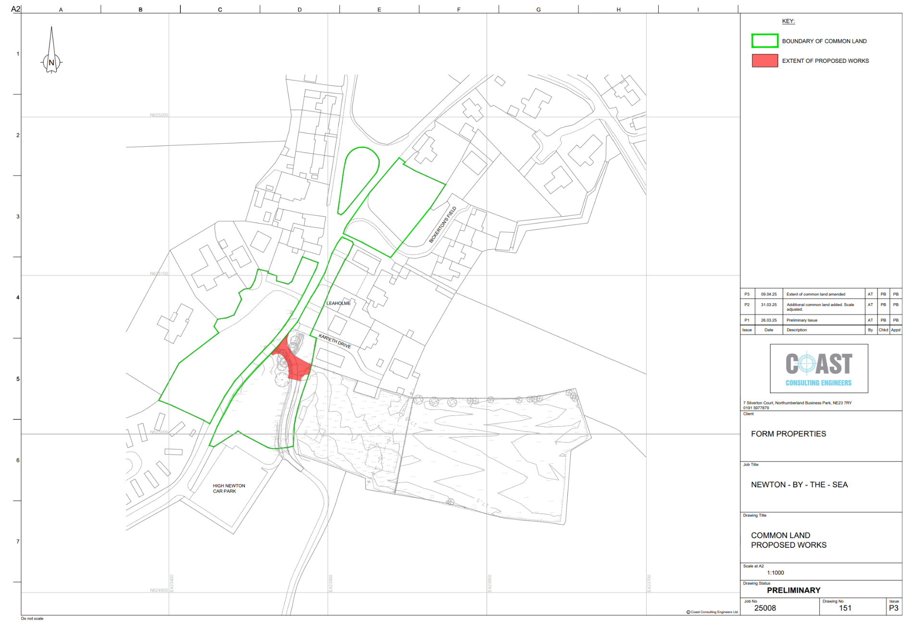
Figure 1 – Location of works on the common
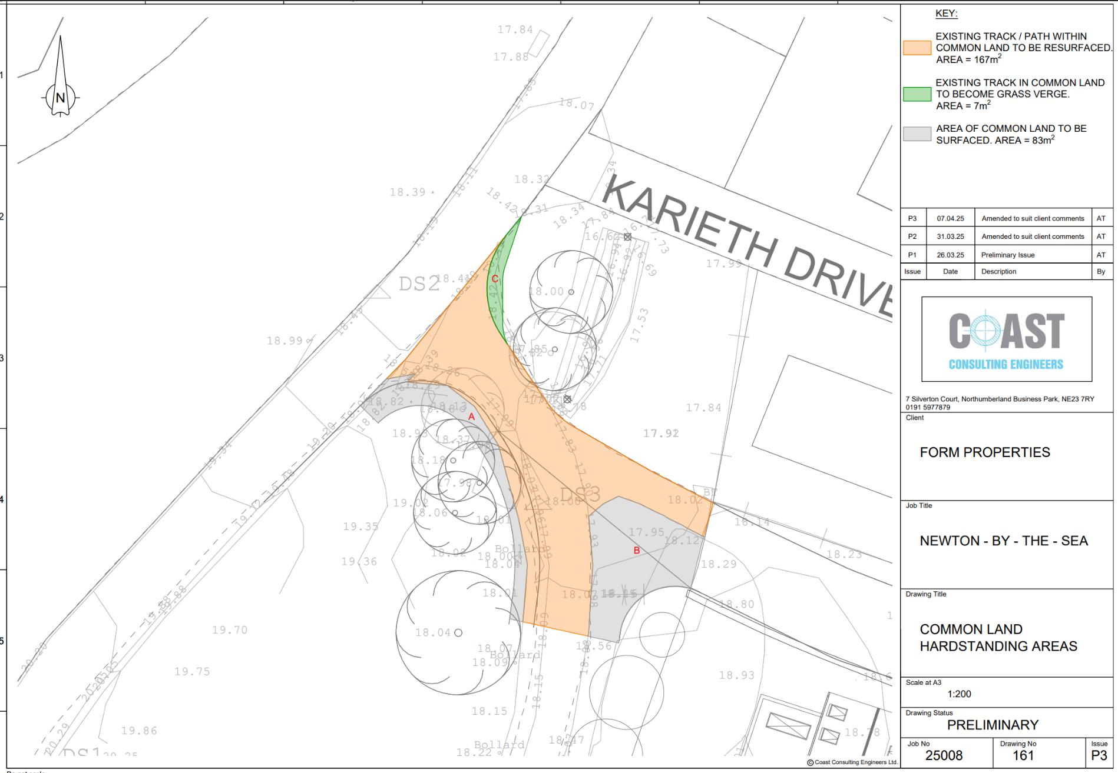
Figure 2 – Plan showing area A and area B

