Rough A (AD & AP Installations and Risers) Complex Decommissioning EA

Rough 47/8A Decommissioning Project
AD and AP Installations

Customer |  | Centrica Energy Storage Ltd
Project |  | 600934
Deliverable |  | CST000582
Version |  | C1
 |  | 11 December 2025

Document Control

Document Identification
Title | Rough A Complex Decommissioning EA
Project No | 600934
Deliverable No | CST000582
Version No | C1
Version Date | 11 December 2025
Customer | Centrica Energy Storage Ltd
Classification | Commercial – Confidential

Author | Cemlyn Barlow, Joe Ferris, Sophie Barrett, Brooke McCluskey, Molly Thornborrow
Checked By | David Vale
Project Manager | David Vale

Amendment Record
The Amendment Record below records the history and issue status of this document.
Version | Version Date | Distribution | Record
A1 | 22 December 2022 | Centrica Energy Storage Ltd | Draft
A2 | 6 February 2023 | Centrica Energy Storage Ltd | Updated Draft
B1 | 16 February 2023 | Centrica Energy Storage Ltd | Updated Draft
C1 | 11 December 2025 | Centrica Energy Storage Ltd | Final

Non- technical Summary

Introduction
This non-technical summary outlines the findings of the Environmental Appraisal conducted by Centrica Energy Storage Limited (CESL) in support of the Rough 47/8 Alpha (Rough 47/8A) complex Decommissioning Programs. The purpose is to understand and communicate the potential significant environmental impacts associated with the proposed project and to inform the decision-making process.
The Rough 47/8A complex is located within the Rough Field in the United Kingdom Continental Shelf Blocks 47/3. 47/6, 47/7, 47/8 and 47/11 in the southern North Sea approximately 29 kilometres northeast of Easington, Yorkshire, in approximately 36 metres water depth. In 2016 CESL announced the closure of the Rough 47/8A facility and the cessation of production was approved by the regulator. The 47/8A platform has ceased production and is now unmanned. The Platform removal operations are planned to commence in Q2 of 2026 with the decommissioning programmes closed-out in Q4 2030.
The Rough 47/8A complex consists of the following infrastructure:
- Rough Alpha Drilling (AD) platform (6 wells);
- Rough Alpha Production (AP) platform (0 wells), including risers ; and
- Rough 47/8A bridge-link.
The proposed Decommissioning Programmes (DPs) include full removal of the Rough AD platform, the Rough AP platform, the bridge link and risers (Figure 1). The subsea infrastructure will be included in a future Decommissioning Programme.
Once preparation for removal has been carried out, the removal of the infrastructure will be undertaken in two phases:
- Surface infrastructure decommissioning phase which includes:
  - Cutting and removal of the Rough AD and AP topside modules; and
  - Cutting and removal of the bridge-link platform connecting the platforms.
- Subsurface infrastructure decommissioning phase which includes:
  - Cutting and removal of the jackets and piles to 3 m below the seabed

Regulatory Context
The decommissioning of offshore oil and gas infrastructure in the United Kingdom Continental Shelf is principally governed by the Petroleum Act 1998 (Petroleum Act), as amended by the Energy Act 2008 and the Energy Act 2016. The Petroleum Act sets out the requirements for formal Decommissioning Programmes, which must be approved by the Department for Energy Security and Net Zero (DESNZ) before the owners of an offshore installation or pipeline may proceed with decommissioning.
The Department for Business, Energy and Industrial Strategy (BEIS) (now the DESNZ) guidance notes, Decommissioning of Offshore Oil and Gas Installations and Pipelines (May 2018), indicates that a DP must be supported by an environmental assessment of the proposed decommissioning option. The Environmental Appraisal fulfils that requirement. In addition, under the Marine and Coastal Access Act 2009 (MCAA) an Environmental Appraisal is required for all licence applications relating to decommissioning operations.
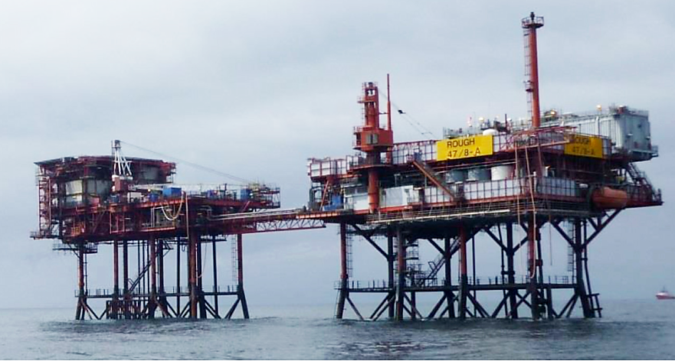
- Rough A Complex, 47/8 AD and AP platforms with bridge link

Scope of the Rough 47/8A Decommissioning Programs
The drilling platform (Rough AD) consists of an eight-leg welded and tubular jacket structure supporting upper and lower topside decks via eight unbraced tubular columns. Leg insert piles fix the whole structure to the seabed. The Rough AD topside consists of:
- Accommodation units, helideck, pedestal crane and MSF, totalling 2,301 metric tonnes (Mt);
The production platform (Rough AP) consists of an eight-leg welded steel tubular jacket structure supporting upper and lower topside decks via tubular columns. Upper and lower decks have been extended on the platform west side and additional deck column bracing installed. In addition to the jacket, the Rough AP topside consists of:
- Control room, MSF North, and MSF South, totalling 2,713 Mt;
- One 4-inch in-field umbilical riser,
- One 16-inch export riser; and
- One 18-inch in-field riser.
The bridge-link structure connects the Rough AP platform at the cellar deck to the Rough AD platform at lower deck level.
Options for re-use of the platforms were considered but in the absence of remaining hydrocarbon reserves in the vicinity of the infrastructure and the limited remaining design life and unsuitable material composition of the infrastructure, re-use of the platforms is unfeasible. Consequently, CESL is proceeding to decommissioning of the infrastructure in a way that is safe and environmentally and socioeconomically acceptable.

Decommissioning Approach
The decommissioning operations for the Rough 47/8A platforms AD and AP will most likely be undertaken using a heavy lift vessel and additional supporting marine vessels, as required. This may include Jack-Up Barge(s) for preparatory works and cargo barges for transportation of Rough A Topsides (or part thereof) and Jacket(s) (including risers). The Rough 47/8A platform topsides will be decommissioned by fully removing the AP & AD Topsides, AP & AD Jackets (including risers) and the bridge link connecting the two platforms. It is possible that Rough AD and AP topsides can be removed by a single lift upon completion of some local dismantlement and/or specific module removal.
The six gas production wells on the Rough AD platform are plugged and abandoned to AB2 status. All platform equipment has been de-energised, with the exception of solar powered navigation aids. Topsides have been cleaned of hydrocarbons and pipelines have been cleaned and disconnected. Pipelines PL26, PL151 and PLU6255 will also be decommissioned at a later date subject to a separate DP.
Recovered infrastructure will be returned to shore and transferred to a suitably licensed decommissioning facility. No asbestos, lead paint or naturally occurring radioactive materials (NORM) have been identified on the platforms during previous sampling and hazardous waste surveys. Additional assessments will be undertaken prior to removal of the topsides to ensure all hazardous materials are accounted for and disposed via an appropriately licenced waste management contractor. It is expected that the materials from the platforms will be recycled, with CESL intending to recycle >95% of the recyclable material that is returned to shore.

Environmental Setting and Sensitivities
An understanding of the surrounding environment is important for planning and to inform the assessment of the risks associated with the proposed decommissioning of the Rough A field. This section provides an overview of the physical, biological and socioeconomic environment and sensitivities to decommissioning activities. Pre-decommissioning environmental and habitat surveys were undertaken in the summer of 2022. The detailed survey findings are provided in the Environmental Appraisal.

Physical and Chemical Environment
The southern North Sea basin is relatively shallow with the bathymetry around the Rough 47/8A infrastructure area ranging from 33.3 to 36.5 metres. Several water masses exist in the North Sea with differing temperature, salinity and residual current patterns and/ or stratification. These different factors play a major role in the supply and dispersion of nutrients, plankton and fish larvae. Maximum tidal stream speeds vary from 0.25 to 0.5 m/s but can reach in excess of 1.00 m/s in the Rough A area. Tidal currents in the location of the Rough A infrastructure are typical of the SNS with relatively strong surface current velocities and mean spring tides ranging from 1.25 to 1.75 m/s. The annual mean significant wave height range between 1.00 and 1.50 m.
In the vicinity of the Rough A field winds vary seasonally and are characterised by large variations in wind direction and speed. The annual wind data generally comes from the south and northwest. During the spring, the frequency of those from the north and east increases Easterly winds are not common, however, and can bring exceptionally cold weather in winter. Wind speed is on average between Beaufort scale 1-6 (1-11 m/s) in the summer months, strong gale force winds of speeds 7-12 (14-32 m/s) occur in winter months.
Sea-surface temperatures increase southwards (from 5 to 7 ºC) in February. This is a result of a stream of relatively warm water extending up from the English Channel which prevents the water temperature from dropping below 5 ºC. In August, temperatures again increase progressively to the south (from 14 to 16.5 ºC). The southern North Sea receives significant freshwater input from the rivers along its eastern boundary and therefore is less saline than the northern North Sea.
The sediment within the Rough A field was mostly composed of sand and gravel, with a lower fines content and was classified as ‘sandy gravel’, ‘gravelly sand’ or ‘muddy, sandy gravel’ throughout the survey area. Both total organic matter and total organic carbon values were comparable to the reference station suggesting that the sediments were comparable to the wider area. The majority of total hydrocarbon values were representative of the wider SNS region and could be ascribed as background. Total 2 to 6 ring polycyclic aromatic hydrocarbon concentrations were generally higher than the SNS mean background concentration, but comparable to the reference station, indicating concentrations were likely to be background for the area. The US EPA 16 PAHs and alkylated PAH concentrations were below their respective effects level values at all station. The mean concentrations for the majority of metals were higher than their respective SNS mean background concentrations with copper, lead and zinc having a mean concentration higher than the SNS 95th percentile value. The concentrations at the main survey array were higher than the reference station, suggesting some input to the sediment from operational activity. Effects level values were exceeded for copper (two stations), mercury (two stations), lead (three stations) and zinc (four stations). The correlations highlighted between the physiochemical variables and the biota component did not indicate that the biological community is affected at the time of sampling. Despite the high levels of metals recorded within the survey area, these did not appear to drive any faunal variability.

Biological and Socioeconomic Environment
The biological and socioeconomic characteristics for the Rough A area are summarized in Table 1. The table highlights the environmental sensitivities for:
- Offshore conservation areas, plankton, benthos, finfish and shellfish spawning and nursery grounds, marine mammals, seabirds; as well as
- Consideration to other sea users, such as the fishing and shipping industries, the renewable energy sector and the military operations; and
Existence of submarine cables, historic wrecks, renewables and other oil and gas installations.
- Environmental sensitivities in the vicinity of Rough 47/8 A field
Aspect | Detail
Site overview
The Rough A field, operated by CESL and lies within UKCS Block 47/8 in the SNS, approximately 29 km southwest of Easington Yorkshire, and 160 km west of the UK/Norwegian median line. The decommissioning programmes are also located within the International Council for the Exploration of the Sea (ICES) rectangle 36F0.
Environmental Aspects
Conservation Interests within 40 km of proposed Rough A Decommissioning
Offshore Marine Protected Areas and Annex I habitats
Special Area of Conservation (SAC) | Rough A lies within the Southern North Sea SAC, designated for the protection of harbour porpoise. The Humber Estuary SAC lies within 40 km of Rough A.
Marine conservation zones (MCZ) | Rough A lies within the Holderness Offshore MCZ, designated for subtidal coarse sediment, subtidal sand, subtidal mixed sediments, Ocean quahog and North Sea glacial tunnel valleys. The Holderness Inshore MCZ lies within 40 km of Rough A.
Special Protection Areas (SPA) | There are 2 SPAs within the Rough A area, Humber Estuary and the Greater Wash SPA designated for Annex I bird species.
Annex I habitats | There are both Annex I sandbanks and reef habitats present within 40 km of the Rough A field.
Offshore Annex II species
Harbour porpoise (Phocoena phocoena) | A very high abundance of harbour porpoise is recorded in Quadrat 47 and adjacent quadrants for March, July, August, September, October, November and December with a moderate abundance the rest of the remaining months.
Grey seals (Halichoerus grypus) | Grey seal densities typically range between 10 – 50 seals per 25 km² with occasional peaks of up to 100 seals per 25 km².
Harbour seals (Phoca vitulina) | Harbour seal densities are typically low (between 0 – 1 seals per 25 km2), reaching peaks of up to 10 seals per 25 km² in localised regions of the block of interest.  There are no haul-out or breeding sites within the vicinity.
Bottlenose dolphin (Tursiops truncatus) | Bottlenose dolphins are recorded in the vicinity around Rough A in the months of July and August.
Marine Plan Policies
East Inshore and Offshore Marine Plans Policies | Rough A falls under the guidance of the East Inshore and East Offshore Marine Plan Policy.
Plankton
The zooplankton communities of the SNS is dominated by copepods including Calanus helgolandicus, C. finmarchicus, Paracalanus and Pseudocalanus spp., Acartia spp., Temora spp. and cladocerans such as Evadne spp. (OESEA, 2022).
Benthic environment
The Rough A field lies within a widespread seabed area that can be classified into mostly coarse sediment. The UKSeaMap describes the seabed in the subtidal section of the proposed area as a mixture of A5.14 Circalittoral coarse sand and A5.13 Infralittoral coarse sand, A5.43 Infralittoral mixed sediment and A5.44 Circalittoral mixed sediment
Fish and shellfish – spawning and nursery areas
Spawning areas | The Blocks of interest overlap with spawning areas for, cod (Gadus morhua), herring (Clupea harengus) lemon sole (Microstomus kitt), plaice (Pleuronectes platessa), sole (Solea solea), sprat (Sprattus sprattus) and sandeel (Ammodytes sp).  ICES rectangle 36F0 is considered a high intensity spawning area for North Sea plaice
Nursery areas | There are nursery areas in the ICES rectangle 36F0 for, cod, herring, lemon sole, plaice, mackerel (Scomber scombrus), sandeel, sprat, whiting (Merlangius merlangus).  There is high intensity nursery ground identified for cod, herring, and whiting ICES rectangle 36F0.
Marine Mammals
Cetaceans | The main marine mammal species occurring in the area are minke whale (Balaenoptera acutorostrata), bottlenose dolphin (Tursiops truncatus), common dolphin (Delphinus delphis), white-sided dolphin (Lagenorhynchus acutus), white-beaked dolphin (Lagenorhynchus albirostris) and harbour porpoise (Phocoena phocoena), with most sightings occurring in the summer months.
Seals | Grey seal densities typically range from 10 – 50 seals per 25 km² in the area, with occasional peaks up to 100 seals. Harbour seal densities are generally low within the block of interest, typically ranging from 0 to 1 seals per 25 km² in the area, with occasional peaks up to 10 seals.  There are no haul-out or breeding sites within the vicinity.
Seabirds
Species commonly found in offshore North Sea waters are Fulmar (Fulmarus glacialis), Gannet (Morus bassanus), Guillemot (Uria aalge), Razorbill (Alca torda), and Kittiwake (Rissa tridactyla); and Herring (Larus argentatus), Great Black-backed (Larus marinus) and Lesser Black-backed (Larus fuscus) gulls.
Seabird sensitivity | In the primary block of interest (47/8), seabird oil sensitivity ranges between low and high throughout the year. In the block of interest, extremely high seabird vulnerability was recorded in October, with very high seabird vulnerability recorded in March
Socioeconomic Aspects
Fisheries | Fishing effort in ICES rectangle 36F0 ranged between 2,563 days in 2020 to 3,394 days in 2024 (Scottish Government, 2025). Between 2020 and 2024, the annual total live weight of fish landed ranged from between 2,991 tonnes landed in 2023 to 4,059 tonnes landed in 2021.Total annual fishing value ranged between £9,094,884 in 2020 to £15,941,288 in 2021 (Scottish Government, 2024).  No shellfish water protected areas or active aquaculture sites occur in the vicinity of the Rough A area.
Shipping | Shipping density in the blocks of interest is considered to be high to very high (EMODnet, 2024).
Oil and gas industries | There are 18 active platforms within 40 km of the Rough A Field infrastructure. The closest, Rough BD is approximately 2 km to the northwest.
Offshore renewables | There are 2 renewable energy sites in production within 40 km of Rough 47/8 A.
Military activities | Within a designated MoD training range, however, there is no military activity expected within the vicinity.
Telecommunications | There is one cable in the Rough A vicinity: TGN Northern Europe 37 km northwest and one planned cable 23 km southeast, NGVL Northern Europe

Assessment of environmental effects and their significance
An environmental risk assessment (ENVID) workshop was undertaken to assist in identifying the potential environmental issues (or aspects) associated with the proposed Rough A decommissioning programmes. Each of the potential environmental issues identified during the ENVID were assessed and their significance determined by combining the likelihood of occurrence (frequency/ probability) with the magnitude of impact (consequence). Cumulative and transboundary impacts were also considered.
The majority of issues were found to be of low or relatively negligible risk to the environment (i.e. not significant) and were scoped out from detailed assessment in the EA. Some issues, however, were considered to be of medium risk to the environment (i.e. potentially significant). For these issues, project controls and mitigation measures were identified to either remove the potential impacts by design or minimise or manage the potential impacts through operational measures. Once mitigation measures were determined, the potential impacts were re‐assessed to determine whether the overall impact significance had been reduced. These remaining impacts are referred to as the residual impacts and were scoped-in for detailed environmental assessment. These included:
- Effects of seabed disturbance during decommissioning activities – vessel anchoring, jacket and pile removal, pipeline cutting, dredging over-trawl survey, etc.
- Potential discharge of residual contaminants during routine decommissioning activities (controlled or intentional discharges).
- Physical presence of vessels causing interference or displacement of other users of the sea.
- Impacts to fisheries.
- Effects of energy use and atmospheric emissions.
- Effects of underwater noise generated during the decommissioning activities.
- Non-routine events, such as the release of hydrocarbons or other fluids during the decommissioning activities or through accidental events such as vessel collisions (accidental releases).
The findings from the impact assessment process for the full removal of the Rough A platforms and bridge are summarised in Table 2.
- Summary of findings from the impact assessment process for the full removal of the Rough A platforms and bridge
Potential sources of impact | Planned mitigation measures | Conclusions
Seabed Impacts
- Preparatory work using a jack-up barge  - Anchoring of HLV during operations  - Removal of anchors and seabed remediation  - Dredging/ excavation and external cutting of piles and risers  - MBES Survey | - Mooring analysis  - Anchor management plan  - Post operation seabed survey  - Consent to locate  - Shipping survey  - Ensure proper anchoring equipment is being used for certain seabed type  - Requirements for excavation to cut the piles will be assessed on a case-by-case basis and will be minimised to provide access only where necessary. Internal cutting will be used preferentially where access is available. | - Disturbance to the seabed is expected to be transient and will have a short-term effect on the local benthic environment. The temporary impacts arising from these activities may include sediment disturbance and benthic fauna disturbance.  - Activities resulting from the decommissioning of the Rough 47/8A jacket and platform are expected to create a maximum seabed impact of 0.081614 km², representing <0.01% of the total area any of the overlapping conservation sites.  - Decommissioning activities are likely to result in minimal overall impact on the conservation sites in the short-term. However, part of the aim of the decommissioning work is to return the seabed to its original state as far as possible.  - No transboundary or cumulative impacts expected.
Discharges to Sea
- Potential discharge of contaminants during topside modules removal operations  - Potential discharge of contaminants during pipeline cutting | - Topsides have been cleaned of hydrocarbons and pipelines have been cleaned and disconnected.  - Contaminants will be skipped and shipped to shore.  - Disposal of waste transported onshore for disposal will be provided by an approved waste management contractor, in compliance with CESL existing standards, policies and procedures. | - There is the possibility that minor discharges of residual materials (such as hydrocarbons) may occur during preparation of topsides for removal. It is expected that these discharges will result in negligible localised effects and are not anticipated to have any discernible impact on the wider marine environment cumulatively or in combination with other activities.
Societal Impacts
- Increase in vessel traffic and vessel collision risk  - Physical presence of decommissioning vessels causing potential interference to other users of the sea, including possible closure to shipping areas.  - Post-decommissioning damage to or loss of fishing gear as a result of depressions and berms, posing potential snagging risks.  - Damage to or loss of gear as a result of subsea obstructions decommissioned in situ, posing potential snagging risks. | - Prior to commencement of operations, the appropriate notifications will be made and maritime notices posted  - All vessel activities will be in accordance with national and international regulations  - Use of designated transit routes for all decommissioning vessels.  - Twenty-four-hour manned bridge policy.  - Continual use of AIS vessel identification  - On-going consultation with fisheries representatives  - Vessel Traffic Survey to be completed as necessary | - The temporary loss of access for vessels during the decommissioning operations is unlikely to have a significant impact on other sea users (i.e. commercial shipping and fishing).  - The EA has highlighted the positive impact that the decommissioning of the Rough 47/8A infrastructure will have on commercial fisheries with the opening of areas of the sea which have previously been excluded for safety reasons.
Atmospheric Emissions
- Vessels for transport and offshore operations  - Helicopters for personnel transport  - Onshore transportation and deconstruction  - Manufacture of new materials  - Recycling  - Emissions of carbon dioxide (CO₂), oxides of nitrogen (NO_{x}), sulphur dioxide (SO2) contributing to greenhouse gases | - Vessels will be audited as part of selection and pre-mobilisation.  - All generators and engines will be maintained and operated to the manufacturers’ standards to ensure maximum efficiency.  - Vessels will use ultra-low sulphur fuel in line with MARPOL requirements.  - Work programmes will be planned to optimise vessel time in the field.  - Fuel consumption will be minimised by operational practices and power management systems for engines, generators and other combustion plant and maintenance systems. | - Total CO₂e emissions generated by the proposed Rough 47/8A facilities decommissioning operations will be 17,188 tonnes.  - Project emissions represent a small proportion (approximately 0.13%) of the total annual CO₂ offshore emissions from the UKCS in 2018.  - Approximately 50% of the energy use is attributed to vessel and helicopter use, with a further 36% attributed to recycling.  - Cumulative and transboundary impacts are small, but unavoidable.
Underwater Noise
- Underwater noise from decommissioning activities | - Machinery and equipment will be in good working order and well-maintained.  - Vessel maintenance will be undertaken by contractors in line with manufacturers and regulatory requirements.  - The number of vessels utilising dynamic positioning would be minimised where possible. | - Sound levels associated with the decommissioning of the Rough 47/8A infrastructure would attenuate to ambient levels.  - Subsea noise levels generated by surface vessels during operations are unlikely to result in physiological damage to marine mammals.  - The proposed decommissioning activities will not result in significant noise disturbance within the SAC to exclude harbour porpoise from more than 20% of the relevant area of the site in any given day or an average of 10% of the relevant area of the site over a season.  - The individual and cumulative impacts from decommissioning activities at Rough 47/8A are not considered significant.
Accidental Events
- Hydrocarbon release | - Hydrocarbon inventories have been minimized  - A Rough Field Oil Pollution Emergency Plan details responsibilities for initial response and longer-term management and will be updated as needed to reflect any change in operations and activities associated with decommissioning. | - Worst-case scenario at the decommissioning area would result from a loss of diesel from on-site vessels.  - Probability of a hydrocarbon spill occurring is low and will not contribute to the overall spill risk in the area.  - Response procedure described in the OPEPs will provide direction to effectively manage the spill in case of an accidental event.  - Oil spill modelling results suggest that in the event of a release or spill no hydrocarbons would impact shorelines.  - Modelling also concluded that a release would not cross the median line.  - Cumulative effects of overlapping footprints for detectable contamination or biological effects are considered unlikely.
- Vessel collision | - Local shipping traffic would be informed of proposed decommissioning activities, and a standby/ support vessel would monitor shipping traffic at all times.
- Spill from a vessel during decommissioning operations | - In the event of an accidental spill to sea, vessels will implement their SOPEP.
- Chemical spills from the decommissioning activities | - CESL will conduct all operations in a controlled manner with trained personnel using suitable equipment. All vessels will have suitable skill kits and an efficient spill response process is in place.  - Chemical inventories have been removed during preliminary decommissioning activities.  - Observed leaks are reported and dealt with immediately by competent personnel and reported to the appropriate authorities. | - The likely credible maximum volume of chemicals that may be subject to a spill event would be very low.  - Any release is likely to be dispersed and diluted rapidly by the receiving environment.  - Many of the compounds are volatile or soluble and are removed from the water by evaporation and dilution.  - Biological Oxygen Demand is likely to be within the capacity of ambient oxygen levels.
- Dropped object event during the decommissioning activities | - Post-decommissioning surveys will be undertaken to assess the presence and potential recoverability of any lost objects wherever practicable. The recovery of such debris will be undertaken to minimise the impact on the environment and to minimise the risk to other users of the sea wherever possible.  - All efforts will be made by CESL’s contractors to minimise the number of dropped objects. During the preparation for removals program, items will be secured to prevent loss wherever practicable. | - Impact on seabed and benthic organisms will be localised and only affect a small area.  - No transboundary or cumulative impacts are likely.

Contents

Acronyms, Abbreviations and Units iv
1 Introduction 6
1.1 Field Overview 6
1.2 Scope of the Proposed Decommissioning Operations 6
1.3 Purpose of Environmental Appraisal 8
Regulatory Context 9
1.4 Report Structure 12
1.5 Transboundary and Cumulative Impacts 13
2 Project Description 14
2.1 Overview 14
2.2 Well Abandonment 14
2.3 Decommissioning of the Rough 47/8A Platforms 14
2.4 Decommissioning Option 16
2.5 Decommissioning methodology 16
2.6 Post-decommissioning surveys 17
2.7 Disposal of Decommissioning Materials 17
2.8 Decommissioning Schedule 17
3 Environmental Baseline 19
3.1 Location of the Rough A infrastructure 19
3.2 Physical and Chemical Environment 19
3.3 Biological Environment 23
3.4 Offshore Conservation Areas 34
3.5 Socioeconomic Environment 40
3.6 Summary of Environmental Sensitivities 49
4 Evaluation of Potential Environmental Impacts 51
4.1 Risk Assessment Methodology 51
4.2 Risk Assessment Findings 56
5 Seabed Impacts 59
5.1 Approach 59
5.2 Sources of Potential Impacts 59
5.3 Short- and long-term impacts 61
5.4 Short-Term Impacts on Sensitive Receptors 62
5.5 Long-term impacts on sensitive receptors 64
5.6 Cumulative and transboundary impacts 64
5.7 Proposed mitigation measures 66
5.8 Conclusions 67
6 Discharges to Sea 68
6.1 Approach 68
6.2 Sources of Potential Impact 68
6.3 Impacts on Sensitive Receptors 68
6.4 Cumulative and Transboundary Impacts 69
6.5 Proposed Mitigation Measures 70
6.6 Conclusions 70
7 Societal Impacts 71
7.1 Sources of Potential Impacts 71
7.2 Impacts on Receptors 72
7.3 Cumulative and Transboundary Impacts 73
7.4 Mitigation measures for Rough 47/8A areas 73
7.5 Conclusions 73
8 Atmospheric Emissions 75
8.1 Regulatory Context 75
8.2 Assessment Methodology 75
8.3 Sources of Potential Impacts 76
8.4 Assumptions 76
8.5 Estimated Energy Use and Emissions 77
8.6 Impacts on Sensitive Receptors 79
8.7 Cumulative and Transboundary Impacts 80
8.8 Mitigation Measures 80
8.9 Conclusions 80
9 Underwater Noise 81
9.1 Regulatory Context 81
9.2 Sources of Potential Impacts 82
9.3 Impacts on sensitive receptors 82
9.4 Protected Areas 84
9.5 Transboundary and Cumulative Impacts 85
9.6 Mitigation Measures 85
9.7 Conclusions 85
10 Physical Presence 87
10.1 Sources of potential Impacts 87
10.2 Impacts on Sensitive Receptors 87
10.3 Protected Areas 87
10.4 Transboundary and Cumulative Impacts 88
10.5 Mitigation Measures 88
10.6 Conclusions 88
11 Accidental Events 89
11.1 Hydrocarbon Release – Approach 89
11.2 Chemical Releases – Approach 93
11.3 Dropped Objects – Approach 95
12 Waste Management 97
12.1 Waste Generation 97
12.2 Regulatory Context 98
12.3 Waste Management 99
13 Environmental Management System 102
13.1 Introduction 102
13.2 Scope of the EMS 102
13.3 Principles of the Asset Integrity Management Strategy 102
13.4 Asset Integrity Management Policy 103
13.5 Summary of Environmental Commitments 103
14 Conclusions 107
15 References 109
Annex A ENVID Worksheets A-1
Annex B E&E Technical Note B-0

Acronyms, Abbreviations and Units

Abbreviation | Definition
A | Alpha
AD | Alpha drilling
AIMS | Asset Integrity Management Strategy
AIS | Automatic identification system
AP | Alpha platform
AWMP | Active waste management plan
B | Bravo
BD | Bravo drilling
BEIS | Department for Business, Energy and Industrial Strategy
CA | Comparative Assessment
CCS | Carbon capture and storage
CEFAS | Centre for Environment, Fisheries and Aquaculture Science
CH4 | Methane
CNS | Central North Sea
CO2 | Carbon dioxide
COUKL | Centrica Offshore UK Limited
COP | Cessation of production
CESL | Centrica Energy Storage Limited
CSL | Centrica Storage Limited
CSV | Construction Support Vessel
°C | Degrees Celsius
DD | Disclosive data
DEFRA | Department of Environment, Food and Rural Affairs
DESNZ | Department for Energy Security and Net Zero (formerly BEIS)
DP | Decommissioning Programme
EA | Environmental Agency
EA | Environmental Appraisal
EC | European commission
EMS | Environmental management system
ENVID | Environmental Identification
EPS | European protected species
ES | Environmental statement
ESAS | European Seabirds at Sea
EU | European Union
EUNIS | European Nature Information System
GHG | Greenhouse gases
GMSL | Global Marine Systems Limited
GWP | Global warming potential
HF | High frequency
HLV | Heavy lift vessel
HSE | Health and safety executive
HSSE | Health safety security and environment
HZ | hertz
ICES | International Council for the Exploration of the Sea
IMS | Integrity Management Systems
IUCN | International Union for Conservation of Nature
JNCC | Joint Nature Conservation Committee
km | Kilometre
kHz | kilohertz
LAT | Lowest astronomical tide
LF | Low frequency
m | Metre
m/s | Metres per second
MAH | Major Accidental Hazard
MARPOL | International Convention for the Prevention of Pollution from Ships
MBES | Multibeam echosounder
MCA | Maritime and coastguard agency
MCCA | Marine and Coastal Access Act 2009
MCZ | Martine conservation zones
MEI | Major Environmental Incident
MF | Mid-frequency
MMO | Marine Management Organisation
MSF | Module support frames
MSFD | Marine Framework Directive
Mt | Metric tonnes
NFFO | National Federation of Fishermen’s Organisations
NIFPO | Northern Ireland Fish Producers Organisation
NGO | Non-government organisations
NORM | Naturally occurring radioactive materials
NOx | Oxides of nitrogen
NNS | Northern North Sea
OGA | Oil and Gas Authority (now North Sea Transition Authority)
OHSAS | Occupational Health and Safety Assessment
OPEP | Oil Pollution Emergency Plan
OPOL | Oil Pollution Operator’s Liability
OPPC | Oil Pollution Prevention and Control Regulations 2005
OPRED | Offshore Petroleum Regulator for Environment and Decommissioning
OSPAR | Oslo Paris Convention
OSRL | Oil spill response Ltd
PETS | Portal Environmental Tracking System
PMF | Priority marine features
PPT | Parts per thousand
Q | Quarter
ROV | Remote operated vehicle
SAC | Special Area of Conservation
SEA | Strategic environmental assessment
SFF | Scottish Fisherman’s Federation
SNS | Southern North Sea
SO₂ | Sulphur dioxide
SOPEP | Shipboard Oil Pollution Emergency Plan
SOSI | Seabird Oil Sensitivity Index
SOx | Oxides of sulphur
SPA | Special Protection Area
SPL | Sound pressure level
SSSIs/ ASSIs | Sites/ Areas of Special Scientific Interest
SSSV | Subsurface safety valve
UK | United Kingdom
UKCS | United Kingdom Continental Shelf
UKHO | UK Hydrographical Office
VMS | Vessel monitoring system
VOCS | Volatile organic Compounds
WFD | European union waste framework directive

Introduction

Centrica Storage Limited (CESL) is applying to the Department for Energy Security and Net Zero (DESNZ) to obtain approval for the decommissioning of the Rough 47/8 Alpha (Rough 47/8A) complex (including risers).This Environmental Appraisal is being submitted by Centrica Energy Storage Limited (CESL).This section provides background to the proposed decommissioning of the Rough 47/8A, outlines the environmental impact assessment process that has been followed for the project and defines the structure of this Environmental Appraisal (EA).

Field Overview
The Rough Field and associated pipelines (PL26, PL151 and PLU6255) lie in the United Kingdom Continental Shelf (UKCS) Blocks 47/3, 47/6, 47/7, 47/8 and 47/11, in the southern North Sea (SNS), approximately 29 kilometres (km) northeast of Easington, Yorkshire, in 36 metre (m) lowest astronomical tide (LAT) water depth (Figure 1.1).
The Rough Field is wholly owned by Centrica Offshore UK Limited (COUKL) and operated by CESL. The Rough Field was licensed in 1964 and in 1975 first gas was brought ashore to Easington Gas Terminal via a 16-inch export pipeline from the Rough Alpha Production platform. In 1985 the Rough Field became operational as a natural gas storage reservoir. Following conversion of the field, Rough 47/8 Alpha gas was imported and exported via an 18-inch in-field pipeline to the Rough 47/3 Bravo facilities, and further to Easington. In June 2016 CESL announced the closure of the Rough 47/8A facility and the Cessation of Production (CoP) was approved by the regulator. The Rough 47/8A platforms have ceased production and are now unmanned. The platform removal activities are planned to commence in Q2 of 2026. It is expected that site remediation will take place by Q2 2030, with decommissioning programme close-out expected within 12 months.

Scope of the Proposed Decommissioning Operations
The Rough 47/8A complex consists of the following infrastructure:
- Rough Alpha Drilling (AD) platform (6 wells);
- Rough Alpha Production (AP) platform (0 wells), including risers; and
- Rough 47/8A bridge-link.
The decommissioning of the Rough 47/8A is proposed as two Decommissioning Programmes (DPs), which includes the decommissioning of the Rough 47/8A installation comprised of the Rough AD platform, the Rough AP platform and the bridge link in one DP and the risers in the other (Figure 1.1 and Figure 1.2). Decommissioning of the subsea infrastructure and remaining pipelines will be included in a future DP.
Based on regulatory requirements and industry best practice, the proposed decommissioning approach is to completely remove the Rough 47/8A platforms and bridge link and transport to shore for recycling and/or disposal. Following initial preparation of the topsides (including cleaning and purging of equipment), the removal of the infrastructure will be undertaken in two phases.
- Surface infrastructure decommissioning phase which includes:
  - Cutting and removal of the Rough AD and AP topside modules; and
  - Cutting and removal of the bridge-link platform connecting the Rough AD and AP platforms.
- Subsurface infrastructure decommissioning phase which includes:
  - Cutting and removal of the jackets and piles to 3 m below the seabed.

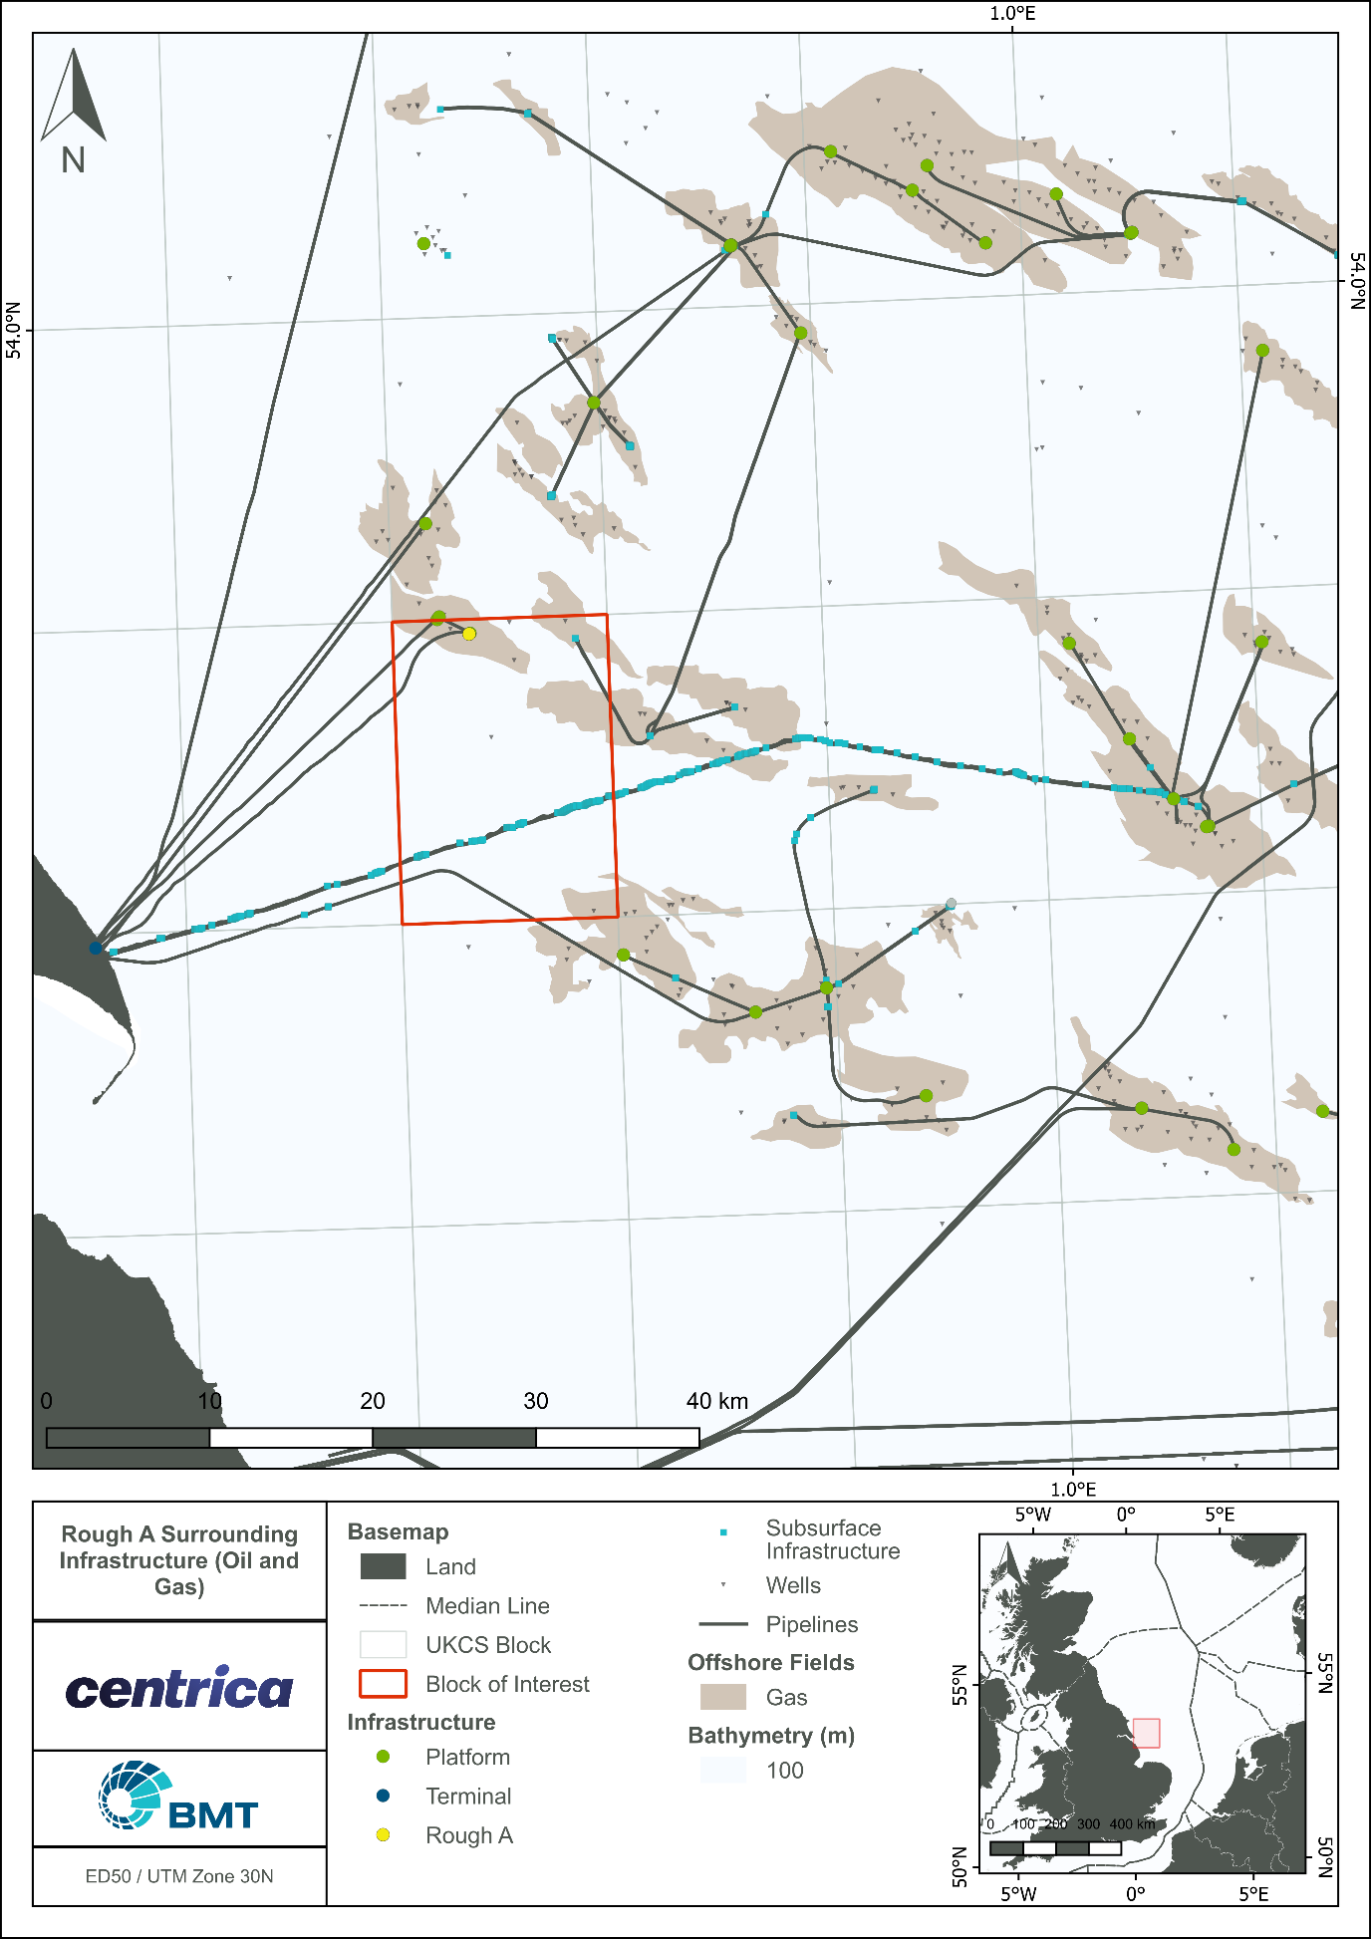
              - Rough 47/8A location in relation to oil and gas Infrastructure in the surrounding area

              - Rough A Complex, 47/8 AD and AP platforms with bridge link

Purpose of Environmental Appraisal
An EA is a systematic process of environmental impact assessment that considers how a project will change existing environmental and societal conditions, assesses the consequence and significance of such changes, and identifies any mitigation or remedial works which may be required (Table 1.1). It is an iterative process that is generally initiated at project inception and provides an aid to project decision-making throughout the planning and design phases so that, where practical, potentially significant environmental effects can be avoided or mitigated at the source.
To support the Rough 47/8A DPs, the EA process was conducted in accordance with the Petroleum Act 1998 (Petroleum Act) as amended by the Energy Act 2008 and the Energy Act 2016, and other applicable environmental legislation such as The Offshore Petroleum Activities (Conservation of Habitats) Regulations 2001 (as amended), the Offshore Petroleum Activities (Oil Pollution Prevention and Control) (OPPC)) Regulations 2005 (as amended) Guidance Notes,
Offshore Chemical Regulations 2002 and the Marine and Coastal Access Act 2009. The guidance outlines that an EA should be a document providing necessary content in proportion to the complexity and magnitude of a project. This EA document presents the findings of the environmental assessment (EA process) and has been prepared as part of the planning and consents process for decommissioning of the Rough 47/8A infrastructure.
            - Key stages of the EA process for decommissioning
EA Stage | Description
Scoping | Allows the study to establish the key issues, data requirements, and impacts to be addressed in the EA, as well as the framework for and limits of the study.
Consideration of alternatives | Demonstrates that other feasible approaches, including alternative project options, scales, processes, layouts, and operating conditions have been considered.
Description of project actions | Provides the purpose and characteristics of the project including stages of development, location and processes.
Description of environmental baseline | Establishes the current state of the environment on the basis of data from literature and field surveys and may involve discussions with the authorities and other stakeholders.
Identification of key impacts and prediction of significance | Seeks to identify the nature and magnitude of identified change in the environment as a result of project activities and assesses the relative significance of the predicted impacts.
Impact mitigation and monitoring | Outlines the measures that will be employed to avoid, reduce, remedy or compensate for any significant impacts. Mitigation measures will be developed into a project environmental management plan. Aspects of the project which may give rise to significant impact which cannot be mitigated to an acceptable or tolerable level of impact may need to be redesigned. This stage will feed back into project activities.
Presentation of the EA | Reporting the environmental assessment process through production of an EA that clearly outlines the above processes. The EA provides a means to communicate the environmental considerations and environmental management plans associated with the project to the public and stakeholders.
Monitoring | Residual project impacts may be monitored during the project activities and following cessation of operations to verify that impact predictions are consistent with the subsequent outcomes.

Regulatory Context
The decommissioning of offshore oil and gas infrastructure in the UKCS is principally governed by the Petroleum Act 1998 (Petroleum Act), as amended by the Energy Act 2008 and the Energy Act 2016. The Petroleum Act sets out the requirements for a formal DP, which must be approved by DESNZ before the owners of an offshore installation or pipeline may proceed.
At the writing of this report, there is no statutory requirement to prepare an environmental statement for decommissioning. However, under the Guidance Notes: Decommissioning of Offshore Oil and Gas Installations and Pipelines under the Petroleum Act 1998 (OPRED, 2018), the DP must be supported by environmental assessment and this EA fulfils the requirement.

The Guidance Notes state that an EA should include an assessment of the following:
- All potential impacts on the marine environment including;
  - exposure of biota to contaminants specifically associated with the decommissioning of the installation/ infrastructure;
  - other biological impacts arising from physical effects;
  - conflicts with the conservation of species with the protection of their habitats, or with mariculture; and interference with other legitimate uses of the sea.
- All potential impacts on other environmental compartments, including emissions to the atmosphere, leaching to groundwater, discharges to surface fresh water and effects on soil.
- Consumption of natural resources and energy associated with reuse and recycling.
- Interference with other users of the sea and consequential effects on the physical environment.
- Potential impacts on amenities, the activities of communities and on future users of the environment.
In addition, DESNZ have advised the oil and gas industry that under the Marine and Coastal Access Act 2009 (MCAA), an EA will be required for all license applications relating to decommissioning operations.
OSPAR Decision 98/3 (the Decision) sets out the United Kingdom’s (UK’s) international obligations on the decommissioning of offshore installations. The Decision prohibits the dumping and leaving wholly or partly in place of offshore installations. The topsides of all installations must be returned to shore, and all installations with a jacket weight of less than 10,000 tonnes must be completely removed for re-use, recycling or disposal on land. Any piles securing the jacket to the seabed should be cut at target depth of 3 m below the natural seabed level, however, consideration will be given to the prevailing seabed conditions and currents (OPRED, 2018).
In addition to the decision, the UK is signed up to the London Convention in 1972 (as amended), which is an agreement to ensure the prevention of marine pollution by dumping of wastes and other matters at sea, and alongside this the UK Government has a moratorium on dumping of waste which has been in force since 1999.

Other Regulatory Issues
The Other Regulatory Issues policy document (version at September 2022) issued by the UK Government applies to all UKCS blocks and covers issues including seasonal concerns where seismic activity occurs, spawning grounds for the herring, and MoD training areas.
For blocks marked under the Other Regulatory Issues policy document (UK Government, 2022) scientific fisheries advice indicates seabed surveys may be required before any drilling activity occurs and to confirm spawning sites within a three-nautical radius of the proposed drilling location. However, no drilling activity is proposed as part of the decommissioning works, therefore the requirement for an additional seabed survey is not applicable.

No seismic survey activity is proposed as part of this scope.
Activities within certain blocks (including 47/8) are of concern to the MoD as they lie within training ranges. Further information is provided in Section 3.5.

Consultations
During preparation of this EA an initial consultation was held with OPRED and other key stakeholders. Further consultation will be sought with statutory consultees and other stakeholders will be conducted, with examples below:
- Centre for Environment, Fisheries and Aquaculture Science (CEFAS)
- Environment Agency (EA)
- Global Marine Systems Limited (GMSL)
- Joint Nature Conservation Committee (JNCC)
- Marine Management Organisation (MMO)
- National Federation of Fishermen’s Organisations (NFFO)
- NSTA
- Northern Ireland Fish Producers Organisation (NIFPO)
- Scottish Fishermen’s Federation (SFF)
A statutory consultation with OPRED will be held prior to decommissioning activities. So far, no concerns have been raised by consultees. Centrica continue to monitor for comments.

Report Structure
The structure for this Rough 47/8A decommissioning EA is detailed in Table 1.2.
            - Rough 47/8A decommissioning EA structure
Section | Description
Non-Technical Summary | A non-technical summary.
Acronyms and Abbreviations | A listing of the acronyms and abbreviations used in the EA.
Introduction | An introduction to the project and the EA process and scope.
Project Description | A description of the decommissioning options and the recommended decommissioning option, as determined through a formal CA process.
Environmental Description | A description of the pre-decommissioning surveys and environmentally sensitive receptors and habitats in the vicinity of the project area.
Risk Assessment | A detailed description of the risk assessment approach and findings.
Seabed Impact | Identification of potential sources of impact to environmental and societal receptors, cumulative and transboundary impacts, and details of practicable mitigation strategies.
Discharges to Sea
Societal Impact
Atmospheric Emissions
Underwater Noise
Accidental Events
Environmental Management | A description of the environmental management procedures and how these will apply to the decommissioning of the Rough 47/8A infrastructure. This section also includes a register of commitments made within the EA.
Conclusions | Key findings and conclusions.
References | Sources of information used to inform the assessment.
Annex A: ENVID worksheets | Summary of the findings from the ENVID workshop
Annex B: Energy and Emissions | A summary of conversion factors and assumptions.

Transboundary and Cumulative Impacts
The EA process also includes the identification of any potential cumulative and transboundary impacts that could be caused by the proposed decommissioning programmes. Cumulative impacts may occur as a result of a number of activities (e.g. discharges or emissions) combining or overlapping and potentially creating a new or larger impact. Even where impacts do not overlap, it is important to consider the incremental effect of many small areas of impact on a particular environment or its use.
Transboundary impacts are those which could have an impact on the environment and resources beyond the boundary of UK waters. The Convention on Environmental Impact Assessment in a Transboundary Context (Espoo, 1991) addresses the need to enhance international co-operation in assessing transboundary environmental impacts. The Espoo Convention was a key step in bringing together all stakeholders to prevent environmental damage before it occurs.
The EA process assessed the transboundary and cumulative impacts of all decommissioning options and are discussed within this EA document.

Project Description

This section presents a description of the Rough 47/8A infrastructure, the scope of the decommissioning operations, infrastructure to be decommissioned, the selected option and associated activities, and proposed schedule.

Overview
The Rough 47/8A platform complex (Figure 2.1) consists of:
- AD and AP topside modules;
- AD and AP module support frames (MSF);
- AD and AP jackets;
- 3 x risers;
- Bridge-link structure: and
- Six platform wells (AD platform)- Decommissioned to AB2 status

Well Abandonment
Well plug and abandonment activities were completed in 2023, and 6 x AD wells have been abandoned to Phase 2 abandonment status. All platform equipment has been de-energised, with the exception of solar powered navigation aids.
The topsides have been cleaned of hydrocarbons and the pipelines isolated and cleaned and are awaiting decommissioning.

Decommissioning of the Rough 47/8A Platforms
The Rough 47/8A platforms (topsides and jackets) will be fully removed. Details of the materials that will be removed are provided in the following subsections.

Rough 47/8A Platforms
The drilling platform (Rough AD) consists of an eight-leg welded and tubular jacket structure supporting upper and lower topside decks via eight unbraced tubular columns. Leg insert piles fix the whole structure to the seabed. The Rough AD topside consists of:
- Accommodation units, helideck, pedestal crane and MSF, totalling 1,755 metric tonnes (Mt);

              - Schematic of Rough 47/8A platform complex

The production platform (Rough AP) consists of an eight-leg welded steel tubular jacket structure supporting upper and lower topside decks via tubular columns. Upper and lower decks have been extended on the platform west side and additional deck column bracing installed. In addition to the jacket, the Rough AP topside consists of:
- Control room, MSF North, and MSF South, totalling 2,439 Mt;
- One 4-inch in-field umbilical riser (PLU6255),
- One 16-inch export riser (PL26); and
- One 18-inch in-field riser (PL151).
The bridge-link structure (150 Mt) connects the Rough AP platform at the cellar deck to the Rough AD platform at lower deck level.

Decommissioning Option
A full removal option is planned for the Rough AD and AP platforms (topsides, jackets and risers) and bridge link. Options to re-use the Rough A complex in situ for future hydrocarbon developments have been considered, but to date none have yielded a viable commercial opportunity. Reasons for this include the absence of remaining hydrocarbon reserves in the vicinity of the infrastructure, and the limited remaining design life and unsuitable material composition of the infrastructure. It is unlikely that an opportunity to re-use the platforms will be feasible and, therefore CESL is proceeding with decommissioning of the infrastructure in a way that is safe and environmentally and socioeconomically acceptable.

Decommissioning methodology
This section outlines methodology of decommissioning of the Rough 47/8A platforms. It is expected that operations will take approximately 35 days; however, for the purposes of estimating atmospheric emissions, a total in-field period of 40 days has been assumed.

Platforms
The decommissioning operations for the Rough 47/8A platforms AD and AP will be undertaken using a heavy lift vessel (HLV) and additional supporting marine spread as required. This may include Jack-Up Barge(s) for preparatory works and cargo barges for transportation of Rough A topsides (or part thereof) and jacket(s). The Rough 47/8A platform topsides will be decommissioned by fully removing the AP & AD Topsides, AP & AD jackets and the bridge link connecting the two platforms. It is possible that Rough AD and AP topsides can be removed by a single lift upon completion of some local dismantlement/ destruct and/ or specific module removal.
For the module removal and/or local dismantlement/ destruct on Rough AD & AP topsides, modules will be separated offshore by deconstruction of the module interfaces and then removed by a dedicated vessel. The modules (or parts thereof) will be back-loaded to the deck of a cargo barge and then transported to shore. The modules may then be assigned for re-use or broken down for recycling and/ or disposal.
It is assumed that the structural integrity of Rough AD & AP topsides may allow for a single lift removal to be completed by the HLV. The topsides will be transported by a cargo barge to a suitable location close to the designated dismantling site (usually a quayside), where any remaining hazardous waste, cables and waste electrical equipment will be removed, separated and disposed of at relevant onshore disposal sites.

Jackets
As the weight (in air) of each jacket structure is less than 10,000 tonnes, these fall within the OSPAR 98/3 category of steel structures for which derogation cannot be sought (OSPAR, 1998). Therefore, the only option available for these platforms is complete removal. “Single Lift” is deemed to be the most appropriate option for the complete removal of both Rough 47/8A jackets. Full removal will involve removing the jackets and footings, including the piles down to target depth of 3 m below the natural seabed. Each jacket will be lifted by the HLV, placed on a barge, sea-fastened and transported to an onshore disposal yard.

Drill Cuttings Piles
No drill cuttings piles have been identified in the area associated with the Rough 47/8A complex. Pre-decommissioning surveys did not find seabed contamination consistent with water-based muds or elevated levels of hydrocarbons. The results of the pre-decommissioning survey is discussed in Section 3.3.

Post-decommissioning surveys
Following completion of all decommissioning activities, an as-left survey will be carried out to ensure that no snag hazards or risks to other users of the sea remain. The 500m Zone will remain in place post removal of 47/8A Topsides and Jackets (including Risers) and the Field ERRV will also be in location whilst 47/3B is manned. Pipelines will remain in-situ until the wider Rough Field Decommissioning is complete and will be monitored and appropriate mitigation plans put in place as required if snagging hazards are discovered. Seabed clearance verification will be carried out after full decommissioning of the Rough field infrastructure which is anticipated to be in 2031.The method, scope and frequency of the post pipeline decommissioning surveys will be agreed with OPRED at a later date, and is outside the scope of this EA, which focusses solely on the removal of the platforms.

Disposal of Decommissioning Materials
In line with waste hierarchy principles, reuse of offshore installations (or parts thereof) was first in the order of preferred decommissioning options for assessment. Recovered infrastructure will be returned to shore and transferred to a suitably licensed decommissioning facility.
The platforms are hydrocarbon free and there are no additional flushing/ cleaning activities required prior to removal activities. No asbestos, lead paint or naturally occurring radioactive materials (NORM) have been identified on the platforms during previous sampling and hazardous waste surveys. Additional assessments will be undertaken prior to removal of the topsides to ensure all hazardous materials are accounted for and disposed via an appropriately licenced waste management contractor.
It is expected that the materials from the platforms will be recycled, with CESL intending to recycle >95% of the recyclable material that is returned to shore. Table 2.1 lists the expected net weight in air.
            - Rough 47/8A platforms and bridge-link inventory tonnage
Decommissioned Item | Component | Weight (Mt)
Rough AD Topsides | Topside | 2,301
Rough AD Jacket | Jacket | 752
Rough AD Jacket | Marine growth estimate | 348
Rough AD Jacket | Estimated net weight of piles | 300
Rough AP Topsides | Topside | 2,713
Rough AP Jacket | Jacket | 731
Rough AP Jacket | Marine growth estimate | 348
Rough AP Jacket | Estimated net weight of piles | 300
Rough Alpha Bridge-Link | Bridge | 150
Total |  | 7,943

Decommissioning Schedule
Figure 2.2 displays a Gantt chart of the proposed project plan schedule.
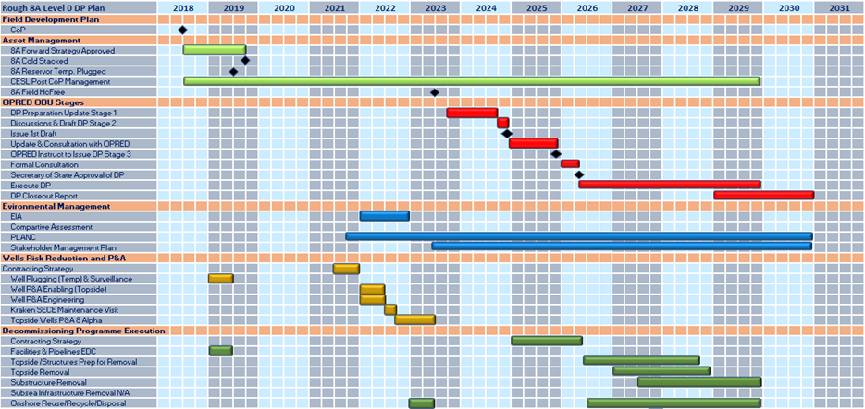
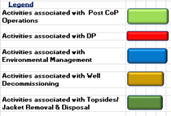
              - Gantt Chart of Project Plan

Environmental Baseline

This section provides a description of the environmental setting of the Rough A decommissioning project and an assessment of the environmental sensitivities in and around this location. An understanding of the environmental sensitivity will inform the assessment of the risks associated with the proposed decommissioning of the Rough A field.

Location of the Rough A infrastructure
The Rough A field, in SNS UKCS Blocks 47/3, 47/6, 47/7, 47/8, and 47/11, is located approximately 29 km southwest of Easington Yorkshire, and 160 km west of the UK/Norwegian median line in 36 m lowest astronomical depth (LAT). The Rough 47/8A infrastructure is located in Block 47/8.

Physical and Chemical Environment
Characteristics of the bathymetry, currents, meteorology, sea temperature, salinity and seabed sediments in the area of the Rough A field are described in the following subsections.

Bathymetry
The North Sea basin is relatively shallow, varying from 30 to 200 m, with the deep Norwegian Trench in the northeast margin reaching approximately 700 m depth. Water depth in the UK SNS varies between 50 and 200 m (NSTF, 1993). Bathymetry around the Rough 47/8A infrastructure area ranges from 33.3 m LAT to 36.5 m LAT (Fugro, 2022a). Seabed depth at the Rough A is approximately 36 m LAT.

Currents
Several water masses exist in the North Sea with differing temperature, salinity and residual current patterns and/ or stratification. These different factors play a major role in the supply and dispersion of nutrients, plankton and fish larvae. The major water masses in the North Sea can be classified as Atlantic water, Scottish coastal water, SNS water, Norwegian coastal water, central North Sea (CNS) water, northern North Sea (NNS) water, Jutland coastal water and Channel water (OESEA, 2022). The Rough A field is located in the area influenced most by the SNS water mass (Figure 3.1).
Tidal currents in the location of the Rough A infrastructure are typical of the SNS with relatively strong surface current velocities and mean spring tides ranging from 1.25 to 1.75 m/s (ABPmer, 2016). Throughout the year the residual current speed reaches up to 0.2 m/s (UKDMAP, 1998). The annual mean significant wave height in the blocks of interest range between 1.00 and 1.50 m (ABPmer, 2016).

Meteorology
In the vicinity of the Rough A field winds vary seasonally and are characterised by large variations in wind direction and speed. The annual wind data generally comes from the south and northwest; during the spring, the frequency of those from the north and east increases (OESEA, 2022). Easterly winds are not common, however, and can bring exceptionally cold weather in winter. Wind speed is on average between Beaufort scale 1-6 (1-11 m/s) in the summer months, strong gale force winds of speeds 7-12 (14-32 m/s) occur in winter months (UKHO, 2013).

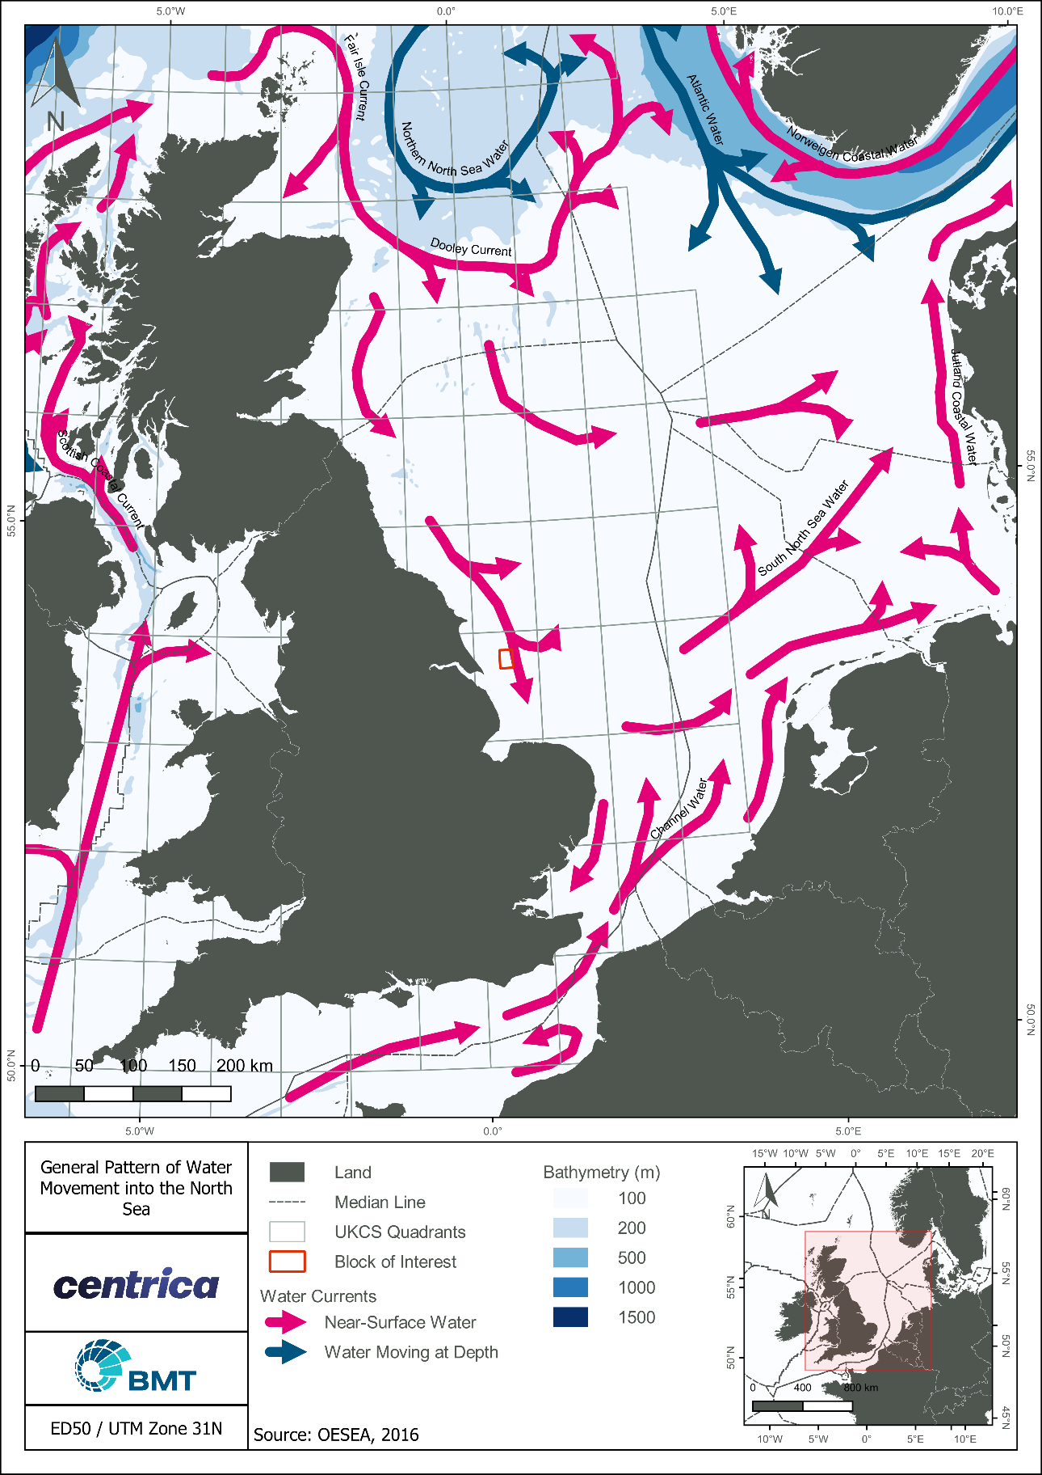
              - Water currents circulation in the vicinity of Rough A

Sea Temperature and Salinity
Sea temperatures in the SNS are some of the coldest areas of UK waters (Jones et al., 2004). Sea-surface temperatures increase southwards (from 5 to 7ºC) in February. This is a result of a stream of relatively warm water extending up from the English Channel which prevents the water temperature from dropping below 5ºC. In August, temperatures again increase progressively to the south (from 14 to 16.5ºC). The SNS receives significant freshwater input from the rivers along its eastern boundary and therefore is less saline than the NSN (OESEA, 2022).
In the SNS, the shallow parts remain well mixed throughout the year due to tidal action with no stratification taking place (OSPAR 2010).
There is little seasonal variation in the salinity of the water column in the Rough A field area, which is around 34.5 parts per thousand (ppt) (NMPI, 2022).

Seabed Sediments

Sediment Types
The SNS extends from the Flamborough front in the north to north of the Dover Strait in the south, with a transition from North Sea water to Atlantic water. This region is shallow (generally 0-50 m), with a predominantly sandy seabed (OESEA, 2022). Mapped information (McBreen et al., 2011) indicates that the SNS general comprises sand and muddy sand with significant areas of coarse sediment, especially closer to shore.
EUSeaMap 2021 is a broad-scale seabed habitat map covering European waters, which uses the European Nature Information System (EUNIS) habitat classification and Marine Strategy Framework Directive (MSFD) predominant habitat classification systems. The UKSeaMap describes the seabed in the subtidal section of the proposed area as a mixture of A5.14 Circalittoral coarse sand and A5.13 Infralittoral coarse sand, A5.43 Infralittoral mixed sediment and A5.44 Circalittoral mixed sediment (EMODnet, 2021) (Figure 3.2).

Environmental Contaminants
Both total organic matter and total organic carbon values were comparable to the reference station suggesting that the sediments were comparable to the wider area. The majority of total hydrocarbon values were representative of the wider SNS region and could be ascribed as background (Fugro, 2022b). Total 2 to 6 ring polycyclic aromatic hydrocarbon concentrations were generally higher than the SNS mean background concentration, but comparable to the reference station, indicating concentrations were likely to be background for the area. The US EPA 16 PAHs and alkylated PAH concentrations were below their respective effects level values at all station (Fugro, 2022b). The mean concentrations for the majority of metals were higher than their respective SNS mean background concentrations with copper, lead and zinc having a mean concentration higher than the SNS 95th percentile value. The concentrations at the main survey array were higher than the reference station, suggesting some input to the sediment from operational activity. Effects level values were exceeded for copper (two stations), mercury (two stations), lead (three stations) and zinc (four stations) (Fugro, 2022b). The correlations highlighted between the physiochemical variables and the biota component did not indicate that the biological community is affected at the time of sampling. Despite the high levels of metals recorded within the survey area, these did not appear to drive any faunal variability (Fugro, 2022b).
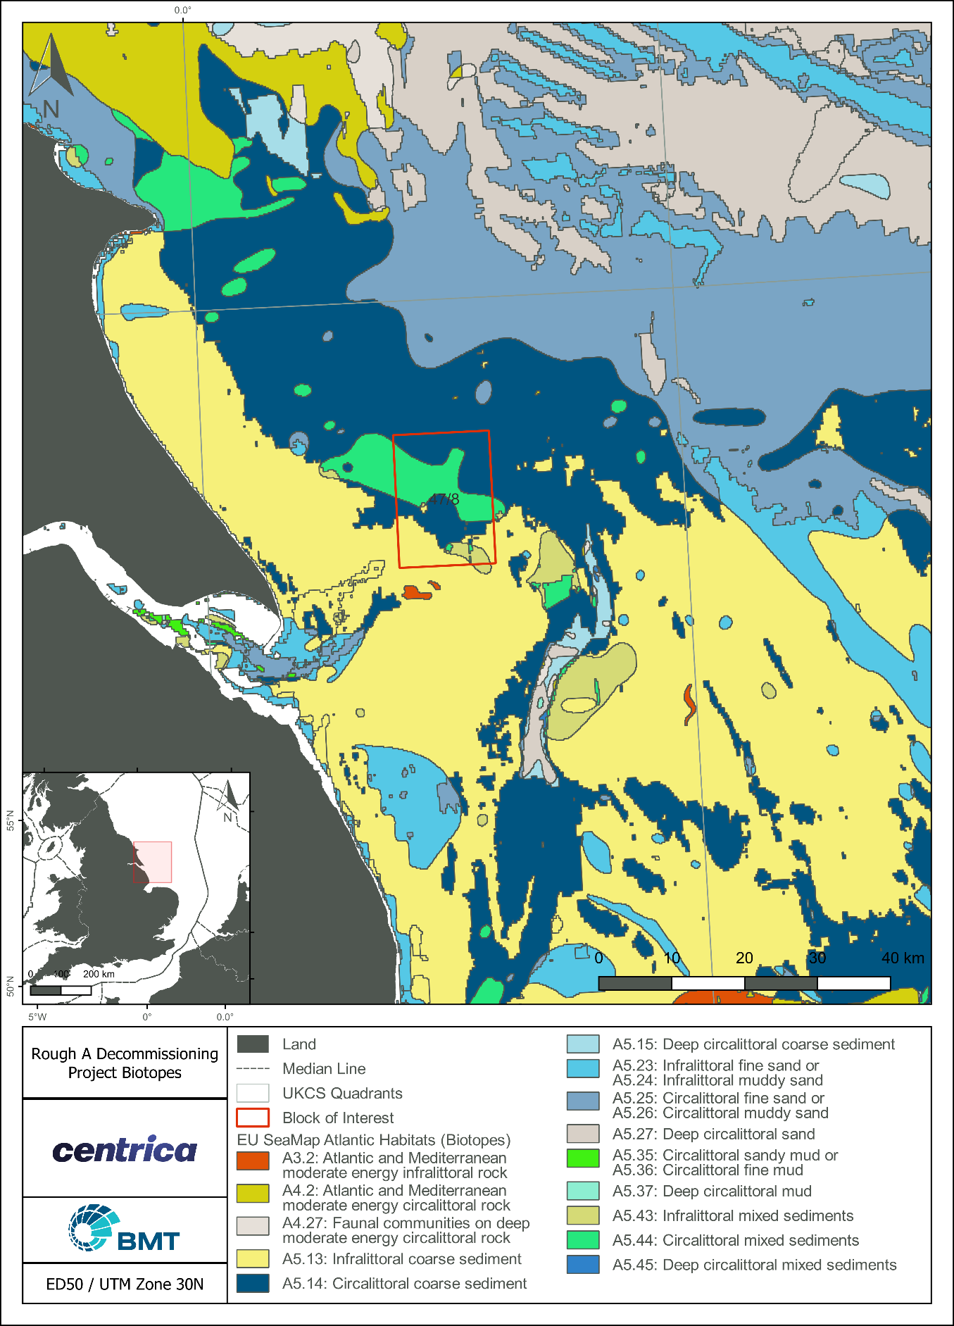
              - Map of EU biotopes in Rough A area

Biological Environment
This section summarises the characteristics of plankton, benthos, finfish and shellfish spawning and nursery grounds, marine mammals, seabirds and offshore conservation areas relevant to the Rough A Decommissioning Project.

Plankton
The majority of the plankton occurs in the photic zone, the upper 20 m of the sea which receives enough light for photosynthesis to occur (Johns and Reid, 2001). The composition of the plankton community reflects environmental conditions such as salinity, temperature, water movements in the area and the presence of local benthic communities that have planktonic larval stages. The majority of phytoplanktonic organisms are unicellular, such as diatoms and dinoflagellates, whereas zooplankton comprises a wide variety of multicellular herbivorous and carnivorous organisms.
The phytoplankton community in the SNS is dominated by the dinoflagellate genus Tripos, along with higher numbers of the diatom, Chaetoceros (subgenera Hyalochaete and Phaeoceros) than are typically found in the northern North Sea. Phytoplankton biomass is greater than in the northern North Sea (OESEA, 2022).
The total biomass of zooplankton follows a seasonal pattern governed by the availability of phytoplankton, their main food source, and consequently the peak in zooplankton biomass occurs after the phytoplankton peak. Zooplankton is not restricted to the upper layers of the water column but exhibit a diurnal movement. Generally, they migrate into the upper layers of the water column at night to feed, and then descend again to deeper water during daylight hours (Johns and Reid, 2001).
The zooplankton communities of the SNS is dominated by copepods including Calanus helgolandicus, C. finmarchicus, Paracalanus and Pseudocalanus spp., Acartia spp., Temora spp. and cladocerans such as Evadne spp. (OESEA, 2022). However, there has been a marked decrease in copepod abundance in the SNS which has been linked to changes in global weather phenomena (OESEA, 2022). The planktonic assemblage in the vicinity of the Rough 47/8A infrastructure is not considered unique.

Benthic Fauna
An understanding of the composition of the seabed (benthic) faunal communities can facilitate in the assessment of the impacts of the decommissioning of Rough A. Benthic fauna comprises species which live either within the seabed sediment (infauna) or on its surface (epifauna). Such species, which may be either sedentary or motile, and may encompass a variety of feeding habits (e.g. filter-feeding, predatory or deposit-feeding) occupy a variety of different niches. Epifaunal and infaunal species are particularly vulnerable to external influences which alter the physical, chemical or biological characteristics of the sediment. These organisms are largely sedentary and are thus unable to avoid unfavourable conditions. High toxicity from metals (such as copper, leads and mercury) may affect different stages of development including disturbance to larval development, reproduction and mortality of marine invertebrates (Botté et al., 2022).
Colonisation of sediments by different species is largely dependent on the type of sediment present and its characteristics. Physical and biological factors including seabed depth, water movements, salinity, temperature and available oxygen are important in determining species abundance and distribution. The species composition and relative abundance in a particular location provides a reflection of the immediate environment, both current and historical (Clark et al., 1997), as every benthic species has its own response and degree of adaptability to changes in the physical and chemical environment. Determination of sediment characteristics is of particular importance, therefore, in the interpretation of benthic environmental survey data.
Benthic fauna is susceptible to physical disturbance of the seabed, for example from fishing-trawls, anchoring or smothering from discharged drill cuttings (DTI, 2001). The effects of discharged drill cuttings on benthic fauna include physical smothering, the presence of potential toxins (heavy metals and hydrocarbons), and organic enrichment (BMT Cordah, 1998). The responses shown by benthic communities to drill cuttings discharges are the result of a combination of these effects. As drill cuttings accumulate on the seabed directly below a development, benthic organisms that occupy the seabed beneath the drill cuttings pile would be smothered. Beyond this point, the effects of any toxins and organic enrichment become more evident, and the changes in the species composition, diversity and abundance of benthic communities may be attributed to one or all of these influences (BMT Cordah, 1998). No drill cuttings have been identified at the Rough A location.

Benthic Habitat Classification
Host communities in the Rough 47/8A area are dominated by infaunal polychaetes and crustacea as well as epifaunal polychaetes, bivalves and echinoderms, particularly in mixed sediments. The deeper sublittoral and circalittoral habitats are characterised by a wide range of echinoderms, polychaetes and bivalves and tend to be more stable than their infralittoral counterparts, supporting a richer community as well as the establishment of communities of burrowing megafaunal species, such as Nephrops (EUNIS, 2018).
Benthic survey results
The 2022 survey and seabed sampling indicate that the sediments of the Rough A area comprised of two main sediment types: gravelly sand/sandy gravel with shell fragments; and boulders and cobble stones classified as circalittoral mixed sediments (A5.44). The variable nature of this sediment typed often leads to diverse communities. A wide range of infaunal polychaetes, bivalves, echinoderms and burrowing anemones such as Cerianthus lloydii are often present in such habitat and the presence of hard substrata (shells and stones) on the surface enables epifaunal species to become established, particularly hydroids such as Nemertesia sp and Hydrallmania falcata. The benthic survey indicated no presence of ocean quahog (Arctica islandica) (Fugro, 2022b). The combination of epifauna and infauna can lead to species rich communities’ (EEA, 2019c).
The second classified as sublittoral sand (A5.2) rippled sand with shell fragments is characterised by a range of taxa including polychaetes, bivalve molluscs and amphipod crustacea’ (EEA, 2019b).
Observations from photographs showed the fauna observed was sparse and included starfish (Asterias rubens), hermit crab (Paguridae), anemone (Urticina sp.) and bryozoan (Flustra foliacea). Fauna associated with hard substrate included soft coral (Alcyonium digitatum), anemones (Actiniaria including Urticina sp. and Metridium sp.), sea urchins (Echinus esculentus), bryozoan (Flustridae), encrusting fauna (Bryozoa) and calcareous worm tubes (Serpulidae). Fauna associated with the gravelly sand/sandy gravel included crabs (Cancer pagurus and Necora puber), hermit crab (Paguridae), starfish (A. rubens) and sea snails (Gastropoda).
Overall, the environmental data obtained from the April/ May 2022 pre-decommissioning survey at the Rough 47/8A site indicated that seabed sediments could generally be considered ‘as typical for this area of the SNS region’ (Fugro, 2022b).

Finfish and Shellfish
Adult and juvenile stocks of finfish and shellfish are an important food source for seabirds, marine mammals and other fish species. Species can be categorised into pelagic and demersal finfish and shellfish:
- Pelagic species occur in shoals swimming in mid-water, typically making extensive seasonal movements or migrations between sea areas. Examples include herring, mackerel, blue whiting and sprat;
- Demersal species live on or near the seabed and include cod, haddock, plaice, sand eel, sole, and whiting;
- Shellfish species are demersal (bottom-dwelling) molluscs, such as mussels and scallops, and crustaceans, such as shrimps, crabs and Nephrops (Norway lobster).
Generally, there is little interaction between fish species and offshore oil and gas developments. Some fish and shellfish species are, however, vulnerable to some offshore oil and gas activities, such as discharges to sea (CEFAS, 2001). The most vulnerable period for fish species is during the egg and juvenile stages of their life cycles. Fish that lay their eggs on the sediment (e.g. herring and sand eel) or which live in intimate contact with sediments (e.g. sand eel and most shellfish) are susceptible to smothering by discharged solids (Coull et al., 1998).
The Rough A infrastructure lies within the International Council for the Exploration of the Sea (ICES) rectangle 36F0. The industry-commissioned Fisheries Sensitivity Maps in British Waters and Strategic Environmental Assessment (SEA) 4 Environmental Report on North Sea Fish and Shellfish (Coull et al., 1998, BEIS, 2022), as well as the CEFAS-led spawning and nursery areas of fish of commercial and conservation importance (Ellis et al., 2010) and Aires et al., 2014; provide data illustrating fish spawning and nursery locations within 36F0 (Figure 3.3 and Figure 3.4).
Spawning and nursery grounds are dynamic features of fish life history and are rarely fixed in one location from year to year. The information provided in Figure 3.3 and Figure 3.4 represents the widest known distribution given current knowledge and should not be seen as rigid, unchanging descriptions of presence or absence (Coull et al., 1998; Ellis et al., 2010). Spawning times represent the generally accepted maximum duration of spawning (Coull et al., 1998).
After spawning, fish hatch quickly from their eggs and many species remain in discrete areas (nursery grounds) in the water column or settle on the seabed as larvae, consuming microscopic organisms and gradually developing the body shape and behaviour patterns of adults. The prevailing water temperature and availability of food can alter the position of these nursery grounds from year to year and they can drift far from initial spawning location. As a result of these factors, it is difficult to define precisely the limits of nursery areas. The maps in Figure 3.4 provide an indication of the likely positions of juvenile concentrations around the UK, rather than a definitive description of the limits of all nursery grounds (Coull et al., 1998). Data from Aires et al. (2014) indicates the probable presence of Age 0 group fish using previously identified nursery grounds by Coull et al. (1998) and environmental habitat variables. Age group 0 fish are defined as fish in the first year of their lives and can also be classified as juvenile.
ICES rectangle 36F0 coincides with the spawning grounds for cod (Gadus morhua; January to April), herring (Clupea harengus; August to October), lemon sole (Microstomus kitt; April to September), plaice (Pleuronectes platessa; December to March), sand eel (Ammodytes sp.; November to February), sprat (Sprattus sprattus; May to August) and, sole (Solea solea; March to May) (Coull et al., 1998; Ellis et al., 2010).
ICES rectangle 36F0 also lies within the nursery grounds for cod (Gadus morhua), lemon sole (Microstomus kitt), herring (Clupea harengus), plaice (Pleuronectes platessa), mackerel (Scomber scombrus), sprat (Sprattus sprattus), sand eel (Ammodytes sp), and whiting (Merlangius merlangus) (Aires et al., 2014; Ellis et al., 2010; Coull et al., 1998; Figure 3.4).


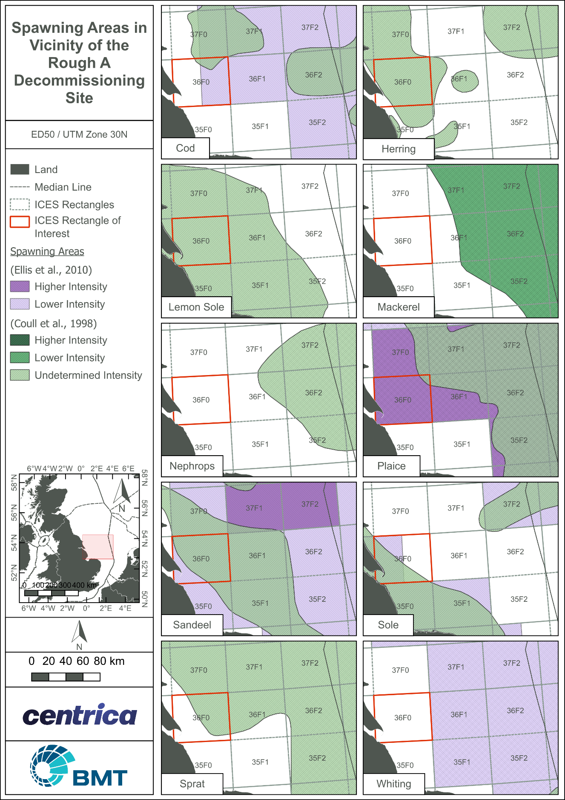
              - Key spawning areas around the Rough A field


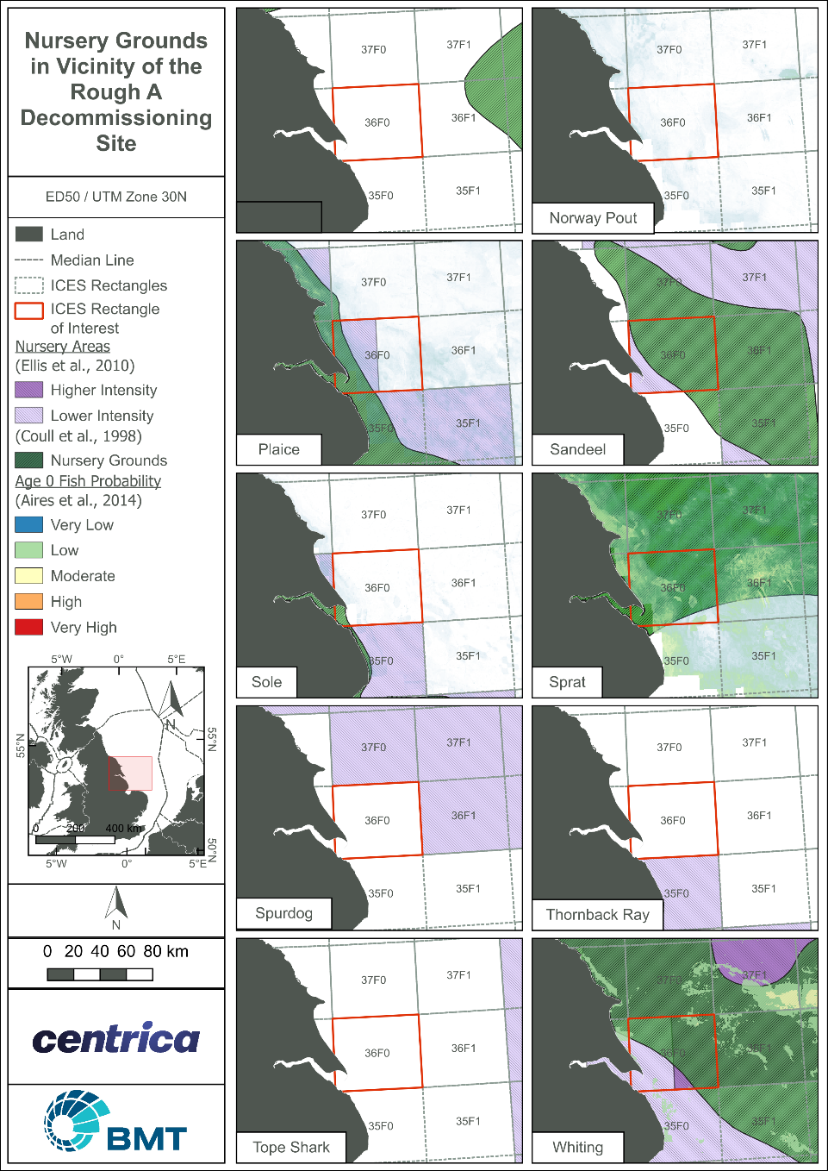
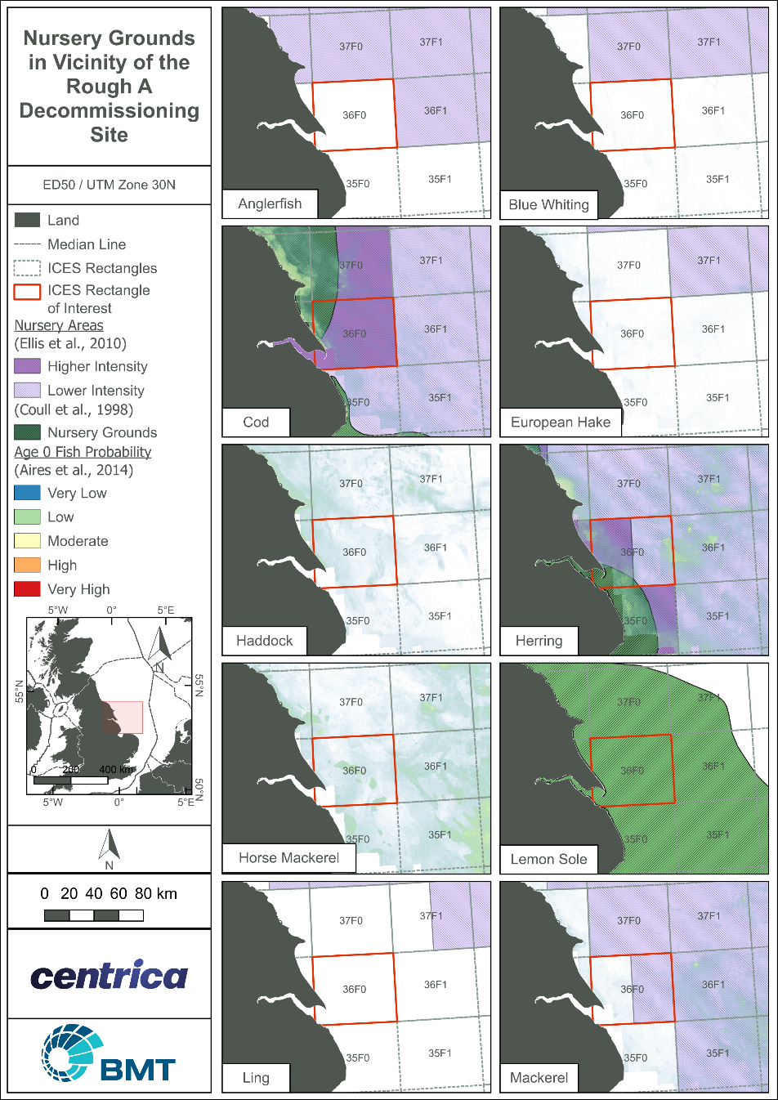
              - Key nursery areas within the Rough A vicinity
In the vicinity of Rough A, data indicate the probable presence of Age 0 group fish (Aires et al., 2014). The predictive model for this group uses previously identified nursery grounds data from Coull et al. (1998), combined with environmental habitat variables. The results provide the probability of the presence of Age 0 group fish within areas that have defined and predictable environmental habitat specifications for the development of juveniles. A very high probability of cod, herring, and whiting has been predicted in localised areas within ICES rectangle 36F0. A low probability has been predicted for sand eel, plaice and mackerel (Aries et al., 2014).
Cod, herring, mackerel, sand eels and whiting are mobile species listed on the PMF list and as such, receive appropriate protection and conservation measures within Scotland’s seas (Tyler-Walters et.al., 2016). Except for cod, which is listed as vulnerable, all other species are indicated as of least concern on the IUCN red list of threatened species (IUCN, 2022).

Marine Mammals
Marine mammals include whales, dolphins and porpoises (cetaceans) and seals (pinnipeds). Marine mammals may be vulnerable to the effects of oil and gas activities and can be impacted by noise, contaminants, oil spills and any effects on prey availability (SMRU, 2001). The abundance and availability of prey, including plankton and fish, can be of prime importance in determining the numbers and distribution of marine mammals and can also influence their reproductive success or failure. Changes in the availability of principal prey species may result in population level changes of marine mammals but it is currently not possible to predict the extent of any such changes (SMRU, 2001).
Cetaceans
Cetaceans can be divided into two main categories: baleen whales (Mysticeti) which feed by sieving water through a series of baleen plates; and toothed whales (Odontoceti) which have teeth for prey capture. These cetaceans are widely distributed in UK waters and are recorded throughout the year (Reid et al., 2003). Cetacean distribution may be influenced by variable natural factors such as water masses, fronts, eddies, upwellings, currents, water temperature, salinity and length of day. A major factor likely to influence cetacean distribution is the availability of prey, mainly fish, plankton and cephalopods (Stone, 1997). Since 1994 cetacean surveys have been undertaken as part of the SCANS (Small Cetacean Abundance in the European Atlantic and North Sea) program. The data provided in this EA comes from SCANS III, Block O and SCANS IV, Block NS-C. The main cetacean species occurring in the Rough A area (primary Quadrant 47) are minke whale (Balaenoptera acutorostrata), white-beaked dolphin (Lagenorhynchus albirostris) and harbour porpoise (Phocoena phocoena), white-sided dolphin (Lagenorhynchus acutus), common dolphin (Delphinus delphis), and bottlenose dolphin (Tursiops truncatus) with sightings occurring throughout the year (Table 3.1; Reid et al., 2003; UKDMAP, 1998).
Minke whales are not regularly present throughout the SNS but are occasionally sighted in the months between July and October (OESEA, 2022; SMRU, 2001). They appear to move into the North Sea at the beginning of May and are present throughout the summer until October (Northridge et al., 1995). During the SCANS III survey in June 2021, minke whales were recorded throughout the North Sea, west of Britain and Ireland and on the Celtic Shelf. The number of minke whales in the SCANS III area is estimated to be approximately 13,101 animals. The abundance of minke whales in SCANS III, Block O is estimated at approximately 603 animals and approximately 412 animals for SCANS IV, Block NS-C (Hammond et al., 2021; Gilles et al., 2023). Within SCANS-IV survey block, estimated density of minke whales is approximately 0.0068 individuals per km² for the entire survey block (Gilles et al., 2023).
Bottlenose dolphins are distributed over the continental shelf, and in the North Sea they tend to be more numerous within about 200 nm of the Scottish and north-eastern English coasts (Northridge et al., 1995). Bottlenose dolphins are present year-round in the North Sea, with most sightings recorded between June and October (Reid et al., 2003). Initial estimates for the total abundance of bottlenose dolphins in the SCANS III area are approximately 19,201 animals (Hammond et al., 2021). The abundance of bottlenose dolphins in Block O is currently unavailable, however SCANS IV data indicates approximately 2,520 individuals within survey Block NS-C with an estimated density of 0.0419 per km² animals for the entire survey block (Hammond et al., 2021; Gilles et al., 2023.).
Common dolphins are distributed over the continental shelf, in the Rough 47/8 area, their densities are low with sightings primarily in September (UKDMAP 1998). Initial estimates for the total abundance of common dolphins in the SCANS III area are approximately 268,540 animals (Hammond et al., 2021). The abundance of common dolphins in the SCANS III area, Block O is not available, though estimates within SCANS IV survey Block NS-C report abundance of approximately 192 animals, with an estimated density of 0.0032 per km²for the common dolphin (Hammond et al., 2021; Gilles et al., 2023).
White-sided dolphins are distributed over the continental shelf, in the North Sea they are present year-round with most sightings recorded between August and July (Reid et al., 2003). Initial estimates for the total abundance of white sided dolphins in the SCANS III area are approximately 2,187 animals (Hammond et al., 2021). Block O and Block NS-C do not have available data for white sided dolphins (Hammond et al., 2021; Gilles et al., 2023).
White-beaked dolphins are distributed over the continental shelf, with most sightings recorded between June and October (Reid et al., 2003). Initial estimates for the total abundance of white-beaked dolphins in the SCANS III area are approximately 36,287 animals (Hammond et al., 2021OESEA 2022). Block O has an estimated abundance of 143 animals while survey Block NS-C has an estimated abundance of 894 animals, and an estimated density of 0.0149 white-beaked dolphins per km² of the entire survey block (Hammond et al., 2021; Gilles et al., 2023) ).
The harbour porpoise is the most common cetacean in UK waters (OESEA, 2022). It is present throughout most of the North Sea throughout the year, with higher numbers occurring between May and October. Initial estimates for the total abundance of harbour porpoise in the SCANS III area are approximately 424,245 animals (Hammond et al., 2021; OESEA, 2022). In Block O it is estimated the abundance of harbour porpoise is 53,485. In Block NS-C, abundance is estimated at 36,286 individuals, with a density of 0.60 animals per km² (Gilles et al., 2023). The harbour porpoise is generally described as a coastal species, but there have been numerous sightings in deep, offshore waters (MacLeod et al., 2003; Northridge et al., 1995, 1997; Rogan and Berrow, 1996).
Of the four Annex II species recorded in the offshore UK waters (McLeod et.al., 2009), only harbour porpoise has been recorded in the Rough A area in very high numbers. The harbour porpoise and other marine mammal species listed in Table 3.1 are mobile species on the PMF list, designated to receive appropriate protection and conservation measures (Tyler-Walters et.al., 2016).
            - Seasonal cetacean sightings around the Rough A field
Species | Jan | Feb | Mar | Apr | May | Jun | Jul | Aug | Sep | Oct | Nov | Dec
Minke whale
Bottlenose dolphin
Common Dolphin
White-sided dolphin
White-beaked dolphin
Harbour porpoise
Key | N | No Data
Key | L | Low densities (0.01 to 0.09 animals/km²)
Key | M | Moderate densities (0.10 to 0.19 animals/km²)
Key | H | High densities (0.20 to 0.49 animals/km²)
Key | VH | Very high densities (≥ 0.50 animals/km²)
Source: UKDMAP (1998)

Pinnipeds
Two species of seal are resident in UK waters, the grey seal (Halichoerus grypus) and the harbour or common seal (Phoca vitulina), both occurring regularly over large parts of the North Sea (SCOS, 2017). Tracking of seals suggests they make feeding trips lasting two to three days, travelling less than 40 km from their haul-out sites and ultimately returning to the same haul-out site from which they departed (Johnston et al., 2002). Grey seals may spend more time further offshore than harbour seals. Both grey and harbour seals are listed in Annex II of the Habitats Directive (Section 3.6). The Rough A Field is 29 km from the nearest coastline; therefore, it is possible that grey and harbour seals would be found in the vicinity of the platform (Jones et al., 2013).

Grey seals
The northeast Atlantic contains approximately half of the world’s population of grey seals with, approximately, 38% occurring in the UK. The population size within UK waters is estimated at 1152,800 (OESEA, 2022). Grey seals spend most of the year at sea and travel long distances between haul out sites and range widely in search of prey (OESEA, 2022). The majority of the grey seal population will be on land for several weeks from October to December during the pupping and breeding seasons, and again in February and March during the annual moult. Densities of grey seals offshore are likely to be lower during these periods (OESEA, 2022). Grey seal density y within Block 47/8 typically ranges from10 – 50 individuals per 25 km² with occasional peaks up to 100 individuals per 25 km² (NMPI, 2022; Figure 3.5).

Harbour Seals
Harbour (common) seals are one of the most widespread pinnipeds with almost circumpolar distribution in the Northern Hemisphere. Within UK waters they belong to a European sub-species, which mainly occur in UK, Icelandic, Norwegian, Swedish, Danish, German and Dutch waters. With approximately 30% of this population occurring in UK waters (OESEA, 2022). Harbour seal counts in the UK are estimated at approximately 28.295animals, the vast majority of which are found in Scotland (OESEA, 2022). Harbour seals haul out on tidally exposed areas of rock, sandbanks or mud. Pupping occurs on land between June and July, and the moult between August and September (OESEA, 2022). Harbour seal density mapping within Block 47/8 is predominately low, with most of the area supporting between 0 – 1 animals per 25 km². However, localised regions within the block exhibit higher densities reaching up to 10 animals per 25 km² (NMPI, 2022; Figure 3.5).

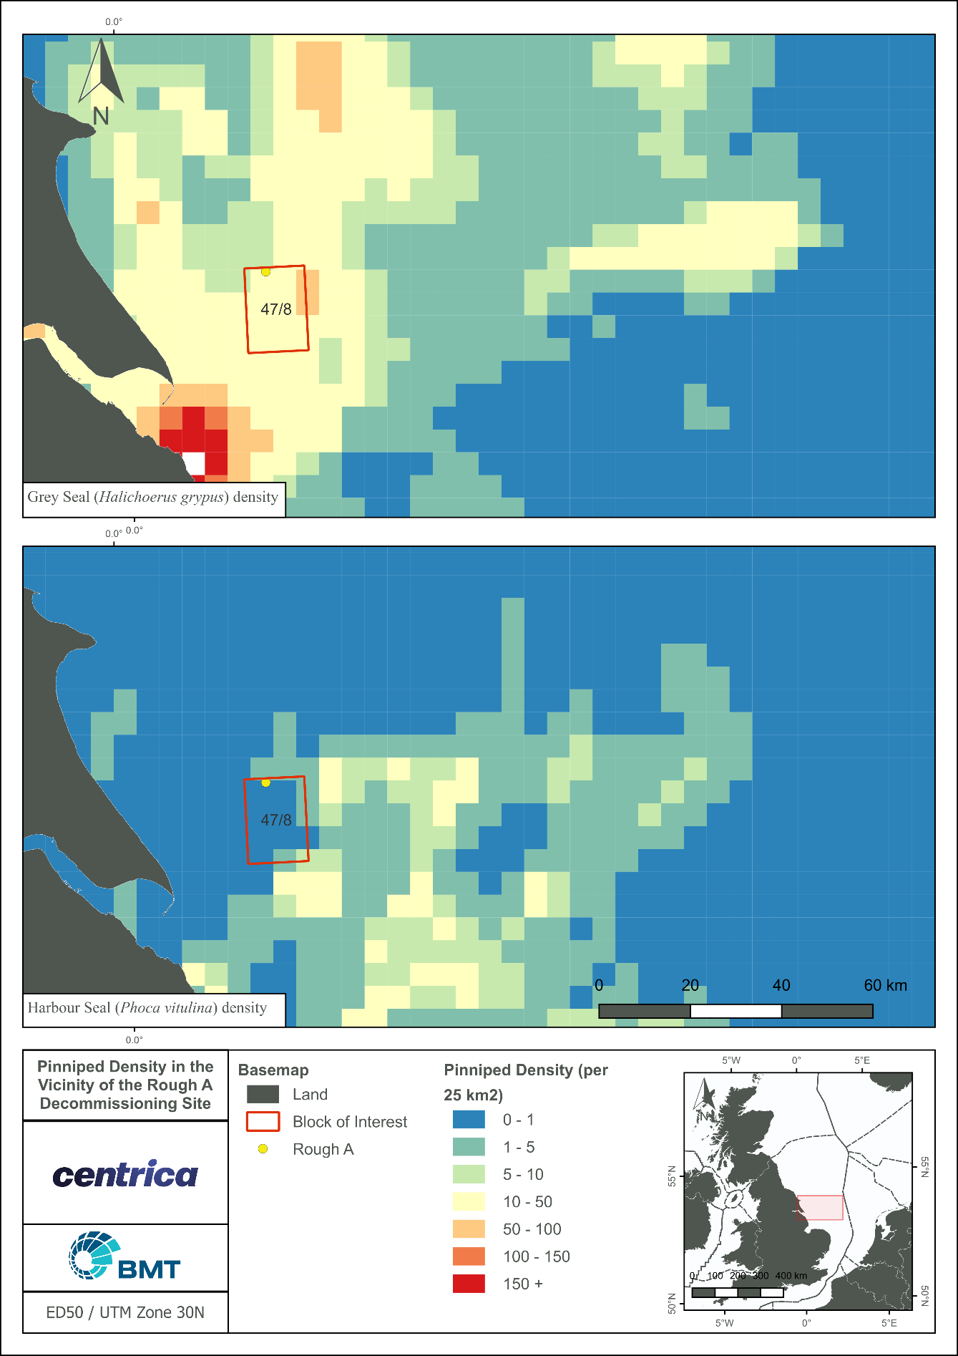
              - Density of grey and harbour seals in the Rough A area

Seabirds
Important numbers of several species of seabird breed on the North Sea coastal margin and depend on the offshore North Sea for their food supply and, for much of the year, their habitat. Species commonly found in offshore North Sea waters are Fulmar (Fulmarus glacialis), Gannet (Morus bassanus), Guillemot (Uria aalge), Razorbill (Alca torda) and Kittiwake (Rissa tridactyla); and Herring (Larus argentatus), Great Black-backed (Larus marinus) and Lesser Black-backed (Larus fuscus) Gulls (DTI, 2001). Other species which are recorded at lower levels include the Pomarine Skua (Stercorarius pomarinus), Arctic Skua (Stercorarius parasiticus), Black-headed Gull (Larus ridibundus), Common Gull (Larus canus), Common Tern (Sterna hirundo), Arctic Tern (Sterna paradisaea), Little Auk (Alle alle), and Puffin (Fratercula arctica) (DTI, 2001).
Seabird species which breed regularly in the UK and around North Sea coastal areas include the four species of petrel (Fulmar, Manx Shearwater (Puffinus puffinus), Storm Petrel (Hydrobates pelagicus) and Leach’s Petrel (Oceanodroma leucorhoa)), two species of cormorant (Cormorant (Phalacrocorax carbo) and Shag (Phalacrocorax aristotelis)), Gannet, two species of skua (Great Skua (Catharacta skua) and Arctic Skua), six species of gull (Herring Gull, Common Gull, Black-headed Gull, Lesser Black-backed Gull, Great Black-backed Gull and Kittiwake), five species of tern (Sandwich Tern (Sterna sandvicensis), Roseate Tern (Sterna dougallii), Common Tern, Arctic Tern and Little Tern (Sterna albifrons)) and four species of auk (Guillemot, Razorbill, Black Guillemot (Cepphus grylle) and Puffin) (DTI, 2001; OESEA, 2022). Puffin and kittiwake are listed as vulnerable on the IUCN red list.
It should also be noted that the foraging area for adult seabirds taking prey to nests in coastal cliff colonies can be up to 300 km. Kittiwakes in particular are known to nest on offshore structures from mid-April. Kittiwakes, obligate surface feeders, are known to heavily utilise the waters off the east English coast, in the vicinity of Rough A (Wakefield et al. 2017, Waggitt et al. 2020). Prior to any platform decommissioning activities from March to August a nesting bird survey shall be undertaken on the platforms. JNCC and OPRED will be consulted on the survey findings.
Kober et al. (2010) analysed European Seabirds at Sea (ESAS) density data for seabirds within the British Fishery Limit to identify ‘hotspots,’ with a view to assigning these marine areas Special Protection Area (SPA) status. Several hotspots for seabirds have been identified around UK, however, none of these overlap with the Rough A area. Table 3.2 presents predicated maximum monthly density of seabirds in the Rough A area (Kober et al., 2010). Seabird density surface maps were developed using Poisson kriging, a special interpolation technique, to generate continuous density surface maps for 32 species and seabirds’ assemblages.
            - Predicted monthly surface density of seabirds in the Rough A area
Species |  | Season | Month
 |  | Season | J | F | M | A | M | J | J | A | S | O | N | D
Northern Fulmar | Fulmarus glacialis | Breeding
Northern Fulmar | Fulmarus glacialis | Winter
Sooty Shearwater | Ardenna gravis | Summer
Manx Shearwater | Adrenna grisea | Breeding
European Storm Petrel | Hydrobates pelagicus | Breeding
Leachs Storm Petrel | Hydrobates leucorhous | Breeding
Northern Gannet | Morus bassanus | Winter
Northern Gannet | Morus bassanus | Breeding
Pomarine Skua | Stercorarius pomarinus | Additional
Pomarine Skua | Stercorarius pomarinus | Additional
Arctic Skua | Stercorarius parasiticus | Breeding
Arctic Skua | Stercorarius parasiticus | Additional
Great Skua | Stercorarius skua | Breeding
Great Skua | Stercorarius skua | Winter
Black-legged Kittiwake | Rissa tridactyla | Breeding
Black-legged Kittiwake | Rissa tridactyla | Winter
Little Gull | Larus minutus | Breeding
Little Gull | Larus minutus | Additional
Little Gull | Larus minutus | Winter
Great Black-backed Gull | Larus marinus | Breeding
Great Black-backed Gull | Larus marinus | Winter
Common Gull | Larus canus | Breeding
Common Gull | Larus canus | Winter
Lesser black-backed gull | Larus fuscus | Breeding
Lesser black-backed gull | Larus fuscus | Winter
Herring Gull | Larus argentatus | Breeding
Herring Gull | Larus argentatus | Winter
Glaucous gull | Larus hyperboreus | Winter
Arctic tern | Sterna paradisaea | Breeding
Common Guillemot | Uria aalge | Breeding
Common Guillemot | Uria aalge | Additional
Common Guillemot | Uria aalge | Winter
Razorbill | Alca torda | Additional
Razorbill | Alca torda | Breeding
Razorbill | Alca torda | Winter
Little Auk | Alle alle | Winter
Atlantic Puffin | Fratercula arctica | Breeding
Atlantic Puffin | Fratercula arctica | Winter
All Species |  | Breeding
 |  | Summer
 |  | Winter
Key
Seabirds' density (numbers per km²) |  |  | Not recorded |  | <1.0 |  | 1.0 – 5.0 |  | 5.1 – 10.0 |  | 10.1 – 20.0 |  | >20.0
Source: Kober et al. (2010)
Birds are vulnerable to oiling from surface oil pollution, which can cause direct toxicity through ingestion, and hypothermia as a result of the birds’ inability to waterproof their feathers. During the moulting season, certain species (e.g. Guillemot, Razorbill and Puffin) become flightless and spend a large amount of time on the water surface, making them particularly vulnerable to surface oil pollution (DTI, 2001). However, seabirds are not normally affected by planned offshore oil and gas operations (DTI, 2001). Although locally important numbers of birds have been killed directly by oil spills, such spills have primarily been associated with the transportation of oil, and little direct mortality of seabirds has been attributed to exploration, production or decommissioning activities in the North Sea (DTI, 2004).
The Seabird Oil Sensitivity Index (SOSI) is a tool which aids planning and emergency decision making with regards to oil pollution (Webb et al., 2016). Identifying areas at sea where seabirds are likely to be most sensitive to oil pollution, it is based on seabird survey data collected from 1995 to 2015, from a wide survey area extending beyond the UKCS using boat-based, visual aerial and digital video aerial survey techniques. The index is independent of where oil pollution is most likely to occur; rather it indicates where the highest seabird sensitivities might lie if there were to be a pollution incident. The SOSI in and around the Rough A area is recorded in Table 3.3. In the primary block of interest (47/8), sensitivity ranges between low and high throughout the year. In the block of interest, extremely high seabird vulnerability was recorded in October, with very high seabird vulnerability recorded in March (Table 3.3).
            - Seabird vulnerability (SOSI) within the Rough A field and wider area
Quadrant/Block | Jan | Feb | Mar | Apr | May | Jun | Jul | Aug | Sep | Oct | Nov | Dec
47/1 | 3 | 1 | 2 | 5 | 2 | 3 | 5 | 2 | 3 | 3 | 3 | 5
47/2 | 3 | 2 | 2 | 5 | 3 | 2 | 5 | 2 | 3 | 3 | 3 | 5
47/3 | 4 | 2 | 2 | 5 | 4 | 2 | 3 | 3 | 3 | 3 | 3 | 5
47/4 | 5 | 1 | 2 | 5 | 5 | 2 | 4 | 3 | 3 | 3 | 4 | 5
47/6 | 3 | 1 | 1 | 5 | 2 | 1 | 5 | 2 | 2 | 2 | 2 | 5
47/7 | 3 | 3 | 2 | 5 | 3 | 2 | 5 | 3 | 3 | 1 | 3 | 5
47/8 | 4 | 3 | 2 | 5 | 5 | 3 | 5 | 3 | 3 | 1 | 3 | 5
47/9 | 4 | 2 | 2 | 5 | 5 | 4 | 5 | 3 | 2 | 1 | 2 | 5
47/11 | 3 | 3 | 2 | 5 | 5 | 4 | 5 | 2 | 4 | 4 | 3 | 5
47/12 | 4 | 3 | 2 | 5 | 5 | 4 | 5 | 3 | 4 | 1 | 3 | 5
47/13 | 4 | 3 | 2 | 5 | 5 | 5 | 5 | 3 | 4 | 1 | 2 | 5
47/14 | 3 | 3 | 2 | 5 | 5 | 5 | 5 | 3 | 5 | 2 | 1 | 2
Key | 1 | Extremely high seabird vulnerability
Key | 2 | Very High seabird vulnerability
Key | 3 | High seabird vulnerability
Key | 4 | Moderate seabird vulnerability
Key | 5 | Low seabird sensitivity
Key | X | Interpolated data red text
Key | X | Primary blocks of interest
Source: Webb et al., 2016

Offshore Conservation Areas
Designated conservation sites are widespread and abundant around the UK coastline and in the marine environment (Figure 3.6). Numerous levels of designation exist from statutory international to local voluntary schemes. These afford differing levels of protection for habitats, species, as well as geological, cultural and landscape features. More widespread designations include the Special Areas of Conservation (SACs) and Special Protection Areas (SPAs) and the Sites/ Areas of Special Scientific Interest (SSSIs/ ASSIs) (DECC, 2011).
The Government is in the process of identifying and designating potential marine conservation sites (Marine SACs), as well as the identification of new marine SPAs, the boundaries of some coastal and marine sites are being extended. In addition, the Marine and Coastal Access Act 2009 has introduced measures for the designation of marine protected areas, known as Marine Conservation Zones (MCZs) in England (DECC, 2011). SACs are sites that were originally adopted by the European Commission (EC) and were formally designated by the government of each country in whose territory the site lies. SACs have continued to be designated by the UK government after the UKs departure from the European Union (EU).

Marine Conservation Zones
There are currently 89 MCZs designated in English waters and two in Northern Irish waters, of which 27 are offshore (JNCC, 2019a). Block 47/8, and the Rough A platforms, overlap with the Holderness Offshore MCZ, which is designated for the broad scale habitats from subtidal coarse sediment, subtidal sand and subtidal mixed sediments. As well as this, the site is designated for the presence of Ocean quahog (A. islandica), a species feature of conservation importance, and North Sea glacial tunnel valleys, a feature of geological interest. Ocean quahog, a slow growing and threatened/ declining species of bivalve mollusc that can take up to 6 years to reach maturity and can live for over 500 years, have been found in the MCZ. However, the benthic surveys indicated that there were no Ocean quahog present in the vicinity of Rough A area (Fugro, 2022b).
The Conservation Objective for the Holderness Offshore MCZ are as follows:
- So far as already in favourable condition, remain in such condition; and
- So far as not already in favourable condition, be brought into such condition, and remain in such condition.
Holderness Offshore Conservation Objective 1 (HO CO1)
With respect to Subtidal coarse sediment, Subtidal sand and Subtidal mixed sediments within the Zone, this means that:
- Its extent is stable or increasing; and
- Its structures and functions, its quality, and the composition of its characteristic biological communities (which includes a reference to the diversity and abundance of species forming part of or inhabiting that habitat) are such as to ensure that it remains in a condition which is healthy and not deteriorating.
Any temporary deterioration in condition is to be disregarded if the habitat is sufficiently healthy and resilient to enable its recovery.
Holderness Offshore Conservation Objective 2 (HO CO2)
With respect to the Ocean quahog (Arctica islandica) within the Zone, this means that;
- The quality and quantity of its habitat and the composition of its population in terms of number, age and sex ratio are such as to ensure that the population is maintained in numbers which enable it to thrive; and
- Any temporary reduction of numbers is to be disregarded if the population is sufficiently thriving and resilient to enable its recovery.
Holderness Offshore Conservation Objective 3 (HO CO3)
With respect to the North Sea glacial tunnel valleys within the Zone, this means that:
- Its extent, component elements and integrity are maintained; and
- Its structure and functioning are unimpaired; and
- Its surface remains sufficiently unobscured for the purposes of determining whether the conditions in paragraphs (i) and (ii) are satisfied.
The only other MCZ within 40 km of the Rough A platforms is the Holderness Inshore MCZ, which is an inshore site covering an area of approximately 309 km². This site is designated for the protection of intertidal sand and muddy sand, moderate energy circalittoral rock, high energy circalittoral rock, subtidal coarse sediment, subtidal mixed sediments, subtidal sand and subtidal mud. As well as this, there is also a protected geological feature, Spurn Head, which is in the south of the MCZ (DEFRA, 2019)

Special Areas of Conservation
The UK government, with guidance from the JNCC and the Department of Environment, Food and Rural Affairs (DEFRA), had statutory jurisdiction under the EC Habitats Directive to propose offshore areas or species (based on the habitat types and species identified in Annexes I and II) to be designated as SACs. The UKs departure from the EU does not alter the standard of protection for these sites.
Table 3.4 lists Annex I habitats and Annex II species of the European Union Habitats Directive (92/43/EEC) that are considered for the identification of SACs in UK offshore waters. There are two known Annex I habitats in the immediate vicinity (within a 40 km radius) of Rough A field (Table 3.4). Sandbanks and reefs are both present. From survey data there is no evidence to suggest that any ‘submerged or partially submerged sea caves’ or bedrock are present. Additionally, Block 47/8 is outside of any identified areas of pockmarks. There are several Annex II species sighted within the area including harbour porpoise, bottlenose dolphin, common dolphin, and grey seals (Reid et al., 2003; UKDMAP, 1998).
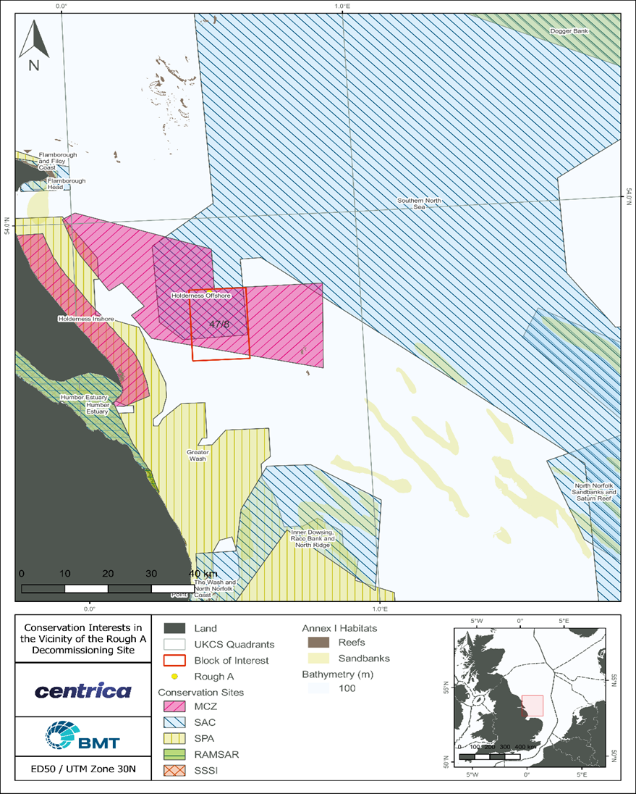
              - Conservation areas in vicinity to Rough A field
Block 47/8, and the Rough A platforms, overlap with the Southern North Sea SAC, designated for the protection of the Annex II species harbour porpoise. The Southern North Sea SAC is located in the offshore waters of the central and southern North Sea, from north of Dogger Bank to the Straits of Dover in the south and covers an area of 36,951 km² (JNCC, 2018a).
The Conservation Objectives of the SNS SAC are in place to ensure that the integrity of the site is maintained and that it makes the best possible contribution to maintaining Favourable Conservation Status (FCS) for Harbour Porpoise in UK waters. The objectives can be achieve through ensuring that three main Conservation objectives are met;
SNS Conservation Objective 1 (SNS CO1)
- Harbour porpoise is a viable component of the site.
SNS Conservation Objective 2 (SNS CO2)
- There is no significant disturbance of the species.
SNS Conservation Objective 3 (SNS CO3)
- The condition of supporting habitats and processes, and the availability of prey is maintained.
The only other SAC within 40 km of the Rough AP and AD platforms is the Humber Estuary SAC, which is an inshore site designated for the protection of mudflats and sandflats not covered by seawater at low tide and estuaries.
            - Annex I habitats and Annex II species known to occur in UK offshore waters
Annex I habitats known to occur in UK offshore waters | Annex II species known to occur in UK offshore waters
- Sandbanks which are slightly covered by seawater all the time  - Reefs (bedrock, biogenic and stony)  - Bedrock reefs – made from continuous outcroppings of bedrock which may be of various topographical shapes;  - Stony reefs – these consist of aggregations of boulders and cobbles which may have some finer sediments in interstitial spaces; and  - Biogenic reefs – formed by cold water corals (e.g. Lophelia pertusa) and Sabellaria spinulosa.  - Submarine structures made by leaking gases | - Grey seal (Halichoerus grypus)  - Harbour or common seal (Phoca vitulina)  - Bottlenose dolphin (Tursiops truncatus)  - Harbour porpoise (Phocoena phocoena)

Special Protection Areas
SPAs are protected areas which have been classified in accordance with Article 4 of the Conservation of Offshore Marine Habitats and Species Regulations 2017 (as amended) in the UK offshore area. They are classified based on the location of rare and vulnerable birds and also for frequently occurring migratory species which are listed on Annex I of the Birds Directive (2009/147/EC). No SPA’s are recorded at the Rough AP and AD platform site, however there are two recorded within 40 km: Greater Wash SPA and the Humber Estuary SPA.

Greater Wash SPA
The Greater Wash SPA is a designated area that extends off the coast of Yorkshire and Suffolk approximately 26 km west of the Rough A platforms. It is classified for the protection of the following Annex I species under the Directive: red-throated diver (Gavia stellata), common scoter (Melanitta nigra), and little gull during the non-breeding season, and for breeding sandwich tern, common tern and little tern (JNCC, 2018b). The site protects important foraging areas for the largest populations of little tern in the UK marine SPA network as well as the second largest non-breeding populations of the red-throated diver and little gull (JNCC, 2018b). The site also protects are regularly occurring migratory bird species not listed as Annex I species.

Humber Estuary SPA
The Humber Estuary SPA extends from the mouth of the Humber and along the estuary to the tidal limits on the River Ouse and Trent approximately 31 km southwest of the Rough A platforms. Its dynamic mudflats, saltmarsh and reedbeds acts as an important breeding area for little terns (Yorkshire Marine Nature Partnership, 2025). Little terns arrive from mid-April to breed, before leaving to their wintering grounds around September. The Humber Estuary SPA protects significant populations (>1% of the UK population) of waterbirds which use the site, and is an important assemblage, being used regularly by over 20,000 waterbirds.

East Inshore and Offshore Marine Plans
The Rough A area is situated within the boundaries of the East Offshore Marine Plan Area which encompasses the marine area from 12 NM out to the Exclusive Economic Zone. The East Inshore and Offshore Marine Plans (DEFRA, 2014) were the first marine plans produced for English Seas and came into force in April 2014. The aim of the marine plans is to help ensure the sustainable development of the marine area through informing and guiding regulation, management, use and protection of the marine plan areas. Policies that will influence the development are outlined in Table 3.5.
            - East Inshore and Offshore Marine Plans Policies
Policy | Topic | Description
ECO1 | Cumulative impacts | Cumulative impacts affecting the ecosystem of the East marine plans and adjacent areas (marine, terrestrial) should be addressed in decision making and plan implementation,
BIO1 | Biodiversity protection | Appropriate weight should be attached to biodiversity, reflecting the need to protect biodiversity as a whole taking into account of the best available evidence including habitats and species that are protected or of conservation concern in the East marine plans and adjacent areas (marine, terrestrial)
FISH1 | Fishing | Within areas of fishing activity, proposals should demonstrate in order of preference:  - That they will not prevent fishing activities on, or access to, fishing grounds;  - How, if there are adverse impacts on the ability to undertake fishing activities or access to fishing grounds, they will minimise them;  - How, if the adverse impacts cannot be minimised, they will be mitigated; and  - The case for proceeding with their proposals if it is not possible to minimise or mitigate the adverse impacts.
FISH2 | Fishing | Proposals should demonstrate, in order of preference:  - That they will not have an adverse impact upon spawning and nursery areas and any associated habitat;  - How, if there are adverse impacts on the spawning and nursery areas, they will minimise them;  - How, if the adverse impacts cannot be minimised, they will be mitigated; and the case for proceeding with their proposals if it is not possible to minimise or mitigate the adverse impacts.
CC1 | Climate Change | Proposals should take account of:  - How they may be impacted upon by, and respond to, climate change over their lifetime; and  - How they may impact upon any climate change adaptation measures elsewhere during their lifetime.
CC2 | Climate change | Proposals for development should minimise emissions of greenhouse gases as far as is appropriate. Mitigation measures will also be encouraged where emissions remain following minimising steps.  Considerations should also be given to emissions from other activities.
OG1 | Oil & Gas | Proposals within areas with existing oil and gas production should not be authorised except where compatibility with oil and gas production and infrastructure can be satisfactorily demonstrated.
GOV3 | Governance | Proposals should demonstrate in order of preference: a) that they will avoid displacement of other existing or authorised (but yet to be implemented) activities; b) how, if there are adverse impacts resulting in displacement by the proposal, they will minimise them; c) how, if the adverse impacts resulting in displacement by the proposal, cannot be minimised, they will be mitigated against, or; d) the case for proceeding with the proposal if it is not possible to minimise or mitigate the adverse impacts of displacement
AGG1 | Aggregates | Proposals in areas where a licence for extraction of aggregates has been granted or formally applied for should not be authorised unless there are exceptional circumstances.
AGG2 | Aggregates | Proposals within an area subject to an Exploration and Option Agreement with The Crown Estate should not be supported unless it is demonstrated that the other development or activity is compatible with aggregate extraction or there are exceptional circumstances.
AGG3 | Aggregates | Within defined areas of high potential aggregate resource, proposals should demonstrate in order of preference: a) that they will not, prevent aggregate extraction; b) how, if there are adverse impacts on aggregate extraction, they will minimise these; c) how, if the adverse impacts cannot be minimised, they will be mitigated; d) the case for proceeding with the application if it is not possible to minimise or mitigate the adverse impacts.
Note: all policies apply to both the inshore and offshore marine area.

Socioeconomic Environment
This section provides information on the broader social and economic considerations within the Rough A area. For offshore oil and gas decommissioning projects, consideration is given to the potential impact on other sea users, such as the fishing and shipping industries, the renewable energy sector and the military operations. The existence of submarine cables, historic wrecks and other oil and gas installations are also considered.
Socioeconomic considerations can also include changes in demographics and to communities, direct and indirect effects on employment, expenditures and incomes, and economic benefits to the wider area resulting from the decommissioning programmes. However, no attempt has been made to quantify these potential changes, and social benefits are only discussed in the context of potential economic impacts.

Commercial Fishing Industry
An assessment of fishing activity in the area has been derived from ICES fisheries statistics, information provided by the (Scottish Government, 2025). Statistical data from ICES rectangle 36F0 on the UK fishing effort, and live weight of demersal, pelagic and shellfish landed by UK vessels, provided by Scottish Government (2025), are reported below. The overall value of the different species by area (financial yield per ICES rectangle) is an indication of the differential worth of areas and is used as a method of expressing commercial sensitivity (Coull et al., 1998). The type of fishing gear and techniques employed by fishermen depends on a variety of factors, such as:
- Species fished, e.g., demersal, pelagic or shellfish;
- Water depth and seabed bathymetry; and
- Seabed characteristics.
Species found in the water column (pelagic species) are fished using techniques that do not interact with the seabed, whereas demersal and shellfish species are generally fished on or near the seabed. Finfish, such as cod, whiting, haddock and flatfish, and shellfish species, such as Nephrops, which are found on or near the seabed, are caught by demersal gear. Demersal trawling methods interact with the seabed and may interact with the existing infrastructure on the seabed and historical seabed anomalies created by oil and gas activities, including footings, pipelines, rock placement or concrete mattresses left or buried in the sediment.
Traps were the most utilised gear type used in ICES rectangle 36F0 in each year from 2020 to 2024 (Scottish Government, 2025).

Annual Fishing effort
Fishing effort in ICES rectangle 36F0 ranged between 2,563 days in 2020 to 3,394 days in 2024 which (Table 3.6; Scottish Government, 2025). Most of the recorded instances of fishing within ICES rectangle 36F0 were from demersal fishing gear, specifically traps and dredges, followed by a small effort with trawls and seine nets(Table 3.6; Scottish Government, 2025).

Fishing Quantity and Value
The relative quantity and values of fish landed from ICES rectangle 36F0 in 2024 was predominately made up of shellfish species, accounting for around 99% of total catch, with demersal species and a small amount of pelagic species making up the remaining catch (Table 3.6; Scottish Government, 2025). Between 2020 and 2024, the annual total live weight of fish landed from ICES rectangle 36F0 ranged from 2,991 tonnes landed in 2023 to 4,059 tonnes landed in 2021 (Table 3.6; Scottish Government, 2025). Total annual value in ICES rectangle 36F0 ranged between £9,094,884 in 2020 and £15,941,288 in 2021 (Table 3.6; Scottish Government, 2025).
The contribution from ICES rectangle 36F0 to the UK’s overall fisheries production is minimal. Landings from this area accounted for less than 1% of the total UK catch volume, which amounted to 767,299.52 tonnes in 2024 (MMO, 2025). In terms of economic value, the catch from rectangle 36F0 represented approximately 1% of the UK’s total annual catch value of £1,189,282,890 (MMO, 2025). These figures indicate that the ecological and economic significance of this area, relative to national fisheries output is relatively low.

            - Total fishing effort and values for 2020 to 2024 within ICES rectangle 36F0 (Scottish Government, 2025)
Year | Total effort* (days) | Total value (£) | Species type | Value (£) | Total quantity (tonnes) | Species type | Quantity (tonnes) | Percentage of total quantity (%)
2024 | 3,394 | 11,792,737 | Demersal | 14,724 | 3,004 | Demersal | 5.25 | 0.17
2024 | 3,394 | 11,792,737 | Pelagic | 7,360 | 3,004 | Pelagic | 4.10 | 0.14
2024 | 3,394 | 11,792,737 | Shellfish | 11,770,652 | 3,004 | Shellfish | 2,994.66 | 99.69
2023 | 3,360 | 15,827,668 | Demersal | 32,753 | 2,991 | Demersal | 17 | 0.58
2023 | 3,360 | 15,827,668 | Pelagic | 1,366 | 2,991 | Pelagic | 1 | 0.04
2023 | 3,360 | 15,827,668 | Shellfish | 15,793,549 | 2,991 | Shellfish | 2,972 | 99.37
2022 | 3,232 | 14,513,645 | Demersal | 18,933 | 3,450 | Demersal | 11 | 0.32
2022 | 3,232 | 14,513,645 | Pelagic | 6,112 | 3,450 | Pelagic | 5 | 0.15
2022 | 3,232 | 14,513,645 | Shellfish | 14,488,601 | 3,450 | Shellfish | 3,434 | 99.52
2021 | 3,258 | 15,941,288 | Demersal | 27,828 | 4,059 | Demersal | 31 | 0.76
2021 | 3,258 | 15,941,288 | Pelagic | 4,527 | 4,059 | Pelagic | 5 | 0.13
2021 | 3,258 | 15,941,288 | Shellfish | 15,908,932 | 4,059 | Shellfish | 4,022 | 99.11
2020 | 2,563 | 9,094,884 | Demersal | 22,277 | 3,194 | Demersal | 20 | 0.64
2020 | 2,563 | 9,094,884 | Pelagic | 4,630 | 3,194 | Pelagic | 3 | 0.09
2020 | 2,563 | 9,094,884 | Shellfish | 9,067,977 | 3,194 | Shellfish | 3,170 | 99.27

Vessel Monitoring System (VMS) Data
Vessel Monitoring System (VMS) satellite tracking data complement the ICES fisheries data and shows information for; the years 2010 to 2020 for all registered commercial fishing vessels over 12 m in length (ICES, 2021) for demersal fisheries, and the years 2010 to 2015 for all registered UK commercial fishing vessels over 15 m in length for pelagic fisheries (Kafas et al., 2013).

Pelagic Fisheries VMS Data
Figure 3.7 illustrates satellite (VMS) density of all UK vessels over 15 m in length by fishing activity (average 2010 to 2022). In order to differentiate between vessels steaming and fishing, only vessels with speeds between 0 and 6 knots are assumed to be fishing. Areas with the highest recorded activity are generally concentrated inshore areas along the coast of England and offshore in ICES rectangle 37F0. This pattern of distribution directly reflects the location of grounds where the pelagic fleet target plaice and cod.
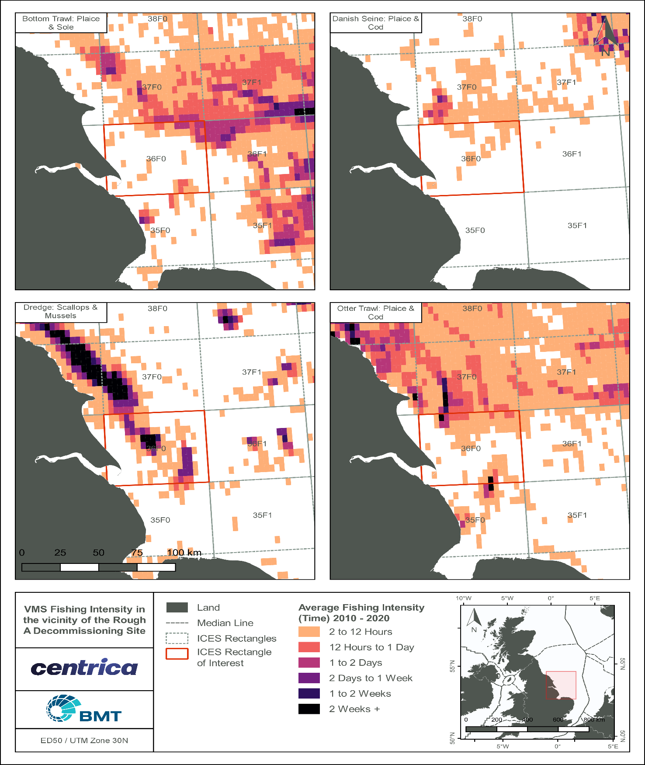
              - Satellite (VMS) commercial pelagic fishing intensity by gear type (2010 – 2022).

Demersal Fisheries VMS Data
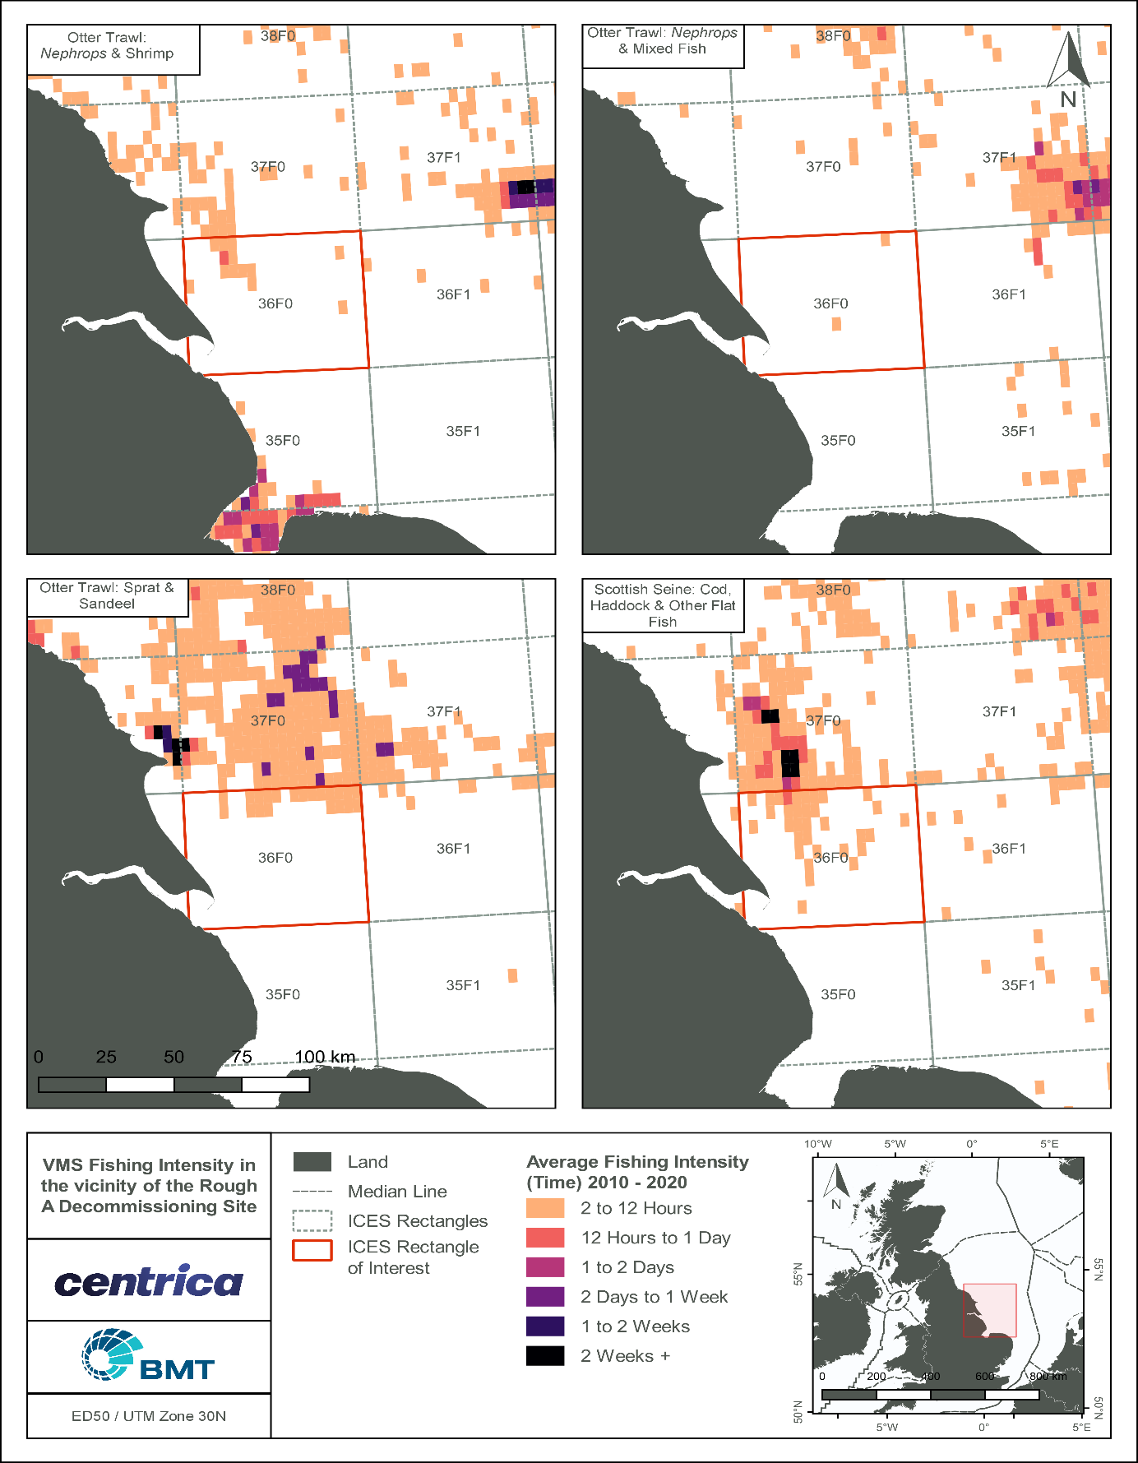
ICES, through a data request from OSPAR, have provided satellite tracking data for vessels above 12 m over the years 2010 to 2020 on fishing intensity/pressure within the OSPAR Maritime, see Figure 3.8 Satellite (VMS) commercial demersal fishing intensity (hours) by gear type (2010 – 2022).
              - Satellite (VMS) commercial demersal fishing intensity by gear type (2010 – 2022).

Commercial fishing in combination with other sea users
Spatial representation of commercial fishing activities associated with the location of oil and gas pipelines is shown in Figure 3.9 (Rouse et al, 2018). The figure shows that little fishing occurred along pipelines within 36F0 (<5 VMS tracks), 5-20 VMS tracks for mobile fishing of Nephrops were recorded, for demersal gear and all other gear types, VMS tracks show very low (<5 VMS tracks) activity along pipelines in ICES rectangle 36F0 between 2007 and 2015.
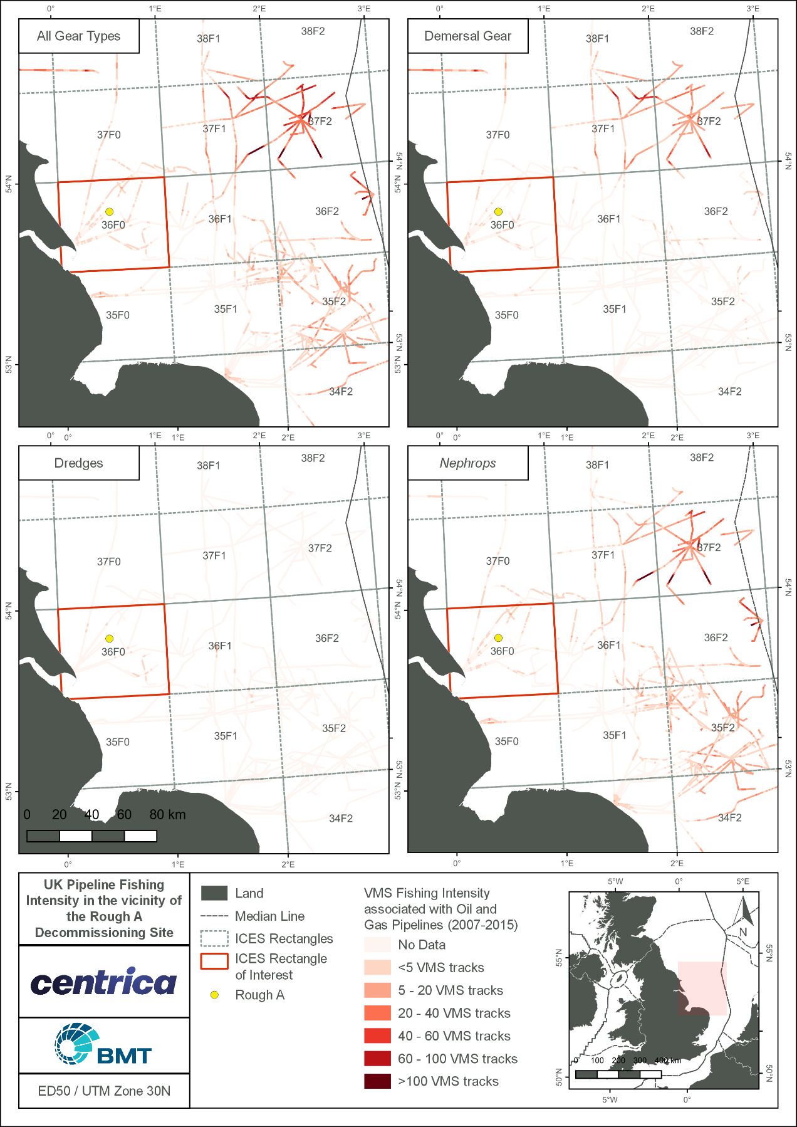
              - Fishing intensity associated with oil and gas pipelines (2007 – 2015)

Oil and Gas Industry
Oil and gas development in this region of the North Sea is relatively intensive. There are several oil developments close to the Rough A field, displayed in Figure 1.1. The location of surface infrastructure within 40 km to Rough A is listed in Table 3.7.
            - Oil and gas developments within proximity of the Rough 47/8A field
Platform | Operator | Distance (km) | Direction FROM site/ block
Rough BD | Centrica Storage Holdings | 2 km | NW
Rough BP | Centrica Storage Holdings | 2 km | NW
Rough CD | Centrica Storage Holdings | 2 km | NW
York | Spirit Energy | 11 km | NW
Minerva | Perenco Oil & Gas | 21 km | NE
Amethyst C1D | Perenco Oil & Gas | 22 km | SE
Tolmount | Harbour Energy Plc | 24 km | N
Cleeton CC | Perenco Oil & Gas | 27 km | NE
Cleeton PQ | Perenco Oil & Gas | 27 km | NE
Cleeton Riser Tower | Perenco Oil & Gas | 27 km | NE
Cleeton WLTR | Perenco Oil & Gas | 27 km | NE
Neptune | Perenco Oil & Gas | 27 km | NE
Amethyst A1D | Perenco Oil & Gas | 29 km | SE
Amethyst A2D | Perenco Oil & Gas | 31 km | SE
Ravenspurn South C | Perenco Oil & Gas | 37 km | NE
Hyde | Perenco Oil & Gas | 38 km | E
Ravenspurn South B | Perenco Oil & Gas | 38 km | NE
Ravenspurn South A | Perenco Oil & Gas | 39 km | NE

Submarine Cables and Pipelines
Currently there are no subsea communication cables laid within Block 47/8 (KIS-ORCA, 2016). The closest submarine cable is the TGN Northern Europe telecommunication cable which is located approximately 37 km northwest of Rough A, as well as a planned cable, the NGVL Northern Europe cable, approximately 23 km southeast (KIS-ORCA, 2016).

Marine Archaeology and Wrecks
In the UK, submerged prehistoric sites and shipwrecks are not protected unless specific action has been taken to protect them. There are, however, two different acts under which wrecks that may be of archaeological interest may be designated, namely the Protection of Wrecks Act 1973 and the Protection of Military remains Act 1986. Designation of wrecks and submerged prehistoric sites is also possible under a third act, the Ancient Monuments and Archaeological Areas Act 1979, which applies to Scotland, England and Wales (DECC, 2009). There are 465 wrecks within 40 km of the Rough A decommissioning area (Figure 3.10). Of these wrecks, 96 are classified as dangerous and non are classified as being historically significant (Wrecksite, 2017). The closest wreck to Rough A is 1.1 km southeast and is a non-dangerous wreck. The next closest wreck is 1.9 km in the same direction and is also non-dangerous.

Shipping
Vessel traffic in the blocks of interest range from high to very high, with cargo ships and tankers being present in the highest average densities between 2018 and 2023 (EMODnet, 2024).

Defence
Under the Other Regulatory Issues policy document (UK Government, 2022), Block 47/8 lies within a Ministry of Defence (MoD) training range. The MoD must be notified 12 months ahead for installation of any new infrastructure, though as this scope of work involves decommissioning of existing infrastructure this is not applicable. There are no recorded historic military disposal sites, nor license conditions, applied to the blocks of interest by the DESNZ on behalf of the MoD within, or close, to the Rough A field.

Renewable Energy Activity
Much of the marine and coastal areas around the UK are being investigated and/or developed as renewable energy resources. Wave, tidal and wind renewable energy studies and projects are underway in several areas (Figure 3.10).

Wave and Tidal
The UK has a particularly good marine current resource with at least 40 possible locations having currents of a suitable speed for energy generation. The closest tidal and wave energy zone to the Rough A Infrastructure is located more than 100 km away, therefore, no interaction with these renewable energy sectors is expected to occur as a result of the proposed decommissioning project.

Wind
There are two production wind farms; Humber Gateway and Westermost Rough, Race Bank and one planned, the Triton knoll, within 40 km of Rough 47/8 A. The closest wind renewable energy zone to the Rough 47/8 A Field is the Humber Gateway Windfarm (4.5km southwest) (EMODNet, 2022).

Gas and Carbon Capture and Storage Activities
As a result of declining natural gas resources in the North Sea, pressure is mounting for more investment in UK gas storage facilities to ensure integrity of supply. Currently the only offshore gas storage facility currently in operation in the UK is located within the wider Rough field. Other licences have been granted such as ENI’s Deborah field located in Block 48/29 in the SNS 36 km northeast of the Bacton terminal. The proposed DPs are unlikely to have a significant environmental impact to the use of existing storage facilities and associated infrastructure.
Carbon capture and storage (CCS) in offshore depleted oil and gas reservoirs is being investigated to manage the emissions of CO₂ and reduce the contribution of fossil fuel emissions to global warming. The closest CCS project to the Rough A field is the Shell Goldeneye project located in the CNS. This development is currently in the ‘agreement for lease’ stage. There are no known CCS plans situated closer to Rough A. Two CCS projects in the SNS, East Coast Cluster and Viking CCS, are in the planning stages. Both of these are greater than 40 km from the Rough A DPs.

Dredging and Aggregate Extraction
Aggregates are mixtures of sand, gravel, crushed rock or other bulk minerals used in construction, principally as a component of concrete. Most UK dredging sites are located in the SNS with the main region of aggregate extraction in the North Sea being the Humber Region (DTI, 2001).
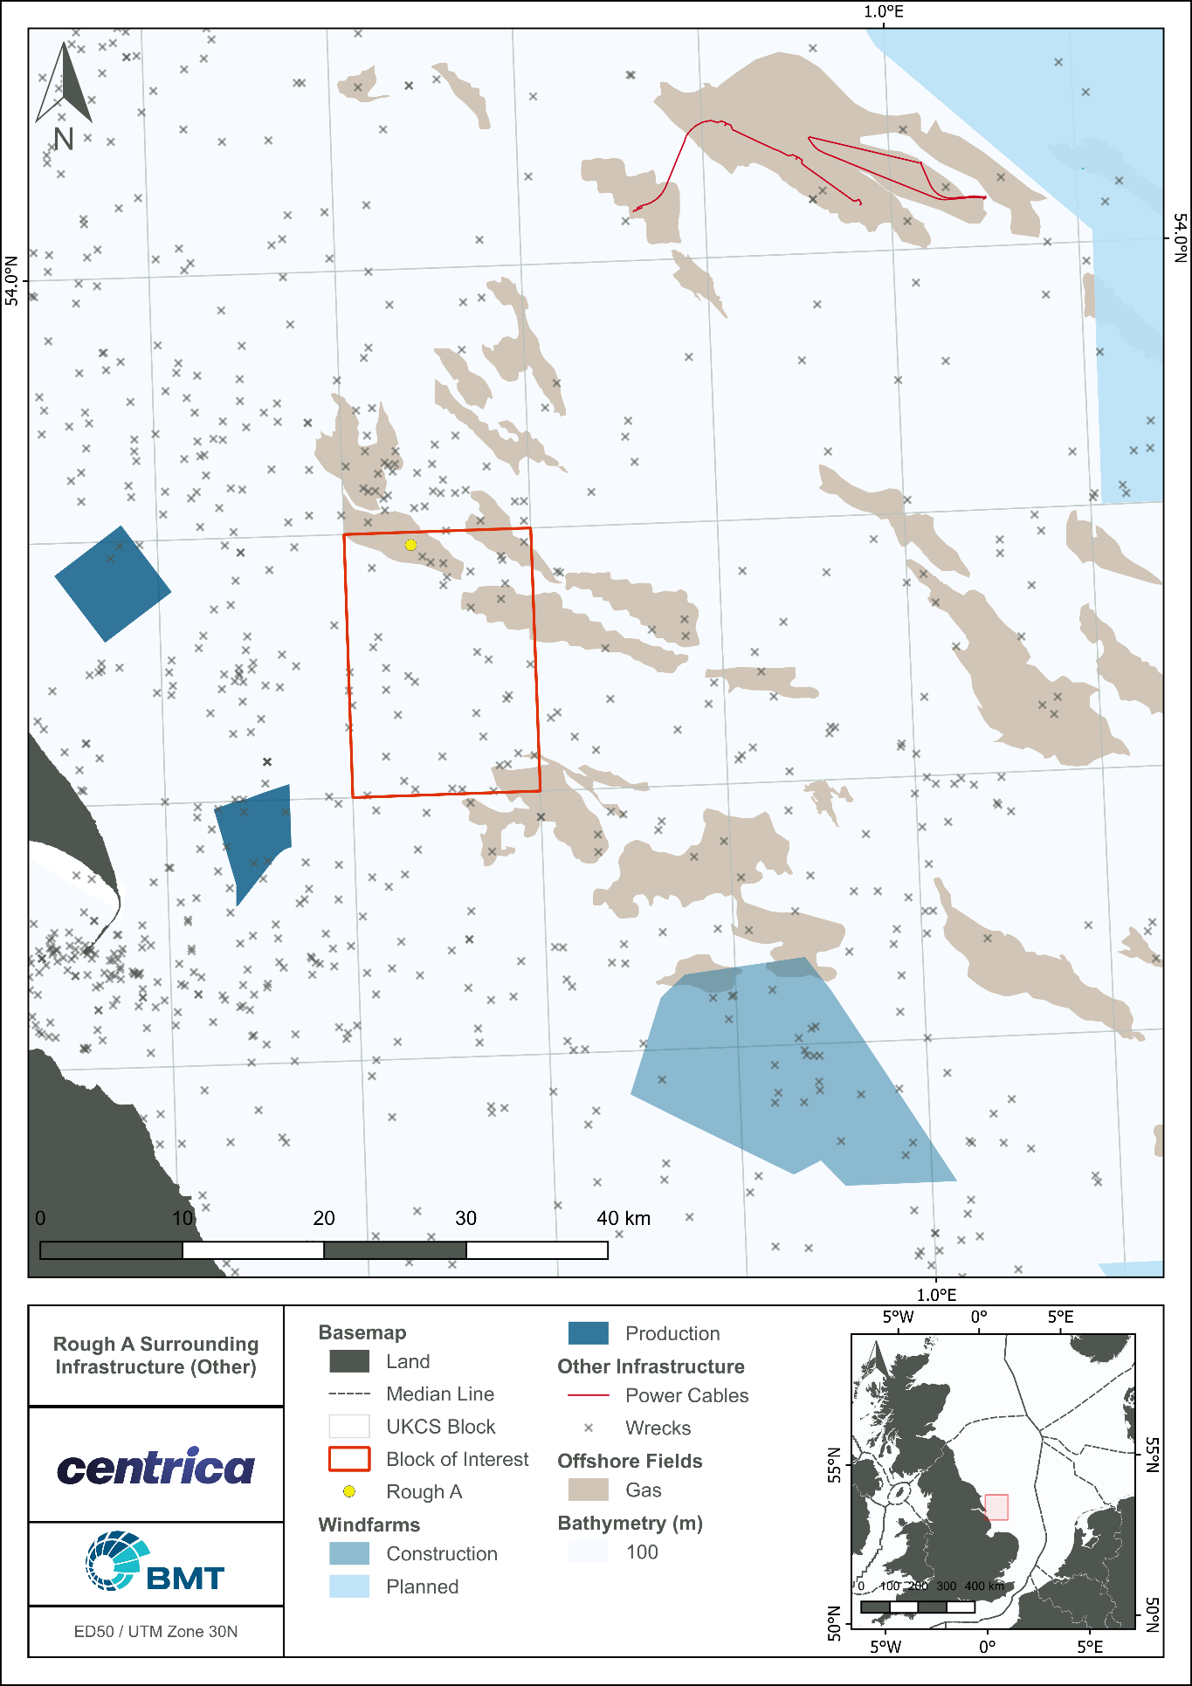
              - Other Infrastructure in Rough A Vicinity

Summary of Environmental Sensitivities
Table 3.8 provides a summary of the sensitivities for the Rough 47/8 A field area.
            - Environmental sensitivities in the vicinity of Rough 47/8 A field
Aspect | Detail
Site overview
The Rough A field, operated by CESL and lies within UKCS Block 47/8 in the SNS, approximately 29 km southwest of Easington Yorkshire, and 160 km west of the UK/Norwegian median line. The decommissioning programmes are also located within the International Council for the Exploration of the Sea (ICES) rectangle 36F0.
Environmental Aspects
Conservation Interests within 40 km of proposed Rough A Decommissioning
Offshore Marine Protected Areas and Annex I habitats
Special Area of Conservation (SAC) | Rough A lies within the Southern North Sea SAC, designated for the protection of harbour porpoise. The Humber Estuary SAC lies within 40 km of Rough A.
Marine conservation zones (MCZ) | Rough A lies within the Holderness Offshore MCZ, designated for subtidal coarse sediment, subtidal sand, subtidal mixed sediments, Ocean quahog and North Sea glacial tunnel valleys. The Holderness Inshore MCZ lies within 40 km of Rough A.
Special Protection Areas (SPA) | There are 2 SPAs within the Rough A area, Humber Estuary and the Greater Wash SPA.
Annex I habitats | There are both Annex I sandbanks and reef habitats present within 40 km of the Rough A field.
Offshore Annex II species
Harbour porpoise (Phocoena phocoena) | A very high abundance of harbour porpoise is recorded in Quadrat 47 and adjacent quadrants for March, July, August, September, October, November and December with a moderate abundance the rest of the remaining months.
Grey seals (Halichoerus grypus) | Grey seal densities typically range between 10 – 50 seals per 25 km² with occasional peaks of up to 100 seals per 25 km²
Harbour seals  (Phoca vitulina) | Harbour seal densities in the area are typically low (between 0 – 1 seals per 25 km²), reaching peaks of up to 10 seals per 25 km² in localised regions of the block of interest.  There are no haul-out or breeding sites within the vicinity.
Bottlenose dolphin (Tursiops truncatus) | Bottlenose dolphins are recorded in the vicinity around Rough A in the months of July and August.
Marine Plan Policies
East Inshore and Offshore Marine Plans Policies | Rough A falls under the guidance of the East Inshore and East Offshore Marine Plan Policy.
Plankton
The zooplankton communities of the SNS is dominated by copepods including Calanus helgolandicus, C. finmarchicus, Paracalanus and Pseudocalanus spp., Acartia spp., Temora spp. and cladocerans such as Evadne spp. (OESEA, 2022).
Benthic environment
The Rough A field lies within a widespread seabed area that can be classified into mostly coarse sediment. The UKSeaMap describes the seabed in the subtidal section of the proposed area as a mixture of A5.14 Circalittoral coarse sand and A5.13 Infralittoral coarse sand, A5.43 Infralittoral mixed sediment and A5.44 Circalittoral mixed sediment.
Fish and shellfish – spawning and nursery areas
Spawning areas | The Blocks of interest overlap with spawning areas for cod, herring, lemon sole, plaice, sole, sprat and sand eel.  ICES rectangle 36F0 is considered a high intensity spawning area for North Sea plaice
Nursery areas | There are nursery areas in the ICES rectangle 36F0 for, cod, herring, lemon sole, plaice, mackerel, sand eel, sprat, whiting.  There is high intensity nursery ground identified for cod, herring, and whiting ICES rectangle 36F0.
Marine Mammals
Cetaceans | The main marine mammal species occurring in the area are minke whale (Balaenoptera acutorostrata), bottlenose dolphin (Tursiops truncatus), common dolphin (Delphinus delphis), white-sided dolphin (Lagenorhynchus acutus), white-beaked dolphin (Lagenorhynchus albirostris) and harbour porpoise (Phocoena phocoena), with most sightings occurring in the summer months.
Seals | There are no haul-out or breeding sites within the vicinity.
Seabirds
Species commonly found in offshore North Sea waters are Fulmar (Fulmarus glacialis), Gannet (Morus bassanus), Guillemot (Uria aalge), Razorbill (Alca torda) and Kittiwake (Rissa tridactyla); and Herring (Larus argentatus), Great Black-backed (Larus marinus) and Lesser Black-backed (Larus fuscus) Gulls
Seabird sensitivity | In the primary block of interest (47/8), seabird oil sensitivity ranges between low and high throughout the year. In the block of interest, extremely high seabird vulnerability was recorded in October, with very high seabird vulnerability recorded in March
Socioeconomic Aspects
Fisheries | Fishing effort in ICES rectangle 36F0 ranged between 2,563 days in 2020 to 3,394 days in 2024 (Scottish Government, 2025). Between 2020 and 2024, the annual total live weight of fish landed ranged from between 2,991 tonnes landed in 2023 to 4,059 tonnes landed in 2021. Total annual fishing value ranged between £9,094,884 in 2020 to £15,941,288 in 2021 (Scottish Government, 2025)  No shellfish water protected areas or active aquaculture sites occur in the vicinity of the Rough A area.
Shipping | Shipping density in the blocks of interest is considered to be high to very high (EMODnet, 2024)
Oil and gas industries | There are 18 active platforms within 40 km of the Rough A Field infrastructure. The closest, Rough BD is approximately 2 km to the northwest.
Offshore renewables | There are 2 renewable energy sites in production within 40 km of Rough 47/8 A
Military activities | There is no military activity expected within the vicinity
Telecommunications | There is one cable in the Rough A vicinity: TGN Northern Europe 37 km northwest and one planned cable 23 km southeast, NGVL Northern Europe

Evaluation of Potential Environmental Impacts

As required by the Petroleum Act, 1998 and OSPAR Decision 98/3, this section identifies and ranks the environmental and societal impacts and risks that could arise from planned and unplanned activities associated with the proposed decommissioning activities.
The activities associated with the decommissioning of the Rough 47/8A platforms have the potential to result in an environmental impact in several different ways, including the physical disturbance of the seabed, discharges to sea, obstruction to other users of the sea, underwater noise and greenhouse gas emissions. These effects could arise as consequences of the following aspects of the decommissioning programmes:
- General decommissioning activities;
- Cutting and removal of the Rough AD and Rough AP topside modules;
- Cutting and removal of the Rough AD and Rough AP jackets, risers and piles; and
- Cutting and removal of the bridge-link platform connecting the Rough AD and Rough AP platforms.
An assessment of the significance of the risks to any environmental and societal receptor as a result of the decommissioning operations looks at both planned/ unplanned operations or accidental events. In support of the risk assessment an environmental risk determination (ENVID) workshop was held on the 31st October 2022. The purpose of the workshop and risk assessment was to:
- Identify potential environmental and societal impacts that may arise from the proposed decommissioning activity;
- Evaluate the potential significance of those potential impacts in terms of the threat that they pose to specific environmental and societal receptors;
- Assign measures to manage and or mitigate the risks in line with industry best practice;
- Identify any additional data requirements/actions to be caried out; and
- Address concerns or issues raised by stakeholders (e.g. CEFAS, EA, GMSL, JNCC, MMO, NFFO, NIFPO and SFF) during the consultation on this EA. At this point, no objections or concerns have been raised by consultees, and Centrica continue to monitor for comments.
Where appropriate, site specific, transboundary and cumulative impacts were also included in discussions during the ENVID and risk assessment process.

Risk Assessment Methodology
The ENVID was undertaken using the following method:
- Decommissioning activities were broken into its component activities, operations and end-points (e.g., physical presence of vessels).
- Receptors at risk (societal or environmental elements) were identified from the potential operational impacts and end-point impacts (Table 4.1).
- The significance of the potential environmental impacts and risks was assessed according to pre-defined criteria. These criteria recognise the likely effectiveness of planned mitigation measures to minimise or eliminate potential impacts/ risks.
- Assessments were undertaken to determine what level of impacts/ risks the component activity/ operation could pose to the different groups of environmental or societal receptors. The following Scoring Criteria and Risk Matrix was applied to complete the associated worksheets:
- Likelihood and Sensitivity Criteria for Unplanned and Planned Events (Table 4.2); and
- Magnitude Table (Table 4.3).
The overall significance of risk for a particular activity was determined by the Risk Matrix (Table 4.4).
At the ENVID workshop, a facilitated discussion took place working through the assessment of the environmental risks and potential impacts, receptors, mitigation measures and additional data requirements and actions for each programme activity. Both planned operations and unplanned or accidental events were considered. Template worksheets were used to record the decommissioning programme activities and outcomes of the discussion under the following headers:
- General activities;
- Preparation and removal of platforms; and
- Electrical umbilicals and J-tube Connection.
Completed ENVID worksheets can be found in Annex A.

List of environmental and societal receptors
Physical and Chemical | Biological | Socio-economic
- Sediment structure / chemistry  - Water quality  - Air quality (local) | - Sediment biology (benthos)  - Water column (plankton)  - Finfish and shellfish  - Seabirds  - Sea mammals | - Integrity of conservation site  - Commercial fishing  - Shipping  - Military operations  - Other users  - Use of resources  - Use of disposal facilities  - Stakeholder Concerns

Likelihood Matrix
LIKELIHOOD CRITERIA  (score) | Highly Unlikely  Rarely happened in industry or sector  (1) | Very Unlikely  Happened in industry or sector  (2) | Unlikely  Similar event has happened in Centrica Group  (3) | Possible  There is a history of casual occurrence across the Group, sector and / or external market  (4) | Probable  Has happened more than once per year across the Group, sector and / or external market.  (5) | Likely  There is a history of regular occurrence across the Group, sector and / or external market.  (6) | Very Likely  There is a history of routine occurrence across the Group, sector and / or external market.  (7) | Highly Likely  There is a history of common occurrence across the Group, sector and / or external market.  (8)
Probability of risk arising | 0.0001% | ≥0.001% | ≥0.01% | ≥0.1% | ≥1% | ≥10% | ≥25% | ≥50%
Likelihood that risk will arise as a result of business / operational activities | ≥0.000001  (<1 in 100,000) | ≥0.00001  (≥1in 100,000) | ≥0.0001  (≥1 in 10,000) | ≥0.001  (≥1 in 1000) | ≥0.01  (≥1 in 100) | ≥0.1  (≥1 in 10) | ≥0.25 (≥1 in 4) | ≥0.5 (≥1 in 2)

Impact Magnitude
IMPACT CRITERIA | Minor (1) | Very Low (2) | Low (3) | Serious (4) | High (5) | Very High (6)
Health, Safety, Environment & Security | Event resulting in minor injury (first aid) and/or temporary disruption with  rapid recovery, managed with adequate existing risk response plans. | Event resulting in recordable injury and/or illness.  Environment, equipment or security breach resulting in very low financial impact, temporary curtailment of specific activities or short-term natural recovery. Adequate risk response plans are in place. | Event resulting in lost time, injury / illness within the workforce or injury to a member of the public (including customers).  Environment or security breach, or damage / loss of non-critical equipment with low financial impact, temporary business shut down and limited business continuity concern. Impact is managed through existing risk response plans. | Event resulting in irreversible illness, permanent disability or fatality within the workforce and/or lost time injury to a member of the public.  Significant localized environmental impact. Security breach with malicious intent. Major damage to critical systems or equipment. Limited cessation of specific activities. | Significant event with multiple workforce fatalities or single fatalities to member of the public.  Major environmental impact. Requires protracted remediation.  Security breach with malicious intent and sustained impact.  Extended operational cessation of assets / activities, significantly affecting operations and customers. | Catastrophic process event with fatalities amongst our workforce or members of the public.  Catastrophic, environmental impact requiring protracted longer-term remediation.  Targeted, organized, persistent and directed attack at multiple sites by multiple people with malicious intent.  Total loss of an asset materially impacting our ability to deliver our strategy.
Regulatory Compliance | Non-reportable technical or administrative breach. | Voluntary notification to regulator with limited public awareness. | Regulatory reporting resulting in specific improvements to defined activities that we can influence favourably. | Regulatory action resulting in request for significant improvement across numerous material activities with limited opportunity to influence favourably. | Regulatory action resulting in temporary cessation of material operations and increasing regulatory constraints significantly affecting numerous assets / activities. | Regulatory action, resulting in removal of license to operate.  Increasing regulatory constraints with assets / activities unable to comply on a timely basis.
Stakeholder Reputation | Very limited or negligible short-term impact on customer base and satisfaction. | Specific stakeholder, including public, concerns raised. Limited short-term impact on customer base. Minor increase in customer complaints. | Wider industry peer, public or other third-party concerns raised. Short-term impact on customer base. Notable increase in customer complaints. | Repeated stakeholder or public concerns and potential share price impact. Significant short-term impact on customer base. Significant increase in customer complaints. | Stakeholder or public concerns with hostile narrative. Some loss of confidence in leadership, impacting on the share price. Significant medium-term impact on customer base, requiring some change to company strategy. | Fundamental shift in market perception of company and leadership and significant impact on our share price. Long-term reduction in customers, requiring significant change to strategy. Actively hostile environment and possible boycott of products.
Lifetime Financial (Operating Cash Flow) | £0m - £10m lifetime impact | £10m - £25m lifetime impact | £25m - £100m lifetime impact | £100m - £250m lifetime impact | £250m - £500m lifetime impact | > £500m lifetime impact
In year Financial (Operating Cash Flow) | £0 - £100k in year impact | £100k-£1m in year impact | £1m-£25m in year impact | £25m - £60m in year impact | £60m - £125m in year impact | >£125m in year impact

Risk Assessment Matrix
 |  | Likelihood Criteria
 |  | Highly Unlikely (1) | Very Unlikely (2) | Unlikely (3) | Possible (4) | Probable (5) | Likely (6) | Very Likely (7) | Highly Likely (8)
Impact Magnitude Criteria | Minor (1) | 1 | 2 | 3 | 4 | 5 | 6 | 7 | 8
Impact Magnitude Criteria | Very Low (2) | 2 | 4 | 6 | 8 | 10 | 12 | 14 | 16
Impact Magnitude Criteria | Low (3) | 3 | 6 | 9 | 12 | 15 | 18 | 21 | 24
Impact Magnitude Criteria | Serious (4) | 4 | 8 | 12 | 16 | 20 | 24 | 28 | 32
Impact Magnitude Criteria | High (5) | 5 | 10 | 15 | 20 | 25 | 30 | 35 | 40
Impact Magnitude Criteria | Very High (6) | 6 | 12 | 18 | 24 | 30 | 36 | 42 | 48
Key: 1-10 Green; 12-24 Amber; 25-48 Red

Risk Assessment Findings
If the risk rating was determined to be Low (Green ), a potential risk may exist, but the associated impacts are deemed to be acceptable, and as such may not require further assessment in the EA. In addition to potential risks of regulatory or stakeholder concern, e.g., noise impacts, risk ratings which was determined to be Moderate (Amber ) or High (Red ) were regarded as potentially significant and require further assessment and mitigation, as appropriate.

A summary of the ENVID risk assessment is provided in Table 4.5.

Activities/ Issues that have been scoped out and their associated impacts
The following environmental issues and risks were identified, but potential impacts were considered too small, localised and likely to be insignificant according to the risk matrix, therefore, were not considered for further assessment in this EA. The risk assessment also considered the potential residual impacts following implementation of anticipated mitigation and control measures. It was therefore agreed that the following would be scoped out of further assessment in the EA:

Planned Events
- Discharge of sewage and macerated water from vessels, as all vessels will comply with standard MARPOL procedure, and impacts are deemed to be routine and insignificant
  - Deterioration of water quality and;
  - Input of organic nutrients into the marine environment
- Helicopter transport, as subsea impact is expected to be insignificant
  - Underwater noise
- Drill cutting disturbance from removal of subsea equipment structures, as drill cuttings are not expected to be present at Rough A
  - Contamination of fish catch and gear;
  - Localised seabed disturbance
- Increased road traffic, as this is out of scope
  - Onshore societal impacts
- Lift modular support frames, as any noise generated is expected to be insignificant in comparison to general vessel noise
  - Underwater Noise

The activities/ risks that have been scoped in and their associated impacts
The activities and risks that were identified, following implementation of anticipated mitigation and control measures, as potentially significant and which will be assessed through the EA include:

Planned Events
- Physical presence of vessels
  - Obstruction to other sea users e.g., fishing and shipping
  - Disturbance to protected areas
- Gaseous emissions from vessels and helicopters
  - Deterioration of air quality at exhaust ports
  - Contribution to climate change through GHG emissions
- Potential anchoring of HLV during operations
  - Disturbance to seabed:
  - Loss of existing seabed habitat due to scarring and anchor mounts;
  - Indirect disturbance to the benthic environment through the suspension and re-settlement of sediments; and
  - Disturbance to and possible loss of benthic species
- Transport of infrastructure to shore via barges and tug vessels
  - Obstruction to other vessels and sea users
- MBES survey to identify large debris
  - Interference with shipping and fishing activities that may occur in the area
  - Temporary localised disturbance to marine animals
- Recovery of debris using subsea grab and subsea baskets and recovery and assessment of further debris identified as snagging risks
  - Disturbance to seabed community and protected features
- Cutting and lifting of topside modules and/or substructure via HLV, deck columns and piles (externally or via internal water injection)
  - Underwater noise:
  - Disturbance and injury to marine mammals and fish; and
  - Disturbance to nesting birds
- Onshore disposal of solid waste
  - Contribution to climate change through GHG emissions;
  - Air quality impacts to flora, fauna and hydrology; and
  - Landfill use and odour associated with marine growth

Accidental/ Unplanned Events
- Hydrocarbon, chemical or other spill release, e.g. diesel from vessels
  - Potentially resulting in significant impacts to marine fauna inhabiting the upper water column (plankton, fish and marine mammals) and benthic fauna. Spillage near shore could impact the coast and coastal communities, as well as cause loss of inventory and closure of fishing grounds
- Vessel collision
  - Potentially resulting in a hazard to other users
- Dropped Objects
  - Potentially resulting in a hazard to other users

Summary of number of risk categories identified with the Rough 47/8A decommissioning activities
Decommissioning Phase | Minor to Low |  | Serious |  | High - Very High
Decommissioning Phase | Planned Events | Unplanned Events | Planned Events | Unplanned Events | Planned Events | Unplanned Events
Vessel Operations | 13 | 1 | 1 | 1 | 0 | 0
Platform Preparation and Removal | 5 | 0 | 3 | 0 | 0 | 0
Umbilical and Protective Materials | 2 | 0 | 0 | 0 | 0 | 0

Of the activities (see Annex A) identified for the decommissioning of the Rough 47/8A the cutting, lifting and removal of topside modules and substructures via HLV, gaseous emissions from vessels, accidental hydrocarbon spill and a contingency plan for dredging and the external cutting of piles were assessed as potentially significant impacts and requiring further assessment within the EA. Thirteen further activities were identified as having low - minor impacts, but require further assessment within the EA due to the regulatory requirements and/or stakeholder concerns associated with them. Taking the effects of planned mitigation into account, the risk assessment indicates that the general decommissioning activities carry minor to low risk; four planned activities and one unplanned activity were identified as potential serious risks. The identified risks are assessed further in Sections 5 to 11:
- Seabed impacts (Section 5);
- Discharges to sea (Section 6);
- Societal impacts (Section 7);
- Energy use and atmospheric emissions (Section 8);
- Underwater noise (Section 9);
- Physical Presence (Section 10); and
- Accidental events (Section 11).
Stakeholder concerns were also considered within Sections 5 through to 12. Impacts or risks that were considered to be low and not of stakeholder concerns were excluded from further investigation in the EA.

Seabed Impacts

This section discusses the potential seabed disturbance resulting from the proposed Rough 47/8A decommissioning project.

Approach
Rough 47/8A decommissioning activities will include work below, at or near the seabed, which may result in short- and/or long-term disturbance to sediments and the marine organisms associated with them. The extent of any disturbance, combined with the seabed type and hydrodynamic conditions during the activities, will determine the burial and smothering extent from suspended sediments and any direct impact to species or habitats, as described in Table 5.1.

Summary of potential sources of seabed disturbance and resultant environmental impacts
Decommissioning activity |  | Environmental impact
 |  | Suspended sediments | Burial and smothering
General Activities | Preparatory work using a jack-up barge. | Short-term | Short-term
General Activities | Anchoring of HLV (worst case) during operations. | Short-term | Short-term
General Activities | Removal of anchors and seabed remediation. | Short-term | Short-term
General Activities | MBES survey and debris removal to confirm there are no snagging risks. | Short-term | Short-term
Platform preparation and removal | Contingency plan for dredging/ excavation and external cutting of piles. | Short-term | Short-term
Platform preparation and removal | Cutting of umbilical, pipeline and J-tube. | Short-term | Short-term

Sources of Potential Impacts
The potential seabed impacts during the Rough 47/8A decommissioning programmes are associated with the full removal of Rough AD and Rough AP platforms and the Alpha Bridge link between the two platforms. Vessel contracts have yet to be awarded. However, it is anticipated that decommissioning of the topsides and jackets will utilise a HLV, which could include a semi-submersible crane vessel, monohull crane vessel or shear leg vessel. Activities that can cause potential seabed impacts include:
- Spudding of jack-up barge for preparatory works;
- Anchoring of HLV during lifting operations;
- ROV dredging/ excavation operations to expose pilings for cutting;
- Cutting of umbilical and J-tube, and 18-inch pipeline and burying of ends; and
- Debris clearance following MBES survey to identify large debris and snagging risks.

Debris clearance
Prior to operations, commencing, an ROV will be used to observe the seabed for potential obstructions from debris. These will be removed, using a grab and subsea baskets as necessary. Placement of up to 20 subsea baskets, and the removal of up to 200 individual items, with an average impact area of 1 m² has been estimated.

Spudding of jack-up barge
For the purpose of this assessment, the barge (JB-117) is assumed to be self-levelling with maximum pay load of 2,000 tons and a crane capacity of 1,000 tons. The barge will jack-up in a single location. The spudcans from a jack-up barge are estimated to impact an area approximately 190 m² (Table 5.2). Centrica are cognisant of the conclusions of the 33rd Round Appropriate Assessment regarding the stated requirement for the removal of stabilisation materials from within a site designated for protected seabed features following the completion of operations. For the removal of Rough A, additional material (e.g. rock) for stabilisation is not expected to be necessary as part of jack-up barge operations at Rough A.

Anchoring of HLV
As discussed, CESL anticipates that a HLV will be required to remove the topsides and jacket. Depending on the vessel selected, this may require anchoring to maintain its position during lifting operations. To calculate a worst case anchoring scenario, calculations have been based on:
- HLV operation with a maximum 6-point mooring system;
- Two vessel operations (jacket and topside lifts), each involving a maximum of one anchored vessel;
- Anchor dimensions of 7.32 x 6.20 m, (based on a 32.5-tonne (32,500 kg) ‘flipper delta’ anchor);
- A chain length of 2,400 m, a maximum seabed contact length of 1,500 m and an average chain width of 0.076 m; and
- Movement of chains is estimated to be up to 2 m to either side of the anchor.
It’s estimated that anchoring the HLV during lifting operations will impact a total seabed area of approximately, 75,281 m² (Table 5.2).

Pile excavation and cutting
The piles of both jackets will be removed to about 3 m below the seabed. Initial plans suggest the cutting method will be internal and it is likely that no dredging will be required. With removal by internal cutting, some minor disturbance may arise from suction generated by the piles on removal from the seabed. However, the dredging/ excavation of an area around each jacket pile has been considered here as a worst-case scenario. Sediment will likely be removed by a ROV mass flow excavator and will be deposited down-current of the jacket piles, where it will undergo natural dispersal. Dimensions excavated were based on the assumption of a 14 m diameter centred on each pile. Seabed disturbance is estimated at 164 m² per pile (Table 5.2).

Cutting umbilical and J-tube and 18-inch pipeline
The electrical umbilical and J-tube, along with the 18-inch pipeline on Rough AP located within the 500 m zone will need to be cut at the seabed and the ends made safe for other users. This will be carried out in close proximity to a jacket pile, and as such, the small amount of seabed disturbance expected to result from this will be incorporated in the estimate for external pile cutting (Table 5.2). There is no protection or stabilisation material to be added at the cut ends.

Seabed Disturbance Associated with Planned Operations
Activity | Item | Assumptions | Estimated impact (km²) | Estimated impact on SNS SAC (%) | Estimated impact on Holderness Offshore MCZ (%)
Permanent Deposits | Marine growth removal | 5 m³ per leg/ pile  16 piles | 0.000080 | <0.00001 | 0.00027
Permanent Deposits | Grout deposits from soil plugs within piles* | 6 m³ per pile  16 piles | 0.000960 | <0.00001 | 0.00027
Permanent Deposits | Sand deposits from soil plugs within piles* | 13 m³ per pile  16 piles | 0.002080 | <0.00001 | 0.00027
Temporary Deposits | Placement of debris baskets | Up to 20 placements of 6 m x 3 m basket | 0.000360 | <0.000001 | 0.00003
Seabed Disturbance | Spudding of jack-up barge | 4 spud cans at 47.6 m² each | 0.000190 | 0.0002 | 0.0064
Seabed Disturbance | Anchoring of HLV | Anchors: (7.32 x 6.20 m) x 6 anchors x 2 operations | 0.000545 | 0.0002 | 0.0064
Seabed Disturbance | Anchoring of HLV | Chains: (1,500 x 0.076 m) x 6 chains x 2 operations | 0.001368 | 0.0002 | 0.0064
Seabed Disturbance | Anchoring of HLV | Chain movement: 2 m to either side of anchor (1,500 x 4 + 0.076) x 6 x 2 operations) | 0.073368 | 0.0002 | 0.0064
Seabed Disturbance | Dredging for external pile cutting | 16 x π x 7 m x 7 m | 0.002463 | 0.0002 | 0.0064
Removal of articles from the Seabed | Debris removal | Estimated clearance area (200 items)  Assuming average of 1m² per item | 0.000200 | <0.000001 | 0.00002
Removal of articles from the Seabed | 3 x Platform risers | Risers are not in contact with the seabed | N/A | <0.000001 | 0.00002
Removal of articles from the Seabed | 2 x jacket removal | Impact included above | N/A | <0.000001 | 0.00002
Total |  |  | 0.081614 | 0.00022% | 0.0069%
*Sand/grout deposited from sand plugs from cutting will disperse within the water column before settling. It is extremely difficult to quantify the area over which this material will settle. For the purposes of this assessment, an estimate has been provided. it is assumed that the most affected area will lie close to the legs and within the area that would be within the excavated area impacted by removal. It would be expected that the material would be spread thinly and any smothering impact would be minimal.

Short- and long-term impacts
The seabed impacts resulting from the decommissioning activities associated with Rough 47/8A decommissioning activities can be classified as short- or long-term. Short-term impacts are defined here as those which have transient impacts lasting a few days to a few years. Long-term impacts are those which will continue to have an impact for decades to centuries following decommissioning.
The activities described in this section that will result in impacts to the seabed, are expected to be transient and will have a short-term effect on the local benthic environment in the Rough 47/8A decommissioning area. The temporary impacts arising from these activities may include sediment disturbance and benthic fauna disturbance.

Short-Term Impacts on Sensitive Receptors
The following provide an overview of the spatial and temporal extent of the short-term impacts based on the current understanding of the seabed environment in the Southern North Sea SAC and Holderness Offshore MCZ.

Sediment disturbance
The SNS is characterised by water depths that are frequently less than 50 m. The presence and location of seabed features, such as sandbanks, sandwaves and sandbars is likely. The platform infrastructure of the decommissioning area is located in the Southern North Sea SAC and Holderness Offshore MCZ which are characterised by subtidal coarse sediments and subtidal mixed sediments (Table 3.4, Section 3) (Defra, 2019; JNCC, 2022).
The disturbance due to pile excavation work will be relatively localised and occur from seabed excavation (where required), the ROV manoeuvring and the use of cutting equipment. The proposed activities will cause some direct impact to fauna living on and in the sediments. These activities will be controlled to minimise excavation activity and to ensure the accurate placement of cut materials and lifting, thereby minimising the risk of sediment disturbance.
Anchoring of an HLV and spudding of a jack-up barge on the seabed has the potential to cause disturbance to the seabed and marine communities. The depth of penetration of the anchors and spud will be dependent on the shear strength and load bearing capacity of the seabed sediment; a firm seabed will result in less depth of penetration than a soft seabed. Post-disturbance recovery of the seabed is also dependent both on the strength of the seabed sediments and the ability of the hydrologic regime to rework disrupted sediments and return the seabed to its original contours.
Sediments that will be redistributed and mobilised due to the proposed activities will be transported by the near-bed currents before settling out over adjacent seabed areas. The natural settling of the suspended sediments is such that the coarser fraction (sands and gravels), which comprises most of the sediment (Section 3.2), will quickly fall out of suspension with the less dense material being the last to settle. This natural process will ensure that all the suspended sediment is not deposited in one location.

Benthic fauna disturbance
The proposed activities will physically disturb the benthic fauna living on and in the sediments in the local area, including potential impact to ocean quahog, which is listed by OSPAR as threatened and/ or declining species, and is a recommended protected feature within Holderness Offshore MCZ. However, no indication of ocean quahog presence was identified during the habitat survey (Fugro, 2022b). The disturbance to benthic fauna will be short-term, localised and confined to an estimated area of impact of approximately 0.081614 km².
Mortality is more likely in non-mobile benthic organisms whereas mobile benthic organisms may be able to move away from the area of disturbance and so be able to return once operations have concluded. Upon completion of the decommissioning activities, the resettled sediment will be quickly recolonised by benthic fauna typical of the area by migration of adults from adjacent undisturbed benthic communities by active or passive transport. In a series of large-scale field experiments, Dernie et al., (2003) investigated the response to physical disturbance (sediment removal down to 10 cm) by marine benthic communities within a variety of sediment types (clean sand, silty sand, muddy sand and mud). Of the four sediment types investigated, the communities from clean sands (such as those prevalent in the Rough 47/8A decommissioning area) had the most rapid physical recovery rate following disturbance.
Studies of seabed dredging sites indicate that faunal recovery times are generally proportional to the spatial scale of the impact where the impact is between 0.1 m² and 0.1 km² (Foden et al., 2009). Therefore, biological recovery is expected to be quicker in less extensive, dynamic sandy habitats (Hill et al., 2011) such as those observed at the Rough 47/8A location. In low-energy areas of the North Sea subject to extensive dredging, local fauna took approximately three years to recover to the original level of species abundance and diversity. Studies of the impacts from anchoring indicate that the faunal recovery from the processes of anchor scarring, anchor mounds and cable scrape is likely to be relatively rapid (1 to 5 years) (DECC, 2011). Based on the dynamic seabed characteristics in the Rough 47/8A decommissioning area, recovery would be expected to be at the shorter end of this range.
A small number of demersal and pelagic fish and their spawning grounds may be temporarily disturbed by the decommissioning activities. There are potential fish spawning grounds in the Rough 47/8A area for cod (January to April), herring (August to October), lemon sole (April to September), plaice (December to April), sand eel (November to February), sole (March to May) and sprat (May to August). The proposed activities are unlikely to have an impact on species populations or their long-term survival.

Impacts to Protected Habitats and Species
Platform removal operations are expected to be carried out within two protected area. The SNS SAC designated for the protection of the Annex II species harbour porpoise, and the Holderness Offshore MCZ, designated for the broad scale habitats from subtidal coarse sediment, subtidal sand and subtidal mixed sediments. As well as this, the site is designated for the presence of Ocean quahog (A. islandica), a species feature of conservation importance, and North Sea glacial tunnel valleys, a feature of geological interest. There are also Annex I habitats in the immediate vicinity (within a 40 km radius) of the Rough A field including Sandbanks slightly covered by water all of the time and reefs (Table 3.4).

Much of the seabed in the area will have experienced similar impacts to date and any additional activity is not expected to significantly impact the area or the Conservation Objectives of protected sites. Removal of the infrastructure means that the seabed beneath the objects can begin recovery. The majority of benthic species which were identified in the surveys were widely distributed and are expected to return to the disturbed area after the work is completed. These findings support both the SNS CO3 and HO CO1 and CO3 to maintain or recover habitat quality and function. JNCC (2012) assess sandbanks to be moderately sensitive to physical disturbance and abrasion because there is the possibility of recovery. FEAST (Feature Activity Sensitivity Tool) assesses sandbanks to have a medium sensitivity to physical change (to another seabed type), stating that since sandbanks are an active feature, maintained by contemporary hydrodynamic and sedimentary processes, it is possible that partial and localised damage to the features’ surface or stratigraphy may occur. However, as this is an active feature it is likely to have some capacity to recover from minor degradation.

Although there are reefs located within 40km of the Rough A field, previous surveys did not find any evidence of Sabellaria spinulosa reef or any other reef forms in the immidiate area (Fugro, 2022b). In the event there is S. spinulosa present during operations, Centrica will ensure BAT practices are utilised to avoid unnessecary impacts to reefs in the area as part of the planned operations.

Ocean quahog, listed on the OSPAR threatened and/ or declining species, were not present in the vicinity of Rough A area (Fugro, 2022b). Therefore, impacts of seabed disturbance are not expected to impact this species or impose on HO CO2.

Harbour porpoise are opportunistic feeders, foraging close to the seabed or near the sea surface, preying on a wide range of fish species including, herring, cod, whiting and sandeels, and their prey will very during and between seasons (Santos and Pierce, 2003). Their prey preference within the SNS SAC is not well known (JNCC, 2016). However, species known to occur within the SAC include herring, cod, whiting, sandeels and sprat, all of which are prey for harbour porpoise. These species will not be greatly impacted due to the localised impact to the seabed and short duration of the operations, supporting SNS CO2 and CO3. It is not expected the disturbance to the seabed will have a significant impact to harbour porpoise or their prey species, further supporting SNS CO1 and CO2.

Long-term impacts on sensitive receptors
Given the anticipated localised, short-term impacts from the removal of the platforms and potential anchoring and spudding, long-term impacts to faunal species and habitats from seabed disturbance are not anticipated (Table 5.1). As discussed in Section 3, environmental contaminants of sediment hydrocarbons and heavy metals, are attributed to previous anthropogenic activities and are not considered to present a risk to seabed species or communities (Fugro, 2022a). Release of heavy metals from disturbance of sediments will not exceed acute toxicity levels at any time, however, chronic toxicity concentrations may be reached within the interstitial spaces of the sediments. Chronic toxicity concentrations will be short lived and localised with minimal potential to impact populations of marine species. The potential for uptake and concentration of metals would also be limited to the local fauna and not likely to result in a significant transfer of metals into the food chain. THC values in the vicinity of the platforms were above the 95th percentile at three sampling stations, with the remaining sediment samples representative of the SNS region. All stations were below the ecological effect threshold (Fugro, 2022a).
Although permanent habitat loss due to the planned operations is small scale, It is thus highly likely that the introduction of any permanent seabed deposits will encourage colonisation similar to that already existing on other structures in the area. Whilst there may be mortality of some individuals, the impact of the proposed operations on habitats and species in the area is unlikely to be significant. Centrica aims to minimise the impact causing habitat loss from operations through planning and mitigation, ensuring best industry practice is used to minimise and avoid unnecessary habitat loss.

Cumulative and transboundary impacts
Following completion of Rough 47/8A decommissioning activities, the total maximum seabed impact is expected to be approximately 0.081614 km². There are no significant cumulative impacts expected from the proposed operations. The operations are expected to affect a maximum total of 0.00022% of seabed in the Southern North Sea SAC and 0.0069% of seabed of the Holderness Offshore MCZ respectively. All dredging, placement of equipment and other causes of disturbance will be kept to a minimum. Other activities taking place within the SAC and MCZ that cause disturbance to benthic habitats include beam trawling and aggregate extraction. Given the extremely limited spatial extent of the proposed operations and the expected lack of significant impact, it is considered that the area of seabed directly affected will not act cumulatively with other developments in the SNS, especially given the similar sediment habitat available both locally and regionally in the SNS.
However, there are several other operations occurring in the Holderness Offshore MCZ and SNS SAC that may result in impacts to the seabed including oil and gas activities, offshore wind developments and aggregate areas. These operations must be considered in-combination with the proposed operations to effectively evaluate cumulative impacts to site integrity for both the Holderness Offshore MCZ (1,176 km²) and SNS SAC (36,951 km²).
A check of the Portal Environmental Tracking System (PETS) site has been undertaken for Block 47/8. There are currently no permits coinciding with the time and location of the proposed operations that could cause cumulative impact to the seabed (DESNZ, 2025). Numerous oil and gas activities have taken place in the Holderness Offshore MCZ and the SNS SAC in 2025, however the footprint associated with these oil and gas operations is unknown due to lack of publicly available data. Despite this, the footprint is likely to be limited to the extreme vicinity of the operations. It is unlikely that any of the third-party operations listed above will occur within close proximity of the proposed operations or result in a large-scale loss of habitat. As ongoing oil and gas operations in the wider SAC are likely to have a localised impacted area, the potential for cumulative effect is considered to be limited. Therefore, they have not been incorporated into this in-combination assessment (excluding previous examples of rock dumping operations with long-term impact). Decommissioning of several oil and gas platforms is also ongoing within the SNS SAC.
There are no known aggregation areas or wind farm developments within the Holderness Offshore MCZ that would contribute to cumulative impacts. Therefore, windfarm and aggregation areas occurring in the SNS SAC that may result in seabed disturbances are listed below in Table 5.3. It is important to note that the extent of disturbance presented is a liberal estimate based solely on the overall project areas extracted from EMODnet (2024) as there is no public data on specific design aspects such as piling locations or cable routes available. Thus, accurate seabed disturbance from cumulative operational activities such as dredging or piling (for the construction of windfarms) is difficult to quantify.
With this considered, total estimated seabed disturbance from wind farm and aggregate areas within the SNS SAC comprise an area of 6,088.62 km² (0.165% of the total area; Table 5.3) with impacts localised to specific project areas. Total maximum seabed impact from decommissioning operations is 0.081614 km² and, it is not expected these works will interfere with other operations within the SNS SAC. There may be temporary increase in vessel activity, but significant cumulative are not expected as a result of the decommissioning work.
In addition to offshore energy projects, commercial fisheries in the SNS SAC and Holderness Offshore MCZ also have the potential to result in seabed disturbance. An exact figure for seabed disturbance from commercial fisheries in the area is not available. However, as discussed in Section 3.5, fishing effort and catch value in the vicinity of the proposed location was low compared to the overall UKCS. Whilst trawls did not comprise the most utilised gear type in ICES rectangle 36F0, and the low level of fishing activity in the vicinity of the proposed operations suggests limited capacity for cumulative impacts. Moreover, the benthic communities associated with shallow, mobile sandy sediments in the in the area are expected to exhibit strong resilience and recoverability to temporary disturbance such as bottom trawls (JNCC, 2024b). Therefore, any impacts resulting from fishing activity in the area are expected to be minimal and localised.
The proposed decommissioning activities will be undertaken, approximately 160 km west of the UK/ Netherlands median line. Therefore, Rough 47/8A decommissioning activities are not anticipated to create transboundary impacts.

Activities within the SNS SAC and Estimated Seabed Disturbance (EMODnet, 2024).
Activity | Status | Project Seabed Disturbance (km²) | % Estimated Disturbance to SNS SAC (Temporary/ Permanent)
Windfarms
Dogger Bank A | Approved | 515.55 | 0.014
Dogger Bank B | Approved | 599.28 | 0.016
R4 Project 1 (Dogger Bank South West) | Planned | 495.17 | 0.013
R4 Project 2 (Dogger Bank South East) | Planned | 493.91 | 0.013
Hornsea Project 2 | Production | 297.80 | 0.008
Hornsea Project 1 (Heron West) | Production | 52.47 | 0.001
R4 project 3 (Outer Dowsing) | Planned | 193.47 | 0.005
Sofia | Under Construction | 126.32 | 0.003
Norfolk Vanguard West | Approved | 295.16 | 0.008
Norfolk Vanguard East | Approved | 578.198 | 0.016
East Anglia Three | Construction | 305.47 | 0.008
Norfolk Boreas | Planned | 452.03 | 0.012
East Anglia One North | Approved | 208.11 | 0.006
East Anglia One | Production | 150.13 | 0.004
East Anglia Two | Approved | 255.55 | 0.007
Five Estuaries | Planned | 148.65 | 0.004
Aggregate Areas
Greater Gabbard | Production Agreement Area | 146.23 | 0.004
North Falls | Production Agreement Area | 150.06 | 0.004
North Inner Gabbard | Production Agreement Area | 6.56 | 0.0002
Humber 5 | Production Agreement Area | 28.24 | 0.001
Humber 3 | Production Agreement Area | 17.2 | 0.0005
North Cross Sands | Production Agreement Area | 6.15 | 0.0002
Off Great Yarmouth | Production Agreement Area | 24.81 | 0.001
Lowestoft | Production Agreement Area | 57.01 | 0.002
Yarmouth | Production Agreement Area | 309.24 | 0.008
Cross Sands | Production Agreement Area | 9.32 | 0.0003
Shipwash | Production Agreement Area | 32.47 | 0.001
Longsand | Production Agreement Area | 12.51 | 0.0003
Outer OTE | Exploration and Option Area | 31.56 | 0.001
Thames D | Production Agreement Aree | 37.46 | 0.001
North Falls East | Production Agreement Area | 52.52 | 0.001
Total |  | 6,088.62 | 0.165

Proposed mitigation measures
Mitigation measures to minimise seabed impacts within the Rough 47/8A decommissioning area are detailed within Table 5.4.

Planned mitigation measures for impacts to seabed
Potential source of impact | Proposed mitigation measure
Subsea equipment cutting, excavation and lifting | - Uses of JNCC guidelines  - Preliminary surveys  - Internal cutting to be used preferentially
Anchoring activities | - Mooring analysis  - Anchor management plan (awareness of Annex 1 Habitats)  - Commitment to avoid contact with Sabellaria spinulosa  - Post operation seabed survey  - Consent to locate  - Shipping survey  - Ensure proper anchoring equipment is being used for certain seabed type
MBES survey | - Consultation with JNCC

Conclusions
The excavating, cutting and lifting of the Rough 47/8A platforms will create a temporary, short-term disturbance of the seabed sediments, over an estimated worst-case area of 0.081614 km². This disturbance will occur due to the seabed dredging, pile, umbilical and pipeline cutting, and anchoring. These activities will be controlled to minimise excavation and ensure that no additional disturbance to the seabed occurs during removal operations, thereby minimising the risk of sediment disturbance. Recovery of the seabed and associated fauna following the removal of the subsea installations is expected to be rapid (less than a year). Overall, decommissioning of Rough 47/8A infrastructure is expected to impact an area of seabed of 0.081614 km². There will be no significant impediment to the Conservation Objectives of local protected sites.

Discharges to Sea

This section discusses the potential planned discharges to sea resulting from the proposed Rough 47/8A decommissioning project. Potential impacts to seabed sediments, including the associated benthic fauna are reviewed in Section 5. Unplanned releases during accidental events are presented in Section 11.

Approach
During the decommissioning of the Rough 47/8A platforms and associated surface and subsea infrastructure and the associated vessel operations, the following subsurface activities or decommissioning strategies may lead to contaminated fluids and/ or solids entering the marine environment:
- Potential discharge of contaminants during topside modules removal operations; and
- Potential discharge of contaminants during pipeline cutting.
This section assesses the type of potential contaminant, the magnitude of impact arising from potential contamination to sensitive receptors and outlines the mitigation measures that will be put in place. Every effort will be made to achieve an acceptable level of cleanliness to meet the intent of current Health and Safety Executive (HSE) and DESNZ guidance. Chemical discharges to the marine environment are subject to a permit under the Offshore Chemical Regulations 2002.

Sources of Potential Impact
The following section provides an overview of the main subsurface discharge streams (excluding accidental), that may have an environmental impact; namely, the removal of topside modules and pipeline cutting.

Potential contaminants from topsides removal
There is a potential of residual hydrocarbon discharge during bridge and service structure cutting and cutting of topside infrastructure. The potential for any contaminants to be discharged will be minimised during the removal of topside infrastructure: all tanks will be drained, and nitrogen purged prior to disassembly; solid contaminants remaining will be skipped and shipped to shore for disposal (CSL, 2022).

Impacts on Sensitive Receptors
The potential for short-term and long-term impacts of discharges to sea from the decommissioning of the Rough 47/8A platforms and subsea infrastructure are assessed for the major taxonomic groups relevant to the southern North Sea marine environment (plankton, benthos and fish) to determine the potential scale of interaction within the vicinity of the discharge. In the vicinity of the discharge site, bioaccumulation in the food chain may occur (DTI, 2001). Laboratory and enclosure research has reported that the composition and toxicity of contaminated water varies greatly, however, high dispersion rates mean that toxicity in receiving waters has rarely been demonstrated (DTI, 2001).

Plankton
Some localised toxicity to planktonic organisms may result from the discharge of fluids contaminated with entrained hydrocarbons during and after the proposed decommissioning operations. The localised discharge of such fluids is likely to become rapidly diluted within the water column to levels below concentrations known to cause lethal or sub-lethal effects to the planktonic community (Lee and Neff, 2011; Neff, 1987).
Consequently, a short-term release of a remaining contaminated fluid does not present a risk to the planktonic community. The long-term impacts of released contaminants are negligible due to the dilution factor, the low concentrations discharged, and the time frame involved.

Fish and shellfish
As pelagic finfish are highly mobile, it is unlikely that there will be an impact on the finfish community (Gamble et al., 1987). There is a low probability of fish, shellfish or other epibenthic organisms in the water column and on the seabed being impacted by residual fluid or solid contaminants due to the expected low concentrations of hydrocarbons or chemical contaminants in the seawater. There is the possibility that fish and shellfish may be exposed to chemical and/ or metal contaminants through their feeding on benthic organisms that have been exposed to low levels of contaminants. However, this food web exposure would be of a low concentration and localised and would only impact individual organisms with little or no impact to the species’ populations in the area.

Protected habitats and species
The Rough 47/8A platforms are located within the Southern North Sea SAC and Holderness Offshore MCZ.
Annex I habitats occurring within the Holderness Inshore MCZ includes sediment habitats ranging from subtidal sand to subtidal coarse sediment.
Annex II species sighted within the Rough 47/8A decommissioning area (Quadrant 47) include harbour porpoise, common dolphin, grey and harbour seals. Harbour porpoise were sighted in high and very high numbers during the months of July, August and September and high during March, October, November, December and moderate numbers in January, February, April, May and June (Reid et al., 2003; UKDMAP, 1998; Section 3.3). Grey seals were sighted in moderate numbers in the offshore Rough 47/8A locations and in much higher numbers closer to shore (NMPI, 2018; Section 3.2.5). Harbour seals in the area were recorded only in low numbers (NMPI, 2018; Section 3.2.5). The harbour porpoise is the protected feature in the Southern North Sea SAC (JNCC, 2019b).
Annex I bird species have been sighted within 40 km of the Rough 47/8A decommissioning area, however, due to the distance from the SPA’s (> 25 km) impacts to populations of protected species are not anticipated as part of the decommissioning works.
Also, ocean quahog, bivalve species featuring on the OSPAR list of threatened and/ or declining species, is a feature designated for protection within Holderness Offshore MCZ (Defra, 2019).
The short-term discharge of contaminated fluids is unlikely to have an effect on the Annex II species noted. The high mobility of these species suggests that no discernible impact on individuals or populations would be expected.
Long-term impacts on Annex I habitats, species and ocean quahog are predicted to be negligible due to the extent of habitat, the dynamic water regime and the volumes and concentrations likely to be lost over time. Long-term impacts to Annex II species of concern are equally unlikely to occur, due to limited exposure to these mobile species.
Consequently, it is not anticipated that the proposed activities will impede the Conservation Objectives of the Southern North Sea SAC of the Holderness Offshore SAC.

Cumulative and Transboundary Impacts
The distances, both spatial and temporal, between operations and the dilution factors for fluid contaminants will prevent cumulative short-term impacts.
Previous monitoring programmes in regions with high densities of offshore installations and significant volumes of entrained water discharges, have confirmed the presence of constituent compounds around the offshore installations, however, they have not identified negative environmental effects (Bakke et al., 2013). In the North Sea, surveys of contaminants in fish tissue have not revealed elevated levels of contaminants from entrained fluids (OSPAR, 2009). Similar results have been found for the Gulf of Mexico (OGP, 2005).
The Rough 47/8A platforms are located, approximately, 160 km west of the UK/ Netherlands median line and since all identified impacts would be localised and within UK waters, neither short- or long-term transboundary impacts are anticipated.

Proposed Mitigation Measures
Proposed measures to mitigate discharges to sea are outlined in Table 6.1.

Mitigation measures to prevent discharges to sea
Potential source of impact | Proposed mitigation measures
Discharge of contaminates from topside module cutting | - All tanks, equipment and pipework drained of chemicals and hydrocarbons and cleaned, and nitrogen purged prior to removal operations  - Solid contaminants skipped and shipped to shore

Conclusions
For both the short-term/ immediate impacts during decommissioning operations, the discharge of residual fluids and chemical contaminants will result in localised effects which are not expected to be of minor significance. These are also not anticipated to have any discernible impact on the wider marine environment cumulatively or in combination with other activities. There will be no significant impediment to the Conservation Objectives of local protected sites.

Societal Impacts

This section describes the societal impacts associated with the proposed decommissioning activities of the Rough 47/8A platforms. The assessment of societal impacts is concerned with the human components of the environment and seeks to identify the societal and economic impacts on people and their activities (Morris and Therivel, 2009).

Sources of Potential Impacts
The following provides a description of those societal impacts which have the potential to result from the proposed decommissioning activities stated above.

Decommissioning vessels presence
During the decommissioning operations, navigational conflicts might occur between fishing and decommissioning vessels transiting to and from the site. This could include towed gear vessels being required to alter towing direction, or the fouling of fixed gear markers. Any interference has the potential to extend beyond the immediate vicinity of the Rough 47/8A Field, being ultimately dependent upon the location of the decommissioning port(s) and associated transiting routes. There may also be the potential for short-term impacts as a result of disruption to previously established shipping operations in the area while decommissioning vessels carry out surveys, remove infrastructure and carry out any field remediation activities as required. For the duration of the proposed activities, the physical presence of the decommissioning vessels will increase the current vessel activity in the vicinity of the Rough 47/8A infrastructure.
It is estimated that a maximum of three vessels may be present at any one time within the Rough 47/8A decommissioning area to undertake flushing operations and structural removal. The type of vessels present may include:
- Jack-up barge;
- Survey vessel;
- Construction Support Vessel (CSV);
- Heavy Lift Vessel (HLV);
- Supply vessels;
- Cargo barges; and
- Anchor handlers.

Damage to or loss of gear
The physical presence of seabed depressions and anchor scars increase the potential for interaction with fishing gear. This may result in the loss of catch/ revenue for fisheries with the potential, in extreme cases, for the loss of the fishing vessel itself.
There is a potential for a number of depressions and berms to be left on the seabed following decommissioning. These would arise from:
- Anchoring the HLV (if required); and
- Excavation at the piles to enable these to be severed from the seabed.
Vessels operating demersal gear have the highest risk associated with fastening gear on obstructions due to the nature of their activity. Whilst there is also potential for pelagic and fixed gear to snag on subsea obstructions, the associated risks are considered to be lower than demersal gear due to the nature of the activities and the design of the gear itself.

Impacts on Receptors
Receptors potentially impacted by the proposed decommissioning activities may include:
- Commercial shipping (cargo, oil and gas related, windfarm support/ construction, and similar); and
- Commercial fishing.

Commercial shipping
The shipping density within the Block 47/8 is between high and very high (EMODnet, 2024). The combined AIS data images for 2012 show a degree of vessel activity in the vicinity of the infrastructure to be decommissioned, primarily concentrated around the entrance to the Humber Estuary, south of Easington (MMO, 2014; OGA, 2018)
Vessel activity within the Rough 47/8A decommissioning area will be associated with:
- Decommissioning activities;
- Site specific surveys conducted before decommissioning operations commence; and
- Post-decommissioning survey work.
The shipping channels in the vicinity of Rough 47/8A are well established and vessel traffic associated with oil and gas infrastructure in the area is well understood. The use of historic shipping data for the decommissioning area provides an indication of the expected vessel activity.
The majority of vessel activities will be concentrated around the Rough 47/A platforms and within their existing 500 m safety exclusion zones. The exclusion zone will remain in place until the structures are removed. These activities will be accompanied by the required permitting and notifications to mariners of planned transit routes, therefore no significant impacts to shipping are anticipated as a result of the proposed decommissioning activities.

Commercial fishing
With respect to commercial fishing, there is the potential for snagging hazards from seabed obstructions (seabed depressions/ anchor mounds and scars) and increased collision potential based on increased vessel numbers operating in the vicinity of the decommissioning area.

Vessel collision risk
The majority of decommissioning activity will be concentrated within Rough 47/8 platforms’ 500-m safety exclusion zones. These exclusions will remain for the duration of the decommissioning activities. Vessel activity that may occur outside of the exclusion zones will be associated with:
- Transiting vessels and barges; and
- Post-decommissioning survey work.
These activities will be short in duration and accompanied by the required notifications to mariners, therefore mitigating potential impact to a negligible level of significance.

Snagging hazards
Of most concern to commercial fishing is the potential risk for snagging posed by seabed depressions/ anchor scars.

Seabed depressions/ anchor scars
The decommissioning activities may result in a number of seabed depressions and anchor scars. The use of a HLV at both platforms has the potential to create anchor scars on the seabed (Section 5). Worst case seabed impacts based on 12, 32.5 tonne anchors with a total chain length of 2,400 m and a maximum contact length of 1,500 m were assessed in Section 5.
Based on the dynamic nature of the SNS environment in the vicinity, it is anticipated that these depressions will backfill naturally over time. The natural recovery of anchor scars and similar depressions were observed between 1 and 5 years, depending on the environmental conditions present (Loe, 2010; Hill et al., 2011; Thompson et al., 2011). Centrica are aware of the hazards infrastructure poses to commercial fishing and will reduce risks as far as possible and ensure any items left on the seabed are fishing friendly and overtrawlable.
After decommissioning the Rough 47/8A platforms, the 500 m exclusions zones around these structures will be removed allowing access to the area.

Cumulative and Transboundary Impacts
The potential societal impacts from decommissioning of the Rough 47/A jackets are not expected to result in any cumulative impacts.
There is the potential that following removal, the platforms will be decommissioned at an overseas decommissioning yard. Should this be the case, there would be additional vessel traffic across the transboundary line, as well as a small increase in road traffic and noise at the location. It is not expected that this would constitute a significant change from normal day-to-day activities at these locations. Should the platforms be returned to a UK-based yard, there would be no transboundary societal issues or impacts.

Mitigation measures for Rough 47/8A areas
Proposed mitigation measures to minimise societal impacts are detailed in Table 7.1.
            - Mitigation measures for potential societal impacts
Potential source of impact | Proposed mitigation measures
Physical presence of decommissioning vessels causing potential interference to other users of the sea. | - Prior to commencement of operations, the appropriate notifications will be made, and maritime notices will be posted.  - Shipping survey to be carried out.  - All vessel activities will be in accordance with national and international regulations.  - Appropriate navigation aids will be used in accordance with the consent to locate conditions to ensure other users of the sea are made aware of the presence of vessels.  - Use of designated transit routes for all decommissioning vessels.  - Continual use of AIS vessel identification.  - 24-hour manned bridge policy.
Damage to or loss of gear as a result of subsea obstructions, posing potential snagging risks. | - On-going consultation with fisheries representatives.  - Post-decommissioning seabed clearance.

Conclusions
The transient loss of access for vessels during the Rough 47/8A decommissioning operation is unlikely to have a significant impact on other sea users (such as commercial shipping and fishing). This is because the majority of the proposed decommissioning activities will occur within the 500-m safety exclusion zones around both platforms. The impacts will be reduced by conducting a shipping survey and minimising the number of vessels travelling to, or standing by, the Rough 47/8A.
There are no negative cumulative or transboundary societal impacts. The decommissioning of the Rough 47/8A platforms may result in a positive impact to other users of the sea by removal of the platforms and in the future making available additional fishing grounds as the 500 m safety exclusion zones are removed. There will be no significant impediment to the Conservation Objectives of local protected sites.

Atmospheric Emissions

This section provides quantitative estimates of the energy use and atmospheric emissions resulting from the proposed decommissioning operations for the Rough 47/8A platforms (topsides and jackets). The potential for environmental impact and mitigation measures to minimise emissions and optimise energy use is also assessed.

Regulatory Context
Atmospheric emissions generated from the decommissioning of the Rough 47/8A platforms will be managed in accordance with current legislation and standards.

Assessment Methodology
This assessment is based on the diesel engine and turbine conversion factors from the Environmental and Emissions Monitoring Systems (EEMS) Data Requirements (2008) which were applied to determine the emissions of various gases during the combustion of fuel. Where EEMS emissions factors were not available, the Institute of Petroleum (IoP) Guidelines for Calculation of Estimates of Energy Use (IoP, 2000) were applied. The assessment includes:
- Identification all structures to be decommissioned.
- Establishment of a materials inventory for each structure.
- Identification of all operations associated with decommissioning each structure, where operations are defined as all offshore and onshore activities of dismantling and transporting the structure and recycling or treating any recovered materials. These operations require power sources using different fuels over varying periods of time.
- Identification of all end-points associated with decommissioning each structure, where end-points are defined as the final states of the materials at the cessation of the decommissioning operations, including the presence of material in landfill sites or on the seabed. If the end-point results in an otherwise recyclable material being removed from the chain of utility, e.g., steel left in situ on the seabed or disposed of in landfill, this is accounted for by a theoretical cost for re-manufacture of the material, with consequent energy use and emissions attributed to the decommissioning process.
- For each operation and end-point, the identification of the associated activities that will be a source of energy use and gaseous emissions.
- Selection of all factors relating to each activity to energy use and gaseous emissions, e.g., the energy typically used to recycle one tonne of steel, or the fuel consumed per day by a supply vessel in transit. The EEMS (2008) and IoP (2000) databases include a set of standard conversion factors based on a wide variety of sources for current industry practice and these or site-specific values may be used, as appropriate, for the particular components being decommissioned. The factors used throughout this report (EEMS, IoP or otherwise, for example as advised by a contractor) are summarised in the Energy and Emissions Technical Note (BMT, 2025; Annex B).
- Calculation of the energy use and gaseous emissions based on these factors.
The calculations predominantly use the energy use and atmospheric emission factors provided within the EEMS Data Requirements (2008) and IoP (2000) guidelines. Annex B details the factors used for the energy and emissions calculations associated with the manufacture of new materials, recycling of materials, general fuel consumption and vessel fuel use.
The Global Warming Potential (GWP), a measure of the radiative effect of a given gas relative to that for carbon dioxide, is used to compare the potential contribution of different atmospheric emissions to climate change. A CO₂ equivalent (CO₂e) is the universal unit of measurement to indicate the GWP of greenhouse gases, expressed in terms of the GWP of one unit of carbon dioxide. GWPs are given in Table 8.1.

Environmental effect of atmospheric emissions and 100-year GWP factors
Gaseous emission | Environmental effect | 100-year GWP factor*
Carbon dioxide (CO₂) | CO₂ is a greenhouse gas, meaning that it inhibits the radiation of heat into space, increasing temperatures at the Earth’s surface. | 1
Methane (CH₄) | Contributes to climate change. | 29.7
Oxides of nitrogen (NO_{x}) | NO_{x} has direct effects upon human health and vegetation - causes respiratory illness and irritation of the mucous membranes. NO_{x} acts as a precursor to low-level ozone formation. It also contributes to acid deposition (wet and dry) which can impact freshwater and terrestrial ecosystems. | 5**
Sulphur dioxide (SO₂) | SO₂ has direct health effects - causes respiratory illness. It also contributes to acid deposition (wet and dry), which can impact freshwater and terrestrial ecosystems. | n/a***
Notes: *GWPs are from IPCC (2021) and refer to the 100-year horizon values. (n/a = not applicable)
**The GWP factor of 5 is for surface emissions. Higher altitude emissions (from aircraft) have greater impacts both because of longer NO_{X} residence times and more efficient tropospheric O₃ production, as well as enhanced radiative forcing sensitivity. NO_{X} emissions from aircraft can therefore have GWPs in the order of 450 for considering a 100-year time horizon. It must be noted however that these numerical values are subject to large quantitative uncertainties.
*** Sulphur dioxide is not applicable because it contributes to aerosol formation which can either warm (through absorption of solar radiation on dark particles) or cool (from forming cloud droplets and reflecting radiation) the atmosphere.

Sources of Potential Impacts
This section reports the findings of the energy and emissions assessment which considered, where appropriate, the following sources:
- Vessels for transportation and offshore operations;
- Helicopters for transportation of personnel;
- Onshore deconstruction;
- Onshore transportation to processing, recycling and landfill sites;
- Manufacture of new items (e.g., temporary steel work) required for decommissioning operations;
- Recycling; and
- New manufacture to replace recyclable materials decommissioned at sea or disposed of in landfill.

Assumptions
The following sub-sections outline the assumptions relevant to the Rough 47/8A infrastructure decommissioning activities as a whole and those assumptions specific to particular components of the infrastructure (e.g., topsides/ jackets). Insufficient information is presently available to be certain which landing and onshore processing locations will be selected because the waste contractor is not yet selected and so it is necessary to identify likely facilities and routes to account for onshore transportation within the energy and emissions budget.

Site-specific assumptions
The following assumptions apply to all components of the Rough 47/8A decommissioning:
- A round trip by helicopter to Rough 47/8A takes 45 minutes and the helicopter uses approximately 467 litres of aviation fuel per hour.
- Recovered material is assumed to be landed at a qualified decommissioning facility, yet to be determined, and subsequently taken to landfill and/ or recycling sites, approximately 80 km from the landing site. Although sufficient information is not available at this stage in the decommissioning process to be certain which landing and onshore processing locations will be selected, it is necessary to make this assumption in order to account for onshore transportation within the energy and emissions budget. As this assumption is made for decommissioning of all the Rough 47/8A components, it has the advantage of enabling a comparison to be made between decommissioning options on the basis of the quantity of material returned to shore.
- Material is transported by lorries that have a capacity of approximately 35 tonnes. Lorries are assumed to use approximately 0.46 litres of fuel per kilometre (Defra & DECC, 2011).
- The energy use associated with offshore and onshore deconstruction of materials is calculated according to the IoP factor for “overall dismantling” (IoP, 2000). This assumption has been made for two reasons. First, there is inconsistency in the level of information provided by contractors on the fuel use of their deconstruction equipment. Second, there is a lack of published data in general on the deconstruction of different types of materials and components. An overall value is used, therefore, to enable a comparison to be made between options based on the quantity of material requiring deconstruction. This also avoids “penalising” any option for which information on deconstruction was provided.
- The estimates of energy use and gaseous emissions will contain an inherent uncertainty. IoP (2000) reports a typical inherent uncertainty of approximately 30 to 40%. However, the primary function of the IoP approach is to compare decommissioning options rather than to obtain absolute estimates of energy use and gaseous emissions.
- Emissions from fuel combustion have been conservatively estimated using emission factors from the EEMS Data Requirements (2008) for Diesel Consumption in Plant Operations (Engines). These factors do not account for vessel-specific characteristics, temporal or spatial variability, or other engine-specific parameters.
- A theoretical replacement cost is calculated for recyclable material left in situ or disposed of in a landfill.

Topsides and jackets assumptions
The following assumptions apply to the decommissioning of the topsides and jackets:
- Estimates of vessel and equipment types, duration of operations, quantities of temporary steel work required (e.g., for deck reinforcement and sea-fastening) and helicopter use were taken from contractor values that were collated and normalised.
- No material is left in situ.
- All recovered material that can be recycled is recycled and the remaining material is sent to landfill.
- Marine growth is not recycled and there is no requirement to include a theoretical replacement cost.
- Recovered steel and anode material is recycled and recovered concrete and wood are taken to landfill.
- Anodes are assumed to be comprised primarily of aluminium. Recycling and re-manufacture of anodes is accounted for using the IoP (2000) factors for aluminium.

Estimated Energy Use and Emissions
The estimated energy use (GJ) and atmospheric emissions (tonnes) for decommissioning of the Rough 47/8A infrastructure is summarised in the sub-section that follows. Table 8.2 summarises the vessels likely to be used during the decommissioning operations.

Summary of vessel and helicopter use during the decommissioning of the Rough 47/8A infrastructure
Vessel/ vehicle type | Topsides | Jackets | Days (estimated worst case) |  | Fuel consumption | Total fuel consumption
Heavy Lift Vessel (HLV) | P | P | In port | 7 | 10 | 70
Heavy Lift Vessel (HLV) | P | P | Transit | 4 | 50 | 200
Heavy Lift Vessel (HLV) | P | P | Field | 21 | 20 | 420
Heavy Lift Vessel (HLV) | P | P | Waiting on weather | 4 | 25 | 100
Cargo Barge | P | P | In port | 5 | 4 | 20
Cargo Barge | P | P | Transit | 4 | 7 | 28
Cargo Barge | P | P | Field | 5 | 22 | 110
Cargo Barge | P | P | Waiting on weather | 1 | 10 | 10
Cargo Barge Tug | P | P | In port | 1 | 1 | 1
Cargo Barge Tug | P | P | Transit | 4 | 10 | 40
Cargo Barge Tug | P | P | Field | 5 | 17 | 85
Cargo Barge Tug | P | P | Waiting on weather | 1 | 17 | 17
Jack-Up Barge | P | P | In port | 4 | 4 | 16
Jack-Up Barge | P | P | Transit | 2 | 7 | 14
Jack-Up Barge | P | P | Field | 60 | 22 | 1,320
Jack-Up Barge | P | P | Waiting on weather | 0 | 10 | 0
Supply Vessel | P | P | In port | 14 | 2 | 28
Supply Vessel | P | P | Transit | 0 | 10 | 0
Supply Vessel | P | P | Field | 14 | 5 | 70
Supply Vessel | P | P | Waiting on weather | 0 | 5 | 0
Survey Vessel | P | P | In port | 1 | 3 | 3
Survey Vessel | P | P | Transit | 0.5 | 22 | 11
Survey Vessel | P | P | Field | 2 | 18 | 36
Survey Vessel | P | P | Waiting on weather | 1 | 10 | 10
Helicopters | P | P | Transit | 4.5 | 0.47 | 5.44

Topside and jacket decommissioning
Estimated energy use and atmospheric emissions during the full removal of the Rough 47/8A platforms is detailed within Table 8.3. Energy use and emissions are expected to arise due to the manufacture of new components or materials required for decommissioning, vessel and helicopter use, transportation of topside and jacket components to processing, onshore deconstruction, recycling and the manufacture of otherwise recyclable materials left in situ lost to landfill. The operations for the removal of the two platforms are predicted to use 211,371 GJ of energy and produce 17,188 tonnes of CO₂e emissions (Table 8.3). Approximately 79% of the energy use is attributed to vessel and helicopter use, with a further 13% attributed to recycling. Vessel and helicopter use account for 50% of CO₂e emissions, while recycling accounts for 36% of CO₂e emissions.

Energy use (GJ) and atmospheric emissions (tonnes) for decommissioning the 47/8A topsides and jackets
Decommissioning Element | Energy Use (GJ) | Emissions (Te) |  |  |  | CO₂e (Te)
Decommissioning Element | Energy Use (GJ) | CO₂ | NO_{x} | SO₂ | CH₄ | CO₂e (Te)
Manufacture of new components or materials required for decommissioning | 24,063 | 1,818 | 3 | 5 | ND | 1,835
Vessel and helicopter use and power generation | 114,773 | 8,510 | 155 | 11 | 0.5 | 8,678
Onshore transportation | 224 | 16 | 0.2 | <0.1 | ND | 17
Onshore deconstruction | 8,337 | ND | ND | ND | ND | ND
Recycling | 58,616 | 6,221 | 10 | 25 | ND | 6,273
New manufacture to replace recyclable materials left in situ or taken to landfill | 5,358 | 381 | 0.7 | 1 | ND | 385
TOTAL | 211,371 | 16,946 | 169 | 42 | 0.5 | 17,188

Note: CO₂ = carbon dioxide; NO_{x} = oxides of nitrogen; SO₂ = sulphur dioxide; CH₄ = methane. Values greater than 1 have been rounded to the nearest whole number.
“ND” indicates that no data is available to enable a conversion to be made between a particular operation and the resulting gaseous emissions. Note that the totals for columns including missing data are not true totals as not all decommissioning elements are included.

Impacts on Sensitive Receptors
Gaseous emissions from the proposed decommissioning activities include CO₂, CH₄, NO_{x}, Oxides of Sulphur (SO_{x}) and Volatile Organic Compounds (VOCs). These have the potential to impact sensitive receptors both onshore and offshore. The direct effect of the emission of CO₂, CH₄ and VOCs is the implication for climate change and the contribution to regional air quality deterioration through low-level ozone production (CH₄ has 29.7 times the global climate change potential of the main greenhouse gas CO₂) (IPCC, 2021). The indirect effects of low-level ozone include deleterious health effects, as well as damage to vegetation, crops and ecosystems.
The direct effect of NO_{x}, SO_{x} and VOC emissions is the formation of photochemical pollution in the presence of sunlight. Low level ozone is the main chemical pollutant formed, with by-products that include nitric and sulphuric acids and nitrate particulates. The effects of acid formation include contribution to acid rain formation and dry deposition of particulates.
The main environmental effect resulting from the emission of SO₂ is the potential to contribute to the occurrence of acid rain, however the fate of SO₂ is difficult to predict due to its dependence on weather.
The exposed offshore conditions, where the decommissioning activities will occur, will promote the rapid dispersion and dilution of these emissions. Outside the immediate vicinity of the decommissioning activities, all released gases would only be present in low concentrations. The Rough 47/8A platforms are located approximately 29 km east of the nearest UK coastline, with no impact to designated coastal or onshore conservation sites from emissions originating offshore is expected.
Annex II species sighted within the Rough 47/8A decommissioning area include the harbour porpoise, bottlenose dolphins and harbour and grey seals, in low to high numbers throughout most of the year (Section 3). In the open conditions that prevail offshore, the atmospheric emissions generated during the decommissioning activities would be quickly dispersed. The atmospheric emissions from the proposed activities are therefore considered unlikely to have any effect on the marine mammals.
Although the onshore transportation, deconstruction and recycling activities will contribute to the overall UK onshore emissions, the overall contribution to UK emissions will be small.
In summary, the atmospheric emissions from the Rough 47/8A decommissioning activities are unlikely to have any significant effect on sensitive receptors, nor impede the Conservation Objectives of local sites.

Cumulative and Transboundary Impacts
The Rough 47/8A infrastructure are located approximately 160 km west of the UK/ Netherlands median line. Gases released from the offshore decommissioning activities are not expected to be present, even in very low concentrations across the UK/ Netherlands median line. However, under the exposed offshore conditions, the quantity of additional air emissions produced is unlikely to create any measurable transboundary impacts.
The potential cumulative effects associated with atmospheric emissions produced by the decommissioning activities includes contribution to climate change by emission of greenhouse gases, the associated effects of climate change, including rising sea-levels and the potential for more frequent extreme weather events, as well as acidification (acid rain) and local air pollution. These effects are the rationale on which global greenhouse gas reduction measures such as the Paris Agreement and the UK Government commitment to achieve Net Zero by 2050.

Mitigation Measures
CESL is taking steps within operations to reduce emissions and align with the targets set by the UK government to reach Net Zero by 2050 in line with the NSTA Stewardship Expectation 11 (NSTA, 2021). Decommissioning activities are included in this commitment, with the intention to drive increased energy efficiencies and minimise emissions. Mitigation measures to minimise energy use and atmospheric emissions during the Rough 47/8A decommissioning operations are detailed within Table 8.4.

Planned mitigation measures for atmospheric emissions
Potential source of impact | Planned mitigation measures
Vessels and helicopters for onshore and offshore transportation and operations.  Onshore and offshore operations. | - Vessels will be audited as part of selection and pre-mobilisation.  - All generators and engines will be maintained and operated to the manufacturers’ standards to ensure maximum efficiency.  - Vessels will use ultra-low sulphur fuel in line with MARPOL requirements.  - Work programmes will be planned to optimise vessel time in the field.  - Fuel consumption will be minimised by operational practices and power management systems for engines, generators and other combustion plant and maintenance systems.

Conclusions
The largest sources of energy use during the decommissioning activities are expected to be vessels and recycling. The predicted maximum total energy use and CO₂e emissions during the proposed Rough 47/8A decommissioning are 211,371 GJ and 17,188 tonnes of CO₂e, respectively.
Emissions from the Rough 47/8A decommissioning activities will contribute to global greenhouse gas emissions and have a non-significant cumulative and a negligible transboundary impact. Emissions will be minimised as far as is practicable. The total annual CO₂e emissions from offshore oil and gas UKCS operations during 2018 was 14.4 million tonnes (NSTA, 2023). The total possible CO₂e emissions for the decommissioning of the Rough 47/8A infrastructure (17,188 tonnes CO₂e) represents ~0.13% of the total annual UKCS CO₂e offshore emissions in 2018 (NSTA, 2023). There will be no significant impediment to the Conservation Objectives of local protected sites.

Underwater Noise

Sound can be categorised as continuous noise where there are no sudden rises or falls in pressure such as vessel movements, or impulsive noise when it is generated from activities which either involve a rapid release of energy, e.g. seismic surveying or explosives use, or is generated through repeated mechanical impact, e.g. hydraulic pile driving. The decommissioning activities and the use of supporting vessels will give rise to non-pulse sounds only (there is no expected use of equipment likely to generate high energy impulse sounds).
Sound is important to many marine organisms, with marine mammals, fish and certain species of invertebrates having a range of complex mechanisms for both the emission and detection of sound (Richardson et al., 1995). Underwater noise may cause animals to avoid activities near its source, potentially interrupting feeding, mating, socialising, resting and migrating, therefore, noise disturbance may have consequential impacts on body condition and reproductive success of individuals and populations (Southall et al., 2007; Richardson et al., 1995). Indirect impacts may also result should the noise disturb prey species, making feeding difficult (Southall et al., 2007; Richardson et al., 1995).
During the proposed decommissioning of the Rough 47/8A infrastructure, noise may be generated by sources such as:
- Survey vessel;
- Construction Support Vessel (CSV);
- Heavy Lift Vessel (HLV);
- Supply vessels;
- Cargo barges;
- Anchor handlers;
- Dredging/excavating and cutting of piles;
- Cutting of topside modules;
- Cutting of Jacket Structural members
- Lifting and removing of platforms; and
- Cutting of the umbilical and pipeline at jacket.
These sources emit low frequency noise both to the air and water column. The introduction of additional anthropogenic noise into the environment has the potential to affect the behaviour of and, in extreme cases, even injure local wildlife. This section will consider the noise and potential impact generated during the Rough 47/8A decommissioning activities.

Regulatory Context
The control of underwater noise is driven by Conservation of Habitats and Species Regulations 2017 (‘the Habitat Regulations’), and the Conservation of Offshore Marine Habitats and Species Regulations 2017, which include a specific reference to the disturbance, injury or death of European Protected Species (EPS).
According to these regulations, it is an offence to:
- Deliberately capture, injure or kill any wild animal of an EPS; or
- Deliberately disturb wild animals of any such species.
Disturbance of animals is defined under the regulations and includes any disturbance which may impair their ability to:
- Survive, breed, rear or nurture their young;
- Hibernate or migrate (where applicable); or
- Significantly affect the local distribution or abundance of the species to which they belong.
In a marine setting, EPS include all species of cetaceans (whales, dolphins and porpoises) (JNCC, 2017). In addition, JNCC (2020) issued guidance for assessing the significance of noise disturbance against Conservation Objectives of harbour porpoise SACs. As underwater noise has the potential to cause injury and disturbance to cetaceans, an assessment of underwater noise generated by the activities associated with the decommissioning programmes is required in line with guidance provided by the JNCC (JNCC, 2017).

Sources of Potential Impacts
Rough A decommissioning operations will result in noise energy being emitted into the marine environment. The primary noise source categories for assessment are noise from vessels and noise from cutting tools.
Survey
Use of MBES is not expected to result in noise impact to sensitive receptors; it is regarded as a low intensity, non-invasive source, and its use does not require consent.

Rough 47/8A decommissioning operations
All potential noise sources associated with Rough 47/8A decommissioning operations are classed as continuous sounds non-pulse noise source and, as such, do not fall into the target Marine Safety Framework Directive (MSFD) descriptor for loud, low-frequency impulsive sounds. Of note here is that the use of explosives is not currently anticipated during the decommissioning activities of the Rough 47/8A infrastructure.

Vessels
Broadband noise source levels for vessels rarely exceed 190 dB re 1 μPa m and are typically much lower (Hannay and MacGillivray, 2005; Genesis, 2011). The level and frequency of sound produced by vessels is related to vessel size and speed, with larger vessels typically producing lower frequency sounds (Richardson et al., 1995). Noise levels depend on the vessel’s operating status and can therefore vary considerably with time. In general, vessels produce noise over the range 100 Hz to 10 kHz, with strongest energy over the range 200 Hz to 2 kHz.

Cutting Tools
Very little information is available on the source noise levels involved in the use of cutting tools. Sound pressure levels of 195 dB (re1μPa) were assumed by Andre et al. (2009, in Faroe 2018). However, studies undertaken by Pangerc et al. (2016) on diamond wire cutting, in which the sound generated was not easily discernible above background noise, suggests that these values are likely to be over-estimates.

Impacts on sensitive receptors
The principal sensitive receptors to the potential impacts of the vessels and cutting tools are the noise-sensitive receptors within the area, which are the marine mammals including cetaceans and pinnipeds. The impacts to fish are also discussed here, although the risk from these types of operations is considered low.

Fish
Many fish species use sound for prey location, predator avoidance and for social interactions. The inner ear of fish, including elasmobranchs (sharks, skates and rays), is very similar to that of terrestrial vertebrates and hearing is understood to be present among virtually all fish (NRC, 2003).
Most fish species detect sounds from below 50 Hz and within the range 500 to 1500 Hz. A small number of species can detect sounds to over 3 kHz, with very few species able to detect sounds over 100 kHz. Fish with the narrower bandwidth of hearing are often referred to as “hearing generalists” or hearing “non-specialists” whilst fish with the broader range are often called “hearing specialists”. The difference between hearing generalists and specialists is that the latter usually have specialised anatomical structures that enhance hearing sensitivity and bandwidth (Popper and Hastings, 2009).
Hearing generalists include salmonids, cichlids, tunas and numerous other species. Hearing specialists include all the Otophysi and Clupeiformes, and some representatives in a wide range of other fish groups including a few holocentrids and sciaenids. The fish known to have the widest hearing frequency bandwidth are limited to the members of the clupeiform genus Alosa (Popper and Hastings, 2009).
The fish species found in the locality of the Rough A infrastructure are mainly “hearing generalists”, except for the European sprat and herring, which are considered as “specialists”.
Fish exhibit avoidance reactions to vessels and the radiated underwater noise may be one of the cues. For example, noise from research vessels has the potential to bias fish abundance surveys by causing fish to move away (De Robertis and Handegard, 2013; Mitson and Knudsen, 2003). Reactions include diving, horizontal movement and changes in tilt angle (De Robertis and Handegard, 2013).
Behavioural responses include any change in behaviour from small and short-duration movements to changes in migration routes and leaving a feeding or breeding site. Such responses vary between species and can depend on factors such as an organism’s age or level of motivation, or the time of day or season. Some changes in behaviour, such as startle reactions, may only be transient and have little consequence for the animal or population (Popper and Hawkins, 2019). A comprehensive review by Popper and Hastings (2009) on the effects of anthropogenic sound on fish concluded that there are substantial gaps in the knowledge that need to be filled before meaningful noise exposure criteria can be developed. De Robertis and Handegard (2013) mentioned that further research is needed, to identify the stimuli fish perceive from approaching vessels and to what extent fish perceiving these stimuli will react, before further recommendations to reduce vessel-avoidance reactions can be made.

Pinnipeds
Pinnipeds (seals) produce a diversity of sounds within a bandwidth from 100 Hz to several tens of kHz. Their sounds are used primarily in critical social and reproductive interactions (Southall et al., 2007). Available data suggest that most pinniped species have peak sensitivities between 1 and 20 kHz (NRC, 2003). However, the data available on the effects of anthropogenic noise on pinniped behaviour are limited. The grey seal and the harbour or common seal are both resident in UK waters and occur regularly over large parts of the North Sea (SCOS, 2017).
Seals may travel past the Rough 47/8 area towards foraging grounds, but grey seal density around the area to be decommissioned diminishes with distance offshore. In offshore regions grey seals can be found in the typical range 10 to 50 seals per 25 km² with occasional peaks up to 100 seals per 25 km². For harbour seals, density is typically low ranging between 0 – 1 animals per 25 km² with a maximum of 10 animals per 25 km² in localised areas of the block (Section 3).

Cetaceans
Cetaceans use sound for navigation, communication and prey detection. Anthropogenic underwater noise has the potential to impact on marine mammals (JNCC, 2017; Southall et al., 2007; Richardson et al., 1995) including cetaceans.
The risks to marine mammals from anthropogenic noise and vibration are well documented (e.g. DTI 2001). Small cetaceans are relatively insensitive to low frequencies, however, there are some indications that large whales may have good low frequency hearing and therefore will avoid areas of intense activity.
The main cetacean species occurring in Rough 47/8A decommissioning area (Quadrant 47) are white-beaked dolphin and harbour porpoise, with sightings occurring throughout the year (Section 3). Rough 47/8A overlaps with the Southern North Sea SAC submitted for the protection of Annex II species harbour porpoise (JNCC, 2019). Further species observed in the surrounding areas include minke whale, bottlenose dolphin, common dolphin and white-sided dolphin.
There are major differences in the hearing capabilities of the different marine mammal species and, consequently, vulnerability to impact from underwater noise differs between species. Table 9.1 shows the classification based upon the hearing types of different marine mammal species as updated by the National Marine Fisheries Service (2024).

Cetacean functional hearing group
Hearing group | Generalised hearing range | Species sighted in Rough 47/8A areas for the planned period of activities
Low-frequency (LF) cetaceans | 7 Hz to 36+ kHz | - Minke whale
High-frequency (HF) cetaceans | 150 Hz to 160 kHz | - White-beaked dolphin  - Atlantic white-sided dolphin  - Bottlenose dolphin  - Common dolphin
Very high-frequency (VHF) cetaceans | 200 Hz to 165 kHz | - Harbour porpoise
Phocid pinnipeds | 40 Hz to 90 kHz | - Harbour seal  - Grey seal
Sources: NMFS, 2024; UKDMAP, 1998
The subsea noise levels generated by the vessels and cutting equipment in combination with the ongoing SNS decommissioning activities, transit of routine platform supply vessels (PSVs), emergency response and rescue vessels (ERRVs) is unlikely to result in the generation of underwater sound above the physiological damage to marine mammals and unlikely to impact the harbour porpoise which is the qualifying species of the Southern North Sea SAC. Southall et al. (2019) suggests that certain strong behavioural responses (such as avoidance) may start to occur at sound levels above 140 dB re 1 µPa m, and so depending on ambient noise levels, sensitive marine mammals may be locally displaced by noise from a vessel in its immediate vicinity. However, due to the short duration and localised nature of the operations, the impact is not expected to be significant.

Protected Areas
The noise generated is not expected to have an effect on the SAC harbour porpoise that surround the operations area. As noted, for very high-frequency (VHF) cetaceans (this includes harbour porpoise) the cumulative SEL limits are significantly more prescriptive using the NOAA thresholds and therefore the impact is also likely to be significantly greater when adopting the NOAAs limits. However, noise is expected to be short in duration, low frequency and similar to that of background noise that is already present in the area. The operations are not expected to have an impact on the harbour porpoise and harbour porpoise prey species, which is part of the SAC Conservation Objectives for the area.
As the scope of work is highly localised and of short duration and as such it is expected impacts to protected areas will be minimal. Therefore, it can be concluded that there will be no negative cumulative impact to the Conservation Objectives of the SNS SAC or Holdernesss Offshore MCZ. The operations are also deemed to be in compliance with relevant policies of the East Inshore and East Offshore Marine Plans.

Transboundary and Cumulative Impacts
The Rough 47/8A decommissioning area is located approximately 160 km west of the UK/ Netherlands median line. At this distance noise levels from vessels would attenuate to a level lower than that likely to cause injury or temporary displacement to any cetacean species. Therefore, there will not be a transboundary impact from the noise generated by the proposed decommissioning operations at the Rough 47/8A area.
It is acknowledged that the noise impacts associated with the subsea activities have the potential to act cumulatively with other noise-generating activities taking place within the SNS. Given there should be no other activities occurring within such close proximity to the platforms, there will be limited potential for injury through cumulative impact. The potential avoidance zones from the cutting and vessel use will be localised, noise will be intermittent and will occur in isolation, therefore not contributing to a wider (cumulative) impact. This activity is not deemed sufficient to exclude marine mammals from a significant remaining portion of their habitat. On this basis, the impact is not deemed significant and there can be no cumulative noise-related impacts from the decommissioning activities.

Mitigation Measures
Appropriate mitigation measures, in accordance with the relevant JNCC guidelines (2017), should be implemented during the proposed decommissioning operations (Table 9.2). Noise generated from vessel activities is generally not considered by JNCC (2017) to pose a high risk of injury. The noise impact assessment undertaken supports this view, showing that it is unlikely there would be significant impact on any marine species including protected harbour porpoise. Consequently, it is considered unlikely that mitigation measures will be required beyond those listed in Table 9.2.

Planned mitigation measures for underwater noise
Potential source of impact | Proposed mitigation measures
Underwater noise from decommissioning activities | - Machinery and equipment will be in good working order and well-maintained.  - Use of JNCC guidelines  - Vessel maintenance will be undertaken by contractors in line with manufacturers and regulatory requirements.  - The number of vessels utilising dynamic positioning would be minimised where possible.

Conclusions
Records indicate previous sightings of up to seven cetacean species near the Rough 47/8A area across the year including harbour porpoise, for which a designated protection area, Southern North Sea SAC, overlaps decommissioned facilities. Grey and harbour seals have been recorded (5 km x 5 km grid) in maximum densities up to 100 and up to 10 animals, respectively. However, the higher observations (around 50 animals) are nearer shore where there will be limited decommissioning activities. These species are all subject to regulatory protection from injury and disturbance. There are various fish species present in the area that may be affected by an increase in anthropogenic noise into the marine environment.
Despite this, sound levels from continuous sound sources associated with the decommissioning of the Rough 47/8A infrastructure would likely attenuate to ambient levels within a short distance of the sound source. It is unlikely that sound produced by decommissioning activities would affect fish, cetacean and pinniped behaviour that would be noticeable at a population level when considering the temporary nature of the operations, the limited spatial extent of the sound generated, and the generally fluid, mobile nature of the populations. If animals are displaced in the immediate vicinity due to the operations, they will likely return to the area after the increase in noise level has ceased. Mitigation measures will be implemented to ensure that this is kept to a minimum, therefore, it has been deemed that fish, cetacean and pinniped species in the area will not be significantly impacted by the Rough A decommissioning programmes. There will be no significant impediment to the Conservation Objectives of local protected sites.

Physical Presence

Vessels will operate within platform 500 m zones of Rough A.

Sources of potential Impacts
Shipping density is high in Block 47/8 (OGA, 2016). Ship activity in the area typically ranges between 0.5-5 hours per km 2/month] along shipping channels, with density increasing around operational platforms (EMODnet Map Viewer, 2024). However, there is mitigation measure in place to ensure there are no impacts to other sea users (Table 10.1). There remains a 500 m safety zone around the platform location. The vessel will operate under SOPEP, and a Communication and Interface Plan (CIP) will be in place. The operations are deemed to be in compliance with relevant policies of the East Inshore and East Offshore Marine Plans.

Impacts on Sensitive Receptors
Centrica is aware of the potential for disturbance to nesting and foraging birds that may be caused by vessel activities near to a platform. Offshore structures such as oil and gas platforms in the North Sea create a manmade archipelago of islands that provide a range of opportunities and threats to birds and the potential remains for birds to utilise the platform for nesting prior to platform removal. Nesting birds have previously been identified at the AP platform, and a survey conducted in September 2025 found evidence of potential nest locations on the Rough AP west face upper deck and the Rough AD south face upper deck (Xodus, 2025). Centrica have previously employed measures including the installation of bird scarers and spikes, fake hawks and off-season washing to try to discourage nesting. Centrica continue to conduct regular ornithological surveys at the location through NBC Environment and will look to apply suitable mitigation, including a Bird Management Plan, to reduce the risk of nesting birds being present at the point of removal. Should nesting birds be identified at the platform prior to removal, Centrica will submit a Wildlife Licence Application. This will be developed in preparation for this eventuality, in line with the Bird Management Plan, and in discussion with OPRED and JNCC.

Protected Areas
The Greater Wash SPA has been designated to protect internationally important populations of seabirds, particularly the Red-throated Diver, Common Scoter, and Little Gull. The SPA's conservation objectives focus on maintaining or restoring the populations of these qualifying species and the habitats that support them. It is expected that the HLV and barges will be travelling to the Rough A location from Europe and therefore will not enter the SPAs. However, in line with these objectives, an assessment of vessel disturbance was undertaken as bird populations from the nearby SPA may be foraging in the vicinity of the proposed operations. A 2 km buffer for Red-throated Diver and a 2.5 km buffer for Common Scoter were applied around each vessel, as recommended by literature (Burt, et al., 2022), (Fliessbach, et al., 2019). These buffers were overlain with species distribution maps to estimate the number of birds potentially impacted (JNCC, 2025). Based on the average densities within the block of interest, 0.0105 birds/km² for Red-throated Diver and 0.0031 birds/km² for Common Scoter, the number of birds impacted per vessel was calculated to be <1 for the Common Scoter and the Red-throated Diver. Distribution mapping confirmed the Lesser Gull has a recorded density of 0 birds/km² within the area of interest, indicating no expected impact from vessel activity. When contextualised against the SPA populations of 1,787 Red-throated Divers and 3,517 Common Scoters, this equates to 0.0074% and 0.0017% of the respective populations being impacted by vessel disturbance as a result of the proposed operations (JNCC,2016). Full consideration of the impact of physical presence of vessels on seabirds and SPAs has been given subsequent to completion of the ENVID (Annex A). However, these assessments demonstrate that the conservation objectives of the SPA are unlikely to be compromised by the proposed operations, and the conclusion of the ENVID is unchanged.

Transboundary and Cumulative Impacts
No transboundary or cumulative impacts are expected from operations, except to note that vessels are expected to arrive in field from mainland Europe.

Mitigation Measures
            - Mitigation measures to be employed to avoid impacts to other sea users
Summary of Mitigation Measures
      - All vessels will use standard shipping lanes to reach and depart from the Rough A locations;
      - Tool-box talks will be given to vessel crew, reminding them to avoid bird aggregations and avoid potentially disturbing activity such as over-revving of engines;
      - There is a Vessel Traffic Survey conducted: Navigational Risk Assessment identifying appropriate mitigation measures;
      - A notification has been issued to all mariners of any operations;
      - There is an Emergency Response and Rescue Vessel (ERRV) dedicated to operations;
      - The Control centre (manned 7 days per week, 12 hours per day, with controller “on call” when out of hours) is set up on the Offshore Support Vessel (OSV); and
      - There will be a CIP in place for platform removal operations.

Conclusions
There is not any significant cumulative impact expected from the physical presence of operations in the area, as all operations will take place within the 500 m zone of the platform. While there may be some additional obstruction to the fishing industry during operations, the intention of the decommissioning is to restore access to the seabed. There will be no significant impediment to the Conservation Objectives of local protected sites.

Accidental Events

This section evaluates the potential impacts of accidental events during Rough 47/8A decommissioning activities and the proposed mitigation measures that will be implemented to reduce the probability of occurrence and ensure that environmental impacts are minimised as reasonably practicable. Accidental hydrocarbon releases present the most likely worst-case impacts to the environment decommissioning operations.

Hydrocarbon Release – Approach
Following sub-sections examine the potential impacts of an accidental hydrocarbon release occurring during the proposed decommissioning activities. The decommissioning guidelines (OPRED, 2018) encourage operators to use the Offshore Petroleum Activities (Oil Pollution Prevention and Control) (OPPC) Regulations 2005 (as amended) Guidance Notes, in the first instance when assessing the potential for hydrocarbon releases to sea during operations (DECC, 2014).

Sources of potential impacts
The potential sources of hydrocarbon releases from Rough 47/8A infrastructure have been identified through knowledge and experience developed from oil and gas operations in the North Sea. The oil spill modelling carried out for Rough 47/8A (Rough Field Oil Pollution Emergency Plan (OPEP); CSL, 2022) indicates that the worst-case hydrocarbon release scenarios considered were a condensate release from the export pipeline (1,904.35 m³) and a diesel release from a vessel (600 m³). Since the pipelines or topsides no longer contain hydrocarbons, the impact assessment is based on the loss of diesel inventory from a vessel supporting the decommissioning programmes. The diesel modelling conducted was based on estimates for a typical vessel’s diesel inventory. The impacts on sensitive receptors have been investigated in detail in the following sections despite the unlikely event of hydrocarbon releases from the Rough 47/8A subsea infrastructure and vessels.

Oil behaviour at sea
When oil is released to the marine environment, it can be subjected to several processes including spreading, evaporation, dissolution, emulsification, natural dispersion, photo-oxidation, sedimentation and biodegradation. The processes of spreading, evaporation, dispersion, emulsification and dissolution are most important early on in a hydrocarbon spill, compared to oxidation, sedimentation and biodegradation which become more important in later stages. The behaviour of crude oil released at depth depends on the immediate physical characteristics of the release, on subsequent plume dispersion processes, and metocean conditions (DTI, 2001).

Hydrocarbon properties
Diesel and aviation fuel have varying percentages of volatile components, evaporating quickly on release. The low asphaltene content in these fuels prevents emulsification, which in turn reduces their persistence the marine environment. Diesel characteristics and subsequent behaviour when released means that it may not represent a significant threat to the environment when compared to a crude oil spill.

Impact assessment and oil spill modelling
An accidental hydrocarbon release can result in a complex and dynamic pattern of pollution distribution and impacts in the marine environment. The extent of the environmental impact of an oil spill depends on variables including:
- Location and time of release;
- Release volume;
- Hydrocarbon properties;
- Prevailing weather/ metocean conditions;
- Environmental sensitivities; and
- Efficacy of the contingency plans.

Overview of the modelling undertaken
Oil spill modelling has previously been undertaken for the Rough 47/8A area and is included within the Rough Field OPEP (CSL, 2022) which has been approved by the regulator. The spill scenario undertaken for a diesel release for the Rough 47/8A area were modelled using BMT’s OSIS spill model. The modelling results suggest that no condensate or diesel would impact shorelines (Table 11.1; Table 11.2). The modelling undertaken shows no evidence to suggest there is potential for a Major Accident Hazard (MAH) or Major Environmental Incident (MEI) to occur as part of the proposed operations in the event of an accidental release.
            - Oil spill modelling input parameters
Model | Source | Hydrocarbon Type | Volume | Release | Wind | Temp (⁰C) |  | Model Type
 |  |  |  |  |  | Air | Sea | Model Type
1. T01 | Vessel Release location coordinates:  53˚ 50' 04.4''N;  00˚ 26' 34.8''E | Diesel | 600 m³ | Instantaneous  (1 hour specified in modelling) | 60⁰ | 4 | 6 | Trajectory (to UK)
2. T02 |  |  |  |  | 270⁰ | 4 | 6 | Trajectory (to UK/Netherlands Transboundary Line)
            - Oil spill modelling output
Model  Run | Source | Hydrocarbon Type | Quantity | Approximate Time (hours) |  | Likelihood of Beaching (%) | Volume (m³)
 |  |  |  | First Beaching | Crossing Median Line | Likelihood of Beaching (%) | Beached | Dispersed | Evaporated
1 | Standby vessel | Diesel | 600 m³ | None | 0 | - | 0 | 363.1 | 236.9
2 | Standby vessel | Diesel | 600 m³ | None | 0 | - | 0 | 362.94 | 237.06

Impact on sensitive receptors
The potential for short- and long-term impacts is assessed for the major taxonomic groups relevant to the SNS marine environment to determine the potential scale of interaction within the vicinity of an accidental spill. Socioeconomic and shoreline impacts are also described below.

Biological receptors
Although a hydrocarbon or chemical release at the Rough 47/8A area is unlikely, there is a potential risk to organisms in the immediate marine environment if a spill were to occur (Table 11.3). As most spills are likely to be on the surface, both planktonic and benthic communities are less likely to be influenced by an accidental spill. Other communities including fish, birds and marine mammals may incur more significant impacts.
            - Biological receptors and associated spill/ release impacts in the Rough 47/8A area
Biological receptor | Impacts to biological receptors at risk in the Rough 47/8A area
Plankton | Localised effects to plankton community due to toxicity. Impacts on communities are unlikely due to natural variability, high turnover and seasonal fluctuation.
Benthos | The impact from diesel to benthic species in the water column or the seabed would be localised. Benthic communities may be affected by gross contamination, with recovery taking several years. Mortality would be dependent on oil sensitivity potentially leading to structural change in the community. The surface release of diesel is unlikely to significantly impact benthic communities and therefore the risk is considered minimal.
Fish, spawning and nursery grounds | Rough 47/8A offshore decommissioning areas (ICES Rectangles 36F0) are located within spawning grounds for cod (January to April), herring (August to October), lemon sole (April to September), plaice (December to April), sand eel (November to February), sole (March to May) and sprat (May to August). These species are present throughout the year.  The Rough 47/8A offshore decommissioning areas also lie within the nursery grounds for blue whiting, cod, European hake, haddock, herring, horse mackerel, lemon sole, mackerel, Norway pout, plaice, sand eel, sole, sprat and whiting. These species are present throughout the year.  Adult fish are expected to avoid the affected area, but if affected, hydrocarbons may result in tainting of the fish, reducing the commercial value. Eggs and larvae may be affected, but such effects are generally not considered to be ecologically important because eggs and larvae are distributed over large sea areas. Demersal species may be influenced by habitat pollution.
Seabirds | The most sensitive times of year for birds in the Rough 47/8A area are February, March, June and October. Within these months there are periods of high and very high sensitivity.
Marine mammals | The main cetacean species occurring within the Rough 47/8A decommissioning area are white-sided dolphins, white-beaked dolphins and harbour porpoise, with sightings occurring throughout the year within Quadrant 47 and surrounding areas. Further species observed in the surrounding areas include minke whales, bottlenose dolphins and common dolphins. Seals may travel through the Rough 47/8A area towards foraging grounds, but grey seal density around the area to be decommissioned diminishes with increasing distance offshore. In offshore regions (at a 5 × 5 km grid) of Quadrant 47, grey seals can be found in the range of 10 to 50 seals per 25 km² with occasional peaks up to 100 seals per 25 km2. For harbour seals, in Quadrant 47, zero to 5 seals per 25 km2 can be found (Section 3).
Offshore protected habitats | There are multiple protected areas within 40 km of the Rough 47/8A decommissioning area, which include SPAs, SACs, RAMSAR sites and SSSIs. More details are available in Section 3.
Inshore protected habitats and species | Based on oil spill modelling, coastal habitats will not be affected by a potential oil spill from the Rough 47/8A area.

Socioeconomic receptors
Several socioeconomic receptors may be impacted by a potential spill from the proposed decommissioning activities and are described in Table 11.4.
            - Summary of socioeconomical receptors and associated impacts in the Rough 47/8A area
Socioeconomic receptor | Impacts to socioeconomic receptors at risk in the Rough 47/8A area
Fisheries | Fishing is one of the primary economic activities in the UK and supports other shore-based activities including fish processing and boat construction. The impacts to offshore fishing are limited to the period that oil remains on the surface as access to fishing grounds would be limited. There is the potential for fish that meet oil to become tainted, precluding commercial sale. There is no UKCS evidence of any long-term effects of oil spills on offshore fisheries.
Tourism | Based on oil spill modelling simulations, a hydrocarbon release is not expected to impact coasts.
Shipping | Shipping lanes are used by shuttle tankers, supply and standby vessels serving the offshore oil installations in the area. Although all may potentially be impacted by an oil spill, the impacts likely last only while oil is on the sea surface, as this may restrict access. However, it is unlikely there would be any long-term impacts on this industry.
Oil and gas | The oil and gas industry is well established in the North Sea. Although the receptors may potentially be impacted by an oil spill, the impacts would likely last only whilst there is oil on the sea surface, as this may restrict access to installations for instance, however, it is unlikely that there will be any long-term impacts on this industry.

Cumulative and Transboundary Impacts
Residual, cumulative and transboundary impacts expected as a result of an accidental oil spill event are summarised in the following sub-sections.

Cumulative impacts
Cumulative effects arising from the proposed decommissioning activities have the potential to act additively in combination with other oil and gas activity. This includes both existing activities and new activities and may act additively with those of other human activities (e.g., fishing and marine transport of crude oil and refined products) (DTI, 2004).
Any accidental hydrocarbon release resulting from the proposed decommissioning activities would be expected to disperse rapidly in the immediate environment, without the potential to combine with other discharges from concurrent incidents. It is difficult to predict whether the impacts from an oil spill on to the marine ecology of the affected area would be cumulative. This would depend on previous disturbances or releases at specific locations. Cumulative effects of overlapping footprints for detectable contamination or biological effects are considered unlikely. No significant synergistic effects are currently identified (DTI, 2004).

Transboundary impacts
Based on oil spill modelling, hydrocarbon releases from Rough 47/8A are not expected to cross medial lines and therefore, no transboundary impacts are anticipated. In the event of any oil slick crossing it, the Maritime and Coastguard Agency (MCA) Counter Pollution and Response Branch has agreements with equivalent organisations in other North Sea coastal states, under the Bonn Agreement 1983.

Proposed mitigation measures
The primary focus of mitigation and management is on preventing or minimising the probability of an accidental spill and second, on reducing the consequences of the event through optimum and efficient containment and release response. During decommissioning, minor non-routine and emergency events such as minor leaks, drips and spills from machinery and hoses on the platform, from vessels or at onshore sites, could cause a localised impact. The accidental release of small quantities of oil would be minimised as far as possible through appropriate management procedures and mitigation measures. The effects of such releases could be rectified quickly on site, and they would be managed through vigilance, operational, inspection and emergency procedures, and specific safeguards such as on-site clean-up equipment and containment measures. For these reasons, such minor events have been excluded from this assessment as they will be managed under normal operational procedures and controls.
The response to a vessel release is detailed in the Rough Field OPEP (CSL, 2022). Table 11.5 lists the planned measures to prevent or reduce the likelihood of a spill occurring during the proposed decommissioning activities. Based on the estimated volumes of diesel, the response capability for both counter pollution and containment will provide an appropriate level of response to a spill. The mitigation measures and contingency plans in place consider all foreseeable spill risks and would ensure that the spill risk is reduced to as low as reasonably practicable.
            - Oil spill mitigation measures for potential spill scenarios occurring during Rough 47/8A decommissioning activities
Potential source of impact | Planned mitigation measures
All oil spills | The hydrocarbon inventories on the platforms will be cleared prior to removal and transport to disposal yard.  The Rough Field OPEP has been produced in accordance with the Merchant Shipping (Oil Pollution Preparedness, Response & Co-operation Convention) Regulations 1998, and the Offshore Installations (Emergency Pollution Control) Regulations 2002. The OPEP details responsibilities for initial response and longer-term management and will be updated as needed to reflect any change in operations and activities associated with decommissioning.  There are three planned levels of response, depending on the size of the spill:  - Tier 1 - standby vessel equipped with dispersants and spraying equipment;  - Tier 2 - air surveillance and dispersant spraying through Oil Spill Response Ltd. (OSRL); and  - Tier 3 - clean-up equipment and specialist staff available through OSRL.
Vessel collision | Local shipping traffic would be informed of proposed decommissioning activities and a standby/ support vessel would monitor shipping traffic at all times.
Spill from a vessel beyond the 500-m exclusion zone | In the event of an accidental spill to sea, vessels will implement their Shipboard Oil Pollution Emergency Plan (SOPEP).

Conclusions
The conclusions from the impact assessment for an accidental hydrocarbon release are that the:
- Worst-case scenario at the decommissioning area would result from a loss of diesel from on-site vessels;
- Probability of a hydrocarbon spill occurring is low and will not contribute to the overall spill risk in the area; and
- Response in the OPEPs will provide the direction to effectively manage the spill in case of an accidental event.

Chemical Releases – Approach
All production chemicals have been removed from the platforms. Although this is the case, there is still the remote possibility of a release of small quantities of chemicals during platform clean-up and removal. Potential sources of impact are presented in the following sub-sections and include a review of the sensitive receptors that may be influenced. In many cases, both impacts and receptors have been detailed in the hydrocarbon release (Section 9). Where the chemical release impacts differ from those described in the hydrocarbon release section, they are discussed in further detail.

Methodology
As part of the Rough 47/8A decommissioning process it is important to consider the magnitude of a potential chemical spill and assess the effects of such an unplanned event on key sensitive receptors.

Sources of potential impact
Technical failure remains the leading cause of chemical spills in the North Sea. The primary sources of loss to the environment are from spills of hydraulic fluids or chemicals. From the proposed decommissioning activities, the most likely incident would be the accidental loss of fluids during substructure or topsides removal.

Impacts on sensitive receptors
Chemical release into the marine environment may impact sensitive receptors in different ways, depending on the following factors:
- Spill volume;
- Depth of release;
- Chemical toxicity;
- Chemical solubility;
- Persistence in the environment;
- Biodegradability of the compound;
- Potential for bioaccumulation in the food chain; and
- Partitioning of individual components.

Biological receptors
Section 3 and Table 11.3 provide an overview of the biological receptors in the decommissioning area sensitive to potential chemical spills. Due to the rapid dispersion and dilution of chemicals upon release, few biological receptors are noticeably impacted. The most sensitive receptors are the planktonic communities.
Plankton (phytoplankton, zooplankton and fish larvae) are likely to come into direct contact with released chemicals, with zooplankton appearing to be the most vulnerable particularly at the early stages of development. However, the impact of a chemical spill is not likely to impact beyond the immediate vicinity of the release point because:
- The likely credible maximum volume of chemicals that may be subject to a spill event would be very low;
- Release is likely to be dispersed and diluted rapidly by the receiving environment;
- Many of the compounds are volatile or soluble and are removed from the water by evaporation and dilution; and
- Biological Oxygen Demand (BOD) is likely to be within the capacity of ambient oxygen levels.

Socioeconomic receptors
The main socioeconomic receptors relevant to a hydrocarbon spill are presented in Table 11.4 and in most cases this information is also pertinent to chemical spills. Dispersion, dilution and potentially very small volumes spilt will result in localised impact areas. No significant socioeconomic impacts are foreseen for fisheries, tourism, oil and gas, or shipping.

Cumulative and transboundary impacts
Most chemical spills are unlikely to result in an environmental impact, due to a combination of rapid dispersion and dilution of the chemicals. The potentially small spilt volumes are unlikely to pose a risk to residual, cumulative or transboundary impacts.

Mitigation measures
The impacts of all the chemicals that may be used or released offshore during decommissioning will be assessed and reported to DESNZ in a relevant permit application.
The proposed mitigation measures to reduce the likelihood of chemical spills to the environment are presented in Table 11.6.
            - Chemical spill planned mitigation measures
Potential source of impact | Planned mitigation measures
Chemical spills from the decommissioning activities | - Chemical inventories will be removed from topsides, and pipelines cleaned and flushed prior to removal.  - All operations will be conducted in a controlled manner with trained personnel using suitable equipment. All vessels will have suitable skill kits and an efficient spill response process is in place.  - No chemical bunkering is anticipated, but any bunkering would be completed in line with Company / Contractor procedures and guidelines.  - Observed leaks and any chemical release are reported and dealt with immediately by competent personnel and reported to the appropriate authorities.

Conclusions
The conclusions from the impact assessment for a chemical release are
- Chemical spills will disperse and dilute quickly, with only localised effects to planktonic communities; and
- Probability of a chemical spill occurring is low and will not significantly add to the overall spill risk in the area.
- There will be no significant impediment to the Conservation Objectives of local protected sites.

Dropped Objects – Approach
There is a potential for certain Rough A decommissioning activities to result in the loss of objects, resulting in environmental impacts. In order to assess these impacts, a consideration of the potentially significant impacts and the associated magnitude and risk has been made. In conjunction with an understanding of the sensitive receptors, it has been possible to assess the significance of these environmental impacts. Depending on its size a dropped object may present a hazard to shipping and subsea infrastructure, and to fishing activities such as trawling. Dropped objects may also impact on the seabed community within the drop zone. Dropped objects can vary in size from tools to large sections of topsides infrastructure or the loss of a vessel.

Sources of Potential Impact
The likely worst case scenario which imposes the greatest environmental and socioeconomic impact for a dropped object would be the loss of a large section of jacket or the topside from the removal phases of the project. As a result of an accident, in extreme circumstances, a section of the upper jacket or the topside could fall to the seabed during the latter stages of the cutting operations, or whilst being transferred to a vessel. This type of event may cause localised effects in the water column, on the seabed or to the benthos. The extent and severity of these effects would depend on the object lost and the amount of seabed and sediment disturbed.

Impacts on Sensitive Receptors
In order to determine the significance level of impacts resulting from a dropped object, there is a requirement to understand the sensitive receptors. Potential impacts on biological and socioeconomic receptors from of an accidental dropped object are described in the following paragraphs.

Biological receptors
In the event of a dropped object, the dominant receptors are the infaunal and epibenthic communities within the drop zone. A comprehensive survey has provided a detailed description of the resident benthic community (Fugro, 2022a). Whilst the impact of a dropped object on the immediate drop zone may be significant, the effect would be localised. The benthic community beyond 500 m from Rough A is indicative of and comparable in diversity and composition with the surrounding SNS region (as detailed in Section 3), therefore, the impact of a dropped object would have no significant impact on the wider community. No other biological receptors would be impacted by a dropped object.

Socioeconomic receptors
The lifting of the jacket on to the HLV would require passing the jacket above adjacent pipelines, however these would be cleaned and disconnected, and therefore of limited risk to the marine environment. Any dropped objects will be recovered during decommissioning operations. No impacts relating to other socioeconomic receptors have been identified from dropped objects.

Transboundary and Cumulative Impacts
In case of a potential loss of objects during the decommissioning process, the impacts will be temporary and will only cause disturbance to a very localised area of seabed and the associated water column. They will not have any residual effects and will not contribute to cumulative or transboundary impacts.

Mitigation Measures
Appropriate mitigation measures in the event of a dropped object should be implemented during the proposed Rough A decommissioning operations (Table 11.7).
            - Planned mitigation measures for dropped objects
Potential source of impact | Planned mitigation measures
Dropped object event from Rough A decommissioning activities | - Where practicable all efforts will be made by Centrica to minimise the number of dropped objects. During the cleaning and preparation for removals program, items will be secured to prevent loss wherever practicable.  - Post-decommissioning surveys will be undertaken to assess the presence and potential recoverability of any objects lost from Rough A wherever practicable. The recovery of such debris will be undertaken to minimise the impact on the environment and to minimise the risk to other users of the sea wherever possible.

Conclusions
The conclusions from the impact assessment for dropped objects are:
- Worst case scenario would be the loss of a major portion of the jacket or the topside during lifting operations.
- Depending on the size of the item, dropped objects may present a hazard to shipping and subsea infrastructure and fishing activities such as trawling.
- Post decommissioning surveys will provide locations of dropped objects and assist in their removal where practicable.
- There will be no significant impediment to the Conservation Objectives of local protected sites.

Waste Management

Decommissioning activities will generate quantities of controlled waste, defined in Section 75(4) of the Environmental Protection Act 1990 as household, industrial and commercial waste or any such waste. The sequence and quantities of controlled waste generated at any one time will depend on the processes used for dismantling and the subsequent treatment and disposal methods.
Three key challenges are associated with waste management for the Rough 47/8A facilities.
- Large quantities of recyclable and controlled waste will be generated within short timeframes. This will require detailed planning to manage the logistics associated with the transport to shore, temporary storage and onward treatment/ disposal of materials.
- There is the potential for “problematic” materials, generated due to cross-contamination of non-hazardous waste with substances that have hazardous properties, which result in the material being classified as hazardous waste. Hazardous waste is defined as material that has one or more properties that are described in The Hazardous Waste (England and Wales) Regulations 2005.
- At the point of generation there may be problems associated with materials with unknown properties. These quantities of “unidentified waste” require careful storage and laboratory analysis to determine whether they are hazardous or non-hazardous waste.
In accordance with the regulatory Decommissioning Guidance Notes under the Petroleum Act 1998 (OPRED, 2018), the disposal of such installations should be governed by the precautionary principle. Throughout the process, worst-case scenarios will be followed, especially when dealing with hazardous and unidentified wastes, and waste treatment options which be chosen that result in the least environmental impact.

Waste Generation
The principles of the Waste Hierarchy will be followed as described below. Typical non-hazardous waste will include scrap metals and plastics that are not cross-contaminated with hazardous waste and can therefore be removed and recovered for reuse, recycling or landfill. Hazardous waste will include oil contaminated materials and chemicals. Many types of hazardous waste generated during decommissioning are routinely generated during production and maintenance of offshore installations. However, the decommissioning process may generate significantly greater quantities of both non-hazardous and hazardous waste when compared to routine operations and as such requires appropriate management.
An estimate of the different types of materials and quantities in the Rough 47/8A infrastructure to be decommissioned is detailed in Table 12.1.
            - Inventory of infrastructure materials that may be encountered during decommissioning of Rough 47/8A
Components | Material | Weight (tonnes)
AD Topsides, Jacket, equipment and infrastructure | Iron and steel (Ferrous metal) | 3,208
AD Topsides, Jacket, equipment and infrastructure | Concrete | 8.2
AD Topsides, Jacket, equipment and infrastructure | Hazardous materials | 36.8
AD Topsides, Jacket, equipment and infrastructure | Other Non-Hazardous materials | 96.9
AD Topsides, Jacket, equipment and infrastructure | Plastics | 0.2
AD Topsides, Jacket, equipment and infrastructure | Non-ferrous metals | 1.5
AD Topsides, Jacket, equipment and infrastructure | Unassigned | 1.2
Rough AD Total |  | 3353
AP Topsides, Jacket, equipment and infrastructure | Iron and steel (Ferrous metal) | 3,253
AP Topsides, Jacket, equipment and infrastructure | Concrete | 19.7
AP Topsides, Jacket, equipment and infrastructure | Hazardous materials | 152
AP Topsides, Jacket, equipment and infrastructure | Other Non-Hazardous materials | 245
AP Topsides, Jacket, equipment and infrastructure | Plastics | 0.04
AP Topsides, Jacket, equipment and infrastructure | Non-ferrous metal | 30.3
AP Topsides, Jacket, equipment and infrastructure | Unassigned | 43.6
Rough AP Total |  | 3,744
Bridge Link | Ferrous metals | 150
TOTAL |  | 7,247

Radioactive waste
Radioactive wastes including sources (e.g., smoke detectors) and Naturally Occurring Radioactive Material (NORM) that can accumulate within pipework and receptacles will be managed in line with current legislative requirements. NORM has not been found in platform components or pipelines during previous sampling and analysis.

Wastes generated during engineering-down and cleaning
During the engineering-down and cleaning, all topside systems will be depressurised, purged, flushed and rendered safe for removal operations. Pipework and tanks are drained to remove sources of potential spills of oils and other fluids. Storage tanks with diesel and lubricating oils are drained and returned to shore for disposal. All waste generated during engineering-down and cleaning will be transported to shore.

Regulatory Context
There is no waste related legislation that specifically covers decommissioning activities, however, CESL will abide by current waste legislation, The Waste (England and Wales) Regulations 2011.
The responsibility for waste management lies with the producer or duty holder to decide whether a substance or object is waste. The action of removal and transfer of redundant installations and infrastructures to shore falls within the legal definition of waste. Having determined a substance or object is waste, the subsequent storage, handling, transfer and treatment of the waste generated is then governed by the relevant waste regulations.
The selection of a disposal yard contractor has not been finalised as of the writing of this document. However, if the selected disposal yard is in a country outside of the UK, the waste will be dealt with in line with the receiving country’s waste legislation.
The international Waste Hierarchy (Figure 12.1) is a conceptual framework enshrined in the Waste Framework Directive (2008/98/EC) (WFD) which has been transposed into UK law through the Waste (England and Wales) Regulations 2011. In addition, the EU Landfill Directive (1999/31/EC), which aims to reduce reliance on landfill as a disposal option, has been made a UK Statutory Instrument. UK waste legislation prioritises the application of the WFD Waste Hierarchy to prevent and manage waste. It ranks the options for dealing with waste, beginning with its prevention. If unwanted material cannot be prevented, re-used or recycled, it is mandatory to consider recovering its energy as electricity and/ or heat. Regulatory guidance notes on decommissioning (OPRED, 2018) require that the use of the waste hierarchy is incorporated into the decommissioning decision-making process.
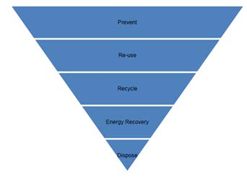
              - The Waste Hierarchy

Waste Management
A specific Active Waste Management Plan (AWMP) (D3 Consulting, 2018) has been developed for the Rough 47/8A decommissioning project in order to address project specific waste management issues. It is designed to ensure that all waste generated during the Rough 47/8A offshore activities are managed according to the decommissioning operator’s Health, Safety, Security and Environment (HSSE) policy and relevant legislation.
It is recognised that, in line with the waste hierarchy, the reuse of an installation or its components is first in the order of preferred decommissioning options. However, as the Rough 47/8A infrastructure is obsolete and/ or in a degraded condition, its components are not considered suitable for safe re-use. The majority of materials removed to shore will be recycled.
Non-hazardous materials, such as scrap metal and plastics not contaminated with hazardous waste, will be removed and, where possible, reused or recycled. Other non-hazardous waste which cannot be reused or recycled will be disposed of to a landfill site. Steel represents the largest weight from the Rough 47/8A facilities.
Where necessary, hazardous waste resulting from the dismantling of the Rough 47/8A facilities will be pre-treated to reduce hazardous properties or, in some cases, rendered non-hazardous prior to recycling or landfilling. Under the Landfill Directive, pre-treatment will be necessary for most hazardous wastes which are destined to be disposed of to landfill site.
Table 12.2 and Figure 12.2 outline the fate of all decommissioned materials from the Rough 47/8A facilities. Only a small amount of materials (approximately 774 tonnes), is expected to be sent to landfill. Opportunities where recovered materials destined for landfill can be reduced, or otherwise recycled or reused, will be actively sought.
            - Proposed fate of Rough 47/8A infrastructure materials
Infrastructure | Recommended decommissioning option | Destination
Rough AP Topside | Full removal  (removal method to be determined) | Reuse*  Recycling  Landfill  Incineration
Rough AD Topside | Full removal  (removal method to be determined) | Reuse*  Recycling  Landfill  Incineration
Jackets (AD and AP) | Full removal (single lift) | Recycling  Landfill
AD-AP Bridge Link | Full removal (single lift) | Recycling  Landfill
*The amount of material suitable for reuse is currently unknown and has therefore not been included. Some material sent to landfill or recycling may be suitable for reuse.

Note: The amount of material suitable for reuse is currently unknown and is therefore not included in the figure. Some of the
material sent to landfill or recycling may be suitable for reuse.
              - Estimated tonnage and predicted disposal routes of decommissioned material

Contractor Management
Waste management activities include: the handling, storage and treatment of waste offshore; the transfer of waste to a waste treatment or dismantling yard for further storage; handling and treatment as appropriate; then further transfer to the final disposal or treatment point. CESL is managing the decommissioning of Rough 47/8A, and these activities will be conducted by contractors and sub-contractors on behalf of CESL according to the waste management system developed for Rough 47/8A decommissioning (D3 Consulting, 2018). These contractors and sub-contractors will prepare all necessary documentation required for the identification, quantification and tracking of wastes generated per asset in order to provide a transparent audit trail from the offshore location through to the final disposal point. Although CESL will not be undertaking the actual physical work, the legal liability i.e., the Duty of Care, for all waste generated from decommissioning remains with CESL for the duration of the programme.
The selection and management of contractors by CESL is managed through existing contractor control processes and procedures. Specific targets to maximise re-use and recycling, and minimise waste to landfill, will be agreed during the contractor selection process, and included in relevant contracts. Specific actions to support the management and minimisation of waste generated by contractors during decommissioning will include:
- Ensuring that waste management issues are clearly addressed within the contractor interface documents;
- Identifying specific roles and responsibilities within CESL and its contractors within the Rough 47/8A AWMP;
- Engaging with contractors to identify effective technical solutions that support waste minimisation and the reuse and recycling of waste, where possible; and
- Establishing specific audit and monitoring schedules within relevant contracts.

Measuring and Monitoring Performance
Specific areas of focus related to waste management during the decommissioning of the Rough 47/8A infrastructure, will be:
- Monitoring legislative compliance; and
- Measuring performance against stated targets.
A range of methods will be used to ensure effective monitoring of waste management activities including regular waste statistic tracking and auditing of contractor and disposal sites.

Environmental Management System

This section describes the arrangements that will be put into place to ensure that the mitigation and other measures of control, including the reduction or elimination of potential impacts are implemented and conducted effectively. This section also serves to outline the key elements of relevant corporate policies and the means by which the environmental aspects of the Rough 47/8A facilities decommissioning operations will be managed.
The Rough 47/8A assets are managed under CESL policies and management system.

Introduction
CESL operate under an Environmental Management System (EMS) which provides the means to minimise the impact from operational activities on the environment, including land, sea and air. As a responsible operator, CESL is committed to understanding, managing and reducing the environmental impact of their activities. All onshore and offshore assets place a high priority on limiting all forms of emissions and controlling waste.
Activities undertaken in relation to the Rough 47/8A assets adhere to the following standards and certifications:
- Environmental Management: OMS Standard. CSL-OMS-00034;
- Process and General Health and Safety: OMS Standard. CSL-OMS-00035;
- Environmental Management System Standard ISO 14001:2015 (Recertified March 2025);
- Management System Standard ISO 9001:2015 (Certified October 2016 – October 2019); and
- Management System Standard OHSAS 18001:2007 (Certified May 2017 – May 2020).

Scope of the EMS
The Environmental Management Standard (Environmental Management: OMS Standard. CSL-OMS-00034) provides the following expectations for ensuring operations meet environmental legislation and good practice:
- Compliance with relevant environmental legislation;
- Clear assignment of responsibilities;
- Training and competence;
- Monitoring of equipment and processes;
- Reporting procedure;
- Minimisation of waste and use of the waste hierarchy;
- Sound risk management and decision making;
- Efficient and cost-effective planning and operations; and
- Continual performance assessment and improvement.

Principles of the Asset Integrity Management Strategy
The CESL Asset Integrity Management Strategy (AIMS) was developed in 2022. The strategy complies with the Asset Integrity Management Policy (DOC-POL-CSL-INT-002) and describes how integrity is managed for the full life-cycle of assets. This strategy is based on the results of previous integrity management audits, a gap analysis against current industry best practice, and feedback from the HSE.
The AIMS comprise the following elements:
- Integrity Management Systems (IMSs) Implementation;
- Leadership, Ownership and Resource;
- Communication;
- IMS Documentation and Information;
- Managing Risk;
- Performance Assessment & Improvement;
- Auditing;
- Management Reviews;
- People, Competence and Behaviours;
- Management of Change.

Asset Integrity Management Policy
CESL recognises that the operation of Major Hazard Installations requires effective management of Asset Integrity (DOC-POL-CSL-INT-002).
This will be based on:
- Implementing and maintaining an Asset Integrity Management System (AIMS) over the total life of the assets. This shall recognise the effects of ageing assets and address any integrity concerns.
- Providing leadership and resource to support this policy, including the appointment of competent individuals with clearly specified roles and responsibilities.
- Complying with all relevant onshore and offshore legal, regulatory, statutory and CESL standards and procedures. Embodied in this is an aspiration to achieve industry best practice.
- Understanding and managing risks using an integrated team approach. This includes having an effective Management of Change process.
- Continual improvement in asset management and asset performance driven by auditing and key performance indicators.
- Communicating this policy to relevant personnel - managers, employees, contractors, and other stakeholders.
- Reviewing this policy on a regular basis to ensure continuous improvement in light of developments in technology, operations and asset care techniques.

Summary of Environmental Commitments
A number of commitments have been made within this EA in order to reduce the potential environmental and socio‐economic impacts from the Rough 47/8A Decommissioning, as far as practicable. These commitments, along with the appropriate section in this EA (where applicable), are summarised in Table 13.1.
            - Summary of environmental commitments
Issue | Commitment | EA Section
Atmospheric emissions | - Vessels will be audited as part of selection and pre-mobilisation.  - All generators and engines will be maintained and operated to the manufacturers’ standards to ensure maximum efficiency.  - Vessels will use ultra-low sulphur fuel in line with MARPOL requirements.  - Work programmes will be planned to optimise vessel time in the field.  - Fuel consumption will be minimised by operational practices and power management systems for engines, generators and other combustion plant and maintenance systems. | Section 8
Underwater noise | - Machinery and equipment will be in good working order and well-maintained.  - Helicopter maintenance will be undertaken by contractors in line with manufacturer and regulatory requirements.  - To minimise potential impacts to marine mammals from decommissioning operations, JNCC protocols will be used for minimising risk to marine mammals from underwater noise throughout operations.  - Vessel maintenance will be undertaken by contractors in line with manufacturers and regulatory requirements.  - The number of vessels utilising dynamic positioning would be minimised where possible | Section 9
Seabed impact | - Optimisaton of anchoring requirement  - Minimise cutting duration  - Optimise cutting location(s) and methods (i.e. preference for internal cutting) | Section 5
Onshore impact | - Licensed contractors and permitted sites will be used for waste disposal. | Section 7
Shipping | - A site-specific shipping assessment has been carried out  - Prior to commencement of operations, the appropriate notifications will be made, and maritime notices will be posted.  - All vessel activities will be in accordance with national and international regulations.  - Appropriate navigation aids will be used in accordance with the consent to locate conditions to ensure other users of the sea are made aware of the presence of vessels.  - The number of vessels travelling to or standing by at Rough 47/8A will be kept to a minimum.  - A mandatory 500-m safety zone will remain around the Rough 47/8A platforms during the decommissioning activities.  - Use of designated transit routes for all decommissioning vessels.  - Continual use of AIS vessel identification.  - 24-hour manned bridge policy. | Section 7
Fisheries | - On-going consultation with fisheries representatives.  - Over-trawlability assessment during decommissioning and periodically thereafter.  - On-going post decommissioning monitoring of the infrastructure decommissioned in situ, the frequency and nature of which will be agreed with DESNZ.  - Materials left in situ will be mapped and the UK Hydrographical Office (UKHO) and Kingfisher informed. | Section 7
Discharges to sea | - Chemical and hydrocarbon inventories will be removed from topsides prior to removal.  - All vessels will be required to demonstrate that non-hazardous drains discharge to the sea only non-hazardous rainwater.  - Access points for non-hazardous deck drains are controlled, so any spillages on deck will not enter the closed drainage system.  - Compliance with the International Convention for the Prevention of Pollution from Ships (MARPOL).  - UK or International Pollution Prevention Certificate for vessel drainage systems.  - Vessel audits to ensure compliance.  - Adhere to the International Convention for the Control and Management of Ships’ Ballast Water and Sediments, adopted in 2004.  - Adherence to recent ballast water guidance.  - Sewage will be treated prior to disposal at sea or contained and shipped to shore.  - Vessels will be audited to ensure compliance.  - Food waste will be macerated as required by MARPOL and The Merchant Shipping (Prevention of Pollution by Sewage and Garbage from Ships) Regulations 2008.  - Following decommissioning, environmental monitoring surveys will be undertaken under an agreed schedule as per DESNZ guidelines. | Section 6
Physical Presence | - 500 m safety zone around platform location  - Vessels will operate under SOPEP and CIP  - Wildlife License Application submitted if nesting birds identified prior to platform removal  - Navigational Risk Assessment and EERV dedicated to operations  - Notification to mariners  - Control centre with OSV | Section 10
Accidental spills and dropped objects | - The OPEP has been produced in accordance with the Merchant Shipping (Oil Pollution Preparedness, Response & Co-operation Convention) Regulations 1998 and the Offshore Installations (Emergency Pollution Control) Regulations 2002.  - Specialist oil spill response services will be provided by Oil Spill Response Limited (OSRL) and are members of the Oil Pollution Operator’s Liability Fund (OPOL).  - Local shipping traffic will be informed of proposed decommissioning activities, and a standby/ support vessel will monitor shipping traffic at all times.  - In the event of an accidental spill to sea, vessels will implement their Shipboard Oil Pollution Emergency Plan (SOPEP).  - Operations will be executed in a controlled manner with trained personnel using suitable equipment.  - All vessels will have suitable skill kits, and an efficient spill response process is in place.  - Routine replacement of perishable equipment such as hoses, and a management program is implemented in order to ensure their integrity.  - Prior to transfer, visual checks are undertaken by trained personnel in communication with the standby vessel.  - Observed leaks are reported and dealt with immediately by competent personnel and reported to the appropriate authorities.  - Items will be secured to prevent loss wherever practicable.  - Post-decommissioning surveys will be undertaken to assess the presence and potential recoverability of any lost objects. | Section 11
Waste | - A waste management plan will be developed and put into place before the decommissioning activities commence. This plan will ensure that staff will undergo appropriate training and will be notified of disposal requirements for each waste type.  - Opportunities where recovered materials destined for landfill can be reduced, or otherwise recycled or reused, will be actively sought out. | Section 12
Environmental responsibilities | - Key environmental responsibilities, duties, communication, reporting and interface management arrangements of CESL and any main contractors involved in the decommissioning activities will be agreed, documented and communicated at the appropriate stages of the project. | Section 13
Delivery of commitments | - The commitments made within this EA will be incorporated into operational work programmes, plans and procedures.  - Programmes will be tracked to ensure that commitments and mitigation measures are implemented throughout the project. | Section 13

Conclusions

The Decommissioning Programmes EA forms an integral part of the operator’s Environmental Management process, ensuring that adequate environmental considerations are incorporated into the decommissioning process. This EA report presents the findings for the selected option for the decommissioning of the Rough 47/8A infrastructure, providing sufficient information to enable a robust evaluation of the potential environmental consequences of the proposed decommissioning activities. It has considered that there are potentially certain times of the year when populations of seabirds, life stages of fish, marine mammal presence and commercial fishing interests may be more susceptible to potential impact. However, the area is not considered particularly sensitive to the proposed decommissioning activities (Section 3).
The Rough 47/8A infrastructure is located in a marine environment that is typical of this part of the SNS. Infrastructure included in the Rough 47/8A DPs is located within two major conservation sites:
- Southern North Sea SAC; and
- Holderness Offshore MCZ.
The Southern North Sea SAC is designated for the conservation of populations of the harbour porpoise, an Annex II species associated with the area. While the Holderness Offshore MCZ is recommended for protection of subtidal coarse sediment, subtidal mixed sediment and the bivalve A. islandica.
The Annex II species recorded within and around the Rough 47/8A infrastructure include harbour porpoise, bottlenose dolphin, harbour seal and grey seal. Harbour porpoises have been sighted in Quadrant 47 and in surrounding quadrants and are present in the area throughout the year, while numbers of bottlenose dolphins are present in summer months (Reid et al., 2003; UKDMAP, 1998). Harbour seals have observed in low densities and grey seals in moderate (offshore) to very high densities (close to shore) throughout the Rough 47/8A decommissioning area (NMPI, 2018).
Following the identification of the interactions between the proposed decommissioning activities and the local environment, the assessment of potentially significant environmental impacts, proposed control and mitigation measures and stakeholder consideration, the key environmental concerns identified for further impact assessment were:
- Effects of seabed disturbance during decommissioning activities – locating of vessels, pipeline cutting, ROV dredging of piles, structure removal and seabed clearance (Section 5).
- Potential release of residual contaminants during routine decommissioning activities (Section 6).
- Physical presence of vessels causing interference/ displacement of other users of the sea (Sections 7 and 10).
- Impacts to fisheries from snagging risk (Section 7).
- Effects of energy use and atmospheric emissions (Section 8).
- Effects of underwater noise generated during the decommissioning activities (Section 9).
- Non-routine events, such as the spillage of hydrocarbons or other fluids during the decommissioning activities or through accidental events such as vessel collisions (Section 11).
Mitigation to avoid and/ or reduce the environmental concerns highlighted above is in line with industry best practice. The Operator has an established EMS process, which will ensure that proposed mitigation measures are implemented and monitored to achieve the outcome presented in this EA report.
A number of oil and gas fields/ installations in the SNS are currently being decommissioned or are reaching the end of their operational life. As a consequence, the potential for additive or cumulative impacts within the SNS will be increased in the short-term. Decommissioning activities may contribute to overall gaseous emissions in the SNS but the impact of this is estimated to be minor in context with total UKCS emissions associated with the oil and gas industry (Section 8). The decommissioning activities at Rough A are predicted to require a maximum total energy use of 211,371 GJ and will result in 17,188 tonnes CO₂e emissions, approximately 0.13% of the of the total annual CO₂ offshore emissions from the UKCS in 2018.
Underwater noise will also be increased during decommissioning mainly due to the presence of vessels but will be transient and is not expected to have a cumulative impact (Section 9). The proposed decommissioning activities will not result in significant noise disturbance within the SAC to exclude harbour porpoise from more than 20% of the relevant area of the site in any given day or an average of 10% of the relevant area of the site over a season.
Activities resulting from the decommissioning of the Rough 47/8A jacket and platform are expected to create a seabed impact of 0.081614 km², representing <0.01% of the total area for any of the overlapping conservation sites (Section 5).
Pipelines have been flushed and cleaned prior to decommissioning activities. However, there is the possibility that minor releases of materials may occur during cutting of pipelines. It is expected that these discharges or releases will result in negligible localised effects and are not anticipated to have any discernible impact on the wider marine environment cumulatively or in combination with other activities.
Decommissioning activities are likely to result in a minor, short-term impact on the conservation sites, and it is not expected that the activity will impede Conservation Objectives. However, part of the aim of the decommissioning work is to return the seabed to its original state as far as possible. Except for the platform piles, which will be cut at three metres below the seabed, the platforms will be removed for onshore dismantling and recycling. Due to distance to the nearest median line (160 km) decommissioning activities are not anticipated to cause any transboundary impacts.
The temporary loss of access for vessels during the decommissioning operations is unlikely to have a significant impact on other sea users (i.e. commercial shipping and fishing). In addition, the EA has highlighted the positive impact that the decommissioning of the Rough 47/8A infrastructure will have on commercial fisheries with the opening of areas of the sea which have previously been excluded for safety reasons.
Overall, the EA has evaluated the environmental risk reduction measures and concludes that CESL has, or intends to, put in place sufficient safeguards to mitigate the potential environmental and societal risk and to monitor the implementation of these measures.
Therefore, it is the conclusion of this EA that the recommended options presented for the decommissioning of the Rough 47/8A infrastructure can be completed without causing significant adverse impact to the environment.

References

APBmer, 2016. ABP Marine Environmental Research Ltd 2014 V1.0 .
Aires, C., González-Irusta, J.M., Watret, R., 2014. Scottish Marine and Freshwater Science Report. Volume 5. Number 10. Updating Fisheries Sensitivity Maps in British Waters.
Berrow, S., Whooley, P., and Ferriss, S., 2002. Irish Whale and Dolphin Group Cetacean Sighting Review (1991-2001): Irish Whale and Dolphin Group.
BMT Cordah, 1998. Review of drill cuttings piles in the North Sea Report for the Offshore Decommissioning
Botté, A., Seguin, C., Nahrgang, J., Zaidi, M., Guery, J., and Leignel, V. 2022. Lead in the marine environment: concentrations and effects on invertebrates. Ecotoxicology, 1-14.
Burt, M.L., Mackenzie, M.L., Bradbury, G. & Darke, J. (2022). Investigating effects of shipping on common scoter and red-throated diver distributions in Liverpool Bay SPA. Natural England Commissioned Report NECR425. Natural England. Available at: https://publications.naturalengland.org.uk/publication/6581005841596416
Communications Project. Report No. Cordah/ODCP.004/1998.BMT, 2022. Energy and Emissions Technical Note for Decommissioning of Rough A Platforms.
Camphuysen, K. 2004. The return of the harbour porpoise (Phocoena phocoena) in Dutch coastal waters. Lutra 47(1): 135-144.
CEFAS (Centre for Environment, Fisheries and Aquaculture Science), 2001. North Sea Fish and Fisheries. Technical report TR_003 produced for Strategic Environmental Assessment – SEA 2.
Clark, R. B., 1997. Marine Pollution. Oxford: Clarendon Press.
Coull, K.A., Johnstone, R., and Rogers, S.I., 1998. Fisheries Sensitivity Maps in British Waters. Published and distributed by UKOOA Ltd.
CSL (Centrica Storage Limited), 2022. Rough Field Oil Pollution Emergency Plan. DOC-CSL-HSE-ER-005. 26/06/2022.
CSL, 2018. CSL Plant and Equipment Decommissioning Guidelines DOC-CSL-ENG-EES-008.
D3 Consulting, 2018a. Active Waste management Plan for Rough 47/8A. Ref: DDD-22922-ENG-INV-RPT-0004. 15th June 2018. Version: 16.164.502 ver A.0.
Davies JM, Hay SJ, Gamble JC and Dow K, 1987. The ecological effects of produced water discharges from offshore oil platforms in the northern North Sea.
De Robertis, A. and Handegard, N. O., 2013. Fish avoidance of research vessels and the efficacy of noise-reduced vessels: a review. ICES Journal of Marine Science 70(1):34-45.
DECC (Department of Energy & Climate Change), 2001. Strategic Environmental Assessment 2 (SEA 2). Available at: https://www.gov.uk/government/consultations/strategic-environmental-assessment-2-sea-2.
DECC, 2002. Strategic Environmental Assessment of parts of the central and southern North Sea. SEA 3 Consultation Document. August 2002.
Department of Energy and Climate Change (DECC), 2009. UKCS Offshore Oil and Gas and Wind Energy Strategic Environmental Assessment – Archaeological Baseline. Available at: https://www.gov.uk/government/uploads/system/uploads/attachment_data/file/196491/OES_Archaeology.pdf
DECC, 2011. UK Offshore Energy Strategic Environmental Assessment 2: Environmental Report - part 2.
DECC, 2014. Department of Energy and Climate Change, OPPC Regulations 2011 Guidance. Available at: https://www.gov.uk/guidance/oil-and-gas-offshore-environmental-legislation. Accessed May 2025.
Defra (Department for Environment, Food & Rural Affairs), 2014. East Inshore and East Offshore Marine Plans. April 2024. Available at: https://assets.publishing.service.gov.uk/media/5a7ec0eced915d74e33f2342/east-plan.pdf. Accessed May 2025.
Defra & DECC, 2011. Guidelines to DEFRA/DECC'S ghg conversion factors for company reporting. Produced by area for the Department for Energy and Climate Change (DECC) and the Department for Environment, Food and Rural Affairs (DERFA). Version 1.2.Defra, (2019. Holderness Inshore MCZ. Available at: https://assets.publishing.service.gov.uk/government/uploads/system/uploads/attachment_data/file/492320/mcz-holderness-factsheet.pdf.
Dernie, K.M., Kaiser, M.J., & Warwick, R.M., 2003. Recovery rates of benthic communities following physical disturbance. Journal of Animal Ecology, 72(6), 1043–1056. https://doi.org/10.1046/j.1365-2656.2003.00775.x
DTI (Department of Trade and Industry), 2001. Strategic Environmental Assessment of the Mature Areas of the Offshore North Sea – SEA 2. Consultation document. DTI, London.
DTI, 2004. Strategic Environmental Assessment of parts of the Northern and Central North Sea to the east of the Scottish mainland, Orkney and Shetland. SEA 5.
Environmental and Emissions Monitoring System (EEMS) (2008). EEMS Data Requirements.
Ellis, J.R., Milligan, S.P., Readdy, L., Taylor, N., and Brown, M.J., 2010. Spawning and nursery grounds of selected fish species in UK waters. Sci. Ser. Tech. Rep. CEFAS Lowestoft, 147: 56 pp.
Espoo, 1991 Convention on Environmental Impact Assessment in a Transboundary Context. United Nations, 1991. Internet: https://www.unece.org/fileadmin/DAM/env/eia/documents/legaltexts/Espoo_Convention_authentic_ENG.pdf.Accessed October 2018.
EMODnet, 2024. European Marine Observation and Data Network (EMODnet) Map Viewer: Human Activities. Available online at: https://emodnet.ec.europa.eu/en/human-activities. Accessed May 2025.
EUNIS, 2018. Habitat Types. European Nature Information System https://eunis.eea.europa.eu/index.jsp Accessed October 2018.
EUSeaMap, 2021. EMODnet Thematic Lot n° 2 – Seabed Habitats EUSeaMap 2021 - Technical Report. Available at https://emodnet.ec.europa.eu/en/euseamap-2021-emodnet-broad-scale-seabed-habitat-map-europe
Fliessbach, K.L., Borkenhagen, K., Guse, N., Markones, N., Schwemmer, P. & Garthe, S. (2019). A Ship Traffic Disturbance Vulnerability Index for Northwest European Seabirds as a Tool for Marine Spatial Planning. Frontiers in Marine Science, 6:192. doi: 10.3389/fmars.2019.00192. Available at: https://www.frontiersin.org/articles/10.3389/fmars.2019.00192/full
Fugro, 2022a. Centrica Rough Gas Field Storage Pre-decommissioning Environmental Survey. Environmental Sampling, 210641-EDS-015 02 | 27 October 2022.
Fugro, 2022b. Centrica Rough Gas Field Storage Pre-decommissioning Environmental Survey. Habitat Assessment, 210641-EDS-013 02 | 28 October 2022
Foden, J., Rogers, S., & Jones, A., 2009. Recovery rates of UK seabed habitats after cessation of aggregate extraction. Marine Ecology Progress Series, 390, 15–26. https://doi.org/10.3354/meps08169
Gamble, J.C., Davies, J.M., Hay, S.J. and Dow, F.K., 1987. Mesocosm experiments on the effects of produced water discharges from offshore oil platforms in the northern North Sea. Sarsia, 72(3-4): 383-386.Bakke, T., Klungsøyr, J. and Steinar, S., 2013. Environmental impacts of produced water and drilling waste discharges from the Norwegian offshore petroleum industry. Marine Environmental Research 92, p. 154-169.
Genesis, 2011. Review and Assessment of Underwater Sound Produced from Oil and Gas Sound Activities and Potential Reporting Requirements under the Marine Strategy Framework Directive. Genesis Oil and Gas Consultants Report for DECC, J71656.
Hallett, M. A., 2004. Characteristics of Merchant Ship Acoustic Signatures During Port Entry/ Exit. Paper presented at the ACOUSTICS 2004, Gold Coast, Australia. 3-5 November 2004.
Hammond, P.S., Lacey, C., Gilles, A., Viquerat, S., Börjesson, P., Herr, H., Macleod, K., Ridoux, V., Santos, M.B., Scheidat, M., Teilmann, J., Vingada, J. and Ǿien, N. SCANS III: Estimates of cetacean abundance in European Atlantic waters in summer 2016 from the SCANS-III aerial and shipboard surveys (Revised 2021). https://scans3.wp.st-andrews.ac.uk/files/2021/06/SCANS-III_design-based_estimates_final_report_revised_June_2021.pdf [Accessed December 2022].
Hannay, D.E. and MacGillivray, A., 2005. Comparative Environmental Analysis of the Piltun-Astokh Field Pipeline Route Options: Sakhalin Energy Investment Company Ltd.
Hill, J.M., Marzialetti, S. and Pearce, B., 2011. Recovery of Seabed Resources Following Marine Aggregate Extraction. Marine Aggregate Levy Sustainability Fund (MALSF) Science Monograph Series: No. 2
HSE (Health and Safety Executive), 1997. The abandonment of offshore pipelines: Methods and procedures for abandonment. Offshore technology report. HSE Books, Norwich. ISBN -7176-1421-2.
IPCC (Intergovernmental Panel on Climate Change), 2021: Climate Change 2021: The Physical Science Basis. Contribution of Working Group I to the Sixth Assessment Report of the Intergovernmental Panel on Climate Change [Masson-Delmotte, V., P. Zhai, A. Pirani, S.L. Connors, C. Péan, S. Berger, N. Caud, Y. Chen, L. Goldfarb, M.I. Gomis, M. Huang, K. Leitzell, E. Lonnoy, J.B.R. Matthews, T.K. Maycock, T. Waterfield, O. Yelekçi, R. Yu, and B. Zhou (eds.)]. Cambridge University Press, Cambridge, United Kingdom and New York, NY, USA, In press, doi:10.1017/9781009157896.
IoP (Institute of Petroleum), 2000. Guidelines for the calculation of estimates of energy use and emissions in the decommissioning of offshore structures.
JNCC (2016). An assessment of the numbers and distributions of wintering red-throated diver, little gull and common scoter in the Greater Wash. JNCC Report No. 574. Peterborough: Joint Nature Conservation Committee. Available at: https://data.jncc.gov.uk/data/c35b649e-f3bd-42d0-b6c4-96ed66cc2fc2/JNCC-Report-574-FINAL-WEB.pdf
JNCC, 2017. JNCC guideline for minimising the risk of injury to marine mammals from geophysical surveys. August 2017. Internet: http://jncc.defra.gov.uk/pdf/jncc_guidelines_seismicsurvey_aug2017.pdf. [Accessed December 2022].
JNCC, 2018a. Southern North Sea MPA. Available at: http://jncc.defra.gov.uk/page-7243. Accessed December 2022.
JNCC, 2018b. Greater Wash SPA. Available at: https://jncc.gov.uk/our-work/greater-wash-spa/.
JNCC, 2019a. Marine Conservation Zones. Available at https://jncc.gov.uk/our-work/marine-conservation-zones/. Accessed December 2022.
JNCC, 2019b. Offshore Marine Protected Areas. Available at: http://jncc.defra.gov.uk/default.aspx?page=6895.
JNCC, 2020. Guidance for assessing the significance of noise disturbance against Conservation Objectives of harbour porpoise SACs (England, Wales and Northern Ireland), 14pp.
JNCC, 2022. Holderness Offshore MPA. Available at: https://jncc.gov.uk/our-work/holderness-offshore-mpa/. Accessed December 2022.
JNCC (2025). Distributions of wintering red-throated diver, little gull, and common scoter in the Greater Wash. JNCC Resource Hub. Available at: https://hub.jncc.gov.uk/assets/9f1f8fb8-de83-444f-b643-9946b019c622
Johns, D. G. and Reid P. C., 2001. An Overview of Plankton Ecology in the North Sea. Technical report produced for Strategic Environmental Assessment – SEA 2. Produced by SAHFOS, August 2001. Technical Report TR_005.
Johnston CM, Turnbull CG & Tasker ML, 2002. Natura 2000 in UK Offshore Waters. JNCC Report 325 http://jncc.defra.gov.uk/PDF/JNCC325-full.pdf.
Jones, E., McConnell, B., Sparling, C. & Matthiopoulos, J., 2013. Grey and Harbour Seal Density Maps. Sea Mammal Research Unit Report to Scottish Government. Marine Mammal Scientific Support Research Programme MMSS.001/11.
Kafas, A., Jones, G., Watret, R., Davies, I. and Scott, B., 2013. 2009 - 2013 Amalgamated VMS Intensity Layers, GIS Data. Marine Scotland, Scottish Government. DOI: 10.7489/1706-1
Kober, K., Webb, A., Win, I., Lewis, M., O’Brien, S., Wilson, J. L., Ried, B. J., 2010. An analysis of the numbers and distribution of seabirds within the British Fishery Limit aimed at identifying areas that qualify as possible marine SPAs. ISSN; 0963-8091. JNCC report No.431.
Lee, K., and Neff, J., 2011. Produced Water: Environmental Risks and Advances in Mitigation Technologies Springer.
Loe, S.A., 2010. Using natural sedimentation to backfill a dredged pipeline trench. Journal of Marine Engineering and Technology, No. A18, 2010.
McLeod, CR, Yeo, M, Brown, AE, Burn, AJ, Hopkins, JJ, & Way, SF (eds.) (2005, updated 2009) The Habitats Directive: selection of Special Areas of Conservation in the UK, 2nd edition (Version 4). Joint Nature Conservation Committee, Peterborough03.McBreen et al., 2011.
Mitson, R.B. and Knudsen, H.P., 2003. Causes and effects of underwater noise on fish abundance estimation. Aquatic Living Resources 16:255-263.
MMO (Marine Management Organisation), 2014. Mapping UK Shipping Density and Routes Technical Annex. A report produced for the Marine Management Organisation, pp 52. MMO Project No: 1066. ISBN: 978-1-909452-26-8.
MMO, 2025. UK sea fisheries annual statistics. Available at https://www.gov.uk/government/collections/uk-sea-fisheries-annual-statistics. Accessed February 2026
Morris, P. and Therivel, R., 2009. Methods of environmental impact assessment: 3rd edition. ABINGDON: ROUTLEDGE.
National Marine Fisheries Service (NMFS), 2024. Update to: Technical Guidance for Assessing the Effects of Anthropogenic Sound on Marine Mammal Hearing (Version 3.0): Underwater and In‑Air Criteria for Onset of Auditory Injury and Temporary Threshold Shifts. NOAA Technical Memorandum NMFS‑OPR‑71, 182 pp.
Nedwell, J.R. and Edwards, B., 2004. A Review of Measurements of Underwater Man-Made Noise Carried out by Subacoustech Ltd , 1993 – 2003. Subacoustech Ltd Report Ref 534r0109.ploration UK PLC, DSTL, DTI, Shell UK Ltd
Nedwell, J.R., Turnpenny, A. W.H., Lovell, J., Parvin, S.J., Workman, R., Spinks, J.A.L., and Howell, D., 2007. A Validation of the Dbht as a Measure of the Behavioural and Auditory Effects of Underwater Noise Subacoustech Report No. 534R1231 To: ChevronTexaco Ltd, TotalFinaElf Ex
Neff, J. M., 1987. Biological effects of drilling fluids, drill cuttings, and produced waters. In: “Long-Term Environmental Effects of Offshore Oil and Gas Development. Elsevier Applied Science Publishers. London, 1987, pages 469-538.
Neff, J. M., 2002. Chapter 11 - Radium Isotopes in the Ocean. In Bioaccumulation in Marine Organisms (pp. 191-201). Oxford: Elsevier.
NMPI (National Marine Interactive Planning Tool), 2022. http://marinescotland.atkinsgeospatial.com/nmpi/. Accessed December 2018
Northridge SP, Tasker ML, Webb A & Williams JM (1995). Distribution and relative abundance of harbour porpoises (Phocoena phocoena L.), white-beaked dolphins (Lagenorhynchus albirostris Gray), and minke whales (Balaenoptera acutorostrata Lacèpede) around the British Isles. ICES Journal of Marine Science 52: 55-66.
NRC (National Research Council), 2003. Ocean Noise and Marine Mammals. (No. National Research Council of the National Academies, Washington DC).
NSTA (North Sea Transition Authority), 2021. Stewardship Expectation 11 – Net Zero Available at: https://www.nstauthority.co.uk/media/7184/se11_net-zero.pdf
NSTA, 2023. Emissions Monitoring Dashboard https://app.powerbi.com/view?r=eyJrIjoiYzJiNjQ2NzktYjIzNS00NTQzLWJkMDUtYThmMmFlNjJmNjQ2IiwidCI6ImU2ODFjNTlkLTg2OGUtNDg4Ny04MGZhLWNlMzZmMWYyMWIwZiJ9
OESEA3 (Offshore Energy Strategic Environmental Assessment), 2016. UK Offshore Energy Strategic Environmental Assessment. OESEA3 Environmental Report. March 2016.
OESEA4 (Offshore Energy Strategic Environmental Assessment), 2022. UK Offshore Energy Strategic Environmental Assessment, OESEA4 Environmental Report. March 2022. Published by the Department for Business, Energy & Industrial Strategy. OGA (Oil and Gas Authority), 2018. UK Offshore oil and gas infrastructure. Available at https://www.gov.uk/oil-and-gas-offshore-maps-and-gis-shapefiles. Accessed December 2022.
OGP (Oil and Gas Producers), 2002. Aromatics in produced water: occurrence, fate and effects, and treatments. Report No. 1.20/324, January 2002. IOGP (International Association of Oil and Gas Producers).
OGP , 2005. Fate and effects of naturally occurring substances in produced water on the marine environment. Report No. 364. February 2005. OGP (International Association of Oil and Gas Producers).
OGUK (Oil and Gas UK), 2013. Long term Degradation of Offshore Structures and Pipelines Decommissioned and left in Situ, Oil and Gas UK. February 2013.
OGUK, 2015. NORM Scale. Internet: http://www.oilandgasuk.co.uk/knowledgecentre/normscale.cfm. Accessed October 2018.
OPRED (Offshore Petroleum Regulator for Environment and Decommissioning), 2018. BEIS Guidance Notes: Decommissioning of Offshore Oil and Gas Installations and Pipelines. May 2018.
OSPAR (Oslo and Paris Convention), 1998. OSPAR (1998). Decision 98/3 on the Disposal of Disused Offshore Installations. Ministerial Meeting of the OSPAR Commission.
OSPAR, 2009. Assessment of impacts of offshore oil and gas activities in the North-East Atlantic. OSPAR Commission. 2009. (Oil and Gas Producers), 2005. Fate and effects of naturally occurring substances in produced water on the marine environment. Report No. 364. February 2005. OGP (International Association of Oil and Gas Producers).
Popper, A.N., and Hastings, M.C., 2009. The Effects of Anthropogenic Sources of Sound on Fishes. Journal of Fish Biology, 75(3), 455-489
Popper, A.N. and Hawkins, A.D., 2019. An overview of fish bioacoustics and the impacts of anthropogenic sounds on fishes. Journal of fish biology, 94(5), pp.692-713.
Reid, J.B., Evans, P.G.H. and Northridge, S.P., 2003. Atlas of cetacean distribution in north-west European waters. JNCC, Peterborough.
Richardson, W.J., Greene Jr., C.R., Malme, C.I., and Thomson, D.H., 1995. Marine Mammals and Noise. Academic Press, San Diego.
Rogan, E. and Berrow, S.D., 1996. A Review of Harbour Porpoises, Phocoena phocoena, in Irish Waters. Report of the International Whaling Commission 46:595-605.
Schulkin, M. and Mercer, J. A., 1985. Colossus Revisited: A Review and Extension of the Marsh-Schulkin Shallow Water Transmission Loss Model (1962). (No. APL-UW 8508).
SCOS (Special Committee on Seals), 2017. Scientific Advice on Matters Related to Management of Seal Populations: 2017. Available at http://www.smru.st-andrews.ac.uk/files/2018/01/SCOS-2017.pdf. Accessed November 2022.
Scottish Government, 2015. Scottish’s National Marine Plan. A single Framework for Managing Our Sea. ISBN: 978-1-78544-214-8
Scottish Government, 2025. 2024 Scottish Sea Fisheries Statistics - Fishing Effort and Quantity and Value of Landings by ICES Rectangles. doi: 10.7489/12559-1
SMRU (Sea Mammal Research Unit), 2001. Background Information on Marine Mammals Relevant to SEA 2. Technical Report produced for Strategic Environmental Assessment – SEA 2. Technical Report TR_006.
Southall, B. L., Bowles, A.E., Ellison, W.T., Finneran, J.J., Gentry, R.L., Greene, C.R., et al., 2007. Marine Mammal Noise Special Issue: Exposure Criteria: Initial Scientific Recommendations Aquatic Mammals.
Stone, C.J., 1997. Cetacean Observations during Seismic Surveys in 1996. JNCC Report No. 228.
Thompson, C. E. L., Couceiro, F., Fones, G. R., Helsby, R., Amos, C. L., Black, K., Parker, E. R., Greenwood, N., Statham, P. J. and Kelly-Gerreyn, B. R., 2011. In situ flume measurements of resuspension in the North Sea. Coastal and Estuarine Shelf Science 94; 77-88.
Tyler-Walters, H., James, B., Carruthers, M. (eds.), Wilding, C., Durkin, O., Lacey, C., Philpott, E., Adams, L., Chaniotis, P.D., Wilkes, P.T.V., Seeley, R., Neilly, M., Dargie, J. & Crawford-Avis, O.T., 2016. Descriptions of Scottish Priority Marine Features (PMFs). Scottish Natural Heritage Commissioned Report No. 406. Internet: https://www.nature.scot/professional-advice/safeguarding-protected-areas-and-species/priority-marine-features-scotlands-seas. Accessed December 2022.
UKDMAP (United Kingdom Digital Marine Atlas), 1998. United Kingdom Digital Marine Atlas – An atlas of the seas around the British Isles. Software third edition compiled by British Oceanographic Data Centre, Birkenhead.
UKHO (UK Hydrological Office), 2013. North Sea (West) Pilot: East coasts of Scotland and England from Rattray Head to Southwold. 9th edition. The Hydrographer of the Navy, UK, 232pp.
UK Government, 2022. Other Regulatory Issues – Version at September 2022. Available at: https://assets.publishing.service.gov.uk/media/635bb639e90e070bc5669bcb/Other_Regulatory_Issues_-_Sept_2022.pdf. Accessed May 2025.
Waggitt, J., Evan, P., Andrade, J. et al., 2020. Distribution maps of cetacean and seabird populations in the North-East Atlantic. Journal of Applied Ecology, 57: 253-269.
Wakefield, E., Owen, E., Baer, J., Carroll, M., et al. (2017). Breeding density, fine-scale tracking and large-scale modelling reveal the regional distribution of four seabird species. Ecological Applications, 27: 2074-2091.
Webb, A., Elgie, M., Irwin, C., Pollock, C. and Barton, C., 2016. Sensitivity of offshore seabird concentrations to oil pollution around the United Kingdom: Report to Oil & Gas UK. Document No HP00061701.
Wrecksite, 2017. http://www.wrecksite.eu/. Accessed December 2022.
Xodus, 2025. Centrica: Ornithological Support. Rough Bird Survey 2025, Document Number L-303778-500-A-REPT-001.
Yorkshire Marine Nature Partnership, 2025. Available at: https://yorkshiremarinenaturepartnership.org.uk/manage/marine-protected-areas/humber-estuary-spa/. Accessed May 2025.

ENVID Worksheets

E&E Technical Note

Note this table only includes activities that have the potential to coincide with decommissioning works commencing Q2 of 2026.

