

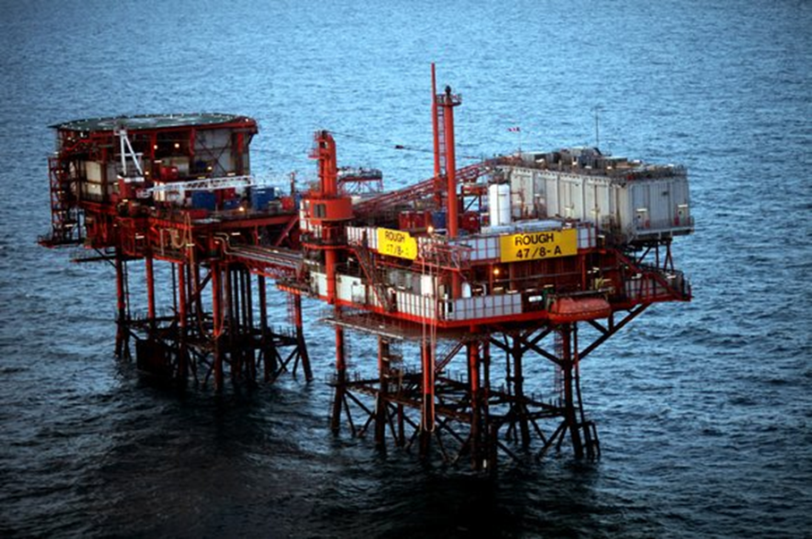

Rough Alpha Installation 47/8A Decomissioning Programmes
AD and AP Installations (including Risers)

20/04/2026

Consultation Version

Document Control

Approvals

 | Name | Signature / Initials | Date
Prepared by | Glenn Wilson  Wells & Decommissioning Manager
Checked by | Scott Wightman  Project(s) Engineer Decommissioning
Reviewed by | Trine Thomsen  Finance Director
Reviewed by | Mark Myles  Senior Asset Manager
Approved by | Martin Scargill  Managing Director

Revision Control

Revision No | Description of Revision | Date
1 | For issue (1st Draft) | March 2023
2 | Company Name update and Platform Topside removal phasing changes | Feb 2024
3 | Incorporation of OPRED Comments | July 2025
4 | Updated project timeline and incorporation of OPRED Comments | December 2025
5 | Incorporation of OPRED Comments | March 2026
6 | Incorporation of OPRED Comments | April 2026

Distribution List

Name / Title | Company | No of Copies
Martin Scargill | Centrica Energy Storage Limited (CESL) | 1 Electronic
Senior Decommissioning Manager | Offshore Petroleum Regulator for Environment & Decommissioning (OPRED) | 1 Electronic
Mark Myles | Centrica Offshore UK Limited (COEUK) | 1 Electronic
Raj Roy | BG International (BG) | 1 Electronic
Mark Myles | GB Gas Holdings Limited | 1 Electronic

Contents

1  1.1  1.2  1.3  1.4  1.5  1.6  1.7  2  2.1  2.2  2.3  2.4  2.5  3  3.1  3.2  3.3  3.4  3.5  4  4.1  4.2  5  6  6.1  6.2  6.3  6.4  6.5  6.6  7  8 | Executive Summary  Decommissioning Programme  Requirement for Decommissioning Programmes  Introduction  Overview of Installations Being Decommissioned  Summary of Proposed Decommissioning Programme  Field Location Including Field Layout and Adjacent Facilities  Industrial Implications  Description of Items to be Decommissioned  Installation: Surface Facilities  Pipelines including stabilisation features  Wells  Drill Cuttings  Inventory Estimates  Removal and Disposal Methods  Topside  Jackets  Pipelines  Wells  Waste Streams  Environmental Appraisal Overview  Environmental Sensitivities (Summary)  Potential Environmental Impacts and their Management  Interested Party Consultations  Programme Management  Project Management and Verification  Post-Decommissioning Debris Clearance and Verification  Schedule  Costs  Close Out  Post-Decommissioning Monitoring and Evaluation  Supporting Documents  Section 29 Notice Holders Letter(s) of Support  Appendix A | 7  7  7  7  8  10  12  15  16  16  17  18  18  18  19  20  23  24  25  25  27  27  31  33  34  34  34  35  35  36  36  37  38  39

Terms and Abbreviations

Abbreviation | Explanation
CA | Comparative Assessment
CESL | Centrica Energy Storage Limited
COUKL | Centrica Offshore UK Limited
DESNZ | Department for Energy Security and Net Zero (formerly BEIS - Department for Business, Energy, and Industrial Strategy)
EA | Environmental Appraisal
HLV | Heavy Lift Vessel
HSE | Health and Safety Executive
IPR | Interim Pipeline Regime
JUDR | Jack up drill rig
JUWB | Jack Up Work Barge
LAT | Lowest Astronomical Tide
N/A | Not applicable
NFFO | National Federation of Fishermen's Organisations
NORM | Naturally Occurring Radioactive Material
NTS | National Transmission System
NSTA | North Sea Transition Authority
OGA | Oil and Gas Authority
OGUK | Oil and Gas UK
OPRED | Offshore Petroleum Regulator for Environment & Decommissioning
OSPAR | Oslo Paris Convention
P&A | Plug and Abandonment
SARMAC | Sarmac Bituminous Mattresses
SLV | Shear Leg Vessel
SPA | Special Protection Areas
SSSV | Subsurface Safety Valve
Te | Tonne
UKCS | United Kingdom Continental Shelf
WGS84 | World Geodetic System 1984
WHPS | Wellhead Protection Structure

Figures and Tables

Figure | Description
Figure 1.1 | Field Locations in UKCS
Figure 1.2 | Rough Field Layout
Figure 1.3 | Adjacent Facilities
Figure 3.1 | Diagram of Topsides
Figure 3.2 | Typical Elevation of AD Jacket Looking West
Figure 6.1 | Gantt Chart of Project Plan

Table | Description
Table 1.1 | Installation being decommissioned
Table 1.2 | Installation Section 29 Notice Holders
Table 1.3 | Pipeline(s) Being Decommissioned
Table 1.4 | Pipeline(s) Section 29 Notice Holders- PL26
Table 1.5 | Pipeline(s) Section 29 Notice Holders- PL151
Table 1.6 | Pipeline(s) Section 29 Notice Holders- PL6255
Table 1.7 | Summary of Decommissioning Programmes
Table 1.8 | Adjacent Facilities
Table 2.1 | Surface Facilities Information
Table 2.2 | Pipeline/Flowline/Umbilical Information
Table 2.3 | Well Information
Table 2.4 | Inventory Estimates
Table 3.1 | Cleaning of Topsides for Removal
Table 3.2 | Topsides Removal Methods
Table 3.3 | Jacket Removal Methods
Table 3.4 | Pipeline or Pipeline Groups Decommissioning Options
Table 3.5 | Well Plug and Abandonment
Table 3.6 | Waste Stream Management Methods
Table 3.7 | Inventory Disposition
Table 3.8 | Reuse, Recycle & Disposal Aspirations for Recovered Material
Table 4.1 | Environmental Sensitivities
Table 4.2 | Environmental Impact Management
Table 5.1 | Summary of Stakeholder Comments
Table 6.1 | Provisional Decommissioning Programme Costs
Table 7.1 | Supporting Documents

Appendices

Appendix | Description | Page
A-1 | Public Notice
A-2 | Correspondence with Consultees

Executive summary

Decommissioning Programmes

This document contains the decommissioning programmes for Rough Alpha Installation and Risers – 47/8A (AD, AP platforms, bridge-link and risers) removal.

Although decommissioning of the Rough Alpha Installations and Risers are being treated in this document as a standalone project, the operational phase may be executed as part of a wider decommissioning campaign. These Decommissioning Programmes are being submitted by Centrica Energy Storage Limited (CESL) and CESL will continue to explore cost saving synergies with other projects

Although the risers for PL 26, PL151 and PL6255 are covered within the boundaries of these Rough Alpha Installation decommissioning programmes, there will be a separate document for the decommissioning programme for the Pipelines (PL26, PL151 and PL6255) associated with the Rough Alpha installation. Future use options are currently being considered for these pipelines and the Decommissioning of them will be addressed at a future date.

Requirement for Decommissioning Programmes

Installation:
In accordance with the Petroleum Act 1998, the Section 29 notice holders of the Rough Alpha installation/field (see Table 1.1) are applying to the Offshore Petroleum Regulator for Environment and Decommissioning (OPRED) to obtain approval for decommissioning the installations detailed in Section 2.1 of this programme. See also Section 8 - Section 29 Notice Holders Letter(s) of Support.

Pipeline:
In accordance with the Petroleum Act 1998, the Section 29 notice holders of the Rough Alpha installation Riser sections of PL26, PL151 and PL6255 (See Table 1.4, 1.5 & 1.6) are applying to the Offshore Petroleum Regulator for Environment and Decommissioning (OPRED) to obtain approval for decommissioning the pipelines detailed in Section 2.2 of this programme. (See also Section 8 - Section 29 Notice Holders Letter(s) of Support).

In conjunction with public, stakeholder and regulatory consultation, the decommissioning programmes are submitted without derogation and in compliance with national and international regulations and OPRED guidelines. The schedule outlined in this document is for a 5 year decommissioning project plan due to begin in Q2 of 2026.

1.3 Introduction
The decommissioning programmes explain the principles of the removal activities and is supported by an environmental appraisal (EA).

The Rough Field is wholly owned by Centrica Offshore UK Limited (COUKL) and operated by Centrica Energy Storage Limited (CESL). The Rough Field is located in the UK sector of the Southern North Sea in Blocks 47/3d and 47/8b, approximately 29 km from the coast of Easington, Yorkshire and operates under Licence Number P323.

The Rough Field development consists of two multi-platform offshore facilities: one is referred to as 47/8A (Alpha) offshore facilities and comprises of the bridge-linked AD and AP platforms and the 47/3B (Bravo) offshore facilities, which comprises of the bridge-linked BD, BP and CD platforms. All are standing in approximately 36 m water depth, with the 47/8A offshore facilities located approximately 2 km South-East from the 47/3B facilities. Gas is exported to the onshore National Transmission System (NTS) via a 36” subsea pipeline between the 47/3B facility and the Easington onshore terminal.

Rough A is situated within the Southern North Sea Special Area of Conservation (SAC) and Holderness Offshore Marine Conservation Zone (MCZ).

First gas from 47/8A Platform was in 1975 and following an assessment of the reservoir’s potential, the field was converted to a gas storage facility in 1985 with gas from the NTS and injected into and exported from the reservoir.

In 2016 CESL announced the permanent removal from service of the 47/8A facilities from the Rough field gas storage operation, effectively triggering the late life operations and de-commissioning phase of the asset after 40 years in operation.

In January 2018 the Oil and Gas Authority (OGA, now North Sea Transition Authority (NSTA)) granted consent for CESL to produce indigenous gas and associated liquids from Rough (47/3B only), thereby authorising the transition from a storage operation to one of production.

At the end of the commercial operations, the offshore and onshore infrastructure is required to be decommissioned and the environment returned to a condition that is agreed with the regulatory authorities. The bridge-linked 47/8A platform facilities are air gapped, hydrocarbon free and the AD wells are decommissioned to Phase 2 Abandonment status. Note that the pipeline PL26 was flushed using inhibited seawater and PL151 was purged using Nitrogen and were then isolated and physically air-gapped where they came onto the Rough Alpha installation.

Overview of Installations/ Pipelines Risers Being Decommissioned
    - Installation
The 47/8A offshore facilities to be decommissioned consist of the bridge-linked AD and AP platforms. The AD platform supports the helideck, accommodation, pedestal crane and wellhead facility. The AP platform supports the central processing facilities, including the gas processing and secondary muster station. There are a total of 6 wells on the AD platform which have been decommissioned to Phase 2 abandonment status.

Initially, gas was exported from 47/8A via a 16” subsea pipeline (PL26) which runs between the AP Platform and Easington Onshore Terminal. This pipeline was constructed in 1974 and was taken out of service (mothballed) in 1988. Following conversion of the field to a gas storage facility, 47/8A gas was imported and exported via an 18” subsea pipeline (PL151) to the 47/3B facilities, and thence to Easington. Electrical power was supplied to the 47/8A facilities via a buried 4” submarine cable (PL6255) from 47/3B. The subsea infrastructure decommissioning will be included in a future Decommissioning Programme.

In 2019 all wells were temporarily plugged and disconnected from the platform process pipework, which in turn has been disconnected from associated pipelines connecting the 47/8A platform to the Easington Terminal and the 47/3B platform. All platform equipment has been de-energised, with the exception of navigation aids. The project was subsequently put on hold in 2020 due to COVID-19. The platform condition is periodically monitored utilising drone technology with any noted degradation of the platform structure reviewed and assessed as required.

The project to permanently plug and abandon (P&A) the wells was restarted in September 2021, with the planned offshore commencement 1st August 2022. An early platform visit was completed in June/July 2022 to undertake safety critical maintenance and preparation activities for the interfacing of the Jack up drill rig (JUDR), using a jack up work barge. Due to the late release of the JUDR from the contract prior to CESL and subsequent weather delays as CESL moved into winter months, the P&A program on Rough 478A did not commence till February 2023. The P&A programme was completed in summer 2023, with all six wells having been Phase 2 Abandoned. Phase 3 scope will be undertaken as part of the installation removal programme of activity.

The Rough Alpha Installation disused pipelines (PL26 & PL151) and Submarine Cable (PL6255), which are currently in an accepted Interim Pipeline Regime [IPR], will continue to be surveyed at 5-year intervals. The Rough Alpha Installation Platforms (AD & AP) are currently monitored by two drone surveys per year as well as on an ad-hoc basis from the Rough field supply vessel.

Table 1.1: Installations Being Decommissioned
Field(s) | Rough | Production Type  (Oil/Gas/Condensate) | Gas
Water Depth (m) | 36 | UKCS block | 47/3d & 47/8b
Distance to median (km) | 160 | Distance from nearest UK coastline (km) | 29
Surface Installations
Number | Type | Topsides Weight (Te) | Jacket Weight (Te)
Rough AD Platform | Fixed Steel Jacket | 2,301 | 1052*
Rough AP Platform | Fixed Steel Jacket | 2,713 | 1031*
Rough Alpha Bridge-Link | Steel | 150 | N/A
Subsea Installations |  | Number of Wells
Number | Type | Platform | Subsea
AD | N/A | 6 | 0
AP | N/A | 0 | 0
Drill Cuttings pile
Number of Piles | N/A | Total Estimated volume (m³) | N/A
*Note: Jacket weights include piles

Table 1.2: Installations Section 29 Notice Holders Details
Section 29 Notice Holder(s) | Registration Number | Equity Interest (%)
Centrica Energy Storage Limited | 03294124 | 0
Centrica Offshore UK Limited | 04248952 | 100
GB Gas Holdings Limited | 03186121 | 0
BG International Limited | 00902239 | 0

    - Pipeline Entry

There are no pipelines being decommissioned as part of these Decommissioning Programmes but the riser elements of PL26, PL151 & PL6255 are being decommissioned as part of the 47/8A Topsides & Jacket (including Risers) Decommissioning scope.
Risers will be cut on the horizontal section at seabed level to ensure that there are no exposed ends. Cut ends will remain open and uncapped with no protection or stabilisation material added. The 500m Safety Zone will remain in place post installation and riser removal, and pipeline inspections will be undertaken as per the agreed frequency of the approved IPR and conditions of the DPN. Note that any findings from inspections will be assessed and remediated at a future date as required. If pipeline ends do become exposed, CESL will engage with OPRED and discuss their mitigation strategy.

Table 1.3: Pipeline(s) Being Decommissioned
Number and total length (km) of Pipeline(s) / umbilical(s)  (Full details to be given in Table 2.3) | 3 x Risers (PL26, PL151 & PL6255)  Total Length of Risers= 0.24km

Table 1.4: Pipelines Section 29 Notice Holders Details PL26
Section 29 Notice Holder(s) | Registration Number | Equity Interest (%)
Centrica Energy Storage Limited | 03294124 | 0
Centrica Offshore UK Limited | 04248952 | 100
GB Gas Holdings Limited | 03186121 | 0
BG International Limited | 00902239 | 0

Table 1.5. Pipelines Section 29 Notice Holders Details PL151
Section 29 Notice Holder(s) | Registration Number | Equity Interest (%)
Centrica Offshore UK Limited | 04248952 | 100
GB Gas Holdings Limited | 03186121 | 0
BG International Limited | 00902239 | 0

Table 1.6. Pipelines Section 29 Notice Holders Details PL6255
Section 29 Notice Holder(s) | Registration Number | Equity Interest (%)
Centrica Energy Storage Limited | 03294124 | 0
Centrica Offshore UK Limited | 04248952 | 100
GB Gas Holdings Limited | 03186121 | 0

1.5 Summary of Proposed Decommissioning Programmes

Table 1.7: Summary of Decommissioning Programmes
Proposed Decommissioning Solution | Reason for Selection
- Topsides
Complete removal and recycling of topsides and bridge link. | To allow full removal to shore and recycled at an approved and licensed UK/EU facility.
- Substructures (Jackets/FPSO etc)
Removal of Jackets to minimum 3 m below the mudline | Meets OPRED regulatory requirements. To allow full removal to shore and recycled at an approved and licensed UK/EU facility.
- Subsea Installation(s) (Template/manifold/WHPS etc)
N/A
- Subsea Installation stabilisation features
N/A
- Pipelines, Flowlines, Umbilicals & Riser Sections
Full removal of risers.  3 x 80m risers to be removed a part of decommissioning scope. | The pipelines have been flushed and cleaned. The riser sections are to be removed as part of 8A substructures and taken to shore and recycled at an approved and licensed UK/EU facility.  Risers will be cut at seabed to ensure there are no exposed cut pipeline ends protruding post substructure removal.  Cut ends will remain open and uncapped with no protection or stabilisation material to be added. The 500m Zone will be kept in place post installation and riser removal and pipeline inspections completed at an agreed frequency. If sections become exposed and/or a snagging Hazard is identified, CESL will engage with OPRED in relation to their mitigation strategy.
- Pipeline and related infrastructure stabilisation features (PLEMs/SSIVs etc)
N/A
7. Pipeline Crossings
N/A
8. Wells
Wells will be plugged and abandoned in accordance with Oil & Gas UK Guidelines for the plugging and abandonment (P&A) of Wells. | Meets OPRED and Health and Safety Executive (HSE) regulatory requirements.
9. Drill Cuttings
N/A | The pre decommissioning survey and environmental sampling have confirmed no drill cuttings are present and therefore no requirement to further assess or address.
10. Interdependencies
Platform removal can only occur after Well P&A, Topside’s cleaning and isolation and pipelines cleaning and isolation

1.6 Field Location Including Field Layout and Adjacent Facilities

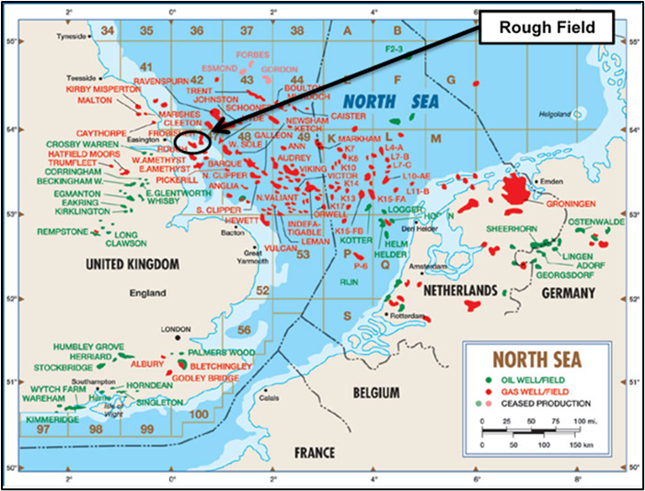
Figure 1.1: Field Location in UKCS

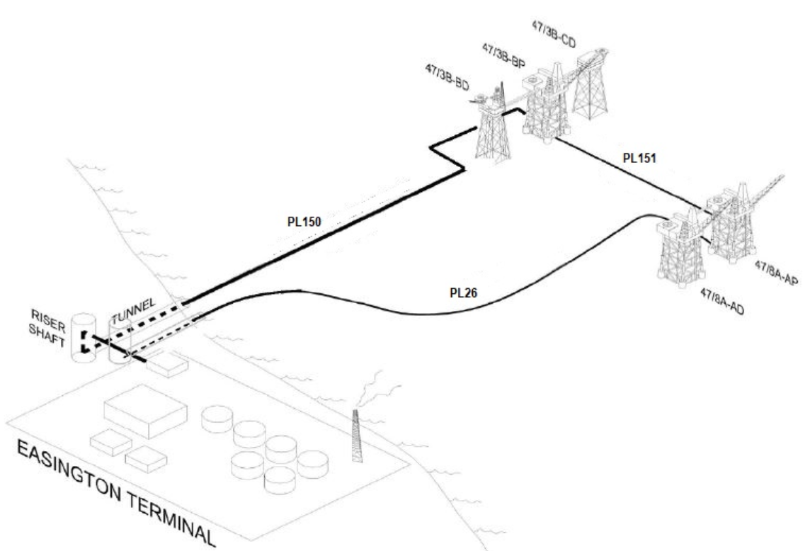

Figure 1.2: Field Layout

Table 1.8: Adjacent Facilities
Operator/Owner | Name | Type | Distance/Direction | Information | Status
Centrica | 47/3B | Bridge – linked Platform | 2km North West of Rough 47/8A | Gas Production | Operating
Centrica | PL150 | 36” Pipeline | Rough BP Platform to Easington Terminal | Gas | Operating
Spirit Energy Resources Limited | York Platform | Platform | 11 km North West of Rough | Gas | Production ceased
Spirit Energy North Sea Limited | Eris | Subsea Tieback | 7.9 km East of Rough | Gas | Operating
Perenco UK Limited | Mercury | Subsea Tieback | 12.7 km South East | Gas | Operating
Perenco UK Limited | Apollo | Subsea Manifold | 9.6 km North East | Gas | Operating
Spirit Energy North Sea Limited | Ceres | Subsea tieback | 16 km South East | Gas | Operating
Perenco UK Limited | Minerva | Platform | 21 km North East | Gas | Operating
Perenco UK Limited | Amethyst | Platform (s) | 22 to 31 km South East | Gas | Decommissioning
Premier Oil UK Limited | Tolmount | Platform | 24 km North | Gas | Operating
Perenco UK Limited | Cleeton | Platform (s) | 27 km North East | Gas | Operating
Perenco UK Limited | Neptune | Platform | 27 km North East | Gas | Operating
Perenco UK Limited | Ravenspurn South (A,B, C) | Platform | 37 to 39 km North East | Gas | Operating
Perenco UK Limited | Hyde | Platform | 38 km East | Gas | Operating
Impacts of Decommissioning Proposals on third party/adjacent facilities
No impacts to other adjacent Facilities are envisaged during the decommissioning of the 47/8A Facilities

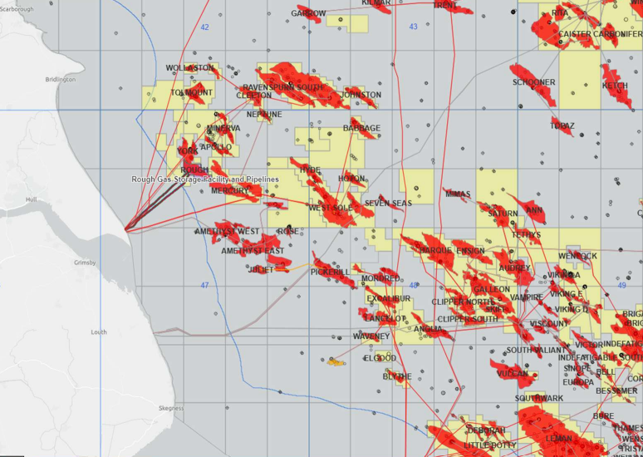
Figure 1.3: Adjacent Facilities

1.7 Industrial Implications
The Decommissioning Programmes will be managed by CESL to ensure safe, efficient and legally compliant delivery of the various elements of the decommissioning scope. The intention is to make efficient use of the supply chain to generate value through the application of knowledge, innovation and technology, explore collaboration opportunities and to employ best practice in the management of the supply chain to deliver a cost effective and reliable service. Where appropriate, existing framework agreements may be used for decommissioning activities.

DESCRIPTION OF ITEMS TO BE DECOMMISSIONED

2.1 Installation: Surface Facilities (Topsides/Jackets)

Table 2.1: Surface Facilities Information
Name | Facility Type |  | Location |  | Topsides/Facilities |  | Jacket (if applicable)
Name |  |  |  |  | Weight (Te) | No of modules | Weight (Te) | Number of legs | Number of piles | Weight of piles (Te)
AD |  | Fixed steel | WGS84 Decimal | 53.82524  0.47119 | 2301 | 1 | 752 | 8 | 8 | 300
 |  | Fixed steel | WGS84  Decimal Minute | 53°49.515’N  0° 28.107’E
AP |  | Fixed steel | WGS84 Decimal | 53.82567  0.472055 | 2713 | 1 | 731 | 8 | 8 | 300
 |  | Fixed steel | WGS84  Decimal Minute | 53° 49.540’N  0° 28.323’E
Bridge-Link |  | Steel | - | N/D | 150 | 1 | N/A | N/A | N/A | N/A

2.2 Pipelines Including Stabilisation Features
There are no pipelines or pipeline stabilisation features being decommissioned as part of the Decommissioning Programmes but the riser elements of PL26, PL151 & PL6255 are being decommissioned as part of the 47/8A Topsides & Jacket (including Risers) Decommissioning scope.

Table 2.2: Pipeline/Flowline/Umbilical Information
Pipeline Number | Description¹ (Include diameter) | Length (km) | Product Conveyed² | From – To  Location Points | Burial Status³ | Pipeline  Status | Current Content
PL26 | Export Line Riser- Steel | 0.08 | Gas | Rough 47/8A ESDV- Rough 47/8A Base of Riser | N/A- Riser Only | Interim Pipeline Regime (IPR) | Flushed- Inhibited Seawater
PL151 | Export Line Riser- Steel | 0.08 | Gas | Rough 47/8A ESDV- Rough 47/8A Base of Riser | N/A- Riser Only | Interim Pipeline Regime (IPR) | Purged- Nitrogen
PL6255 | Electrical/Fibreoptic Umbilical Cable Riser- Steel | 0.08 | N/A | Rough 47/8A platform Telecomms Room - Rough 47/8A Base of Riser | N/A- Riser Only | Interim Pipeline Regime (IPR) | N/A

Wells

Table 2.3: Well Information
Platform Wells | Designation | Status | Category of Well
47/08-A1 | Gas Production | Phase 2 Abandoned | PL-2-4-4-3
47/08-A2 | Gas Production | Phase 2 Abandoned | PL-2-4-4-3
47/08-A3 | Gas Production | Phase 2 Abandoned | PL-0-4-4-3
47/08-A4Z | Gas Production | Phase 2 Abandoned | PL-2-3-4-3
47/08-A5 | Gas Production | Phase 2 Abandoned | PL-2-4-4-3
47/08-A6Z | Gas Production | Phase 2 Abandoned | PL-2-4-4-3
Subsea Wells
N/A
E & A Wells
N/A

2.4 Drill Cuttings
The pre decommissioning survey and environmental sampling have confirmed no drill cuttings are present and therefore no requirements to assess or address.

2.5 Inventory Estimates

Table 2.4: Estimated Inventory: Installation (s)
Asset | Non-Ferrous Metal (Te) | Concrete (Te) | Ferrous Metal (Te) | Haz Mat (Te) | NORM (Te) | Other Non-Haz | Plastics (Te) | Unassigned (Te) | Total
AD | 1.5 | 8.2 | 3,208 | 36.8 | 0 | 96.9 | 0.2 | 1.2 | 3,353
AD | 0.04% | 0.24% | 95.68% | 1.10% | 0.00% | 2.89% | 0.01% | 0.04% | 100%
AP | 30.3 | 19.7 | 3,253 | 152 | 0 | 245 | 0.04 | 43.6 | 3,744
AP | 0.81% | 0.53% | 86.89% | 4.06% | 0% | 6.54% | <0.01% | 1.16% | 100%
Rough Alpha Bridge-Link | 0 | 0 | 150 | 0 | 0 | 0 | 0 | 0 | 150
Rough Alpha Bridge-Link | 0% | 0% | 100% | 0% | 0% | 0% | 0% | 0% | 100%

Note that the weights included within Table 2.4 include all inventory to be removed within the scope of these decommissioning programmes. i.e. Topsides, Jackets, Risers and Bridge Link.

3 REMOVAL AND DISPOSAL METHODS
CESL assessed options for extending the producing life of the 47/8A facilities and this was deemed unviable due to the asset age/integrity as well as the commercial viability. Options for the re-use of 47/8A pipelines are currently under investigation. Waste generated during decommissioning will be segregated by type and periodically transported to shore in an auditable manner through licensed waste contractors.
A phased approach to Topsides Removal and Disposal has been identified and it can be summarised in the following phases:
• Topsides Preparation for Removals Phase
• Topsides and Jacket Removals Phase
• Disposal Phase

3.1 Topsides

3.1.1 Topsides Decommissioning Overview
Topsides Description:
Topsides Description: The AD platform supports the helideck, accommodation, pedestal crane and wellhead facility with a weight of 2,301 Te. The AP platform supports the central processing facilities, including the gas processing and secondary muster station with a total weight of 2,713 Te. There is also a bridge, linking the two platforms with a total weight of 150 Te.

Removal method: the topsides will be completely removed and recovered to shore. Possible methods are described in Table 3.2.

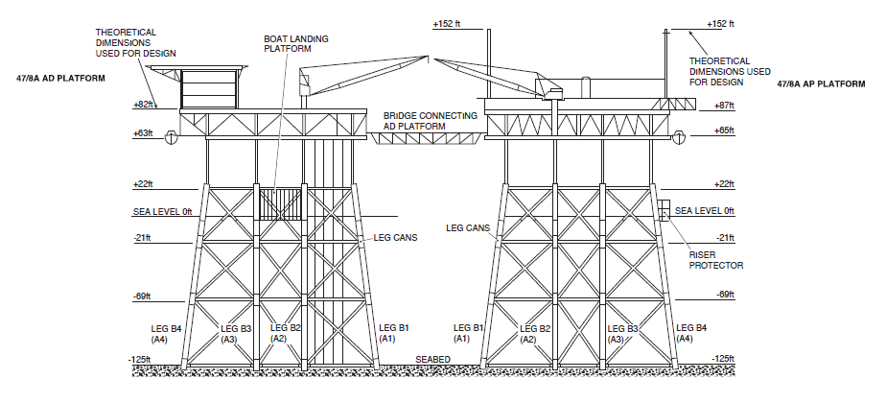
Figure 3.1: Diagram of Topsides

Preparation/Cleaning: The methods used to flush, purge and clean the topsides prior to removal to shore are summarised in Table 3.1. Note that the platform is hydrocarbon free and there are no additional flushing/ cleaning activities required prior to removal activities.

Table 3.1: Cleaning of Topsides for Removal
Waste Type | Composition of Waste | Disposal Route
Onboard hydrocarbons | Full recovery | Returned to shore for separation and use. Platform was made hydrocarbon free prior to personnel leaving platform
Other hazardous materials | NORM was not present in all samples taken during flush and clean operations. | N/A
Original paint coating | The presence of lead-based paints has been identified to be less than 1% by mass. | May give off toxic fumes / dust if flame-cutting or grinding / blasting is used so appropriate safety measures will be taken. Painted items will be disposed of onshore with consideration given to any toxic components.
Asbestos and Ceramic Fibre | Asbestos register and safety case confirms there is no asbestos present on the installations. | Any asbestos identified throughout decommissioning will be disposed of via an appropriately licenced waste management contractor.

Topsides preparation for removal work will involve removal/ destruct of local areas on the 47/8A platform in order to facilitate the larger removals campaign. Preparation for Removal activities will also include ‘asset make-safe to allow re-boarding of the platform, as well as inspection and access creation. This phase of works would use a Walk to Work Vessel and/or Jack-Up Barge.

Removal Methods: Topsides will be completely removed and returned to shore. Recovered material will be transported to shore for disposal by a contractor. As per the waste hierarchy, components of the 47/8A Topsides & Jackets will be re-used and/or reconditioned where viable with CESL intending to recycle >95% of the recyclable material that is returned to shore. In the event that Transfrontier Shipment of Waste is required (TFSW) is required, CESL will liaise with the relevant Environmental and Waste Authority(s) and ensure that all relevant PLANC(s) are in place in accordance with the relevant regulations. Table 3.2 details the methodology for topside removal

Table 3.2: Topsides Removal Methods
1) HLV (semi-submersible crane vessel) ☑ 2) SLV ☑ 3) Jack up Work barge ☑ 4) Piece small or large ☑ 5) Other ☐
Method | Description
Single lift removal by HLV | Removal of topsides and jacket as a complete unit followed by transportation to shore for re-use, recycling, and disposal as appropriate. Note that preparation for removals scope using JUWB requires to be completed prior to completing single lift removal by HLV
Modular removal by HLV and re-use/recycle | Removal of topsides as several units/ modules unit followed by transportation to shore for reuse, recycling, disposal as appropriate.
Offshore removal ‘piece small’ for onshore reuse/disposal | Removal of topsides in a series of smaller sub-units making use of a JUWB, followed by transportation to shore for a programme of re-use, recycling, or disposal as appropriate.
Piece medium deconstruction using HLV | Topsides and Bridge-Link will be removed separately from the jacket followed by transportation to shore for re-use, recycling, and final disposal to landfill as appropriate.

Note that a number of these methods will be carried forward into competitive tendering and a final decision on the decommissioning method will be made following a commercial tendering process and OPRED informed.

3.2 Jackets
3.2.1 Jacket Decommissioning Overview
The AD jacket installation has a weight of 752 Te. The AP jacket has a weight of 731 Te and each jacket has 300Te of piles which require to be removed. It is proposed that the piles will be cut internally circa 3 m below the seabed. Should it not be possible to access the piles internally, external excavation and access will be required. OPRED will be consulted prior to any external excavation or piles cutting. The jacket will be returned to shore for recycling or other disposal routes as appropriate.

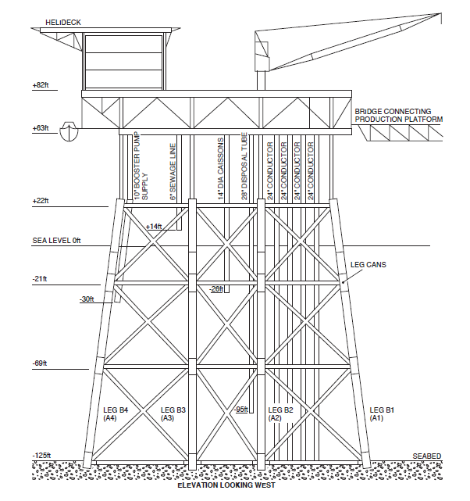

Figure 3.2: Typical Elevation of AD Jacket Looking West

3.2.2 Jacket Removal Methods

Table 3.3: Jacket Removal Methods
1) HLV (semi-submersible crane vessel) ☑ 2) SLV ☑ 3) Piece small or large ☑ 4) Other ☐
Method | Description
Internal Pile cutting and Onshore Disposal using HLV | Piles shall be cut from inside the legs and cut to a minimum of 3 m below seabed and lifted in a single lift followed by recovery to shore for recycling and disposal as appropriate.
External Pile Cutting and Onshore Disposal using HLV | Excavate around the external of each leg and base members (if necessary) and external cut to a minimum of 3m below seabed. Recover as a single lift followed by recovery to shore for recycling and disposal as appropriate.
Onshore disposal using ‘piece small” | Removal of Jacket by dismantlement offshore for transportation and onshore disposal and recycling. Jacket Piles cut 3m below seabed (external or internal cutting).
Proposed removal method and disposal route | A final decision on the decommissioning method will be made following an independent option review.

Comparative Assessment Method: No comparative assessment has been necessary with the development and planning of this Decommissioning Programme as it complies to the clear seabed guidance with the planned full removal of the Rough Alpha Installation as described in this Decommissioning Programme submission.

Outcome of Comparative Assessment: N/A – no comparative assessment undertaken

Note that a number of these methods will be carried forward into competitive tendering and a final decision on the decommissioning method will be made following a commercial tendering process and OPRED informed

3.3 Pipelines
3.3.1 Pipeline Decommissioning Overview
The PL26, PL151 & PL6255 riser sections are to be removed with the 47/8A Topsides/ Jackets and are part of these Decommissioning programmes submission. The riser section is from the interface with the topsides systems to the flanged connection to the pipeline which is at seabed level. The remaining pipelines elements and subsea infrastructure associated with 47/8A will be covered under a separate decommissioning programme.

Given that the full length of the risers associated with PL26, PL151 & PL6255 are to be removed, there was no requirement to complete a Comparative Assessment

Table 3.4: Pipeline or Pipeline Groups Decommissioning Options
Pipeline or Group (as per PWA) | Condition of line/group  (Surface laid/trenched/ buried/spanning) | Whole or part of pipeline/group | Decommissioning options considered*
PL26 Riser | N/A | N/A | N/A- Full length of riser to be removed
PL151 Riser | N/A | N/A | N/A- Full length of riser to be removed
PL6255 | N/A | N/A | N/A- Full length of riser to be removed

3.4 Wells
Table 3.5: Well Plug and Abandonment
The wells which require to be abandoned, as listed in Section 2.3 (Table 2.3) will be plugged and abandoned in accordance with OGUK Guidelines for the suspension and abandonment of wells. Well Plug & Abandonment activities were completed in 2023 and 6 x AD Wells have been abandoned to Phase 2 abandonment status.

3.5 Waste Streams

Table 3.6: Waste Stream Management Methods
Waste Stream | Removal and Disposal method
Bulk liquids | Bulk liquids have been removed and taken onshore for handling at the appropriately permitted facilities prior to onshore treatment and disposal.
Marine growth | To be taken onshore with the infrastructure identified for removal for handling at the appropriately permitted disposal yard prior to onshore disposal.
NORM/LSA Scale | No NORMs were present in all samples taken during flush and clean operations.
Asbestos | Asbestos register and safety case confirms there is no asbestos present on the installations.
Other hazardous wastes | All chemicals have been removed from installations have been taken onshore with the infrastructure identified for removal for handling at the appropriately permitted disposal yard prior to onshore disposal. There are no hydrocarbons remaining on the platform. Diesel is the only medium of fuel left on the asset.
Onshore Dismantling sites | Appropriately permitted UK and/or European sites will be selected through the procurement process. Note that no site has yet been selected but OPRED will be advised once any decision is made.

Table 3.7: Inventory Disposition
 | Total Inventory Tonnage | Planned tonnage to shore | Planned tonnage left in situ
Installations | 7247 | 6959 | 288 (Piles)

Note that the weights included within Table 3.7 include all inventory to be removed within the scope of these decommissioning programmes. i.e. Topsides, Jackets, Risers and Bridge Link.

Table 3.8: Reuse, Recycle & Disposal Aspirations for Recovered Material
Inventory | Reuse | Recycle | Disposal (e.g Landfill)
Installations | <1% | >89% | >10%

All wastes generated during decommissioning operations will be handled in accordance with the CESL Waste Management Strategy, and a project-specific Waste Management Plan will be developed. CESL will ensure that waste management and minimisation during the planned operations comply with the existing regulatory framework. Waste will be segregated and stored in suitable containers on the various vessels involved in operations, and its subsequent transportation, treatment and ultimate fate will be monitored.

CESL will ensure that all waste contractors are appropriately registered, and all waste managers are appropriately authorised for the activities and types of waste being treated or disposed of. This will be achieved through following established CESL procedures and will include a requirement for the contractor to provide HS&E policy statements, ISO registration certificates, waste management licences and registered waste carriers certificates. No waste from the decommissioning project is expected to be shipped across frontiers. CESL will ensure compliance with their legal “Duty of Care” with regard to the management, treatment and disposal of all waste equipment and materials retrieved onshore during the programme. CESL intends to recycle >95% of the recyclable material that is returned to shore. If it is possible to reuse or sell any recovered equipment, CESL will evaluate the opportunity on a case-by-case basis.

It is not currently possible to predict the market for re-usable materials with confidence however, there is the target that >95% of the recyclable material that is returned to shore is recycled

4 ENVIRONMENTAL APPRAISAL OVERVIEW

4.1 Environmental Sensitivities (Summary)
This section summarises the outcomes of the EA conducted for the proposed decommissioning of the Rough Alpha Installation. The information is based on the EA report (BMT, 2025). The environmental setting and sensitivities of the 47/8A area are summarised in Section 4.1.

An EA is a systematic process of environmental impact assessment that considers how a project will change existing environmental and societal conditions, assesses the consequence and significance of such changes, and identifies any mitigation or remedial works which may be required. It is an iterative process that is generally initiated at project inception and provides an aid to project decision-making throughout the planning and design phases so that, where practical, potentially significant environmental effects can be mitigated at the source. The process also provided an opportunity for consultation with stakeholders (refer to Section 5) at an early stage to ensure that all concerns are identified and can be addressed.

The EA was carried out in accordance with the Petroleum Act 1998 (Petroleum Act) as amended by the Energy Act 2008 and the Energy Act 2016, and other applicable environmental legislation such as The Offshore Petroleum Activities (Conservation of Habitats) Regulations 2001 (as amended), the Offshore Petroleum Activities (Oil Pollution Prevention and Control) (OPPC)) Regulations 2005 (as amended) Guidance Notes, Offshore Chemical Regulations 2002 and the Marine and Coastal Access Act 2009.

In addition to the pre-decommissioning environmental survey in 2022, specialist studies were commissioned on commercial shipping traffic and the extent of hydrocarbon contamination of the seabed in the vicinity of the 47/8A Facilities and Pipelines, to provided validation to the information that had inform the EA and assess potential impacts. The activities associated with the decommissioning of the Rough 47/8A platforms have the potential to result in an environmental impact in several different ways. These effects could arise as consequences of the following aspects of the decommissioning programmes:

- General decommissioning activities, including onshore disposal;
- Topsides Preparation for Removals Phase
- Cutting and removal of the Rough AD and Rough AP topside modules;
- Cutting and removal of the Rough AD and Rough AP jackets, risers and piles; and
- Cutting and removal of the bridge-link platform connecting the Rough AD and Rough AP platforms

A scoping exercise was conducted to identify potential environmental impacts and an environmental issues identification (ENVID) workshop was held. During the ENVID, key activities associated with each phase of the project were described with technical input from members of the project team and recorded on a scoring matrix. The environmental aspects associated with these activities were then identified and the physical, biological, and socio-economic impacts on the environment were determined with reference to the local environmental sensitivities.

All aspects that were scored as “significant” were fully assessed as part of the EA. Any aspect that was scored “insignificant” was deemed not to require further assessment. While it is recognised that this approach is subjective to some extent and open to a level of interpretation, it aims to provide consistency and transparency to the overall scoping process.

It was deemed that the proposed activities may result in the following environmental and societal impacts:
- Disturbance to the seabed
- Discharges to sea
- Societal impacts
- Energy use and atmospheric emissions
- Underwater noise and vibration arising from the decommissioning operations
- Accidental event from a large hydrocarbon spill
- Waste Management

Impacts or risks that were considered to be low and not of stakeholder concerns during the ENVID were excluded from further investigation in the EA. Stakeholder concerns were also considered within these areas of potential impacts. A detailed assessment of environmental sensitivities and impacts is contained within the supporting EA and is summarised in the following tables.

Table 4.1: Environmental Sensitivities
Environmental Receptor | Main Features
Conservation Interests within 40 km of proposed Rough A Decommissioning
Offshore Marine Protected Areas and Annex I Habitats
Special Area of Conservation (SAC) | Rough A lies within the Southern North Sea SAC, designated for the protection of harbour porpoise. The Humber Estuary SAC lies within 40 km of Rough A.
Marine conservation zones (MCZ) | Rough A lies within the Holderness Offshore MCZ, designated for subtidal coarse sediment, subtidal sand, subtidal mixed sediments, Ocean quahog and North Sea glacial tunnel valleys. The Holderness Inshore MCZ lies within 40 km of Rough A.
Special Protection Areas (SPA) | There are 2 SPAs within the Rough A area, Humber Estuary and the Greater Wash SPA
Annex I habitats | There are both Annex I sandbanks and reef habitats present within 40 km of the Rough A field
Offshore Annex II Species
Harbour porpoise (Phocoena phocoena) | A very high abundance of harbour porpoise is recorded in Quadrat 47 and adjacent quadrants for March, July, August, September, October, November and December with a moderate abundance the rest of the remaining months.
Grey seals (Halichoerus grypus) | Grey seal densities typically range between 10 – 50 seals per 25 km² with occasional peaks of up to 100 seals per 25 km².
Harbour seals  (Phoca vitulina) | Harbour seal densities are typically low (between 0 – 1 seals per 25 km²), reaching peaks of up to 10 seals per 25 km² in localised regions of the block of interest.
Bottlenose dolphin  (Tursiops truncatus) | Bottlenose dolphins are recorded in the vicinity around Rough A in the months of July and August.
Marine Plan Policies
East Inshore and East Offshore Marine Plan Policies | Rough A falls under the guidance of the East Inshore and East Offshore Marine Plan Policy
Seabed | The Rough A field lies within a widespread seabed area that can be classified into mostly coarse sediment. The UKSeaMap describes the seabed in the subtidal section of the proposed area as a mixture of A5.14 Circalittoral coarse sand and A5.13 Infralittoral coarse sand, A5.43 Infralittoral mixed sediment, and A5.44 Circalittoral mixed sediment.
Fish | The 47/8A offshore facilities are located within ICES rectangle 36F0 and are within the spawning grounds of cod, herring, lemon sole, plaice, sandeels, sole and sprat. ICES rectangle 36F0 is considered a high intensity spawning area for North Sea plaice.  There are also nursery grounds for cod and herring, lemon sole, mackerel, plaice, sandeel, sprat and whiting. There is high intensity nursery ground identified for cod, herring, and whiting in ICES rectangle 36F0.
Fisheries | Fishing effort in ICES rectangle 36F0 ranged between 2,350 days in 2019 to 3,360 days in 2023 (Scottish Government, 2024). Between 2019 and 2023, the annual total live weight of fish landed ranged from between 2,991 tonnes landed in 2023 to 4,059 tonnes landed in 2021. Total annual fishing value ranged between £9,094,884 in 2020 to £15,941,288 in 2021. No shellfish water protected areas or active aquaculture sites occur in the vicinity of the Rough A area.
Marine Mammals | The main marine mammal species occurring in the area are minke whale (Balaenoptera acutorostrata), bottlenose dolphin, common dolphin (Delphinus delphis), white-sided dolphin (Lagenorhynchus acutus), white-beaked dolphin (Lagenorhynchus albirostris) and harbour porpoise, with most sightings occurring in the summer months.  Given that the Rough Field is located within 40 km of the coastline, it is possible grey or harbour seals might be found in this vicinity.  Based on the available information, Block 47/8A is not considered to be significant for feeding, breeding, nursery or migrating marine mammals.
Birds | Species commonly found in offshore North Sea waters are Fulmar (Fulmarus glacialis), Gannet (Morus bassanus), Guillemot (Uria aalge), Razorbill (Alca torda), and Kittiwake (Rissa tridactyla); and Herring (Larus argentatus), Great Black-backed (Larus marinus) and Lesser Black-backed (Larus fuscus) gulls.  In the primary block of interest (47/8), seabird oil sensitivity ranges between low and high throughout the year. In the block of interest, extremely high seabird vulnerability was recorded in October, with very high seabird vulnerability recorded in March  The decommissioning projects of the 47/8A are located approximately 29 km from the nearest UK coast. Sensitive onshore breeding areas (Spurn Point & Bempton Cliffs) are located are located 31 km and 65 km away respectively.  Offshore activities will take consideration of seabird presence throughout duration of decommissioning activities. Mitigation of seabird disturbance is currently ongoing and is anticipated to continue throughout the duration of the decommissioning activities.
Other Users of the Sea | EMODnet (2024) data shows high to very high shipping activity in the block 47/8A. Key vessels associated with this traffic are cargo ships and tankers which present the highest average densities between 2028 and 2023. The location is within a designated MoD training range, however, there is no military activity expected within the vicinity.
Offshore Renewables | There are 2 renewable energy sites in production within 40 km of Rough 47/8A.
Telecommunications | There is one cable in the Rough A vicinity: TGN Northern Europe 37 km northwest and one planned cable 23 km southeast, NGVL Northern Europe.
Atmosphere | Energy use and emissions were calculated for the proposed program. Emissions are not expected to result in a significant increase to the current UKCS emissions attributed to oil and gas activities and general vessel movements in the area.

4.2 Potential Environmental Impacts and their Management
Environmental Impact Assessment Summary:

Overview: Although there is expected to be some environmental impact during the decommissioning of the Rough Alpha Installation, long term environmental impacts from the decommissioning operations are expected to be negligible. In addition, incremental cumulative impacts and transboundary effects associated with the planned decommissioning operations are expected to be negligible. There will be no planned use of explosives during these activities. We acknowledge that there will be a requirement for an updated environmental protection assessment to be produced and submitted to OPRED should this program change. Removal of the 47/8A facilities will in the long-term result in a positive impact to the environment through the removal of the 500 m exclusion zone and the associated platforms.

Table 4.2: Environmental Impact Management
Activity | Main Impacts | Management
Topsides Removal (inc Risers & Bridge Link) | Dropped objects, Accidental release of contaminants, and use of landfill space. | - Completion of dropped Object Sweeps/ assessment prior to operations  - Retention/ securing/ removal of potential dropped Objects  - Minimise residual content of any vessels.  - All tanks drained and nitrogen purged prior to removal operations.  - Solid contaminants skipped and shipped to shore.  - Remove all hazardous waste as far as reasonably practicable.  Recycle or reuse as much material as possible.
Jackets Removal (inc Risers) | Seabed disturbance from anchoring & dredging to cut piles | - Internal cuts to minimise seabed disturbance, where this is not possible the minimum amount of dredging will be planned.  - Mooring analysis  - Anchor management plan  - Post operation seabed survey  - Consent to locate  Ensure proper anchoring equipment is being used for seabed type
Subsea Cutting and Removal | Seabed disturbance, accidental release of contaminated material, use of landfill space | - Pipelines and umbilicals flushed prior to cutting  - Minimal dredging where possible  - Wells plugged and minimise any residual material by flushing or purging if required  Recycle or reuse whenever possible
Offshore activities | Physical presence of decommissioning vessels causing potential interference to other users of the sea | - Prior to commencement of operations, the appropriate notifications will be made, and maritime notices posted  - All vessel activities will be in accordance with national and international regulations  - Appropriate navigation aids will be used in accordance with the consent to locate conditions to ensure other users of the sea are made aware of the presence of vessels  - Use of designated transit routes for all decommissioning vessels.  - Continual use of AIS vessel identification  24-hour manned bridge policy
Post decommissioning | Damage to or loss of gear as a result of subsea obstructions, posing potential snagging risks | - Consultation with fisheries representatives  - Post-decommissioning seabed clearance  Seabed Clearance Survey following decommissioning, upon agreement with the regulator
Vessels and helicopters onshore and offshore transportation and operations | Energy use & GHGs emissions | - Vessels will be audited as part of selection and pre-mobilisation.  - All generators and engines will be maintained and operated to the manufacturers’ standards to ensure maximum efficiency.  - Vessels will use ultra-low sulphur fuel in line with MARPOL requirements.  - Work programmes will be planned to optimise vessel time in the field.  Fuel consumption will be minimised by operational practices and power management systems for engines, generators and other combustion plant and maintenance systems.

5 INTERESTED PARTY CONSULTATIONS
Consultations Summary:

Table 5.1: Summary of Stakeholder Comments
Who | Comment | Response
- Informal Stakeholder Consultations
- Public
- Statutory Consultations
National Federation of Fishermen’s Organisations
Scottish Fishermen’s Federation
Northern Ireland Fish Producers Organisation
Global Marine Group
North Sea Transition Authority | Centrica has consulted with NSTA under S29(2A) of the Petroleum Act

6 PROGRAMME MANAGEMENT

6.1 Project Management and Verification
CESL Standard procedures for operational control and hazard identification and management will be used. Where possible the work will be coordinated with other decommissioning operations in the Southern North Sea. The management team will monitor and track the process of consents and the consultations required as part of this process. Any changes in detail to the offshore removal programme will be discussed and agreed with OPRED.

The execution of this project will follow CESL Management System and requirements, which will include the timely management of all applicable consents, licences and permits required for the work. This will include, but not be limited to, the relevant environmental permits, waste management and disposal consents, and notifying other users of the sea of the offshore activities, as well as any associated reporting requirements.
The project will be subject to internal peer reviews at key stages. This will involve CESL and other stakeholders. Key technical decisions are also subject to approval from the CESL internal ‘technical authorities’.

Upon approval of the Decommissioning Programme, OPRED will be given regular progress reports which will continue during the offshore removal operations.

6.2 Post-Decommissioning Debris Clearance and Seabed Clearance Verification
This DP covers removal of 47/8A Topsides and Jackets (including Risers). Upon completion, an as-left survey will be carried out to ensure that no snag hazards or risks to other users of the sea remain. The 500m Zone will remain in place post removal of 47/8A Topsides and Jackets (including Risers) and the Field ERRV will also be in location whilst 47/3B is manned. Pipelines will remain in-situ until the wider Rough Field Decommissioning is complete will be monitored and appropriate mitigation plans put in place as required if snagging hazards are discovered. Seabed clearance verification will be carried out after full decommissioning of the Rough field infrastructure which is anticipated to be in 2031

Within twelve months of completion of the work, CESL will provide the following information to OPRED:
- As left survey report
- Project close-out report

6.3 Schedule
Project Plan: Figure 6.1 provides an overview of the decommissioning programme, with key dates and defined milestones. A legend is also included for information. Note that durations detailed within Gantt Chart represent timing/ execution windows as opposed to absolute durations.

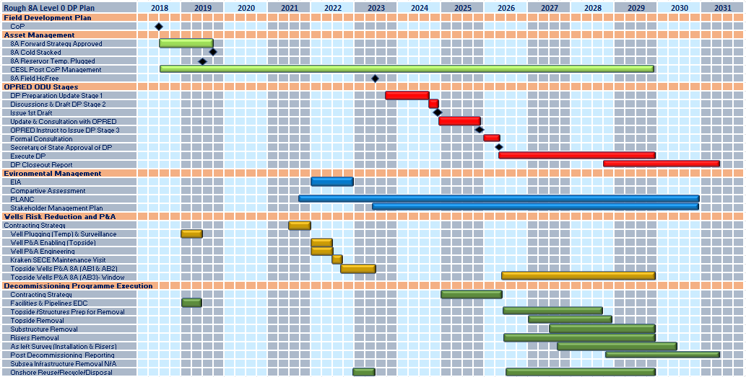

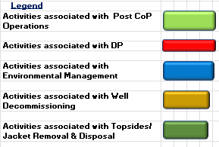
Figure 6.1: Gantt Chart of Project Plan

6.4 Costs
Table 6.1: Provisional Decommissioning Programme(s) costs
Item | Estimated Cost (£m)
Project Management | Provided to DESNZ in confidence under separate cover
Well Abandonment | Provided to DESNZ in confidence under separate cover
Making Safe | Provided to DESNZ in confidence under separate cover
Platform(s)/Jacket(s) - Preparation/Removal and Disposal | Provided to DESNZ in confidence under separate cover
Continuing Liability – Future Pipeline and Environmental Survey Requirements | Provided to DESNZ in confidence under separate cover
TOTAL | Provided to OPRED

6.5 Close Out
A close out report will be submitted to OPRED within twelve months of the completion of the offshore work, as required in the OPRED guidelines. The report will explain any variance from the Decommissioning Programmes

6.6 Post-Decommissioning Monitoring and Evaluation
CESL will carry out a post-decommissioning as-left survey, centred on the 47/8A platforms.

A copy of the survey results will be provided to OPRED.

7 SUPPORTING DOCUMENTS
Table 7.1: Supporting Documents
Document Number | Title
A21008/A000/31/01/369/00005 | Environmental Appraisal
A21008/A000/31/01/369/00008 | Material Inventory Report
210641-EDS-015 (02) _8A | Rough 47/8A Pre-Decommissioning Environmental Baseline Survey
210641-EDS-013 (02) _8A | Rough 47/8A Habitat Assessment

SECTION 29 NOTICE HOLDERS LETTER(S) OF SUPPORT
8.1- Centrica Energy Storge Limited

8.2- Centrica Offshore UK Limited

8.3- GB Gas Holdings Limited

8.4- BG International Limited

APPENDIX
A.1- Public Notices

A.2- Correspondence with Consultees

