

Application Decision
by Dominic Dobbs
Appointed by the Secretary of State for Environment, Food and Rural Affairs
Decision date: 8 May 2026

Application Ref: COM 3371734
Highleadon Green, Highleadon, Newent, GL18 1HG
Register Unit Number: CL 35
Commons Registration Authority: Forest of Dean District Council

- The application, dated 14 August 2025, is made under Section 38 of the Commons Act 2006 (the 2006 Act) for consent to carry out restricted works on common land.
- The application is made by RWE Renewables UK Solar & Storage Limited.
- The works comprise:
- The Installation of a 32mm water pipe at an approximate depth of 1m.
- The excavation of a trench for the laying of the pipe measuring approximately 15m long by 1m deep and 0.6m wide.
- The use of temporary plastic barrier fencing to enclose the working area. Each barrier will measure approximately 1m high.

Decision
- Consent is granted for the works in accordance with the application dated 14 August 2025 and the plans submitted with it subject to the following conditions:
- the works shall begin no later than three years from the date of this decision;
REASON: To provide certainty to users of Highleadon Green.
- the land shall be fully reinstated within one month from the completion of the works (note that this does not apply to any physical changes or permanent features introduced as part of the works for which consent is granted);
REASON: To retain access for commoners, public and livestock across Highleadon Green.
- Any temporary fencing shall be removed within one month of completion of the works.
REASON: To retain access for commoners, public and livestock over Highleadon Green.
- For the purposes of identification only the location of the works is shown on the attached plan.

Preliminary Matters
- I have had regard to Defra’s Common Land Consents Policy Guidance (November 2015) in determining this application under section 38, which has been published for the guidance of both the Planning Inspectorate and applicants. However, every application will be considered on its merits and a determination will depart from the guidance if it appears appropriate to do so. In such cases, the decision will explain why it has departed from the guidance.

- This application has been determined solely on the basis of written evidence. I have taken account of the representations made by the Open Spaces Society (OSS), Natural England (NE) and Historic England (HE).

- I am required by section 39 of the 2006 Act to have regard to the following in determining this application:
- the interests of persons having rights in relation to, or occupying, the land (and in particular persons exercising rights of common over it);
- the interests of the neighbourhood;
- the public interest; Section 39(2) of the 2006 Act provides that the public interest includes the public interest in; nature conservation; the conservation of the landscape; the protection of public rights of access to any area of land; and the protection of archaeological remains and features of historic interest;
- any other matter considered to be relevant.

Reasons

- The applicant explains that the works are required to allow for the water connection to a power plant substation building to the Severn Trent distribution system. They have assessed other connection routes with Severn Trent to avoid crossing the Common land but have been advised that the distribution system proposed would be the only practical option due to the long distances to the other alternatives.

The interests of those occupying or having rights over the land
- Forest of Dean District Council are the owners of the land and it follows that they have been consulted on the application and have not proved comment. The common land register records rights to graze 20 sheep and rights of pasturage for 2 ponies over the whole of the common land at Highleadon Green.

- I am satisfied that the applicant has carried out the required consultation and no further comments were received, and the planned works would not interfere with the interest of those occupying or having rights over the land.

The interests of the neighbourhood and public access
- The interests of the neighbourhood relate to whether the works will unacceptably interfere with the way the common land is used by local people and is closely linked with interests of public access.

- The common land at Highleadon green is located near the B4215 highway. It is remote in location being largely rural, open and uncultivated land. It is my view that this area of the Common has high natural value but is unlikely to be often used for recreational activities outside such as walking or access to open areas.

- The applicant explains that the works are required to improve and felicitate infrastructural needs within the area. The water pipe is intended to be a permanent feature however it will be located underground and therefore will not create an impediment to access on the Common.

- For the duration of the works the excavation of the trenches will create barriers to people’s access of the Common. However, these will be temporary in nature and once they are filled will not continue to be impediments on the Common

- The temporary fencing would impact access, blocking access to the areas of the Common where the works are taking place. However, the impact will be minimal when considering the overall size of the Common, which will also remain accessible via other routes. The fencing is also planned to be temporary in nature. I am satisfied that such fencing is appropriate on health and safety grounds and that it will be removed on completion of the works, which can be secured by attaching a suitable condition to the consent.

- Overall, I do not believe the works as planned would create any unacceptable impediment to people’s access to and across the Common and I do not believe the implementation of these works would interfere with the way the Common is currently used.

- NE have been consulted on the application and stated that “while the proposed works may cause temporary disturbance to local wildlife such as insects, small mammals, and birds, we do not anticipate any significant adverse impacts on designated sites, local biodiversity, landscape character, or public accessibility
across the Common.”

- OSS have commented that they regard the works as de minimis and probably not requiring consent. However, they have no objection to consent being granted.

The public interest
- As well as having regard to the public interest in the protection of public rights of access, I must also have regard to the public interest in nature conservation, the conservation of the landscape and the protection of archaeological remains and features of historic interest.

Nature conservation and conservation of the landscape
- NE have stated that “The works are temporary in nature. Upon completion, the affected area will be reinstated using topsoil and sown with native seed mixes. Provided that restoration is carried out appropriately, they do not foresee any lasting visual or environmental impacts.

- The applicant has outlined their plan to fill in any excavations with the same soil taken from the sight and there plans to undertake the required landscaping works to return the site to its original sate. Additionally, the proposed works within this application are all temporary in nature and their impact on the Common will be minor.

- Overall, I am of the view that the works will not negatively impact on nature conservation interests of the Common or impact the landscape interests of the Common once the land has been reinstated.

Protection of archaeological remains and features of historic interest.
- Historic England were consulted on the application and they do not view that the works will impact any historic or heritage assets.

- There is no evidence before me to suggest that these interests will be harmed by the proposed works if the above conditions are applied by the applicant.

Conclusion

- In this case I conclude that the works will not introduce an unacceptable barrier to public access to the Common and the works will not seriously harm the other interests set out in paragraph 5 above. Consent for the works is therefore granted subject to the conditions set out at paragraph 1 above.

Dominic Dobbs

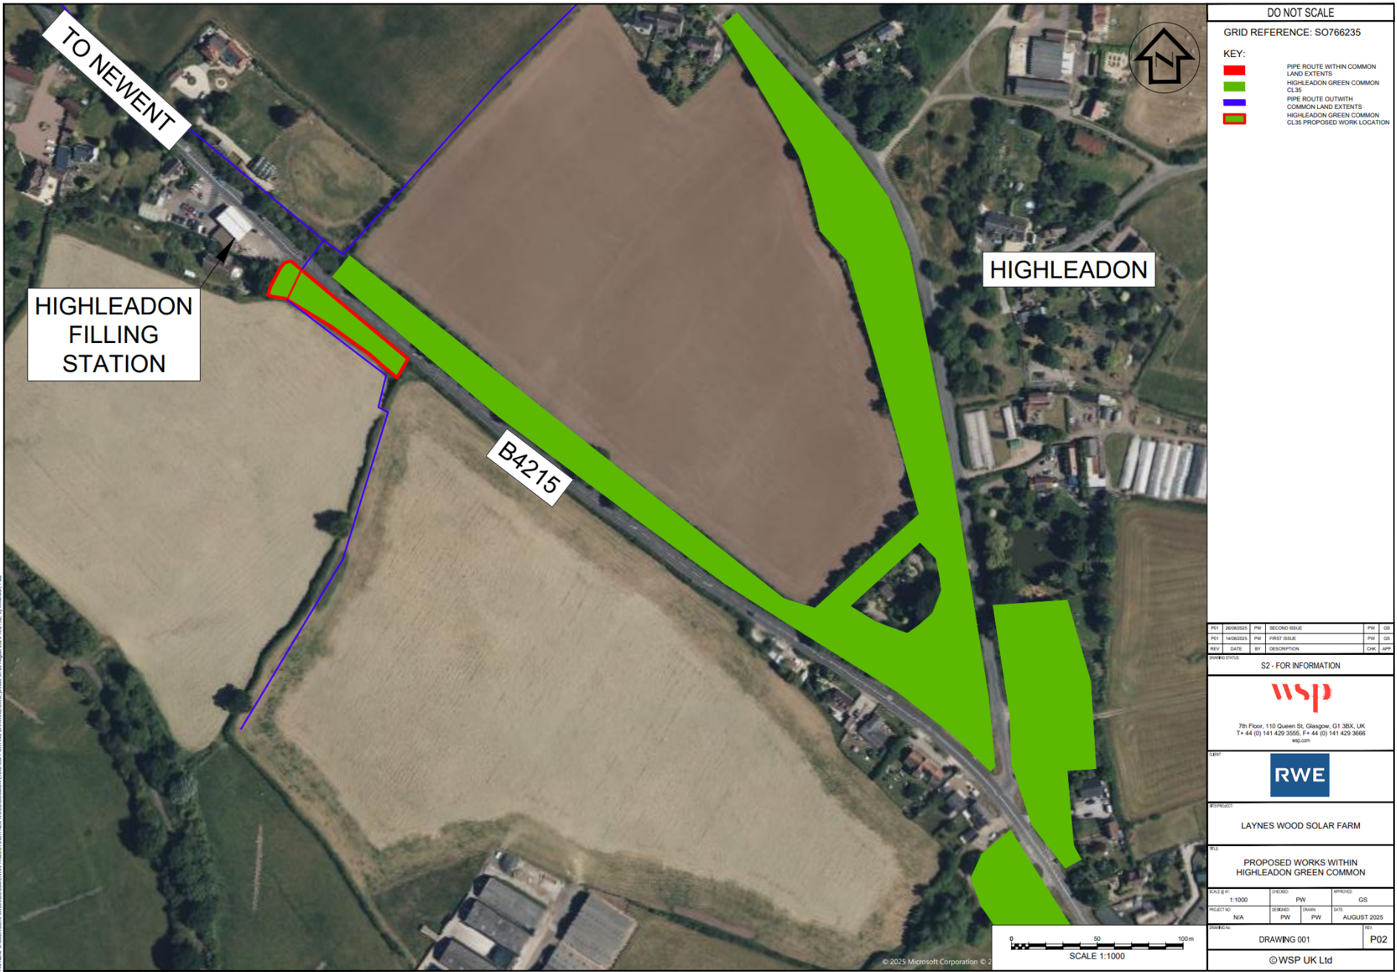
Plan 1 – Location of works on the common

