COMMUNITY PARTNERSHIP FUND
GRANT APPLICATION
APPLICATION FORM

Summary

Northern Ireland’s community and voluntary sector is defined by an extensive and diverse range of expertise, developed through decades of first-hand experience in the delivery of interventions, solutions and support for communities. There is much to be learned from the sector at the heart of delivering on behalf of local communities.

Through the Community Partnership Fund, we want to harness the expertise of well-established groups to: identify and support smaller grassroots community groups; help them build strong networks; empower groups to generate ambitious ideas and pursue larger-scale projects; and navigate funding opportunities while building financial resilience.

The Community Partnership Fund will operate over the course of three years and provide up to £1million to a forum of established voluntary organisations who can support grassroots community groups in Northern Ireland

Applications must include a three-year delivery plan, detailing the methods, topics, and design of support.

Funding will be provided in line with the following schedule:

Year | Total
Year 1: 2026/27 (Development Year) | Up to £300,000
Year 2: 2027/28 | Up to £300,000
Year 3: 2028/29 | Up to £400,000

Objectives

The Community Partnership Fund programme awards up to £1m between 2026-29 to a forum to establish a development offer for the voluntary sector in Northern Ireland. Its aim is to encourage grassroots organisations to develop strong networks, be ambitious for their communities in the ideas they generate, improve financial resilience and strengthen their ability to access funding.

The successful forum will help identify smaller community groups who operate informally, including those in rural areas, those who are below the radar of traditional funding, or those who lack confidence to engage with institutions and established networks, in order to support them from idea generation through to project delivery.

Applications for the forum are welcomed from established voluntary and community sector organisations, civic society, and national representative bodies who can demonstrate that they have formed a partnership with other sector leaders to develop and deliver a unified offer of training and support. One organisation must act as Head Recipient for financial accountability

Applicants must include a three-year delivery plan, detailing the methods, topics and design of support they propose. At a minimum, applicants must detail proposals which will deliver on the following key criteria:
- Engaging smaller grassroots groups: Identifying and supporting smaller grassroots community groups that are currently below the radar of traditional funding;
- Building Networks: Creating crucial networking opportunities to help these organisations form new contacts;
- Fostering Ambition: Empowering groups to generate ambitious ideas and pursue larger-scale projects and funding; and
- Navigating Funding: Providing comprehensive support to help groups identify opportunities and guide them from initial idea generation through to final project delivery, while building financial resilience to manage funding transitions and secure long-term sustainability.

Applications will be assessed on the demonstration of the below criteria. Applicants must score a minimum of 50/75 to be eligible for funding and meet the minimum scoring value set per criterion.

Criteria | Detail | Max Score
[1] Capability, Experience and Forum Make-up | - A minimum of 5 years experience for Head Recipient and 2 years experience for constituent groups in delivering support directly to the community and voluntary sector  - Applicant forum’s structure and capacity to manage and deliver a grant funded programme  - Forum demonstrates a mix of experience offering combined breadth of subject matter expertise;  - Constituents individually offer depth and breadth of experience | 15  (Min for award = 10)
[2] Programme Design | - Demonstrates how well the project aligns with the stated objectives and the strength of its proposed contribution.  - Strength of programme design including a 3 year delivery plan and timeline, noting the Year 1 Development Year and stipulated increase in funding in Year 3  - Methods of delivery, topics of support and how they meet the four key areas stipulated  - Clarity across programme’s aims, activities, timeline and intended outcomes  - Allocation of budget across 3 years of delivery, noting the stipulated increase in funding in Year 3  - Identification of delivery risks and how the same will be mitigated | 25  (Min for award = 20)
[3] Reach of Delivery | - Strategy for and commitment to identifying and building relationships with grassroots community groups  - Strength of plan to ensure suggested offer delivers for harder-to-reach grassroots and voluntary organisations, particularly those operating informally or below the radar of traditional funding  - Number of organisations forum proposes to support per year | 15
[4] Impact and Outcomes: | - Identification of indicators of success and methods for monitoring e.g., the number of organisations partaking, geographic reach, benefits gained, beneficiary satisfaction.  - Evidence of an agile approach to delivery which allows for continuous improvement across successive years of delivery.  - Sustainability of improvements to the community and voluntary sector’s ambition of goals, capacity, and improved sector ability to access funds beyond the immediate delivery period. | 10
[5] Value for money: | - Demonstration that the budget is appropriate, well justified and represents good value for the scale and impact of programming offered.  - Adherence to the financial schedule, and compliance with eligibility rules.  - Demonstrate how funding will be balanced between forum management and direct training delivery against the aim of the programme.  - Demonstrate that the grant offers better value than a siloed approach by maximising collective expertise to deliver economies of scale. | 10
 | Total | 75

Following application assessment, applicant organisations who achieve the required minimum score of 50/75 will be invited to participate in an interview. It is anticipated that interviews will be held in July 2026.

PLEASE READ THIS BEFORE CONTINUING YOUR APPLICATION

Accounts
All members of your forum will be required to provide copies of your most recent accounts/financial statements. Non-statutory bodies must submit a governing document.

Individual Organisational Capability and Experience
You must provide a summary of how the forum organisations’ previous experience, internal structures, and subject matter expertise contribute to your forum's capability to deliver this grant (in the application form).

Forum Makeup
You should provide an outline of the makeup of your proposed forum and how it will work together to provide breadth and depth of training provision without duplication.

Programme Design
You must summarise your programme design, including the methods and specific topics of support you propose to deliver (in the application form). You must separately submit a programme plan and budget with milestones, deliverables and costs associated with the programme.

Reach and Inclusivity of Delivery
You must detail your approach to ensuring appropriate reach, including a summary of the steps you will take to ensure accessibility and inclusivity (in the application form).

Impact and Outcomes
Monitoring and evaluating the success of a programme is essential to form a picture of how your grant will have an impact on the sector more widely. If your forum is successfully awarded funding, it is expected that you adhere to monitoring and evaluation by identifying the benefits which the programme is working to deliver, the baseline from which the programme aims to deliver changes, any changes in need or progress made as a result of the intervention. You will be expected to outline how you intend to monitor and evaluate the programme in the application form. If successful, you must provide updates on the development and delivery of the programme, in line with the below schedule.

Year | Update
Year 1 (Development Year) | Verbal - 3 x meetings with Funder
Year 1 (Development Year) | Written - circa w/c 2 November 2026
Year 1 (Development Year) | Written - circa w/c 22 March 2027
Year 2 | Verbal - 3 x meetings with Funder
Year 2 | Written - circa w/c 6 September 2027
Year 2 | Written - circa w/c 20 March 2028
Year 3 | Verbal - 3 x meetings with Funder
Year 3 | Written - circa w/c 6 September 2028
Year 3 | Written - circa w/c 20 March 2029

ORGANISATION DETAILS

The Community Partnership Fund should be formed from a forum of organisations, however it must identify a lead organisation. If successful, this is who the Northern Ireland Office will enter into a contract with.

LEAD ORGANISATION (HEAD RECIPIENT)
Organisation name
Organisation address
Organisation type
Charities Commission number (if applicable)
Companies House number (if applicable)
Year organisation was established (must demonstrate 5 years of delivery experience)
Yearly income
Name of nominated contact lead
Email of nominated contact lead
Senior contact (e.g. CEO, Chair, Director)
Email of senior contact
Organisation total annual income in FY 25/26
Organisation total annual income in FY 24/25
Organisation total annual income in FY 23/24
Separately, you are required to provide a copy of your most recent accounts/financial statements.

If the lead organisation is a non-statutory body, you must submit a governing document (e.g. constitution or memorandum and articles of association) which includes appropriate statements on members, Directors or Trustees not benefiting financially from the organisation or its dissolution, a minimum of 3 unrelated people on the committee, this will be unrelated trustees for charities and unrelated directors for companies limited by guarantee, and have your own bank account (which requires 2 signatories).

PARTNER ORGANISATION 1 (FORUM MEMBER)

For each partner organisation in your forum, please copy and paste this table below as needed.
Organisation name
Organisation address
Organisation type
Charities Commission number (if applicable)
Companies House number (if applicable)
Year organisation was established (must demonstrate 2 years of experience)
Yearly income
Name of nominated contact lead
Email of nominated contact lead
Senior contact (e.g. CEO, Chair, Director)
Email of senior contact
Organisation total annual income in FY 25/26
Organisation total annual income in FY 24/25
Organisation total annual income in FY 23/24
Separately, you are required to provide a copy of your most recent accounts/financial statements.

If the organisation is a non-statutory body, you must submit a governing document (e.g. constitution or memorandum and articles of association) which includes appropriate statements on members, Directors or Trustees not benefiting financially from the organisation or its dissolution, a minimum of 3 unrelated people on the committee, this will be unrelated trustees for charities and unrelated directors for companies limited by guarantee, and have your own bank account (which requires 2 signatories).

PARTNER ORGANISATION 2 (FORUM MEMBER)

For each partner organisation in your forum, please copy and paste this table below as needed.
Organisation name
Organisation address
Organisation type
Charities Commission number (if applicable)
Companies House number (if applicable)
Year organisation was established (must demonstrate 2 years of experience)
Yearly income
Name of nominated contact lead
Email of nominated contact lead
Senior contact (e.g. CEO, Chair, Director)
Email of senior contact
Organisation total annual income in FY 25/26
Organisation total annual income in FY 24/25
Organisation total annual income in FY 23/24
Separately, you are required to provide a copy of your most recent accounts/financial statements.

If the organisation is a non-statutory body, you must submit a governing document (e.g. constitution or memorandum and articles of association) which includes appropriate statements on members, Directors or Trustees not benefiting financially from the organisation or its dissolution, a minimum of 3 unrelated people on the committee, this will be unrelated trustees for charities and unrelated directors for companies limited by guarantee, and have your own bank account (which requires 2 signatories).

GOVERNANCE
Summarise the expected governance arrangements to ensure good working over the course of the 3 year delivery period

300 words max.

ELIGIBILITY
Please confirm all organisations within your proposed forum are eligible to apply for this funding
Please confirm the following statements are true to the best of your knowledge and belief:

- No individuals applying for funding from the Community Partnership Fund have been convicted of i) corruption, fraud; ii) money laundering; iii) terrorism;
- The Head Recipient applicant operates and resides in Northern Ireland;
- Where applications are being made collectively by a number of organisations all other organisations operate in the United Kingdom only;
- All applicants are formally established for public benefit and not for profit;
- All applicants involved have the required resources to deliver the proposed project plan; and
- All applicants have the ability to obtain any required insurance to deliver the grant (where required) and will do so ahead of beginning any programme.

[I confirm]/[I do not confirm]

Signed: ________________
If working with children, young people or vulnerable adults, please confirm you have a safeguarding policy in place explaining how they’ll be safe.
Please confirm the following statement is true:

‘I hereby declare that the information submitted is, to the best of my knowledge and belief, true and accurate.’

Signed: ________________

If required, please copy/add the section above.

CONFLICT OF INTEREST
Please declare any conflicts of interest that could compromise the conduct of the project/bid (for lead organisation and partner organisations).

APPLICATION
SUMMARY
Project title
Summary of project and expected activities (1000 words)
PROGRAMME LOGISTICS
Please note: a Development Year has been included in the Community Partnership Fund, allowing the successful Grant Recipient time to finalise and deepen their project plan. While it is not a requirement to use the Development Year, applicants will be required to share and discuss their finalised delivery plan with the Northern Ireland Office, ahead of programme delivery commencement.
Start and end date of Development Year (latest end 31 March 2027)
Expected start and end date of Programme Delivery (latest start 1 April 2027 / latest end 31 March 2029)
Location(s) of programme and activity(s)
ORGANISATIONAL CAPABILITY AND EXPERIENCE
Please outline your organisation's experience in delivering support directly to the community and voluntary sector, including the number of years of experience held by the organisation.

(500 words max.)
Please outline your organisation's existing internal structures and capacity to successfully deliver and manage a grant-funded programme of this scale and duration (3 years).

(300 words max.)
Please describe the depth of your organisation's experience and subject matter expertise relevant to the objectives of the Community Partnership Fund (e.g., engaging smaller grassroots groups, building networks, fostering ambition, and navigating funding/building financial resilience).

(500 words max.)
PROGRAMME DESIGN
Please outline the methods and specific topics of support you propose to deliver.

Please note, it is intended that the Development Year will be used to create a precise delivery plan and to develop specific programming.

(1500 words max.)
Please provide details on how the specific outputs of your project will deliver against the four fund objectives and their expected impact:
1) Engaging the underserved;
2) Building networks;
3) Fostering ambition; and
4) Navigating funding and upskilling leaders (including the Connect Fund).

(750 words max.)
Please set out how your project sits alongside the broader funding landscape. As a reminder, projects must enhance, not duplicate, existing provision. Where building on existing work, you must detail the new benefits/outputs for community groups.

(500 words max.)
Please summarise your approach to Budget planning and management in delivering this programme.

(500 words max.)
Please confirm that you have included the required Budget and Delivery Plan, detailing delivery across the 3 years of the Fund.

[Please share within the same email used to submit your application]
Please set out an assessment of need for the sector.

You should use supporting/empirical evidence and provide a sectoral analysis of the state of the sector as well as identifying emerging needs/challenges. You may want to include a summary of available offers, compared against how your proposed project will best deliver for the sector.

(500 words max)

RISKS/MITIGATIONS
Please summarise potential risks and mitigations in delivering this project (add/delete rows as needed). If you are successful, it is expected that you will be proactive in raising any risks, regardless of how minor they may be.
Risk | Mitigation
REACH AND INCLUSIVITY OF DELIVERY
Please detail your approach to ensuring programme activities benefit community and voluntary sector organisations across Northern Ireland, addressing both urban and rural settings and wider accessibility considerations.

(500 words max.)
Please provide an estimation of the number of community and voluntary groups who will benefit through your organisation's delivery of this programme each year.

(200 words max.)
IMPACT AND OUTCOMES
Outline how you intend to monitor/evaluate the project. You should specifically identify what ‘success’ looks like and the methods you will use for monitoring and evaluating these indicators.

(500 words max.)
Please outline your approach to implementing key learning which results from monitoring throughout the lifecycle of the programme.

(300 words max.)
Please outline how your proposed programming will ensure the sustainability of improvements to the community and voluntary sector’s capacity, capability, and ability to influence change beyond the immediate 3-year delivery period.

(300 words max.)

ANNEX A: Budget Tool
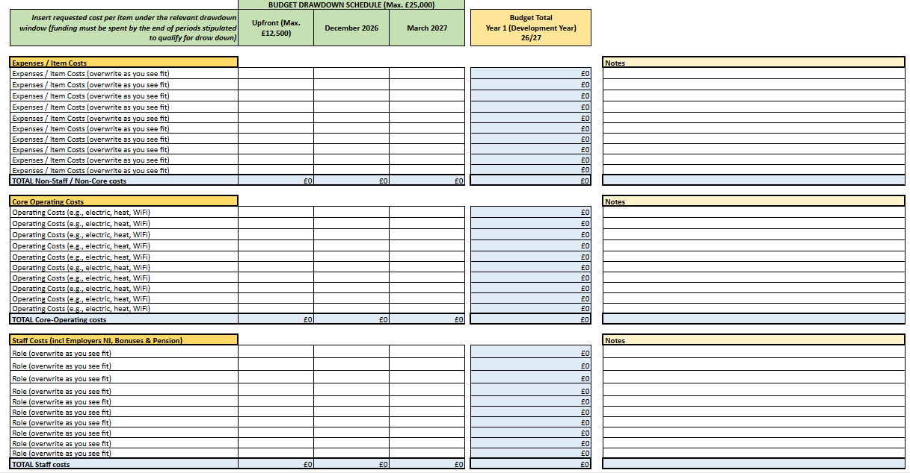

ANNEX B: Programme Plan Tool

