
Coastal Modelling Standards
Date: April 2026
Version: 2.0

We are the Environment Agency. We protect and improve the environment.
We help people and wildlife adapt to climate change and reduce its impacts, including flooding, drought, sea level rise and coastal erosion.
We improve the quality of our water, land and air by tackling pollution. We work with businesses to help them comply with environmental regulations. A healthy and diverse environment enhances people's lives and contributes to economic growth.
We can’t do this alone. We work as part of the Defra group (Department for Environment, Food & Rural Affairs), with the rest of government, local councils, businesses, civil society groups and local communities to create a better place for people and wildlife.

Published by:
Environment Agency
Horizon House, Deanery Road,
Bristol BS1 5AH
www.gov.uk/environment-agency
© Environment Agency 2020
All rights reserved. This document may be reproduced with prior permission of the Environment Agency.
Further copies of this report are available from our publications catalogue: www.gov.uk/government/publications or our National Customer Contact Centre: 03708 506 506
Email: enquiries@environment-agency.gov.uk

Contents
Acronyms and Abbreviations 7
Executive Summary 11
1.1 Background 14
1.2 Target quality standards 14
1.3 Project objectives 15
1.4 This report 16
1.5 Definitions 16
2.0 Methodology 21
2.1 Approach 21
2.2 Main components of open coast flood model 22
3.0 Framework for non-real-time models 26
3.1 Source data 28
3.1.1 Event combinations 29
3.1.2 Sea level 32
3.1.3 Wave data 35
3.1.4 Wave overtopping 39
3.1.5 Climate change 53
3.1.6 Calibration and verification metrics 53
3.2 Pathway data and modifications during storms 62
3.2.1 Storm induced morphology changes 62
3.2.2 Barrier breaching and asset failures 65
3.3 Inundation model 67
4.0 Guidelines for scoring quality of models 71
4.1 General 71
4.2 Quality scoring 71
4.2.1 Non-real time models 72
4.2.2 Real time models 74
4.3 Method for designing model to target standard 77
References 80
Appendix A. Summary of reviewed literature 88
A.1 Coastal practitioners 88
A.2 Scientific papers and consultancy reports 88
Appendix B. Guidelines for scoring non-real-time models 92
B.1 Source-pathway-receptor conceptual model 92
B.2 S1: Event combinations 93
B.2.3 Additional requirements for joint probability contour analysis 95
B.3 S2: Climate change 97
B.4 S3: Coastal water level 99
B.4.1 Coastal water level – tides (astronomical) 99
B.4.2 Coastal water level – storm surge (peaks) 101
B.4.3 Coastal water level – storm surge (profile) 102
B.4.4 Coastal water level – combined tides and surge 103
B.4.5 Coastal water level – wave setup 104
B.5 S4: Coastal wave data 106
B.5.1 Coastal wave data – offshore wave data 106
B.5.2 Coastal wave data – find forcing 107
B.5.3 Coastal wave data – type of nearshore wave model 108
B.5.4 Coastal wave data – validation of nearshore wave model 109
B.5.5 Coastal wave data – validation of emulator 110
B.5.6 Coastal wave data – type of surf zone model 112
B.5.7 Coastal wave data – resolution of surf zone model 113
B.6 S5: Wave overtopping 114
B.6.1 Wave overtopping – calculation method 114
B.6.2 Wave overtopping – AEP calculation method 115
B.7 P1: Bathymetry data 116
B.7.1 Bathymetry – source of bathymetry data 116
B.7.2 Bathymetry – age of bathymetry data 117
B.8 P2: Beach morphology 118
B.8.1 Beach morphology – beach profile data 118
B.8.2 Beach morphology – subtidal nearshore profile data 119
B.8.3 Beach morphology – impact of morphological change 119
B.9 P3: Flood defence data 121
B.9.1 Flood defence data – flood defence geometry 121
B.9.2 Flood defence data – breach scenarios 122
B.10 P4: Topography data 124
B.10.1 Topography – spatial resolution of LiDAR data 124
B.10.2 Topography – Age of LiDAR data 125
B.10.3 Topography – Type of LiDAR data 125
B.11 P5: Land use (OS map) 127
B.12 M1: Flood inundation model type 128
B.13 M2: Inundation model – grid resolution (outputs of interest: water levels & time of inundation) 129
B.14 M3: Inundation model – grid resolution (outputs of interest: water levels, time of inundation and flow velocities) 130
B.15 M4: Inundation model – bed resistance 131
B.16 M5: Validation targets – flooded areas 132
B.17 M6: Validation targets – flood depths 133
B.18 M7: Validation targets – flood depths 134
Would you like to find out more about us or your environment? 135
incident hotline 135
fFloodline 135
Environment first 135

Acronyms and Abbreviations
Abbreviation Description
0D Zero-dimensional (referring to a single point)
1D One-dimensional (referring to a line)
2D Two-dimensional (referring to a plane)
3D Three-dimensional
AAD Annual Average Damages
AEP Annual exceedance probability
AES Atmospheric Environmental Service, now called the Meteorological Service of Canada (MSC)
BODC British Oceanographic Data Centre
CAM Coastal Area Models
CCO Channel Coastal Observatory
CF Correlation factor
CFB Coastal Flood Boundary
CFBD Coastal Flood Boundary Data
CFFS Coastal Flood Forecasting System
CS3X Surge model developed by NOC
CSI Critical success index
DEM Digital Elevation Model
DTM Digital Terrain Model
EA Environment Agency
EAD Expected Annual Damage
ECMWF European Centre for Medium-Range Weather Forecasts
EurOtop European Wave Overtopping Manual
FAR False Alarm Ratio
FEMA Federal Emergency Management Agency
FEWS Flood Early Warning System
FFC Flood Forecasting Centre
FGS Flood Guidance Statement
FNMOC Fleet Numerical Meteorology and Oceanography Centre, Monterey, California, USA
FRA Flood Risk Assessment
FRMRC Flood Risk Management Research Consortium
FWA Flood Warning Area
FWDO Flood Warning Duty Officer
FWLoS Flood Warning Level of Service
FWS Flood Warning System
GIS Geographical Information System
GPEs Gaussian Process Emulators
Hm0 Wave height
HWL High Water Level
IMFS Incident Management Forecasting System
JPA Joint Probability Analysis
JPC Joint Probability Contour
LiDAR Light Detection and Ranging
MAE Mean Absolute Error
MDSF Modelling and Decision Support Framework
MFDO Monitoring and Forecasting Duty Officer
MO Met Office (in the UK)
MQS Model Quality Standard
MVPA Multivariate Probability Analysis
MWD Mean Wave Direction
NaFRA National Flood Risk Assessment
NCEP National Centers for Environmental Prediction, Maryland, USA
NEMO Nucleus for European Modelling of the Ocean (MO Surge model)
NFFS National Flood Forecasting System (superseded with IMFS)
NCLD National Coastal Loading Database
NN Neural Network
NOC National Oceanographic Centre
NRW Natural Resources Wales
POD Probability of Detection
RANS Reynolds-averaged Navier Stokes
RASP Risk Assessment for Strategic Planning
RMS Root Mean Square
RMSE Root Mean Square Error
RP Return Period
RPRR Return period response ratio
RV Response Variable
SEPA Scottish Environmental Protection Agency
SI Scatter Index
SL Sea Level
SLR Sea Level Rise
SPH Smooth Particle Hydrodynamics
SPR Source, Pathway and Receptor
SoP Standard of Protection
SON State of the Nation project (reported in HR Wallingford, 2015a)
SWAB Boussinesq wave model
SWAN Simulating Waves Nearshore
T02 Average Zero Crossing Period
Te Ratio of the energy period
Tp Peak Wave Period
TQS Target Quality Standard
UK United Kingdom
UKCMF United Kingdom Coastal Monitoring and Forecasting
UKCP18 UK Climate Change Projections 2018
UKMO UK Met Office
VOF Volume of Fluid
WAAD Weighted Annual Average Damage
Wdir Wind Direction
WL Water Level
Wspd Wind Speed
WWIII Wave Watch 3

Executive Summary
In 2015, the Environment Agency hired CH2M (now Jacobs) to develop standards for modelling coastal floods. The project was motivated by the need for consistent national standards for open coast flood modelling projects. The Environment Agency’s vision is to make numeric standards and a quality scoring system for models. The numeric grades used for example, 1/2/3/4/5 align with those used in asset management. They will help assess open coast models used for defining flood risk (non-real time).
The Environment Agency (Andrews, 2015) created quality targets to assess model quality at a high level. The large estuary modelling standards project (CH2MHILL, 2015) provided guidance for a detailed evaluation of large estuary flood model quality. This evaluation is based on the source-pathway-receptor (SPR) model. The open coast modelling standards project (CH2M, 2016) did the same for open coast flood models providing guidance and a workbook. The SPR model was used to identify the building blocks of a flood model, grading each element individually. The element grades are combined to determine the model quality score.
Jacobs was asked to update the modelling standards in late 2021. The update would include recent developments on using multivariate probability analysis. It would also improve the verification and calibration metrics in the open coast standards. This work is documented in Section 3 and Appendix B of this report. The present report is based on CH2M (2016), including updates to Section 3 and Appendix B and minor changes to other sections of the report.
Literature review
A review of available literature found many related studies on large estuary modelling standards produced by the Environment Agency and others (CH2MHILL, 2015). They have provided guidance in the form of statements or protocols on many modelling issues but missing a graded system (A/B/C) of flood model quality. The Environment Agency (Andrews, 2015) developed consistent standards for flood modelling. They also provided a high-level assessment for model quality based on a set of simple questions. The large estuary modelling standards project (CH2MHILL, 2015) provided guidance for a detailed evaluation of large estuary flood model quality. This evaluation is based on the source-pathway-receptor (SPR) model. The open coast modelling standards project (CH2M, 2016) did the same for open coast flood models providing guidance and a workbook.
The review covered relevant research on open coast flood modelling providing evidence for how different parts of these models affect model performance. This information has been used in grading the various elements and determining the model quality standard. In this project, we used recent research results on multivariate probability analysis, joint probability contour analysis, and model validation. The research was undertaken in the State of the Nation project. We used the research to update metrics for the relevant elements in the standards.
The research does not provide enough evidence for all the relevant parts. Additional research has been recommended for these parts.
Guidelines on modelling
The model quality standard is assessed based on the quality scores for the following components of the open coast flood model:
1) SPR conceptual model and source data
2) pathway data
3) model build and validation parameters
Each component comprises several elements that are individually scored for quality. The source data has 5 elements. The pathway data has 5 elements. The model build has 4 elements. It gives specific guidance on each element's role in coastal flooding. Guidance on how each element is scored can be found in Appendix B (non-real time modelling). Also, some elements are critical. If the quality of any critical element is poor, the whole model is graded as poor.
Section 5 provides a guide to develop a new model to achieve a target quality standard. A companion Excel workbook tool is provided for use in assessing model quality standard.
Recommendations
A summary of the recommendations from the present work is given below.
More research is needed to understand the effects of parts of the open coast flood model where little or no guidance is available. Additional research is required in the following areas.
Effect of storm-induced changes to beach levels on wave overtopping and hence flood risk.
It is natural to assume that lowering beach levels in storms will raise wave heights at the toe of the defence. But it's unclear if the offshore bar made by the eroded material may limit the wave height at the toe. This could reduce the risk of increased overtopping. We also need tools to predict beach level changes in storms considering both alongshore and cross-shore sediment transport.
Effect of wave setup on wave overtopping volumes.
The evidence on the importance of wave setup in wave overtopping calculations is available from the work of Stansby et al (2013). They used empirical formulas like EurOtop. More tests are needed to compare empirical formulas to advanced ones for wave setup to improve the evidence.
Combined wave overtopping and water overflow when waves break on defence crest.
More research is required to better understand predicting combined wave overtopping and water overflowing. This happens when waves break on the defence crest (negative freeboard). Wave breaking creates induced forces from wave radiation stresses increasing the volume of water that goes over the structure. At present, EurOtop's guidance is a simple superposition of wave overtopping with zero freeboard and water overflowing the defence. They noted that this method is not validated.
Consultation with various stakeholders.
The consultation aims to discuss and agree on the scoring scheme for various quality elements. This is particularly important for elements where the evidence is weak or non-existent.
The consultation will need to discuss the level of validation required for different quality scores. Validation needs will depend on budgets available, intended use, and how any uncertainty will be used. For example, in detailed flood defence design, freeboard must account for uncertainty. This includes the uncertainty in the estimated water level and overtopping volumes if the target quality cannot be achieved.
Recommended update frequency
The evidence used to make the scoring guidelines should be reviewed every 5 years to keep it up to date. The companion Excel workbook tool should be updated (as necessary) at the same time.

1.1 Background
The Environment Agency commissioned a project in 2015 to develop national standards for open coast flood modelling. The vision is to develop standards and a quality scoring framework that will assist in evaluating open coast models. This framework will be used for assessing flood risk and flood models.
Following previous high-level standards work, the project looks to provide guidance and a scoring workbook for detailed quality assessment of an open coast flood model.
During 2021, Jacobs updated the open coast modelling standards. This included recent developments on:
- use of multivariate probability analysis
- improvement of verification and calibration metrics
This report supersedes the 2016 report.

1.2 Target quality standards
National modelling standards were set by the Environment Agency for the following environments:
- coastal
- estuarine
- river
The intended use of the model established the target standards (grade A, B and C) as described below.

1.2.1 A - Design
The grade means that the model achieves the best possible quality at the current state of knowledge and technology. This grade is to minimise any potential error in the modelling process.
The typical uses of such a model are:
- detailed scheme design – such as crest levels, flows, volume
- individual property level protection

1.2.2 B- Appraisal
This grade lies between the lowest acceptable quality and the best available quality. In practice, it may contain elements of both.
The typical uses of such a model are:
- appraisal of flood risk management solutions
- damage estimation based on depth – such as average or estimated annual damages

1.2.3 C- Strategic
The lowest acceptable quality at the current state of knowledge and technology. This grade is to ensure a good balance between project cost and effort.
The typical uses of such a model are:
- catchment or coastal cell – broad scale investment information
- catchment scale development decisions – such as flood zones
- weighted annual average damage (WAAD) estimation
- setting flood alert areas

1.2.4 U- Unsatisfactory
This grade is not satisfactory for flood modelling work at the current state of knowledge and technology.

1.3 Project objectives
The project is to ensure consistent development of open coast flood models for non-real-time flood modelling.
The main objectives of the project are to:
- establish standards for the flood risk management industry on how to build and review open coast models
- support the provision of evidence for flood risk management decisions
- develop a framework for quality scoring of open coast flood models
- assess model quality standards
The framework for scoring models is used to determine if an existing model meets required target standards and identify weak aspects of the model. The framework is also a guide on how to build a new model or update an existing model to meet the required standard.
In this project, the standards have been updated to meet the following objectives:
- incorporate the multivariate method - this is the preferred method for generating open coast boundary forcing mechanisms
- improve verification and calibration metrics within the open coast standards

1.4 This report
The report outlines a quality scoring framework for open coast flood models. It also evaluates the model quality standard for non-real-time flood modelling. The various sections in this report are briefly summarised as follows:
Section 1 project background and definition of key terms
Section 2 methodology used for this study
Section 3 considerations for non-real-time modelling
Section 4 framework for evaluating flood model quality standard and guidelines for modelling to prescribed standards

1.5 Definitions

1.5.1 Open Coast
The coast is a strip of land that extends inland to the first major change in terrain features not influenced by coastal processes.
The main type of coastal features is:
- dunes
- cliffs
- low-lying areas – possibly protected by dikes or seawalls

1.5.2 Source
Source is the origin of a hazard.
Examples include:
- heavy rainfall
- strong winds
- surge
- waves

1.5.3 Pathway
Route that a hazard takes to reach a receptor. A pathway must exist for a hazard to be realised.
Examples include:
- beach
- flood defence
- floodplain

1.5.4 Receptor
Receptor refers to the entity that may be harmed be that a person, property, or habitat. For example, heavy rainfall (the source) flood water may flow across the floodplain (the pathway) and flood housing (the receptor) suffering damage (the consequence). The vulnerability of a receptor can be modified by increasing its resilience to flooding.

1.5.5 Consequence
An impact such as economic, social, or environmental damage or improvement that may result from a flood. It may be expressed:
- quantitatively (monetary value)
- by category (high, medium or low)
- descriptively

1.5.6 Flood
Land that has been covered by water that would not normally be covered by water.

1.5.7 Non-real time flood model
Non-real time flood models are used to establish flood levels and maps corresponding to specified annual exceedance probabilities (AEP). The maps can be defended or undefended and show the areas that flood during such an extreme event. These models are used to plan and design risk mitigation.

1.5.8 Open coast flood model
An open coast flood model (or system of models) can provide information over a given coastal area on:
- flooding times
- extents of flooding
- flood depths
- current speed
The system of models included in open coast flood modelling is described below.
Inundation model
This model simulates the movement of flood waters coming from the sea into the adjoining coastal areas.
The environmental sources of flooding to this model are:
- the time variation of water levels
- wave overtopping volumes at the coastal boundary of the inundation model.
This data is obtained from a nearshore model.
Nearshore model
This model (or system of models) determines the time variation of water levels and wave overtopping volumes. This is at the coastal boundary of the inundation model.
The environmental sources of flooding to this model at the offshore boundary of the nearshore model are:
- the time variation of hydrodynamic conditions - such as tides, surges and currents
- wave conditions – such as wave height, period and direction
The meteorological forcing conditions over the nearshore model area are also required such as wind and pressure. This data is taken from an offshore model.
Offshore model
This model (or system of models) determines the time variation at the boundaries of the nearshore model of:
- hydrodynamic conditions – such as tides, surges and currents
- wave conditions
- meteorological forcing conditions – such as wind and pressure
The offshore model is typically a large-scale regional model that is used to predict the hydrodynamic conditions over large areas. In the UK, the offshore model comprises of the operational UK regional models available at the Met Office.
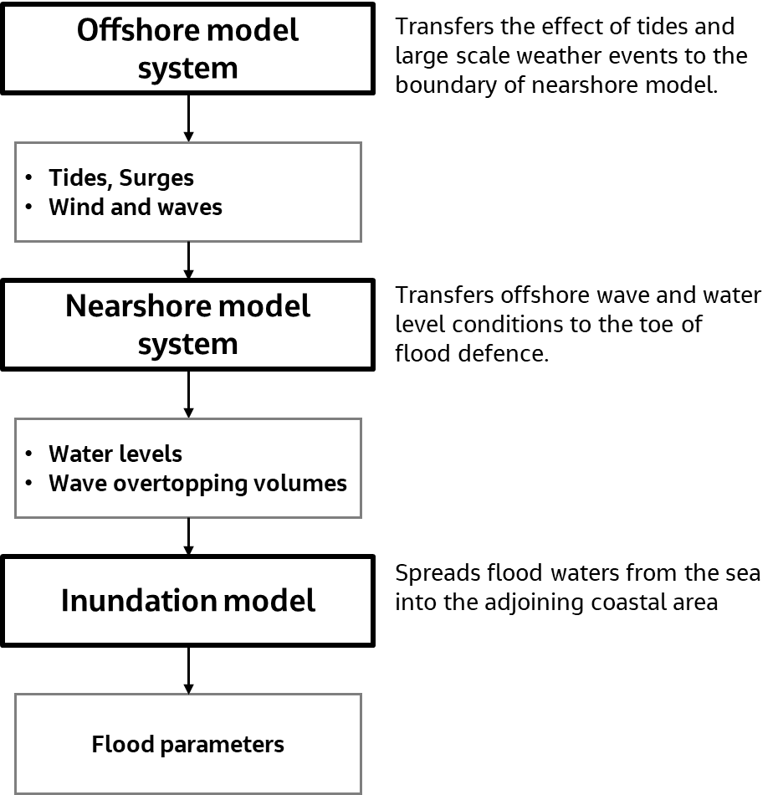
Figure 1.1: Schematic open coast flood model system
The result from the inundation model is the key output from an open coast flood model. The result comprises the flood extents, depths and velocities. These results are used to identify receptors that are flooded and quantify the consequences. It is also used for emergency preparation by the relevant organisations. The quality of the output from the inundation model depends on various parameters such as the accuracy of the:
- source of flooding and the extreme scenarios investigated – this includes coastal boundary conditions that are outputs from the nearshore model system
- representation of the flood pathways – this includes beaches, flood defences and their condition (including likelihood of breach), roads and buildings
- model, or method, used to move the source of flood waters into the adjoining coastal areas

1.5.10 Model quality standard
The model quality standard is a quality score, using a grading system (A/B/C/U). The assigned model quality standard is based on an assessment and scoring of various elements of the open coast flood model. The score is a measure of how well the model determines flood conditions.

2.0 Methodology
Explanation of the study approach and method used to develop the framework.

2.1 Approach
For this purpose, the source-pathway-receptor-consequence (SPRC) model has been used. This model is commonly used for understanding flood models.
As in the preceding section, there are two types of standards. These are:
- the target quality standards (TQS) based on the proposed use of the model
- the realised model quality standard (MQS) which is based on an assessment of various elements of the flood model
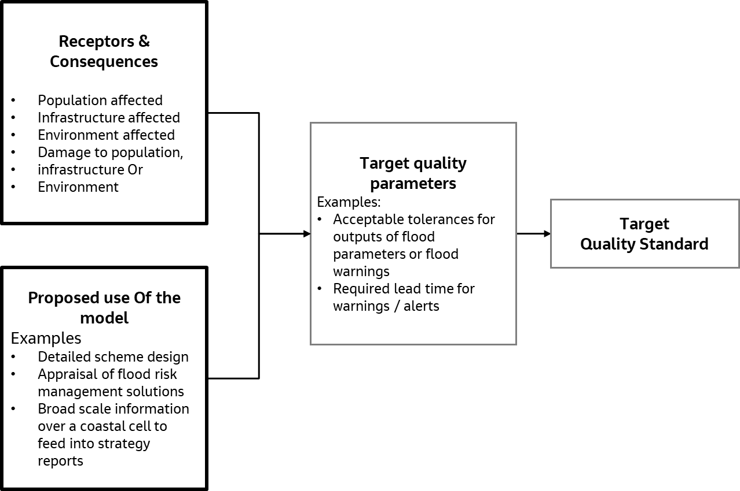
Figure 2.1: Schematic block flow diagram for assessment of Target Quality Standard
The receptors and consequences in combination with the proposed use of the model can be used to set the target quality parameters for the model. This can the feed into the required target standards. The Environment Agency's work delivers consistent standards for modelling. It provides the high-level framework for the project and sets the target standard.
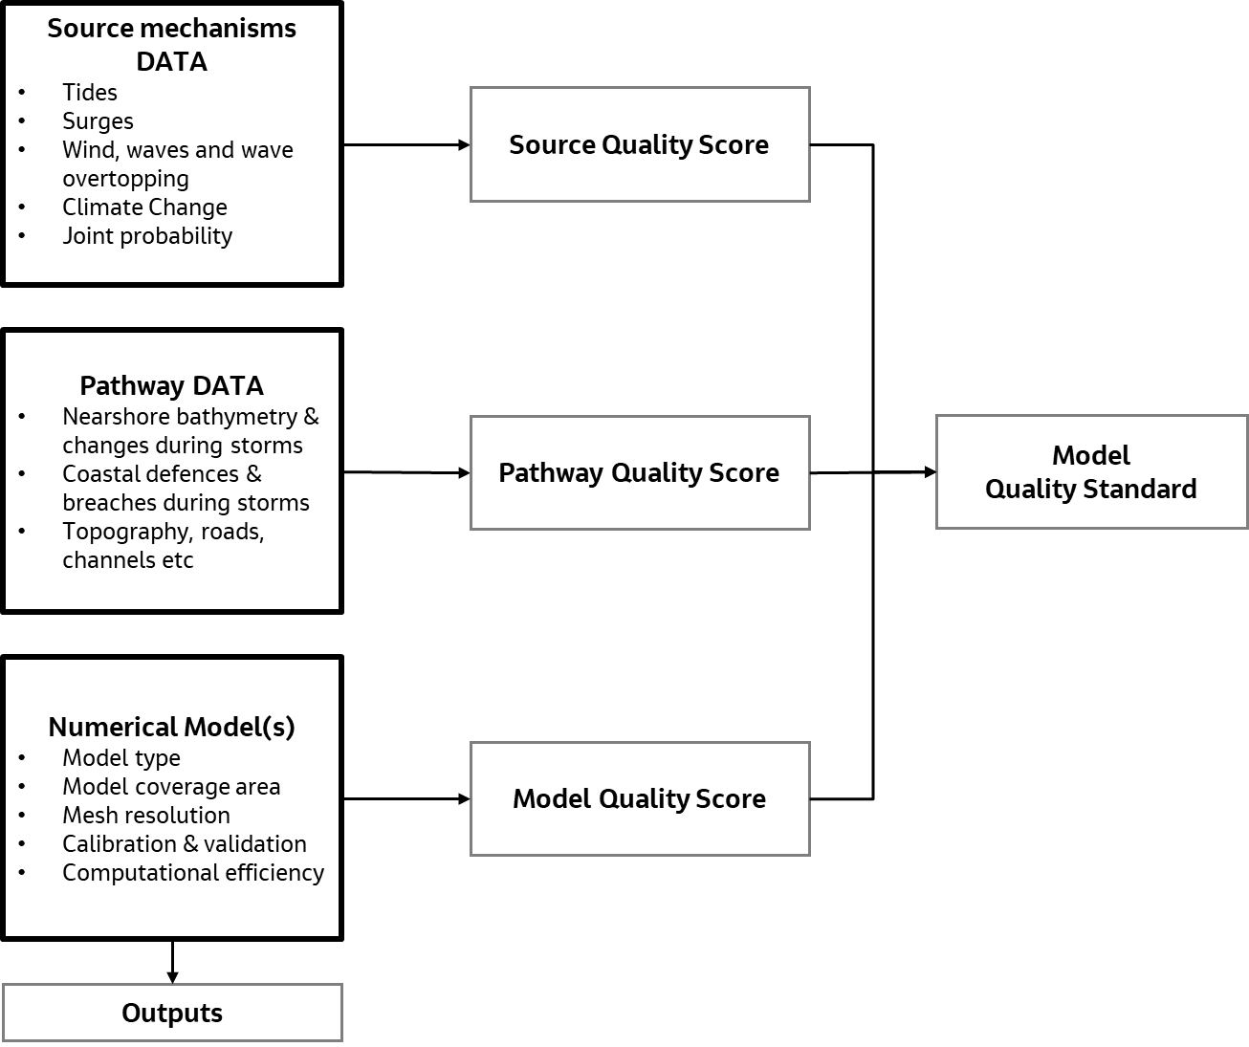
Figure 2.2: Schematic block flow diagram for assessment of realised Model Quality Standard
Figure 2.2. shows that the model quality standard is dependent on the quality score for:
- data used for the source mechanisms
- data used for flow pathways
- numerical model build parameters
This model information is used to simulate flood waters spreading from the sea to coastal areas and helps understand how this water affects receptors. This approach is the same as that used for large estuaries. This approach is transparent and helps to quickly find weak points in any flood model.

2.2 Main components of open coast flood model
Using the SPRC model, the main components of an open coast flood model are described below
A framework is developed for quality-scoring each type of data. The quality score for each dataset is based on an assessment of the uncertainty in the data. It is also based on the effect of the uncertainty on the predicted flood parameters.

2.2.1 Source mechanisms data
Information on sources of flooding is required to predict the flooding extents and depths. The source data comprise information on wind, waves, tides and surges that are potential sources of flooding. For the open coast, this data is reduced to water levels and wave overtopping volumes at the defences. The environmental forcing data includes both primary and derived data. Primary data are forcing data used for modelling such as:
- wind
- offshore waves
- tides
- surge at the coast
Derived data are created from the primary data. This includes:
- nearshore waves
- wave overtopping volumes
- wave setup
The impact of climate change on this data is also considered. Joint probability analysis methods used to determine the intensity of these sources for a specified event is important for event-based non-real-time modelling.

Tides
High tides mean high water levels. In combination with high storm surges this can results in
- wave overtopping of flood defences
- water level overflowing defences
In either case, the result is flooding in coastal areas.

Storm surge
Storm surges are created due to wind and low atmospheric pressures during storms. Storm surges move over the continental shelf and can result in large increases of water above the astronomical tidal level.

Waves and wave overtopping
High waves can cause significant overtopping of defences at high waters, leading to flooding of landward areas.

Climate change
Effect of climate change on forcing mechanisms. This can be in the form of:
- raised sea levels
- increased storminess – wind and waves
- long term changes to the beach levels at the toe of defences due to sea level rise
These factors need to be considered in flood hazard mapping for future events

Joint probability analysis
Flooding on the open coast depends on a combination of several forcing mechanisms described above. Accounting for the joint occurrence of main forcing mechanisms in flood hazard mapping with specific recurrence intervals is crucial.

2.2.2 Pathway data
The pathway data comprise of:
- bathymetry
- topography
- potential breaches through flood defences
- other features (natural and man-made)
These can influence the movement and spreading of flood water in coastal areas. A good description of the key flood pathways is important for providing an accurate prediction of where the flood waters will move to. The pathway data is described below.

Bathymetry

Propagation of tides, surges, and waves in nearshore areas depend on accurate bathymetry data.

Coastal defences
The wave overtopping and/or water overflowing a defence depends on the geometry of the defence. Damages to defences can lead to early breaching of the defence and can lead to changes in flow paths and flooding patterns.

Coastal erosion
Coastal erosion can result in reduced beach levels at defences and can lead to increased incident wave height and wave overtopping volumes. It can also lead to undermining of coastal defences and potential failures leading to a breach. A breach in the line of defence can let flood waters pass through. Coastal areas with sedimentary material should be identified. The potential effect of nearshore bathymetry changes should be considered in model development. This is especially the case for areas experiencing long term coastal erosion or coastal change.

Topography
This is important for describing the land levels used in inundation modelling.

2.2.3 Model construction, validation, and production
To identify the receptors of floodwater, it is important to identify the land areas affected by flooding. This task is conducted with a numerical coastal flood model using input data on the sources and pathway. The type of model used and how the model is built are very important to consider getting accurate predictions of:
- areas affected by flooding
- flood depths
- current speeds
The model construction data is described below.

Model type and physical processes included in the model
The type of model used for different components of the open coast flood modelling will be evaluated and quality scored. This is important as there are various choices to make at various stages of coastal flood modelling.

Model coverage and mesh resolution
This is important to capture the required details in the coastal area, including:
- bathymetry
- channels
- infrastructure

Model calibration and validation metrics
Model calibration is used to get the optimal model parameters that are:
- not measurable – such as bed roughness
- measurable parameters that are not known – such as bathymetry in some areas
- accounting for model simplifications
Model validation is to measure how well the calibrated model is reproducing events not used in the calibration. Appropriate model validation metrics are specified and used in the quality scoring of the model. The validation of the entire model complex will need to be based on how well the flood events, or frequencies, are reproduced.

3.0 Framework for non-real-time models
Information on several aspects of open coast flood modelling were brought together from:
- scientific literature
- consultancy reports
- feedback from coastal practitioners
A list of these publications and practitioners are available in the main report.
The evidence from the literature review is used to discuss the key elements of an open coast flood model. Fourteen elements have been considered for determining the quality standard of an open coast model. These comprise of:
- 5 elements for source of flooding data
- 5 elements for pathway data
- 4 elements for the inundation model
Each element may also be divided into two or more sub-elements as listed below.

Source data elements
Event combinations include:
- probability analysis
- additional requirements for multi-variate probability analysis
- additional requirements for joint probability contour analysis
Coastal water levels include:
- storm surges
- astronomical tides
- combination of surge and tides
- wave setup
Coastal wave data includes:
- offshore wave and wind data
- type of nearshore wave model
- validation of nearshore wave model
- emulator validation
- type of surf zone wave model
- resolution of surf zone wave model
Wave overtopping includes:
- coastal water level (covered above)
- coastal wave data (covered above)
- defence data (covered in pathway data)
- beach morphology (covered in pathway data)
- overtopping calculation method
- calculating method for exceedance probability
Climate change includes:
- sea level rise
- storminess
- long term effect on other parameters (such as beach level, nearshore wave conditions and overtopping volumes)

Pathway data elements
Pathway data elements include land use data (OS maps) and those shown below.
Bathymetry includes:
- source of data
- age of data
Defence data includes:
- defence geometry
- breach scenarios
Beach morphology includes:
- beach profile data
- subtidal profile data
- effect of storms on beach profile
Topography data includes:
- spatial resolution of Light Detection and Ranging (LiDAR) data
- age of LiDAR data
- type of LiDAR data

Inundation model elements
Inundation model elements include:
- type of flood inundation model
- model grid resolution
- bed resistance mapping
- model validation or sensitivity tests

3.1 Source data
Good information on the source of flooding data is important to predict flood extent and depths. For the open coast, this data is the water overtopping volumes at the defence. When the still water level is lower than the crest level of the defence, overtopping of the defence is due to wave overtopping. When the still water level is higher than the crest level of the defence overtopping is caused by the water level. When the water level is at or just above the crest level of the defence, the overflowing water is from both waves and still water. Accurately calculating wave overtopping and still water levels at defences is important to give good information on coastal flooding.
Figure 3.1 is a schematic representation of the key steps for wave overtopping calculations. For ease of understanding how the key steps feed into the final calculation, they are described from the bottom-up.
The wave overtopping calculations require the following inputs:
- still water level at the toe of the defence
- wave data at the toe of the defence
- geometry of the defence
When this data is available, the wave overtopping volumes can be calculated. Where data at the toe is not available, you can transform nearshore wave data across the beach profile to the toe of the defence. If nearshore wave data is not available, you can create this by transforming offshore wave data to nearshore areas. This includes:
- effects of wave transformation over the bathymetry
- wind forcing
- changing still water levels
The still water level, wave, and wind data are the environmental forces that contribute to flooding. The bathymetry, beach profile, and defence geometry are pathways carrying the environmental forces to the boundary of the inundation model.
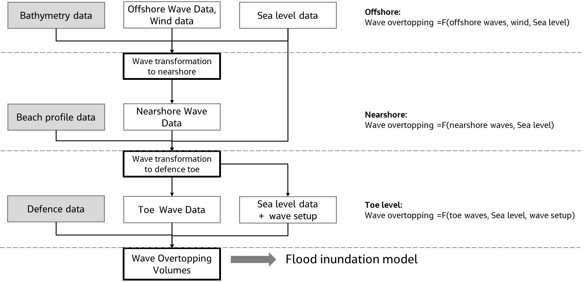
Figure 3.1: Schematic illustration of key steps for wave overtopping calculations.

3.1.1 Event combinations
AEP is used to specify the rarity of an extreme event. The AEP is the probability that a given event will be equalled or exceeded each year. For example, a flood event that occurs on average once in 100 years has a 1 in 100 chance of occurring in any given year. For example, AEP = 1%.
The standard of protection (SoP) of a flood defence is the AEP below which the defence will be overtopped. A flood defence with SoP of 1% (1 in 100) will be overtopped by a storm event corresponding to 0.5% (1 in 200). Flood maps are calculated for specified AEPs.
The AEP for a storm event is determined by various selected environmental forces. As coastal flooding depends on many variables you must specify the combination of these variables that result in a specified extreme event.
The method for identifying the combination of variables is based on analysing extreme value probabilities. The data available should cover several decades (over 40 years) to be useful for extreme value analysis. The events can be determined at different stages in the calculation. These stages are offshore, nearshore and at the toe depending on where data is available. This is described in the sub-section below.

3.1.1.1 Offshore
If the extreme value analysis is carried out offshore, data on waves, wind and sea level are required. If the wave spectrum is unimodal waves can be characterised by:
- wave height (Hm0)
- peak wave period (Tp)
- mean wave direction (MWD)
This is usually the case in storm conditions when wind created waves dominate.
If the wave spectrum is known to have multi-modal, you will need extra parameters to describe the wave conditions. Extra parameters are needed for multi-modal waves. They are the wave parameters (Hm0, Tp, MWD) for each part of the wave spectrum.
Wind can be characterised by wind speed (Wspd) and wind direction (Wdir). The total number of parameters are six;
- Hm0
- Tp
- MWD
- Wspd
- Wdir
- Sea level (SL)
The offshore wave parameters are used to specify the wave conditions at the offshore boundary. As the waves propagate over the model area, the wind forcing results in extra wave growth. This depends on wind speed and the distance over which the wind blows. The sea level (SL) is important in shallow and transitional waters. The sea level affects the water depth, and hence affects shallow water wave processes. This includes as:
- refraction
- shoaling
- wave dissipation due to breaking and bottom friction

3.1.1.2 Nearshore
Extreme value analysis can be carried out at a nearshore location if long-term wave data is available. In this case, the effect of wind forcing on waves is negligible over the 100m to 500m length of the nearshore profile. For example, the wave generated over a fetch of 100m to 500m is 0.1 to 0.25m high. This is based on wind speed of 20 m/s and average depth of 5m using fetch limited wave growth curves in the Coastal Engineering Manual (USACE Publications - Engineer Manuals). Wave dissipation due to wave breaking is also expected to dominate in the surf zone. When the extreme value analysis is carried out at the nearshore, four variables should be considered. These variables are Hm0, Tp, MWD and SL.

3.1.1.3 Toe
You can undertake the extreme value analysis at the toe of the defence if long-term wave data is available. In this case four variables (Hm0, Tp, MWD and SL) should be considered. If the sea level data does not include wave setup this can introduce errors in the determination of wave overtopping. If using a 1D wave model you should include the computed wave setup in the sea level before undertaking the extreme value analysis.

3.1.1.4 Methods for carrying out probability analysis for event combinations
The common methods used for determining the event combinations are described below.
None
In this case, joint probability analysis is not carried out. The events are combined based on their individual marginal probabilities. The event combinations with AEP of 1 in X consist of the events with AEP of 1 in X for each environmental variable. This assumes that wave and sea levels are dependent. This assumption is not valid along many coasts. For example, along coasts with high tidal ranges, with a mean range greater than 2m. High tide levels do not always occur with high waves since tides are of astronomical origin whilst waves and storm surge are of meteorological origin. This approach results in excessively conservative design.
Defra/EA desk study method
The method accounts for dependence between two events (A and B). You use a correlation factor (CF) or correlation coefficient (ρ) to modify the joint probability that is calculated. This assumes the events are independent. This method is described in Defra/Environment Agency (2005). The method outputs discrete pairs of variables satisfying each selected joint exceedance AEP.
The Defra/EA report provides some guidance for CF values at various locations along UK coast. This is based on detailed studies looking at the link between high water levels and wave heights, or surge level and precipitation. Some practitioners used the Spearman’s rank correlation coefficient or Spearman’s ρto measure the statistical dependence between two variables. This is to find the correlation coefficient and is then converted to the CF value.
This method deals only with two variables, typically high-water levels and waves. This method can be very sensitive to the assumed correlation coefficient (ρ) or CF. A 25% increase in ρ can lead to estimated joint probability curve for the 1 in 100 AEP becoming 1 in 200 AEP. Similarly, a 25% reduction in ρ can move the 1 in 100 AEP down to a 1 in 50 AEP. Care must be exercised in selecting the correlation coefficient.
Simplified joint probability method
In this method, high water levels are split into two components:
- astronomical tides
- meteorological storm surges
The astronomical tides and high waves are assumed to be completely independent. The chance of high waves and high tides occurring together is a product of their separate probabilities. Storm surge and waves are assumed to be completely dependent. The chance of both storm surge and high waves is equal to the chance of storm surge or high waves. Based on these assumptions, you can find pairs of high-water level and high waves with a given joint exceedance probability.
This method also deals with two variables – high water levels and waves. It is based on simplifying assumptions of dependence between tides/surge and waves.
JOINSEA method
This is a rigorous joint probability method for two variables. These are wave height and water level. The method involves determining the marginal extremes of the individual variables and fitting a statistical distribution describing the dependency between the variables. You use the fitted distributions to make a 10,000-year synthetic record using the Monte Carlo method. The contours of specified joint exceedance probability are determined using the countback technique. The method is described in HR Wallingford (1998).
For a given AEP, selected combinations of the two variables can be used to determine overtopping. The worst combination is used for flood modelling. This is the joint probability contour approach. An alternative approach is to use the long synthetic record of the two variables to calculate wave overtopping. Thereafter determine the values for specified AEP using the countback technique. The latter approach is more rigorous but involves more effort. Especially if the analysis is carried out offshore and the waves need to be transformed nearshore and to the defence toe.
Multivariate probability method
This method is based on the approach of Heffernan and Tawn (2004) to determine joint probability combinations for many variables. Gouldby et al (2014) applied this method for determining probability combinations for:
- wind
- waves
- water levels
A multivariate extreme value method is applied to the available dataset. A Monte Carlo sampling procedure is applied to synthetically generate large samples of events. The generated large sample of events cover extreme variables that are not captured in the available dataset.
This method was used in the State of the Nation project. It derived a 10,000-year sample of extreme nearshore waves and water levels around the coast of England. In the project, the analysis was carried out offshore and transformed to nearshore locations. It is not practical to use advanced wave transformation models for the large sample of events. This method also requires the use of meta-models (emulators) to approximate computationally intensive spectral wave models (simulators).

3.1.2 Sea level
Nearshore extreme sea levels are required for wave transformation modelling and overtopping calculations. Sea levels at the toe of defences on the open coast are made up of astronomical tide, storm surge and wave setup.
Current UK practice is to get the extreme nearshore water levels from the Coastal Flood Boundary (CFB2018) dataset. This will provide extreme water levels and surge profile shapes. This is available from the CFB dataset (Environment Agency, 2019) around the UK coast. The State of the Nation project used the CFB2008 dataset. This was used alongside the class ’A’ tide gauge data and a couple of EA tide gauges (HR Wallingford/Environment Agency, 2015).
Wave setup is typically not included in nearshore extreme water levels. This is discussed further in section 3.1.2.1.

3.1.2.1 Wave setup
Wave setup is the increase in still water level due to breaking waves induced forces. On a plane beach slope, the wave setup increases linearly from zero at some point in the surf zone until it reaches a maximum at the shoreline. This increase in water level reduces the effective freeboard leading to an increase in the predicted overtopping rates. The Flood Risk Management Research Consortium 2 (FRMRC2) study (Stansby et al, 2013), found by using EurOtop that estimated wave overtopping volumes increase by as much as 30%. This includes wave setup in the calculation of the still water level at the toe of the structure. They also found best agreement between EurOtop and their Boussinesq wave model (SWAB) when the effect of wave setup in water level was used. See also section 3.1.4.
According to the EurOtop 2 (2018) manual, “...wave set-up is implicitly reproduced in the physical model tests on which the overtopping equations are based (over the length of foreshore reproduced in the model). There is, in general, no requirement to add on an additional water level increase for wave set-up when calculating overtopping discharges using the methods reported in the document, unless the foreshore is very long and very gently. In that case numerical models should give the wave set-up one or two wave lengths in front of the toe of the structure…”
According to EurOtop 2, it is not necessary to include the effect of wave setup in the EurOtop wave overtopping equations. A wide range of foreshore slopes were used to derive the EurOtop equations. The influence of wave breaking and changes in mean water level is not explicitly included in the equations. Only represented in the equations only on average. The EurOtop Neural network (NN) tool does not explicitly include the effect of the foreshore. The possible contribution of wave setup should be considered for each project depending on the foreshore characteristics and the location of the defence.
For gentle beach slopes, the wave setup at the shoreline is about 10% of the breaking wave’s height. For moderate storm events with wave heights of 2 to 3m at breaking, 0.2 to 0.3m can be added to still water level at shoreline. Depending on the location of the toe of the defence, an increase in still water level of up to 0.2 to 0.3 m can occur at the toe. Neglecting this value is the same as using combined tide and surge level for the 1 in 20 AEP instead of the 1 in 200 AEP. Figure 3.2 shown that the difference between the 1 in 200 AEP extreme sea level and 1 in 20 AEP is 0.3m or lower. This was at 26 out of 49 stations analysed in Environment Agency (2019). The difference between the 1 in 200 AEP extreme sea level and 1 in 50 AEP is 0.3m or lower. This is at 47 out of 49 stations analysed in Environment Agency (2019).
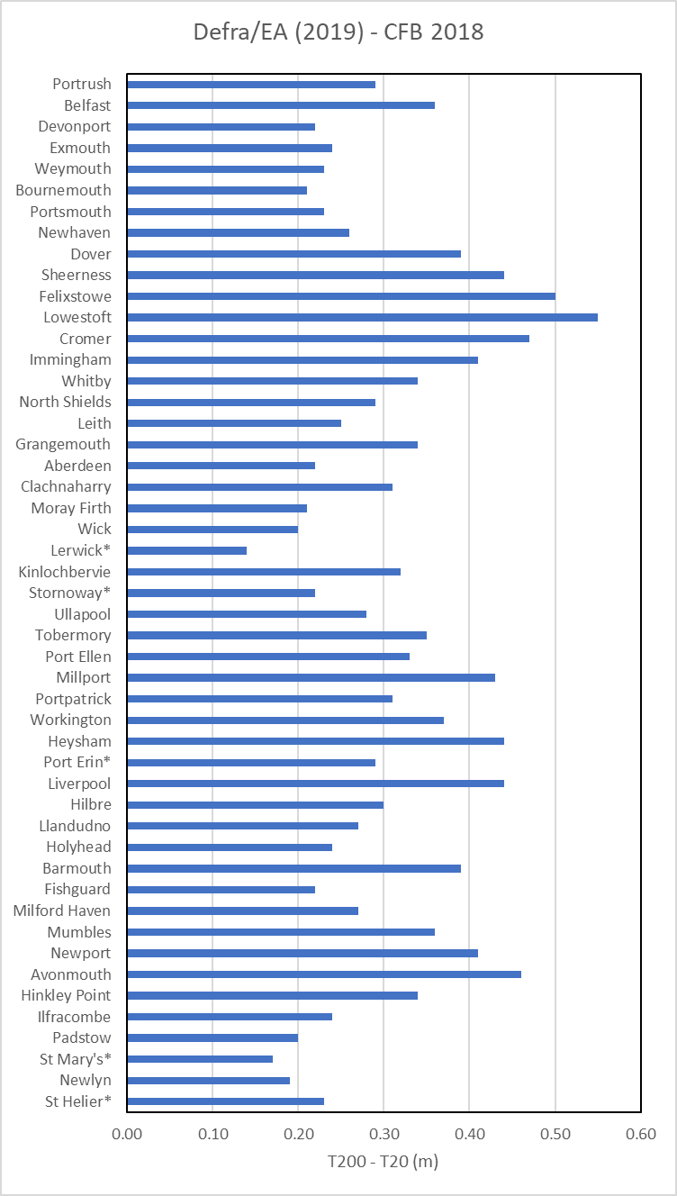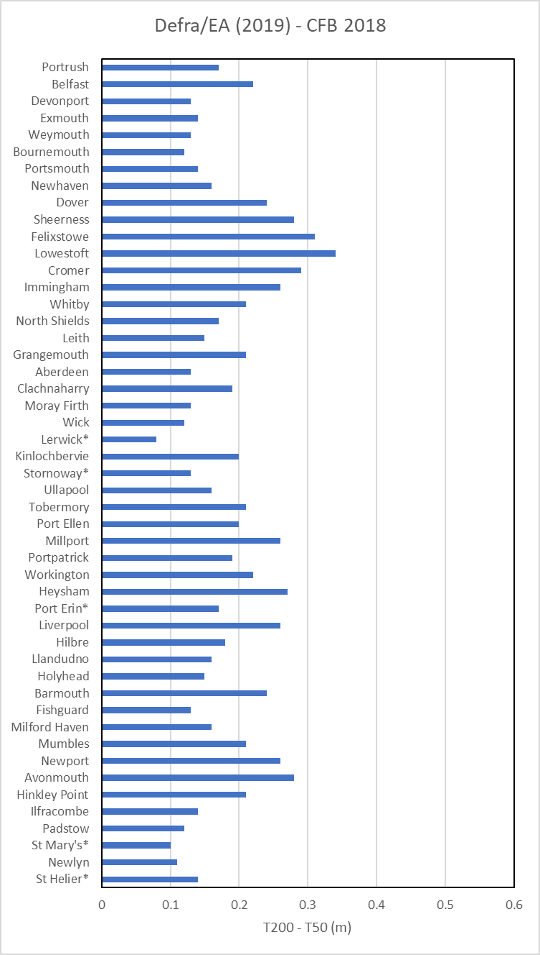
Figure 3.2: Difference between the extreme sea level (central estimate) for the 1 in 200 AEP and 1 in X AEP. Left panel: X=20, Right panel: X=50. Data from Environment Agency (2019).
Detailed numerical models include the effect of wave setup to predict wave overtopping. It is not necessary to separately include the effect of wave setup if such models are used. In summary, not including wave setup may lead to underestimating wave overtopping volumes if using empirical formulas such as EurOtop.
The methods commonly used for calculating wave setup are:
- simple relationship between breaking wave height and wave setup
- combined 1D wave and hydrodynamic model
For the simple relationship, some authors have used simplifying assumptions to derive maximum wave setup at the shoreline. They use assumptions about plane beach slope and breaker criterion. Goda (2000) computed the wave setup at the shoreline using a random wave breaking model for a plane beach slope. They developed a family of curves relating wave setup to wave steepness for different beach slopes. For slopes of 1/50 to 1/100 and deepwater wave steepness of 0.005 to 0.010, the wave setup is 13% to 17% of the deepwater wave height.
The combined method uses a 1D wave and hydrodynamic model to calculate wave conditions and radiation stresses along a beach profile. It can be combined with the momentum equation to determine wave setup. Examples of such models are: SWAN1D or LITPACK.

3.1.3 Wave data

3.1.3.1 Offshore wave data
The nearshore wave model uses offshore wave data from the Met Office hindcast wave models. If wave buoy data is available, you will check the modelled offshore waves. For example, you will check SON (Stuiver, 2015). In the SON project, the Met Office model was compared with data from wave buoys. The data was adjusted slightly at locations where it was needed (only on the northeast coast). In the FRMRC2 study, the POL-WAM model was also compared with wave buoy measurements. The data was found to underestimate the wave height at the peak of the storm on 9-Nov-2007. The underestimation is about 1.5 metres. You must assess and consider potential underestimation in offshore wave conditions. This is key to getting accurate results.
The offshore boundary for the wave model is typically tens of kilometres long. It is important to ensure that the offshore wave data varies along the boundary. In the FRMRC2 study, the effect of using different types of offshore boundary data was investigated. For a study on the UK east coast the boundary data types investigated were:
- uniform wave parameters along boundary
- spatially varying wave parameters along boundary
- spatially varying wave spectra along boundary
It was concluded that the three boundary conditions produce very similar estimates for the peak of the storm. The discrepancy in significant wave height below 0.1m. This result cannot be generalised. The spatial variation in offshore wave conditions is expected to vary with the size of the:
- storm
- location and length of the offshore boundary
- the presence of offshore islands or headlands, that shelter waves from particular directions

3.1.3.2 Types of nearshore wave models
A wave model is often used to transform offshore wave conditions to the toe of the flood defence. Important wave processes that are required in such a model include:
- local wind-wave generation between the offshore location and the coast
- refraction and shoaling
- shallow water wave dissipation processes (due to wave breaking and bottom dissipation)
- diffraction and/or directional spreading (especially in the vicinity of offshore islands or nearshore sand banks)
A list of the commonly used wave models in connection with coastal flood modelling are below. Application areas and limitations are also included. Models may underestimate nearshore wave heights. This is due to models excluding the effect of local wind-wave generation during storm events except at locations where the waves are depth-limited. Such models include the Boussinesq wave models or mild slope models. These models require more computational effort and are not normally used in coastal flood modelling.

Type 1 wave model: 2D parameterised spectra wind-wave model
Example models are: HISWA, MIKE 21 NSW and parametrised version of MIKE 21 SW. This model solves a parameterized version of the 2D wave action equation. The wave action frequency spectrum is defined by its zeroth and first moments. The directional spectrum is preserved. The method can transform wave conditions from offshore to nearshore, or to the defence line (depending on model resolution). The model run time is typically minutes to hours.
The model has the following limitations:
a) The method assumes a spectral shape by its nature. It cannot simulate mixed seas and swells with double-peaked wave spectra.
b) The method does not consider the effect of wave reflection at structures. Thus, the method cannot be used for wave modelling in harbours.
c) The method does not consider the effect of wave diffraction around islands. Offshore islands typically shelter nearshore waves. This is due to random waves spreading in different directions. Hence, this limitation is usually not important in many practical cases
Type 2 wave model: 2-dimensional fully spectra wind-wave model
Examples are: SWAN, MIKE 21 SW (fully spectral version), and TOMAWAC. This method solves a parameterised form of the 2D conservation of wave action equation. The wave action frequency spectrum is defined by its zeroth and first moments. The directional spectrum is preserved. The method can transform wave conditions from offshore to nearshore, or to the defence line (depending on model resolution). The model run time is typically hours to days.
The model has the following limitations:
a) The method does not consider the effect of wave reflection at structures. Thus, the method cannot be used for wave modelling in harbours.
b) The method does not consider the effect of wave diffraction around islands. Offshore islands typically shelter nearshore waves. This is due to random waves spreading in different directions. Hence, this limitation is usually not important in many practical cases

An extended list of wave models can be found in Defra/EA (2004). Models that ignore local wind-wave generation during storms likely underestimate nearshore wave heights, except where waves are depth-limited. Such models include the Boussinesq wave models or so-called mild slope models. Also, these models require much more computing power. These models are not usually used to transform offshore waves to nearshore areas in coastal flood modelling.
The State of the Nation Project (HR Wallingford, 2015) transformed offshore waves to the structure's toe in two stages. A 2D spectral wave model transformed offshore to nearshore (5 m contour) waves. A 1D spectral model transformed nearshore to the structure toe waves. This 2-stage approach allows for sensitivity testing of beach profiles and structure geometry. It does this without re-running the offshore to nearshore wave model.
Other practitioners, like those at CH2M (now Jacobs), have used a 2-stage approach. It transforms offshore waves to nearshore (say 5 m contour) using a 2D spectral wave model. A 1D model then transforms the waves from the nearshore depth to the toe of the structure.

3.1.3.2 Wave data setup associated with the Multivariate approach (SoN)
The wave data at the toe of the defence is determined using a wave model. This is typically a spectral wave model. The wave data can be found in two wave transformation steps, as used in the State of the Nation project. See Figure 3.3. Another option is in one integrated wave transformation step.

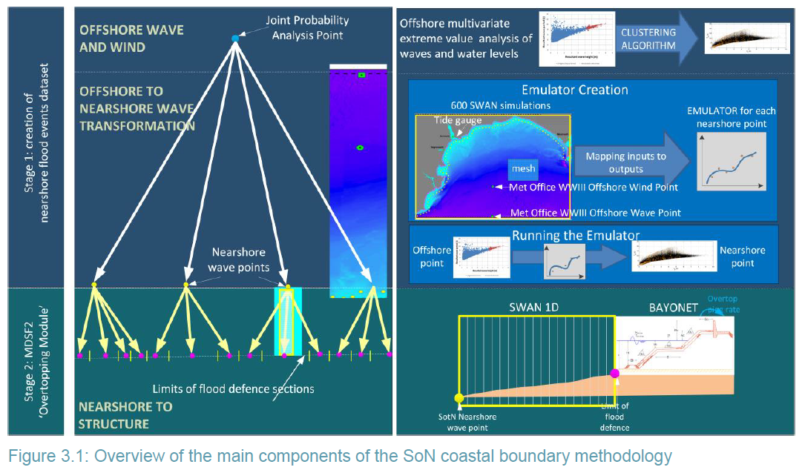
Figure 3.3: Overview of the main components of the SoN coastal boundary methodology

In the 2-step approach, a 2D spectral wave model does two things. First, it transforms the offshore waves and winds to nearshore areas. Next, a 1D spectral wave model is used to transform the nearshore waves to the toe of the defence.
You would need to run 500,000 to 800,000 simulations to get 10,000 years of results data. However, using Gaussian Process Emulators (GPE) can reduce this to 1000 to 5000 simulations.
Advantages in the 2-step approach
- the 2D offshore spectral wave model only needs to reflect the bathymetry. It doesn't need to be finer to compute wave decay. So, simulations can be quicker.
- 1D nearshore spectral wave models are 100 times faster than 2D ones
- the 1D spectral wave model better accounts for wave setup. It has a specific option for calculating it
Disadvantages in the 2-step approach
- extract data from the offshore model. Then, enter it into the nearshore model for 1,000 to 5,000 simulations.
- extract data from the nearshore model. Then, enter it into the Overtopping model for 1000 to 5000 simulations.
- for each change in the defence profile, a separate 1D spectral wave model is required. So, if 20 profiles represent the defence, 20 models are needed.
In the 1-step approach, we use a 2D spectral wave model. It transforms the offshore wave conditions and wind directly to the toe of the flood defences.
Advantage of the 1-step approach
- wave conditions can be extracted directly at all the defence toe locations for between 1000 & 5000 simulations
- data only needs to be extracted and re-entered once between the 2D model and the Overtopping model for between 1000 and 5000 simulations
Disadvantages of the 1-step approach
- 2D spectral wave model resolution must be fine enough in the nearshore to be able to compute wave decay, increasing simulation times
- to account for wave setup, requires coupling a 2D hydrodynamic model with a spectral wave model. This will increase simulation times
- storm induced bathymetry changes require significantly more analyses and computer time

3.1.3.3 Validation of nearshore wave model
The validation metrics for the nearshore wave model is described in section 3.1.6.

3.1.3.4 Surf zone wave model
1D wave models solve the wave action equation. They solve it in the direction perpendicular to the coast. The wave conditions in the direction parallel to the coast are assumed to be uniform. The model is valid for transforming wave conditions from a nearshore location to the toe of the flood defence. The location will be close to the shore and the bathymetry contours are locally straight and parallel. You usually exclude the effect of local wind-wave generation. It’s not important near the coast.
The method does not include the effect of 2D variation in bathymetry. It also does not include the effect of sheltering from coastal structures. So, do not use it to transform waves from the open ocean to the nearshore.
A list of the commonly used 1D wave models is summarised below:
Type 1 surf model or Goda’s method
This method assumes a plane beach profile. It incorporates Goda’s description of wave breaking in random waves. The method can be applied along beach profiles where a plane slope can approximate the beach profiles. The method is not applicable if bars are present on the profile. The typical computational time takes seconds.
Type 2 surf model or parametric spectral wave model
This method solves the 1-D conservation of wave energy equation on a general beach profile. This is parameterised as Hm0 and MWD. It includes the effect of depth-induced wave breaking using Battjes and Janssen’s method. The effect of directional spreading of wave energy is also included. You can apply this if the mesh resolution resolved the profile features. The method can be applied along any beach profile. This doesn’t matter is bars are present or not if the mesh resolution is adequate to resolve the profile features. The typical computational time takes seconds to minutes. An example software is LITPACK.
Type 3 surf model or fully spectral 1D wave models
This method solved the 1-D conservation of wave energy equation (fully spectral model) on a general beach profile. The model includes the effect of depth-induced wave breaking using the Battjes and Janssen’s method. The effect of distribution of wave energy in frequency and direction is also included. The method can be applied along any beach profile. It works even if bars are present if the mesh resolution is adequate to resolve the profile features. The typical computational time takes seconds to minutes. An example software is SWAN1D.

3.1.4 Wave overtopping
During storm conditions overtopping of water can occur at coastal defences. This is due to high waves and raised water levels. Two types of overtopping conditions are distinguished, namely:
- positive freeboard - overtopping when still water level is lower than structure crest level
- negative freeboard - overtopping when still water level is above structure crest level
In the first case, when the water level is below the crest, high waves break in front of the structure. This can cause spray and water overtopping the defence impacting the landward side. Many studies have been carried out to quantify the volume of overtopping water in this case. These studies have included laboratory experiments and numerical models. The results of these studies are summarised in section 3.1.4.1. The case of combined wave overtopping and still water overflow is addressed in section 3.1.4.2.

3.1.4.1 Type of overtopping model
Wave overtopping calculations are required to give the overtopping rate at the boundary in the inundation model. Wave overtopping calculations have large uncertainties. Even with the best methods, the error is likely to be at least a factor of ten (Hunt, 2015).
The methods available to calculate wave overtopping rates are summarised below. These are from EurOtop, (2007) and Defra/Environment Agency (2008).
Empirical formulas
Examples are EurOtop and Hedges and Reis (1998).
This formula calculates overtopping rates. It uses wave parameters and water depth at the toe of the structure and uses the structure’s geometry. The formula is based on results from field and laboratory datasets and is very simple to use.
According to EurOtop (2018), the accuracy is at best within a factor of 1 to 3. The largest errors are for small overtopping discharges. Many actual structures differ from the idealised versions tested in labs so will not predict overtopping as well as structure-specific model tests.
The application is limited to a few simple structure configurations. Use outside of this range would require extrapolation and may not be valid.
A neural network approach was developed to use the CLASH database of overtopping test results. For example, BAYONET, EurOtop NN.
Nonlinear shallow water equation models
Examples are AMAZON, ANENOME and ODIFLOCS.
1D nonlinear shallow water equations are simplified forms of the Navier-Stokes equations. Only applicable in shallow water (h/L<0.05).
Waves travel as a bore. At the crest of the structure the model can compute the flow either side of the crest, overtop or return.
Uses real profiles, not the simplified structure configurations used in the empirical methods and are relatively quick to run.
Boussinesq wave model
Examples are SWAB, MIKE 21 BW 1D.
It can transform nearshore waves through the surf zone to the structure crest. It does this to determine the wave-by-wave overtopping rates.
This approach has high computational requirements so is not commonly used in practical applications.
Navier-Stokes models
Use either to Volume of Fluid (VOF) method or the Smooth Particle Hydrodynamics (SPH).
Currently not suitable for engineering application due to exceptionally high computational requirements. The method requires several minutes to simulate fractions of a second in real time.
Physical models
Used to develop empirical formulas.
It is an established and reliable method. It predicts overtopping volumes and optimises coastal defence designs.
Not suitable for direct use in flood modelling due to the high cost and timescale of setup and testing.

3.1.4.2 Overtopping worked examples and recommendation for a single method
Currently the EurOtop empirical formulas are the most used method. The EurOtop Neural Network method is often used (Burgess, 2015; JBA Consulting, 2008 and 2010, and Hunt, 2015). This utilises the database of physical model testing to determine overtopping rates. AMAZON is a numerical model that can be used for non-standard profiles that don’t match the EurOtop standard cross sections (Royal Haskoning, 2010 and 2012). The output from both these methods includes the mean overtopping discharge(m³s⁻¹m⁻¹).
Stansby et al (2013) reported using a Boussinesq wave model (SWAB). They used it to calculate wave-by-wave overtopping rates at a structure. They compared the predicted overtopping rates using EurOtop with hourly averaged SWAB predictions. SWAB predicted much higher overtopping rates. They were over 50% higher in the 2nd and 3rd hours of the 4-hour event. The best agreement came from including the effect of wave setup in the water level used for the EurOtop predictions. As stated earlier, wave setup increased the predicted overtopping rate by about 30%.
Stansby et al (2013) used the SWAB model to study how the timing of the overtopping inputs affects flood size and depth. The inputs used were wave by wave, hourly averaged and 6-hourly averaged. They concluded that the three-time series of overtopping discharge had very similar flood extents. This was when they were imposed as boundary conditions in the inundation model. The comparison of the highest water mark reached during the simulation is sensitive to the timing of overtopping discharge. The highest water mark is reached with the wave-by-wave overtopping but, the difference in maximum water level is less than 0.1 m.
Stansby et al (2013) also investigated the effect of uncertainties in the offshore wave height and coastal water levels on predicted overtopping rates. They showed that a 10% error in offshore wave height led to an error in overtopping rates of less than 30%. However, a 10% error in water level could increase overtopping rates by a factor of 3.7. This result shows that overtopping calculations are more sensitive to water level than wave height.
In addition to wave height and water level, another potentially important parameter is wave period. According to Van der Meer and Bruce (2013), “It is long‐established that wave period as well as slope angle have large influence on wave overtopping at gentle slopes, where waves are of the plunging (breaking) type. This influence is not present for steep slopes and surging or non‐breaking waves and for vertical walls.”
Summary
The current practice is mainly to use EurOtop empirical equations neural network for calculating wave overtopping volumes. Nonlinear shallow water equation models are used when considering complex or nonstandard structures.

3.1.4.3 Combined overflow and wave overtopping
When the water level is above the crest (negative freeboard), the excess water will flow over the defence and flood the land behind. Also, the breaking waves over the structure will induce additional landward directed forces due to radiation stress gradients. This will increase the rate of flow overtopping the defence above the no-waves case. As water levels increase still water overflowing the defence will become dominant as wave breaking reduces.
Many studies have looked at this and published many methods. These methods are described below.
EurOtop (2007)
The method recommended in the EurOtop manual is superposition of the overflow. This uses the weir formula for a broad crested weir and the wave overtopping rate for zero freeboard, see Eq 5.16 in EurOtop manual. The manual states that an experimental verification of this approach has not been carried out.
Hughes and Nadal (2009)
The empirical formula is created from 27 small-scale laboratory experiments. They studied combined wave overtopping and surge overflow with negative relative freeboards. The range of freeboard values in the test is: -0.1<Rc/Hm0<-2.0 with a seaward slope of 1:4.25.
This formula is used in the State of the Nation project (HR Wallingford, 2015).
Reeve et al. (2008)
The empirical formula is based on flume tests. They studied wave overtopping on a seawall with negative freeboard. The model is based on the Reynolds-averaged Navier-Stokes equations developed by Lin and Liu (1998).
They tested irregular breaking and non-breaking waves on seawalls with slopes of 1:3, 1:4 and 1:6. They had small negative freeboards (R = Rc/Hs) in the range 0.0>R≥-1.0.
Nonlinear shallow water equation models
This class of models has been described in Section 3.1.4.1.
This method can also be used to simulate combined steady surge and wave overtopping. The method is limited to shallow waters (h/L0<0.05). The raised water level and depths in these areas make it likely that the results are unreliable. See also the discussion in Defra/EA R&D Interim guidance note FD 2410/GN1 on this class of models.
Boussinesq wave model
This class of models has been described in Section 3.1.4.1.
This method can also be used to simulate combined steady surge and wave overtopping. We are not aware of any application where this has been attempted.
Navier-Stokes models
Use either the VOF or the SPH method.
Jones et al (2012) used a Reynolds-averaged Navier Stokes based model (RANS) to study how embankment crest width affects combined overflow and wave overtopping.
This method is not suitable for engineering applications. It needs very high computational requirements. The SPH method requires several minutes to simulate fractions of a second in real time.
Physical models
Used to develop empirical formulas.
Established and reliable method to predict overtopping volumes.
Not suitable for direct use in flood modelling due to the high cost and timescale of setup and testing.
Summary
The current practice is to use EurOtop for calculating wave overtopping volumes applied at the defences. The still water level is applied at the seaward boundary of the inundation model. This means that the weir equation is applied at the defences and then combined with the wave overtopping volume. In the State of the Nation project, the method of Hughes and Nadal (2009) was used.

3.1.4.4 Determination of wave overtopping AEP
The method for finding the AEP for wave overtopping is shown in Figure 3.4. You need to do a bivariate or multivariate probability analysis to determine the extreme events.
For bivariate analysis, you study two variables (usually SL and Hm0). This is to find joint probability contours. Further details are in Section 3.1.4.4.
In the multivariate analysis, the analysis is carried out using many variables. For example, six variables (Hm0, Tp, MWD, Wspd, Wdir and SL) are used in the State of the Nation study. The analysis is used to make a 10,000-year sample of extreme conditions. This data can also be used to generate joint probability contours. Alternatively, the data can be used to find the response variable of interest such as wave overtopping. Then the response variable dataset is used to find the extremes. The latter is the response variable approach. Further details are in Section 3.1.4.5.
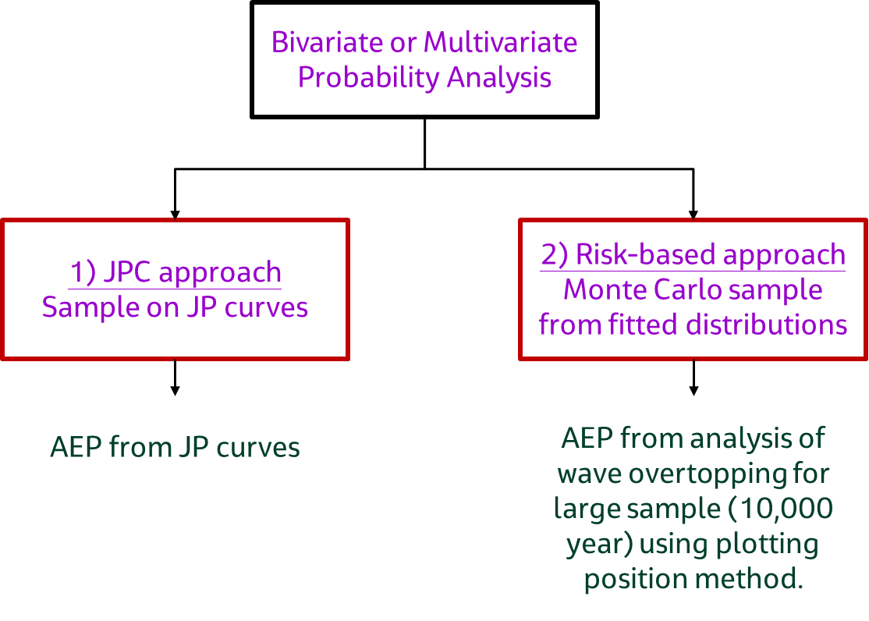
Figure 3.4: Schematic illustration of AEP method of calculation

3.1.4.5 Joint probability contour approach
In the bivariate approach, you use extreme analysis for two variables. You do this to find the joint probability contours. For wave overtopping analysis, the two variables used are SL and Hm0. To find the wave overtopping values for a given AEP, you pick several points on the joint probability contour (JPC). Wave overtopping is evaluated at these points. The highest wave overtopping values from these points is given the AEP for the JPC.
The 3 methods of bivariate analysis used in the UK for coastal flooding studies are:
- the FD2308 desk-based analysis
- the rigorous JOINSEA approach
- JP contours generated from State of the Nation datasets

All three methods can be used to generate joint probability contours. In addition, the JOINSEA approach can be used to generate a large Monte Carlo sample of SL and Hm0.
The limitations of the JPC approach have been known for some time (see Defra/EA FD2308, HR reports and papers). The approach underestimates the chance of wave overtopping compared to the response variable approach. Furthermore, only two of the dependent variables (SL and Hm0) are considered. The other variables are determined using fitted relationships (Tp, Wspd, Wdir) or by carrying out the JPC for different mean wave direction (MWD) sectors.
The JPC underestimates the response variable. This is shown in a hypothetical table for variables X1 and X2 (see Figure 3.5). The 9% JPC is sketched as a green line (connecting the green filled circles) in Figure 3.5.
For simplicity, you assume the response variable is Z = X1 + X2. You want the Z-value for an exceedance probability of 9%. Using the joint exceedance contour approach, several points are selected on the JPC. The point with the highest Z value is selected as the return value for the 9% exceedance probability.
One of such points on the JPC is (4,3). The joint exceedance probability for X1 ≥ 4 and X2 ≥ 3 is 9% (see the area shaded with green bars in Figure 3.5). It is correct that the exceedance probability of X1 ≥ 4 and X2 ≥ 3 is 9%. Yet the exceedance probability of Z ≥ 7 (= X1+X2) can be easily demonstrated to be higher than 9%. All points on the red line in Figure 3.5 lie on Z = 7. The true exceedance probability of Z ≥ 7 includes all points above the red line and is estimated as 23.5%. This demonstrates that the JPC approach underestimates the exceedance probability for the response variable Z=X1+X2. This result can be generalised for any response variable Z that is dependent on both X1 and X2.
For example, you take wave overtopping (Z) and two dependent variables (wave heights [X1] and water levels [X2]). The JPC approach would lead to an underestimation of the exceedance probability of wave overtopping.
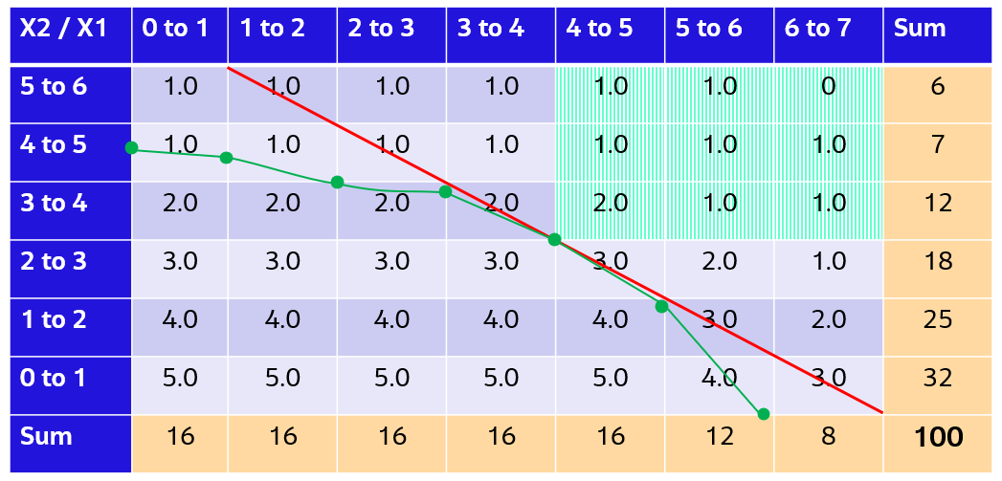
Figure 3.5: Schematic joint frequency of occurrence table for variables X1 and X2. The frequency of occurrence in the table is in percent. Green line shows 9% JPC. Red line shows Z = X1+X2 = 7.
An alternative way to show that the JPC approach is underestimated can be seen in Figure 3.6. The overtopping rate (Qa) calculated at point A can also have the same values at all points along the red curve. The overtopping rate Qb is calculated at B. The exceedance probability of Qa is the area above the red curve. It is the number of events above the red curve divided by the total number of events. The JPC approach underestimates because it doesn't include the shaded area when estimating the exceedance probability. This underestimation occurs at all points on the JPC. When you use the highest value on the curve and assigned a joint exceedance probability, the true exceedance probability for the variable underestimated.
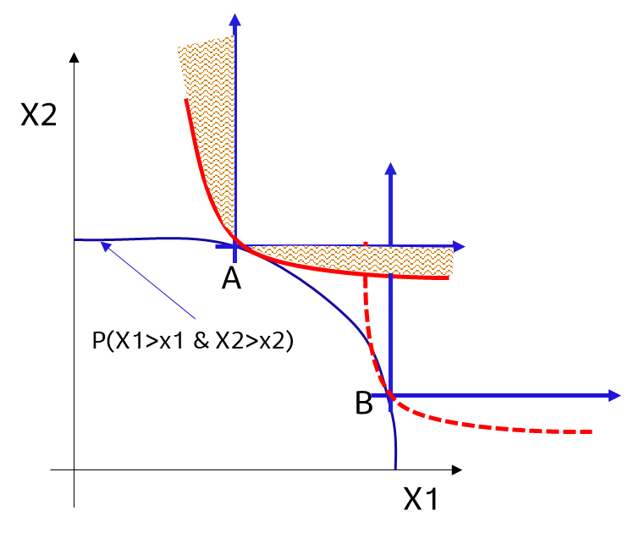
Figure 3.6: Schematic illustration of AEP method of calculation using Joint Probability Contours.
When X1 and X2 are perfectly dependent, the JPC approach correctly finds the exceedance probability of variable Z. Figure 3.7 shows this. This is because, in this case, the frequency of occurrence will be non-zero only along a diagonal. All other values will be zero. In wave overtopping, this happens when wave height is perfectly dependent on water level. This can happen at sites where the wave height at the toe of the defence is depth limited.
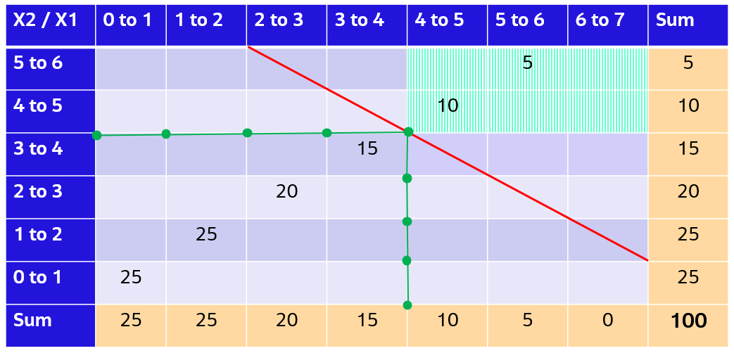
Figure 3.7: Schematic joint frequency of occurrence table for variables X1 and X2, where X1 and X2 are perfectly dependent. The frequency of occurrence in the table is in percent. Green line shows 15% JPC. Red line shows Z = X1+X2 = 8.
The limitations of the bivariate approach are described below.
It underestimates the exceedance probability of the response variable except when the two variables are perfectly dependent.
It deals with only 2 of the 6 important variables for wave overtopping calculations. The other variables are determined using fitted relationships (Tp, Wspd, Wdir) or by carrying out the JPC for different direction sectors (MWD).
To ensure confidence in the fitted relationships, they must meet minimum quality standards. Examples of the fitted relationships are shown in Figure 3.8 and Figure 3.9. The wave model that transforms the offshore JPC to nearshore must also meet minimum quality standards. The additional quality standards for joint probability contour approach are set out below:
- Additional requirements – JPC approach
- A – design:
- Allowable tolerances for fitted relationships used are:
- 1) Tp = f(Hm0), tol = ±1 s,
- 2) Wspd = f(Hm0), tol=±2m/s,
- 3) Wdir = f(MWD), tol=±10deg,
- B – Appraisal: Same as A
- C- Strategic: Same as A, but tolerance increased by 50%
- U-Unsatisfactory: None of the above
Remarks: 95% of data should be within allowable tolerance for wave heights > 100% AEP Hm0.
- Wave model validation – wave height
- A – Design: RMSE ≤ 0.3 m OR SI < 20%
- B – Appraisal: RMSE ≤ 0.4 m OR SI < 20% to 25%
- C- Strategic: RMSE ≤ 0.5 m OR SI < 25% to 30%
- U-Unsatisfactory: RMSE > 0.5 m OR SI > 30% OR No validation
Remarks: Validation based on peak Hm0 data.
- Wave model validation – wave period
- A – Design: RMSE Tp ≤ 1 s & |Bias_Tp| < 0.5 s.
- B – Appraisal: RMSE Tp ≤ 1.5 s & |Bias_Tp| < 0.7 s.
- C- Strategic: RMSE Tp ≤ 1.5 s & |Bias_Tp| < 1.0 s.
- U-Unsatisfactory: RMSE Tp > 1.5 s OR |Bias_Tp| > 1.0 s OR No validation
Remarks: Validation based on wave period data associated with peak Hm0. In addition to Tp, other wave period parameters such as T02, Te can be used for validation. RMSE is the root mean square error and bias is the deviation between the modelled and measured data.
- Wave model validation – wave direction
- A – Design: MAE_MWD ≤ 10 deg.
- B – Appraisal: MAE_MWD ≤ 15 deg.
- C- Strategic: MAE_MWD ≤ 20 deg.
- U-Unsatisfactory: MAE_MWD > 20 deg OR No validation
Remarks: Validation based on wave direction data associated with peak Hm0. MAE is the mean absolute error between the modelled and measured data.
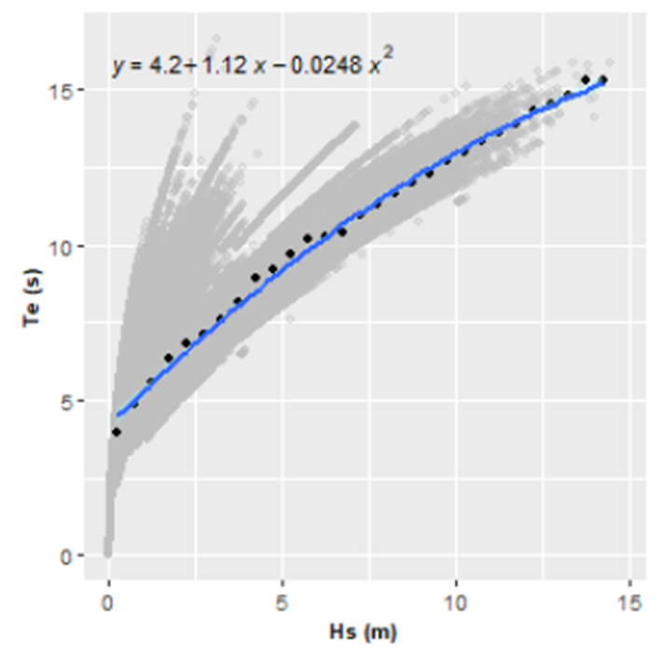
Figure 3.8: Example relationship between Te and Hm0 fitted to data. Source: JBA (2021)
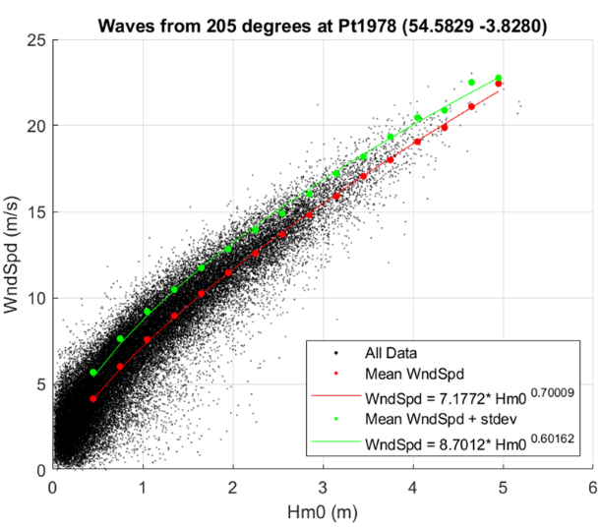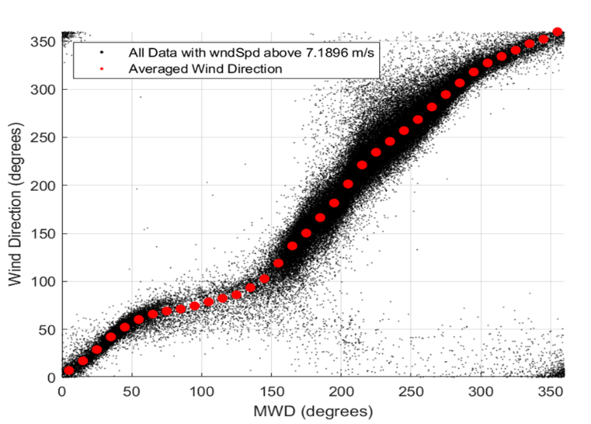
Figure 3.9: Example relationship between Wind speed and Hm0 (Left) and Wind direction and MWD (right)

3.1.4.6 Response variable approach
The response variable (RV) approach solves this problem by carrying out extreme value analysis on the response variable of interest. This is also called the risk-based approach. For a given length of hindcast data, you can calculate the wave overtopping time series and undertake extreme value analysis of the time series. The approach with hindcast time series is risky as they cover a short period (30 to 50 years). It will not cover combinations of extreme wave and water level parameters needed for a robust estimate of extreme wave overtopping.
The response variable approach creates a long time series of the dependent parameters covering thousands of years. In the State of the Nation (SoN) study, a 10,000-year data sample of extreme wave, wind and water level parameters was generated offshore. You transform the offshore datasets to nearshore locations. These are at depths of about -5 mODN. You use them to make 10,000-year nearshore datasets at about every 1 km around the coast of England. The availability of these datasets means that you can use the response variable approach to determine the chance of waves overtopping flood defences.
The SoN datasets typically consist of hundreds of thousands of events. It is not practical to model waves transformations for these events with a 2D spectral wave model. The approach used for transforming the offshore data to nearshore points is using Gaussian Process Emulators (GPEs). To build trust in the transformation, the model and emulator must meet minimum accuracy requirements compared to measurements. These are set out below:
- Wave model validation – wave height
- A – Design: RMSE ≤ 0.3 m OR SI < 20%
- B – Appraisal: RMSE ≤ 0.4 m OR SI < 20% to 25%
- C- Strategic: RMSE ≤ 0.5 m OR SI < 25% to 30%
- U-Unsatisfactory: RMSE > 0.5 m OR SI > 30% OR No validation
Remarks: Validation based on peak Hm0 data.
- Wave model validation – wave period
- A – Design: RMSE Tp ≤ 1 s & |Bias_Tp| < 0.5 s
- B – Appraisal: RMSE Tp ≤ 1.5 s & |Bias_Tp| < 0.7 s
- C- Strategic: RMSE Tp ≤ 1.5 s & |Bias_Tp| < 1.0 s
- U-Unsatisfactory: RMSE Tp > 1.5 s OR |Bias_Tp| > 1.0 s OR No validation
Remarks: Validation based on wave period data associated with peak Hm0. In addition to Tp, other wave period parameters such as T02, Te can be used for validation. RMSE is the root mean square error and bias is the deviation between the modelled and measured data.
- Wave model validation – wave direction
- A – Design: MAE_MWD ≤ 10 deg
- B – Appraisal: MAE_MWD ≤ 15 deg
- C- Strategic: MAE_MWD ≤ 20 deg
- U-Unsatisfactory: MAE_MWD > 20 deg OR No validation
Remarks: Validation based on wave direction data associated with peak Hm0. MAE is the mean absolute error between the modelled and measured data.
- Emulator validation – wave height
- A – Design: RMSE ≤ 0.3 m OR SI < 20%
- B – Appraisal: RMSE ≤ 0.4 m OR SI < 20% to 25%
- C- Strategic: RMSE ≤ 0.5 m OR SI < 25% to 30%
- U-Unsatisfactory: RMSE > 0.5 m OR SI > 30% OR No validation
Remarks: Validation based on peak Hm0 data.
- Emulator validation – wave period
- A – design: RMSE Tp ≤ 1 s & |Bias_Tp| < 0.5 s
- B – Appraisal: RMSE Tp ≤ 1.5 s & |Bias_Tp| < 0.7 s
- C- Strategic: RMSE Tp ≤ 1.5 s & |Bias_Tp| < 1.0 s
- U-Unsatisfactory: RMSE Tp > 1.5 s OR |Bias_Tp| > 1.0 s OR No validation
Remarks: Validation based on wave period data associated with peak Hm0. In addition to Tp, other wave period parameters such as T02, Te can be used for validation. RMSE is the root mean square error and bias is the deviation between the modelled and measured data.
- Emulator validation – wave direction
- A – design: MAE_MWD ≤ 10 deg
- B – Appraisal: MAE_MWD ≤ 15 deg
- C- Strategic: MAE_MWD ≤ 20 deg
- U-Unsatisfactory: MAE_MWD > 20 deg OR No validation
Remarks: Validation based on wave direction data associated with peak Hm0. MAE is the mean absolute error between the modelled and measured data.
- Additional requirements – Multivariate Probability Analysis (MVPA) approach
- A-Design: No physically unrealistic event in the 10,000 years sample
- B-Appraisal: Number of physically unrealistic events <50 in 10,000 years sample
- C-Strategic: Number of physically unrealistic events < 100 in 10,000 years sample
- U-Unsatisfactory: None of the above
Remarks: Physically unrealistic events are defined as events where on or more of the conditions below are satisfied.
Wave steepness > 0.12.
Hm0/depth > 1.2.
High winds occurring together with low waves (wind speed > 30*Hm0 on open coast). The open coast constraint is developed by requiring that the wind speed is not greater than the value required to generate corresponding significant wave height for a fetch of 5 km. The fetch limited wave growth formula in the Coastal Engineering Manual (EM 1110-2-1100) has been used to develop this constraint. Wind speed of 30 m/s and Hm0 < 1 m are physically unrealistic combinations on the open coast.

3.1.4.7 Comparison of JPC and RV approaches
In a case study by Hames et al (2017) (cited by JBA, 2021), wave overtopping rates were calculated for a 1% AEP event. They did this for two defences using the JPC and RV approaches. The JPC method's 100-year event had overtopping rates. They had return periods of 40-years and 16-years. This was when compared to the rates from the RV method.
Hames et al (2020) (cited by JBA, 2021) did more research. They assessed the inaccuracy of the JPC approaches for determining extreme response variables (wave overtopping). The research was for different types of defences and covered different JPC approaches along the coast of England. The results were compared against extreme response variables from multivariate approaches. In total:
- 592 sea defence structures were assessed around the country
- 9 different JPC approaches were assessed
They used data from the nearshore outputs from the SoN study for sea defences. Different methods were used to calculate associated wave periods and directions across multiple JP regions.
Overall, the JPC approach underestimated the benchmark return period for most of the defences tested. Hames results are presented as RPRR (Return period response ratio). RPRR is the ratio of the peak overtopping rate return period for the JPC approach to the RV approach. RPRR < 1 means that the JPC approach underestimates the response, and vice-versa for RPRR > 1. The results show RPRR < 1 for most defences (80 to 90% of the defences in JP regions 1, 2, 4 & 5 and 60 to 70% of defences in JP 3 and 6). The JP regions are as defined in the State of the Nation study.
Hames et al. (2020) also reported the following.
The analysis showed that using data to calculate the wave period gave a closer match to the multivariate approach. This was better than assuming the wave steepness.
The JPC approaches were most likely to overpredict for vertical walls. They were most likely to underpredict for shingle beaches.
For defences along the north Cornish, South Essex, and north Kent coastlines the simplified approach has lower dependence. This is more likely to predict lower extreme overtopping rates than in other areas.
In 2021, JBA compared extreme response variables (wave overtopping) from the multivariate approach using different JPC methods. In total:
- 2 JPC approaches were assessed (FD2308 and Bivariate-SoN)
- 58 sea defence structures were assessed at 5 locations
The results do not show a clear pattern. One method did not consistently predict more or less overtopping than the others.
Table 3.1: Approaches studied in JBA (2021)
Location | No of defences | Methods with highest overtopping
Great Yarmouth | 7 | Multivariate approach
Romney Marsh | 12 | FD2308 approach
Isles of Scilly | 16 | Mix of all 3 methods
Ilfracombe | 2 | FD2308 approach
East Kent | 11 | Multivariate approach

In Hames et al (2020), the JP contours were based on data at the toe of the defences. They provide boundary conditions for the wave overtopping models. In the JBA tests, the JP contours were defined using the offshore data setting boundaries for the wave models. The models then provided nearshore data for the overtopping models. This can make a difference as there are more variables that impact the response in the offshore data.
JBA carried out additional investigation using the JPC approach with nearshore data. The analysis was repeated at Ilfracombe and Romney Marsh. There, the FD2308 JPC method had the highest overtopping rate compared to the multivariate rates. The results show reduced overtopping rates with nearshore data. However, the rates were still higher than the multivariate approach at Romney Marsh. They are closer to the multivariate approach at Ilfracombe.
In summary, comparing JPC to RV at some defences shows that the JPC usually underestimates the SoP at flood defences. However, in some cases the JPC approach was found to predict the same or higher than the RV approach. As shown in Section 3.1.4.4, the JPC approach is expected to predict lower or the same exceedance probability as the RV approach. Real cases may differ from the comparison cases due to extra parameters used in the JPC analysis. For example, the wave period is determined from a fitted relationship with wave height in the JPC approach.

3.1.5 Climate change
Climate change will affect how likely and severe future storms are. This will happen through sea level rise (SLR), the effect of SLR on beaches, and increased storminess. SLR is routinely considered in coastal flood modelling studies. Storminess is sometimes considered as a sensitivity test (for example. CH2M, 2015).
Sea level rise
The UK Climate Change Projections 2018 (UKCP18) provides the latest assessment. It shows how the climate may change up to 2100 and after. You can download data on sea level rise along the UK coastline from the UKCP18 website. The Met Office hosts the site.
Effect of sea level rise on beach profile
The influence of SLR on a beach profile is rarely considered. You can use simple methods to translate an equilibrium beach profile due to sea level rise. For example, you can use the Bruun rule. This method assumes the beach is at equilibrium which may not be true on a managed beach. The concept of an equilibrium beach is simple to apply on a micro-tidal beach (tidal range < 2 m). The "zero" position of the equilibrium profile (where land and water meet) does not vary much. However, on a macro-tidal beach (tidal range > 4 m), the inter-tidal region is wider. It is not clear if the equilibrium profile approach applies here.
Storminess
Changes in future wind and wave conditions are provided in ‘Guidance on Flood and coastal risk projects, schemes and strategies: Climate Change Allowances’ (Environment Agency, 2021). This guidance says that offshore wind speeds and extreme wave height should be increased by 5% from 1990 to 2055. They should also be increased by 10% from 2056 to 2125. A surge of +2 mm per year should be added to a 2017 baseline to all exceedance probabilities less than the H++ scenario. The 2017 baseline aligns extreme sea levels with those in the coastal flood boundary extreme sea levels data (2018).

3.1.6 Calibration and verification metrics
One key goal of coastal flood risk assessment is to understand where floods will happen. It also aims to know how big the floods will be during extreme storms. Given this, the approach to calibration and verification should start with flooded areas and flood depths. As flooding is caused by extreme events, this data is not always available. In many cases with available data, the data is limited to a few events (< 5) so is inadequate.
Calibration requires adjusting model parameters until the modelled data matches the measured data. Verification uses the best model parameters following calibration, for a different event. This is to confirm the model's accuracy. Calibration and verification are referred to here as validation.
Our approach is to consider validation metrics at different levels (low to high). The levels are based on how close the model data is to the target data (flood extents and scale). They are also based on available datasets for validation (Figure 3.10). The highest level of validation will be against flood depths and extents. The level of validation reduces with distance from these metrics. In addition, validation is needed at many levels. Data and modelling must meet standards for all processes that cause flooding. This is necessary to ensure that the model meets the target standard for the intended use. This is because the data to validate coastal flood models is often limited.
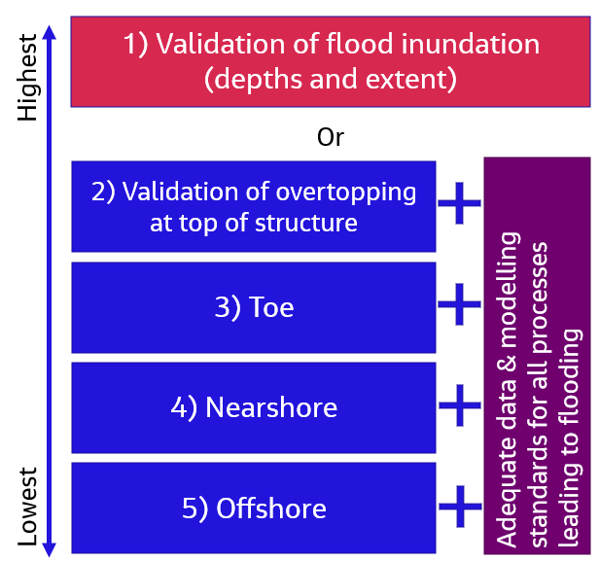
Figure 3.10: Schematic illustration of validation levels at different locations.

3.1.6.1 Validation at offshore location
Key information regarding validation at offshore location is summarised below:
Relevant parameters for validation
Parameters for validation at offshore location include:
- wave (Hm0), Tp, MWD)
- wind parameters (Wspd, Wdir)
Data sources
Data sources include measured wave data from:
- Cefas Wavenet
- Copernicus satellite derived.
Key tuning parameters
No tuning parameters are available. This is because the hindcast model used to produce the offshore wind and wave data is not available to the coastal modeller. Where the model does not validate well the hindcast data can be adjusted to match the measurements.
Remarks on validation
Calibrating these parameters provides confidence about their accuracy. However, additional processes that influence the calculated flood depth and extents are:
- wind wave growth and wave transformation to nearshore
- wave transformation across the surf zone
- wave run up and overtopping at the structure
- inundation
Validating only the offshore waves does not give confidence in the final results. If the wave and wind data are wrong, the flood model will likely be wrong.
Good practice
It is good practice to validate the offshore wave data before use. The SoN study validated the offshore wave data against measured data. They adjusted the data where needed. Examples are shown in Figure 3.11.
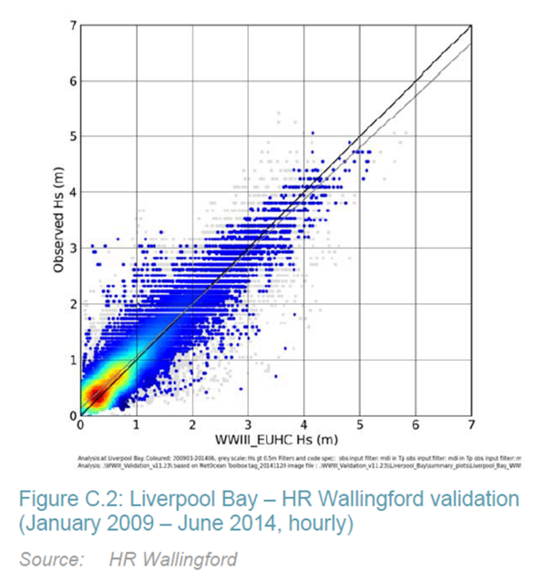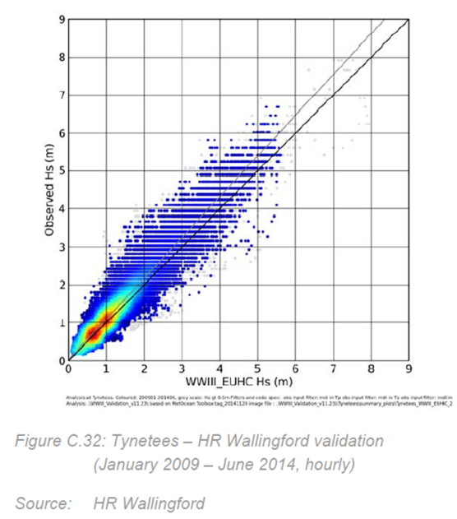
Figure 3.11: Validation examples for offshore wave height. Left: Validation OK, small positive bias. Right: Offshore conditions adjusted to correct for negative bias.

3.1.6.2 Validation at nearshore location
Key information regarding validation at nearshore location is summarised below:
Relevant parameters for validation
Wave parameters (Hm0, Tp, MWD).
In principle, water level (WL) should also be added to this list, if based on modelled data. However, current practice in the UK is to base the WL data on measured data at tide gauges.
Data sources
Measured wave data from:
- Cefas Wavenet
- British Oceanographic Data Centre (BODC)
- National Coastal Monitoring
Key tuning parameters
Parameters include:
- wind input
- wind source term formulation
- bed roughness
- offshore wave conditions
- bathymetry resolution
- water levels
Remarks on validation
Calibrating these parameters provides confidence about their accuracy. However additional processes that influence the calculated flood depth and extents are:
- wave transformation across the surf zone
- wave run up and overtopping at the structure
- inundation
Validation of the nearshore waves alone does not give full confidence in the final output but better than only validating the offshore wave dataset. If the nearshore wave parameters are wrong, the flood result will be wrong.
Good practice
It is good practice to validate the nearshore wave data before use.
In the SoN study, the nearshore wave parameters were validated against measured data. Examples are shown in Figure 3.12 and Figure 3.13. The State of the Nation calibration statistics for Hm0 and T02 are summarised in Table 3.2 and Table 3.3. Example calibration statistics from other studies are summarised in Table 3-4.
Jacobs found that the measured and modelled wave height agree well if the RMSE is under 0.3m or the SI is less than 20%. This is not always practical as it depends on the accuracy of the offshore wave and wind data. There may also be difficulties with the measured data as seen in the State of the Nation study. If these targets can't be reached for these reasons, aim for the best quality that's possible.
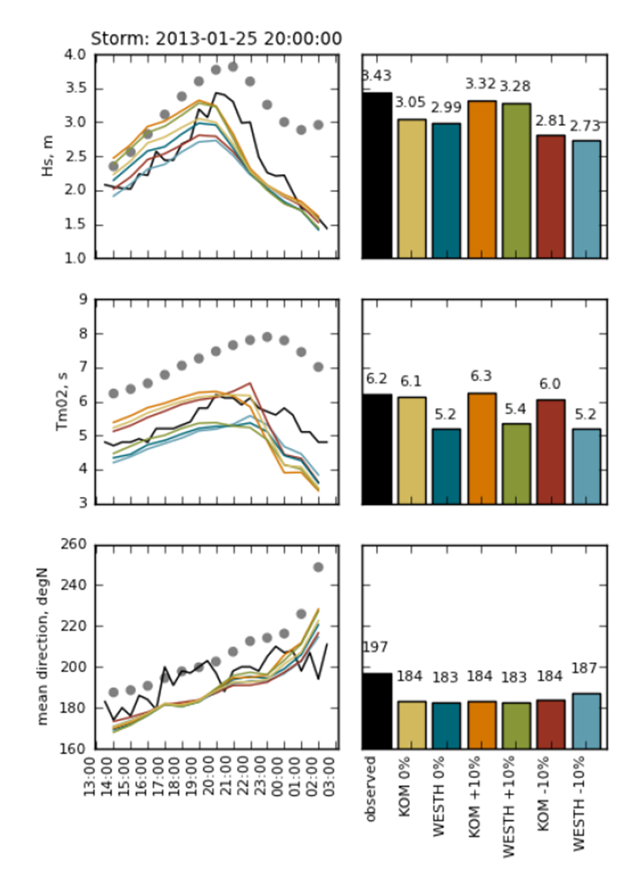
Figure 3.12: Validation example for nearshore waves. Observed is the solid black line, the offshore model is represented as grey dots and SWAN model predictions colour coded as labelled. Source: HR Wallingford, 2015b
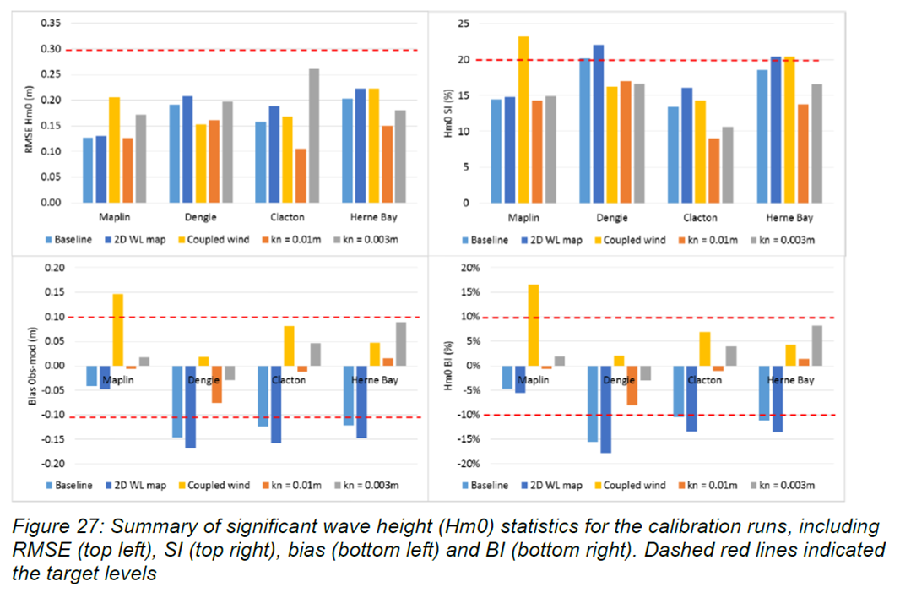
Figure 3.13: Validation example for nearshore waves. Source: CH2M, 2018
Table 3.2: Calibration error statistics for Hm0 in State of the Nation wave transformation models
Table 3.3: Calibration error statistics for T02 in State of the Nation wave transformation models.
Table 3-4: Summary of calibration/validation stats from some previous studies
 | Wave height - RMSE (m) | Wave height - SI (%)
ECMWF, 2014 | 0.44 | 18
Laurence et al., 2009 | Not reported | 12
Halcrow, 2011 | 0.23 | 35
Halcrow, 2014 | 0.07 | 15
Halcrow, 2015 | 0.35 to 0.67 | 26 to 41
HR Wallingford/EA, 2015 | 0.50 | Not reported

3.1.6.3 Validation at toe of the defence
Key information regarding validation at toe of the defence is summarised below:
Relevant parameters for validation
Wave (Hm0, Tp, MWD).
Change in water level due to wave setup.
Data sources
The environment at the toe of a structure is highly dynamic especially during storm events, which lead to overtopping. We do not collect measurements of waves and water levels at these locations.
Key tuning parameters
Wave breaking parameters.
Beach profile.
Remarks on validation
In practice it is not possible to validate waves and water levels at the toe. This is because the measurements are usually not available.
Good practice
Not applicable.

3.1.6.4 Validation at top of defence
Key information regarding validation at top of the defence is summarised below:
Relevant parameters for validation
Wave overtopping volumes.
Data sources
Wave overtopping is random and recording it in the field is challenging. We do not collect data on wave overtopping volumes.
Research studies are ongoing to collect more data on wave overtopping at flood defences. Examples are: Wirewall project, Chesil Beach and Drainage project.
Key tuning parameters
Not applicable.
Remarks on validation
In practice it is not yet possible to validate wave overtopping volumes. This may change in the future based on results of ongoing research.
Good practice
Not applicable.

3.1.6.5 Validation at floodplain
Key information regarding validation at floodplain is summarised below:
Relevant parameters for validation at offshore location
Flood inundation (depth and extents).
Data sources
Environment Agency Recorded Flood Outlines & Historic Flood Map Surge watch
Key tuning parameters
Flow paths (topography resolution, resolution of culverts and channels, etc).
Bed roughness and model resolution.
Remarks on validation
Recorded flood outlines and historic flood maps do not cover every flood. They only cover those where records were made. In most places, there are less than five (< 5) recorded flood outlines. This is not enough for calibration and validation. There are also challenges to recording accurate flood outlines, these include:
- time of event – if flooding occurs at night, survey is not possible
- location – rural areas are harder to reach and survey
- consistency of survey methods - aerial photography or survey of debris lines
A validation example is shown in Figure 3.14. For this study, the model was sensitive to:
- antecedent pond levels – as this affects the amount of storage before flooding occurs
- levels of the low spots in the defences
- flow paths such as culverts being fully resolved
Good practice
It is good practice to validate against historical flood outlines when this data is available.
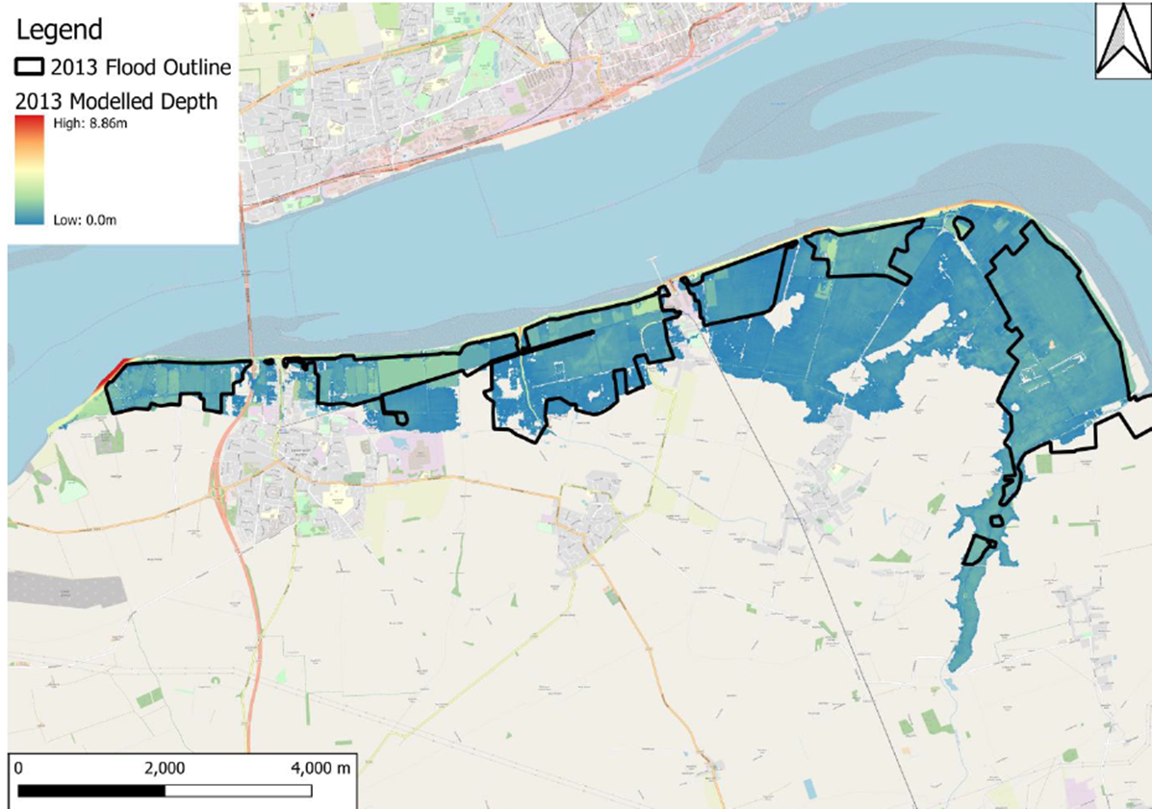
Figure 3.14: Validation example for flood inundation. For this event, wave overtopping is small, and water level is high. Only one flood outline available. Source: Jacobs, 2021

3.2 Pathway data and modifications during storms

3.2.1 Storm induced morphology changes
During a storm, sediment from the backshore is moved offshore. It creates a bar at or below the low water line. This may increase the water depth at the toe of a structure increasing the chance of overtopping. If oblique waves attack the coast, they can cause big changes to beach levels. This happens because of longshore sediment transport during the storm. If you use the pre-storm profile for the calculations, the overtopping rates may be too low.

3.2.1.1 Current practice
Storm-induced morphology changes are rarely included in models unless the primary defence is the beach ridge. However, practitioners agree that it's a key factor in wave overtopping rates. One study by JBA Consulting (2012) looked at overtopping using a design profile and an emergency profile. Both profiles were taken from the local Beach Management Plan. The design profile is a geometric representation of a coastal structure or beach providing a certain SoP. It fully details the dimensions, shape, and size of the profile. The emergency profile's 'crisis levels' are defined by parameters like crest height and width. These levels are where the beach's protection is significantly compromised (Rogers et al., 2010).

3.2.1.2 Methods available
Three class of methods are available to predict the cross-shore response of a beach to a storm. The methods include:
- historical beach profile analysis
- empirical methods
- numerical modelling
The three methods are summarised below:
Historical data analysis
Traditional historical data analysis
Analysis of measured beach profiles to assess past response to storms.
It assumes the beach behaviour and environmental forcing conditions will not change.
Measured data will relate to the behaviour of a specific beach. It can be used to calibrate/validate numerical models of beach response.
Uncertainty that the storm response is captured in the beach profiles. The method is only useful if long-term and well-timed beach surveys are available.
Advanced historical data analysis
Ensemble re-sampling methods. ‘Data-driven’ approach which relies on existing measurements and statistical analysis. Correlates beach profiles with wave conditions.
Examples include Canonical Correlation Analysis (Reeve and Horrillo-Caraballo, 2011).
Quick simple method that does not require large computational effort.
The method can predict a beach's response to waves if a strong link between beach profiles and waves can be found.
A good historical record is needed. It should cover 10 years of 6-monthly beach surveys. It should also cover a time series of measured or hindcast wave conditions.
Would not be able to forecast changes in the beach not contained in the historical dataset.
Empirical methods
The empirical equations predict the response of a profile to constant wave and water levels conditions.
Examples include SHINGLE (Powell, 1990) and the Bradbury et al. (2006) approach.
The application areas and limitations are:
- shingle and sand beaches
- assumes constant wave conditions and single grain size
- simple to apply, limited number of calculations.
- does not take account of underlying geology.
- some equations are limited
- does not replicate beach response to bimodal wave conditions - see Polidoro et.al. (2018)
Numerical models
Model physical processes to predict beach profile changes and cross-shore sediment transport. Physical processes include wave, flow and sediment transport. Some models also predict cross-shore variations in longshore transport rates.
Examples are:
- COSMOS 2D
- LITPACK
- XBEACH
The application areas and limitations are:
- some models can include revetments or no erodible areas in the profile
- some models can be used to assess sub-beach down cutting, for example, clay beneath sand
- limited or no inclusion of alongshore effects
- do not model beach recovery well
- unable to simulate over wash/ breaching scenarios
- can be limitations when used for a beach fronting a sea wall
- Van Rijn et al (2003) reported that profile models could not simulate the beach's behaviour accurately during storms
Consider the length and timing of beach profile monitoring and changes in beach management. These factors matter when using old data to predict future beach response. If no post-storm profiles are available, then historic data may be little help in predicting beach response to storms. Empirical models are available for use on sand and shingle beaches. Numerical models are only applicable for use on sand beaches (Rogers et al., 2010). The empirical and numerical models are sensitive to grain size. They fail to predict mixed sand and gravel beach response. Work is ongoing to develop models for mixed sand and gravel beaches. Currently, no models replicate cross-shore profiles in beach response to bimodal waves.
No models can accurately consider the effects of both longshore and cross shore sediment transport. Cross shore models do not account for longshore transport. Shoreline plan shape models of shorelines, which do consider longshore transport are not suitable for looking at short term storm response. They assume the cross-shore profile does not change, which is not a valid assumption during a storm. They are designed for medium to long term beach plan form evolution. Coastal Area Models (CAM) also consider longshore and cross shore response. However, they are computationally demanding, costly, and unsuitable for storm response predictions. This is because results in the swash zone are unreliable.
An alternative to numerical modelling of beach response was proposed by JBA Consulting (2015). The alternative is to consider ‘what if’ scenarios. For example, what would wave overtopping be if the beach was depleted by 30 or 50% during or before an event.
The FLOODsite Consortium (2007b) developed a framework assessing the impacts of profile change on flood risk. This is shown in Figure 3.15. Although this framework was developed for rivers and estuaries it can be equally applied to open coasts. This framework ensures that storms effect on present beach shape is considered.
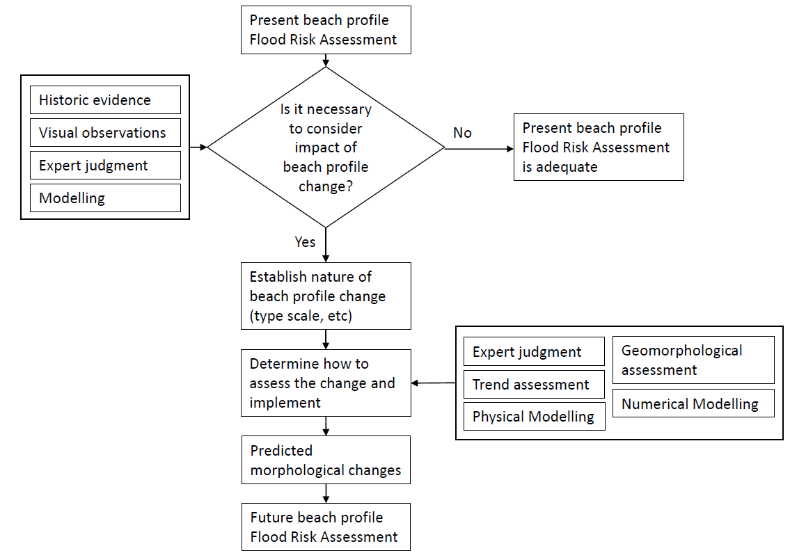
Figure 3.15: Framework for assessing the impacts of beach profile change on flood risk (Adapted from Figure 3.7.1 in FLOODsite report T05_07_02)
Currently, none of the available methods predict beach response to storms well. This led JBA Consulting (2015) to suggest the use of ‘what if’ scenarios. You can move forward by making a range of beach profile responses by combining:
- numerical models
- historical data
- expert coastal engineering knowledge of the area
These beach profiles would be used in the overtopping calculations. They would estimate how overtopping volumes change with beach profiles during storms. This approach also fits well with the framework suggested in the FLOODsite report.

3.2.2 Barrier breaching and asset failures

3.2.2.1 Current practice
Currently breaching or asset failure is not modelled directly. In many cases, the breaching or failure of a structure or beach is predetermined. This is based on visual inspection of the defence, where past breaches occurred and the importance of the protected area (JBA Consulting, 2008). Typically, inundation models are run with and without the breach to find the potential impacts. The model shows the breach as a static, 50m to 200m wide removal of the defence from toe to crest. This may require many runs that vary the location (Hall, 2015).

3.2.2.2 Available methods
A variety of breach models are available. These are for soil embankments and shingle barrier breaches. Another approach to asset failure is available in the form of fragility curves. This can include barrier breaching.
Soil embankment breaching models
Breach initiation and growth models are available for soil embankments (FLOODsite Consortium, 2009). These can be categorised as:
- non physically based, empirical models
- semi-physically based, analytical and parametric models
- physically based models
The more complex the model the lower the uncertainty. This reduced uncertainty comes with longer computational time and more data requirements. The physically based models take too long to compute. They are unsuitable for coastal flood modelling at present. Many models were made for research purposes which are not widely available. These breach models have a limited range of conditions where they work reliably. There are big uncertainties about when a breach will start. Current practice is to make a breach in advance. This is the most practical way to show the worst-case flood extent.
Shingle barrier breaching models
Empirical formulas and 1D profile models are available for breach prediction on barrier beaches (Hartley and Pontee, 2008; Obhrai at al., 2008). Breach location is determined using the Bradbury approach. It shows if a profile will be over-washed under certain wave conditions. This is combined with a critical freeboard coefficient determining the barrier response to the overtopping. This simple formula for predicting breach location use wave parameters and barrier dimensions. It does not take account of beach permeability. The wave parameters may use wave height, period and length. The barrier dimensions may use cross section and freeboard. This method is very sensitive to crest height and, wave heights and period. Estimates of breach dimensions can be calculated based on an empirical relationship This relates to the spring tidal prism to the cross-sectional area of the breach. The inlet's stability is estimated based on the stability ratio (Bruun and Gerritsen, 1960). The ratio was developed for the overall stability of tidal inlets.
SHINGLE (Powell, 1990) is a parametric 1D beach profile model for shingle beaches. This can be used to model the response of a beach to storm waves. A study by Obhrai et al. (2008), using physical modelling, showed that both the Bradbury Approach and SHINGLE worked well with storm waves. They failed to predict the threshold wave height that causes breaching with swell waves. Like the breach initiation and growth models, the SHINGLE model and Bradbury approach do not work well. This happens when they are used for conditions different from those they were developed for.
Fragility curves
Defence failure can be added to a system-wide flood risk analysis using fragility curves (Simm et al., 2009). The curves show the chance of failure under a range of loadings. For example, overtopping unit discharge – incorporating water level and waves). A prototype software tool was developed to generate fragility curves for specific sites. Fragility curves are generated using fault trees and a range of limit state equations. These assume data is available. The National Flood Risk Assessment studies used many precomputed 'standard' fragility curves. They were part of the Risk Assessment for Strategic Planning (RASP) methodology. They are based on 61 defence types and 5 condition grades. The grades are determined by visual inspection. For each defence type, there are 5 fragility curves available. These include the best estimate, plus upper and lower bounds.

3.2.2.3 Breach dimensions
There are several methods available to determine the width and dimensions of a breach. These are outlined above. However, in many cases a standard breach width will be based on local knowledge or past events. The tidal flood warning, tidal flood risk pilot project was undertaken for the Environment Agency by Posford Duvivier (1999). They suggested breach widths for a selection of coastal defence types as follows:
- earth bank (including bank with concrete facing) – 200m
- dunes – 100m
- shingle bank – 100m
- reinforced concrete – 50m

3.2.2.4 Summary
Various methods are available for assessing barrier breaching and asset failures. The methods include:
- soil embankment breaching models
- shingle barrier breaching models
- fragility curves
The breaching models are uncertain. So, for now, the best approach is to use fragility curves.

3.3 Inundation model

3.3.1 Type of model
Inundation modelling translates high coastal water levels and overtopping volumes to flood extent, depth, and speed. Several inundation models are available. The FLOODsite report on inundation models (Report T08-07-01) reviewed different types of them. However, it did so in the context of fluvial or estuary flooding. This has been supported by reviews of additional publications, where applicable. Below are the relevant inundation models for flooding on the open coast. The computation times for the different models are from Pender et al. (2006) as cited in the FLOODsite report.
Type 1: 0D model
GIS level contour model (also known as horizontal projection approach).
This method assumes inundation of all areas below the extreme water level. This may work in areas where the land slopes up from the shoreline. Also, where there are no defences. In areas with defences, this model will greatly overstate flood risk. The volume of water overflowing the defence during high water is unlikely to be enough to immediately fill the area behind the defences. This approach does not include wave overtopping. so will underestimate flood risk when water level is just below the crest.
GIS volume contour model.
The method calculates water level. this is based on the volume that overtops or breaches during the storm. The volume model is better than the level model as considers the total water available for inundation. The level model assumes the water available is infinite.
Computation time is seconds.
Type 2: 1D model
Compartmentalised floodplain 1D/ Bucket model.
The floodplain is a series of storage cells. The cells are spill linked 1D reservoir units. The model is quick to build and run.
Examples are Flood Modeller 1D, HEC-RAS, MIKE 11 and InfoWorks RS.
Works well for areas of uniform topography. The model can provide an indication of flood timing, and this is an advantage over 0D models.
Computation time is minutes.
Type 3: 2D- model
Simplified 2D shallow water equation solver
These models treat in–channel flow using the simple kinematic or diffusion wave forms of equations. They describe floodplain flows in terms of continuity and mass flux equations. The equations are for a grid of square cells allowing 2-D dynamic flow fields on the floodplain. Examples are: LISFLOOD-FP, JFLOW.
Simplified models can also be classified as:
- 3-term models
- 2-term models
- 0-term models
3-term models solve a version of the SWEs. This version neglects the advective acceleration terms. Examples are: LISFLOOD-FP, RFSM-EDA
‘2-term’ models utilise Manning’s uniform flow law (e.g. ISIS Fast Dynamic). Another type is UIM which solves the SWE without the acceleration terms.
0-term models are based mainly on continuity and topographic connectivity. They only predict a final flood state, with no time variations. Examples are: ISIS Fast and RFSM Direct.
Skinner et al. (2015) says these models have been successfully applied and tested. They simulate hydraulics in shallow areas with fast, one-way flow (Bates and De Roo, 2000; Bates et al., 2010; Neal et al.,2011; Stephens et al., 2012; Coulthard et al., 2013; Wong et al., 2014).
Defra/Environment Agency (2013) carried out benchmarking of various 2D models. They concluded that the ‘3-term’ and ‘2-term’ packages predict the final extent of flooding and the dynamics of flooding like the SWE under certain situations. These conditions are described below.
‘3-term’ packages are comparable with SWE packages. However, this is not the case for quickly changing flows. It also does not apply in places where momentum conservation is important. For example, in the complex flow field downstream of a dam failure. These models are also less robust in the prediction of high velocity and supercritical flows. For example, those that can be encountered during urban flooding. In such cases, they often predict oscillating values producing higher peak estimates than the SWE models.
The '2-term' package (ISIS Fast Dynamic) is comparable with SWE packages in situations with very low momentum flow. However, it is not suitable where predictions of inundation velocities are required. The approach has some benefits in terms of computational cost, although this is not fully demonstrated by the current set of benchmark tests.
Coastal flows are unlikely to be "very low momentum flow". They are more likely to be rapidly varying flow. This is especially true after a breach or when waves and still water level go over the structure crest. Therefore, this method is not reliable for open coast flooding models.
Computation time is hours.
Type 4: 2D model
2D shallow water equation solvers.
The models solve the depth averaged 2D shallow water equations.
Examples are:
- Flood Modeller 2D
- TUFLOW
- MIKE 21
- DELFT3D
The equations are often applied to flows that are wide relative to their depth. The flows also have large changes in velocity across the field.
2D schemes can also more easily represent moving boundary effects. They may be more useful for simulating areas where the extent of flooding changes through time (see Bates and Horritt, 2005). This is the case with most flooding instances on the open coast.
Computation time is hours to days.
Type 5: 3D model
3D solution of the three-dimensional Reynolds averaged Navier Stokes equations.
These models are too detailed for practical use at the present time.
Computation time is days.

3.3.2 Summary
Use of 2D (Type 4) inundation models is considered best practice for the most reliable prediction.

4.0 Guidelines for scoring quality of models

4.1 General
The guidelines in this section provide a framework for designing a model to the right quality standard. They also help assess the standard of an existing model. The Source-Pathway-Receptor model has been used as a clear basis to develop a quality standard (A/B/C) for an open coast flood model. The “source” represents the key sources of flooding for the coastal area (wind, waves, tides, surge). The "pathway" is the path through which flood waters travel. They travel from offshore to the nearshore through breaches in defences to coastal roads and buildings. The “receptor” represents the receptors of flooding (people and infrastructure). The tool for determining the receptors that are flooded is the inundation model.
You develop the quality standard by scoring each part of the flood model. They cover conceptual understanding based on:
- the source-pathway-receptor model
- data on flood sources
- data on flow pathways
- model build parameters
The scores are given based on the evidence collated in the literature review (see Sections 3).
There are two classes of coastal flood models. The first is non-real-time models. You use non-real-time models to set flood levels and create maps for defended or undefended scenarios, corresponding to specific annual exceedance probabilities (AEP). The flood maps show the areas that are inundated during such an event. They are used to warn and alert coastal communities.
The quality of any modelling study is likely to depend on three factors:
1) conceptual understanding of what needs to be modelled, good quality data, choice of model and model construction
2) the capability and experience of the modeller
3) quality control and modelling processes
The guidelines presented in this section deal mainly with the first factor. A brief discussion of the other two factors and relevant documentation is discussed in the companion standards for large estuaries (CH2MHILL, 2015).

4.2 Quality scoring
The model quality standard is assessed based on the quality scores. These scores are for the following components:
- SPR conceptual model and source data
- pathway data
- model build and validation parameters
Each component comprises various elements, see for example Figure 4.1. Each element gets a quality score (A=1, B=2, C=3, and U=4). You use a weighted average of the quality scores to set the component quality standard.

4.2.1 Non-real time models
Figure 4.1 shows the components (and corresponding elements) in an open coast flood model. More details about the sub-parts in the "source" and "pathway" components are in Figure 4-2 and Figure 5-3.
You score each component as A, B, C, or U using a weighted average score for all the elements. A spreadsheet tool has been developed for use in scoring the individual elements. This tool can be used to review an existing open coast flooding model to determine its quality score.
As will be shown in Section 4.3, it can also be used to develop a new model to the required target standard.
Appendix B contains a detailed description of the basis for scoring each element. This includes:
- role of the element in the open coast flood model
- weight attached to the element. This is based on the relative importance of the element to coastal flooding. Some elements are considered critical. If the quality of these critical elements is not good, it brings down the quality of all things in that section. If an element is not important for a site, its weight is set to zero and will not add to the final score.
- type of data required to describe the element
- relevant literature that informed the quality scoring basis of the element
- requirements for the different quality scores – A, B, C and U
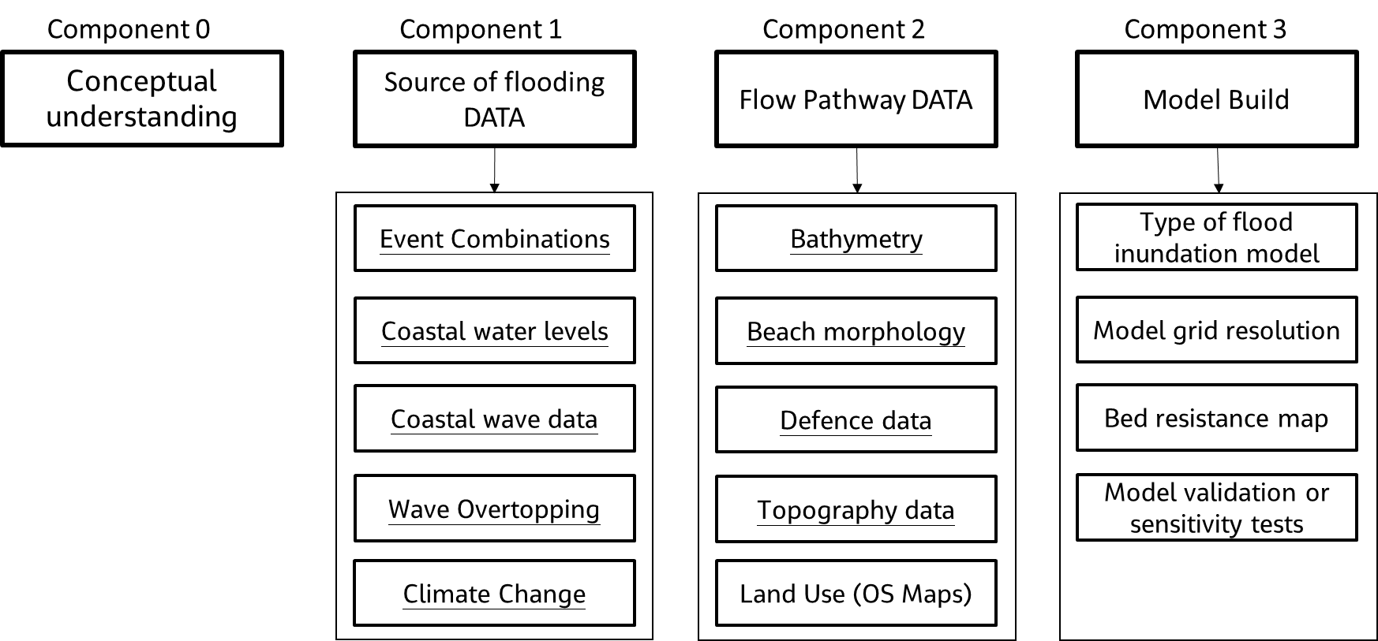
Figure 4-1: Key components and associated elements of flooding model for open coast (non-real-time models). Underlined elements comprise sub-elements shown in Figure 4-2 and Figure 4-3.
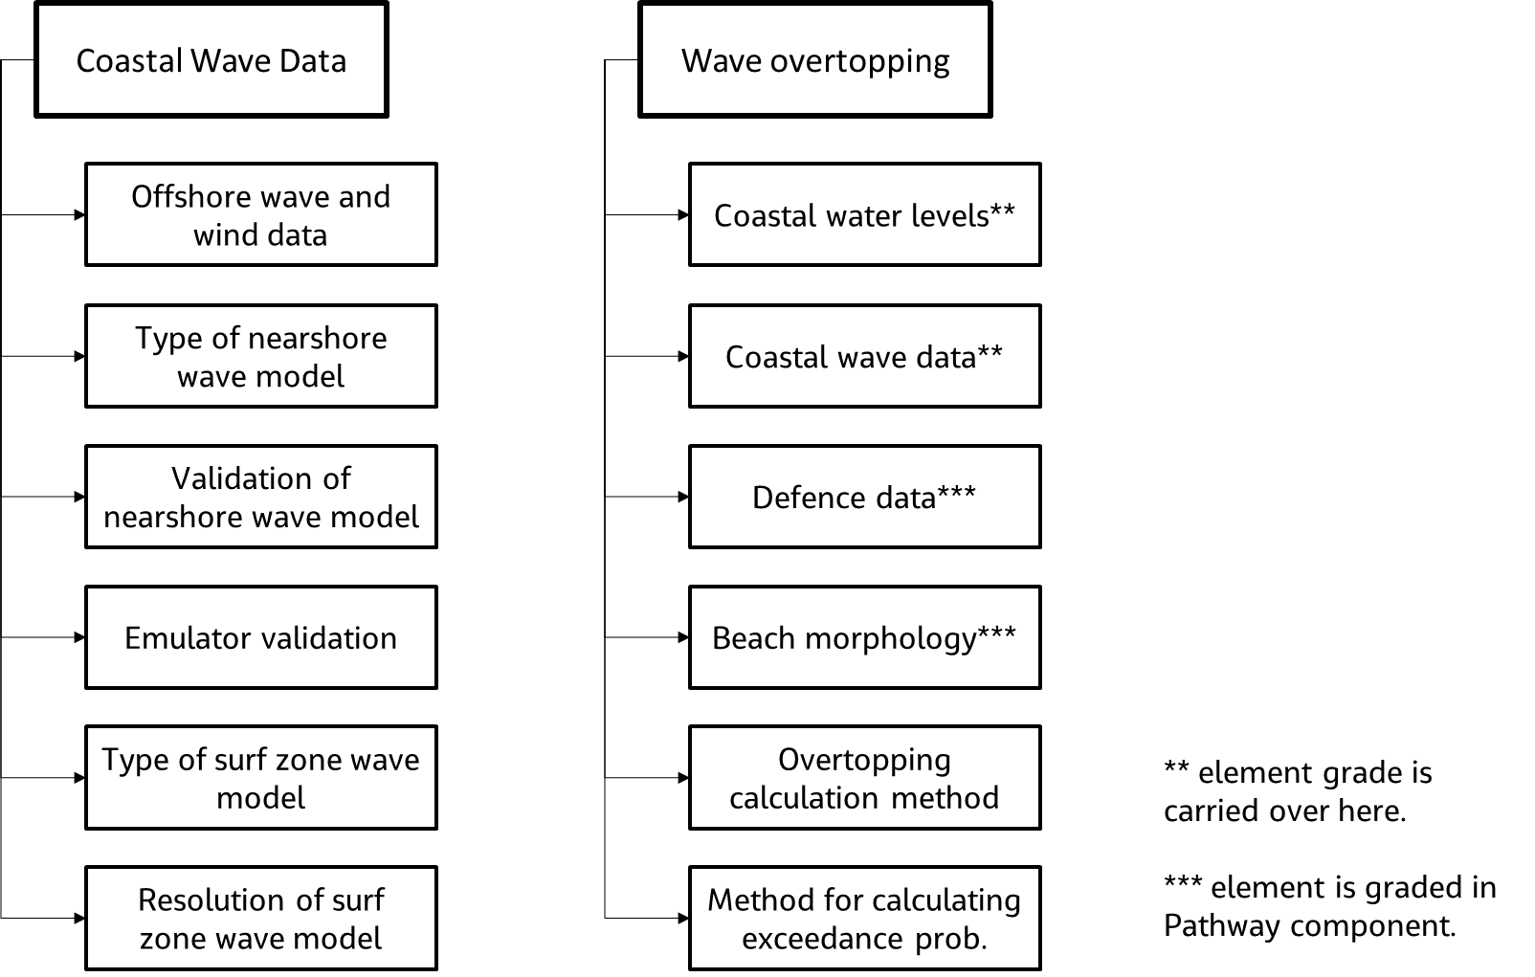

Figure 4-2: Detail on the elements that are part of the “source” component.
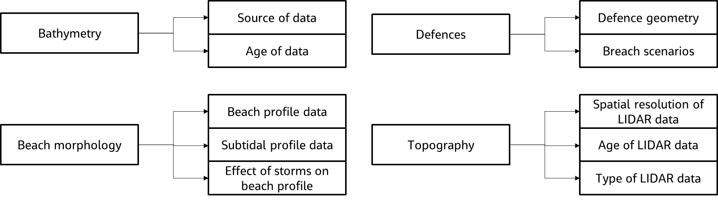
Figure 4-3: Detail on the elements that are part of the “pathway” component.

4.3 Method for designing model to target standard
The guidelines in this section provide a framework for designing a model to the needed quality standard, based on its use. The target quality standards for different types of model use are presented in Section 1.2.
Figure 5-8 shows the key steps for designing a model a target standard. These steps should be carried out at the inception stage of a project and are described below.
The first step is to clarify the use of the model and set the target quality score as described in Section 1.2. This must be clearly documented to avoid future potential misuse of the model.
Next step is to develop a conceptual understanding of the flooding problem. This can be done by:
- developing a conceptual SPR model
- identifying the area of interest
- key sources of flooding
- main flow pathways (including flood defences and potential sections that are vulnerable)
- potential inundation extents
Use this understanding to find all the project's important parts. The spreadsheet tool can be used to complete this with unimportant elements weighted to zero. The important elements in the spreadsheet are then set to be as good as the target score.
We then collate the available source/pathway data. The worksheet “_Example” can be used as a reminder of easily accessible data for UK coasts. The data for each element should match the target quality level as far as possible. See Appendix B (non-real time modelling) for more details. After collating the data, use the spreadsheet tool to score the available data for each element.
Next step is to carry out preliminary design of required models and tools. A preliminary design of all the models and tools that will be used should be carried out. These can include:
- joint probability analysis
- wave model
- wave overtopping model
- beach morphology
- breach analysis
- inundation model
For example, in a nearshore wave model, we need to outline the model type, grid spacing, and targets for calibration and validation. See Appendix B (non-real time modelling) for more details on achieving our quality targets. After that, use the spreadsheet to score the initial design. It is important to be as realistic at this stage as the choices will also depend on the budget and time available for the project.
Once the above tasks are done the next step is to assess the preliminary model score. This is preliminary, as it is based on preliminary design of the required models and tools.
If the target quality score is met or exceeded, then proceed with model development. Where the target score is not achieved, you can use the spreadsheet tool to identify the model elements needing improvement to reach the target score. A plan to improve the quality of these elements is prepared and discussed with the EA officer.
If a plan is agreed with the EA officer, the required extra data is collected so the quality of the required models/tools can be improved. A second check can confirm that the model will meet the target quality standard before continuing with model development. Alternatively, the EA officer may agree to progress the model subject to a list of caveats about the model. This is the last step in this process.
During model development, ensure that it meets the intended quality level. If limits force a lower quality level for an element, the impact on the overall score should be evaluated. If it will lower model quality, talk to the EA officer.
Finally, at the end of model development undertake a final check to make sure the model meets the intended quality standard. Record this in the model log.
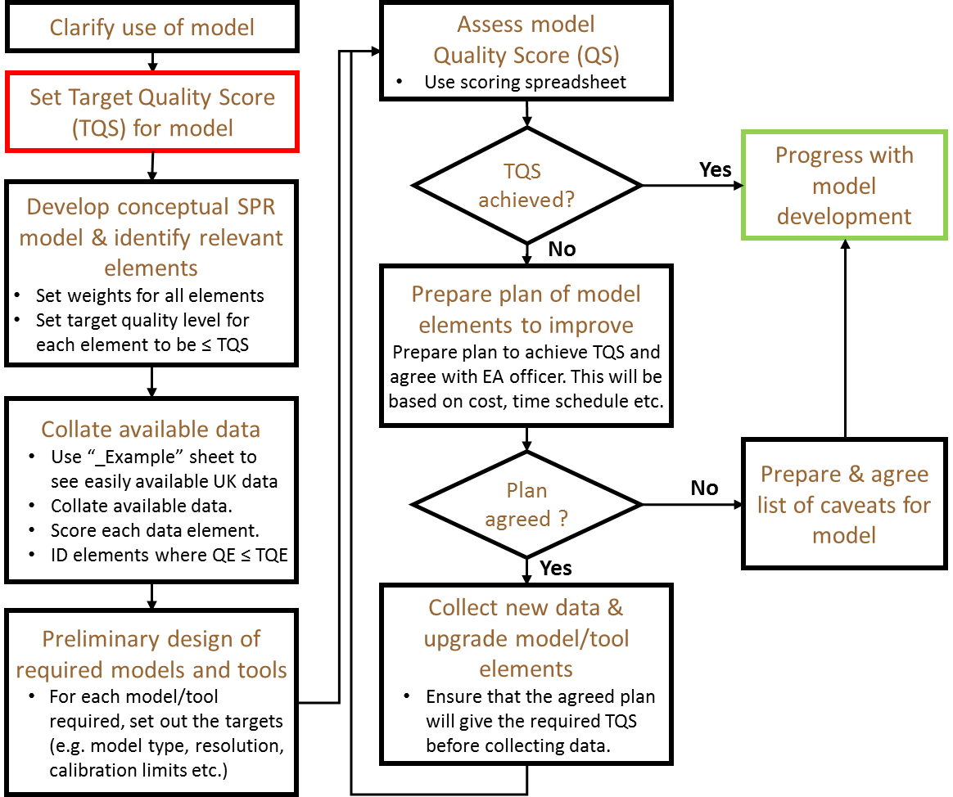
Figure 4-8: Block flow chart for designing a model to a Target Quality Score

References
ABPmer, 2010. Southampton Coastal Defence Strategy: Conceptual understanding and modelling approach. Report No: R.1726.
ABPmer, 2011. Southampton Coastal Flood and Erosion Risk Management Strategy: Data Review and Model Calibration. Report No: R.1745.
Andrews, Iain. 2015. Personal communications (including power-point presentation titled: “Modelling standards - what do we have v2-4.pptx” received in Feb 2015. This presentation describes the status of the work carried out on delivering consistent standards for modelling).
Bates, P.D., Dawson, R.J., Hall, J.W., Horritt, M.S., Nicholls, R.J., Wicks, J. and Hassan, M.A.A.M., 2005. Simplified two-dimensional numerical modelling of coastal flooding and example applications. Coastal Engineering, 52, 793-810.
Battjes, J.A. and Gerritsen, H. 2002. Coastal modelling for flood defence. Philosophical Transactions of the Royal Society, 360, 1461-1475.
Bidlot, J-R, D J Holmes, P A Wittmann, R. Lalbeharry, H S Chen, 2002. Intercomparison of the Performance of Operational Ocean Wave Forecasting Systems with Buoy Data, Weather and Forecasting, Vol 17, pp 287-310, Published by American Meteorological Society
Bunney and Saulter, 2014. Performance of the Met Office Atlantic short-range wave ensemble prediction system. Forecasting Research Technical Report No. 603
Burgess, K. 2015, Personal Communication.
Cali, M. 2015, Personal Communication.
CH2M, 2016, Standards for modelling and forecasting flooding on open coasts. Report prepared for
the Environment Agency.
CH2M, 2015. Tayport Coastal Feasibility Study – Feasibility study report. Report prepared for Fife council, Nov 2015
CH2M, 2018. Outer Thames Estuary Wave Model – Extreme nearshore wave data. Report prepared for TEAM2100, Aug 2018 (Annex II: Technical Note – Wave model setup and calibration)
CH2M HILL, 2012. Grangemouth Flood study. Report prepared for Waveney district council, Oct 2014
CH2M HILL, 2014. Lowestoft tidal defences - Additional modelling studies. Report prepared for Waveney district council, Oct 2014
CH2M HILL, 2015. Standards for modelling and forecasting flooding in large estuaries. Report prepared for Environment Agency, 20 April 2015
Chen, Y., Shi, F. and Kirby, J.T. 2010. Coupling of Wave and Circulation Models for Predicting Storm-Induced Waves, Surges, and Coastal Inundations. Centre for Applied Coastal Research. Research report no. CACR-10-06.
Cranston M., L. Naysmith, A. Tavendale, L. McLean, P. Hart, C. Whitlow, C. Powis and K. Hu., 2013. The Firths of Forth and Tay flood warning scheme and the storm of December 2012. ICE Breakwaters Conference, Edinburgh.
CREW (Centre of Expertise for Waters), 2012. Coastal Flooding in Scotland: A guidance document for coastal practitioners.
De Kleermaeker, S., Verlaan, M., Kroos, J., and Zijl, F., 2012. A new coastal flood forecasting system for the Netherlands, Hydro12 – Taking care of the sea, 13–15 November 2012, Rotterdam, 2012. Hydro12_44_New_Flood_Forecasting_System_for_Dutch_Coast_-_Paper.pdf (utwente.nl) Accessed 03-Dec-2015.
Defra/Environment Agency, 2003. Coastal flooding hazard by wave overtopping SHADOW Phase 1. Use of Numerical models of wave overtopping: A summary of current understanding. R&D Interim guidance note FD2410/GN1.
Defra/Environment Agency, 2004. Best Practice in Coastal Flood Forecasting R&D Technical Report FD2206/TR1
Defra/Environment Agency, 2004. Risk assessment for flodd and coastal defence for strategic planning. R&D Technical Report W5B-030/TR.
Defra / Environment Agency 2005. Use of Joint Probability Methods in Flood Management, A Guide to Best Practice. R&D Technical Report FD2308/TR2, March 2005
Defra/Environment Agency, 2005. Protocols for Minimum Standards In Modelling - Flood Warning Management System Phase 2a, R&D Technical Report W5C-021/2a. Report prepared for Defra/Environment Agency FCERM management R&D Programme, April 2005
Defra/Environment Agency, 2007. Best Practice in Coastal Flood Forecasting R&D report 2007 (HR Wallingford) SC050069.
Defra/Environment Agency, 2013. Benchmarking the latest generation of 2D hydraulic modelling packages Report – SC120002. Joint Defra/EA FCERM R&D programme project SC120002.
Defra/Environment Agency, 2005. Protocols for Minimum Standards In Modelling - Flood Warning Management System Phase 2a, R&D Technical Report W5C-021/2a. Report prepared for Defra/Environment Agency FCERM management R&D Programme, April 2005
Environment Agency, 2019. Coastal flood boundary conditions for the UK: update 2018 User guide SC060064/TR7, May 2019.
Environment Agency, 2014. Computational modelling to assess flood and coastal risk, Operating Instruction 379-05. (This version supersedes the 2010 version).
ECMWF, 2014. ‘The Wave Model’ presentation ECMWF | Advancing global NWP through international collaboration
ESCP (Eastern Solent Coastal Partnership), 2013. Southsea and north Portsea Island coastal flood and erosion risk management scheme. Scoping stage report. Technical report: Flood Risk Modelling.
Environment Agency, xxxx. Model QA checklist (FRAs)
Environment Agency. Managing our models - Framework for model management (document undated).
Environment Agency, 2006. SFRM Specification for Flood Risk Mapping.
Environment Agency, 2007. Real time model development for flood forecasting, Operational Instruction 145_07, June 2007.
Environment Agency, 2009. Tips and advice for developers of flood forecasting model types used in NFFS. Operational Instruction 536_05, May 2009
Environment Agency, 2010. Model report performance scope for WEM Lot 1 suppliers, Sep 2010.
Environment Agency, 2012. Forecasting Model Performance Framework Proposal, Draft v 0.7 Nov. 2012.
Environment Agency, 2013. Real time model development for flood forecasting, OI issued 16-Sep 2013.
European Union (EU) Floods Directive, Directive 2007/60/EC Chapter 1 Article2. Directive - 2007/60 - EN - EUR-Lex (europa.eu) Retrieved on 06 Feb 2015.
FLOODsite Consortium, 2007a. Evaluation of Inundation Models, Report T08-07-01, Revision Number 1_7_P15, April 2007
FLOODsite Consortium, 2007b. Predicting morphological changes in rivers, estuaries and coasts, Report T05-07-02, Revision Number 1_0_3_P31, April 2007, p106-207.
FLOODsite Consortium, 2009. Breaching Processes: A state-of-the-art review, Report T06-06-03, Revision Number 5_2_P01, February 2009.
Flood Risk Management Research Consortium, 2008. Research Outcomes in the Application of 2D Flood Inundation Models for Flood Risk Management. FRMRC Research Report WP5.2-4
Gouldby, B., Méndez, F.J., Guanche, Y., Rueda, A., Mínguez, R., 2014, "A methodology for deriving extreme nearshore sea conditions for structural design and flood risk analysis", Coastal Engineering, vol. 88, pp. 15-26.
Gouldby, B., David Wyncoll, Mike Panzeri, Mark Franklin, Tim Hunt, Dominic Hames, Nigel Tozer, Peter Hawkes, Uwe Dornbusch and Tim Pullen, 2014. " Multivariate extreme value modelling of sea conditions around the coast of England", Proceedings of the Institution of Civil Engineers, Maritime Engineering, 170, Issue MA1, Pages 3-20 (March 2017).
Golding B. W., 2007. Uncertainty Propagation in Flood Forecasting: The FRMRC Thames Collocation, 2007
Grey, D. 2013. Best Data: UKCMF Wave, wind and surge forecasts. Published by Met Office, 2013.
Halcrow, 2010. Portsea Island and Porcester to Farlington Flood Propagation Modelling - Development control, Areas of Benefit and Flood Warning Assessments. TUFLOW modelling report. September 2010.
Halcrow, 2012. Knott-End Sea Defence Study, Hydraulic modelling report. February 2012.
Halcrow, 2012. Coastal Processes Report: Brighton Marina to River Adur Flood and Coastal Erosion Risk Management Strategy. Brighton and Hove City Council. December 2012.
Halcrow, 2011. Technical assistance for the preparation of projects under priority axis 5 - Wave Modelling Report, Report prepared for A.N. Apele Romane, Administratia Bazinala de Apa Dobrogea – Litoral. July 2011.
Halcrow, 2014. Khalifa Port and Industrial Zone (KPIZ) Project – Framework Design Services - Task Order 008: Hydraulic and Navigation Studies, Numerical Modelling Report. Prepared for Abu Dhabi Ports Company, UAE, March 2014.
Halcrow, 2015. Hydrodynamic Model of Scottish Shelf Waters: Pentland Firth and Orkney Waters Model – Volume 1. September 2015.
Hall, N. 2015, Personal Communication.
Hall, J.W., Sayers, P.B., Walkden, M.J.A. and Panzeri, M. 2006. Impacts of climate change on coastal flood risk in England and Wales: 2030-2100. Philosophical Transactions of the Royal Society, 364, 1027-1049.
Hames DP, Gouldby BP and Hawkes PJ, 2019. Evolution of joint probability methods in coastal engineering practice in the UK. Proceedings of the Institution of Civil Engineers – Maritime Engineering 172(2): 45–54, Evolution of joint probability methods in coastal engineering practice in the UK | Proceedings of the Institution of Civil Engineers - Maritime Engineering (icevirtuallibrary.com)
Hartley, L. and Pontee, N. 2008. Assessing breaching risk in coastal gravel barriers. Proceedings of the Institute of Civil Engineers. Maritime Engineering, 161, 143-152.
Harper, B., Hardy, T., Mason, L. and Fryar, R. 2009. Developments in storm tide modelling and risk assessment in the Australian region. Natural Hazards, 51, 225-238.
Heffernan, J.E. and Tawn, J.A., 2004. A conditional approach for multivariate extreme values (with discussion). Journal of the Royal Statistical Society: Series B (Statistical Methodology). 66(3): 497-546.
HR Wallingford, 1998. The joint probability of waves and water levels: JOIN-SEA – A rigorous but practical new approach. Report SR 537.
HR Wallingford, 2015a. State of the Nation Flood Risk Analysis: Coastal Boundary Conditions. MCR5289-RT025-R02-00. Prepared for the Environment Agency. October 2015.
HR Wallingford, 2015b. State of the Nation Flood Risk Analysis: SWAN 2D Wave Calibration Report – JP17 Thames Estuary. MCR5289-RT012-JP17-R03-00. Prepared for the Environment Agency. September 2015.
HR Wallingford, 2015c. State of the Nation Flood Risk Analysis. SWAN 2D Wave Calibration Report, JP1 North Cumbria.
HR Wallingford, 2015d. State of the Nation Flood Risk Analysis. SWAN 2D Wave Calibration Report, JP3.
HR Wallingford, 2015e. State of the Nation Flood Risk Analysis. SWAN 2D Wave Calibration Report, JP5 Bristol Channel.
HR Wallingford, 2015. State of the Nation Flood Risk Analysis. SWAN 2D Wave Calibration Report, JP8 South Cornwall.
HR Wallingford, 2015f. State of the Nation Flood Risk Analysis. SWAN 2D Wave Calibration Report, JP9 Lyme Bay.
HR Wallingford, 2015g. State of the Nation Flood Risk Analysis. SWAN 2D Wave Calibration Report, JP13 West Sussex.
HR Wallingford, 2015h. State of the Nation Flood Risk Analysis. SWAN 2D Wave Calibration Report, JP16 East Kent.
HR Wallingford, 2015i. State of the Nation Flood Risk Analysis. SWAN 2D Wave Calibration Report, JP21 Lincolnshire.
HR Wallingford, 2015j. State of the Nation Flood Risk Analysis. SWAN 2D Wave Calibration Report, JP24 Northumberland.
Hunt, T. 2015, Personal Communication.
JBA Consulting, 2005. Protocols for Minimum Standards in Modelling, Flood Warning Management System Phase 2a. R&D Technical Report W5C-021/2a, April 2005 Report prepared for Environment Agency.
JBA Consulting, 2008. Central Area Tidal Areas Benefitting for Defences. Main Assessment Report Prepared for the Environment Agency. March 2008.
JBA Consulting, 2012. West Bay Tidal Modelling. Final Report. Prepared for the Environment Agency.
JBA Consulting, 2015. Investigating Coastal Flood Forecasting, State of Play and Trends Report, Draft Report. February 2015. Report prepared for Environment Agency.
Jacobs, 2021. Barton Upon Humber OBC: Model updates and calibration for the Barton Haven to New Holland Model. Report prepared for the Environment Agency
JBA Consulting, 2021. Coastal Model Method Comparison, Final Report. Prepared for the Environment Agency. August 2021.
HR Wallingford, 1998. The joint probability of waves and water levels: JOIN-SEA – A rigorous but practical new approach. HR Report SR 537, November 1998
LANDFORM, 2011. Coastal flood risk – from storm surge and waves to inundation. Report from workshop held on 26th May 2011.
Laurence, J., Kofoed-Hansen, H. and Chevalier, 2009. High resolution metocean modelling at EMEC’s (UK) marine energy test sites. Proceedings of the 8th European Wave and Tidal Energy Conference, Uppsala, Sweden, 2009.
Lawless, M., Powis, C. New Standards and Methods for Validating Coastal Flood Forecasting Systems. Unpublished (?), obtained via the Office for Public Works website, Ireland.
Leonard-Williams and Francis, 2013. Development of a methodology utilising look-up tables to accelerate spectral wave model run times. Weather Science Technical Report N0.571. Met Office.
Lowe, J. A., Howard, T. P., Pardaens, A., Tinker, J., Holt, J., Wakelin, S., Milne, G., Leake, J., Wolf, J., Horsburgh, K., Reeder, T., Jenkins, G., Ridley, J., Dye, S., Bradley, S. (2009), UK Climate Projections science report: Marine and coastal projections. Met Office Hadley Centre, Exeter, UK.
Morris, M.W., Hassan, M. and Kortenhaus, A. and Geisenhainer, G. and Visser, P.J. and Zhu, Y. 2008a. In: FLOODrisk 2008, 30 September - 2 October 2008, Keble College, Oxford, UK. (2008)
Morris, M.W., Hanson, G. and Hassan, M. 2008b. Improving the accuracy of breach modelling: why are we not progressing faster? Journal of Flood Risk Management, 1 (3). pp. 150-161. (2008)
Mott MacDonald, 2013. Clacton and Holland-on-sea PAR Environmental Baseline review. Tendring District Council.
Tyndall, 2005. Assessing coastal flood risk at specific sites and regional assessment of coastal flood risk. Technical Report N0 45. October 2005.
NOC (National Oceanography Centre), 2015. Modelling coastal erosion and sediment transport on the Dungeness Foreland, UK. Research & Consultancy Report No. 48.
Obhrai, C., Powell, K. & Bradbury. 2008. A laboratory study of overtopping and breaching of shingle barrier beaches. Reproduced from a paper presented at: International Conference on Coastal Engineering 2008
Hamburg, Germany. 31 August – 5 September 2008.
Parsons, A. 2015, Personal Communication.
Polidoro, A. and Pullen, T.A. and Eade, J. and Mason, T. and Blanco, B. and Wyncoll, D. (2018) Gravel beach profile response allowing for bimodal sea-states. Proceedings of the Institution of Civil Engineers - Maritime Engineering, 171 (4).
Posford Duvivier, 1999. Section 105 Tidal Flood Warning Tidal Flood Risk – Pilot Project, Final Report. Prepared for the Environment Agency October 1999.
Reeve and Horrillo-Caraballo, 2011. Statistical resampling methods of coastal flood risk management. FRMRC (Flood Risk Management Research Consortium) SWP2 WP2.2 Research Report 3. July 2011
Rogers, J., Hamer, B., Brampton, A., Challinor, S., Glennerster, M., Brenton, P. and Bradbury. 2010. Beach Management Manual (Second Edition)
Royal Haskoning, 2010. Weymouth flood risk strategy report. Prepared for the Environment Agency. June 2010.
Royal Haskoning, 2012. Guernsey coastal defences flood risk assessment studies. Vol2- Local area reports and appendices. March 2012.
Royal Haskoning, 2008. Tidal Flood Forecasting System, Technical Manual, Version2.0. January 2008. “State of the Nation” project briefing document for Environment Agency staff. Document provided by the EA for this study.
Saulter and Bunney, 2015. Developing, trialling and demonstrating the benefits of a wave ensemble prediction system for coastal flood forecasting. Forecasting Research Technical Report No. 606.
Sene et al, 2014. Uncertainty estimation in fluvial flood forecasting applications. In: Applied Uncertainty Analysis for Flood Risk Management, K. Beven and J. Hall (Editors), World Scientific, 684pp
Shim, J., Kim, J., Kim, D., Heo, K., Do, K., Park, S., 2013. Storm surge inundation simulations comparing three-dimensional with two-dimensional models based on Typhoon Maemi over Masan Bay of South Korea. In: Conley, D.C., Masselink, G., Russell, P.E. and O’Hare, T.J. (eds.), Proceedings 12th International Coastal Symposium (Plymouth, England), Journal of Coastal Research, Special Issue No. 65, pp. 392-397, ISSN 0749-0208
Simm, J., Gouldby, B., Sayers, P., Flikweert, J.J., Wersching, S. and Bramley, M. 2008. Representing fragility of flood and coastal defences: Getting into the detail. Flood Risk Management – Research and Practice Proceedings of FLOODrisk 2008, Keble College, Oxford, UK. 30 September to 2 October 2008.
Slott, J.M., Murray, A.B., Ashton, A.D. and Crowley, T.J. 2006. Coastline responses to changing storm patterns. Geophysical research letters, 33, L18404.
SNIFFER (Scotland and Northern Ireland Forum For Environmental Research. 2008. Coastal flooding in Scotland: A scoping study. Final report. Project FRM10.
Stansby, P., Chini, N., Apsley, D., Borthwick, A., Bricheno, L., Horrillo-Carballo, J., McCabe, M., Reeve, D., Rogers, B.D., Saulter, A., Scott, A., Wilson, C., Wolf, J. and Yan, K. 2013. An integrated model system for coastal flood prediction with a case history for Walcott, UK, on 9 November 2007. Journal of Flood Risk Management, 6, 229-252.
Stuiver C. 2015. Chesil Beach Extreme Value Analysis & Joint Probability Analysis, CH2M Tech memo, Sep 21, 2015
URS, 2012. Southampton Coastal Flood Risk and Erosion Management Strategy: Main Document. EC09/01/1673MD. Prepared for Southampton Cite Council. November 2012.
URS-Scott Wilson, 2011. Proposed Development at Helensburgh: Flood Risk Assessment. Prepared for Argyll and Bute Council. November 2011.
Van der Meer, J.W. and T. Bruce. New Physical Insights and Design Formulas on Wave Overtopping at Sloping and Vertical Structures. Journal of Waterway, Port, Coastal, and Ocean Engineering, ASCE, ISSN 0733-950X/04014025(18).
Van Rijn, L.C., Walstra, D.J.R., Grasmeijer, B., Sutherland, J., Pan, S. and Sierra, J.P. 2003. The predictability of cross-shore bed evolution of sandy beaches at the time scale of storms and seasons using process-based Profile models. Coastal Engineering, 47, 295-327.
Wang, H.V., Loftis, J.D., Lui, Z., Forrest, D. and Zhang, J. 2014. The storm surge and sub-grid inundation modelling in New York City during Hurricane Sandy. Journal of Marine Science and Engineering, 2, 226-246.
Wang, H.V., Loftis, J.D., Forrest, D., Smith, W. and Stamey, B. 2014. Modelling storm surge and inundation in Washington, DC, during Hurricane Isabel and the 1936 Potomac River Great Flood. Journal of Marine Science and Engineering, 3, 607-629.
Wolf, J. 2009. Coastal flooding – Impacts of coupled wave-surge-tide models. Natural Hazards, 49, 241-260.
Zijl, F. Sumihar, J. Verlaan, M. Improved operational water-level forecasting on the Northwest European Shelf and North Sea (DCSMv6 and DCSMv6-ZUNOv4), eSurge User Consultation Workshop, Delft, January 20, 2015.

Appendix A. Summary of reviewed literature

A.1 Coastal practitioners
The coastal practitioners who provided feedback to this work are listed below in alphabetical order (first name). Each practitioner is listed with company affiliation and the report version/s that feedback was provided.
- Andy Parsons, CH2M/Jacobs, 2016 and 2022
- Kevin Burgess, CH2M/Jacobs, 2016
- Marcello Cali, CH2M, 2016
- Niall Hall, Environment Agency, 2016 and 2022
- Tim Hunt, Environment Agency, 2016

A.2 Scientific papers and consultancy reports
The scientific papers and consultancy reports that were reviewed for this work are listed below in alphabetical order.
- ABPmer, 2010. Southampton Coastal Defence Strategy: Conceptual understanding and modelling approach
- ABPmer, 2011. Southampton Coastal Flood and Erosion Risk Management Strategy: Data Review and Model Calibration
- Bates et al., 2005. Simplified two-dimensional numerical modelling of coastal flooding and example application
- Battjes and Gerritsen, 2002. Coastal modelling for flood defence
- Chen et al., 2010. Coupling of Wave and Circulation Models for Predicting Storm-Induced Waves, Surges, and Coastal Inundations
- CREW, 2012. Coastal Flooding in Scotland A guidance document for coastal practitioners
- Defra/EA, 2003. Use of Numerical models of wave overtopping: A summary of current understanding
- Defra/EA, 2004. Risk Assessment for Flood and Coastal Defence for Strategic Planning
- Defra/EA, 2004. Best Practice in Coastal Flood Forecasting
- Defra/EA, 2005. Use of Joint Probability Methods in Flood Management, A Guide to Best Practice
- Defra/EA, 2009. Adapting to Climate Change: Advice for flood and coastal erosion risk management authorities
- Defra/EA, 2014. Beach Modelling: Lessons learnt from past scheme performance
- ECMWF, 2014. ‘The Wave Model.’ Presentation at: http://www.ecmwf.int/newsevents/training/meteorological_presentations/pdf/NM/OcWaves14.pdf, Last accessed 05/Feb/2016
- ESCP (Eastern Solent Coastal Partnership), 2013. Southsea and north Portsea Island coastal flood and erosion risk management scheme
- FLOODsite Consortium, 2007a. Evaluation of Inundation Models, Report T08-07-01
- FLOODsite Consortium, 2007b. Predicting morphological changes in rivers, estuaries and coasts, Report T05-07-02
- FLOODsite Consortium, 2009. Breaching processes: State of the art, Report T06-06-03
- Gouldby et al., 2014. A methodology for deriving extreme nearshore sea conditions for structural design and flood risk analysis
- Halcrow, 2010. Portsea Island and Porcester to Farlington Flood Propagation Modelling - Development control, Areas of Benefit and Flood Warning Assessments
- Halcrow, 2012a. Knott-End Sea Defence Study, Hydraulic modelling report
- Halcrow, 2012b. Coastal Processes Report: Brighton and Hove City Council
- Halcrow, 2015. Hydrodynamic Model of Scottish Shelf Waters: Pentland Firth and Orkney Waters Model – Volume 1
- Hall et al., 2006. Impacts of climate change on coastal flood risk in England and Wales: 2030-2100
- Harper et al., 2009 Developments in storm tide modelling and risk assessment in the Australian region
- Hartley and Pontee, 2008. Assessing breaching risk in coastal gravel barriers
- Heffernan and Tawn, 2004. A conditional approach for multivariate extreme values (with discussion)
- HR Wallingford, 1998. The joint probability of waves and water levels: JOIN-SEA – A rigorous but practical new approach
- HR Wallingford/EA, 2015. State of the nation flood risk analysis: Coastal boundary conditions
- HR Wallingford, 2015. State of the Nation Flood Risk Analysis. SWAN 2D Wave Calibration. Report, JP1 North Cumbria.
- HR Wallingford, 2015. State of the Nation Flood Risk Analysis. SWAN 2D Wave Calibration. Report, JP3.
- HR Wallingford, 2015. State of the Nation Flood Risk Analysis. SWAN 2D Wave Calibration. Report, JP5 Bristol Channel.
- HR Wallingford, 2015. State of the Nation Flood Risk Analysis. SWAN 2D Wave Calibration. Report, JP8 South Cornwall.
- HR Wallingford, 2015. State of the Nation Flood Risk Analysis. SWAN 2D Wave Calibration. Report, JP9 Lyme Bay.
- HR Wallingford, 2015. State of the Nation Flood Risk Analysis. SWAN 2D Wave Calibration. Report, JP13 West Sussex.
- HR Wallingford, 2015. State of the Nation Flood Risk Analysis. SWAN 2D Wave Calibration. Report, JP16 East Kent.
- HR Wallingford, 2015. State of the Nation Flood Risk Analysis. SWAN 2D Wave Calibration. Report, JP17 Thames Estuary.
- HR Wallingford, 2015. State of the Nation Flood Risk Analysis. SWAN 2D Wave Calibration. Report, JP21 Lincolnshire.
- HR Wallingford, 2015. State of the Nation Flood Risk Analysis. SWAN 2D Wave Calibration
- JBA Consulting, 2008. Central area tidal areas benefiting from defences main assessment report
- JBA Consulting, 2012. West Bay tidal modelling
- JBA Consulting, 2015. Investigating coastal flood forecasting: State of play and trends
- Landform Event, 2011. Coastal flood risk – from storm surge and waves to inundation
- Laurence et al., 2009. High-resolution metocean modelling at EMEC’s (UK) marine energy test sites
- Lowe et al., 2009. UK Climate Projections science report: Marine and coastal projections
- Mott MacDonald, 2013. Clacton and Holland-on-Sea PAR Environmental Baseline Review
- Tyndall, 2005. Assessing coastal flood risk at specific sites and regional assessment of coastal flood risk
- NOC, 2015. Modelling coastal erosion and sediment transport and the Dungeness Foreland, UK
- Obbhari et al., 2008. A laboratory study of overtopping and breaching of shingle barrier beaches
- Panzeri et al., 2012. A GIS framework for probabilistic modelling of coastal erosion and flood risk
- Posford Duvivier, 1999. Section 105 Tidal Flood Warning Tidal Flood Risk – Pilot Project, Final Report.
- Reeve and Horrillo-Caraallo, 2011. Statistical resampling methods for coastal flood risk management. FRMRC (Flood Risk Management Research Consortium).
- Rogers et al., 2010. Beach Management Manual
- Royal Haskoning, 2010. Weymouth flood risk strategy report
- Royal Haskoning, 2012. Guernsey coastal defences flood risk assessment studies. Vol2- Local area reports and appendices
- Shim et al., 2013. Storm surge inundation simulations comparing three-dimensional with two dimensional models based on Typhoon Maemi over Masan Bay of South Korea
- Simm et al., 2009. Representing fragility of flood and coastal defences: Getting into the detail
- Slott et al., 2006. Coastline response to changing storm patterns
- SNIFFER, 2008. Coastal flooding in Scotland – A Scoping Study
- Stansby et al, 2013. An integrated model system of coastal flood prediction with a case history for Walcott, UK, on 9 November 2007
- Stuiver, C. 2015 Chesil Beach Extreme Value Analysis & Joint Probability Analysis
- URS – Scott Wilson, 2011. Proposed Development at Helensburgh – Flood risk assessment
- URS, 2012. Southampton coastal flood and erosion risk management strategy: Main document
- Van Rijn et al., 2003 The predictability of cross-shore bed evolution of sandy beaches at the timescale of storms and seasons using process-based profile models
- Wang et al., 2014 The storm surge and sub-grid inundation modelling in New York city during Hurricane Sandy
- Wang et al., 2015 Modelling storm surge and inundation in Washington DC, during Hurricane Isabel and the 1936 Potomac River great flood
- Wolf, 2009 Coastal flooding impacts of coupled wave-surge-tide models

Appendix B. Guidelines for scoring non-real-time models

B.1 Source-pathway-receptor conceptual model
The development of a conceptual SPR model is a key step in understanding the problem. This model should identify the area of interest the main flow paths (including defences and vulnerable sections) and key sources of flooding. For existing models, this will form a report or description of the problem within a report. It need not be explicitly called SPR model.
Weight: 1
Data required:
High level description of the flooding problem, identifying the key sources, pathways and receptors
Relevant literature:
EA Model report performance scope
Defra/EA (2005), Protocols for Minimum Standards In Modelling
Element grades:
A – Design: SPR conceptual model up to date (< 2yrs old).
B – Appraisal: SPR conceptual model is 2 to 5 years old
C – Strategic: SPR conceptual model is 5 to 10 years old
U – Unsatisfactory: SPR conceptual model is > 10 years old or SPR model not available.
Comment: none

B.2 S1: Event combinations
The grade for “Event combinations” is derived from grades given to the following sub-elements:
- probability analysis
- additional requirements for multi-variate probability analysis
- additional requirements for joint probability contour analysis
The guidelines for grading each of the above sub-elements are set out below.

B.2.1 Probability analysis
Flooding on the open coast depends on the combination of waves and water levels. The Joint Probability Analysis (JPA) method accounts for the joint occurrence of these forces and is important to understand. It does so for a given AEP or average recurrence interval.
Weight: 1
Data required:
Methodology for determining event combinations for different AEPs
Relevant literature:
Gouldby, B., Méndez, F.J., Guanche, Y., Rueda, A., Mínguez, R., 2014, "A methodology for deriving extreme nearshore sea conditions for structural design and flood risk analysis", Coastal Engineering, vol. 88, pp. 15-26.
HR Wallingford, 1998. The joint probability of waves and water levels: JOIN-SEA – A rigorous but practical new approach. HR Report SR 537, November 1998.
Element grades:
A- Design
Multivariate Probability Analysis (MVPA) involving rigorous analysis of the statistical functions for the extremes and the dependencies between the variables (e.g. HTA method or equivalent). This analysis is used to generate large Monte Carlo sample of H, T, MWD & SL (+ Wspd, Wdir if offshore data).
OR
Use of State of the Nation dataset.
B-Appraisal
MVPA involving rigorous analysis of the statistical functions for the extremes and the dependencies between the variables (e.g. HTA method or equivalent).
OR
Two-variable joint probability involving a rigorous finding of the statistical functions for the extremes and dependencies between the two variables (JOINSEA method or equivalent).
OR
Joint probability contours from SON nearshore dataset.
C-Strategic
JPA based on simplified assumptions. For example, the chance of joint events caused by weather are assumed to be dependent (i.e. wind, waves, and storm surge). But the chance of joint events caused by weather and astronomical forcing are assumed to be independent (i.e. high tide and extreme waves).
OR
JPA is based on an EA/Defra desk-study method using known correlations between relevant pairs of variables. For example, from rigorous JPA using the JOINSEA method or Spearman's rank coefficient.
U – Unsatisfactory
Event combinations determined without any sound basis.
Comment:
The MVPA approach may become the minimum standard for an “A” grade once the method gets widespread recognition and acceptability. For example, the method has been applied in the ongoing State of the Nation (SON) project for the open coast.

B.2.2 Additional requirements for multivariate probability analysis
The MVPA method (e.g. Heffnan and Tawn, 2004) is used to find probability combinations for many variables. Gouldby et al (2014) used this method to find marginal extremes and dependence between winds, waves, and water levels parameters. We use a Monte Carlo sampling procedure to generate large samples of events (10,000-year sample) from the fitted probability distributions and dependence structure.
The "additional requirement" makes sure that the variable combinations from the probability analysis are physically realistic.
Weight: 1
Weight =0, if multivariate probability analysis is not used.
Data required:
Check event combinations from multivariate analysis.
Relevant literature:
None
Element grades:
A – Design: No physically unrealistic event in the 10,000 years sample.
B – Appraisal: Number of physically unrealistic events < 50 in 10,000 years sample.
C – Strategic: Number of physically unrealistic events < 100 in 10,000 years sample.
U – Unsatisfactory: None of the above
Comment:
Physically unrealistic events are defined as events where one or more of the conditions below are satisfied.
Wave steepness > 0.12
Hm0 / Depth > 1.2
High winds occurring together with low waves (wind speed > 30*Hm0 on open coast). The open coast constraint requires that the wind speed is not greater than the value needed to make corresponding significant wave height for a 5km fetch. The Coastal Engineering Manual (EM 1110-2-1100) has a fetch limited wave growth formula was used it to make this constraint. Wind speeds of 30 m/s and Hm0 < 1 m are considered physically unrealistic on the open coast.

B.2.3 Additional requirements for joint probability contour analysis
In joint probability contour analysis (JPC), two variables are used in the probability analysis. We determine the other variables, used in deriving wave overtopping, are created using fitted relationships. This is described in Section 3.
The "Additional requirement for JPC analysis" ensures that the fitted relationships used are strong. If scatter is present in the data (greater uncertainty in the fitted relationship) this is also considered in the element grade.
Weight: 1
Weight =0, if joint probability analysis is not used.
Data required:
Fitted relationship to determine additional variables.
Relevant literature:
See Section 3.1.4.4
Element grades:
A – Design:
- Tp = f(Hm0), tol = ±1 s
- Wspd = f(Hm0), tol = ±2m/s
- Wdir = f(MWD), tol = ±10deg
B – Appraisal: Same as A
C – Strategic: Same as A, but tolerance increased by 50%.
U – Unsatisfactory: None of the above
Comment:
95% of data should be within allowable tolerance for wave heights > 100% AEP Hm0.

B.3 S2: Climate change
Climate change affects forcing mechanisms by raising sea levels, increasing precipitation, which increases runoff, and increasing storminess, (wind and waves). These effects could raise coastal water levels and increase wave overtopping volumes. Assessment of these effects is important for assessing flood risk into the future.
Climate change can also have indirect effects. For example, causing long-term changes to the beach profile (Bruun’s rule). This can lead to the beach lowering at the base of the sea defence. This results in higher waves and overtopping. We should assess this effect to better understand the impact of climate change.
Weight: 1
Weight = 0, if the project objective is only to carry out a study for the present-day conditions.
Data required:
Allowance for changes to sea levels, wind and waves due to climate change.
Data source:
The data may be obtained from the UKCP18 website hosted by the Met Office. See also Environment Agency (2021) Guidance on Flood and coastal risk projects, schemes and strategies: climate change allowances and Flood risk assessments: climate change allowances - GOV.UK (www.gov.uk)
Relevant literature:
https://www.gov.uk/guidance/flood-and-coastal-risk-projects-schemes-and-strategies-climate-change-allowances
Element grades:
A – Design:
Sensitivity tests to the effect of climate change on sea level (sea level rise), wind and waves (storminess), and impact of sea level rise on beach profile. Latest EA guidance on climate change applied.
B – Appraisal:
Sensitivity tests to the effect of climate change on sea level (sea level rise) and wind and waves (storminess), Latest EA guidance on climate change applied.
C – Strategic:
Sensitivity tests to the effect of climate change on sea level (i.e. sea level rise) only. Latest EA guidance on climate change applied.
U – Unsatisfactory:
Effect of climate change not properly considered.
Comment:
None

B.4 S3: Coastal water level
The grade for “Coastal Water Level” is derived from grades given to the following sub-elements:
- tides (astronomical)
- storm surge (peaks)
- storm surge (profile)
- combined tides and surge
- wave setup
The guidelines for grading each of the above sub-element are set out below.

B.4.1 Coastal water level – tides (astronomical)
Astronomical tides cause periodic rise and fall of sea water levels. The tides can be conceived of as a sum of different sinusoidal waves (harmonics), each with different amplitude and phases. The tides are modified by shallow water harmonics as they propagate towards the coast. Tides are further modified in an estuary as the flow cross-section reduces further away from the sea.
The accurate prediction of tides is very important for modelling open coast flooding. In areas exposed to waves action, high waves at high tide can cause significant overtopping at flood defences.
We predict the astronomical tide levels based on harmonics. The harmonics are calculated from time series of water levels at a tide gauge. To get the most reliable estimate for all relevant tidal harmonics, the length of data at the tidal gauge should be at least 19 years.
The score for data length quality is based on work by Neil Ryan of the Environment Agency (EA). It is also based on work by the tidal prediction team at the National Oceanographic Centre (NOC). They assessed the confidence in tide tables using different record lengths and data quality.
Weight: 1
Data required:
Predicted tide time series (using harmonics) corresponding to high spring tide period when high tide is between MHWS and HAT. Furthermore, the spatial variation in water levels along the coast is also required.
We can get the variation in water levels by interpolation between nearby tidal gauges, if the gauges are within 20 km of each other. This requires that no amphidromic point lies between them. Instead, a 2D numerical hydrodynamic model can find the spatial variation in water levels.
Relevant literature:
For validation limits, see: Environment Agency, 1998. Quality control manual for computational estuarine modelling, R&D Technical Report W168 (Section A.4.2.2 Estuaries). Report prepared by Binnie Black & Veatch for the Environment Agency.
For length of data record: Ryan, N., 2015 Private communication.
Element grades:
A – Design:
Tide prediction from data at a class A tide gauge
OR any tide gauge where the data have been quality controlled
OR calibrated model (tide levels RMSE ≤ 0.10 m).
In all cases, length of record ≥ 19 years (for calculation of tidal harmonics).
B – Appraisal:
Tide prediction from data at any tide gauge where the data have been quality controlled
OR calibrated model (tide levels RMSE ≤ 0.10m).
In both cases, length of record is between 5 and 19 years (for calculation of tidal harmonics).
C – Strategic:
Tide prediction from data at any tide gauge where the data have been quality controlled
OR interpolated from adjacent tide gauges
OR calibrated model (tide levels RMSE ≤ 0.10m).
OR tidal harmonics from the Admiralty Tide Tables or any other source (agreed with EA).
In all cases, length of record is ≥ 1 year (for calculation of tidal harmonics).
U – Unsatisfactory:
Tide prediction from data at tide gauge data less than 1 year
OR tidal harmonics are older than 30 years without review
OR data obtained from a tide gauge that is too far from the site of interest
OR data derived from un-calibrated or unsuitable models
Comment:
This is a critical element.
If this data is U-grade, overall SourceData score = U regardless of the other scores.

B.4.2 Coastal water level – storm surge (peaks)
Storm surges are due to wind and atmospheric pressure differences and can raise water levels at the coast. It is the increase in water level due to storm surge during spring tides that usually causes flooding.
Weight: 2
Data required:
Extreme storm surge (peak and profile) corresponding to different AEP (or return period) are required.
Data sources:
This data can be obtained from:
- CFB database for UK coasts
- analysis of storm surge residual data at a suitable tide gauge
Where nearby tidal gauges have newer extreme water level data, we can estimate the levels at other gauges (without detailed modelling). This is completed using the CFB water level slopes.
Relevant literature:
Environment Agency (2011) Coastal Flood Boundary Conditions for UK mainland and islands - Project: SC060064/TR2: Design sea levels, Flood and Coastal Erosion Risk Management Research and Development Programme, February 2011.
Element grades:
A- Design:
Extreme water levels from the CFB database (EA, 2011) that has been updated to include newer tide gauge data. The data and analysis should be under 3 years old.
Measured data from Class A gauge or another gauge with good quality control. The length of data should be at least 30 years, and appropriate Extreme Value Analysis (EVA) carried out. The data and analysis should not be more than 3 years old.
B – Appraisal:
Extreme water levels from the CFB database (EA, 2011), where the flood modelling was before 2018, and tide gauge data used was 10 years old.
Data from calibrated storm surge model for 20 (or more) events spread over 20 or more years and appropriate Extreme Value Analysis (EVA). The data and analysis should not be more than 10 years old.
C – Strategic:
Data from calibrated storm surge model for 10 (or more) events spread over 10 or more years
OR extreme water levels provided by EA (basis not available)
U – Unsatisfactory:
Effect of storm surge not considered or considered incorrectly
Comments:
This is a critical element.
If this data is U-grade, overall SourceData score = U regardless of the other scores.

B.4.3 Coastal water level – storm surge (profile)
Storm surges (due to wind and atmospheric pressure differences) developed in the sea can result in raised water levels at the coast. The storm surge profile affects how long high water (tides and surge) will last and the peak water level. For example, if the storm surge profile is narrow, it is less likely to combine with a high astronomical tide resulting in high total water levels. The converse is the case if the storm surge profile is broad.
Weight: 1
Data required:
Average dimensionless storm surge profile (time series of residual surge levels during the storm) obtained from historical storms. This data can be obtained by analysis of storm surge residual data at a suitable tide gauge as carried out in the EA/Defra CFB study.
Ideally, a storm surge profile is required for each of the AEPs to be investigated. However, there is hardly enough data to carry out such analysis. The current approach is to derive the average profile from available storms in the historical data. This approach assumes that the average profile is the best estimate of the storm surge profile for any given storm.
Relevant literature:
Environment Agency (2011) Coastal Flood Boundary Conditions for UK mainland and islands - Project: SC060064/TR2: Design sea levels, Flood and Coastal Erosion Risk Management Research and Development Programme, February 2011.
Element grades:
A – Design:
Data from EA/DEFRA CFB method (2011, SC060064 CFB conditions for UK)
Measured profiles from Class A gauge (≥ 15 extreme storm events)
Note: The top 15 storm surge events at Class A gauges were used in SC060064 to derive the normalised surge profile.
B – Appraisal:
Average profile from calibrated storm surge model for 10 (or more) storm surge events.
C – Strategic:
Average profile from calibrated storm surge model for 5 (or more) storm surge events
OR average profile using storm surge residual data from tide gauge for 5 or more storm events.
U – Unsatisfactory:
Effect of storm surge not considered or considered incorrectly
Comment:
The effect of the storm surge profile may be quite critical in some cases, but this is difficult to quantify without site specific sensitivity testing.

B.4.4 Coastal water level – combined tides and surge
We need to combine the predicted tide and surge profiles to create the extreme water level at the coast. The CFB method (Environment Agency/Defra, 2011) says to combine tide and surge profiles by aligning the surge peak with the high tide level. This gives you the desired extreme water level. The CFB method also recommends checking the impact of +/- 3hrs phase shift between the surge peak and the high tide level. Further details can be seen in (EA/DEFRA, 2011).
The method for combining tide and surge profiles can have big impacts on how quickly a high-water level is reached and how long it lasts. It can also influence the extent and persistence of flooding.
Weight: 1
Data required:
Methodology for combining tide and surge profile
Relevant literature:
Environment Agency (2011) Coastal Flood Boundary Conditions for UK mainland and islands - Project: SC060064/TR2: Design sea levels, Flood and Coastal Erosion Risk Management Research and Development Programme, February 2011.
Element grades:
A – Design:
Combined surge-tide profile using the CFB method or any other method approved by EA. Should Include sensitivity of surge-tide profile to phasing of surge peak & high tide (3 cases).
B – Appraisal:
Combined surge-tide profile using the CFB method or any other method approved by EA. Should Include sensitivity of surge-tide profile to phasing of surge peak & high tide (2 cases).
C – Strategic:
Combined surge-tide profile using the CFB method or any other method approved by EA. Sensitivity to phasing not considered.
U – Unsatisfactory: None of the above
Comment:
None

B.4.5 Coastal water level – wave setup
Wave setup is the increase in still water level due to breaking waves induced forces. The wave setup increases approximately linearly from zero at some location in the surf zone to a maximum at the shoreline. This increase in water level can have a significant impact on the predicted overtopping rates.
Weight: 1
Data required:
Methodology for wave setup
Relevant literature:
Stansby, P., Chini, N., Apsley, D., Borthwick, A., Bricheno, L., Horrillo-Carballo, J., McCabe, M., Reeve, D., Rogers, B.D., Saulter, A., Scott, A., Wilson, C., Wolf, J. and Yan, K. 2013. An integrated model system for coastal flood prediction with a case history for Walcott, UK, on 9 November 2007. Journal of Flood Risk Management, 6, 229-252.
Element grades:
A – Design: Wave setup calculated from 1D profile model.
B – Appraisal: Wave setup added as a percentage of breaking wave height. For example, using 15-19% at shoreline as in Dean and Dalrymple, 2002 method.
C – Strategic: Wave setup not considered in existing studies.
U – Unsatisfactory: Wave setup not considered in new studies
Comment:
None

B.5 S4: Coastal wave data
The grade for “Coastal Wave Data” is derived from grades given to the following sub-elements:
- offshore wave data
- wind forcing
- type of nearshore wave model
- validation of nearshore wave model
- emulator validation
- type of surf zone model
- resolution of surf zone model
The guidelines for grading each of the above sub-element are set out below.

B.5.1 Coastal wave data – offshore wave data
High waves at high water levels during extreme events can cause significant overtopping of defences. This leads to flooding of the landward areas they protect.
Offshore waves can be mainly swell waves. These waves come from distant areas and move to the coast. Or they can be wind-waves from local storms. They can also be a mix of both. The waves change as they move towards the coast and can cause big waves to spill over flood defences and alter beaches.
Further discussion on waves and wave modelling can be found in Defra/Environment Agency (2004, 2007).
Weight: 2
Data required:
Hourly time series of integral wave parameters. For example, significant wave height, peak wave period and mean wave direction.
Relevant literature:
Defra/Environment Agency, 2007. Best Practice in Coastal Flood Forecasting R&D report 2007 (HR Wallingford) SC050069.
State of the Nation Coastal Modelling, 2015.
Element grades:
A – Design:
Measured offshore wave data with length of record ≥ 30years.
OR data from UK Met office wave model or any other competent authority. The hindcast data should satisfy the following requirements:
- resolution of wave model ≤ 12km
- model validated with RMSE_Hm0 ≤ 0.5m or RMSE/average peak Hm0 ≤ 0.20.
- length of record should be ≥ 30years
B – Appraisal:
Measured offshore wave data with length of record ≥ 20years.
OR data from UK Met office wave model or any other competent authority. The hindcast data should satisfy the following requirements:
- resolution of wave model ≤ 12km
- model validated with RMSE_Hm0 ≤ 0.5m or RMSE/average peak Hm0 ≤ 0.25
- length of record should be ≥ 20years
C – Strategic:
Measured offshore wave data with length of record ≥ 10years.
OR data from UK Met office wave model or any other competent authority. The hindcast data should satisfy the following requirements:
- resolution of wave model ≤ 12km
- model validated with RMSE_Hm0 ≤ 0.5m or RMSE/average peak Hm0 ≤ 0.30.
- length of record should be ≥ 10years
U – Unsatisfactory:
No data satisfying A/B/C
Comment:
RMSE_Hm0 should be calculated using a dataset comprising storm peak Hm0 data or wave height data above specified threshold. H = mean annual Hm0 + 2*standard deviation (Hm0).

B.5.2 Coastal wave data – find forcing
When transforming offshore waves to the nearshore, it is important to consider the effect of wind. The wind adds energy to the waves increasing wave height. The height increases until they become fully formed or shallow water processes become dominant.
Weight: 2
Data required:
Extreme wind speed and direction (at 10m elevation above MSL) for the different AEP (or return period).
Time series of wind conditions during the selected storms.
Relevant literature:
Defra/Environment Agency, 2007. Best Practice in Coastal Flood Forecasting R&D report 2007 (HR Wallingford) SC050069. - State of the Nation Coastal Modelling, 2015.
Element grades:
A – Design: Data from Met Office or equivalent agency / organisation. The meteorological model resolution should be ≤ 12 km and hourly temporal resolution.
B – Appraisal:
From model with spatial resolution of >12km but <0.5 degree at 3 hourly temporal resolution.
C – Strategic:
From model with spatial resolution of >0.5 degree but <1 degree at 6 hourly temporal resolution.
U – Unsatisfactory:
None of the above
Comment:
None

B.5.3 Coastal wave data – type of nearshore wave model
High waves at flood defences at high water levels can cause significant wave overtopping. This leads to flooding of the landward areas. In extreme cases, it can also lead to breaching of the defences.
The wave data (at flood defences) can be obtained from wave measurements. Alternatively, and this will be common, it can be found using wave models to transform the offshore wave conditions. It is recommended that we transform offshore waves to the toe of the structure in two stages. First, we transform them from offshore to nearshore, then from nearshore to the toe of the structure (as in the SoN project). The grading for the nearshore model type is considered here.
Weight: 1
Data required:
Type of nearshore wave model
Relevant literature:
Defra/Environment Agency (2004). Best Practice in Coastal Flood Forecasting R&D Technical Report FD2206/TR1
Defra/Environment Agency, 2007. Best Practice in Coastal Flood Forecasting R&D report 2007 (HR Wallingford) SC050069.
Element grades:
A – Design: Calibrated 2D fully spectral wind-wave model.
Offshore data transformed using calibrated 2D fully spectral wind-wave model to nearshore areas. A parametric spectral wind-wave model can be used if sensitivity against fully spectral model is carried out and found to be consistent.
B – Appraisal: Calibrated parametric spectral wind-wave model
Offshore data transformed using calibrated 2D parametric spectral wind-wave model to nearshore areas.
C – Strategic: As specified in “B” grade
U – Unsatisfactory: None of the above
Comment:
This is a critical element. If this data is U-grade, overall SourceData score = U regardless of the other scores.

B.5.4 Coastal wave data – validation of nearshore wave model
Validating the nearshore wave model is important to ensure the model properly represents the change of offshore waves to a specified nearshore contour (typically 5 to 8m). This ensures that errors in wave parameters used in the wave overtopping calculations are minimised.
Weight: 1
Data required:
Validation statistics for wave model
Relevant literature:
See Section 3.1.6.
Element grades: Wave Height
A – Design: RMSE ≤ 0.3 m or SI < 20% on peak Hm0.
B – Appraisal: RMSE ≤ 0.4 m or SI < 20 to 25% on peak Hm0
C – Strategic: RMSE ≤ 0.5 m or SI < 25 to 30% on peak Hm0
U – Unsatisfactory: RMSE >0.5 m or SI > 30% OR no validation
Validation based on a database comprising storm peak Hm0 data or wave height data above a specified threshold, H. This threshold is the mean annual Hm0 plus 2 times the standard deviation of Hm0.
RMSE is the root mean square error for Hm0
Scatter index or SI is the ratio of RMSE to the average storm peak Hm0.
Element grades: Wave Period
A – Design: RMSE Tp ≤ 1 s & |Bias_Tp| < 0.5 s.
B – Appraisal: RMSE Tp ≤ 1.5 s & |Bias_Tp| < 0.7 s.
C – Strategic: RMSE Tp ≤ 1.5 s & |Bias_Tp| < 1.0 s.
U – Unsatisfactory: RMSE Tp > 1.5 s OR |Bias_Tp| > 1.0 s OR No validation
Validation based on wave period data associated with peak Hm0.
In addition to Tp, other wave period parameters such as T02 or Te can be used for validation.
RMSE is the root mean square error and bias is the deviation between the modelled and measured data.
Element grades: Wave Direction
A – Design: MAE_MWD ≤ 10 deg.
B – Appraisal: MAE_MWD ≤ 15 deg.
C – Strategic: MAE_MWD ≤ 20 deg.
U – Unsatisfactory: MAE_MWD > 20 deg OR No validation
Validation based on wave direction data associated with peak Hm0. MAE is the mean absolute error between the modelled and measured data.
Comment:
None

B.5.5 Coastal wave data – validation of emulator
Validation of the emulator is important to ensure the model adequately represents the transformation of the offshore waves to the specified nearshore location. It is typically about 5m depth. This ensures that errors in wave parameters used in the wave overtopping calculations are minimised.
Weight: 1
Data required:
Validation statistics
Relevant literature:
See Section 3.1.6.
Element grades: Wave Height
A – Design: RMSE ≤ 0.3 m or SI < 20% on peak Hm0.
B – Appraisal: RMSE ≤ 0.4 m or SI < 20 to 25% on peak Hm0
C – Strategic: RMSE ≤ 0.5 m or SI < 25 to 30% on peak Hm0
U – Unsatisfactory: RMSE >0.5 m or SI > 30% OR no validation
Validation based on a dataset comprising storm peak Hm0 data or wave height data above specified threshold. H (= mean annual Hm0 + 2*standard deviation of Hm0).
RMSE is the root mean square error for Hm0.
Scatter index or SI is the ratio of RMSE to the average storm peak Hm0.
Element grades: Wave Period
A – Design: RMSE Tp ≤ 1 s & |Bias_Tp| < 0.5 s.
B – Appraisal: RMSE Tp ≤ 1.5 s & |Bias_Tp| < 0.7 s.
C – Strategic: RMSE Tp ≤ 1.5 s & |Bias_Tp| < 1.0 s.
U – Unsatisfactory: RMSE Tp > 1.5 s OR |Bias_Tp| > 1.0 s
OR
No validation.
Validation based on wave period data associated with peak Hm0.
In addition to Tp, other wave period parameters such as T02 or Te can be used for validation.
RMSE is the root mean square error and bias is the deviation between the modelled and measured data.
Element grades: Wave Direction
A – Design: MAE_MWD ≤ 10 deg.
B – Appraisal: MAE_MWD ≤ 15 deg.
C – Strategic: MAE_MWD ≤ 20 deg.
U – Unsatisfactory: MAE_MWD > 20 deg
OR
No validation.
Validation based on wave direction data associated with peak Hm0.
MAE is the mean absolute error between the modelled and measured data.
Comment:
None

B.5.6 Coastal wave data – type of surf zone model
High waves at flood defences at high water levels can cause significant wave overtopping. This leads to flooding of the landward areas. In extreme cases, it can also lead to breaching of the defences.
The wave data can be obtained from wave measurements. Instead, it can often be obtained using wave models to transform the offshore wave conditions. It is recommended that transformation of offshore wave is carried out in two stages. From offshore to nearshore and then nearshore through the surf zone to the toe of the structure. This process was undertaken in the SoN project.
Weight: 1
Data required:
Type of Surf Zone Model
Relevant literature:
Defra/Environment Agency (2004). Best Practice in Coastal Flood Forecasting R&D Technical Report FD2206/TR1
Defra/Environment Agency, 2007. Best Practice in Coastal Flood Forecasting R&D report 2007 (HR Wallingford) SC050069.
Element grades:
A – Design: SWAN1D or equivalent.
Nearshore waves (at 5 to 8 m contour) transformed to toe of structure using 1-D spectral wave model such as SWAN1D or equivalent.
B – Appraisal: Parametric 1-D spectral wave model in LITPACK or equivalent
Nearshore waves (at 5 to 8 m contour) transformed to toe of structure using 1-D spectral wave model such as LITPACK or equivalent
C – Strategic:
Nearshore waves (at 5 to 8 m contour) transformed to toe of structure using Goda’s method (or equivalent).
U – Unsatisfactory:
None of the above
Comment:
None

B.5.7 Coastal wave data – resolution of surf zone model
To ensure the model can resolve surf zone processes correctly a minimum number of grid points is required.
Weight: 1
Data required:
Number of grid points across the surf zone.
Relevant literature:
None
Element grades:
A – Design: 10 to 12 grid points across the surf zone.
B – Appraisal: 8 to 10 grid points across the surf zone.
C – Strategic: 6 to 8 grid points across the surf zone.
U – Unsatisfactory: Less than 6 grid points across the surf zone.
Comment:
None

B.6 S5: Wave overtopping
The grade for “Wave Overtopping” is derived from grades given to the following elements and sub elements:
- coastal water levels
- coastal wave data
- defence data
- beach morphology
- overtopping calculation method
- method for calculating exceedance probability
The guidelines for grading the first four elements have been outlined elsewhere in this document. The guidelines for grading the last two sub-elements are set out below.

B.6.1 Wave overtopping – calculation method
During high water events, the wave run-up height is higher than the crest level of the flood defence, waves will then spill over the defence. Lots of wave’s overtopping can flood the land behind the defences.
Weight: 1
Data required:
Wave overtopping calculation method
Relevant literature:
EuroTop manual
Element grades:
A – Design: Calculations using EuroTop neural network method or other methods/models approved by the EA. An alternative to EuroTop is AMAZON. This is based on the solution of nonlinear shallow water equations. Other models can also be used if approved by the relevant EA officer.
B – Appraisal: Empirical formulas such as EurOtop or Hedges and Ruis (1998) method
C – Strategic: As specified in “B” grade, see comment
U – Unsatisfactory: Calculations using obsolete method.
Comment:
There are many uncertainties in calculation of wave overtopping rates, no matter the method used that are currently available. Due to this, only three grades (A, B, and U) are available for this element.

B.6.2 Wave overtopping – AEP calculation method
The AEP for a wave overtopping rate can be found using the response variable (RV) or joint probability contour (JPC) approaches.
In the RV approach, we calculate wave overtopping for a large Monte Carlo sample (10,000-year sample). The extreme overtopping rates are determined using the plotting position or countback method.
The JPC approach calculates wave overtopping for selected sample points on the joint probability contour for each AEP. The maximum value on the JPC is assigned the same AEP as the JPC.
Weight: 1
Data required:
AEP calculation method
Relevant literature:
See Section 3.1.4.5
Element grades:
A – Design: The response variable (RV) approach is used to determine the wave overtopping AEPs.
B – Appraisal: JPC and Response Variable (RV) methods
The JPC approach is used for the analysis of long-list options to derive the short-list. The RV approach is used to determine the wave overtopping AEPs for the short-list options.
In the Joint Probability Contour (JPC) = Approach, where wave overtopping is calculated for sample points on JPC to determine maximum for each AEP. The maximum value on the JPC is assigned the same AEP as the JPC.
C – Strategic: JPC method
By calculating OT for sample points on JPC to determine maximum for each AEP (JPC approach).
U – Unsatisfactory: None of the above.
Comment:
None

B.7 P1: Bathymetry data
The grade for “Bathymetry data” is derived from grades given to the following sub-elements:
- source of bathymetry data
- age of bathymetry data
The guidelines for grading these two sub-elements are set out below.

B.7.1 Bathymetry – source of bathymetry data
Propagation and transformation of waves from offshore to nearshore areas depend sensitively on the bathymetry. It affects wave processes such as:
- refraction
- shoaling
- bottom friction
- depth induced wave breaking
If the bathymetry is not resolved well, the predicted nearshore wave parameters will be wrong. This will affect wave overtopping and flooding.
Weight: 1
Data required:
Information on the source of bathymetry data and the bathymetry data.
Relevant literature:
None
Element grades:
A – Design: Approved bathymetric surveys for study (including sub-tidal LIDAR surveys)
B – Appraisal: Sea charts - 1:10,000 or better
C – Strategic: Sea charts - 1:25,000 or better
U – Unsatisfactory: Larger scale sea charts or unknown
Comment:
Note 1: Where only non-overlapping datasets are available for a project, use a weighted average score, weighted by the area covered by each dataset. However, if the rating for any area is U, then the whole dataset is U. This is true unless it can be shown that the U-area does not affect the wave conditions near the areas of interest. A sensitivity analysis can be carried out to assess the impact of the area on the locations of interest. For example, by increasing or decreasing depths over the U-area by 1 or 2 m.
Note 2: SeaZone data is sometimes used in coastal studies as the best available bathymetry data. It should be noted that this data contains a mixture of:
- international charted bathymetry
- ‘off the shelf’ regional products
- surveys built from SeaZone database of underwater terrain data
For scoring in this element, it is important to know the data sources for different areas in the SeaZone bathymetry. If the data sources are not known, set grade to “B”.

B.7.2 Bathymetry – age of bathymetry data
We expect that over decades, natural processes or human actions (like coastal defences and beach management) may change the bathymetry. This will make current data, out-of-date.
Weight: 1
Data required:
Age of data for 80% or more of the study area.
Relevant literature:
None
Element grades:
A – Design: ≤ 5 years
B – Appraisal: 5 to 10 years
C – Strategic: 10 to 20 years
U – Unsatisfactory: > 20 years or unknown
Comment:
Note 1: Where only non-overlapping datasets are available for a project, use a weighted average score, weighted by the area covered by each dataset. However, if the rating for any area is U, then the whole dataset is U. This is true unless it can be shown that the U-area does not affect the wave conditions near the areas of interest.

B.8 P2: Beach morphology
A baseline cross shore profile (backshore or structure out to nearshore contour: -5 to 8 m) is used in the surf zone wave transformation modelling. This is used to transform the nearshore waves to the toe of the defence. Due to the logistics of data collection across this region it is likely that two data sets will be required. Beach profiles typically only extend to around Mean Low Water Springs (MLWS). Therefore, bathymetry data is required to complete the profile out to the near shore contour (-5 to 8 m). The Channel Coastal Observatory (National Coastal Monitoring) has data on both beach profiles and bathymetry for many locations around England. Lidar data is also available and can be used to extract profiles from if survey data is not available.
The grade for “Beach morphology” is derived from grades given to the following sub-elements:
- beach profile data
- subtidal nearshore profile data
- impact of morphological change
The guidelines for grading these sub-elements are set out below.

B.8.1 Beach morphology – beach profile data
We need beach profile data and nearshore bathymetry data to create the active cross shore profile for surf zone modelling.
Weight: 1
Data required:
Beach profiles for use in surf zone model
Relevant literature:
None
Element grades:
A – Design: Baseline beach profile data derived from 2 years of profile data. At least 4 profiles: 2 winters, 2 summer in the last 5 years. A minimum cross shore interval of 5m.
B – Appraisal: Baseline beach profile data derived from 1 year of profile data. At least 2 profiles: 1 winter, 1 summer in the last 5 years. A minimum cross shore interval of 5m.
C – Strategic: Baseline beach profile data derived from the most recent winter profile within the last 5 years. A minimum cross shore interval of 5m.
U – Unsatisfactory: None of the above.
Comment:
None

B.8.2 Beach morphology – subtidal nearshore profile data
We need nearshore bathymetry and beach profile data to make the cross-shore profile for surf zone modelling.
Weight: 1
Data required:
Subtidal section of cross shore profile for use in surf zone model
Relevant literature:
None
Element grades:
A – Design: Multi beam bathymetry data.
B – Appraisal: Single beam bathymetry data.
C – Strategic: See comment for ‘B’ grade.
U – Unsatisfactory: None of the above.
Comment:
None

B.8.3 Beach morphology – impact of morphological change
During a storm, sediment moves from the backshore and transported offshore. This can create a bar at or below the low water line. This may raise the water depth at the toe of a structure increasing the chance of overtopping. So, it is important to consider how storms may change beach shape. Figure 3-1 provides a framework for considering changes to beach shape during a storm adapted from FLOODsite report T05_07_02. It is recommended to use many 'what if' beach profile scenarios to assess sensitivity to wave overtopping volumes and fragility curves.
Weight: 1
Data required:
Assessment of importance of morphological changes, and the timescale
Relevant literature:
FLOODsite report T05_07_02.
Beach Management Manual
Element grades:
A – Design: Considered morphological change through the framework. Including the use of historical data of winter beach profiles over at least 10 years and expert judgment. This should include a minimum of 6 'what if' beach profiles.
B – Appraisal: Considered morphological change through the framework. Including the use of expert judgment to derive a minimum of 3 'what if' beach profile scenarios.
C – Strategic: Same as 'B'.
U – Unsatisfactory: Assessment not carried out.
Comment:
Weight = 0, if the assessment shows that morphological change is not important.

B.9 P3: Flood defence data
The grade for “Flood defence data” is derived from grades given to the following sub-elements:
- flood defence geometry
- flood defence breach scenarios
The guidelines for grading these sub-elements are set out below.

B.9.1 Flood defence data – flood defence geometry
We need a good description of the flood defence crest and toe levels to accurately model water overflowing the defence. Also, knowing the structures condition is key to help assess the risk of breaching during storm conditions.
We need a good description of the flood defences cross-section and structure type to calculate wave overtopping volumes on the open coast.
Weight: 1
Data required:
Flood defence crest/toe levels and cross section
Relevant literature:
None
Element grades:
A – Design: From site survey
OR
AIMS database - High Quality flag in AIMS; Defence data updated 1 year or less.
B – Appraisal: AIMS database
Moderate quality flag in AIMS; Defence data updated 3 years or less
C – Strategic: AIMS database
Fair Quality flag in AIMS; Defence data updated 5 years or less
U – Unsatisfactory: No data
OR poor-quality flag/missing data in AIMS database
OR data from Lidar and photogrammetry surveys
OR old tidal defence surveys.
Comment:
In all cases, the flood defence information should be at a sufficient interval to properly describe the flood defences in the area of interest. If this is not the case, the score is “U”.

B.9.2 Flood defence data – breach scenarios
Damage to flood defences can lead to breaches, leading to flooding in the previously protected areas.
Furthermore, during events with extreme water levels, waves and water can overflow a sand dune. This can lead to breaching of the dune (or any other natural flood defence made of sediments). This will lead to flooding in the hitherto protected landward areas.
You can find more on breaching in flood defences in FD2320 (section 12.S3.2), and FD2411.
Weight: 1
Data required:
Breach scenarios considered
Relevant literature:
Defra/Environment Agency, 2005. Framework and Guidance for Assessing and Managing Flood Risk for New Development – Full Documentation and Tools, R&D Technical Report FD2320/TR2, October 2005
Simm, J., Gouldby, B., Sayers, P., Flikweert, J.J., Wersching, S. and Bramley, M. 2008. Representing fragility of flood and coastal defences: Getting into the detail. Flood Risk Management – Research and Practice Proceedings of FLOODrisk 2008, Keble College, Oxford, UK. 30 September to 2 October 2008
Element grades:
A – Design: Use fragility curves to determine the location and probability of breaching under extreme wave conditions.
B – Appraisal: Location of breaching determined based on site inspections, value and local knowledge of past events.
C – Strategic: As specified in ‘B’ grade
U – Unsatisfactory: Not considered
Comment:
Weight = 0, if risk of breaching is considered close to 0.
This is a critical element.
If this data is U-grade, overall Pathway Data score = U regardless of the other scores.

B.10 P4: Topography data
The topography data is specified using LiDAR data. The grade for “Topography data” is derived from grades given to the following sub-elements:
- spatial resolution of LiDAR data
- age of LiDAR data
- type of LiDAR data
The guidelines for grading these sub-elements are set out below.

B.10.1 Topography – spatial resolution of LiDAR data
The LiDAR data resolution should be adequate to resolve spatial variation in flood pathways during a storm. This is important for modelling flood inundation in urban areas to resolve flow paths such as roads that are only a few metres wide.
The needed resolution depends on the topography's complexity and presence of features like buildings and roads. In open grasslands, a coarse grid may be enough. While in urban areas, a more detailed resolution is required to resolve key flow pathways. In general, a spatial resolution resolving each feature in the model with at least 5 grid points is required.
Weight: 1
Data required:
Spatial resolution of the LiDAR data
Relevant literature:
None
Element grades:
A – Design: ≤ 1.0m
B – Appraisal: Up to 2m
C – Strategic: Up to 5m
U – Unsatisfactory: > 5m OR any other dataset e.g. SAR (Synthetic Aperture Radar), data where the vertical error is poorer than that obtained with comparable LiDAR dataset.
Comment:
The above scores are applicable for urban areas. For rural areas, the minimum resolution for each grade can be scaled up subject to the agreement of the EA project manager.
Note: Where only non-overlapping datasets are available for a project, use a weighted average score, weighted by the area covered by each dataset. However, if the rating for any area is U, then the whole dataset is U.
This is a critical element. If this data is U-grade, overall Pathway Data score = U regardless of the other scores.

B.10.2 Topography – Age of LiDAR data
Over decades, infrastructure changes (e.g. new roads), urban growth, and rural development will make current LiDAR data out-of-date. More importantly, it will make the flow paths in the data wrong. So, you must know when the data was collected and if the flow paths have changed since then.
Weight: 1
Data required:
Age of data for 80% or more of the primary flood risk area of interest
OR area weighted age for the entire area.
Relevant literature:
None
Element grades:
A – Design: ≤ 2 years
B – Appraisal: 2 to 5 years
C – Strategic: 5 to 10 years
U – Unsatisfactory: > 10 years
Comment:
This is a critical element. If this data is U-grade, overall Pathway Data score = U regardless of the other scores.

B.10.3 Topography – Type of LiDAR data
LiDAR data is generally provided unfiltered, i.e. with trees, bridges and buildings included. This gives an unrealistic land surface. The data should be filtered to remove these features. Removing buildings is important as flood waters will enter the properties. Failing to remove the buildings will overestimate the flood extent. The bed roughness over buildings is increased to simulate the reduced flow speeds through a building.
Weight: 1
Data required:
Type of data
Relevant literature:
Flood Risk Management Research Consortium, 2008
Element grades:
A – Design: Filtered LiDAR data
B – Appraisal: Same as A
C – Strategic: Same as A
U – Unsatisfactory: Unfiltered LiDAR
Comment:
This is a critical element. If this data is U-grade, overall Pathway Data score = U regardless of the other scores.

B.11 P5: Land use (OS map)
We need OS mapping data to show the land use in the area to specify bed and floodplain resistance for each type of land. This is important for a good representation of the influence of varying land use on flood propagation.
Weight: 1
Data required:
OS mapping data
Relevant literature:
Andrews (2015)
Element grades:
A – Design: Master map 1:1500
B – Appraisal: 1:4,000
C – Strategic: 1:10,000
U – Unsatisfactory: Larger scale maps.
Comment:
None

B.12 M1: Flood inundation model type
The model type used must represent the key physical processes well. This is important to produce accurate flood information such as flood depths, velocities, and inundated areas.
Weight: 1
Data required:
Modelling approach and model type
Relevant literature:
See Section 3.3
Element grades:
A – Design: 2D depth averaged models such as TUFLOW, MIKE21.
B – Appraisal: Same as grade ‘A’
C – Strategic:
2D models using simplified kinematic or diffusion wave forms of equations. Examples are: LISFLOOD-FP and JFLOW
GIS - level contour model. Only if the floodplain is narrow (< 350 m), with <100 receptors, no essential infrastructure and no defences.
GIS - volume contour model. Only if the floodplain is narrow (< 350 m), with <100 receptors, no essential infrastructure with defences.
1D bucket model (only if less than 100 receptors and no essential infrastructure)
U – Unsatisfactory: None of the above.
Comment:
This is a critical element.
If this data is U-grade, overall Model Build score = U regardless of the other scores.

B.13 M2: Inundation model – grid resolution (outputs of interest: water levels & time of inundation)
This is important to capture the required details in flooded areas or use alternative methods to represent sub-grid features. For example, where buildings or other obstacles are not resolved.
Weight: 1
Data required:
Grid resolution
Relevant literature:
See Section 3.3.3 in CH2MHILL (2015)
Element grades:
A – Design: ≤ 5m
B – Appraisal: 5m to 10m
C – Strategic: 10m to 25m
U – Unsatisfactory: > 25m
Comments:
For complex urban flood areas, the minimum resolution required may be more restrictive. This should be agreed with the responsible EA project officer.
In all cases, we assume the model specifies roughness that varies by land use. Otherwise, we will consider the model Unsatisfactory.
This is a critical element. If this data is U-grade, overall Model Build score = U regardless of the other scores.

B.14 M3: Inundation model – grid resolution (outputs of interest: water levels, time of inundation and flow velocities)
This is important to capture the required details in the inundated areas. Also, research has shown that model resolution is key and determines if a model can reliably provide flood parameters.
Weight: 0
Weight = 1 if velocities are of interest (e.g. for hazard mapping).
Data required:
Grid resolution
Relevant literature:
See Section 3.3.3 in CH2MHILL (2015)
Element grades:
A – Design: ≤ 2m
B – Appraisal: 2m to 4m
C – Strategic: 4m to 6m
U – Unsatisfactory: > 6m
Comment:
For open areas with gentle topography, the minimum resolution may be less strict, especially true if it can be shown with sensitivity tests. This should be agreed with the responsible EA project officer.

B.15 M4: Inundation model – bed resistance
It is important to use spatially varying bed resistance in the inundation area. This is needed to model the effects of the varying land use on the flood extent.
Weight: 1
Data required:
Spatially varying bed resistance map
Relevant literature:
See Section 3.3.3 in CH2MHILL (2015)
Element grades:
A – Design: Spatially varying roughness map based on land use
B – Appraisal: As in (A)
C – Strategic: As in (A)
U – Unsatisfactory: Spatially varying roughness map based on land use NOT used
Comment:
None

B.16 M5: Validation targets – flooded areas
Model validation provides the needed documentation to shows that a model is accurately reproducing a flood parameter of interest.
We use model calibration to get the best model parameters for unmeasurable parameters such as bed roughness. It can also assist in improving other parameters such as bathymetry. We use model validation to measure how well the calibrated model is reproducing events that have not been used in calibration.
Calibration and validation need enough measured data to compare against model predictions. The validation data should be quality controlled including information on any errors in the measured data. The validation data comprise of:
1) aerial images showing flood extents during historical floods,
2) map of flood extent that has been put together by collating anecdotal data from several sources. For example, eye-witness accounts of flooding & flood marks on structures.
Weight: 0
Weight = 1 if data is available for model validation.
Data required:
Percentage of the flooded area predicted correctly.
Relevant literature:
None
Element grades:
A – Design: > 95% area predicted correctly for 2 or more historical floods
B – Appraisal: > 90% area predicted correctly for 2 or more historical floods
C – Strategic: > 80% area predicted correctly for 2 or more historical floods
U – Unsatisfactory: < 80% area predicted correctly OR no validation
Comment:
None

B.17 M6: Validation targets – flood depths
Model validation provides the needed documentation to shows that a model is accurately reproducing a flood parameter of interest.
We use model calibration to get the best model parameters for unmeasurable parameters such as bed roughness. It can also assist in improving other parameters such as bathymetry. We use model validation to measure how well the calibrated model is reproducing events that have not been used in calibration.
Calibration and validation need enough measured data to compare against model predictions. The validation data should be quality controlled including information on any errors in the measured data.
Weight: 0
Data required:
Measured and modelled flood depths at several locations in the inundated area
Relevant literature:
None
Element grades:
A – Design: Error ≤ 0.10m
B – Appraisal: Error ≤ 0.20m
C – Strategic: Error ≤ 0.30m
U – Unsatisfactory: Error > 0.30m OR no validation
Comment:
Default weight=0. If data is available for model validation, set Weight = 1.
The error should be determined as an average over several locations (minimum 10 locations). The error is calculated as the mean absolute difference between the predicted and measured flood depths.

B.18 M7: Validation targets – flood depths
Model validation provides the needed documentation to shows that a model is accurately reproducing a flood parameter of interest. However, if validation data is not available, sensitivity tests can assess the potential uncertainty in predicted results due to lack of calibration and validation data. The tests should vary the model’s calibration parameters within the standard acceptable range.
Weight: 2
If model validation metrics are available, set Weight = 0.
Data required:
Measured and modelled flood depths at several locations in the inundated area
Relevant literature:
None
Element grades:
A – Design: Sources of uncertainty identified (uncertainty in extreme sea levels, wave heights, and bed resistance). Sensitivity tests carried out within likely limits.
B – Appraisal: Sources of uncertainty identified, and sensitivity tests carried out within +/- 20% of estimated values (bed resistance, coefficients, extreme sea levels, and waves).
C – Strategic: Sensitivity tests carried out within +/- 20% of estimated bed resistance map & extreme sea levels.
U – Unsatisfactory: Sensitivity tests not carried out.
Comment:
This is only required in the absence of model calibration. The contractor must demonstrate how the sensitivity tests are incorporated in the results.

Would you like to find out more about us or your environment?
Then call us on
03708 506 506 (Monday to Friday, 8.00 am to 6.00 pm)
mail: enquiries@environment-agency.gov.uk
Or visit our website
www.gov.uk/environment-agency

incident hotline
0800 807060 (24 hours)

fFloodline
0345 988 1188 (24 hours)
Find out about call charges (https://www.gov.uk/call-charges)

Environment first
Are you viewing this onscreen? Please consider the environment and only print if absolutely necessary. If you are reading a paper copy, please don’t forget to reuse and recycle.

This study deals mainly with flooding from the sea into the adjoining coastal areas. Combination events are excluded. Such as the effects of high rainfall and/or high river flow in combination with flooding from the sea.

