ENGAGEMENT FOR CHANGE FUND
GRANT APPLICATION
PROPOSAL FORM

Summary

Northern Ireland’s community and voluntary sector is defined by an extensive and diverse range of expertise, developed through decades of first-hand experience in the delivery of interventions, solutions and support for the communities of Northern Ireland. There is much to be learned from the sector at the heart of delivering on behalf of local communities. Through the Engagement for Change Fund, we want to connect community and voluntary sector organisations with the support and upskilling opportunities required to enable organisations to lead, promote and advocate for their work and the communities which they support, promoting a stronger, more inclusive democracy and bolstering their ability to effectively influence policy-makers at the strategic Governmental level. The Fund will have a particular focus on supporting more women into the forums of public debate, addressing the specific barriers and challenges women face in accessing and thriving within the public forum

The Engagement for Change Fund will operate over the course of 3 years. Following a competitive process, £100,000 will be provided to a single delivery organisation for the provision of support for the community and voluntary sector, focusing on the development of leadership and advocacy skills, and with specific focus on supporting more women into the public forum. Applicants are welcome to include in their application their intention to work with other organisations in the delivery of their programming, should this collaboration extend reach, depth or impact of delivery.
Applications must include a three-year delivery plan, detailing the methods, topics, and design of support. Successful applicants will have the opportunity to update their delivery plans for Years 2 and 3 following the delivery of Year 1, in consultation with the Northern Ireland Office. Please refer to the Budget & Programme Plan Tool on Gov.uk.

Funding will be provided in line with the following schedule.
Year | Total
Year 1: 2026 / 27 (Development Year) | £25,000
Year 2: 2027 / 28 | £25,000
Year 3: 2028 / 29 | £50,000

Objectives

The Engagement for Fund awards £100,000 over the course of 3 years for the provision of support for the community and voluntary sector in Northern Ireland, focusing on the development and enhancement of the leadership and advocacy skills necessary to promote and advocate for the critical work delivered, and the communities supported by these organisations. The Engagement for Change Fund will promote stronger, more inclusive democracy and bolster the ability of community and voluntary sector organisations to effectively influence policy-makers. Whilst support provided through programming should be open to people of all genders, the Fund will have a particular focus on supporting more women into the forums of public debate, empowering and supporting women to feel confident and effective in engagement with strategic Government policy-making processes

Applications must include a three-year delivery plan, detailing the methods, topics, and design of support. At a minimum, applications must detail proposals which will deliver on six key areas of support:

- Supporting Women into the Public Forum: Programming to upskill, empower and support women to feel confident and effective in engagement with strategic Government policy-making processes, delivering a demonstrable, measurable increase in the representation of women from the community and voluntary sector engaging with the forums of public debate. This may be an independent stream of support, or may be built into all support streams offered.
- Understanding the Policy Landscape: Training on how Government policy at the UK and Northern Ireland level is made, key Government policy priorities, the roles of different policy-makers (local, regional, national), and how to identify key decision points.
- Effective Communication and Advocacy: Skill development focused on crafting clear, concise policy positions, writing compelling submissions, and delivering persuasive presentations to officials and politicians. This should include responding to requests for consultation.
- Networking and Coalition Building: Support for the creation of strategic alliances and partnerships with other community groups and stakeholders to amplify their collective voice and influence. This should include a focus on the importance of investment in local sector-level relationships. It is expected that the delivery organisation will create opportunities for connection between the community and voluntary sector organisations who access support, and facilitate strategic introductions to a selection of Governmental officials.
- Media and Digital Engagement: Training on the use of traditional and social media to effectively raise awareness of specific issues, monitor public sentiment, and create momentum.
- Evidence and Data Collection: Training on how to collect and use robust data, case studies, and evidence to support their advocacy positions and demonstrate the need for change.

Applications will be assessed on the demonstration of the below criteria. Applicants must score a minimum of 50/75 to be eligible for funding and meet the minimum scoring value set per criterion. The final funding grant will be provided to a single delivery organisation.

Criteria | Detail | Max Score
[1] Capability and Experience | - A minimum of 5 years experience in delivering support directly to the community and voluntary sector;  - Depth of experience and subject matter expertise;  - Applicant’s existing internal structure and capacity to deliver and manage a grant funded programme. | 15  (Min for award = 10)
[2] Programme Design | - Strength of programme design including a 3 year delivery plan and timeline, noting the stipulated increase in funding in Year 3;  - The methods and topics of support, to include the six key areas of support stipulated;  - Clarity across programme’s aims, activities, timeline and intended outcomes.  - Identification of delivery risks and how the same will be mitigated. | 25  (Min for award = 20)
[3] Reach and Inclusivity of Delivery | - Strength of plan to ensure activities benefit community and voluntary sector organisations across Northern Ireland, regardless of urban or rural setting;  - Number of individuals/organisations applicant proposes to support per year;  - Specific strategy and commitment to supporting more women into the public forum, including details on how delivery will be adapted to meet the needs of diverse cohorts of women (e.g., age, geographic location, sectoral focus). | 15
[4] Impact and Outcomes | - Identification of indicators of success and methods for monitoring e.g., the number of individuals/organisations participating, geographic reach, benefits gained, beneficiary satisfaction.  - Evidence of an agile approach to delivery which allows for continuous improvement across successive years of delivery.  - Sustainability of improvements to the community and voluntary sector’s capacity, capability, and ability to influence change beyond the immediate delivery period. | 10
[5] Value for Money | - Demonstration that the budget is appropriate, well justified and represents good value for the scale and impact of programming offered.  - Adherence to the financial schedule, and compliance with eligibility rules.  - Clear demonstration of how funding will be utilised to deliver against the aim of the programme. | 10  (Min. for award = 8)

Following application assessment, applicant organisations who achieve the required minimum score of 50/75 will be invited to participate in an interview. It is anticipated that interviews will be held in June 2026.
PLEASE READ THIS BEFORE CONTINUING YOUR APPLICATION

Accounts
You will be required to provide a copy of your most recent account/financial statements and a governing document.

Organisational Capability and Experience
You must provide a summary of how your organisation’s previous experience, internal structures, and subject matter expertise contribute to your organisation's capability to deliver this grant (in the application form).

Programme Design
You must summarise your programme design, including the methods and specific topics of support you propose to deliver (in the application form). You must separately submit the Engagement for Change Budget & Programme Plan Tool with milestones, deliverables and costs associated with the programme.

Reach and Inclusivity of Delivery
You must detail your approach to ensuring appropriate reach, including a summary of the steps you will take to ensure accessibility and inclusivity (in the application form).

Impact and Outcomes
Monitoring and evaluating the success of a programme is essential to form a picture of how your grant will have an impact on the sector more widely. If your programme is successfully awarded funding, it is expected that you adhere to monitoring and evaluation by identifying the benefits which the programme is working to deliver, the baseline from which the programme aims to deliver changes, any changes in need or progress made as a result of the intervention. You will be expected to outline how you intend to monitor and evaluate the programme (in the application form). If successful, you must provide updates on the development and delivery of the programme, in line with the below schedule.

Year | Update
Year 1 (Development Year) | Verbal - 3 x meetings with Funder
Year 1 (Development Year) | Written - circa w/c 2 November 2026
Year 1 (Development Year) | Written - circa w/c 22 March 2027
Year 2 | Verbal - 3 x meetings with Funder
Year 2 | Written - circa w/c 6 September 2027
Year 2 | Written - circa w/c 20 March 2028
Year 3 | Verbal - 3 x meetings with Funder
Year 3 | Written - circa w/c 6 September 2027
Year 3 | Written - circa w/c 20 March 2028
ORGANISATION DETAILS

Please provide details of the Lead Applicant. If successful, this is who the Northern Ireland Office will enter into a contract with.

LEAD ORGANISATION (HEAD RECIPIENT)
Organisation name
Organisation address
Organisation type (e.g., Charity, CIC, Private Limited Company)
Charities Commission number (if applicable)
Companies House number (if applicable)
Year organisation was established
Yearly income
Name of nominated contact lead
Email of nominated contact lead
Senior contact (e.g. CEO, Chair, Director)
Email of senior contact
Organisation total annual income in FY 25/26
Organisation total annual income in FY 24/25
Organisation total annual income in FY 23/24
Separately, you are required to provide a copy of your most recent accounts/financial statements.

If the lead organisation is a non-statutory body, you must submit a governing document (e.g. constitution or memorandum and articles of association) which includes appropriate statements on members, Directors or Trustees not benefiting financially from the organisation or its dissolution, a minimum of 3 unrelated people on the committee, this will be unrelated trustees for charities and unrelated directors for companies limited by guarantee, and have your own bank account (which requires 2 signatories).

PARTNER ORGANISATION(S) (IF APPLICABLE)
PARTNER ORGANISATION 1
Organisation name
Organisation address
Organisation type (e.g., Charity, CIC, Private Limited Company)
Charities Commission number (if applicable)
Companies House number (if applicable)
Year organisation was established
Name of nominated contact lead
Email of nominated contact lead
PARTNER ORGANISATION 2
Organisation name
Organisation address
Organisation type (e.g., Charity, CIC, Private Limited Company)
Charities Commission number (if applicable)
Companies House number (if applicable)
Year organisation was established
Name of nominated contact lead
Email of nominated contact lead

GOVERNANCE
Summarise the expected governance arrangements to ensure good working over the course of the 3 year delivery period

300 words max.

ELIGIBILITY
Please confirm you are eligible to apply for this funding:
Please confirm the following statements are true to the best of your knowledge and belief:

- No individuals applying for funding from the Engagement for Change Fund have been convicted of i) corruption fraud; ii) money laundering; iii) terrorism.
- The applicant operates and resides in Northern Ireland.
- The applicant is formally established for public benefit and not for profit.
- The applicant has the required resources to deliver the proposed programme plan.
- The applicant has the ability to obtain any required insurance to deliver the grant (where required) and will do so ahead of beginning any programme.

[I confirm]/[I do not confirm]

Signed: ________________

Please confirm the following statement is true:

[I hereby declare that the information submitted is, to the best of my knowledge and belief, true and accurate.]

Signed: ________________

CONFLICT OF INTEREST
Please declare any conflicts of interest that could compromise the conduct of the programme/bid.

APPLICATION
SUMMARY
Project title
Summary of project and expected activities (300 words max.)
PROGRAMME LOGISTICS
Please note: A Development Year has been included in the Engagement for Change Fund, allowing the successful Grant Recipient time to finalise and deepen their project plan. Whilst it is not a requirement to utilise the Development Year, applicants will be required to share and discuss their finalised delivery plan with the Northern Ireland Office, ahead of programme delivery commencement.
Start and end date of Development Year (latest end 31 March 2027)
Expected start and end date of Programme Delivery (latest start 1 April 2027 / latest end 31 March 2029)
Location(s) of programme and activity(s)
ORGANISATIONAL CAPABILITY AND EXPERIENCE
Please outline your organisation's experience in delivering support directly to the community and voluntary sector, including the number of years of experience held by the organisation.

(500 words max.)
Please describe the depth of your organisation's experience and subject matter expertise relevant to the objectives of the Engagement for Change Fund (e.g., understanding of policy landscape and influence, upskilling in key areas, supporting women's participation in the public forum).

(500 words max.)
Please outline your organisation's existing internal structures and capacity to successfully deliver and manage a grant-funded programme of this scale and duration (3 years).

(300 words max.)
PROGRAMME DESIGN
Please outline the methods and specific topics of support you propose to deliver.

Please note, the Development Year can be utilised to create a precise delivery plan and to develop specific programming.

(1500 word max.)
Please provide details on how specific outputs proposed will deliver on the Engagement for Change Fund objectives and their expected impact. Particularly, how activities will support the community and voluntary sector to lead and advocate for their work, engage with policy-makers, and support women into the public forum.

(500 words max.)
Please set out how your project sits alongside broader support opportunities in Northern Ireland. As a reminder, projects must enhance, not duplicate, existing provision. Where building on existing opportunities, you must detail the new benefits/outputs for community and voluntary sector organisations.

(500 words max.)
Please summarise your approach to Budget planning and management in delivering this programme.

(500 words max.)
Please confirm that you have included the required Budget and Delivery Plan, detailing delivery across the 3 years of the Fund.

[Please share within the same email used to submit your application]
RISKS/MITIGATIONS
Please summarise potential risks and mitigations in delivering this project (add/delete rows as needed). If you are successful, it is expected that you will be proactive in raising any risks, regardless of how minor they may be.
Risk | Mitigation
REACH AND INCLUSIVITY OF DELIVERY
Please detail your approach to ensuring programme activities benefit community and voluntary sector organisations across Northern Ireland, addressing both urban and rural settings and wider accessibility considerations.

(500 words max.)
Please provide an estimation of the number of individuals / organisations from the community and voluntary sector who will benefit through your proposed programme each year. | 2026/2027:  2027/2028:  2028/2029:
Please describe how your proposed yearly participant numbers are appropriate, in line with your programming proposal.

(300 words max.)
Please describe your specific strategy and commitment to supporting more women into the public forum. You should include details on how delivery will be adapted to meet the needs of diverse cohorts of women (e.g., age, geographic location, sectoral focus).
(500 words max.)
IMPACT AND OUTCOMES
Please outline how you intend to monitor / evaluate the programme. You should specifically identify what ‘success’ looks like and the methods you will use for monitoring and evaluating these indicators.

(500 words max.)
Please outline your approach to implementing key learning which results from monitoring throughout the lifecycle of the programme.

(300 words max.)
Please outline how your proposed programming will ensure the sustainability of improvements to the community and voluntary sector’s capacity, capability, and ability to influence change beyond the immediate 3-year delivery period.

(300 words max.)

ANNEX A: Budget Tool - Please refer to the Engagement for Change Budget & Programme Plan Tool

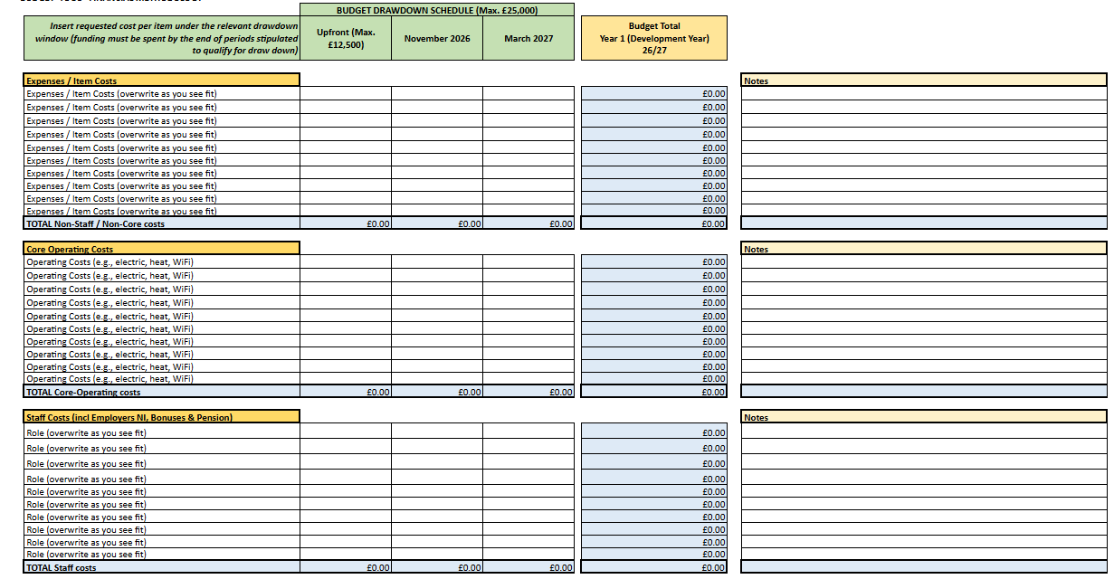

ANNEX B: Programme Plan Tool - Please refer to the Engagement for Change Budget & Programme Plan Tool

