Low Pay Commission:
Worker Experiences
February 2026
Prepared by: Laura Piggott, Honor Gray and Jed Gaffin
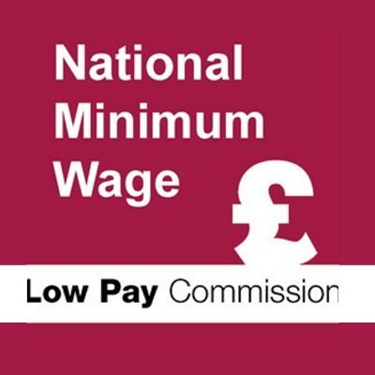



Contents
Executive summary 2
Characteristics of survey respondents 5
Key findings 9
Job satisfaction 12
Working conditions 17
Living standards 37
Decision-making about working arrangements 49
Changing jobs 63
Appendix 76

Executive summary

Background and methodology
- It is widely recognised that pay levels are associated with differences in workers’ day-to-day experiences, including income, job quality, security and living standards. Against the backdrop of further increases to the National Living Wage and National Minimum Wage in April 2025, the Low Pay Commission commissioned YouGov to conduct new research with UK workers to provide a representative view of worker experiences for those with below-average hourly earnings.
This research aims to build a detailed picture of how low-paid workers experience their pay, living standards and working conditions, and how these factors interact in their everyday lives. It explores various topics including how pay levels relate to financial security and decision-making about work. The study also examines how experiences vary across different groups of workers by a range of personal characteristics. The findings are intended to complement existing quantitative evidence and to inform the Low Pay Commission’s recommendations to the Government on future minimum wage rates and the longer-term development of the National Living Wage.
YouGov conducted an online survey of 2,271 working adults aged 21 and over, employed by an organisation in the UK, and earning the equivalent of between £12 and £18 per hour. Fieldwork took place between 24th October and 24th November 2025. The results are weighted to be representative of UK workers by age, gender, region, wage level and industry. All respondents were drawn from YouGov’s online research panel.
For the purposes of this report, the sample has been segmented into the following four wage bands. Where appropriate due to small sample sizes, the first two groups have been combined.
- Minimum wage workers: Up to £12.30 per hour (n=298)
- Near-minimum wage workers: £12.31–£13.20 per hour (n=571)
- Upper low-paid workers: £13.21–£15.00 per hour (n=663)
- Medium-paid workers: £15.01–£18.00 per hour (n=739)
At the time when this research was conducted, the National Living Wage (effective 1 April 2025) was £12.21 per hour. Fieldwork was completed before the official announcement of the 2026 minimum wage rates on 25th November 2025.
Please see the Appendix for a description of the weighting procedures and sources used.

Comparisons with previous Low Pay Commission research
In 2023, the Low Pay Commission contracted YouGov to conduct an online survey of 1,001 low-paid workers in the UK aged 16 and over, for which fieldwork took place between 2nd and 22nd August 2023. Low-paid workers were defined as those earning £12 per hour or less, and within this sample was a group of 373 minimum wage workers defined as earning £10.42 or less. At the time the survey was conducted, the minimum wage rates (effective 1 April 2023) were as follows:
- National Living Wage (aged 23 and over): £10.42
- 21-22 Year-Old Rate: £10.18
- 18-20 Year-Old Rate: £7.49
- 16-17 Year-Old Rate: £5.28
- Apprentice Rate: £5.28
For a selection of findings in the report, comparisons have been made with the results of this 2023 study where questions were asked in a comparable way. Comparisons are drawn between the sub-samples of people earning roughly the minimum wage from both surveys, and the 2023 results have been filtered by those aged 21 and over in order to align with the 2025 sample frame.
Both survey samples were designed to be representative of their respective populations of low-paid workers; however, different weight schemes were applied. Therefore, although the findings are broadly comparable, these comparisons should be interpreted with a degree of caution.

Notes for interpretation
Where respondents currently have more than one job, their responses refer to the job in which they work the most hours.
The quantitative findings throughout the report are presented in the form of percentages, and all differences stated between sub-groups are statistically significant at the 95% confidence level (p<0.05) unless otherwise indicated. In some instances, apparent differences between figures may not be considered ‘statistically significant’ due to sample sizes.
Where percentages do not sum up to 100, this is due to rounding, the exclusion of ‘don’t know' and ‘prefer not to say’ responses, or because respondents could give multiple answers.
Throughout the report, full-time work refers to those working 30 hours or more per week, and part-time work to those working fewer than 30 hours per week.

Characteristics of survey respondents
This section provides a brief overview of selected characteristics of the survey sample to support interpretation of the findings presented in the report. These figures describe the profile of the survey sample and should not be taken as estimates for the overall workforce.
Figures show weighted proportions of survey respondents. Unweighted base sizes are provided for reference.
- Wage level and working status
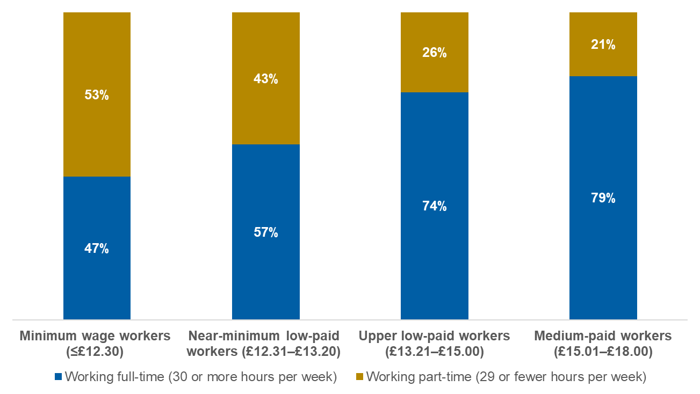
Base: Minimum wage workers (n=298); Near-minimum low-paid workers (n=571); Upper low-paid workers (n=663); Medium-paid workers (n=739)

- Wage level and receipt of income-related benefits
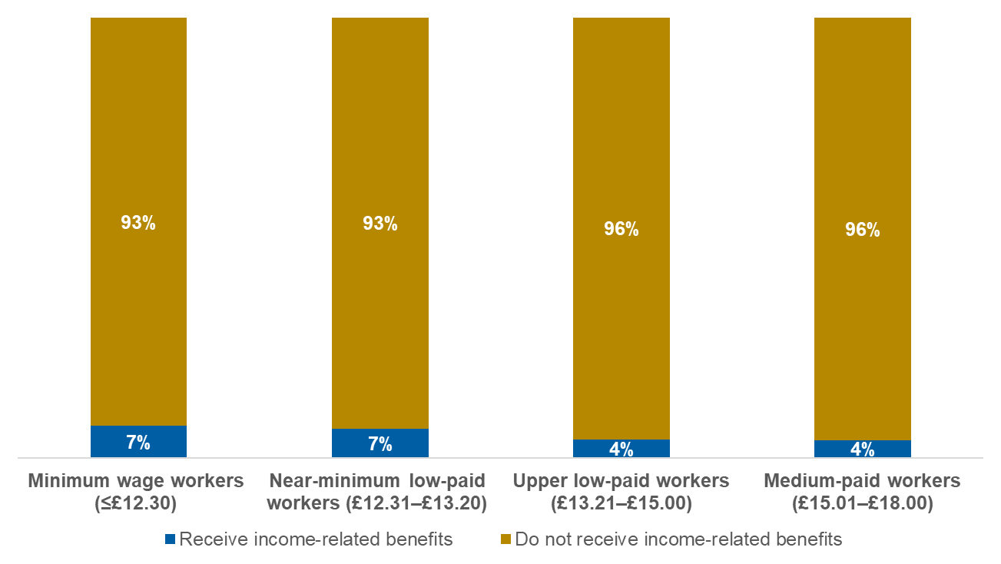
Base: Minimum wage workers (n=294); Near-minimum low-paid workers (n=568); Upper low-paid workers (n=658); Medium-paid workers (n=736)
Note: the benefits classified as income-related for the purposes of this analysis were Council Tax Benefit, Housing Benefit, Child Tax Credit, Working Tax Credit, Income Support, Pension Credit, Jobseeker’s Allowance (JSA) and Universal Credit

- Wage level and disability status
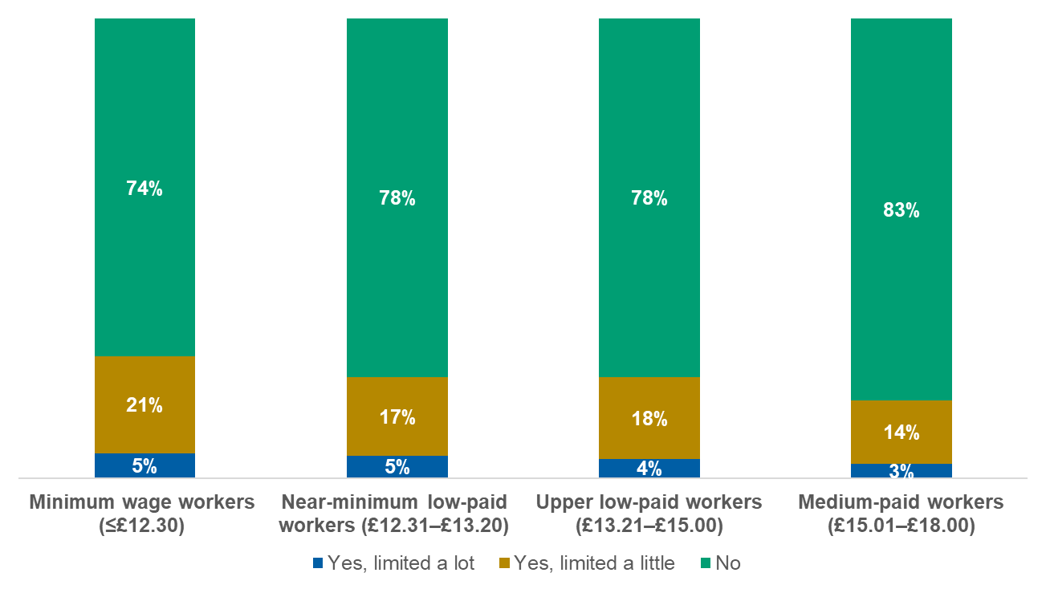
Base: Minimum wage workers (n=296); Near-minimum low-paid workers (n=569); Upper low-paid workers (n=661); Medium-paid workers (n=732)

- Wage level and presence of children under 18 in the household
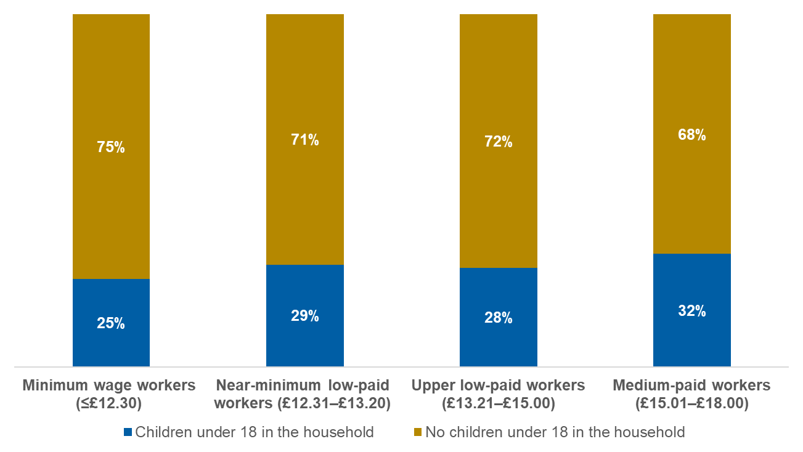
Base: Minimum wage workers (n=298); Near-minimum low-paid workers (n=567); Upper low-paid workers (n=656); Medium-paid workers (n=735)

Key findings
Purpose and scope of the research
- This research explores how workers across different wage bands – minimum wage, near-minimum wage, upper low-paid and medium-paid – experience their working lives, with a particular focus on how low pay affects workers’ attitudes towards their job, living standards and decisions about employment. The findings highlight areas where experiences differ significantly across the wage groups, as well as areas where attitudes are broadly aligned. These patterns illustrate how low pay is related to workers’ day-to-day conditions, financial stability and opportunities for progression.
Job satisfaction is lower at the bottom of the pay distribution
Overall, workers closest to the minimum wage report somewhat lower job satisfaction than those on higher hourly rates, and this difference is clearest for satisfaction with working hours. Minimum wage and near-minimum wage workers are less likely to report very high satisfaction with the predictability and number of hours they work, while differences in perceived flexibility are present but smaller. Within the lowest wage bands, lower satisfaction is more commonly reported by younger workers, those working full-time, and workers with a disability or long-term health condition, indicating that experiences of low-paid work are not uniform across groups.
Lower-paid workers report less stable and more constrained working patterns
Working patterns are generally less stable at the lower end of the pay distribution, reflecting both greater variability in schedules and a higher likelihood of working fewer hours. Minimum wage workers are more likely than other low- and medium-paid workers to report that their hours and working days vary week-to-week, and among those with variable hours, the extent of variation tends to be smaller for medium-paid workers. Across wage bands, workers commonly report that employers largely determine the number of hours worked. Among those with variable schedules, minimum wage workers are more likely to report shorter notice for their work schedules than higher-paid workers, while most workers say employers stick to allocated schedules all or most of the time. Overtime is widespread across wage groups, with younger minimum wage and near-minimum wage workers more likely to report working extra hours regularly. Around half of minimum wage workers report that additional hours are available, more often on a short-term basis than is the case for medium-paid workers.
Living standards rise with pay, but many workers face ongoing financial pressure
In terms of living standards, satisfaction with pay and self-reported financial comfort increase with wage level, though many workers across all low- and medium-paid wage bands describe their financial position as covering the essentials but having limited room for luxuries. Minimum wage workers are more likely than medium-paid workers to report struggling to meet costs or going without essentials.
Minimum wage and near-minimum wage workers are more likely than those in the higher wage bands to report a recent pay rise in April 2025, consistent with the timing of the National Living Wage increase, though not all minimum wage workers report an April increase. Across wage levels, larger pay rises are more likely than smaller rises to be associated with an increased sense of financial comfort. Among workers experiencing financial difficulty, cutting back spending is common across wage groups, while those closer to the minimum wage are more likely than medium-paid workers to report responding by working more hours or taking on extra shifts.
Decisions about work reflect a balance of opportunity, risk and constraint
Decisions about hours, progression and changing jobs reflect a mix of preferences and constraints. Minimum wage workers are more likely than higher-paid workers to say they would like to increase their paid hours, and many would also accept extra hours if offered even when they do not actively want more. For those who would not accept extra hours, reasons are most often about personal circumstances or satisfaction with current hours.
Progression appears more limited at the bottom of the pay distribution: minimum wage workers are least likely to report having been promoted, and across wage groups most workers think it is unlikely they will be offered a promotion in the next year. If offered, minimum wage and near-minimum wage workers are more likely than higher-paid workers to say they would be unlikely to accept. Commonly cited concerns about accepting a promotion are around taking on extra responsibility, the opportunity not being interesting, and thinking the pay would not be enough to make up for the extra work. Likelihood of considering moving jobs in the next year is broadly similar across wage bands, but workers often perceive moving as risky. When weighing hypothetical pay rises against job attributes, workers across wage levels are unwilling to accept worse work–life balance or reduced control over hours, suggesting that job quality considerations remain important even where higher pay is offered.
Low pay is associated with broader differences in job quality and security
Overall, the findings point to low pay being associated with a combination of lower job satisfaction, less predictable working patterns, greater financial pressure and more constrained choices about hours, progression and job mobility. While many of these experiences are shared to some degree across the low- and medium-paid workforce, they tend to be more pronounced among workers closest to the minimum wage and among younger workers, people with disabilities and those with childcare responsibilities, who often face additional constraints. This highlights how the impact of low pay extends beyond earnings alone and is associated with the quality and security of work for many workers.

Job satisfaction

Workers closest to the minimum wage report lower overall job satisfaction
Key findings
- Overall job satisfaction is lower among workers closest to the minimum wage compared with those earning higher hourly rates.
- Within the lowest wage bands, lower satisfaction is more commonly reported by younger workers and those working full-time.
- Workers with a disability or long-term health condition in the lowest wage bands are also more likely to report lower overall job satisfaction.
- Taken together, these findings show that job satisfaction among low-paid workers varies across groups and stages of working life.

- Workers closest to the minimum wage report lower overall job satisfaction than those earning higher hourly rates, with satisfaction increasing steadily across the wage bands. While most minimum wage and near-minimum wage workers say they are satisfied overall, satisfaction is more common among upper low-paid and medium-paid workers (Figure 5).

- Level of overall job satisfaction
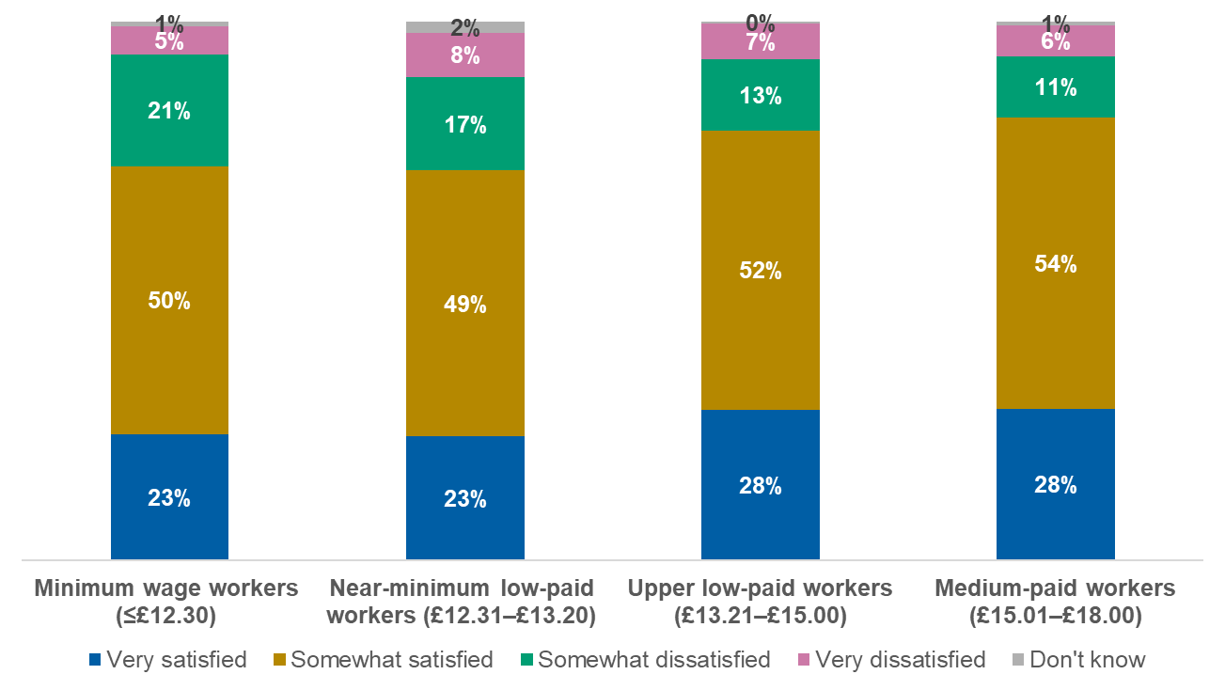
Base: Minimum wage workers (n=298); Near-minimum low-paid workers (n=571); Upper low-paid workers (n=663); Medium-paid workers (n=739)
How satisfied or dissatisfied do you feel with the following aspects of your job? – Your job on the whole
- Among minimum wage and near-minimum wage workers, younger people aged 21-29 and 30-49 are less likely to report being very satisfied with their job than older workers aged 50 and over, highlighting that within the lowest wage bands, dissatisfaction with work is experienced disproportionately earlier in working life (Figure 6).

- Proportion who are very satisfied with their job overall: minimum wage and near-minimum wage workers by age
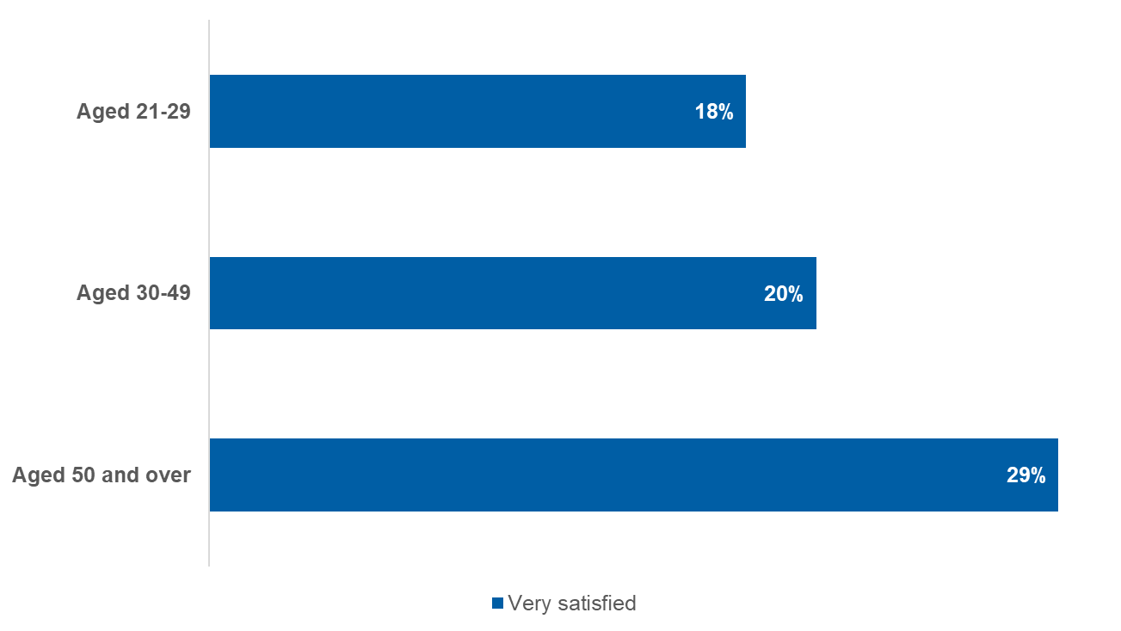
Base: Minimum wage and near-minimum wage workers aged 21-29 (n=124); Minimum wage and near-minimum wage workers aged 30-49 (n=400); Minimum wage and near-minimum wage workers aged 50 and over (n=345)
How satisfied or dissatisfied do you feel with the following aspects of your job? – Your job on the whole
- Within the minimum wage and near-minimum wage worker cohort, lower job satisfaction is also more common among full-time workers and those with a disability or long-term health condition, with differences of around 10 percentage points compared with their counterparts.
In August 2023, similar research conducted by the Low Pay Commission and YouGov found nearly identical levels of overall job satisfaction among minimum wage workers aged 21 and over, with three quarters (74%) having reported being satisfied. Within this category, 21% were very satisfied and 52% were somewhat satisfied.

Satisfaction with working hours and flexibility increases with pay
Key findings
- Satisfaction with working hours increases steadily with wage level, with workers closest to the minimum wage least likely to report high satisfaction.
- Differences by wage level are most pronounced for the predictability and number of hours worked, and less notable for flexibility within the job.
- Among minimum wage workers, satisfaction with flexibility is higher among part-time workers than full-time workers.
- Overall, these findings suggest that dissatisfaction with working arrangements among low-paid workers reflects both pay level and working patterns.

Satisfaction with aspects of their job related to working hours increases steadily with wage level, with minimum wage workers least likely to report high satisfaction with predictability and number of hours. Differences by wage level are less pronounced for high satisfaction with the flexibility of their job (Figure 7).
- Proportion who are very satisfied with each aspect of their job
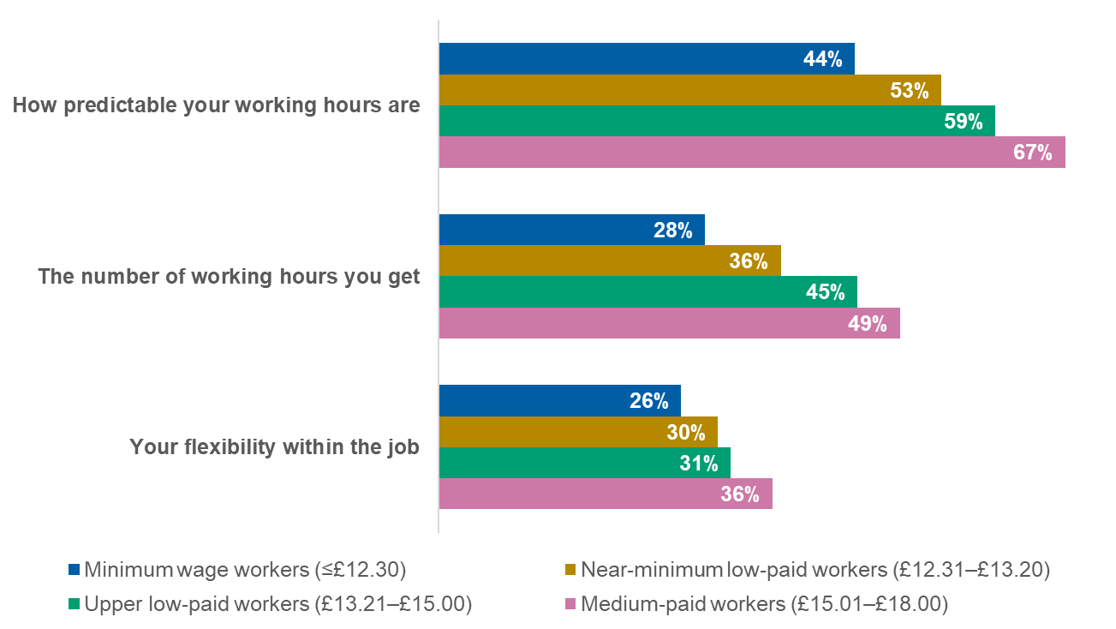
Base: Minimum wage workers (n=298); Near-minimum low-paid workers (n=571); Upper low-paid workers (n=663); Medium-paid workers (n=739)
How satisfied or dissatisfied do you feel with the following aspects of your job? – The number of working hours you get; How predictable your working hours are; Your flexibility within the job
Among minimum wage workers, satisfaction with flexibility differs by working status. Part-time workers are more likely than full-time workers to report high satisfaction with flexibility, suggesting that fewer working hours are associated with a greater sense of control over working arrangements. Meanwhile, high satisfaction with working hours – both in terms of number and predictability – is relatively consistent between full- and part-time minimum wage workers (Figure 8).
- Proportion who are very satisfied with each aspect of their job: minimum wage workers by working status
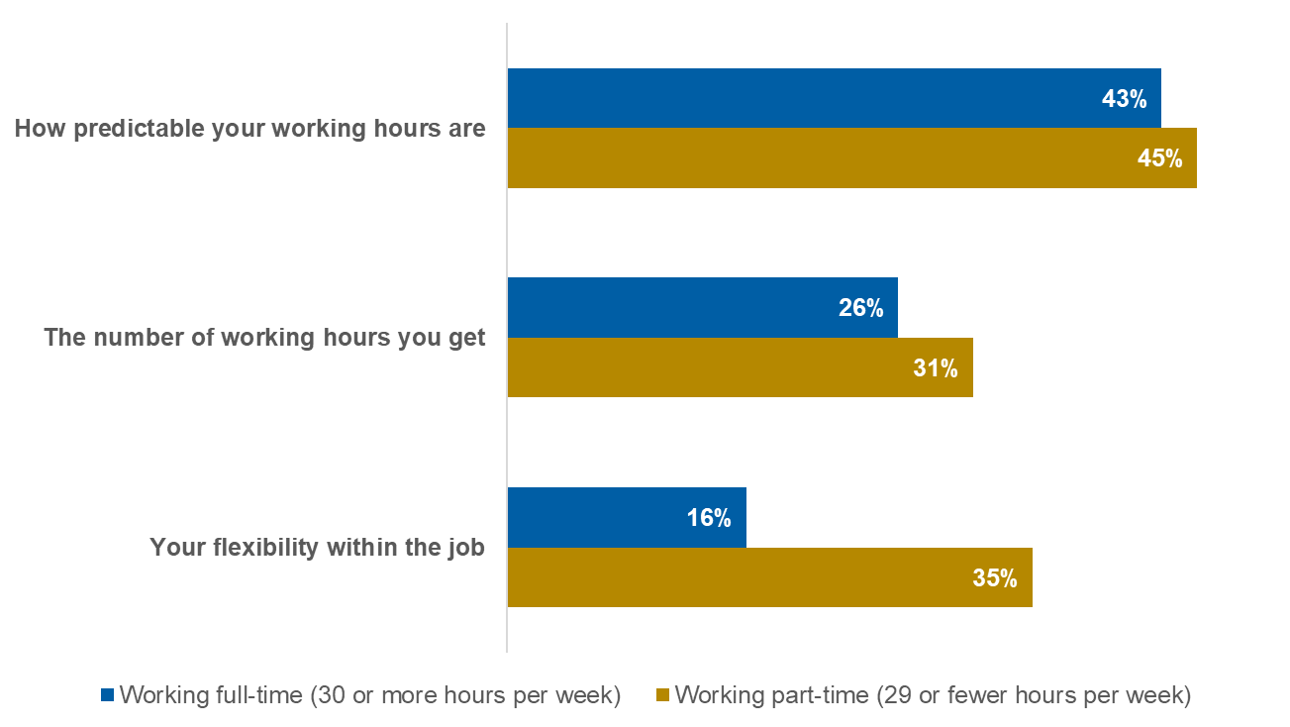
Base: Minimum wage workers working full-time (n=134); Minimum wage workers working part-time (n=164)
How satisfied or dissatisfied do you feel with the following aspects of your job? – The number of working hours you get; How predictable your working hours are; Your flexibility within the job
Among minimum wage and near-minimum wage workers, younger workers are less likely than those aged 50 and over to report being very satisfied with the number of hours they work, with a gap of roughly 15 percentage points.

Working conditions

Lower-paid workers are more likely to report variable and employer-led working patterns
Key findings
- Minimum wage workers are more likely than higher-paid groups to experience unpredictable working patterns, with hours and days varying more than for higher‑paid groups.
- Instability is more common among part-time workers, including those on lower pay, though even full‑time staff on lower wages report less consistency than higher earners.
- Employers control most decisions about working hours across wage levels, but minimum wage workers have notably less say over their schedules than medium‑paid staff.
- Overall, workers on lower pay are more likely to experience insecure and employer-driven working patterns.

- Across wage levels, findings indicate that workers closest to the minimum wage tend to experience more variation in their weekly hours than those earning a higher wage (Figure 9).

- Variation in working hours each week

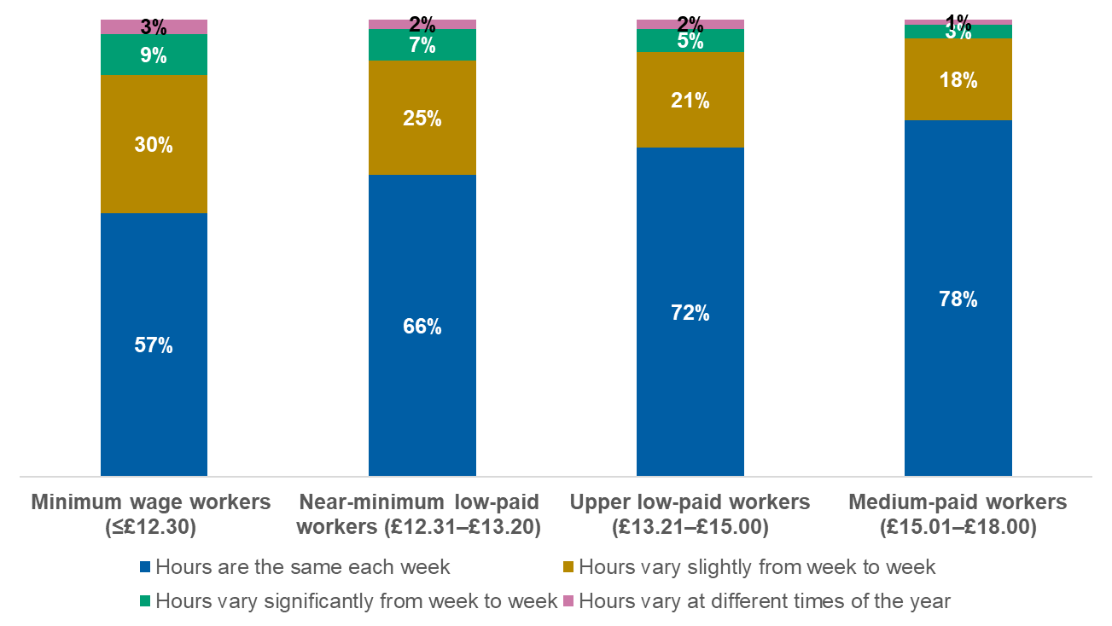
Base: Minimum wage workers (n=298); Near-minimum low-paid workers (n=571); Upper low-paid workers (n=663); Medium-paid workers (n=739)
Which of the following best describes your typical working hours?
- Among minimum wage workers, those working part-time are more likely to have variable hours week-to-week than those working full-time (Figure 10). This is the case across the other wage bands as well.

- Proportion whose hours vary each week: minimum wage workers by working status
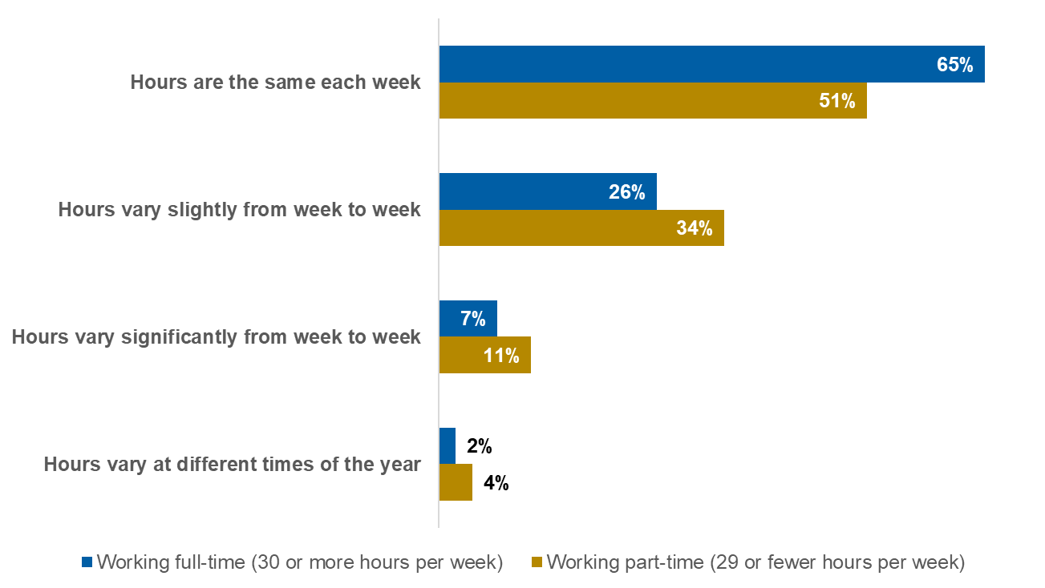
Base: Minimum wage workers working full-time (n=134); Minimum wage workers working part-time (n=164)
Which of the following best describes your typical working hours?
- Minimum wage workers with children under 18 in their household are less likely to say their hours vary from week to week, compared with those who do not, with a difference of more than 10 percentage points.
Workers on lower wages are more likely to experience week-to-week variation in their working hours (Figure 11). However, among those whose hours do vary, the extent of this variation is broadly similar across the three lowest wage groups. Medium-paid workers differ in experiencing both less frequent and less pronounced variation, indicating greater overall stability.

- Extent to which working hours vary each week

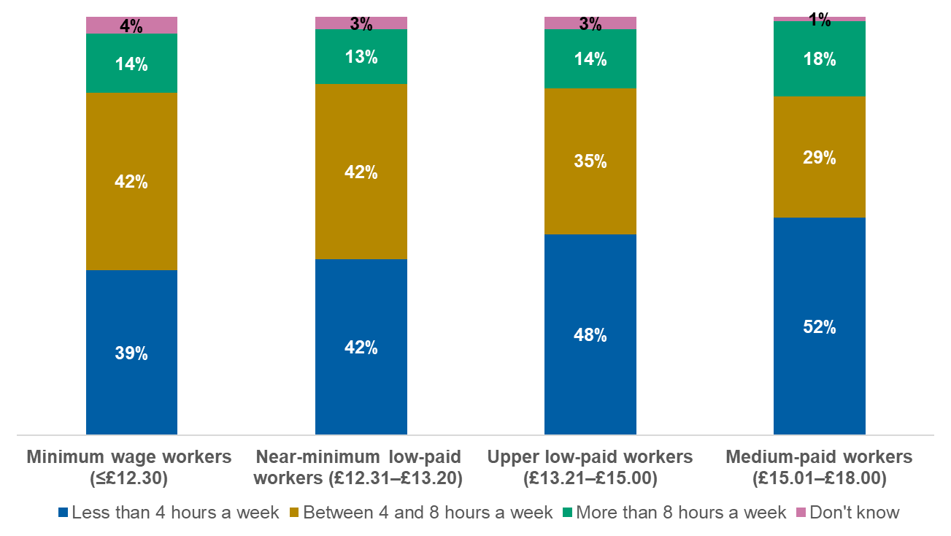
Base: Minimum wage workers whose hours vary (n=111); Near-minimum low-paid workers whose hours vary (n=176); Upper low-paid workers whose hours vary (n=170); Medium-paid workers whose hours vary (n=149)
You have said your working hours vary each week. How much do they usually vary?
- When looking at the extent to which working days vary from week to week, the overall trend mirrors that of the variation in working hours, whereby those earning less are more likely to experience variation in their working days on a weekly basis (Figure 12).

- Extent to which working days vary each week

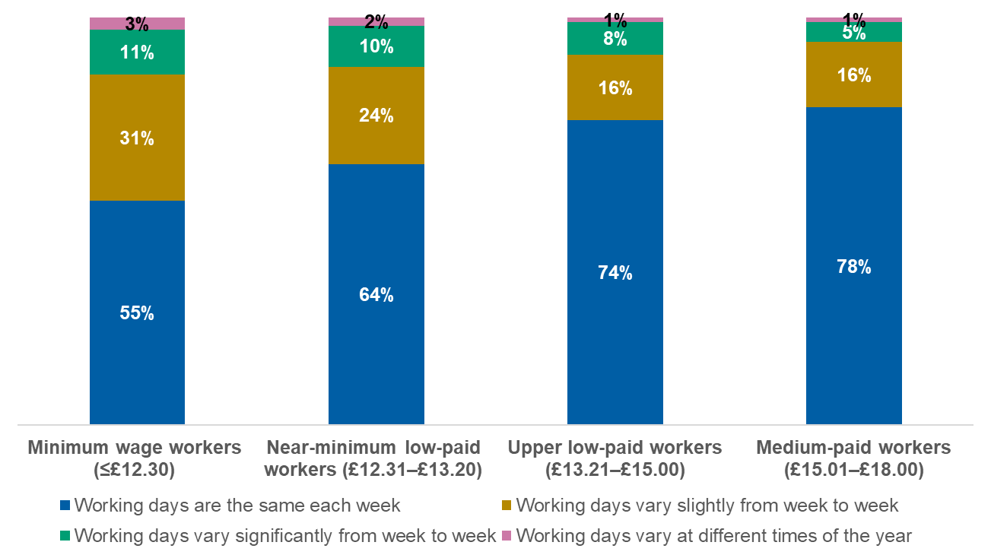
Base: Minimum wage workers (n=298); Near-minimum low-paid workers (n=571); Upper low-paid workers (n=663); Medium-paid workers (n=739)
Which of the following best describes your typical working days?
- Unlike variation in working hours, minimum wage workers who work full- and part-time experience similar levels of weekly variation in the days they work. However, this is not the case among the other wage bands, where part-time workers similarly experience more variation.
Among minimum wage workers, those who have children aged under 18 in their household are significantly more likely to say that their working days are the same each week, with a difference of 20 percentage points compared with those who do not.
Around seven in ten (71%) minimum wage workers say that the number of hours they are paid to work is determined largely by their employer, with less than one in ten saying their hours are determined by themselves (8%), and one in five (20%) saying their hours are set by both themselves and their employer equally. This trend is consistent across wage bands.
Minimum wage and near-minimum wage workers aged 21-29 are more likely to say that the number of hours they work is predominantly determined by their employer than those aged 50 and over at the same pay level, with roughly 10 percentage points separating them.
Minimum wage workers who work part-time are more likely to report having more influence in dictating their working hours, compared with those working full-time (Figure 13). Part-time workers reporting greater agency in the determination of their working hours is consistent across all wage bands.
- Agency in determining working schedule: minimum wage workers by working status
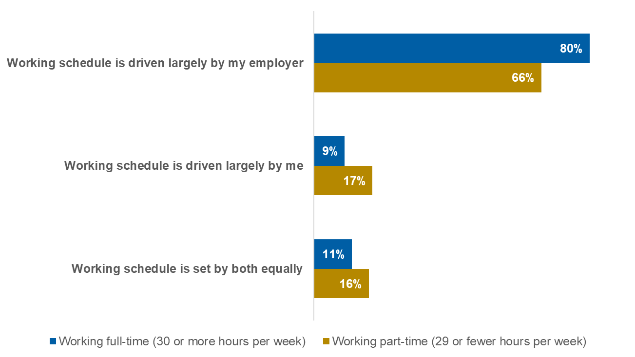
Base: Minimum wage workers working full-time (n=134); Minimum wage workers working part-time (n=164)
Which of the following best describes how your working schedule is decided?
Approximately two in five (37%) low- and medium-paid workers overall say their working hours or days vary, and when these respondents are asked how much notice they typically get for their work schedule, minimum wage workers are significantly more likely to say they tend to get notice of one week or less, compared with medium-paid workers (Figure 14). Perhaps the most notable difference across wage bands is the proportion of those who receive notice of four weeks or more; minimum wage workers report this at a significantly lower proportion than the other wage bands, with a difference of 10 percentage points or more in comparison with the higher-paid groups.
- Typical notice received for work schedule

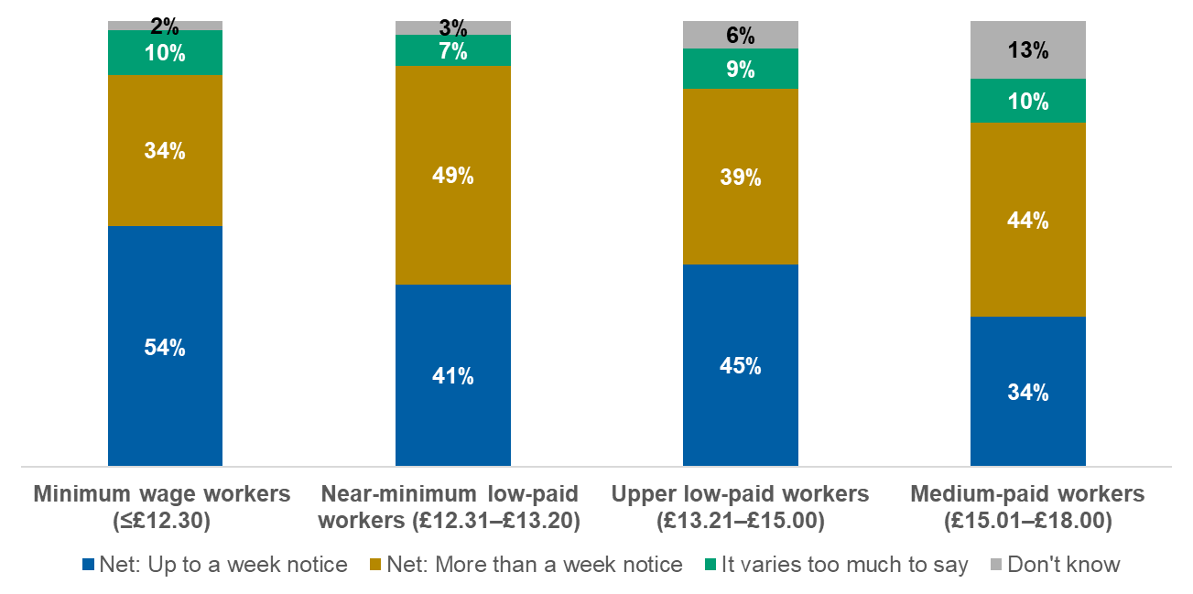
Base: Minimum wage workers (n=149); Near-minimum low-paid workers (n=242); Upper low-paid workers (n=236); Medium-paid workers (n=205)
How much advance notice do you typically get for your work schedule?
Of those who experience variable working hours or days from week to week, a quarter (24%) of minimum wage workers say their employer sticks to the schedule originally allocated all of the time, while three in five (59%) say their employer sticks to it most of the time. These proportions are generally consistent across wage bands.
Among minimum wage workers, the proportion who say their employer typically sticks to their allocated schedule all of the time is consistent across full-time and part-time minimum wage workers; however, the proportion who say their employers stick to their schedule most of the time is higher among part-time workers than full-time workers, separated by roughly 15 percentage points.

Regular uptake of extra hours is more common among lower-paid workers
Key findings
- Many minimum wage workers regularly work beyond their contracted hours, with around three‑quarters doing so at least occasionally.
- Younger workers on minimum or near‑minimum wages are more likely than older groups to work extra hours on a regular basis.
- Minimum wage workers have greater access to additional hours than medium‑paid workers, especially short‑notice opportunities.
- Overall, working beyond contracted hours is more common among lower-paid workers, reflecting both uptake and availability of extra hours.

Roughly three quarters (77%) of minimum wage workers say they work overtime or beyond their normal contracted hours. One in six (17%) say they do so every week, while more commonly, one in three (34%) say they do this at least two or three times a month. While patterns of working extra hours are broadly similar across wage bands, younger minimum wage or near-minimum wage workers aged 21-29 are much more likely to say they work overtime or beyond their contracted hours at least two or three times per month than those aged 50 and over (Figure 15).
- Proportion who work overtime: minimum wage and near-minimum wage workers by age
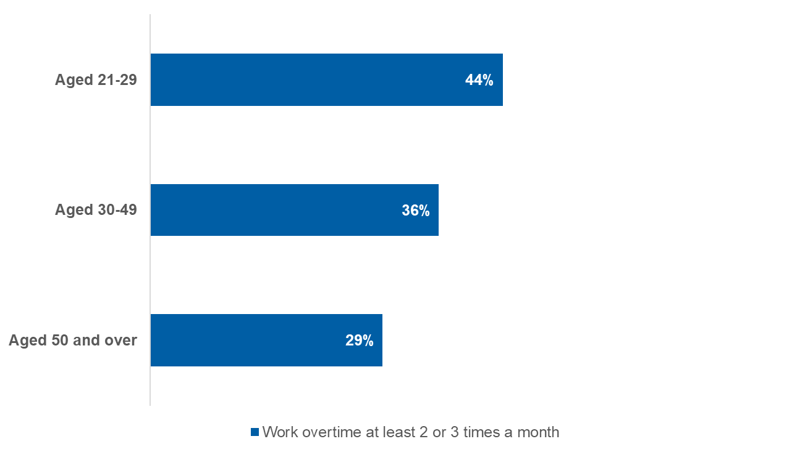
Base: Minimum wage and near-minimum wage workers aged 21-29 (n=124); Minimum wage and near-minimum wage workers aged 30-49 (n=400); Minimum wage and near-minimum wage workers aged 50 and over (n=345)
On average, how often do you work overtime or more than your normal contracted hours?
In August 2023, similar research conducted by the Low Pay Commission and YouGov found that 60% of minimum wage workers aged 21 and over contracted to work 15 hours per week or less reported that they work overtime, which is lower than the proportion of the same subgroup who say they do so in 2025 (75%).
Approximately half of minimum wage workers say they have additional hours available to them, a higher share than among medium-paid workers (Figure 16). This difference is driven specifically by the proportion of minimum wage workers who say they have access to additional hours on a short-term basis, while availability of long-term additional hours is similar across wage groups.
- Availability of additional hours
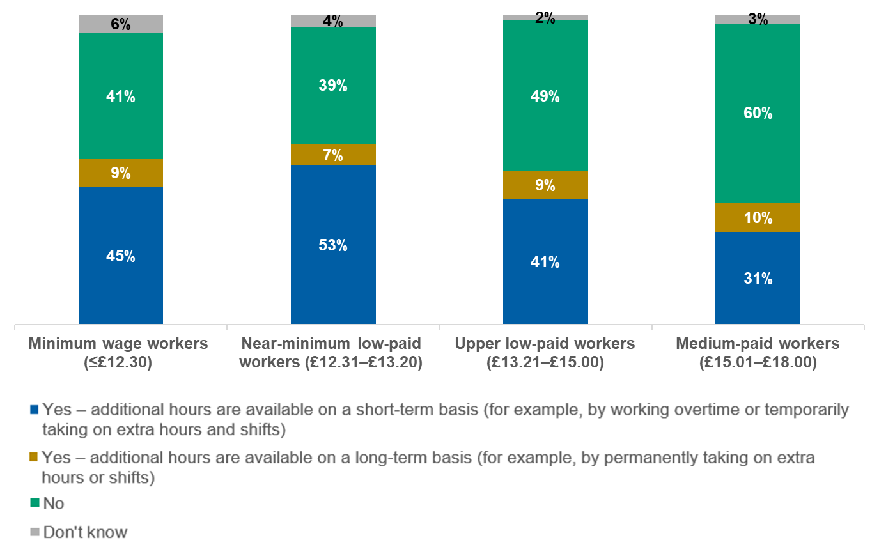
Base: Minimum wage workers (n=298); Near-minimum low-paid workers (n=571); Upper low-paid workers (n=663); Medium-paid workers (n=739)
Are additional work hours available to you at your current employer? Please select all that apply.
Minimum wage workers in part-time employment are significantly more likely to say there are additional working hours available to them compared with those in full-time employment, with a difference of roughly 20 percentage points. This trend is consistent across all other wage bands as well.

Workload intensity is reported to have increased since the previous year even as hours remain stable
Key findings
- Most minimum wage and near‑minimum wage workers report little change in their working hours over the past year, with greater stability among higher‑paid groups.
- Work expectations have shifted more noticeably, with many minimum wage workers experiencing increased workloads compared with the previous year.
- Younger workers and those with a disability or long‑term health condition are particularly likely to report rising work intensity.
- Overall, hours have remained steady for many, but the demands within those hours are felt to have intensified.

The majority of minimum wage workers say their working hours have not changed since the previous year, while a significant minority report working more hours. A similar pattern is seen among near-minimum wage workers, though stability increases at higher wage levels, with medium-paid workers most likely to report no change and least likely to say they are working more hours (Figure 17).
- Working hours compared with previous year
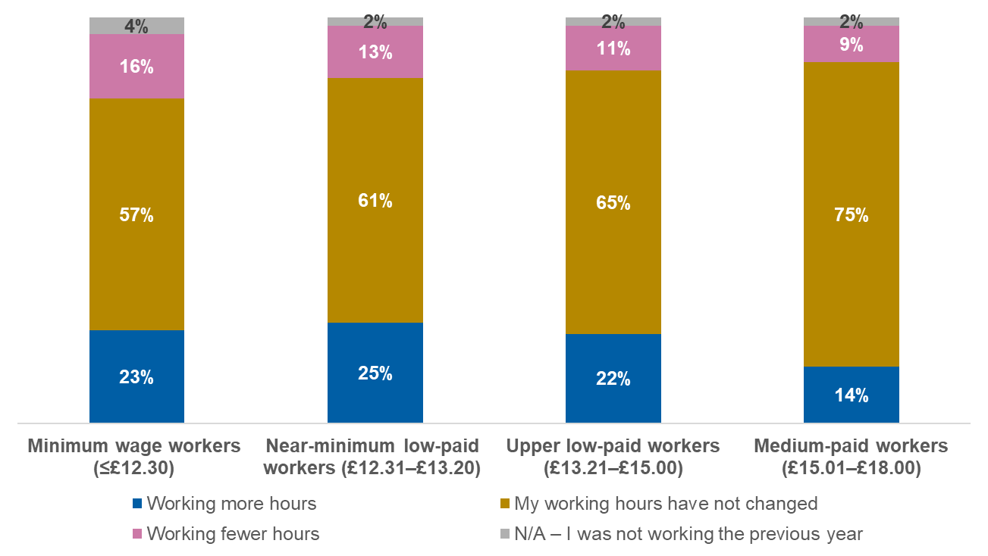
Base: Minimum wage workers (n=298); Near-minimum low-paid workers (n=571); Upper low-paid workers (n=663); Medium-paid workers (n=739)
Thinking about your work over the past year… To what extent, if at all, have your working hours changed compared with the previous year?
Among minimum wage and near-minimum wage workers, younger adults are more likely to say they are working more hours than last year compared with older adults (Figure 18). This trend is linear with age, which is also reflected across these age groups within the other wage bands.
- Proportion working more hours compared with previous year: minimum wage and near-minimum wage workers by age

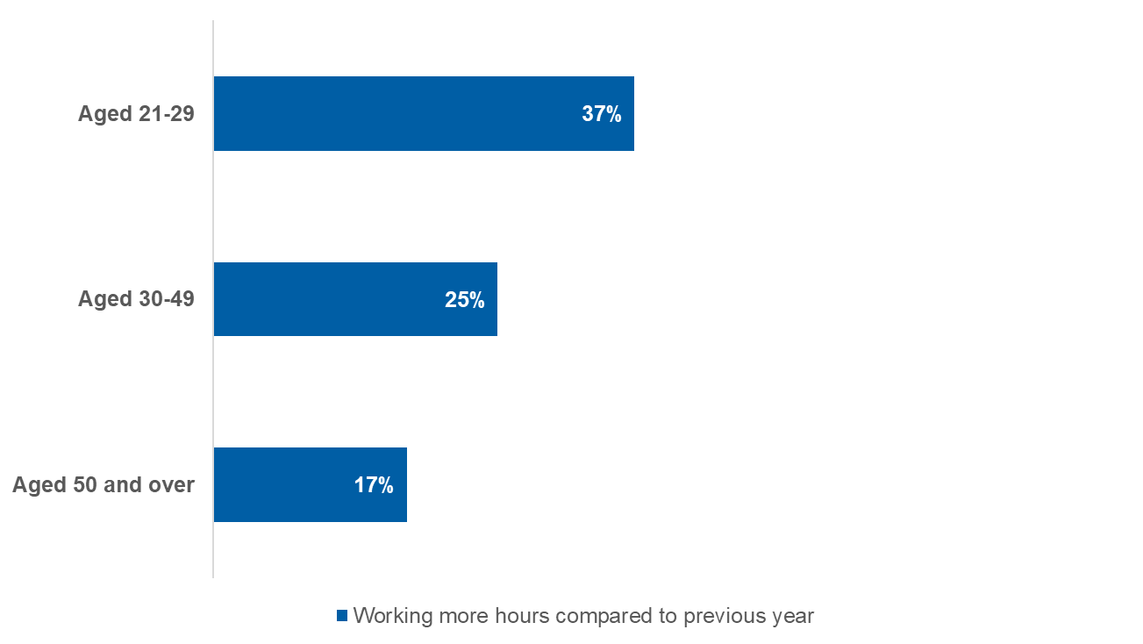
Base: Minimum wage and near-minimum wage workers aged 21-29 (n=124); Minimum wage and near-minimum wage workers aged 30-49 (n=400); Minimum wage and near-minimum wage workers aged 50 and over (n=345)
Thinking about your work over the past year… To what extent, if at all, have your working hours changed compared with the previous year?
Most minimum wage workers report that expectations within their paid hours have stayed the same over the past year, while a substantial minority say they are expected to do more. Unlike changes in hours worked, this pattern is broadly consistent across wage bands (Figure 19).

- Perception of whether expected to do more or less work within paid hours compared with previous year
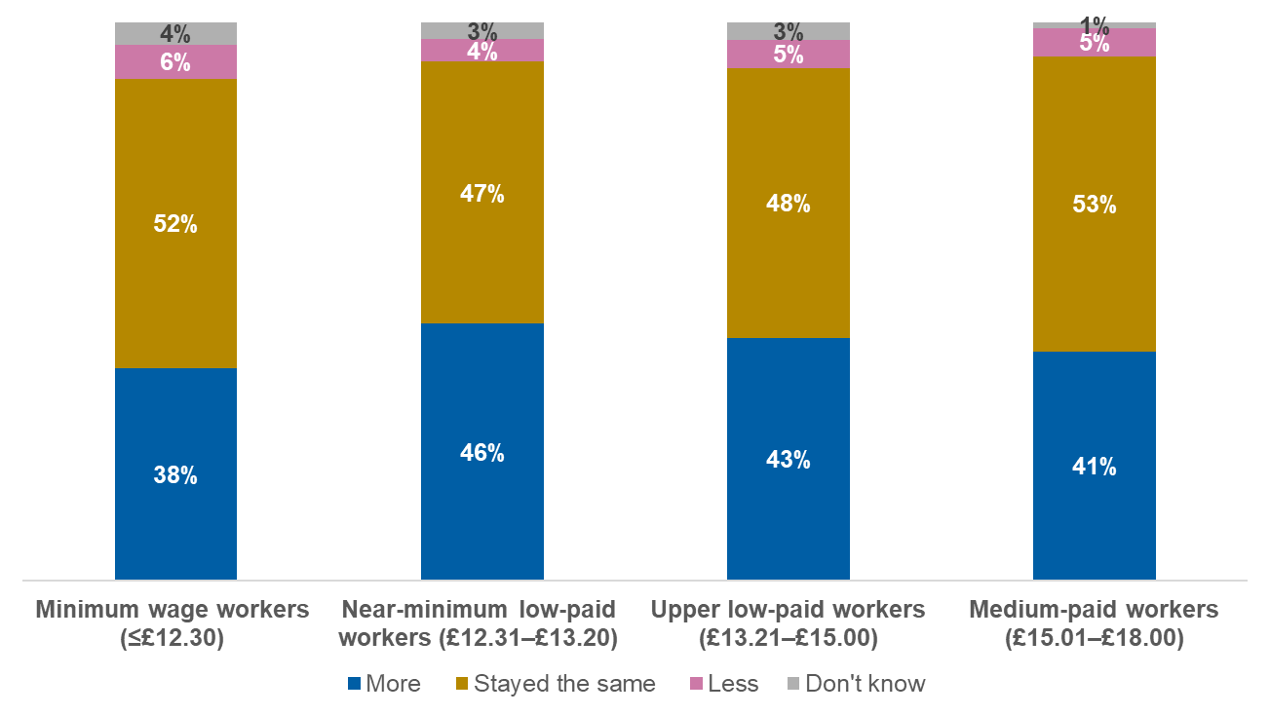
Base: Minimum wage workers (n=298); Near-minimum low-paid workers (n=571); Upper low-paid workers (n=663); Medium-paid workers (n=739)
Thinking about your work over the past year, are you expected to do more work, less work or the same within your paid working hours compared with the previous year?
- Among minimum wage and near-minimum wage workers, young people aged 21-29 are more likely to say they are expected to do more work than in the previous year, compared with those aged 50 and over (Figure 20).

- Proportion expected to do more work compared with previous year: minimum wage and near-minimum wage workers by age

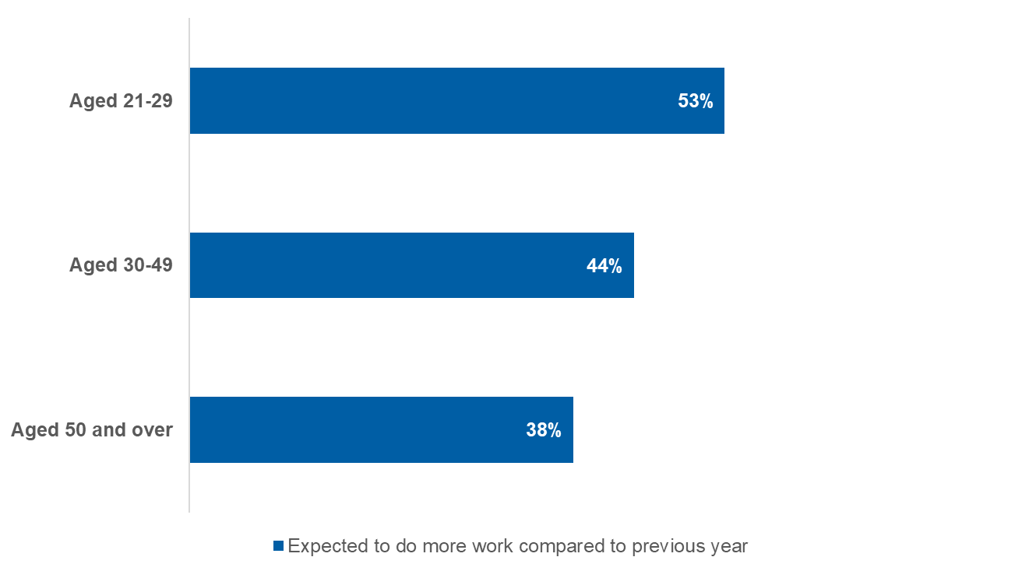
Base: Minimum wage and near-minimum wage workers aged 21-29 who worked the previous year (n=119); Minimum wage and near-minimum wage workers aged 30-49 who worked the previous year (n=387); Minimum wage and near-minimum wage workers aged 50 and over who worked the previous year (n=343)
Thinking about your work over the past year, are you expected to do more work, less work or the same within your paid working hours compared to the previous year?
- Additionally, minimum wage and near-minimum wage workers with a disability or long-term health condition are more likely to say they are expected to do more work compared with the previous year than those who do not have a disability, with a difference of roughly 10 percentage points. This trend is also evident among upper low-paid workers, while there is no significant difference between those with and without a disability among medium-paid workers.
Among those reporting increased workload, the top three reasons cited by minimum wage workers are that there are fewer people to do the work, the volume of work has increased, and the type of work has changed (Figure 21). While staffing shortages are cited at similar levels across wage bands, higher-paid workers are more likely to attribute increased demands to greater responsibility or seniority.
- Perceived reasons for being expected to do more within working hours compared with previous year
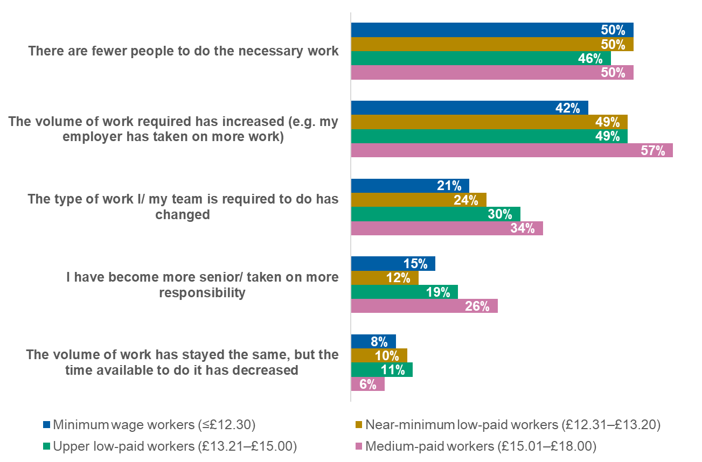
Base: Minimum wage workers (n=108); Near-minimum low-paid workers (n=248); Upper low-paid workers (n=269); Medium-paid workers (n=291)
You said you have to do more within your working hours compared with the previous year. Which, if any, of the following are the reasons for this? Please select all that apply.
Among minimum wage or near-minimum wage workers, young people aged 21-29 are less likely to cite that there are fewer people to do the necessary work than those aged 50 and over, with a difference of approximately 20 percentage points, and more likely to say they have become more senior or taken on more responsibility, with a difference of 15 percentage points.

Progression opportunities are limited across pay levels, and appear most constrained for minimum wage workers
Key findings
- Progression is least common among minimum wage workers, with higher-paid groups more likely to report having been promoted by their current employer.
- Across all wage bands, most workers do not expect to be offered a promotion in the next year.
- Younger and full-time low-paid workers are more optimistic about progression, but expectations remain low overall.
- Overall, these findings point to progression being uncommon across the workforce, with limited confidence in advancement even among groups most likely to progress.

Minimum wage workers are significantly less likely to report having been promoted or moved to a more senior position by their current employer, compared with all other wage bands (Figure 22). This reflects the fact that workers earning above the minimum wage are more likely to have progressed beyond the wage floor over time.
- Ever received a promotion while working for their current employer
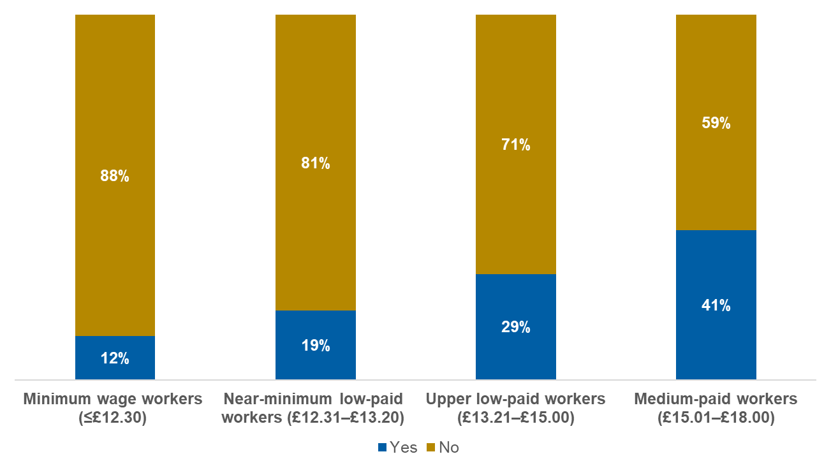
Base: Minimum wage workers (n=298); Near-minimum low-paid workers (n=571); Upper low-paid workers (n=663); Medium-paid workers (n=739)
Thinking about the time you’ve spent working for your current employer, have you ever been promoted or moved to a more senior position?
There is no significant difference in experience of promotion between age groups among minimum wage and near-minimum wage workers.
Full-time minimum wage workers are more likely to say they have experienced a promotion with their current employer than those working part-time (Figure 23). This is also the case in the other wage bands.

- Promotion experience: minimum wage workers by working status
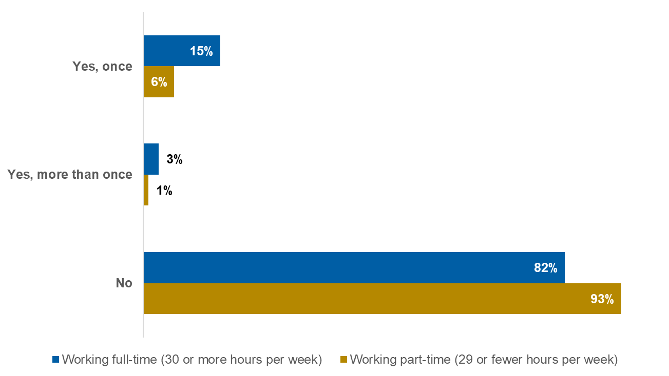
Base: Minimum wage workers working full-time (n=134); Minimum wage workers working part-time (n=164)
Thinking about the time you've spent working for your current employer, have you ever been promoted or moved to a more senior position?

58. In August 2023, similar research conducted by the Low Pay Commission and YouGov revealed that two in ten (20%) minimum wage workers aged 21 and over had been promoted or moved to a more senior position by their current employer, which is higher than the proportion who report this to be the case in the current research (12%).
- When minimum wage workers are asked how likely they think it is that they will be offered a promotion or more senior position in the next 12 months with their current employer, a majority say they think this is unlikely across all wage groups (Figure 24).

- Promotion expectations with current employer
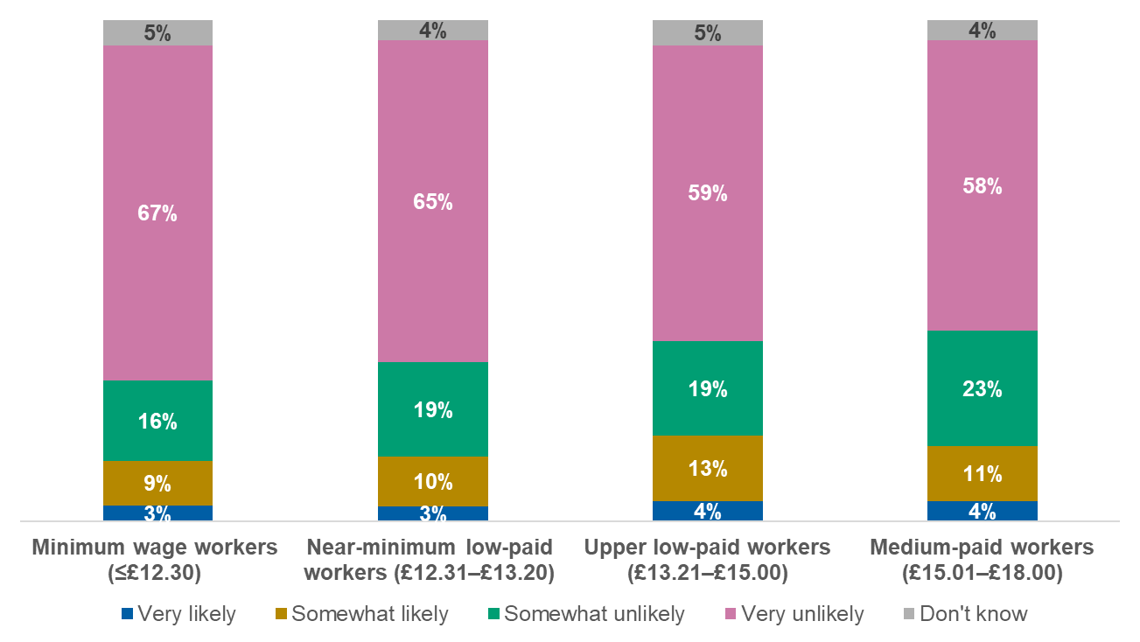
Base: Minimum wage workers (n=298); Near-minimum low-paid workers (n=571); Upper low-paid workers (n=663); Medium-paid workers (n=739)
For this question, we are interested in how likely or unlikely you think the following circumstances are…You will be offered a promotion/more senior position with your current employer in the next 12 months
- Among minimum wage or near-minimum wage workers, younger adults are more likely to be optimistic about their prospects for promotion in the next 12 months (Figure 25). This linear trend is evident across all wage bands.

- Proportion who think they are likely to get a promotion in the next 12 months: minimum wage and near-minimum wage workers by age

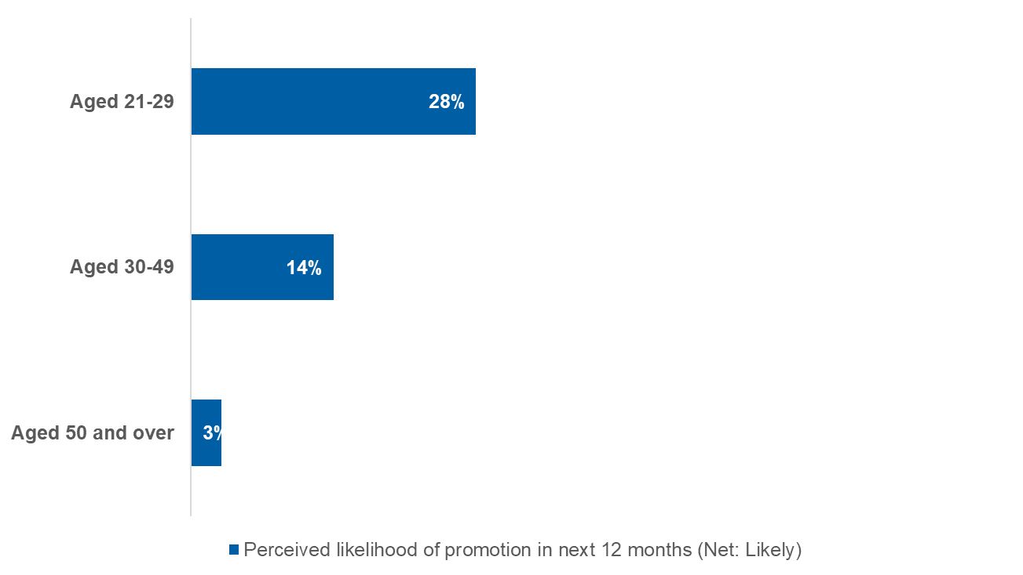
Base: Minimum wage and near-minimum wage workers aged 21-29 (n=124); Minimum wage and near-minimum wage workers aged 30-49 (n=400); Minimum wage and near-minimum wage workers aged 50 and over (n=345)
For this question, we are interested in how likely or unlikely you think the following circumstances are. - You will be offered a promotion/more senior position with your current employer in the next 12 months
- Full-time minimum wage workers are more likely than those working part-time to expect a promotion in the next 12 months, with a difference of 10 percentage points. This pattern is consistent across wage bands.
In August 2023, similar research conducted by the Low Pay Commission and YouGov found an identical proportion of minimum wage workers aged 21 and over said they thought they were likely to get promoted in the following 12 months (12%).

Living standards
Living standards are shaped by a variety of factors in addition to hourly pay. Total household income, including whether workers live with higher earners or receive other income or benefits, will also play a role in how financially secure low-paid workers feel. The findings in this section therefore reflect how pay interacts with wider household circumstances, rather than wage income alone.

Satisfaction with pay is closely linked to wage level, but varies by life stage and working pattern
Key findings
- Workers closest to the minimum wage are less likely to feel satisfied with their level of pay than those earning higher hourly rates.
- Satisfaction with pay increases steadily across wage bands, with upper low-paid and medium-paid workers more likely to report feeling satisfied.
- Among workers in the lowest wage bands, satisfaction with pay is lower among younger workers and those working full-time.
- Overall, although wage level is strongly linked to satisfaction with pay, perceptions vary across age groups and working patterns.

Satisfaction with pay increases steadily with wage level, with minimum wage and near-minimum wage workers least likely to feel satisfied (Figure 26).

- Level of satisfaction with their level of pay
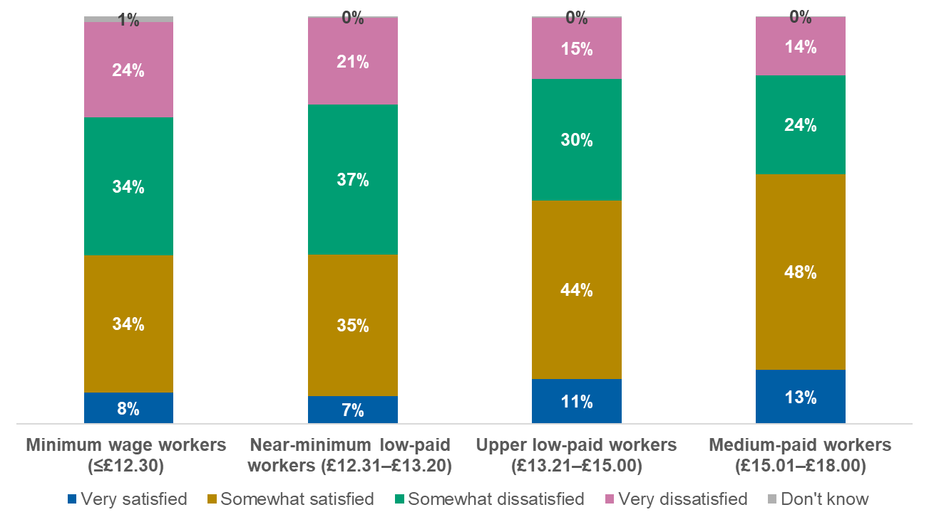
Base: Minimum wage workers (n=298); Near-minimum low-paid workers (n=571); Upper low-paid workers (n=663); Medium-paid workers (n=739)
How satisfied or dissatisfied do you feel with the following aspects of your job? – Your level of pay
- Among minimum wage and near-minimum wage workers, satisfaction with pay increases with age (Figure 27), likely in part reflecting differences in wider household and earning circumstances.

- Proportion who are satisfied with their level of pay: minimum wage and near-minimum wage workers by age
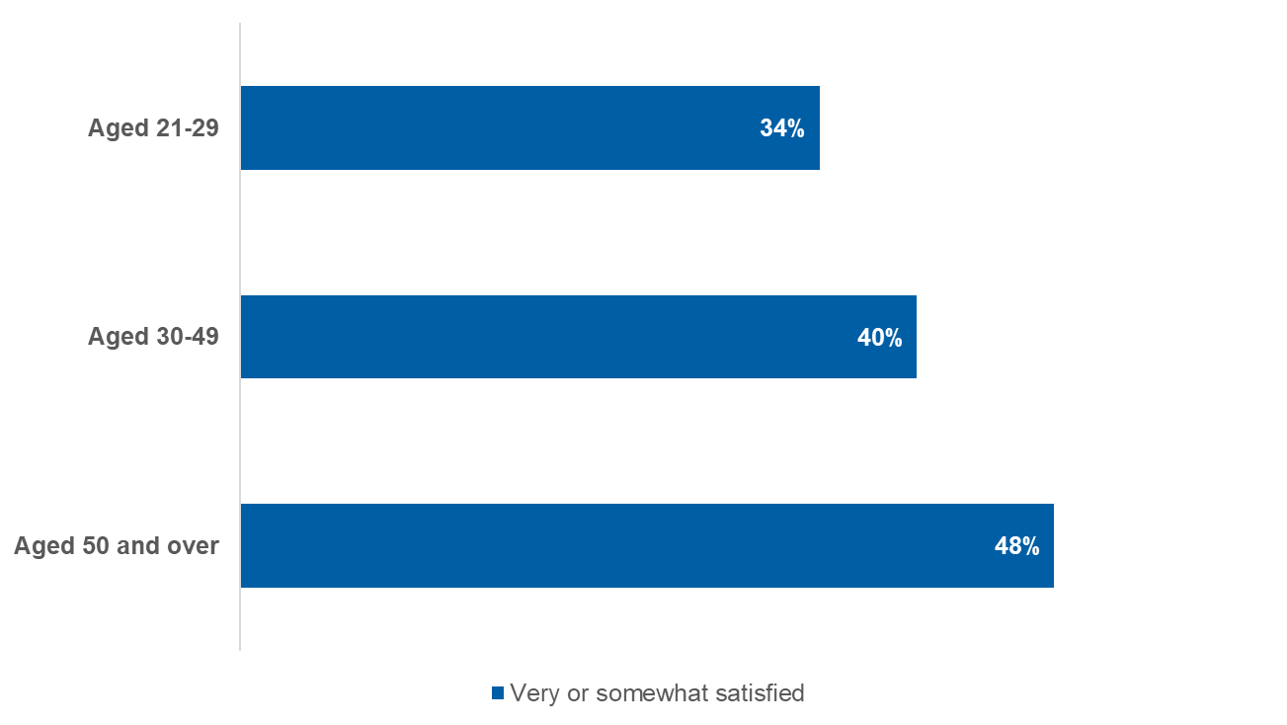
Base: Minimum wage and near-minimum wage workers aged 21-29 (n=124); Minimum wage and near-minimum wage workers aged 30-49 (n=400); Minimum wage and near-minimum wage workers aged 50 and over (n=345)
How satisfied or dissatisfied do you feel with the following aspects of your job? – Your level of pay
- As observed with overall job satisfaction, minimum wage and near-minimum wage workers employed part-time tend to be more satisfied with their level of pay than full-time workers in the same wage band, with more than 10 percentage points separating them. Meanwhile, differences by disability status or the presence of children in the household are minimal.
Among minimum wage workers, there is no difference between main and secondary household earners in satisfaction with level of pay. The same is true when comparing main and secondary earners among low- and medium-paid workers as a whole.
In August 2023, similar research conducted by the Low Pay Commission and YouGov observed comparable levels of satisfaction with pay among minimum wage workers aged 21 and over. Forty-one percent reported being satisfied, while the majority (59%) were dissatisfied.

Reported pay rise timing reflects the April 2025 minimum wage uprating
Key findings
- Minimum wage workers are more likely than higher-paid workers to report receiving their most recent pay rise in April 2025.
- Workers earning above the minimum wage are more likely to report pay rises occurring outside April 2025.
- Not all minimum wage workers report receiving a pay rise in April, reflecting potential differences in pay review timing and recall.

Minimum wage workers are much more likely than those in higher wage bands to report having received their most recent pay rise in April 2025, with steadily decreasing proportions of those in higher wage bands reporting this (Figure 28). This pattern is consistent with the timing of the 2025 increase in the National Living Wage, which primarily affects workers at or close to the statutory minimum. Not all minimum wage workers report an April increase, possibly reflecting differences in the timing of pay reviews and some imprecision in recall, among other factors. In contrast, workers in wage bands above the minimum wage are more likely than lower earners to have received a pay rise in the months before or after April 2025.

- Recall of timeline for most recent pay rise with current employer
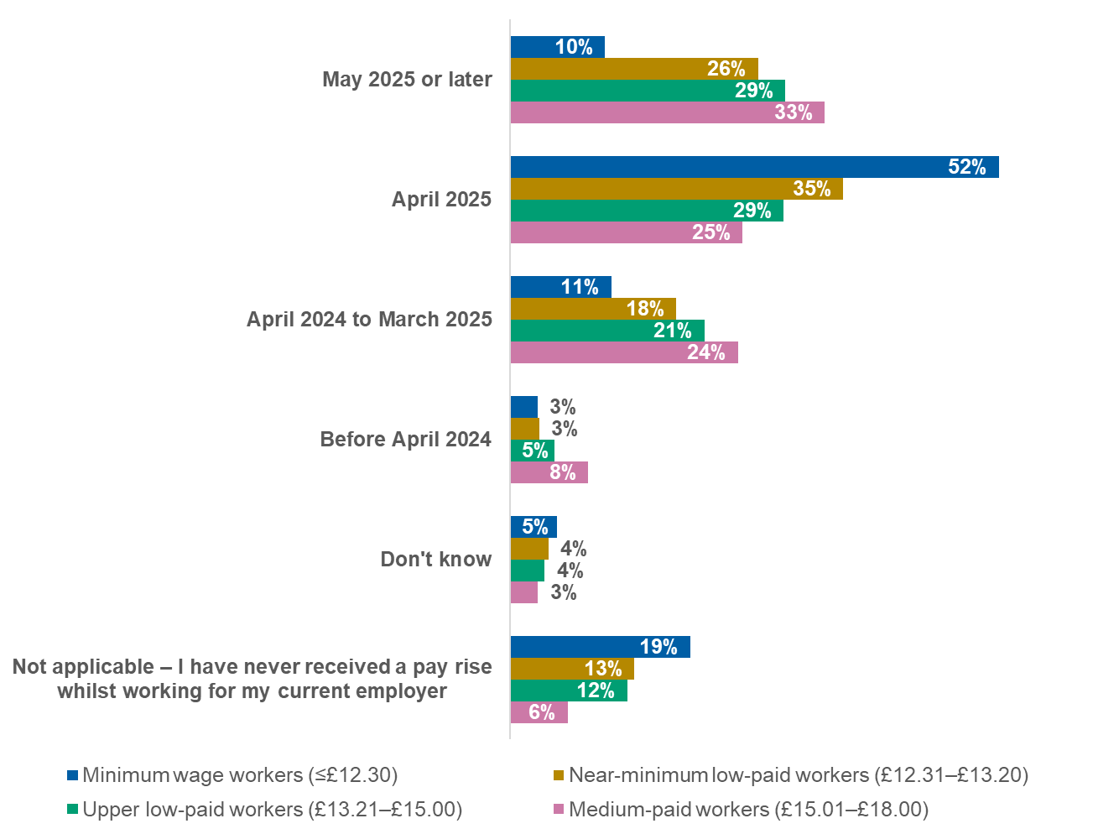
Base: Minimum wage workers (n=298); Near-minimum low-paid workers (n=571); Upper low-paid workers (n=663); Medium-paid workers (n=739)
Thinking about your time working for your current employer… When did you receive your most recent pay rise? By pay rise, we mean any permanent increase in your total contractual pay (but not bonuses).

Financial comfort increases with wage level, although a significant portion of workers at all levels report having little money for non-essential spending
Key findings
- A sense of financial comfort increases with wage level, though many workers across all pay bands report covering essentials but having limited room for luxuries.
- Workers closest to the minimum wage are more likely to report financial strain or going without essentials.
- Financial comfort is lower among low-paid workers with children, disabilities, or who receive income-related benefits.
- Although larger pay rises are associated with greater improvements in financial comfort, many low-paid workers manage financial pressure through spending cuts or increased working hours.

- A sense of financial comfort increases somewhat with wage level. Minimum wage workers are less likely than medium-paid workers to describe themselves as being comfortable financially, while minimum wage workers more frequently than medium-paid workers say they can only just afford their costs and often struggle to make ends meet, or cannot afford their costs and often have to go without essentials like food and heating (Figure 29).
Across all wage bands, however, workers most commonly report that they do not often have money for luxuries but can normally comfortably cover the essentials, with roughly two in five stating so. This highlights that although the overall financial position of most minimum wage workers is comparable to that of workers in other hourly pay bands, a larger minority have a sense of financial vulnerability.

- Self-reported financial position
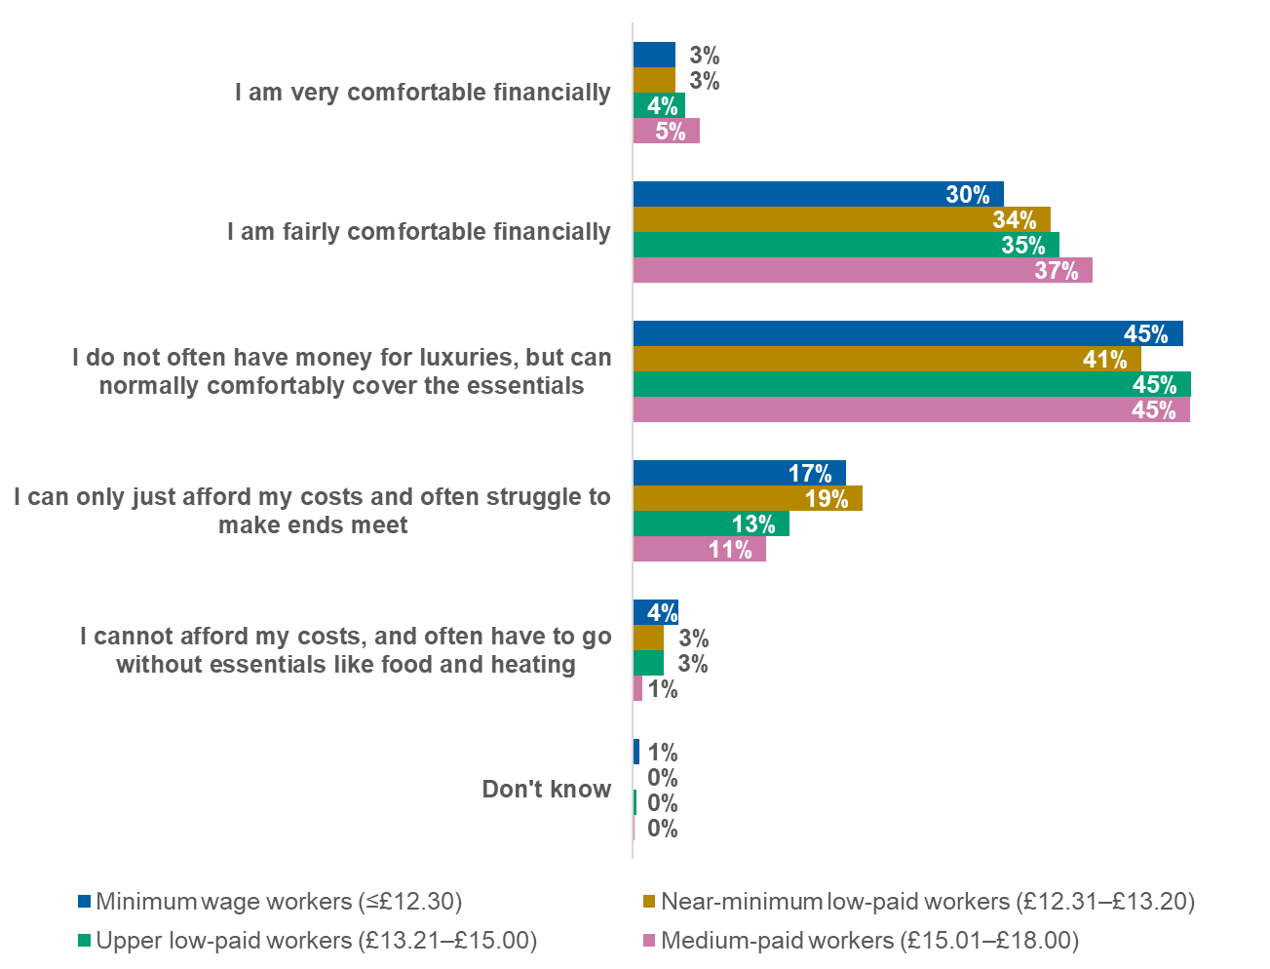
Base: Minimum wage workers (n=298); Near-minimum low-paid workers (n=571); Upper low-paid workers (n=663); Medium-paid workers (n=739)
Thinking about your finances, which of the following best reflects your position?
- Financial comfort also varies by household circumstances. Minimum wage and near-minimum wage workers with children in their household are less likely than those without to report feeling comfortable financially, and conversely, more often say that they can only just afford their costs and often struggle to make ends meet (Figure 30). Minimum wage and near-minimum wage workers with a disability or long-term health condition also less commonly report feeling financially comfortable than those without, with a difference of nearly 10 percentage points.

- Self-reported financial position: minimum wage and near-minimum wage workers by presence of children under 18 in the household
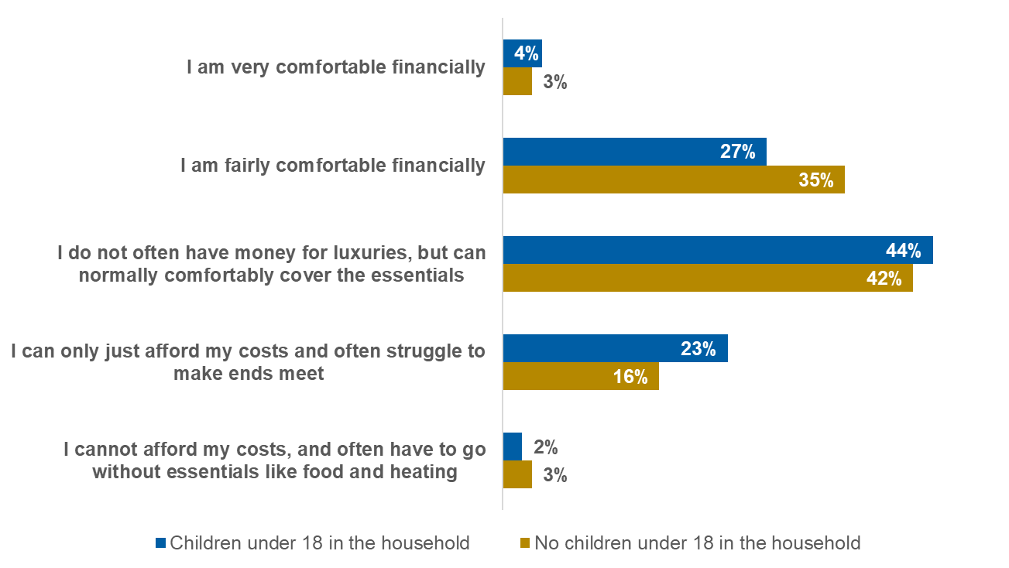
Base: Minimum wage and near-minimum low-paid workers with children under 18 in the household (n=258); Minimum wage and near-minimum low-paid workers without children under 18 in the household (n=607)
Thinking about your finances, which of the following best reflects your position?
- Among low- and medium-paid workers as a whole, those receiving income-related benefits are less likely to report feeling financially comfortable (18% compared with 40% of those not receiving benefits). This pattern likely reflects a combination of factors, including lower or less secure working hours and wider household circumstances, rather than benefit receipt alone.
The two wage bands closest to the minimum wage – minimum wage and near-minimum wage workers – express nearly identical perspectives on the extent to which their most recent pay rise made them feel more financially comfortable, with the majority saying that it made little or no difference. Meanwhile, those belonging to the higher two wage groups – upper low-paid and medium-paid workers – are more likely to state that their most recent pay rise brought them an increased sense of financial comfort (Figure 31).

- Extent to which most recent pay rise made them feel more financially comfortable
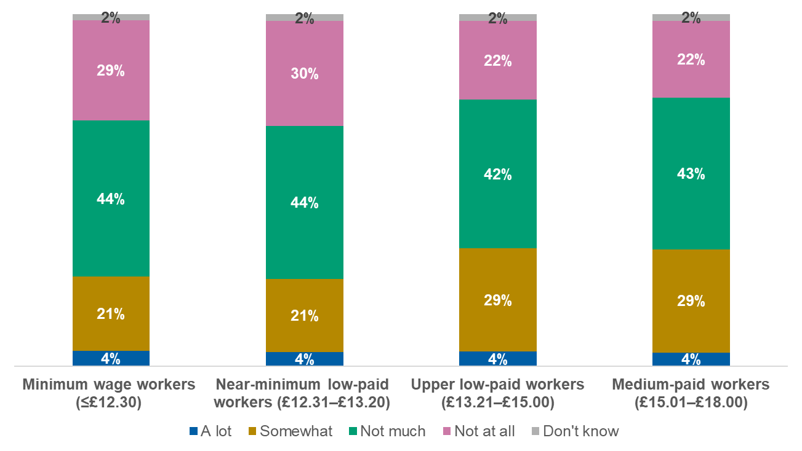
Base: Minimum wage workers (n=250); Near-minimum low-paid workers (n=517); Upper low-paid workers (n=621); Medium-paid workers (n=707)
Thinking about your finances, to what extent did your most recent pay rise make you feel more financially comfortable?
- Looking at low- and medium-paid workers as a collective, there is a direct correlation between the size of their most recent pay rise and the degree to which it made them feel more financially comfortable. Among those paid an hourly rate, two in five (39%) workers who most recently received a smaller pay rise of 0-49 pence say it did not make them feel more financially comfortable at all, while this decreases substantially to one in five (18%) of those who had a larger pay rise of 50-99 pence and just 6% of those were given a more substantial pay rise of £1.00-£1.49. A similar trend exists when looking at the results among those awarded their most recent increase based on an annual salary.
Notably, younger minimum wage and near-minimum wage workers aged 21-29 are more likely to report that their most recent pay rise gave them an increased sense of financial comfort than their older counterparts aged 30-49 and 50 and over, with differences of 10 percentage points or more. Meanwhile, there are fewer differences between subgroups for other key demographics such as children in the household, disability status and working status.
Among the low- and medium-paid workers who said they can only just afford or cannot afford their costs, the mitigating actions they have most commonly taken in the past year have been to reduce their spend on essential and non-essential goods. For these actions as well as others, results are relatively consistent across the wage bands. However, findings reveal that minimum wage and near-minimum wage workers more often than medium-paid workers have worked more hours or taken on extra shifts (Figure 32). This indicates that although low- and medium-paid workers facing financial difficulty use similar coping strategies overall, those earning closer to the minimum wage are considerably more likely than medium-paid workers to respond by increasing their working hours.

- Actions taken to afford monthly costs in the past year
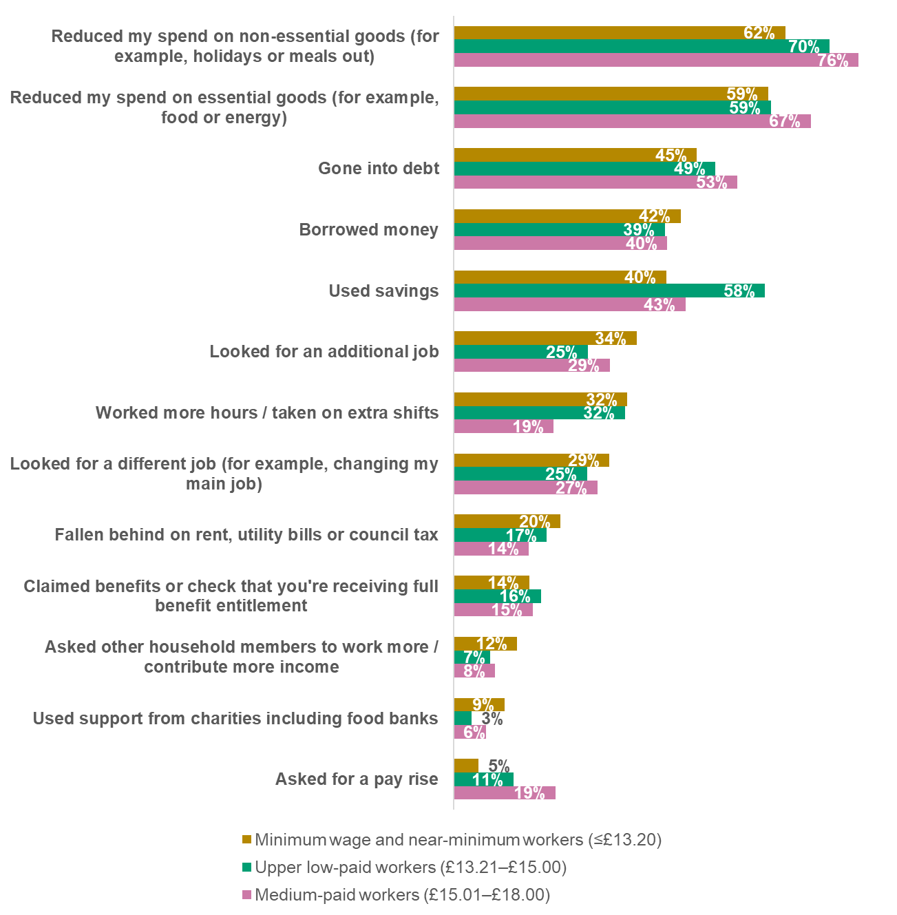
Base: Minimum wage and near-minimum workers (n=192); Upper low-paid workers (n=105); Medium-paid workers (n=93)
You have said you can only just afford / cannot afford your monthly costs. Which of the following options have you used to afford your monthly costs in the last 12 months?
Note: Options for ‘Other’, ‘Not applicable’ and ‘Prefer not to say’ are not shown

Decision-making about working arrangements

Lower-paid workers show limited desire to increase hours but higher willingness to accept them
Key findings
- While most minimum wage workers do not actively want to increase their paid working hours, many would accept additional hours if these were offered by their employer.
- Among those unwilling to work additional hours, reasons are more often related to personal circumstances or satisfaction with their current hours than concerns about taking on extra responsibility, with minimum wage and near-minimum wage workers more likely than medium-paid workers to report constraints around personal circumstances.
- Even when presented with sizeable hypothetical pay increases, most low-paid workers report no desire to change their working hours, suggesting that decisions about hours are shaped by factors beyond hourly pay alone.

- Minimum wage workers express more interest than those in all other wage bands in increasing their paid working hours, while desire to increase paid working hours declines as wage level rises. Conversely, medium-paid workers are more likely than minimum wage workers to want to decrease their working hours (Figure 33).

- Desire to increase or decrease paid working hours
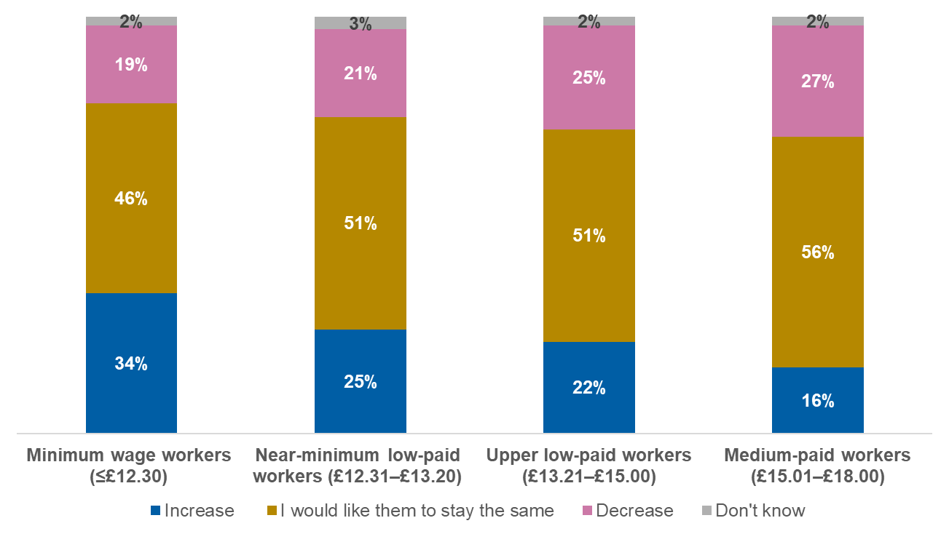
Base: Minimum wage workers (n=298); Near-minimum low-paid workers (n=571); Upper low-paid workers (n=663); Medium-paid workers (n=739)
To what extent would you like to increase or decrease your paid working hours, or would you like them to stay the same?
- Among minimum wage and near-minimum wage workers, young people aged 21-29 are most likely to want their working hours to increase, while those aged 50 and over are most likely to want them to decrease (Figure 34). Number of hours worked also plays a key role in desire to change working hours, with minimum wage and near-minimum wage workers who are contracted to work eight hours or less per week more likely to report a desire to increase their working hours. This is half as likely compared with those in the same group who work 16 hours or more per week.
- Desire to increase or decrease paid working hours: minimum wage and near-minimum wage workers by age

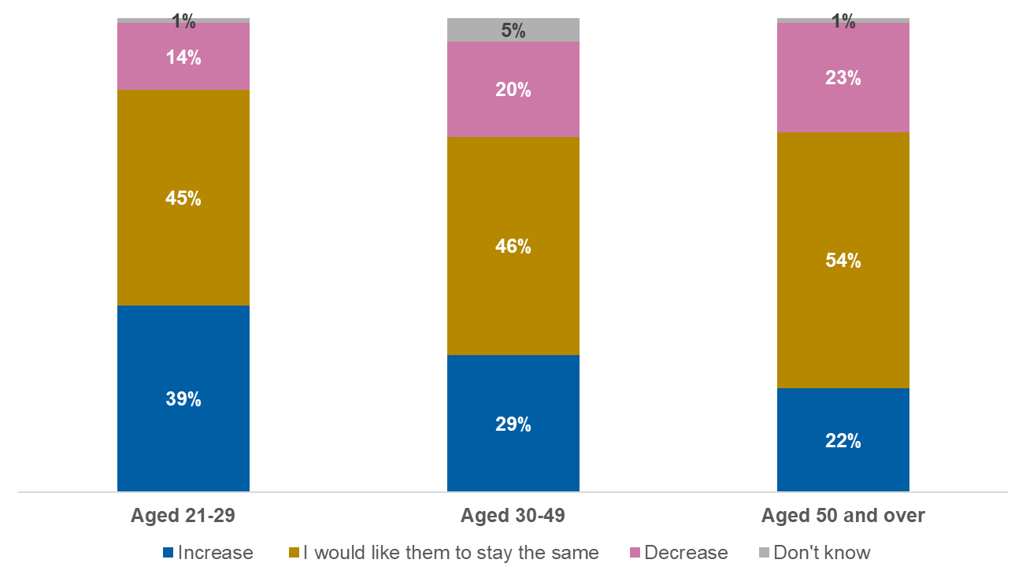
Base: Minimum wage and near-minimum wage workers aged 21-29 (n=124); Minimum wage and near-minimum wage workers aged 30-49 (n=400); Minimum wage and near-minimum wage workers aged 50 and over (n=345)
To what extent would you like to increase or decrease your paid working hours, or would you like them to stay the same?
Minimum wage and near-minimum wage workers who have children in their household are more likely to want to increase their paid working hours than those without, separated by almost 10 percentage points. Meanwhile, among all low- and medium-paid workers, those not receiving income-related benefits are more than twice as likely to say they would like to decrease their paid working hours than those who are receiving them.
Despite a minority saying they would like to increase their paid working hours, when looking at minimum wage workers’ willingness to accept additional paid working hours if offered by their employer, the majority say they would accept them. Medium-paid workers are least likely to say they would accept additional paid work hours if offered, although it is still a majority who would. This highlights a clear pattern whereby willingness to work additional paid hours is directly correlated with closeness to the minimum wage (Figure 35).
- Would accept additional paid work hours
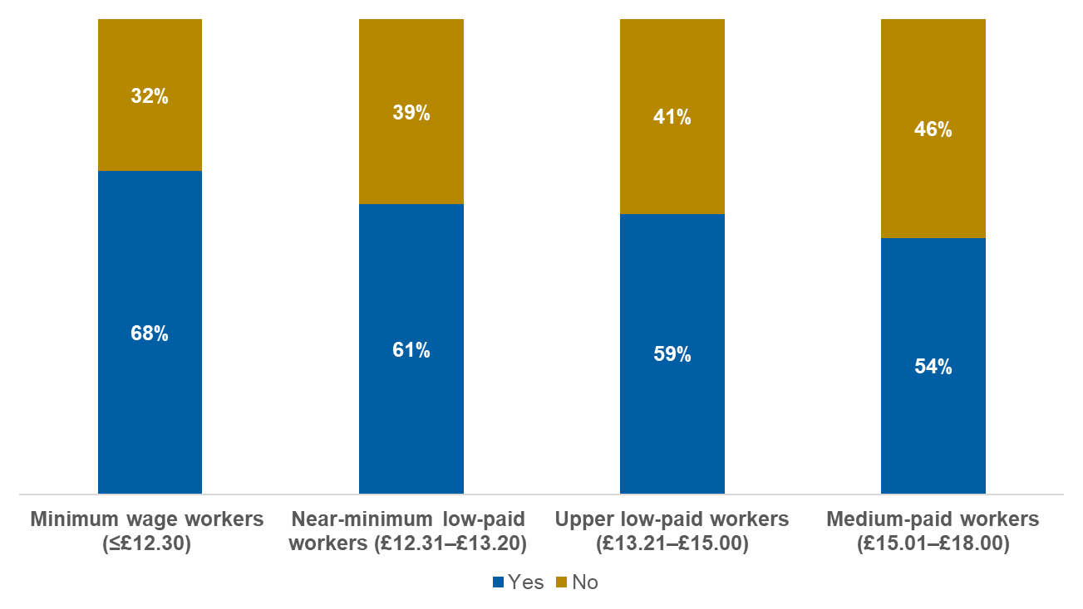
Base: Minimum wage workers (n=298); Near-minimum low-paid workers (n=571); Upper low-paid workers (n=663); Medium-paid workers (n=739)
If your current employer offered you additional paid work hours, would you take them?
Reflecting desire to increase working hours, younger minimum wage and near-minimum wage workers aged 21-29 (76%) are more likely to accept additional hours, with those aged 50 and over least likely (48%). Number of contracted hours also drives willingness to accept additional paid work hours, with minimum wage and near-minimum wage workers who are contracted to work for eight hours or less per week more likely to say they would accept them compared with those contracted to work for 35 hours or more, with a gap of roughly 15 percentage points. Those with a disability or long-term health condition are also less likely to say they would accept additional paid working hours than those without a disability as well as those who do not have children in the household, with a gap of roughly seven percentage points.
The main reasons provided by minimum wage workers for not wanting additional paid work hours include satisfaction with number of hours currently worked and personal circumstances preventing them from working more hours, while a smaller proportion say it is due to extra hours meaning taking on more responsibility (Figure 36). There is a similar pattern among the other wage bands, however, medium-paid workers are most likely to say they do not want additional hours due to satisfaction with their current hours, while minimum wage and near-minimum wage workers are most likely to say their personal circumstances prevent them from working more hours.
- Reasons for not wanting additional paid work hours
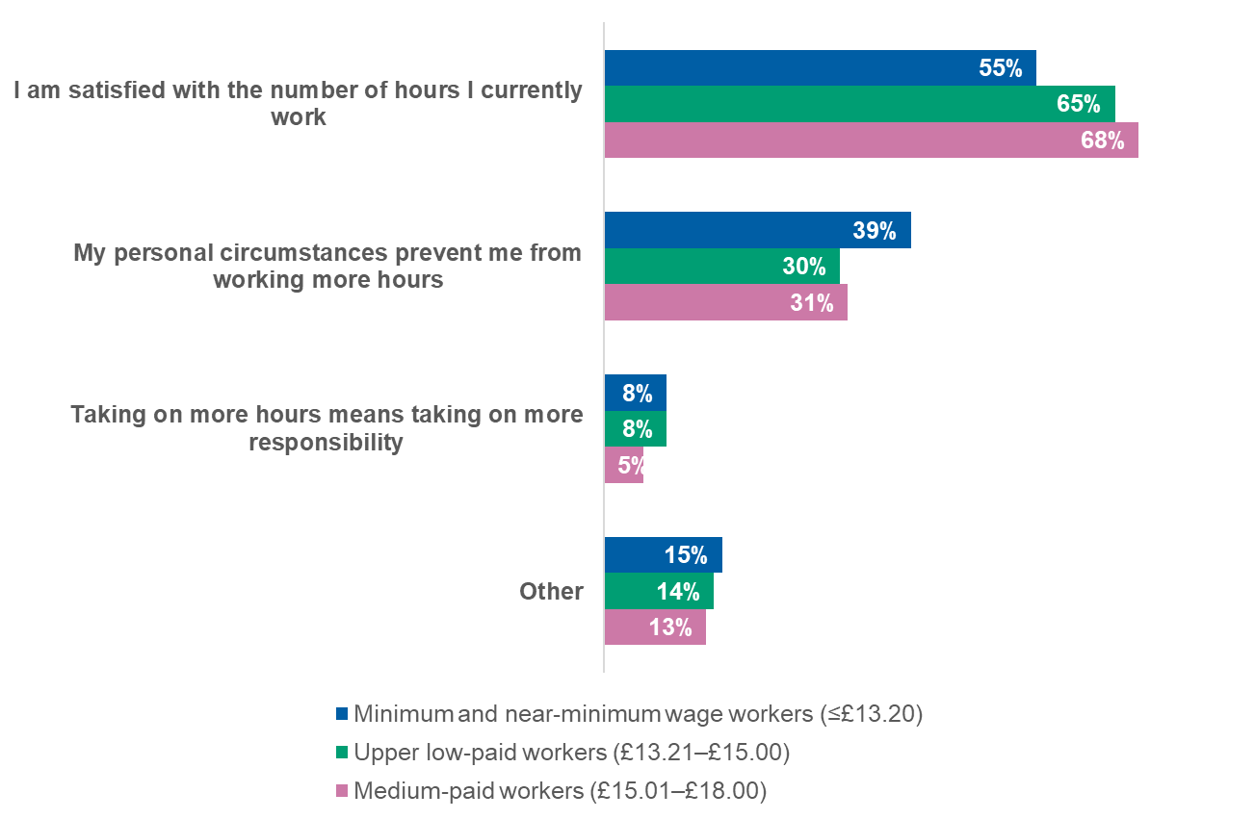
Base: Those who do not want additional paid work hours who are minimum wage and near-minimum workers (n=329); Upper low-paid workers (n=287); Medium-paid workers (n=343)
You said you would not use additional paid work hours, which of the following are your reasons for this? Please select all that apply
Among minimum wage and near-minimum wage workers, younger people aged 21-39 are twice as likely to cite not wanting additional work hours due to increased responsibility while they are less likely to provide satisfaction with number of hours worked as a reason.
Minimum wage and near-minimum wage workers who work part-time are more likely to cite personal circumstances as preventing them from working more hours, compared with those who work full-time. Meanwhile, those working full-time are twice as likely to not want to take additional paid work hours due to the extra responsibility that comes with it than those working part-time (Figure 37). People with a disability/long-term health condition or children in their household are more likely than their counterparts to report personal circumstances preventing them from working more hours, with a gap of roughly 20 percentage points in both cases.
- Reasons for not wanting additional paid work hours: minimum and near-minimum wage workers by working status
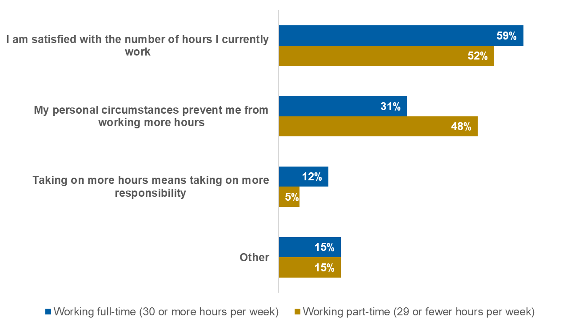
Base: Those who do not want additional paid work hours who are minimum wage and near-minimum wage workers working full-time (n=170); Minimum wage and near-minimum wage workers working part-time (n=159)
You said you would not use additional paid work hours, which of the following are your reasons for this? Please select all that apply
Workers who are paid hourly were asked whether it would make them want to change their working hours if their pay was to increase by £2 or £3 an hour. Among minimum wage workers who were presented with the option of a £2 increase, the majority say they would not change their working hours. Findings are similar across the other wage levels as well as among those offered a £3 hourly increase, showing that a pay rise of this size does not have a meaningful impact on desire to change paid working hours (Figure 38).
- Desire to change paid working hours if offered £2/£3 more per hour
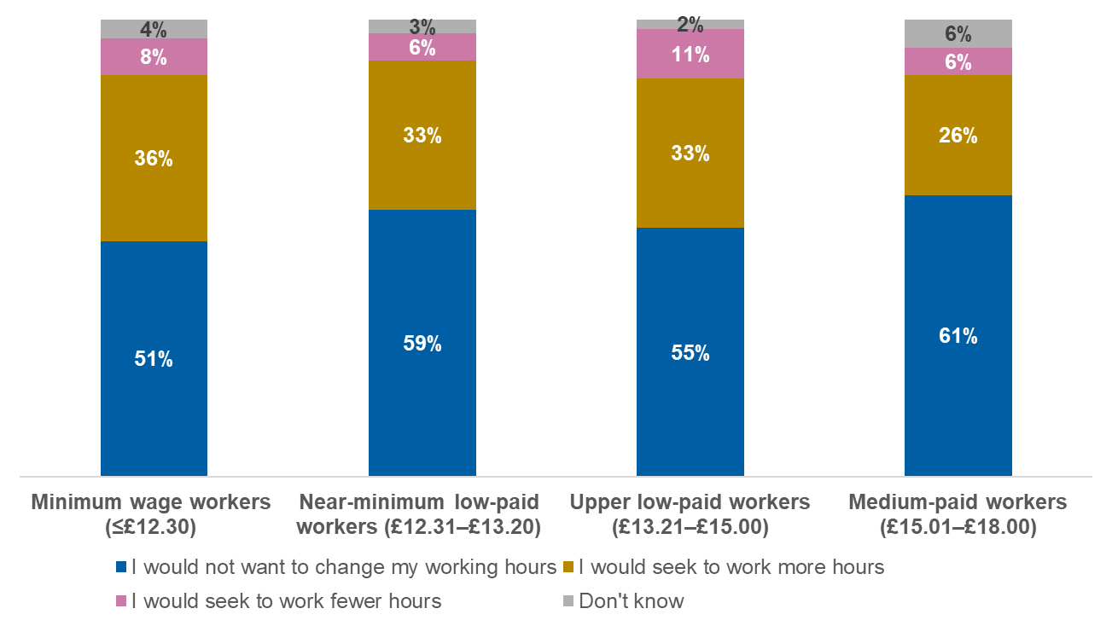
Base: Those paid hourly who are minimum wage workers (n=222); Near-minimum low-paid workers (n=398); Upper low-paid workers (n=281); Medium-paid workers (n=174)
If your pay were to increase by £2/£3 an hour, which of the following best describes how this would change your attitude towards your working hours, if at all?
- Among minimum wage and near-minimum wage workers paid hourly, younger people aged 21-39 are more likely to say the £2 or £3 pay increase would make them want to work more hours. Meanwhile, those who are older (aged 50 and over) are more likely to say it would not make them want to change their hours, with differences of around 10 percentage points.
There are also differences based on working status, with minimum wage and near-minimum wage workers employed part-time being more likely to not want to change their hours for a pay increase of £2 or £3 per hour compared with those who work full-time, with roughly 10 percentage points between them. Conversely, those who work full-time are nearly twice as likely to seek to work fewer hours based on this offer.
Minimum wage and near-minimum wage workers with a disability or long-term health condition are more likely to not want to change their working hours based on the pay increases offered than those without a disability, with a difference of almost 10 percentage points. Meanwhile, those with children in the household are more likely to say they would work more hours as a result of the pay increase (Figure 39).
- Desire to change paid working hours if offered £2/£3 more per hour: minimum and near-minimum wage workers by presence of children in the household

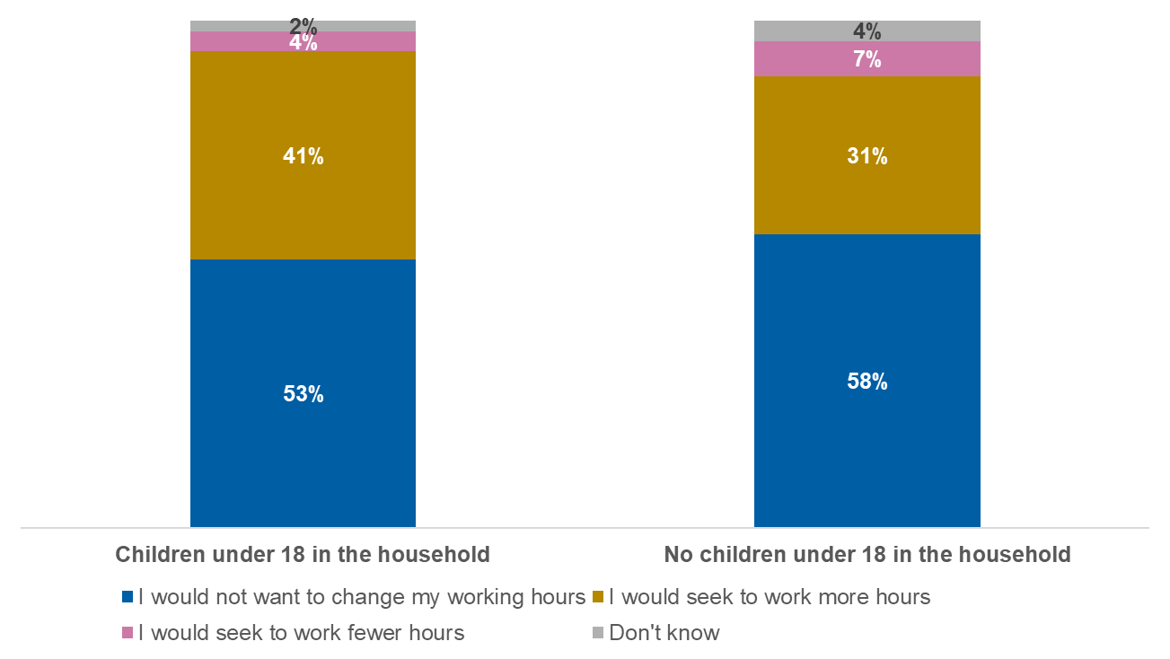
Base: Those paid hourly who are minimum wage or near-minimum wage workers with children under 18 in the household (n=188); Those paid hourly who are minimum wage or near-minimum wage workers without children under 18 in the household (n=428)
If your pay were to increase by £2/£3 an hour, which of the following best describes how this would change your attitude towards your working hours, if at all?

Progression decisions reflect perceived trade-offs for low-paid workers
Key findings
- Progression is not only seen as unlikely by many minimum wage and near-minimum wage workers, but is also often viewed as unattractive or difficult to accommodate when it is available.
- Reluctance to accept progression is commonly linked to perceived trade-offs, including increased responsibility, limited financial reward, reduced flexibility and caring commitments, and in some cases is more pronounced among those closest to the minimum wage.
- Overall, the findings suggest that for many low-paid workers, progression is not simply about opportunity, but about whether advancement fits with existing work and life constraints.

Consistent with earlier findings in this report, the majority of minimum wage workers feel it is unlikely they will be offered a promotion in the next 12 months. Although that picture is relatively consistent across the other wage groups, likelihood to accept a promotion if offered differs based on wage level, with minimum wage and near-minimum wage workers less likely to accept one compared with their higher paid counterparts (Figure 40).
- Likelihood of accepting a promotion if offered

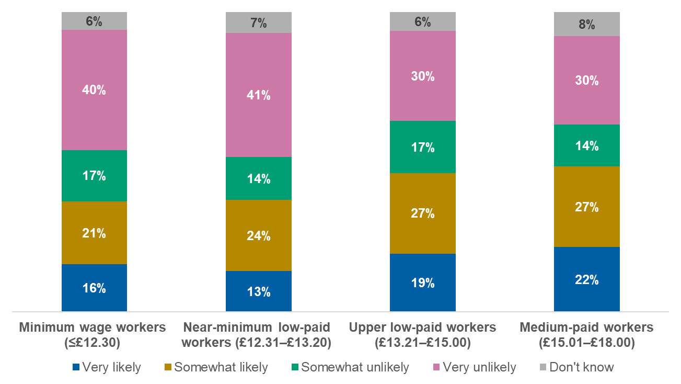
Base: Minimum wage workers (n=298); Near-minimum low-paid workers (n=571); Upper low-paid workers (n=663); Medium-paid workers (n=739)
For this question, we are interested in how likely or unlikely you think the following circumstances are.
Likelihood of accepting a promotion varies based on age, with younger minimum wage and near-minimum wage workers aged 21-29 more commonly saying they would be likely to accept a promotion than their older counterparts (Figure 41).

- Likelihood of accepting a promotion if offered: minimum and near-minimum wage workers by age

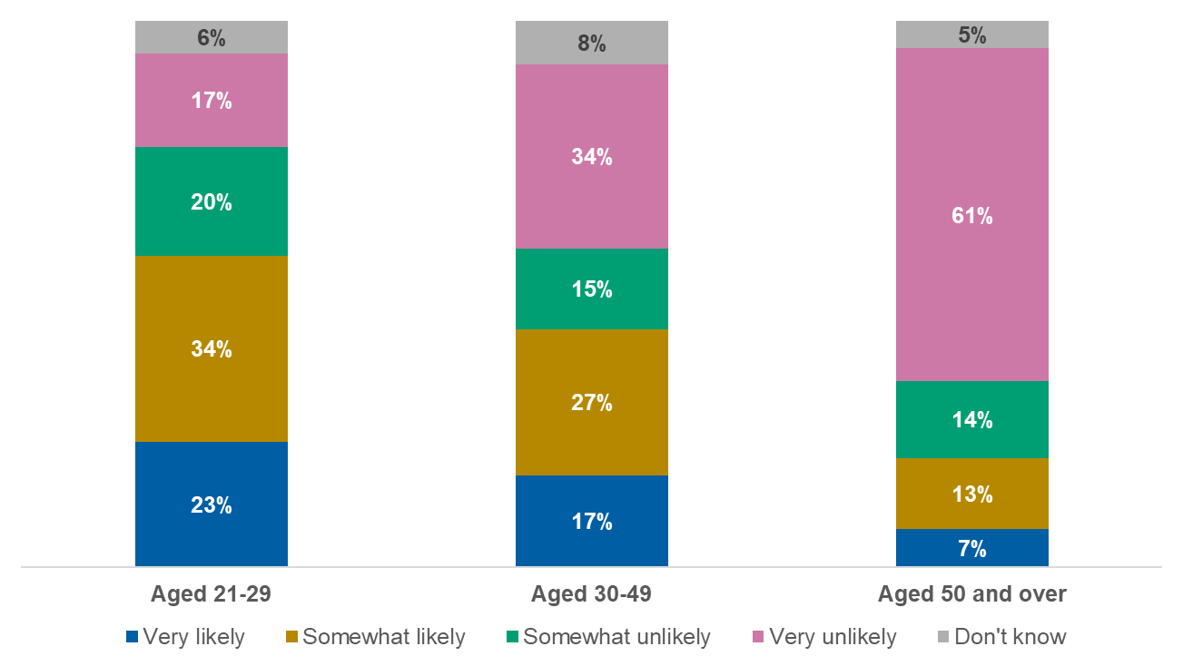
Base: Minimum wage and near-minimum wage workers aged 21-29 (n=124); Minimum wage and near-minimum wage workers aged 30-49 (n=400); Minimum wage and near-minimum wage workers aged 50 and over (n=345)
For this question, we are interested in how likely or unlikely you think the following circumstances are.
- Likelihood of accepting a promotion among minimum wage and near-minimum wage workers also varies based on working status, with those working full-time more likely to say they would accept one than those working part-time, with a difference of roughly 20 percentage points. Additionally, people with children in their household more often say they would accept a promotion than those without, separated by 10 percentage points.
In August 2023, similar research conducted by the Low Pay Commission and YouGov showed a consistent picture for likelihood to accept a promotion among minimum wage workers, with the majority (54%) having said they would be unlikely to do so and around one in three (34%) saying they would be likely to.
Among minimum wage workers who say they would be unlikely to accept a promotion with their current employer, the main reasons cited are not wanting to take on extra responsibility, the opportunity not being interesting, or not thinking the pay would be enough to make up for the extra work (Figure 42). There is a similar picture across the wage bands, although minimum wage and near-minimum wage workers (23%) are more likely than upper low-paid (17%) and medium-paid workers (15%) to express reluctance because they feel they would have less flexibility in when they work.
- Reasons for being unlikely to accept a promotion if offered
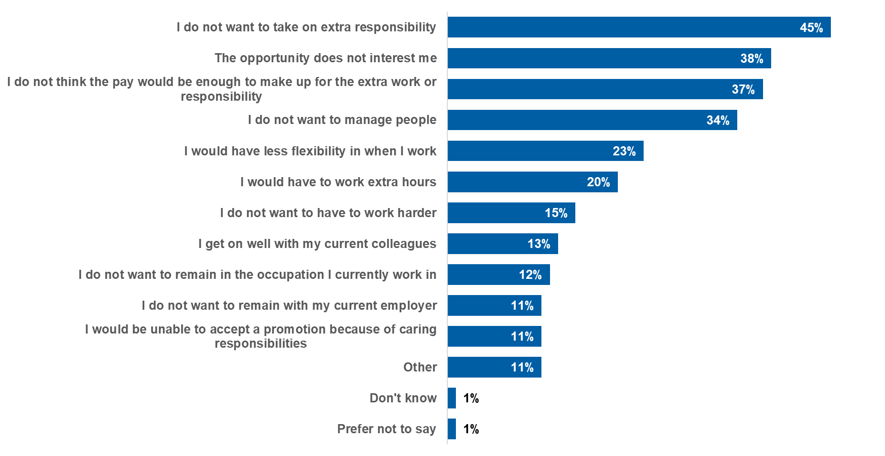
Base: Minimum wage workers and near-minimum wage workers who would be unlikely to accept a promotion (n=505)
You have said you would be unlikely to accept a promotion/more senior position with your current employer. What are your reasons for this? Please select all that apply.
Younger minimum wage and near-minimum wage workers aged 21-39 are more likely than this wage band as a whole to cite concerns for the pay not being enough to make up for extra work (45% compared with 37% overall) as a reason for being unlikely to accept a promotion. They are also twice as likely as minimum wage and near-minimum wage workers overall to cite not wanting to remain in their current occupation and not wanting to remain with their current employer, with differences of more than 10 percentage points. Meanwhile, those aged 50 and over are more likely to not accept a promotion due to the opportunity not interesting them.
Among minimum wage and near-minimum wage workers, those working part-time are more likely to cite having less flexibility when they work and having to work extra hours as reasons to be unlikely to accept a promotion than those working full-time. Conversely, those working full-time more often say they do not want to have to work harder do not think the pay would be enough and do not want to remain at their current employer than those working part-time, with differences of around 10 percentage points compared with their counterparts. Those with children in the household are also four times as likely to report being unable to accept a promotion due to caring responsibilities compared with those without.

Lower-paid workers are most likely to see benefits from Employment Rights Act reforms
Key findings
- Minimum wage workers are more likely than higher-paid workers to say changes related to shift notice and sick pay would improve their working conditions.
- Perceived benefits are generally strongest among those most directly affected by individual policies, including younger workers, parents and workers with a disability or long-term health condition.
- Differences by working status are limited, suggesting that views on these reforms are shaped more by personal and employment circumstances than by hours worked.
- Overall, support for Employment Rights Act changes is highest among lower-paid workers and those most exposed to the areas targeted by the reforms.

In this section, workers were asked to consider whether changes introduced through the Employment Rights Act, including new provisions on areas such as shift notice, sick pay eligibility and protections from dismissal, would make a difference to their working conditions. These options have been selected because they represent recent legislative reforms that may influence workers’ day-to-day conditions.
Minimum wage workers are more likely to say factors related to shift work and sick pay would make a positive difference to their working conditions. Meanwhile, upper low-paid workers are most likely to report that enhanced protection against dismissal for pregnant women and new mothers and changes to make it more likely that employers accept flexible working requests would make a positive difference. Notably, protection against unfair dismissal making a positive difference is consistent between wage levels (Figure 43).
- Factors which would make a positive difference to working conditions
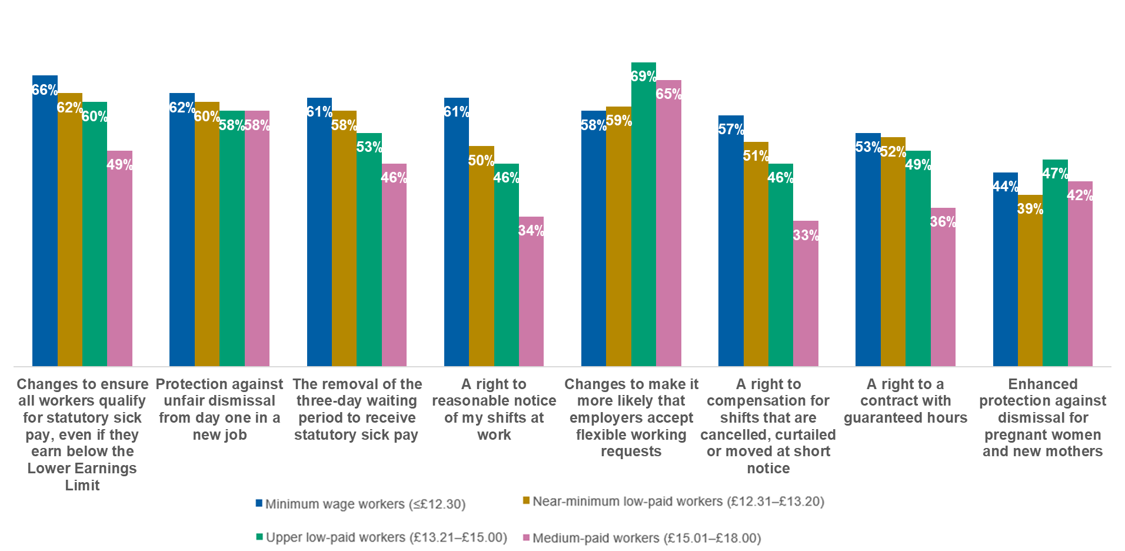
Base: Minimum wage workers (n=298); Near-minimum low-paid workers (n=571); Upper low-paid workers (n=663); Medium-paid workers (n=739)
Please indicate whether each of the following would make a difference to your working conditions.
Among minimum wage and near-minimum wage workers, younger people aged 21-29 are more likely to report that each factor would make a positive difference to their working conditions, apart from the removal of the three-day waiting period for sick pay, which is highest among those aged 30-49.
Those with a disability or long-term health condition are more likely to report that changes to ensure all workers qualify for sick pay would make a positive difference (68%) compared with those without one (62%). Additionally, those with children in the household more often say that enhanced protection against dismissal for pregnant women and new mothers would make a positive difference (55%) than those without children in the household (36%). Notably, apart from changes to flexible working requests, which is higher among those working full-time (62%) than those working part-time (55%), agreement is consistent between full-time and part-time workers.

Changing jobs

Job move intentions are shaped more by personal factors than by wage level
Key findings
- Likelihood of considering a job move is broadly similar across wage levels, with most workers reporting they are unlikely to move in the next 12 months.
- Age plays a more important role than wage level, with younger workers significantly more likely to consider moving jobs than older workers.
- Differences by working status, disability and presence of children in the household are minimal, indicating broadly similar levels of job stability across these groups.
- Overall, job mobility intentions appear to be shaped more by life stage and personal circumstances than by pay level alone.

- The majority of minimum wage workers report being unlikely to consider moving jobs in the next 12 months, and this pattern is broadly consistent across wage levels (Figure 44).
- Likelihood of moving jobs
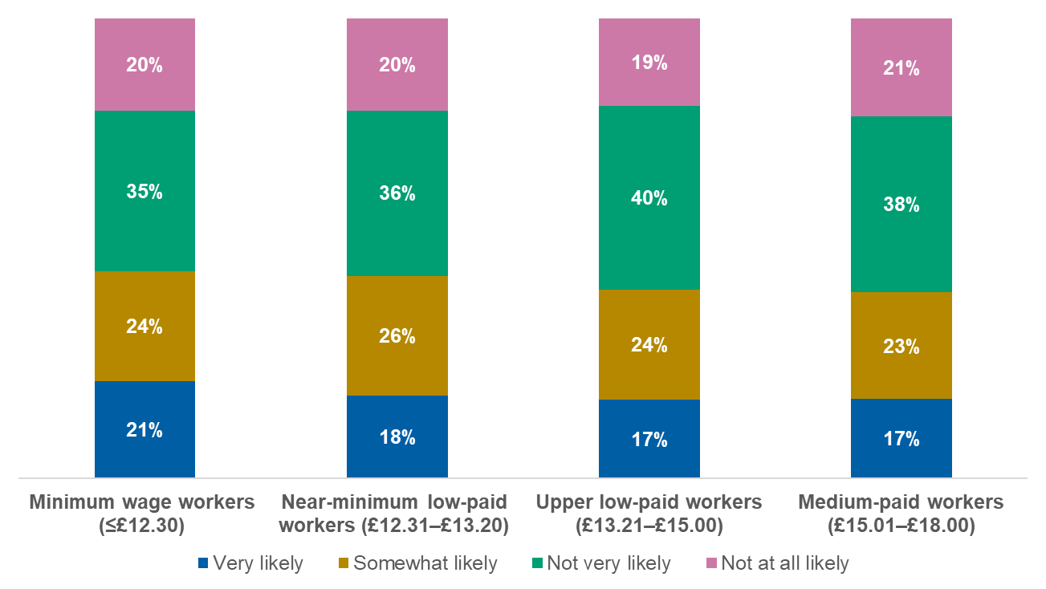
Base: Minimum wage workers (n=298); Near-minimum low-paid workers (n=571); Upper low-paid workers (n=663); Medium-paid workers (n=739)
In relation to your current job, how likely or not are you to consider moving jobs in the next 12 months?
Younger minimum wage and near-minimum wage workers are significantly more likely to consider moving jobs in the next 12 months, a pattern also seen across the other wage groups (Figure 45). Meanwhile, likelihood to consider moving jobs is consistent between other demographics such as working status, disability or having children in the household.
- Likelihood of moving jobs: minimum wage and near-minimum wage workers by age
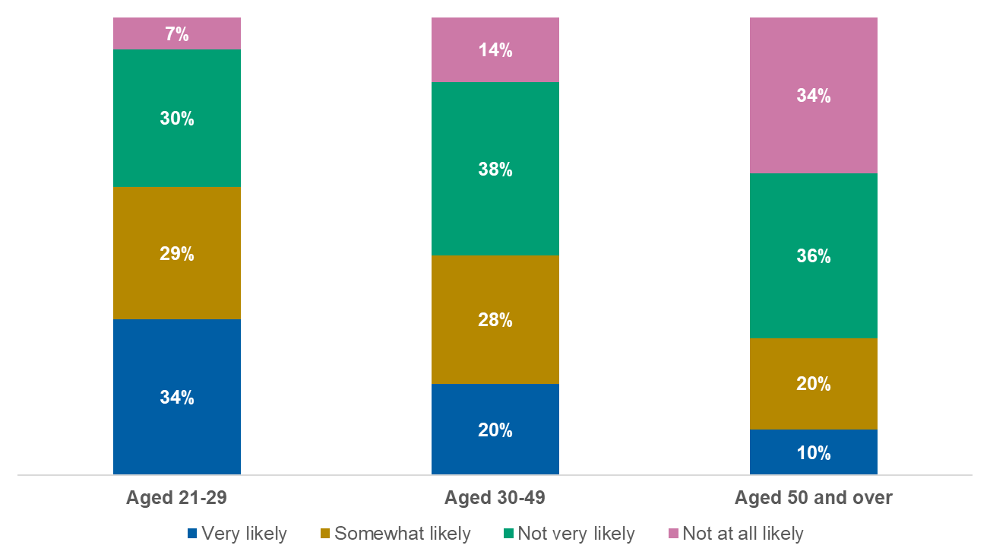
Base: Minimum wage and near-minimum wage workers aged 21-29 (n=124); Minimum wage and near-minimum wage workers aged 30-49 (n=400); Minimum wage and near-minimum wage workers aged 50 and over (n=345)
In relation to your current job, how likely or not are you to consider moving jobs in the next 12 months?

Concerns about job security and work–life balance limit low-paid workers’ willingness to change jobs
Key findings
- Perceived risk, job availability and flexibility are key barriers to moving roles, with similar patterns across wage levels.
- Barriers are more pronounced for some groups, including workers with a disability and those working part-time, particularly in relation to flexibility and balancing work with other commitments.
- Across wage groups, workers generally find it harder to identify roles offering good work–life balance than roles meeting pay or hours needs.
- Overall, decisions about changing jobs appear to be shaped less by pay alone and more by perceived stability, constraints and day-to-day job quality.

When considering barriers to moving jobs, risk and lack of availability are key concerns, while most feel confident in their skills and experience necessary to get a new job. The majority of minimum wage workers agree that moving jobs is a big risk, however, most feel that they have the skills and experience necessary to get a new job. Agreement is split when considering whether there are suitable jobs in the local area, and lowest when considering whether their personal circumstances mean they can get a new job. These findings are consistent across wage bands (Figure 46).
- Future employment agreement statements (agreement % shown)
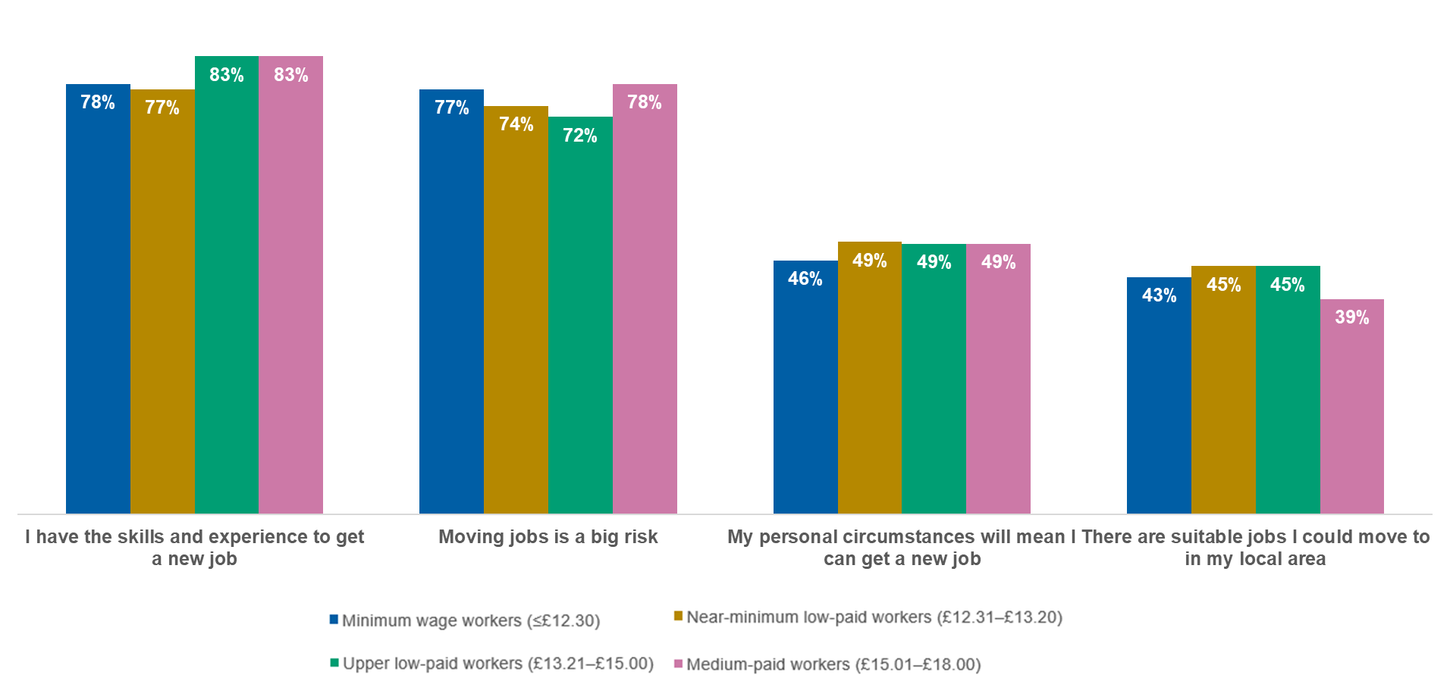
Base: Minimum wage workers (n=298); Near-minimum low-paid workers (n=571); Upper low-paid workers (n=663); Medium-paid workers (n=739)
To what extent do you agree or disagree with each of the following statements?
Among minimum wage and near-minimum wage workers, those aged 21-29 are more likely to agree that their personal circumstances mean they can get a new job (57%) than those aged 50 and over (36%). Meanwhile, those aged 30-39 are slightly more likely than overall to disagree they have the skills and experience necessary to get a new job (23% compared with 17% overall). Agreement across the statements is consistent among full and part-time workers, apart from agreement as to whether they have the skills necessary, with part-time workers being more likely to agree to this (81%) than those working full-time (74%).
Barriers to moving jobs are also exacerbated among minimum wage and near-minimum wage workers with a disability or long-term health condition. For example, they are less likely to agree that there are suitable jobs in their local area, more likely to agree that moving jobs is a big risk and more likely to disagree that their personal circumstances mean they can get a new job (Figure 47).
- Future employment agreement statements (agreement % shown): minimum and near-minimum wage workers by disability or long-term health condition status
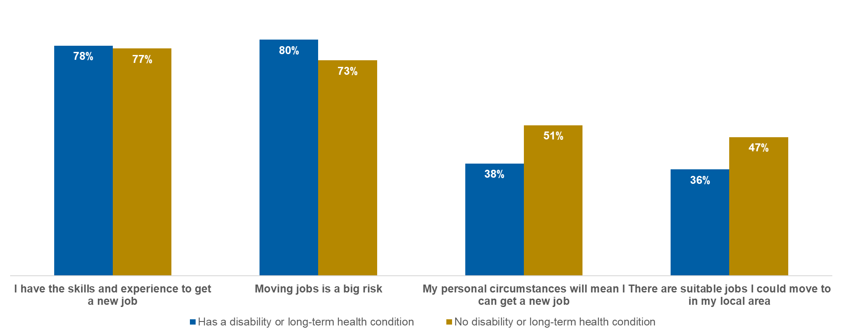
Base: Minimum wage and near-minimum wage workers with a disability or long-term health condition (n=200); Minimum wage and near-minimum wage workers without a disability or long-term health condition (n=655)
To what extent do you agree or disagree with each of the following statements?
When considering how easy or difficult it is to find a new job that meets their needs, workers feel it is easier to find a job that meets their needs in terms of pay and work hours, while having a good work–life balance is harder to find.
Perceptions are split among minimum wage workers on whether it is easy or difficult for the job’s location to meet their needs, with a similar pattern across the wage bands (Figure 48).
In terms of work–life balance, the majority of minimum wage workers feel it would be difficult for a job to meet these needs. However, a slight majority feel it would be easy to find a job that meets their needs in terms of number of hours. Perceptions of ease increase with wage level, with upper low-paid workers and medium-paid workers most likely to believe it would be easy to find a job that meets their needs around number of hours.
The majority of minimum wage workers also feel it would be easy to find a job that meets their needs in terms of levels of pay; however, this decreases as wages increase.
In August 2023, similar research conducted by the Low Pay Commission and YouGov observed a comparable pattern, by which levels of pay and number of work hours were perceived as needs more easily met among minimum wage workers compared with work–life balance. However, this disparity has decreased due to an increase in the proportion of minimum wage workers who feel it is easy to find a job that meets their needs in terms of location (38% to 49%) and work–life balance (32% to 42%).

- Perceived ease of finding a job that meets needs in the following areas (easy % shown)
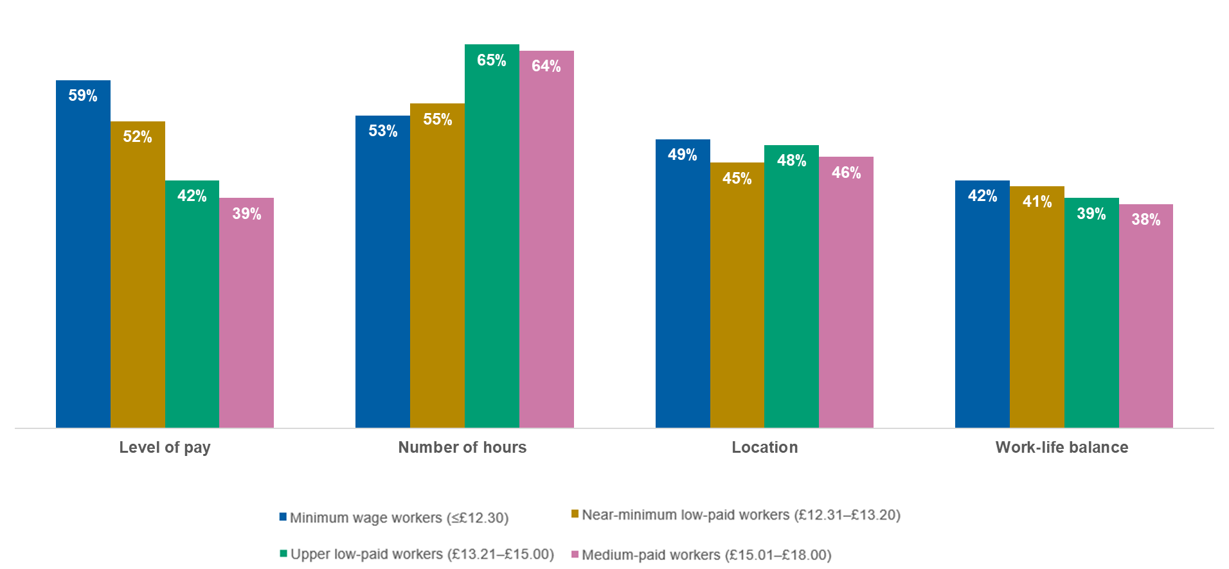
Base: Minimum wage workers (n=298); Near-minimum low-paid workers (n=571); Upper low-paid workers (n=663); Medium-paid workers (n=739)
And how easy or difficult do you think it would be for you to find a new job that meets your needs in the following areas?
- Perceptions among minimum wage or near-minimum wage workers are consistent across age groups, apart from number of hours and location, for which those who are older (50 and over) are less likely to feel it would be easy to find a new job that meet their needs, with differences of around 10 percentage points compared with the overall figures.
In terms of hours worked, those working full-time are more likely to feel it is easy for a new job to meet their needs in terms of the number of hours. Meanwhile, those working part-time more often feel finding a job that meets their needs for level of pay would be easy (Figure 49).

- Perceived ease of finding a job that meets needs in the following areas (easy % shown): minimum wage workers by working status

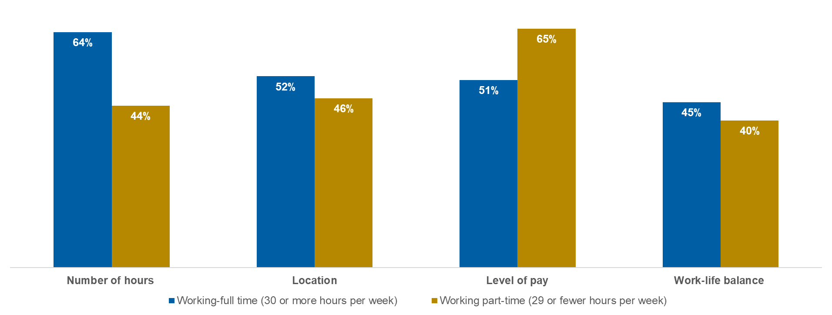
Base: Minimum wage and near-minimum wage workers working full-time (n=134); Minimum wage and near-minimum wage workers working part-time (n=164)
And how easy or difficult do you think it would be for you to find a new job that meets your needs in the following areas?
- Consistent with barriers to moving jobs, those with a disability or long-term health condition are more likely to feel it would be difficult for a new job to meet their needs in terms of location, work–life balance and number of hours compared with those without one, with differences of around 10 percentage points.

Job security, reliability and work–life balance concerns make moving jobs feel risky for low-paid workers
Key findings
- Perceived risks associated with moving jobs are driven primarily by concerns about job security, reliability, management quality and work–life balance, rather than fears about performance or skills.
- These perceptions are broadly similar across wage levels, although medium-paid workers are slightly less likely to view unreliability as a risk.
- Risk perceptions vary modestly across demographic groups, with younger workers, part-time workers, and those with disabilities or caring responsibilities more likely to view certain aspects of job change as risky.
- Overall, moving jobs is widely perceived as involving uncertainty and potential loss of job quality, reinforcing cautious attitudes toward job mobility.

When considering the various risks associated with moving jobs, job security and unreliability are reinforced as key barriers, along with concerns for work–life balance or a bad manager, as opposed to concerns related to performance or lack of experience.
The vast majority of minimum wage workers feel that having a bad manager is a high or moderate risk, consistent across the wage levels. Concerns about job security and employer reliability follow closely behind and are broadly consistent across wage levels, although medium-paid workers are slightly less likely to view unreliability as a risk (Figure 50).
Reinforcing workers’ concerns about finding a job with adequate work–life balance, the majority of minimum wage workers feel a lack of flexible or hybrid working is a high or moderate risk when moving to a new job. This is more likely among medium-paid workers; however, it is driven by them being less likely to say they are uncertain, as opposed to a difference in no or low risk perception.
Concerns about underperforming at the new job are relatively split. This is broadly consistent across wage levels, although medium-paid workers are slightly more likely to feel underperforming is not a risk.
- Perceived risk of taking a new job (high/ moderate risk % shown)
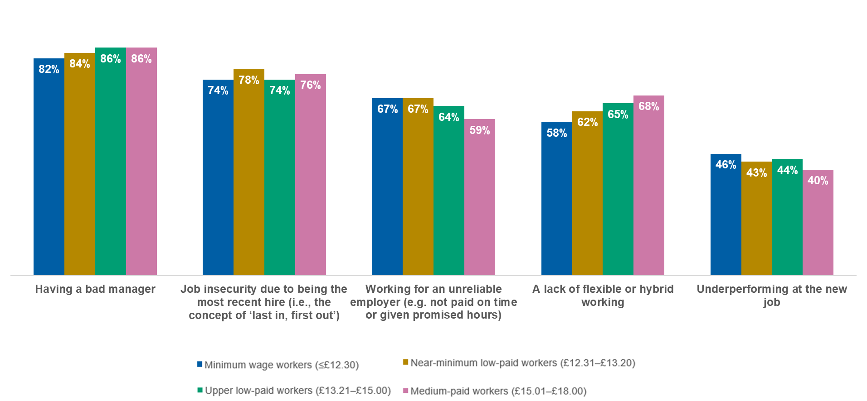
Base: Minimum wage workers (n=298); Near-minimum low-paid workers (n=571); Upper low-paid workers (n=663); Medium-paid workers (n=739)
How much of a risk, if any, do you think each of the following would be to you if taking a job with a different employer?
In August 2023, similar research conducted by the Low Pay Commission and YouGov showed a comparable pattern, with having a bad manager, unreliability and insecurity perceived as bigger risks among minimum wage workers compared with risks of underperforming. However, working for an unreliable employer (59% to 67%) and underperforming (38% to 46%) are more likely to be perceived as a risk in 2025 compared with 2023.
Risk perceptions are relatively consistent across age groups for minimum wage and near-minimum wage workers. However, younger workers aged 21-29 are more likely than older workers to perceive having a bad manager and underperforming as high or moderate risks (Figure 51). Similar to perceived barriers of moving jobs, those working part-time are more likely to feel a lack of flexible working is a high or moderate risk than those working full-time. There is a similar pattern among those with a disability or long-term health condition and those with children in their household, with differences of around 10 percentage points compared with their counterparts.
- Perceived risk of taking a new job (high/ moderate risk % shown): minimum wage and near-minimum wage workers by age
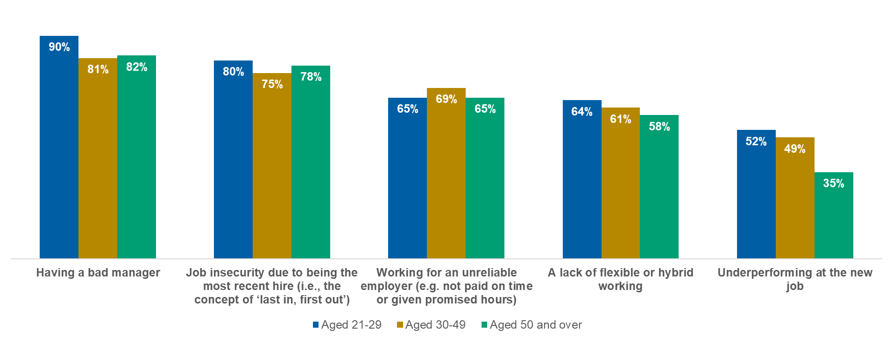
Base: Minimum wage and near-minimum wage workers aged 21-29 (n=124); Minimum wage and near-minimum wage workers aged 30-49 (n=400); Minimum wage and near-minimum wage workers aged 50 and over (n=345)
How much of a risk, if any, do you think each of the following would be to you if taking a job with a different employer?

Workplace conditions play a key role in low-paid workers’ decisions to change jobs, even where higher pay is available
Key findings
- Workers are generally more willing to accept trade-offs such as longer commutes or reduced access to training than changes that would worsen work–life balance, working relationships or control over hours.
- This pattern is evident across wage groups, although minimum wage workers are slightly more willing than higher-paid workers to accept some deteriorations in job quality in exchange for higher pay.
- Younger workers and full-time workers are more likely to accept job changes involving reduced control or poorer working relationships, while part-time workers are more cautious.
- Overall, decisions about job mobility reflect a balance between potential pay gains and the perceived risk of reduced job quality and stability.

When presented with various factors and asked whether they would accept them for a specified pay rise, workers are more willing to take a job with a longer commute time or inadequate access to training and development, while elements such as less control over hours worked, worse working relationships and worse work–life balance are less likely to be accepted (Figure 52).
Among workers paid hourly who are offered a £2 or £3 pay rise, this pattern is broadly consistent across wage levels. However, medium-paid workers are slightly less likely to accept if the commute time were to be increased by an extra 15 minutes, and minimum wage workers are slightly more likely to accept if the new job were to have a much worse work–life balance or they had much less control over the timing of their working hours, with differences of five percentage points or more. Between those offered a £2 or £3 pay increase, the main difference is regarding extra commuting time, for which 54% of those offered a £2 increase would take the new job compared with a higher proportion (63%) of those offered £3.
- Would accept a new role for £2 or £3 more an hour in the following scenarios: minimum wage or near-minimum wage workers

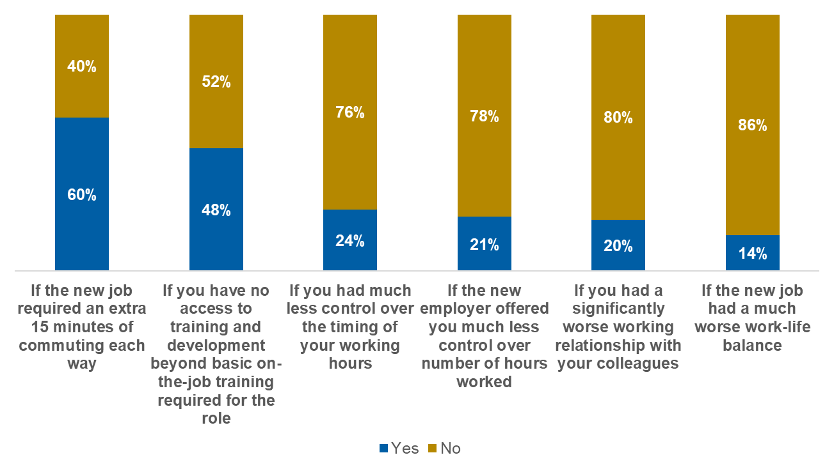
Base: Minimum wage and near-minimum workers who are paid hourly (n=620)
For the following question, please imagine you have been offered a new role by another employer paying £2/£3 more an hour than you currently earn. In each of the following scenarios, would you accept the new job for an extra £2/£3 per hour or stick with your current job at its current hourly rate?
- A similar pattern is observed when considering workers paid an annual salary rather than hourly wages who are offered a £2,000 or £3,000 pay rise, with minimum or near-minimum wage workers being more likely to accept all factors, apart from extra commuting time and worse work–life balance. Among low- and medium-paid workers overall, those offered £3,000 are also slightly more likely to accept a job which requires more commuting time and no access to training and development compared with those offered £2,000, with differences of around 10 percentage points.

- Would accept a new role for £2,000 or £3,000 more per year in the following scenarios: minimum wage or near-minimum wage workers

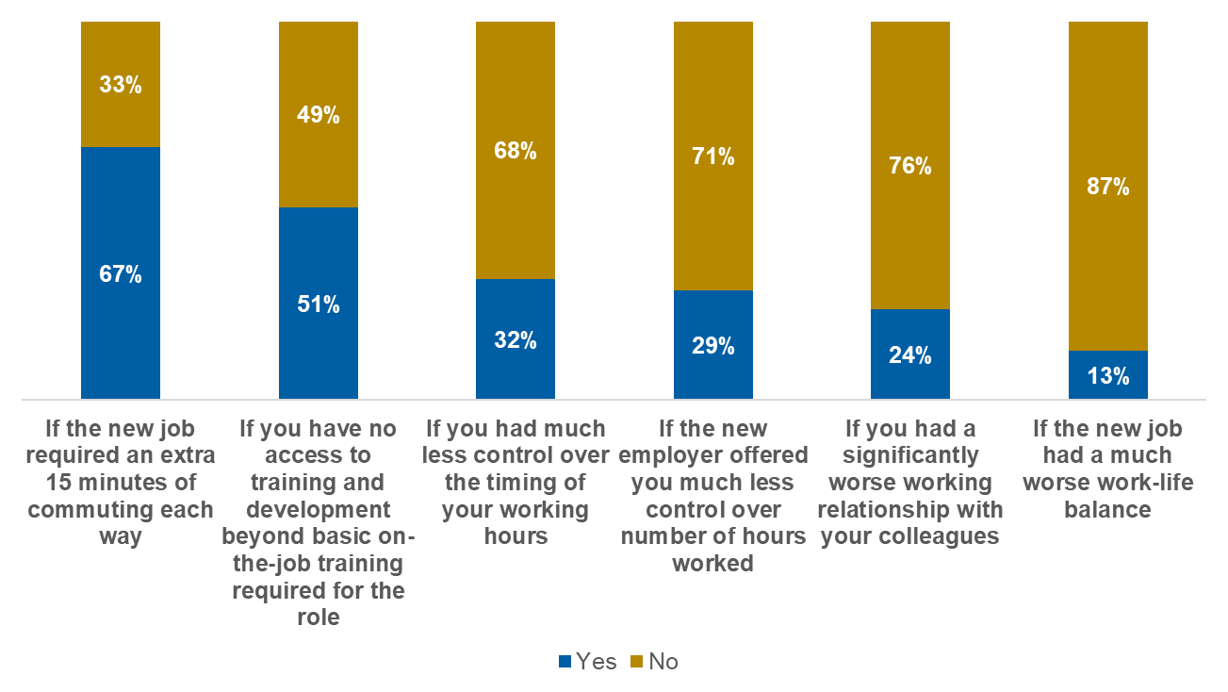
Base: Minimum wage and near-minimum workers who are paid yearly (n=249)
For the following question, please imagine you have been offered a new role by another employer paying £2,000/£3,000 more per year than you currently earn. In each of the following scenarios, would you accept the new job for an extra £2,000/£3,000 per year or stick with your current job at its current rate?
- Younger minimum wage and near-minimum wage workers aged 21-39 are more likely to accept a new job for a £2 or £3 hourly increase for all factors listed, apart from access to training and development. There is a similar pattern among those paid annually, where those aged 21-39 are more likely to accept a new role if they had less control over work hours and worse working relationships with their colleagues, with differences of around 15 percentage points compared with their older counterparts.
Minimum wage and near-minimum wage workers who are paid hourly and work full-time are more likely than part-time workers to accept the new role in exchange for a pay increase if the job required more commuting time and if they had less control over the timing of their working hours and the number of hours worked (Figure 54).

- Would accept a new role for £2 or £3 more an hour in the following scenarios (% yes shown): minimum and near-minimum wage workers by working status
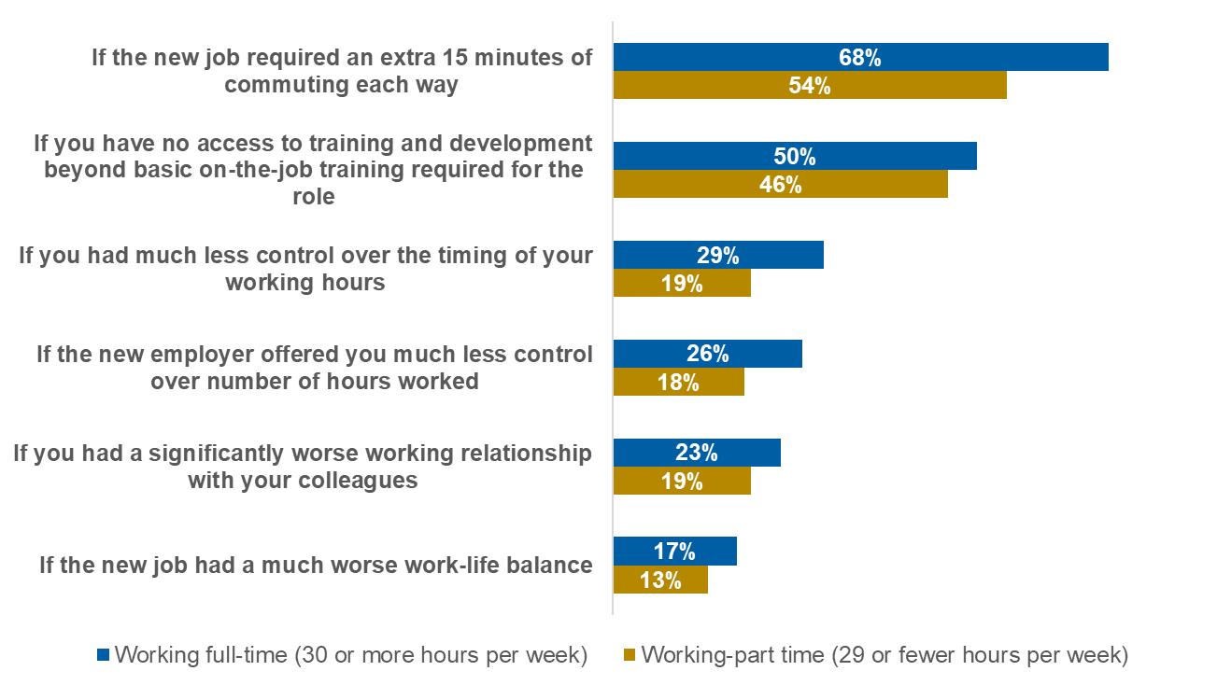
Base: Minimum wage and near-minimum workers who are paid hourly working part-time (n=253); Minimum wage and near-minimum workers who are paid hourly working full-time (n=367)
For the following question, please imagine you have been offered a new role by another employer paying £2/£3 more an hour than you currently earn. In each of the following scenarios, would you accept the new job for an extra £2/£3 per hour or stick with your current job at its current hourly rate?

Appendix

Sample profile
- YouGov uses RIM (Random Iterative Method) weighting as its standard approach. RIM is used when there are a number of different standard weights that all need to be applied together. This weighting method calculates weights for each individual respondent from the targets and achieved sample sizes for all chosen variables.
We reviewed the achieved sample of low- and medium-paid workers against its population profile. Where differences existed, RIM weighting was used to correct for these differences to ensure representative samples were achieved.
The sample of low- and medium-paid workers earning between £12 and £18 per hour was weighted by age, gender, region, wage level and industry. The statistics used for weighting were drawn from Labour Force Survey microdata.
Table 1: Breakdown of the sample by wage level
Wage level | Unweighted count | Weighted count | Weighted percentage
£12.00-£12.29 | 288 | 295 | 13.06%
£12.30 - £14.50 | 1,070 | 1,090 | 47.92%
£14.51-£18.00 | 913 | 886 | 38.74%

Table 2: Breakdown of sample by industry
Industry | Unweighted count | Weighted count | Weighted percentage
Primary industries: A, B (Agriculture & mining) | 25 | 23 | 0.80%
Manufacturing: C | 169 | 193 | 8.50%
Utilities and construction: D, E, F | 98 | 92 | 4.06%
Retail, transport and storage: G, H | 418 | 511 | 22.48%
Hospitality: I | 126 | 156 | 6.80%
IT, finance and real estate: J, K, L | 295 | 121 | 5.34%
Professional and admin: M, N | 118 | 281 | 12.36%
Public administration and other services: O, S | 313 | 155 | 6.82%
Education: P | 323 | 259 | 11.42%
Health and social work: Q | 348 | 425 | 18.73%
Arts, entertainment and recreation: R | 38 | 55 | 2.41%

Table 3: Breakdown of sample by age
Age | Unweighted count | Weighted count | Weighted percentage
21-34 | 656 | 818 | 36.37%
35-49 | 846 | 727 | 31.49%
50 and over | 769 | 727 | 31.86%

Table 4: Breakdown of sample by gender
Gender | Unweighted count | Weighted count | Weighted percentage
Male | 872 | 999 | 43.94%
Female | 1,399 | 1,272 | 55.78%

Table 5: Breakdown of sample by region
Region | Unweighted count | Weighted count | Weighted percentage
London and South East | 445 | 500 | 21.81%
Outside London and South East | 1,826 | 1,771 | 77.91%

https://www.gov.uk/national-minimum-wage-rates

