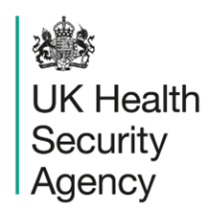

Oral fluid kit request form for confirmation of Measles, Mumps or Rubella

Clinical Services Unit, UKHSA, 61 Colindale Avenue, London NW9 5HT
Please complete and return this form with the sample.

GP surgery information
Surgery name and full address including postcode: |  |  | Health Protection Team:  Click or tap here to enter text.  CIMS identifier:  Click or tap here to enter text.
Patient information
Surname: Click or tap here to enter text.  Forename: Click or tap here to enter text.  Date of birth: Enter as dd/mm/yyyy  Age: Click or tap here to enter text.  NHS number: Enter as nnn nnn nnnn  Sex: Choose an item. |  | Patient/guardian/parent address including postcode:
Test Requested (please tick the test required) |  | Measles ☐ Mumps ☐ Rubella ☐
Patient / parent please complete sections below:
Sample information: | Date sample taken (dd/mm/yyyy): ____/____/_______
Clinical information:
Date of onset (date of rash onset if measles/rubella): Enter date as dd/mm/yyyy ____/____/_______
Is the patient pregnant Yes ☐ No ☐

If yes, the number of weeks

Vaccination history
MMR 1 Yes ☐ No ☐ Date:
MMR 2 Yes ☐ No ☐ Date:
MMRV 1 Yes ☐ No ☐ Date:
MMRV 2 Yes ☐ No ☐ Date:
Other measles/rubella containing vaccine (please specify):________________Date:________________
Kit Supplier Reference Use Only – Click or tap here to enter text. Click or tap here to enter text.

Health Protection Team
First address line
Second address line
Postcode
www.gov.uk/ukhsa

CONFIDENTIAL

00 Month 20XX

CIMS ref: Click or tap here to enter text.

Dear Parent/Guardian of XXX

Re: Test kit for Measles, Mumps or Rubella (MMR)
Your doctor thinks you/your child might have either measles, mumps or rubella.

We send a simple test to everyone who might have these infections to check if there has been an infection. The test helps us understand if these infections are spreading in the community.

We have enclosed a test kit with instructions which are easy to follow. Once you have taken the sample and packed it up, it can be put in the Royal Mail post using the pre-paid addressed box.

Please follow the enclosed instructions or watch the video via the QR code below.

It is a simple and easy test to take for both adults and children and it is completely pain free.

Please complete this test even if one has already been done by your local hospital or doctor.

It can be done even if the person is better or fully recovered.

The result will go to your health protection team and doctor within a few weeks.

Two doses of MMR vaccine or the measles, mumps, rubella, varicella (MMRV) vaccine provide long lasting protection against these infections. Contact your family doctor if you are unsure if you and your family are protected.

For more information on measles, mumps or rubella visit the NHS website:
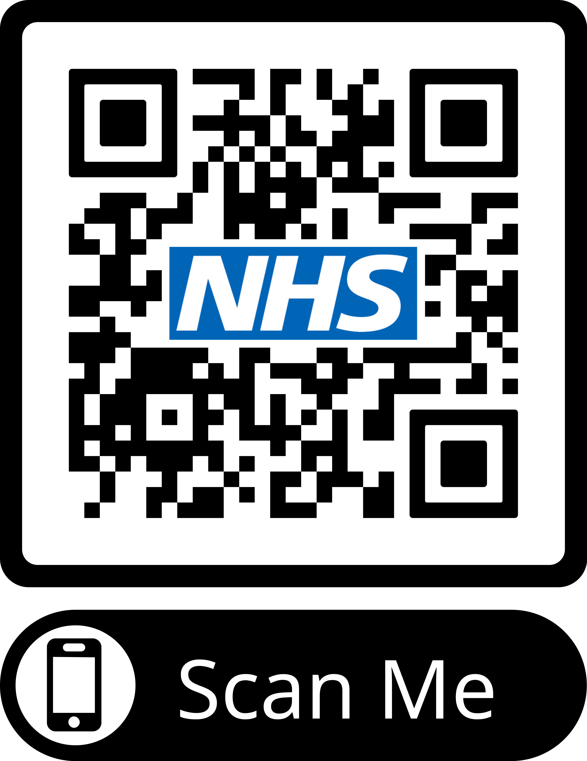
https://www.nhs.uk/conditions/

Yours sincerely,

Health Protection Team

