

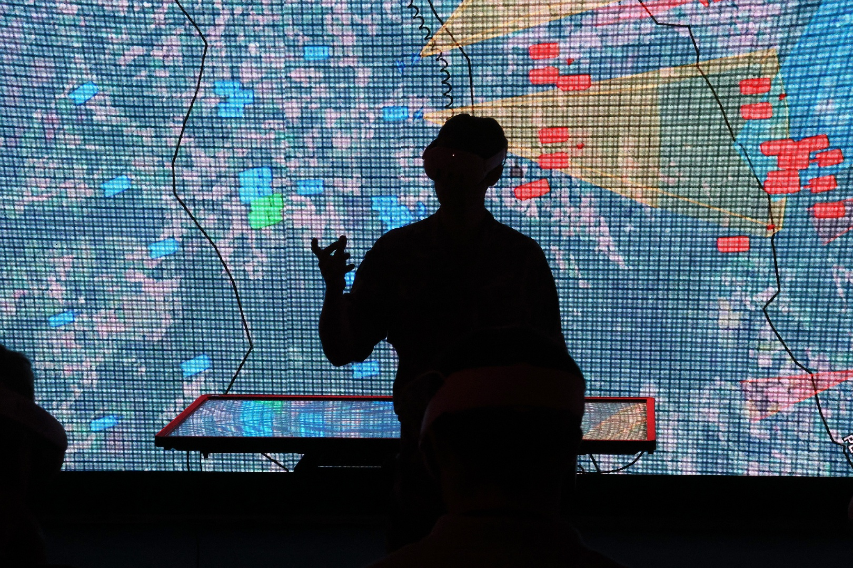
Defence Universities Alliance
Membership Application Form

Contents
Introduction 3
Organisation Details 3
Section 1: Essential Criteria 3
Section 2: Research and Development 5
Section 3: Skills, Careers and Training 7
Section 4: Promotion and Collaboration 9

Defence Universities Alliance Application Form

Introduction
This document is the main application form to be used for applying to be a founding member of the Defence Universities Alliance (DUA). It must be completed in full and returned, alongside the additional evidence template, to the DUA team at dos-ocsa-dua@mod.gov.uk, by the close of the application window at 11:59 PM on the 17th of May 2026.
Please read the DUA membership application guidance before completing and submitting your application.

Organisation Details
Please provide the below details for your institution and a nominated point of contact for correspondence for your application.
Institution Name | Enter text.
UK Provider Registered Number | Enter text.
Primary Region | Choose an item.
POC Full Name | Enter text.
POC Role | Enter text.
POC Email Address | Enter text.
POC Phone Number | Enter text.

Section 1: Essential Criteria
Question 1
Is your institution signed up to the Armed Forces Covenant?
Choose an item.

Question 2
Please use the table provided below to supply your self-assessment against NPSA’s trusted research evaluation framework (TREF).

TREF Category | DUA Baseline | Self-Assessment
Endorse: senior endorsement and governance
Senior sponsor: trusted research | Intermediate | Choose an item.
Senior sponsor: network | Intermediate | Choose an item.
Leadership culture | Foundation | Choose an item.
Institutional risk appetite | Foundation | Choose an item.
Compliance | Intermediate | Choose an item.
Encourage: communications
Internal comms strategy | Intermediate | Choose an item.
Wider trusted research links | Intermediate | Choose an item.
Institutional role modelling | Intermediate | Choose an item.
Educate: training
Training provision | Foundation | Choose an item.
Training provision | Intermediate | Choose an item.
Personnel security training | Intermediate | Choose an item.
External training | Intermediate | Choose an item.
Environment: institutional risk and collaboration
Sensitive research | Intermediate | Choose an item.
Risk review | Foundation | Choose an item.
Recording | Intermediate | Choose an item.
Recording | None set | Choose an item.
Recruitment | Foundation | Choose an item.
Policies on visitors | Foundation | Choose an item.
Employment contracts and policies | Foundation | Choose an item.
Policies on secondments out (working overseas) | Foundation | Choose an item.
Overseas travel | Foundation | Choose an item.
Enable: people processes and guidance
Staff on campus | Foundation | Choose an item.
Response | Foundation | Choose an item.
Due diligence | Intermediate | Choose an item.
Entry and exit procedures | Foundation | Choose an item.
High risk jurisdictions | Foundation | Choose an item.
Reporting concerns | Foundation | Choose an item.
Environment: data and devices
Leadership | Intermediate | Choose an item.
Risk management | Intermediate | Choose an item.
Improve | Foundation | Choose an item.
Test | Foundation | Choose an item.
Evaluate: impact measurement
Governance / endorse | Foundation | Choose an item.
Comms / encourage | Intermediate | Choose an item.
Environment | Foundation | Choose an item.
Environment | Foundation | Choose an item.

Question 3
For any areas within the TREF where your institution has self-assessed as not meeting the research security baseline for the DUA, please provide a clear summary for how your institution plans to reach this baseline within 6 months of becoming a member of the DUA.

Character Limit | 3250 (~500 words)
Please provide your answer in the box below.

Question 4
Please provide a declaration of intent that your institution intends to sign up-to and publish the DUA charter if successful in your membership application.

Do you agree to sign the DUA charter? |  |  | Choose an item.
Full Name | Enter text. | Role Title | Enter text.

Section 2: Research and Development
Question 5
Please list your institution’s most recent Research Excellence Framework (REF) score. | Enter text.
How many Defence relevant impact case studies did you submit? | Enter text.

Question 6
How does your institution engage with and support the delivery of Defence and National Security R&D for government?

Include details of both current and recent activities, including for international governments, directly or indirectly (e.g. state sponsored universities) and the impacts of the research your institution delivers.

Please include the total amount of overall funding received for FY 23-24 and for FY 24-25 from MOD (inc Dstl), and separately from any international governments.

Character limit | 3250 (~500 words) | Section Weighting | 35%
Please provide your answer in the box below.

Question 7
How does your institution engage with and support the delivery of Defence and National Security R&D for the defence industrial sector?

Include details of both current and recent activities and the impacts of the research your institution delivers.

Please also include the total amount of overall commercial (Primes and SMEs) funding received for FY 23-24 and for FY 24-25 for Defence and National Security relevant R&D.

Character limit | 3250 (~500 words) | Section Weighting | 35%
Please provide your answer in the box below.

Additional Evidence for Question 6 and 7
Please use the respective R&D tabs within the additional evidence template to provide a more detailed breakdown of the R&D activity you have provided or supported on for Defence, the defence sector, and international governments up to the last 3 years, including any current or ongoing activity. Further guidance is available in the application guidance and within the template itself.

Question 8
Please summarise any specialist or sovereign capabilities, facilities, or infrastructure which your institution provides or stewards for Defence and National Security or the defence sector.

Character limit | 3250 (~500 words) | Section weighting | 10%
Please provide your answer in the box below.

Question 9
Please summarise the extent to which your institution engages with and supports the defence and national security R&D, and innovation, network and ecosystem. Please include details of any R&D or innovation centres, hubs, accelerators, catapults or other such structures and mechanisms of note.

Character limit | 3250 (~500 words) | Section weighting | 10%
Please provide your answer in the box below.

Question 10
Please outline how your institution will improve and increase its support to, and capacity for defence and national security relevant research?

Character limit | 3250 (~500 words) | Section weighting | 10%
Please provide your answer in the box below.

Section 3: Skills, Careers and Training
Question 11
Please provide your institutions most recent Teaching Excellence Framework Scores.
Overall TEF score | Enter text.
Teaching score | Enter text.
Student outcomes score | Enter text.
Student experience score | Enter text.

Question 12
How does your institution support or provide training and continuing professional development opportunities for those employed in defence and national security relevant careers across industry, government, and the armed forces?

Character limit | 3250 (~500 words) | Section weighting | 25%
Please provide your answer in the box below.

Additional Evidence for Question 12
Please use the training tab within the additional evidence template to provide a full list of defence and national security relevant training and professional development courses, opportunities, and centres that you provide for industry and government. Further guidance is available in the application guidance and within the template itself.

Question 13
Please outline both:

How your institution develops and equips graduates, postgraduates, and other SQEP, with defence and national security relevant skills. (Please provide details of relevant courses and also the total number of Defence funded PhDs currently enrolled at your institution)

And how your institution contributes to the flow of these skilled individuals into the defence and national security careers pipeline, including your promotion of these careers as part of a balanced portfolio of careers advice. (Include careers in Defence, defence industry, the Armed Forces and the wider defence sector.)

Word limit | 5000 (~750 words) | Section weighting | 55%
Please provide your answer in the box below.

Additional Evidence for Question 13
Please use the careers tab within the additional evidence template to provide a full list and breakdown of defence and national security relevant courses that are contributing to the flow of skilled graduates, postgraduates, and other talent into defence and national security careers. (Further guidance is available in the application guidance and within the template itself.)

Question 14
How will your institution increase its support to:

The development of graduates, postgraduates and other talent with defence and national security relevant skills.

The promotion of defence and national security careers to these skilled individuals (As part of balanced career guidance)

And the flow of these skilled individuals into the defence and national security career pipeline.

Character limit | 3250 (~500 words) | Section weighting | 20%
Please provide your answer in the box below.

Section 4: Promotion and Collaboration
Question 15
How does your institution currently publicly promote Defence and National Security aims and publicise its own involvement with government and industry in pursuit of these aims?

Character limit | 1750 (~250 words) | Section weighting | 10%
Please provide your answer in the box below.

Question 16
How will your institution become more public in its promotion of Defence and National Security aims, and its own involvement with Defence and the DUA, both within the institution and externally?

Character limit | 3250 (~500 words) | Section weighting | 30%
Please provide your answer in the box below.

Question 17
What will your institution bring to the DUA if successful in becoming a member? (Include anything not already mentioned within your application)

Character limit | 3250 (~500 words) | Section weighting | 30%
Please provide your answer in the box below.

Question 18
How do the strategic aims of your institution align with Defence and National Security aims and priorities?

Character limit | 3250 (~500 words) | Section weighting | 30%
Please provide your answer in the box below.

