

Application Decision
by Dom Dobbs
Appointed by the Secretary of State for Environment, Food and Rural Affairs
Decision date: 15 April 2026

Application Ref: COM/3370080
Hillside Common and Rye Common, Odiham, Hook, Hampshire
Register Unit Number: CL 194
Commons Registration Authority: Hampshire County Council

- The application, dated 9 June 2025, is made under Section 38 of the Commons Act 2006 (the 2006 Act) for consent to carry out restricted works on common land.
- The application is made by Shell UK.
- The works comprise:
- The creation of a 5 meter wide working area across the Common for the laying of electric cable measuring approximately 350m long.
- The use of temporary fencing to create a safe working area. Up to approximately 720m of fencing is to be in place at one time.

Decision
- Consent is granted for the works in accordance with the application dated 9 June 2025 and the plans submitted with it subject to the following conditions:
- The works shall begin no later than three years from the date of this decision;
REASON: To provide certainty to users of Hillside Common and Rye Common.
- The land shall be fully reinstated within one month from the completion of the works (note that this does not apply to any physical changes or permanent features introduced as part of the works for which consent is granted);
REASON: To retain access for commoners across Hillside Common and Rye Common.
- Any temporary fencing shall be removed within one month of completion of the works.
REASON: To retain access for commoners, public and livestock over Hillside Common and Rye Common.
- For the purposes of identification only the location of the works is shown on the attached plans.

Preliminary Matters
- I have had regard to Defra’s Common Land Consents Policy Guidance (November 2015) in determining this application under section 38, which has been published for the guidance of both the Planning Inspectorate and applicants. However, every application will be considered on its merits and a determination will depart from the guidance if it appears appropriate to do so. In such cases, the decision will explain why it has departed from the guidance.

- This application has been determined solely on the basis of written evidence. I have taken account of the representations made by Natural England (NE).

- I am required by section 39 of the 2006 Act to have regard to the following in determining this application:
- the interests of persons having rights in relation to, or occupying, the land (and in particular persons exercising rights of common over it);
- the interests of the neighbourhood;
- the public interest; Section 39(2) of the 2006 Act provides that the public interest includes the public interest in; nature conservation; the conservation of the landscape; the protection of public rights of access to any area of land; and the protection of archaeological remains and features of historic interest;
- any other matter considered to be relevant.

Reasons

- The applicant explains that the works have been requested to connect the Chosley Solar Farm to the Fleet substation north of Farnham Road outlining that this route was agreed upon by National Grid, SSE, and the council, as alternate would have wider negative environmental impacts.

The interests of those occupying or having rights over the land
- Hampshire county council are the owners of the land. It follows that the council have been consulted on the application and have not made any comments in relation to this application. The common land registers records the right of estovers over the whole of the land at Hillside Common and Rye Common.

- I am satisfied that the planned works would not interfere with the interest of those occupying or having rights over the land and.

The interests of the neighbourhood and public access
- The interests of the neighbourhood relate to whether the works will unacceptably interfere with the way the Common is used by local people and is closely linked with interests of public access.

- The Common is separated into northern and southern sections by the A287 Farnham Road which the planned cable route would cross. I believe the common is an active space for open air recreational activities for the public and has high recreational and environmental value.

- The applicant explains that works include the laying of new electric cables. Once the cables are installed any excavation will be refilled and will not have a lasting impact on the Common. For the duration of the works, there will impediments to and across the Common. However, this impediment will be temporary in nature only lasting for the duration of the works.

- Overall, I do not view that the works will cause an unacceptable impediment to the public’s access of the Common.

- NE have been consulted on the application and stated that they do not view that the works will have any negative impact in regard to access.

- The fencing would temporarily impact access to the Common by blocking access to the area of the Common where the works are taking place. However, the impact will be minimal when considering the overall size of the Common, which can still be accessed

- I am satisfied that such fencing is appropriate on health and safety grounds and that it will be removed on completion of the works, which can be secured by attaching a suitable condition to the consent

- Overall, I do not believe the works as planned would create any unacceptable impediment to people’s access to and across the Common or affect the recreational value of the Common.

The public interest
- As well as having regard to the public interest in the protection of public rights of access, I must also have regard to the public interest in nature conservation, the conservation of the landscape and the protection of archaeological remains and features of historic interest.

Nature conservation and conservation of the landscape

- The proposed works within this application are either temporary in nature or will be a permanent feature not visible on the Common. Additionally, it is understood that the land will be restored once the works are completed which can be ensured by attaching the appropriate condition for the restoration of the Common.

- NE have outlined that they have no environmental concerns however would expect that any excavations or impact on the land to be reinstated with material located at the site to replicate the Common as it was before the works were carried out.

- I do not view that the works as planned will have any long-term negative impacts on the landscape and there are no conservation concerns present.

Protection of archaeological remains and features of historic interest.
- HE has been consulted on the application and have not provided comment.

- There is no evidence before me to suggest that these interests will be harmed by the proposed works.

Conclusion

- In this case I conclude that the works will not introduce an unacceptable barrier to public access to the Common and the recreational value of the Common will not be affected. Additionally, the Nature conservation, Landscape value and Historic interests of the Common will not be affected. The proposed works are mainly temporary in nature and the permeant features will not be visible or introduce a lasting impact to the values of the Common. The works will not seriously harm the other interests set out in paragraph 5 above. Consent for the works is therefore granted subject to the conditions set out at paragraph 1 above.

Dom Dobbs

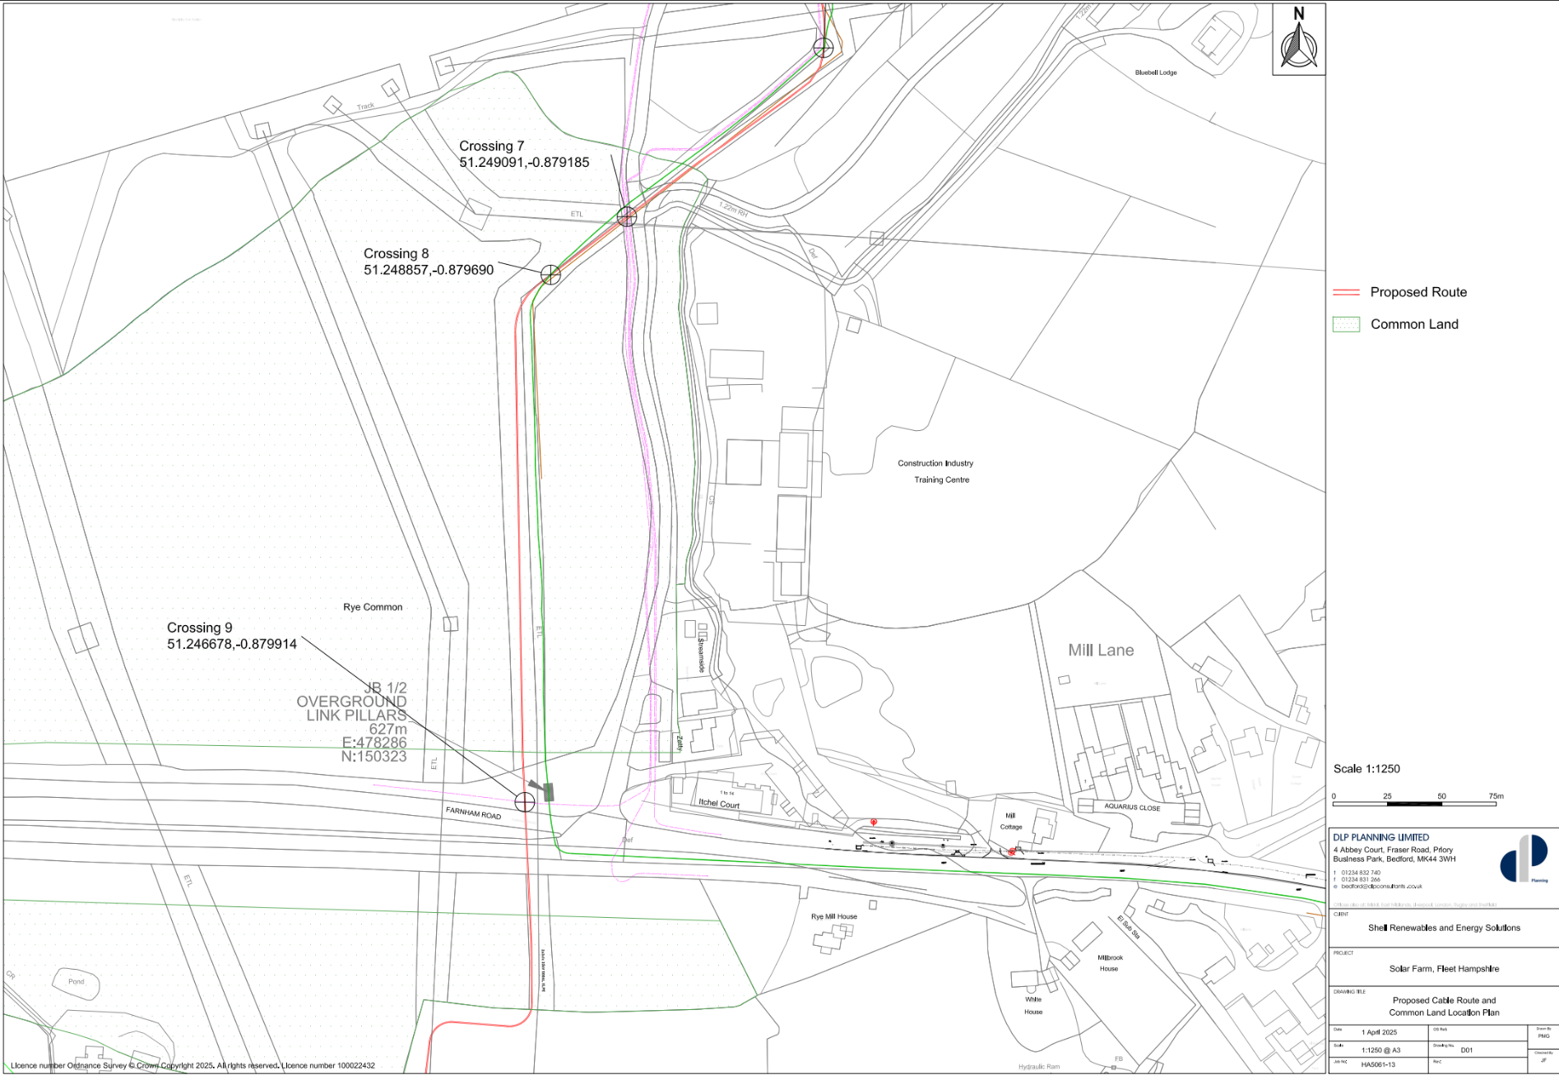
Figure 1 – location of works

