Sustainability Strategy

The Insolvency Service 2025-2030



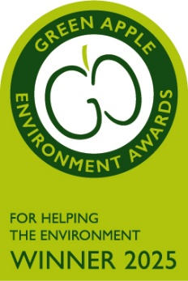

Foreword

By Duncan Beach – Chief Executive Officer

I am proud to introduce the Insolvency Service’s second sustainability strategy, which sets out our vision and commitments for the period 2025 to 2030. This strategy builds on the strong foundations laid by our first sustainability strategy (2022–2025) and reflects the progress we have made in embedding sustainability into the heart of our operations.

Over the past three years, our first sustainability strategy has delivered measurable progress across our environmental and wellbeing priorities. We now have full visibility of our carbon footprint for the first time, with baselines established across carbon, energy, waste, Information and Communication Technology and travel - enabling us to target the highest impact areas for reduction. Our digital-first approach and targeted policies have already led to a reduction in avoidable business travel and paper use, lowering our operational emissions and resource consumption. Improved data quality, recognised through a Green Apple Award in November 2025, has strengthened decision making and accelerated change. At the same time, our wellbeing and thermal comfort initiatives have supported a healthier, more resilient workforce. These outcomes mark a step change in how we operate and form a strong platform for a more ambitious second strategy.

As an agency, our role extends beyond insolvency and enforcement; we are a vital contributor to the UK’s economic resilience and social wellbeing. By supporting individuals and businesses in financial distress, tackling financial wrongdoing, and maximising returns to creditors, we help maintain confidence in the economy and protect the most vulnerable in society. These actions reflect our commitment to the principles of sustainable development and align with the United Nations Sustainable Development Goals, particularly Goal 1 (No Poverty), Goal 8 (Decent Work and Economic Growth), and Goal 12 (Responsible Consumption and Production). Through this strategy, we aim to embed these values into every aspect of our operations, ensuring that our environmental ambitions complement our social and economic responsibilities.

This new strategy builds on this foundation to deliver measurable reductions in our environmental impact. Aligned with the UN Sustainable Development Goals, the Greening Government Commitments, the UK’s net zero pathway and International Standards for Environmental Management (ISO 14001) and Occupational Health and Safety (ISO 45001), it sets clear objectives to cut emissions, minimise resource use, embed circular procurement, and promote sustainable travel. It will also expand our contribution to nature recovery and further strengthen our workforce through improved wellbeing, climate resilience and carbon literacy. Together, these outcomes will enhance the social value we create and drive year on year improvements across the agency.

Sustainability is not the responsibility of one team or department; it is a shared commitment. Every colleague, partner, and supplier has a role to play in helping us achieve our goals. Through collaboration, innovation, and a shared sense of purpose, we can create a more resilient, inclusive, and environmentally responsible agency.

This strategy is not just about compliance; it is about leadership. It is about demonstrating that we can deliver public services in a way that protects the planet, supports our communities, and builds a better future for generations to come.

I would like to thank everyone who has contributed to the development of this strategy, especially our Environmental Champions and our dedicated Sustainability Team. Your passion and commitment are helping to shape a more sustainable Insolvency Service.

Let’s continue this journey together…

Contents
1.0 Introduction 5
1.1 About us 5
1.2 Our Vision for a Sustainable Future 5
2.0 Our Approach 6
2.1 The Sustainable Development Goals 7
2.2 National Policy Obligations 9
2.3 Our Environmental Policy 9
2.4 Combined Management System 10
3.0 Leadership and Governance 11
4.0 Scope 12
4.1 Our Estate 12
4.2 Our Employees 13
4.3 Our customers 14
5.0 Key Themes 15
5.1 Carbon and Energy Management 16
5.2 Waste and Resource Management 17
5.3 Sustainable Procurement 18
5.4 Sustainable Travel 19
5.5 Biodiversity and Nature Recovery 20
5.6 A Sustainable Workforce 21
6.0 Monitoring and Reporting 22
6.1 Greening Government Commitments (2025-2030 Framework) 22
6.2 Management Review 23
7.0 Appendices 25
7.1 Appendix A: Overview of Policy Development 25
7.2 Appendix B: Objectives and Targets 26
7.3 Appendix C: Useful links and resources 41
7.4 Appendix D: Glossary of Terms 42

Introduction

About us
The Insolvency Service leads a world-class insolvency and enforcement system. This supports the government’s number one mission: to kickstart economic growth by safeguarding the foundations a stable economy needs. We do this by supporting people in financial distress, tackling financial wrongdoing and maximising returns of money owed to creditors.

The Insolvency Service helps deal with problems arising from personal and business debt that affect people's lives and the wider economy. We serve as both safety net and gatekeeper, helping individuals and viable businesses recover from financial difficulties while preventing exploitation of the system.

We maintain economic confidence through three interconnected roles: supporting individuals in financial distress, tackling financial wrongdoing, and maximising returns to creditors. We help people facing insurmountable debt find orderly solutions and fresh starts, with services like Debt Relief Orders and Breathing Space schemes, while ensuring employees receive redundancy payments swiftly when businesses fail. We uphold market integrity by investigating misconduct, disqualifying unfit directors, and expanding our remit under new legislation to combat broader economic crime. Simultaneously, we recover and redistribute funds to creditors, securing value from insolvency proceedings and holding directors financially accountable, thereby reinforcing trust in the financial system.

This strategy will play an important role in the delivery of our new Investigation and Enforcement Strategy and the forthcoming agency strategy which will be launched in 2026. Supporting a sustainable workforce enabling the agency to recruit, retain and invest in a motivated, skilled, professional and adaptable workforce. Assisting with the provision of the tools our workforce needs to be successful. Operating a sustainable procurement plan that delivers value for money, realises social benefits along our supply chains, whilst minimising environmental impact and identifying opportunities for green growth.

Our Vision for a Sustainable Future
This is the agency’s second sustainability strategy and this document seeks to build on our previous strategy (2022-2025) with effect from December 2025.

Key achievements from our first sustainability strategy include the establishment of a strong governance structure to oversee sustainability objectives and targets, led by the Environmental Strategy Group (ESG) and the Sustainable Procurement Working Group (SPWG). These groups have played a central role in embedding sustainability across the agency’s operations.

The agency has demonstrated its commitment to sustainability since the introduction of our first sustainability strategy by creating a new sustainability team comprising of the Head of Sustainability, and Health and Safety; a Sustainability Manager; a Sustainable Resources Lead; and a Sustainable Supply Chain Lead.

We have developed and implemented new sustainability related policies and procedures including a sustainable travel plan and business travel procedure, a sustainable procurement strategy, and a new thermal comfort procedure to help mitigate the impacts of climate change on staff wellbeing and comfort when working from one of our regional centres.

Additional successes include the launch of a dedicated Paper Reduction Working Group (PRWG), aimed at addressing paper and printing (identified as our largest source of carbon emissions). We have also introduced an environmental champions’ network to drive behavioural change and support employee-led sustainability initiatives. Furthermore, we have implemented a Combined Management System (CMS) aligned with ISO 45001 and ISO 14001, enhancing our performance in both environmental management and occupational health and safety.

Our Approach
Sustainable development is a key priority for the agency. We are dedicated to fulfilling the commitments outlined at international, national, and organisational levels (see also appendix A for further details). We understand that sustainability is a shared responsibility, and we recognise the importance of equipping our employees with the knowledge and skills needed to embed sustainability into our decisions and daily operations. development is a priority for us as an agency.

We remain committed to our vision for a sustainable agency shaped around the themes of carbon and energy management, waste and resource use, sustainable procurement, biodiversity and nature recovery, sustainable travel and a sustainable workforce (see figure 1 below).






A carbon aware workforce that embeds the principles of sustainability into all of our activities
An agency that is resilient and adapted to a changing climate
An agency that uses resources wisely and applies circular economy principles
An agency that collaborates across its supply chain to deliver social, economic and environmental benefits
An agency that recognises and promotes the importance of nature and its links to improved employee wellbeing
A digital first agency providing equitable access to our services for all our customers. An employer that promotes hybrid working and supports employees to choose sustainable transport options

Figure 1: Insolvency Service Sustainability Vision

The Sustainable Development Goals
In 2015, United Nation member states agreed a shared agenda for Sustainable Development. Central to this was the determination of 17 shared goals, the Sustainable Development Goals or SDGs. These 17 SDGs are an urgent call to all nations to recognise that ending poverty, reducing inequalities, improving health, and tackling the climate crisis must be factored into all decision-making if we are to achieve a safe and just society.

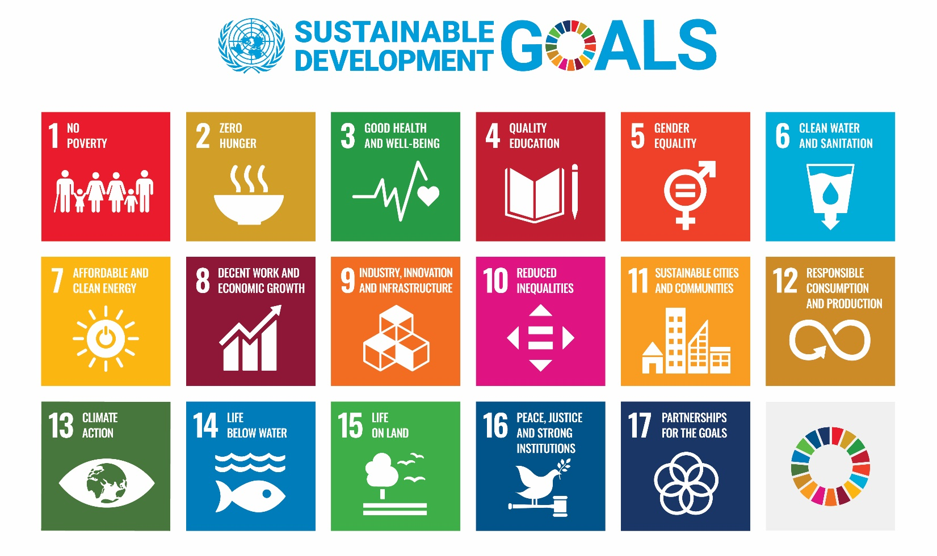
Figure 2: The Sustainable Development Goals (SDGs)
As a government agency, we have a responsibility to contribute to the delivery of the Sustainable Development Goals (SDGs). These goals have been embedded into the development of this strategy and our previous sustainability strategy, reflecting our ongoing commitment to supporting their achievement. For each of our thematic areas, we have identified the relevant SDGs and outlined how we can drive positive change through our core business activities, the management of our estate, and our supply chain practices.

Our sustainability strategy reflects not only our environmental ambitions but also the broader role we play in supporting the UK’s economic resilience and social wellbeing. As an agency, we go beyond insolvency and enforcement—helping individuals and businesses in financial distress, tackling financial wrongdoing, and maximising returns to creditors. These actions underpin confidence in the economy and protect the most vulnerable in society, demonstrating that sustainability is about people as much as the planet. This approach aligns with the United Nations Sustainable Development Goals, particularly goal 1 (no poverty), goal 8 (decent work and economic growth), and goal 12 (responsible consumption and production). Through this strategy, we commit to embedding these principles across all aspects of our operations, ensuring that our social and economic responsibilities complement our environmental objectives.

National Policy Obligations
We have a number of key government requirements that we have to meet including new Greening Government Commitments (GGCs) (see Section 6.1 for further details), The Climate Change Act 2008, The Waste Regulations, the Environment Act 2021, the Clean Growth Strategy 2018, The Department for Environment, Food and Rural Affairs’ (Defra) 25 Year Environment Plan, the Procurement Act 2023 and TCFD (Task Force on Climate-related Financial Disclosures) reporting.

Although originally designed for the private sector, the TCFD framework is increasingly being adopted by public sector bodies, including government agencies, to enhance transparency and accountability in addressing climate-related risks and opportunities. As a UK government agency, aligning with the Task Force on Climate-related Financial Disclosures (TCFD) framework demonstrates our commitment to transparency and climate resilience.

The TCFD is structured around four key pillars (governance, strategy, risk management and metrics and targets). Governance involves disclosing how climate-related risks and opportunities are managed at the leadership level, including the roles of senior officials and oversight bodies (see also figure 3. below). Strategy requires us to assess and communicate the actual and potential impacts of climate change on our objectives, services, and long-term planning. Risk Management focuses on how we identify, evaluate, and respond to climate-related risks within our broader risk frameworks. Finally, Metrics and Targets ensure we track and report relevant data such as emissions, energy use, and climate adaptation goals. This helps us to measure progress and drive accountability.

The Procurement Act 2023, which came into effect in February 2025, has introduced a shift in approach to public sector procurement across the UK. For government agencies, the Act mandates a move away from awarding contracts based mainly on cost (the “Most Economically Advantageous Tender”) to a broader evaluation under the “Most Advantageous Tender” (MAT) criteria. This change allows agencies to consider environmental sustainability, social value, and public benefit as core factors in procurement decisions. Government departments are now legally required to maximise public benefit, which includes delivering positive social, economic, and environmental outcomes (the widely recognised three pillars of sustainability).

Our Environmental Policy
Here at the Insolvency Service, we are committed to protecting and enhancing the environment both locally and globally. In July 2025, our Executive Leadership Team endorsed our second environmental policy to clearly set out our broad objectives in this area. In this respect we will make every effort to:

EP1. Reduce the impact of our activities on global environmental issues such as climate change, resource depletion, loss of habitat and biodiversity.
EP2. Prevent environmental pollution arising from our own operations by meeting the requirements of all relevant environmental legislation and use our powers to minimise the impact of others.
EP3. Minimise the volume of waste generated by the agency, whilst embedding the Waste Hierarchy of Reduce, Re-use and Recycle into all our waste procedures.
EP4. Preserve and enhance biodiversity on our sites where we have the opportunities and scope to do so.
EP5. Encourage the use of sustainable modes of transport or consider alternative working practices where practical e.g. proportionate hybrid working, to mitigate the environmental impact of travel.
EP6. Support environmental initiatives that improve health and wellbeing.
EP7. Encourage the reduced consumption of natural resources, water and energy.
EP8. Operate a Sustainable Procurement Plan that minimises the use of environmentally damaging products, packaging and services by considering whole life costs; encourages the reuse and use of recycled materials; and incorporates Social Value considerations within procurement activities.
EP9. Provide information and support to staff and customers to promote the skills and knowledge required for sustainable development.
EP10. Commit appropriate levels of staff and financial resources to deliver the aims of the environmental policy.
EP11. Develop strategic partnerships with local, regional and national organisations to improve the management of environmental issues.
EP12. Operate and maintain a management system in line with the requirements set out in ISO14001 (environmental management) to embed continuous improvement to enhance environmental management.
EP 13. Review the Environmental Policy every three years in line with the requirements of ISO14001 and annually assess the effectiveness of our Sustainability Strategy to reflect the current objectives and targets of the agency.

This sustainability strategy sets out how we intend to deliver against each of these objectives, whilst setting them into the wider sustainability agenda.

Combined Management System
The agency first demonstrated its commitment to environmental responsibility through the implementation of effective environmental management practices across its sites, as outlined in its initial sustainability strategy. Building on this foundation, the agency has advanced its approach by introducing a new integrated management system that combines environmental management with occupational health and safety. This evolution reflects a broader commitment to embedding sustainability and wellbeing into the agency’s core operations.

The combined ISO 45001 and ISO 14001 management system brings together two internationally recognised standards: ISO 45001, which focuses on occupational health and safety, and ISO 14001, which addresses environmental management. Integrating these systems enables the agency to streamline processes, reduce duplication, and adopt a more cohesive approach to managing both employee wellbeing and environmental impact.

Key benefits of this approach include improved operational efficiency, stronger regulatory compliance, enhanced risk management, and increased stakeholder confidence. It also supports the alignment of health, safety, and environmental objectives with strategic goals, fostering a culture of continuous improvement and demonstrating leadership in sustainable and responsible governance.

Another benefit of the agency adopting a management system approach is that often complex requirements that the agency needs to meet, for example the new requirements set out in the Greening Government Commitments, can be broken down into specific procedures with assigned roles and responsibilities, to improve the agency’s response and effectiveness of delivery (see also Appendix 1. which gives an overview of the Sustainability Strategy Framework).

Leadership and Governance
Our sustainability aims and objectives are set and delivered through a number of strategic groups. Our Board, Executive Leadership Team, Environmental Strategy Group, Sustainable Procurement Working Group, Paper Reduction Working Group and Environmental Champion network; are responsible for the leadership, support, oversight and implementation of this strategy. However, we recognise that every employee has a role to play, whether directly employed by us or working for one of our suppliers. Our governance structure is detailed in figure 3 below:
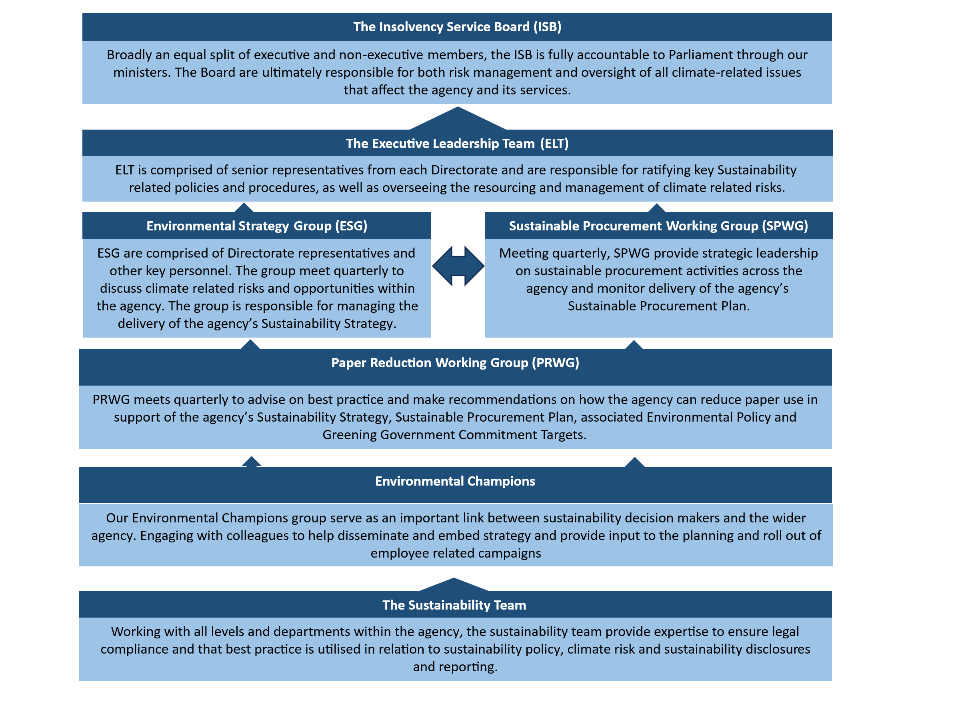
Figure 3: Insolvency Service Sustainability Governance Structure.

Scope
The scope of our sustainability strategy covers agency directorates office-related activities, hybrid working, and off-site related work which includes: customer site visits, remote interview facilities and court attendance.

Our Estate
We have 11 regional centres located in each of the main English regions, Wales and Scotland:

Region/ Country | Location​
East Midlands | Nottingham​
Eastern | Ipswich​
London | Stratford East​
North East | Newcastle​
North West​ | Manchester​
South East | Croydon​
South West | Exeter
Wales | Cardiff
West Midlands | Birmingham
Yorkshire and Humber | Leeds
Scotland | Edinburgh
Table 1: Insolvency Service Regional Centres
We also have a number of remote interview facilities that enable our official receiver and investigation staff to conduct interviews in areas where we do not have a regional centre. Our staff can find details of where our current remove interview facilities are sited via our intranet pages.

Our Employees
We currently employ approximately 2000 staff across the nine Directorates. We recognise how important a healthy, happy workforce is to deliver a sustainable agency.

Wellbeing extends beyond physical health to encompass a holistic balance across several key areas: physical, emotional, social, spiritual, intellectual, and economic. Defined as “the state of being comfortable, healthy, or happy,” wellbeing is essential for personal resilience, optimal functioning, and achieving potential. For organisations like the Insolvency Service, supporting wellbeing not only benefits individuals but also enhances service delivery and stakeholder satisfaction.

The wellbeing strategy aims to create a safe and supportive work environment, improve employee engagement, and enhance recruitment and retention. Developed in collaboration with the Civil Service, trade unions, and network groups, the strategy reflects a shared commitment to integrated wellbeing support.

Our wellbeing strategy, “Wellbeing 4 Everyone” (WE), focuses on four key priorities:

- promoting healthy lifestyles
- encouraging open dialogue on mental health
- supporting early intervention for physical health issues
- fostering a culture that supports performance and attendance

Our wellbeing strategy enhances sustainability by fostering a healthy, resilient, and engaged workforce. By supporting physical, emotional, financial, and environmental wellbeing, organisations can reduce absenteeism, improve retention, and boost productivity. This creates a positive workplace culture that encourages collaboration and innovation, while also promoting sustainable practices and early interventions that help employees stay well and perform effectively. Ultimately, it strengthens organisational resilience and long-term success.

Our customers
Putting customers at the heart of everything we do has always been our ethos at the Insolvency Service. This commitment is formally recognised through our national Customer Service Excellence (CSE) standard, which we have proudly held for 25 years.

Our customers include individuals in financial distress requiring bankruptcy or debt relief orders. We act as an impartial source of information for the public on insolvency and redundancy matters. We look into the affairs of companies in liquidation, reporting any director misconduct. We investigate trading companies and take action to wind them up or disqualify directors where there is evidence of misconduct. We also act as trustee or liquidator where no private sector insolvency practitioner is in place.

We are an agency committed to continuous improvement in how we deliver for both our customers and the wider public. We champion a first-class digital approach to improve the customer experience and deliver a consistent service. Through our optimised use of digital services, we aim to improve customer satisfaction, increase efficiencies, and maximise value for money for the public.

This customer-centric and digitally enabled approach also supports our sustainability goals. By reducing reliance on paper-based processes, minimising travel through remote services, and streamlining operations, we lower our environmental impact. Digital transformation not only enhances operational efficiency but also contributes to a more sustainable public service model.

Sustainability, in turn, enhances the customer experience. A streamlined, digital-first service is faster, more accessible, and more resilient. Customers benefit from quicker resolutions, reduced administrative burdens, and a more transparent process. By aligning our services with sustainable practices, we demonstrate our commitment to long-term value for individuals, communities, and the environment.

Key Themes

Figure 4: Sustainability strategy thematic areas

In our first sustainability strategy we set out the six key thematic areas upon which our objectives and targets are focused. These are carbon and energy management, waste and resource management, sustainable procurement, sustainable travel, biodiversity and nature recovery, and a sustainable workforce. These themes were identified through the original sustainability review of the agency’s activities as part of the development of the agency’s previous sustainability strategy. These themes are key to both our vision for a sustainable agency and the objectives outlined in our environmental policy (see section 2.).

For each thematic area, the agency has set out its key aim and how these relate both to our environmental policy, but also to our wider requirements set out for the agency under the Greening Government Commitments. Full details of these objectives and key performance indicators (KPIs) can be found in appendix B.

The sustainability team is actively monitoring emerging research on the economic, social, and environmental impacts of artificial intelligence (AI). As this field evolves, we recognise the importance of understanding both the opportunities and risks associated with AI use. While AI potentially presents significant benefits such as efficiency gains, enhanced decision-making, and potentially even contributions to climate solutions, these must be carefully weighed against any negative impacts. These include resource and energy use and ethical considerations. This is a rapidly developing area, and we anticipate setting further objectives and targets in due course to ensure our approach remains responsible, inclusive, and aligned with our broader sustainability goals.

Carbon and Energy Management

 | 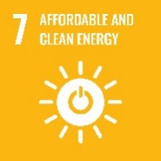 | 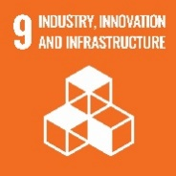 | 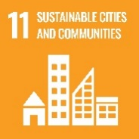 | 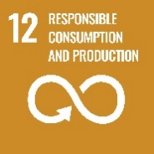 | 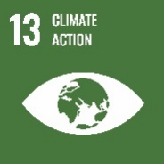 | 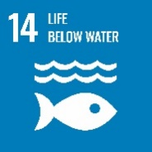
 | 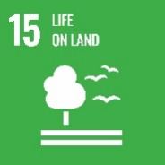
Figure 5: SDGs relating to Carbon and Energy Management
"By improving how we monitor our carbon and energy use, we've made real progress in managing both more effectively. Having better visibility has helped us focus on the areas that matter most, and it's made our strategy more targeted and impactful. It’s been a big step forward in making our work more sustainable and transparent." Insolvency Service Sustainability Manager

Our Aim: An agency that is resilient and adapted to a changing climate

Climate change represents one of the most pressing global challenges of our time. According to the Intergovernmental Panel on Climate Change (IPCC, 2022), human activities are the primary driver of climate change, leading to increasingly frequent and severe weather events such as heatwaves, heavy rainfall, and droughts. A significant contributor to global greenhouse gas (GHG) emissions—estimated at around 20%, is the use of fossil fuel-based heating and electricity in commercial and residential buildings. These emissions not only accelerate climate change but also contribute to poor air quality and associated health risks.

The UK Government has taken a leading role in addressing this challenge, becoming the first nation to legislate a legally binding commitment to reduce GHG emissions under the Climate Change Act (2008). This Act sets a target to achieve net zero emissions by 2050, based on 1990 levels. For government agencies, this includes a statutory obligation to reduce Scope 1 and Scope 2 emissions, which arise from direct energy use and purchased electricity in office buildings. In addition, the Clean Air Act (2019) identifies air pollution, largely driven by fossil fuel combustion, as the most significant environmental risk to public health in the UK. Transitioning away from fossil fuels not only supports national climate and clean air objectives but also fosters innovation, green growth, and improved public wellbeing.

As an agency, our commitment to carbon and energy management is central to this sustainability strategy. By improving energy efficiency and reducing reliance on fossil fuels, we contribute to key government initiatives including the Clean Growth Strategy (2018) and Defra’s 25 Year Environment Plan. These efforts also support our goal of becoming a more economically sustainable organisation, delivering greater social value through responsible public spending and enhanced environmental performance.

Waste and Resource Management

 | 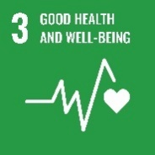 | 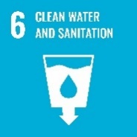 |  | 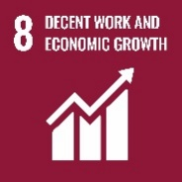
Figure 6: SDGs relating to Waste and Resource Management
“The agency’s sustainability strategy has set a clear vision for environmental responsibility and directly led to the creation of my role as Sustainable Operations Lead. It reflects a strong commitment to embedding sustainable practices across all operations, with measurable objectives that drive long-term cultural change. Through collaboration with the Environmental Champions Network, we’re promoting good practice and demonstrating that effective waste and resource management is a core organisational value, not just a legal obligation.” Insolvency Service Sustainable Operations Lead

Our Aim: An agency that uses resources wisely and applies circular economy principles

In alignment with national priorities, including the forthcoming Industrial Strategy: Invest2035, the agency recognises the opportunity to support green growth and innovation by embedding the principles of a circular economy into our waste and resource management practices. This approach is central to building a more sustainable and resilient future, where economic development is decoupled from resource depletion and environmental degradation.

Transitioning to a circular economy offers long-term benefits by focusing on three core principles: eliminating waste and pollution, circulating products and materials, and regenerating natural systems. Our strategy is guided by the Waste Hierarchy, prioritising waste prevention through initiatives such as behaviour change campaigns to reduce paper usage and improve water efficiency. We aim to extend the life of materials through reuse, redistribution, and repair, and adopt a zero-to-landfill approach by ensuring that non-reusable items are repurposed as components or raw materials. This reduces the need for virgin resource extraction and supports a regenerative economy. In doing so, we also contribute to nature recovery, and we are actively exploring nature-based solutions to enhance our climate resilience. Further details on these initiatives will be outlined in our upcoming Biodiversity and Nature Recovery Plan (see Section 5.5).

Sustainable Procurement

 | 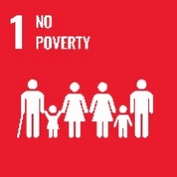 | 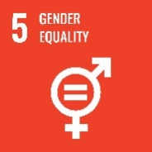 |  |  |  | 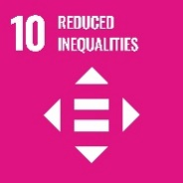
 |  |  |  |  |  | 
Figure 7: Sustainable Development Goals relating to Sustainable Procurement
"As I near my one-year mark as Sustainable Supply Chain Lead, I’ve been reflecting on the journey so far, and it’s encouraging to see how far we’ve come. By embedding our sustainable procurement strategy, we’ve started to build a supply network that’s not only more responsible and transparent, but also more resilient. Looking ahead, we’re focused on strengthening relationships with our suppliers, using data more effectively to guide decisions, and continuously improving our practices. This will help us to ensure that our supply chain becomes a real driver of long-term environmental and wider social value gains." Insolvency Service Sustainable Supply Chain Lead

Our Aim: An agency that collaborates across its supply chain to deliver social, economic and environmental benefits

Procurement plays a critical role in delivering the agency’s strategic objectives, with nearly a third of our annual expenditure directed toward goods and services. In line with the Public Services (Social Value) Act 2012, we are committed to embedding social, economic, and environmental value into our procurement processes. This means actively seeking opportunities to generate social value through our contracts whether by supporting local communities, promoting inclusive employment, or contributing to the government’s rural proofing agenda.

We expect our suppliers to uphold high standards of transparency and compliance, including adherence to health and safety legislation and the Modern Slavery Act 2015. In addition, we recognise the environmental impact of our supply chain, both locally and globally. Our environmental policy (see Section 2) outlines our commitment to reducing these impacts, and we require suppliers to demonstrate how they will support these objectives when delivering services on our behalf. This includes compliance with relevant legislation such as the waste regulations and the Finance Act 2021, as well as alignment with broader frameworks including the Sustainable Development Goals (SDGs) and the Procurement Act 2023.

We also encourage suppliers to adopt best practices and innovative approaches, including the application of circular economy principles to reduce waste and promote resource efficiency. While value for money remains a core consideration, it is assessed through a balanced evaluation of the ‘most advantageous tender’, incorporating social, environmental and economic impacts and opportunities. We also expect our suppliers to contribute to building sustainable businesses and supporting the transition to a green economy.

Sustainable Travel

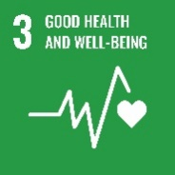
Figure 8: SDGs related to Sustainable Travel

Our Aim: A digital first agency providing equitable access to our services for all of our customers. An employer that promotes hybrid working and supports employees to choose sustainable transport options

Transport remains the largest source of air and noise pollution in the UK and is a significant contributor to the nation’s greenhouse gas emissions. According to Public Health England, increasing the number of journeys made by walking or cycling not only reduces local air pollution and carbon emissions but also delivers substantial benefits to physical and mental wellbeing. As a government agency, we recognise the importance of promoting sustainable travel as part of our commitment to environmental stewardship and public health.

Our own business travel and commuting activities represent a considerable portion of our carbon footprint. Our hybrid working policy enables proportionate home working, thereby reducing the need for daily commuting. In addition, our sustainable travel plan and business travel procedure provide guidance and support for employees to make more environmentally responsible travel choices. These include prioritising active travel, using public transport, and exploring lower emission alternatives where possible.

By embedding sustainable travel principles into our operations, we aim to reduce emissions, improve air quality, and support the government’s wider objectives on net zero, clean air, and green growth. Our approach also contributes to creating a healthier, more resilient workforce and aligns with our broader sustainability goals.

Biodiversity and Nature Recovery

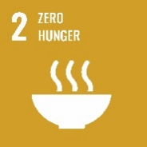
Figure 9: SDGs relating to Biodiversity and Nature Recovery

Our Aim: An agency that recognises and promotes the importance of nature and its links to improved employee wellbeing

Biodiversity is in crisis. According to the Living Planet Index (2020), global wildlife populations have declined by an average of 68% since 1970, largely due to human activities such as habitat destruction, pollution, and climate change. The UK is among the most nature-depleted countries in the world, with 41% of native species in decline and 1 in 10 at risk of extinction. This loss of biodiversity not only threatens ecosystems but also undermines the essential services nature provides such as clean air, water, food, and climate regulation.

In response, the UK Government’s 25 Year Environment Plan sets out a long-term vision to protect and enhance the natural environment. This includes restoring habitats, improving the management of green spaces, and creating new opportunities for wildlife to thrive. Nature based solutions such as rewilding, tree planting, and wetland restoration can also play a vital role in carbon sequestration, helping to mitigate climate change while supporting the growth of the green economy and creating new jobs in conservation and land management.

There is also growing recognition of the link between nature and human wellbeing. Research from organisations such as MIND highlights that access to green spaces can significantly improve mental health, reduce stress, and boost self-esteem. As a government agency, we are committed to supporting both environmental and social outcomes through our approach to biodiversity and nature recovery.

To this end, we will develop a comprehensive Biodiversity and Nature Recovery Plan. We will seek to build strategic partnerships with other agencies, local authorities, and environmental organisations to deliver nature recovery at a broader scale. Our efforts will align with national commitments under the 25 Year Environment Plan, the Environment Act 2021, and the UK’s support for the UN Global Biodiversity Framework, which aims to halt and reverse biodiversity loss by 2030.

A Sustainable Workforce

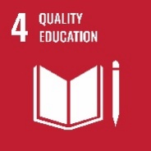
Figure 10: Sustainable Development Goals relating to a Sustainable Workforce
“Being part of the Environmental Champions Network allows us to take a lead in saving public money through efficiency, draw on the volunteers that we have to identify sustainability opportunities and to champion the principles of ‘reduce, reuse and recycle’. We can contribute to the responsible running of our agency – delivering for the people we serve.” An Insolvency Service Environmental Champion

Our Aim: A carbon literate workforce that embeds the principles of sustainability into all of our activities

A truly sustainable organisation recognises that its people are central to delivering long-term environmental, social, and economic value. As an agency committed to supporting people in financial distress, we understand that embedding sustainability into our workforce is essential to achieving our broader mission. This means ensuring that sustainability is not only reflected in our policies and operations, but also in the knowledge, behaviours, and wellbeing of our employees.

We are committed to integrating sustainability into our decision-making processes by conducting sustainability appraisals of key policies, plans, and programmes. Our vision is for all employees to be aware of our sustainability objectives and empowered to take meaningful action in their roles. To support this, we are investing in carbon literacy training and providing access to learning resources, tools, and managerial support. This will enable staff to understand the environmental impact of their work and make informed, responsible choices in their day-to-day activities.

Our environmental champions network plays a vital role in driving engagement through targeted campaigns and behaviour change initiatives. These efforts help to embed a culture of sustainability across the organisation, encouraging staff to take ownership of our environmental goals and contribute to continuous improvement.

Beyond the workplace, we also recognise the opportunity to support our employees in making sustainable lifestyle choices that benefit their health, wellbeing, and finances. By becoming more carbon aware, staff can make informed decisions about how they heat and power their homes, what they eat, and how they travel, reducing their personal carbon footprints while potentially lowering household costs and improving quality of life.

The agency will also continue to support volunteering activities by our employees. Employees are allowed up to 5 days paid special leave to take part in volunteering activities during working hours within any 12-month period. By promoting volunteering, we aim to harness the power of our employees' skills and dedication to make a positive impact on our communities, while simultaneously fostering personal and professional growth. By actively participating in volunteering activities, we can strengthen the agency's commitment to social responsibility and create a more engaged and fulfilled workforce.

Through these efforts, we aim to build a resilient, informed, and motivated workforce that is equipped to lead and support the transition to a more sustainable future, both within the agency and in the communities we serve.

Monitoring and Reporting

Greening Government Commitments (2025-2030 Framework)
The Greening Government Commitments (GGCs) are the UK government’s framework for improving the environmental performance of its operations. It applies to UK government departments, executive agencies (EAs), non-departmental public bodies (NDPBs), and non-ministerial departments (NMDs).
Managed by Defra, in collaboration with departments including the Cabinet Office, DBT, DESNZ, and HM Treasury. The GGCs aim to reduce carbon emissions, improve resource efficiency, and support nature recovery across the government estate.

Bodies must collect and submit their data to their parent department who is responsible for consolidating returns and submitting them to Defra. As an agency, we submit our return to the Department for Business and Trade (DBT).
The commitments cover a wide range of sustainability areas with particular requirements for reporting. This is summarised in figure 11. below:

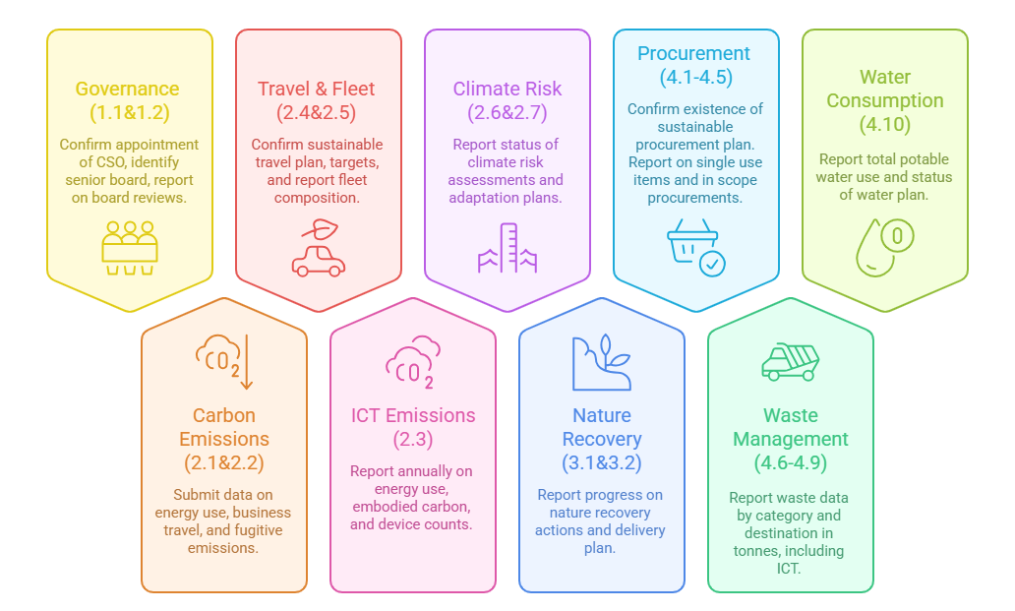
Figure 11: GGC Commitments 2025 to 2030
Although government bodies report via departments, they must ensure their data is ready in time for departmental submission. Below are the deadlines for the agency to report to DBT.

Quarter | Period | Deadline to Department
Q1 | 1 April – 30 June | By 15 September
Q2 | 1 July – 30 September | By 15 December
Q3 | 1 October – 31 December | By 15 March
Q4 | 1 January – 31 March | By 30 June
Table 2: GGC reporting framework.
Annual GGC and TCFD targets and objectives will also be reported on in the agency’s Annual Report and Accounts Sustainability chapter.

Management Review
The performance of the objectives and targets from this strategy are reported under the combined management system’s management review process. This includes quarterly reports and updates to the Environmental Strategy Group and Sustainable Procurement Working Group, and annual updates to the Executive Leadership Team (ELT) and Insolvency Service Board (ISB).

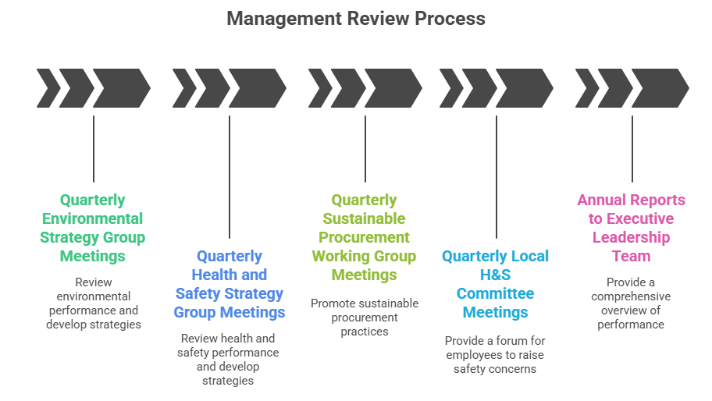
Figure 12: Insolvency Service Combined Management System management review process

Appendices

Appendix A: Overview of Policy Development
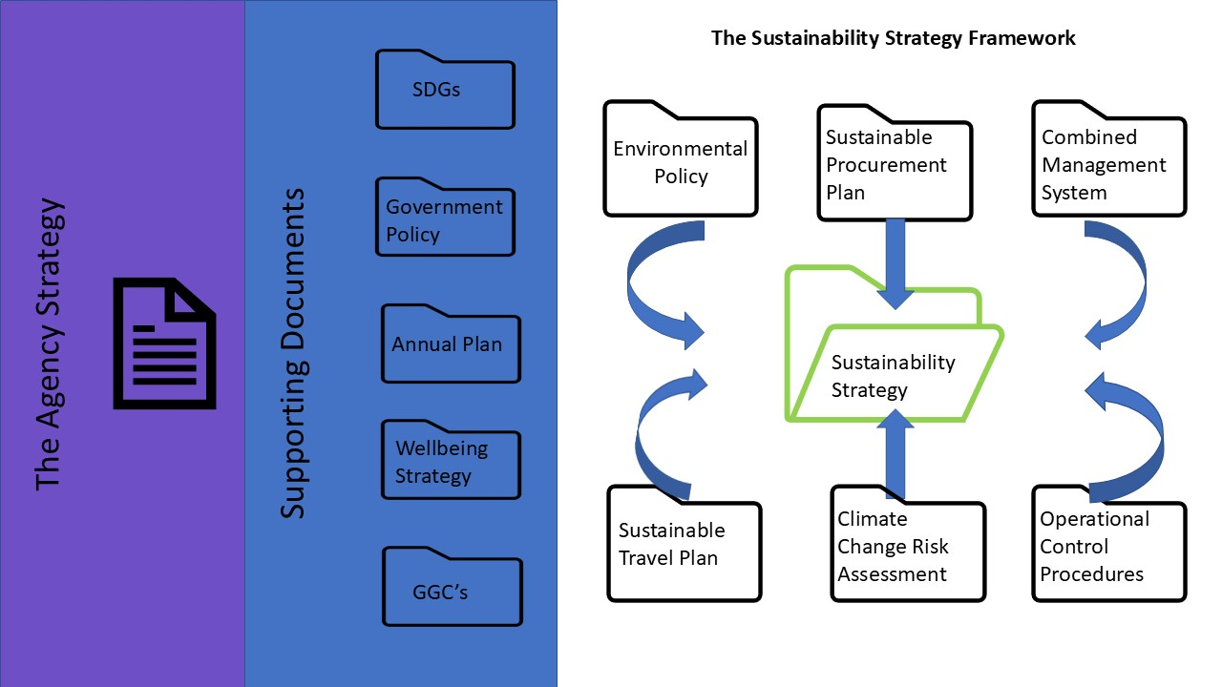

Appendix B: Objectives and Targets
Our Aim
An agency that is resilient and adapted to a changing climate.
GGC 2025/26 Requirements | Our Objectives | Key Performance Indicators
Commitments 2.1 and 2.2 (direct and overall)  These commitments are split into direct (scope 1) and overall (scope 1, 2 and business travel) and ICT targets.  The direct reduction target includes:  - emissions from the combustion of fuel, for example in boilers, generators, heaters and furnaces (scope 1 in the GHG Protocol).  - fugitive emissions arising from emissions leaks, for example from refrigeration and air conditioning units (scope 1 in the GHG Protocol).  The overall reduction target includes:  - emissions from the combustion of fuel, for example in boilers, generators, heaters and furnaces (scope 1 in the GHG Protocol).  - fugitive emissions arising from emissions leaks, for example from refrigeration and air conditioning units (scope 1 in the GHG Protocol).  - emissions from energy used, either self-generated or from sources supplied by another purchase, including for electricity, heat, steam, and cooling (scope 2 in the GHG Protocol).  Commitments 2.6 and 2.7 (climate change risks and planning)  Requirements include:  - an up-to-date Climate Change Risk Assessment (comply or explain).  - a Climate Change Adaptation Plan (comply or explain).  - consideration of external publication of Climate Change Adaptation Plan.  - consideration of flooding and overheating risks. | Environmental Policy Commitments:  EP1 Reduce the impact of our activities on global environmental issues such as climate change, resource depletion, loss of habitat and biodiversity.  EP2 Prevent environmental pollution arising from our own operations by meeting the requirements of all relevant environmental legislation and use our powers to minimise the impact of others.  EP12 [new] Operate and maintain a management system in line with the requirements set out in ISO14001 [environmental management].  Other Commitments and Targets  - Direct reductions (Scope 1):  - 100% of direct energy emissions to be reported quarterly.  - year one (2025/6) - Establish a baseline of direct energy emissions (tonnes CO2e).  - years two to five – Establish employee behavioural change activities to contribute to DBT direct energy reduction targets.  Fugitive Emissions (Scope 1):  - 100% of F-gas and ODS equipment to be serviced (including leak tests) in line with legal requirements (GPA).  - years two to five – Establish compliance due diligence schedule to support DBT fugitive emission reduction targets  - year one (2025/6) - Establish a baseline of fugitive emissions intensity  - emissions (kgCO_{2e}) from F-gas and ODS equipment to be reported quarterly  Purchased Energy (Scope 2):  - 100% of purchased energy emissions to be reported quarterly  - year one (2025/6) - Establish a baseline of purchased energy emissions (tonnes CO_{2e})  - years two to five – Establish employee behavioural change activities to contribute to DBT purchased energy reduction targets  Climate Change Risk Assessment and Adaptation:  - years 1-5 - The agency will maintain a climate change risk register in its CMS  - year 1 - Implementation of TCFD Phase 3: application of new GGC 2025-2030 emissions methodology for metrics and targets  - year 1 - Delivery of Climate Change Risk Workshops in all business areas to identify further physical and transitional risks  - year 2 - Development of an agency Climate Change Adaptation Plan  - years 3-5 – Implementation of agency Climate Change Adaptation Plan | - % CMS non-conformances closed out within agreed timescales  Direct reductions:  - % completion rate for quarterly direct energy data returns (GPA)  - % reporting rate for quarterly direct energy data returns (GGC quarterly returns)  - % delivery rate of internal behavioural change projects within agreed timescales (Environmental Champions)  Fugitive emissions:  - % of due diligence checks completed in line with internal CMS audit schedule  - % reporting rate for quarterly fugitive emissions data returns (GGC quarterly returns)  Purchased energy:  - % completion rate for quarterly purchased energy data returns (GPA)  - % reporting rate for quarterly purchased energy data returns (GGC quarterly returns)  - % delivery rate of internal behavioural change projects within agreed timescales (Environmental Champions)  Climate Change Risk Assessment and Adaptation:  Physical Risk Metrics  - number of Regional Centres located in flood/ fire/ storm prone areas covered by Climate Change Adaptation Plans (years 3-5)  Transitional Risk metrics  - number of Climate Change Risk Workshops delivered and % of employees in attendance (per FTE) (year one)
Table 3: Carbon and Energy Management commitments

Our Aim
An agency that uses resources wisely and applies circular economy principles.

GGC 2025/26 Requirements | Our Objectives | Key Performance Indicators
Commitments 4.1, 4.2, 4.3 and 4.4 (procurement)  [Apply] Circular principles or requirements in specifications to reduce demand for finite resources, maximise reuse value and minimise waste:  - minimising demand for primary resources and maximising reuse of existing resources through specification design and obligations.  - stretching the lifetime of products and services through reuse, repair, and remanufacture  - focusing on eliminating waste and using robust certification standards  - designing out waste and building circular economy principles into the specification, such as through closed loop repair and recycling  - considering materials used at each value chain stage in terms of the ability to reuse, refurbish and recycle within that country source  - monitoring volume and longevity at product level and investigate hotspots  - train and build awareness of maximising product lifecycles and value  Commitment 4.5 (single-use items)  Organisations must report (annually) how they have reduced the procurement of single-use items.  Commitments 4.6, 4.7 and 4.8 (managing waste)  Organisations must report on their municipal, major mineral and other waste. For each category they must report on the destination (metric tonnes) each quarter:  - recycling  - anaerobic digestion  - composting  - incineration with energy recovery  - incineration without energy recovery  - landfill  - other  Commitment 2.3 (life-cycle ICT emissions)  Organisations must report (annually) kWh/ CO_{2e} figures for:  - on-premise servers and data centres  - off-premise servers and data centres  - private cloud data centres  - embodied carbon emissions from on- and off-premises servers and data centres  - emissions from public cloud use, as reported by the supplier and including embodied emissions  Numbers of ICT devices, by:  - end-user devices (such as desktops, laptops, tablets, smartphones, thin clients)  - peripherals (such as monitors, keyboards and mice)  - networking and telephony equipment  - audio-visual devices (such as projectors, Screens and videoconferencing units)  - imaging devices (such as printers and scanners)  Commitments 4.9 (managing used ICT)  Organisations must report on their used ICT devices by category.  For each category, organisations must report the number (units), mass (tonnes), and value returned (£) by destination (annually):  - reuse (donated within government; to charities, school or other NGOs; or sold)  - recycling  - incineration with energy recovery  - incineration without energy recovery  - landfill  Commitment 4.10 (water consumption)  Organisations must report (quarterly):  - total potable water consumption, measured in cubic metres  - if they have an up-to-date water plan and whether it meets the ‘must’, ‘should’ or ‘could’ standard  - whether they have published this plan externally  Organisations must report (annually):  - the number of sites fitted with at least one smart water meter and the total number of sites with a water supply | Environmental Policy Objectives  EP1 Reduce the impact of our activities on global environmental issues such as climate change, resource depletion, loss of habitat and biodiversity.  EP2 Prevent environmental pollution arising from our own operations by meeting the requirements of all relevant environmental legislation and use our powers to minimise the impact of others.  EP3 Minimise the volume of waste generated by the Agency, whilst embedding the Waste Hierarchy of Reduce, Re-use and Recycle into all our waste procedures.  EP4 Encourage the reduced consumption of natural resources, water and energy.  EP8 Operate a procurement policy that minimises the use of environmentally damaging products, packaging and services by considering whole life costs; encourages the reuse and use of recycled materials; and incorporates Social Value considerations within procurement activities.  EP9 Provide information and support to staff and customers to promote the skills and knowledge required for sustainable development.  EP11 Develop strategic partnerships with local, regional and national organisations to improve the management of environmental issues.  Other Objectives and commitments:  Move towards a paperless office environment:  - year one (2025/6) – Establish a baseline of paper use and associated carbon emissions (£ and CO_{2e})  - years 2-5 – set reduction targets for agency paper use  General Office waste:  - year one (2025/6) - Establish a baseline of waste produced by category and disposal method (metric tonnes).  - years two to five – Establish employee behavioural change activities to contribute to DBT waste reduction targets  Managing ICT emissions and waste:  - year one (2025/6) - Establish a baseline of ICT waste produced by category and disposal method (metric tonnes)  - years two to five – set reuse targets for organisational ICT waste  Water Consumption  - year one (2025/6) - Establish a baseline of waste produced by category and disposal method (metric tonnes) (DBT)  - years two to five – Establish employee behavioural change activities to contribute to DBT water reduction targets | - % non-conformances against the agency’s waste procedures closed out within agreed timescales.  Move towards a paperless office  - tonnage (weight), cost (£) and emissions (CO_{2e}) of purchased paper per annum  - % of purchased paper that is recycled  - reduction in paper purchased year on year from a 2025/26 baseline  General Office Waste  - % completion rate for quarterly waste data returns (GPA)  - % reporting rate for quarterly waste data returns (GGC quarterly returns)  - % delivery rate of internal behavioural change projects within agreed timescales (Environmental Champions) per annum  - total weight (tonnes) and emissions (CO_{2e}) associated with confidential waste per annum  ICT Waste and Resource Management:  - % of returned ICT items sent for reuse  - total ICT waste produced and disposal method (CO_{2e} and tonnes per FTE) per annum  - carbon emissions (tonnes CO_{2e}) per FTE associated with data or cloud storage.  Water Consumption:  - % delivery rate of internal behavioural change projects within agreed timescales (Environmental Champions) per annum.
Table 4: Waste and Resources commitments

Our Aim
An agency that collaborates across its supply chain to deliver social, economic and environmental benefits.

GGC 2025/26 Requirements | Our Objectives | Key Performance Indicators
Commitments 4.1, 4.2, 4.3 and 4.4 (procurement)  [Apply] Circular principles or requirements in specifications to reduce demand for finite resources, maximise reuse value and minimise waste:  - minimising demand for primary resources and maximising reuse of existing resources through specification design and obligations  - stretching the lifetime of products and services through reuse, repair, and remanufacture  - focusing on eliminating waste and using robust certification standards  - designing out waste and building circular economy principles into the specification, such as through closed loop repair and recycling  - considering materials used at each value chain stage in terms of the ability to reuse, refurbish and recycle within that country source  - monitoring volume and longevity at product level and investigate hotspots  - train and build awareness of maximising product lifecycles and value  Organisations must report (quarterly):  - whether they have a sustainable procurement plan and when it was last reviewed  - whether they have published this plan externally  Organisations must report (annually):  - the number and total spend of procurements valued at or above £2 million (inclusive of VAT) with at least 4 sustainable procurement characteristics, and the total number and spend of procurements valued at or above £2 million (inclusive of VAT)  - organisations’ sustainable procurement maturity questionnaire  - whether they have met the minimum Government Buying Standards when buying goods and services  - the number of new or re-procured highest- and second-tier contracts and how many have enacted appropriate and proportionate sustainability measures  Commitment 4.5 (single-use items)  Organisations must report (annually) how they have reduced the procurement of single-use items. | Environmental Policy Commitments  EP8 To operate a procurement policy that minimises the use of environmentally damaging products, packaging, and services by considering whole life costs; encourages the reuse and use of recycled materials; and incorporates Social Value considerations within procurement activities.  Other objectives and commitments  Sustainable Procurement Plan:  - year 1 – develop new Sustainable Procurement Plan including the following:  - priority sustainable procurement topics for the organisation  - a plan for tackling adverse impacts  - a summary of how GBS best practice is being met or is on track to be met  - plans to engage the supply chain including identifying climate change risks and impacts in relation to the requirement being procured, and outline plans to ensure service continuity and resilience  - plans to ensure all future highest- and second-tier contracts will be sustainable  - provision of templates or specifications which avoid or reduce GHG emissions, referencing high integrity principles and standards, using industry best practice and going beyond those required by the minimum GBS  - development of contractual targets for residual emissions to reduce GHG emissions and incentivise supplier action  - application of circular principles or requirements in specifications to reduce demand for finite resources, maximise reuse value and minimise waste  - weighted environmental sustainability questions in tender documentation (in addition to those for social value)  - apply best practice sustainability terms and conditions in contracts (separate to GHG or carbon)  - seek opportunities to integrate Sustainability Action Plans (environmental sustainability in addition to Social Value) to address key risks and opportunities in key contracts  - embed requirements for suppliers to share in the UK’s commitment to achieving net zero by 2050 in contracts  - years 2-5 – Implementation of Sustainable Procurement Plan | - % non-conformances against the agency’s Social Value Procedure closed out within agreed timescales  - number and total value (£) of awarded contracts with a value of £2 million (inc. VAT) or above per annum  - % of contracts with a value of £2 million (inc. VAT) or more with at least 4 sustainable procurement characteristics included per annum  - % of awarded contracts including Government Buying Standards (GBS) in contract requirements (per annum)  - % and No of Gold and Silver contracts meeting in-contract sustainable procurement objectives and targets (per annum)  - number and % of contracts awarded including Social Value (per annum)  - cost (£) and number of single use items purchased per annum  - year on year reduction in number of single use items purchased from a 2025/26 baseline
Table 5: Sustainable Procurement commitments

Our Aim
A digital first agency providing equitable access to our services for all of our customers. An employer that promotes hybrid working and supports employees to choose sustainable transport options

GGC 2025/26 Requirements | Our Objectives | Key Performance Indicators
Commitments 2.1 and 2.2 (direct and overall)  Overall reduction targets including:  - emissions resulting from the use of vehicles leased by the department (scope 1 in the GHG Protocol) and from business-related travel (excluding staff commutes and international flights) on public transport or employee owned or leased vehicles (scope 3 in the GHG Protocol)  Commitment 2.5 (business travel and commuting)  Organisations should set targets based on the proportion of total domestic travel for commuting and business travel by sustainable modes.  For a staff travel plan, organisations should consider the current travel behaviours of staff for commuting and business travel and outline interventions to encourage the use of sustainable alternatives.  Organisations must report (quarterly):  - whether they have a plan to improve the sustainability of their business travel and commuting  - whether they have published this plan externally  - whether they have a target on the proportion of commuting and business journeys made by sustainable means  Organisations should design a staff travel survey to develop targets and to inform an organisation’s plan for encouraging sustainable commuting:  - distance travelled by employees per day  - the number of days per week that employees use different vehicle types  - if employees use multiple modes for the journey, what proportion of the distance travelled per day they travel by each mode  - number of commuting days per week  - number of weeks worked per year  Commitments 2.1 and 2.2 (direct and overall)-  Kilometres (km) travelled data for business travel, by fuel source, vehicle type or transport method, from:  - fleet (N/A)  - non-fleet (private and hire vehicles)  - public transport | Environmental Policy Objectives  EP1 Reduce the impact of our activities on global environmental issues such as climate change, resource depletion, loss of habitat and biodiversity.  EP2 Prevent environmental pollution arising from our own operations by meeting the requirements of all relevant environmental legislation and use our powers to minimise the impact of others.  EP5 Encourage the use of sustainable modes of transport or consider alternative working practices where practical e.g. proportionate hybrid working, to mitigate the environmental impact of travel.  EP6 Support environmental initiatives that improve health and wellbeing.  EP7 Encourage the reduced consumption of natural resources, water and energy.  EP9 Provide information and support to staff and customers to promote the skills and knowledge required for sustainable development.  Other objectives and commitments  Business Travel (Scope 3):  - Year one (2025/6) – Establish a baseline of business travel by distance (km) and emissions (tonnes CO_{2e}) for:  - hire cars  - taxis  - private vehicles  - public transport  - domestic flights  - international flights  - years 1-5 continue to implement the agency’s Business Travel Procedure  - years two to five – set reduction targets for organisational business travel (km travelled) and associated emissions (tonnes CO_{2e})  - year on year reduction in non-essential travel for internal meetings  - reduce carbon emissions (tonnes CO_{2e}) per FTE associated with overall business travel year on year (vs 2025/26 baseline)  - reduce cost (£) per FTE associated with overall business travel year on year (vs 2025/26 baseline)  Commuting  - year on year increase in annual sustainable travel survey returns  - years two to five – establish employee behavioural change activities to contribute to increase in sustainable travel modes for commuting activities. | - % non-conformances against the Business Travel Procedure closed out within agreed timescales  Business Travel:  - total cost (£) of travel and emissions (tonnes CO_{2e}) associated with internal meetings  - total cost (£) of hotel and emissions (tonnes CO_{2e}) associated with internal meetings  - total cost (£) of business travel by car (private car, taxi, hire cars) (per FTE)  - total emissions (CO_{2e}) of business travel by car (private car, taxi, hire cars) for non-customer visits (per FTE)  - total emissions (CO_{2e}) and costs (£) of business travel associated with courier activities  - number of domestic flights per annum  Commuting  - % completion rate of Sustainable Travel Survey (per FTE) per annum  - % delivery rate of internal behavioural change projects within agreed timescales (Environmental Champions) per annum
Table 6: Sustainable Travel commitments

Our Aim
An agency that recognises and promotes the importance of nature and its links to improved employee wellbeing

GGC 2025/26 Requirements | Our Objectives | Key Performance Indicators
Commitments 3.1 and 3.2 (restoring nature)  Reporting requirements.  Organisations are expected to:  By 31 March 2026 Submit baseline estate data (Defra will provide guidance).  Provide Quarterly Reporting  Report progress on:  - nature recovery plans and biodiversity actions  - delivery plan implementation (from 31 March 2027)  - external publication of the delivery plan (from 31 March 2027)  - professional amenity PPP users and completion of IPM plans  Ongoing Actions:  - maintain and enhance nature in line with existing plans  - where no plan exists, consider actions such as:  - adjusting estate management for wildlife and ecosystem services  - supporting local nature recovery strategies  - managing invasive species (liaising with Defra if needed)  - promoting access to nature for staff and the public  - enabling staff volunteering for nature recovery  Target Setting (Optional but Encouraged)  Targets may include:  - creating/restoring wildlife habitats  - sustainable woodland and canopy cover management  - improving protected site conditions  - installing green infrastructure and nest boxes  - planting native species and wildflowers  - reducing peat and water use  - managing peatland and restoring hedgerows  - enhancing access to green/blue spaces  Our role  As a government organisation, we do not directly deliver these requirements as we do not own our estate. However, we are committed to supporting the cross-government nature strategy and will collaborate with relevant estate-owning bodies to ensure alignment and progress. | Environmental Policy Objectives  EP1 Reduce the impact of our activities on global environmental issues such as climate change, resource depletion, loss of habitat and biodiversity.  EP2 Prevent environmental pollution arising from our own operations by meeting the requirements of all relevant environmental legislation and use our powers to minimise the impact of others.  EP4 Preserve and enhance biodiversity on our sites where we have the opportunities and scope to do so.  EP6 Support environmental initiatives that improve health and wellbeing.  EP7 Encourage the reduced consumption of natural resources, water and energy.  EP9 Provide information and support to staff and customers to promote the skills and knowledge required for sustainable development.  Other objectives and commitments  - year one – Identification of nature-based volunteering opportunities for staff  - years two to five – promotion of nature-based volunteering activities to staff  - years two to five – Establish employee behavioural change activities to contribute to DBT Nature Recovery targets | - % delivery rate of internal behavioural change projects within agreed timescales (Environmental Champions) per annum
Table 7: Biodiversity and nature recovery commitments

Our Aim
A carbon literate workforce that embeds the principles of sustainability into all of our activities
GGC 2025/26 Requirements | Our Objectives | Key Performance Indicators
Commitments 1.1 and 1.2 (governance)  For bodies, GGC performance must be monitored at the highest level of organisational governance, and they should have a chief sustainability officer at a senior level. Bodies that are too small to appoint a chief sustainability officer must at least appoint a senior responsible owner for GGC performance.  Organisations must report (quarterly):  - whether the organisation has a chief sustainability officer or senior responsible owner for the GGCs  - what is the most senior board which monitors GGCs performance  - how this board is informed of GGC performance  - when this board last discussed the GGCs | Environmental Policy Objectives  EP1 Reduce the impact of our activities on global environmental issues such as climate change, resource depletion, loss of habitat and biodiversity.  EP2 Prevent environmental pollution arising from our own operations by meeting the requirements of all relevant environmental legislation and use our powers to minimise the impact of others.  EP6 Support environmental initiatives that improve health and wellbeing.  EP7 Encourage the reduced consumption of natural resources, water and energy.  EP9 Provide information and support to staff and customers to promote the skills and knowledge required for sustainable development.  EP10 Commit appropriate levels of staff and financial resources to deliver the aims of the environmental policy.  Other objectives and commitments  - continue to implement Environmental Champion Network ensuring that there is at least one champion in each regional centre  - continue to promote employee volunteering activities  - investigate methodologies to estimate the impact of volunteering activities on local communities | - number of employees certified carbon literate  - number of environmental champions per regional centre  - the total number of volunteering days contributed by each directorate annually  - the number of employees participating in volunteering activities  - employee feedback on the volunteering program
Table 8: Sustainable Workforce commitments

Appendix C: Useful links and resources

About us - The Insolvency Service - GOV.UK (www.gov.uk)

Department for Business, Energy & Industrial Strategy - GOV.UK (www.gov.uk)

Home - United Nations Sustainable Development

IPCC — Intergovernmental Panel on Climate Change

25-year environment plan - House of Commons Library (parliament.uk)

Biodiversity 2020: A strategy for England’s wildlife and ecosystem services - GOV.UK (www.gov.uk)

Build Back Better - our plan for growth (publishing.service.gov.uk)

Climate Change Act 2008 (legislation.gov.uk)

Home - Leaders Pledge for Nature

The Ten Point Plan for a Green Industrial Revolution (publishing.service.gov.uk)

Sustainable procurement in government: Guidance to the flexible framework - GOV.UK (www.gov.uk)

Task Force on Climate-Related Financial Disclosures | TCFD) (fsb-tcfd.org)

WRAP - The Climate Crisis: Act Now

Energy Saving Trust

Home - Sustrans.org.uk

Global Slavery Index

Corporate Standard | Greenhouse Gas Protocol (ghgprotocol.org)

Sector by sector: where do global greenhouse gas emissions come from? - Our World in Data

WWF Footprint Calculator

Biodiversity | WWF

Information & Support - Mind

Social value in procurement – Procurement Essentials - CCS (crowncommercial.gov.uk)

Appendix D: Glossary of Terms

Circular Economy – is an economic model which will see us keeping resources in use as long as possible, extracting maximum value from them, minimising waste and promoting resource efficiency.

Climate Change – is a long-term shift in temperatures and weather patterns. These shifts may be natural, such as through variations in the solar cycle. But since the 1800s, human activities have been the main driver of climate change (through the greenhouse effect), primarily due to burning fossil fuels like coal, oil and gas.

Greenhouse Gases – are any gas that has the property of absorbing infrared radiation (net heat energy) emitted from Earth’s surface and reradiating it back to Earth’s surface, thus contributing to the greenhouse effect. Carbon dioxide, methane, and water vapour are the most important greenhouse gases (and to a lesser extent, surface-level ozone, nitrous oxides, and fluorinated gases which also trap infrared radiation). Many of these gases are associated with the burning of fossil fuels.

Intergovernmental Panel on Climate Change (IPCC) - is the United Nations body for assessing the science related to climate change. The IPCC prepares comprehensive Assessment Reports about the state of scientific, technical and socio-economic knowledge on climate change, its impacts and future risks, and options for reducing the rate at which climate change is taking place.

Rewilding - Rewilding seeks to reinstate natural processes and, where appropriate, missing species – allowing them to shape the landscape and the habitats within. Rewilding encourages a balance between people and the rest of nature. It can provide opportunities for communities to diversify and create nature-based economies; for living systems to provide the ecological functions on which we all depend; and for people to reconnect with wild nature.

Sustainability – is the integration of environmental health, social equity and economic vitality in order to create thriving, healthy, diverse and resilient communities for this generation and future generations.

Sustainable Development Goals - The 2030 Agenda for Sustainable Development, adopted by all United Nations Member States in 2015, provides a shared blueprint for peace and prosperity for people and the planet, now and into the future. At its heart are the 17 Sustainable Development Goals (SDGs), which are an urgent call for action by all countries - developed and developing - in a global partnership.

