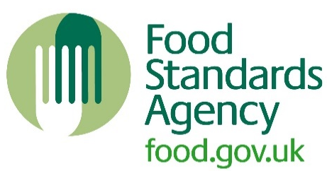Quiz 3
Overview of activity: | 10-question challenge/quiz on key topics.
Learning objective: | To get to know the pack as well as refreshing your food safety knowledge.
Target audience: | Level 2
Resources required: | SFBB packs
Estimated duration of activity: | 20 minutes.
Links to other resources: | -
Guidance notes: | The learners can work alone or in pairs. This quiz can be used to recap their SFBB knowledge and general food hygiene knowledge. It can be used in a lesson or as additional study.
Safer food better business
Quiz 3
1 | Name the temperature range that fridges should operate between.
2 | Describe three types of illness that you must report to your supervisor/head chef.
3 | Name two occasions you would need to change your cleaning cloth.
4 | What action would you take if you saw mouse droppings in the kitchen?
5 | Name three ways you would prevent cross-contamination in the kitchen.
6 | When cooking with peanuts, describe two precautions you would need to take.
7 | How can you tell when gravy is cooked safely?
8 | Name three important items that you must have at the handwashing basin.
9 | Name three foods that need extra care.
10 | What is the minimum core temperature of food kept hot for service?
Answers
1 | Fridges should be between 0°C and 5°C (8°C or below is the legally required temperature for chilled food).
2 | Sickness, diarrhoea, cuts and sores.
3 | Possible answers include: after using it on a surface used for the preparation of raw meat/poultry, after wiping up spills such as raw egg, after cleaning up dirt/soil from vegetables.
4 | Report to supervisor.
5 | Possible answers include: washing hands, washing and disinfecting work surfaces, equipment etc. after using them with raw meat/poultry/eggs, storing raw and ready-to-eat food separately.
6 | Store peanuts in a sealed container, clearly labelled. Make sure surfaces and equipment have been thoroughly cleaned and staff wash their hands, before and after preparing the food.
7 | It is simmering.
8 | Liquid soap, warm water, disposable towels.
9 | Cooked rice, eggs, shellfish, pulses (as well as raw meat/poultry).
10 | 63°C.

