NOTICE OF ORDER

Wildlife and Countryside Act 1981 – Section 53
BRISTOL CITY COUNCIL
Council of Bristol Definitive Map and Statement Modification Order No.7 2024

Notice is hereby given that the above referenced Order has been submitted to the Secretary of State for Environment, Food and Rural Affairs for determination. An Inspector will be appointed by the Secretary of State to determine the Order.

The start date for the above Order is 7 April 2026.

Consideration of the Order will take the form of a public local inquiry.

The Inquiry will be held at City Hall, College Green, Bristol, BS1 5TR on Tuesday 6 October 2026 at 10.00am.

The effect of the Order, if confirmed without modifications, will be to modify the definitive map and statement for the area by adding to them:

A footpath (No.678) in Stoke Bishop running from grid reference 356112 176316 at Parrys Lane on the field boundary of Stoke Lodge playing fields, in a generally north-westerly direction to grid reference 355929 176573, north-east of Stoke Lodge, at a junction with footpath nos.682, 683, and 684, being a total distance of approx. 317m with a minimum width of 2m

A footpath (No.679) in Stoke Bishop running from grid reference 355872 176421 at Shirehampton Road, in a generally north-westerly direction for approx. 53m to grid reference 355828 176443, then in a generally north-easterly direction for approx. 94m to grid reference 355874 176523, north-west of Stoke Lodge at a junction with footpath nos.682 and 685, being a total distance of 147m with a minimum width of 2m

A footpath (No.680) in Stoke Bishop running from grid reference 355739 176753 at the north-eastern end of Stoke Paddock Road in a generally south-easterly direction following Cheyne Road to grid reference 355792 176724, at a junction with footpath nos.683, 685 and 686 on the field boundary of Stoke Lodge playing fields on Cheyne Road, being a total distance of approx. 64m with a minimum width of approx. 2m

A footpath (No.681) in Stoke Bishop running from grid reference 356007 176607 at a junction with footpath no 87, in a generally south-westerly direction to grid reference 355993 176585 at a junction with footpath nos.684 and 686 on West Dene, being a total distance of approx. 26m with a minimum width of 2m

A footpath (No.682) in Stoke Bishop running from grid reference 355929 176573 north-east of Stoke Lodge at a junction with footpath nos.678, 683 and 684, in a generally south-westerly direction to grid reference 355874 176523, north west of Stoke Lodge at a junction with footpath nos.679 and 685, being a total distance of approx. 81m with a minimum width of 2m

A footpath (No.683) in Stoke Bishop running from grid reference 355929 176573 north-east of Stoke Lodge at a junction with footpath nos.678, 682 and 684, in a generally north-westerly direction to grid reference 355792 176724 at a junction with footpath nos.680, 685 and 686 at the field boundary of Stoke Lodge playing fields on Cheyne Road, being a total distance of approx. 204m with a minimum width of 2m

A footpath (No.684) in Stoke Bishop running from grid reference 355929 176573 north-east of Stoke Lodge at a junction with footpath nos.678, 682 and 683, in a generally east-north-easterly direction to grid reference 355993 176585 at a junction with footpath nos.681 and 686 on West Dene, being a total distance of approx. 65m with a minimum width of 2m

A footpath (No.685) in Stoke Bishop running from grid reference 355874 176523 north-west of Stoke Lodge at a junction with footpath nos.679 and 682, in a generally north-westerly direction to grid reference 355792 176724 at a junction with footpath nos.680, 683 and 686 on the field boundary of Stoke Lodge playing fields on Cheyne Road, being a total distance of approx. 217m with a minimum width of 2m

A footpath (No.686) in Stoke Bishop running from grid reference 355993 176585 at a junction with footpath nos.681 and 684 on West Dene, in a generally north-westerly direction to grid reference 355792 176724 at a junction with footpath nos.680, 683 and 685 on the field boundary of Stoke Lodge playing fields on Cheyne Road, being a total distance of approx. 244m with a minimum width of 2m

as shown on the Order map accompanying the Order.

Any queries relating to this Order should be referred to Helen Sparks by email: helen.sparks@planninginspectorate.gov.uk quoting reference number ROW/3363939 on all correspondence. Alternatively, queries may be sent in writing to The Planning Inspectorate, Rights of Way Section, c/o QUADIENT, 69 Buckingham Avenue, Slough, Berkshire, SL1 4PN. Telephone: 0303 444 5682.

Any person wishing to view the statements of case and other documents relating to this Order may do so by appointment at City Hall, College Green, Bristol, BS1 5TR. Web address - www.bristol.gov.uk/residents/streets-travel/public-rights-of-way-service/definitive-map-modification-orders-register-of-applications. If there are any queries, please contact legal.support@bristol.gov.uk or rightsofway@bristol.gov.uk.

Timetable for sending in statements of case and proofs of evidence

Within 8 weeks of the start date by [by 2 June 2026]

The Order Making Authority, or where the Order Making Authority is taking a neutral stance and the applicant or other party are taking the case forward in support of the order, must ensure their statement of case is received by the Secretary of State. As soon as possible after the deadline, the Secretary of State will send a copy (excluding copies of any supporting documents - these will be available to view at the Authority’s offices) to everyone who has made an objection or representation and the applicant and any other person who has written to us in respect of the Order.

Within 14 weeks of the start date [by 14 July 2026]

Everyone who has made an objection or representation and anyone who wishes to give evidence at the Inquiry must ensure their statement of case is received by the Secretary of State. As soon as possible after the deadline, the Secretary of State will send full copies to the Authority. Copies will also be sent to the applicant, every person who has made an objection or representation and any other person who has written to us in respect of the Order (excluding copies of any supporting documents - these will be available to view at the Authority’s offices).

Within the same period the applicant (if applicable) must ensure their statement of case is received by the Secretary of State. As soon as possible after the deadline, the Secretary of State will send a full copy to the Authority. Copies will also be sent to everyone who has made an objection or representation and any other person who has written to us in respect of the Order (excluding copies of any supporting documents - these will be available to view at the Authority’s offices).

4 weeks before the date of the inquiry [by 8 September 2026]

The Authority, everyone who has made an objection or representation, the applicant (if applicable) and anyone who wishes to give evidence at the Inquiry must ensure their proof of evidence (together with any summary) is received by the Secretary of State. As soon as possible after the deadline, the Secretary of State will send copies of:

- the Authority’s proof of evidence to everyone who has made an objection or representation, the applicant and anyone who has submitted a statement of case (including copies of any supporting documents – although none should be submitted with a proof of evidence);

- the applicant’s proof of evidence to the Authority, everyone who has made an objection or representation and anyone else who has submitted a statement of case (including copies of any supporting documents – although none should be submitted with a proof of evidence); and

- all other proofs of evidence to the Authority, the applicant, everyone who has made an objection or representation and anyone else who has submitted a statement of case (including copies of any supporting documents – although none should not be submitted with a proof of evidence).

All parties must keep to the timetable set out above and ensure that statements of case and proofs of evidence are received by the Secretary of State on time. Late documents will be returned.

We cannot accept any inflammatory, discriminatory or abusive comments. Any documents containing such comments will be returned.

If you use Artificial Intelligence (AI) to create or alter any part of your documents, information or data, you should tell us that you have done this when you provide the material to us. See the detailed guidance for further information.

Notice of order for inquiry

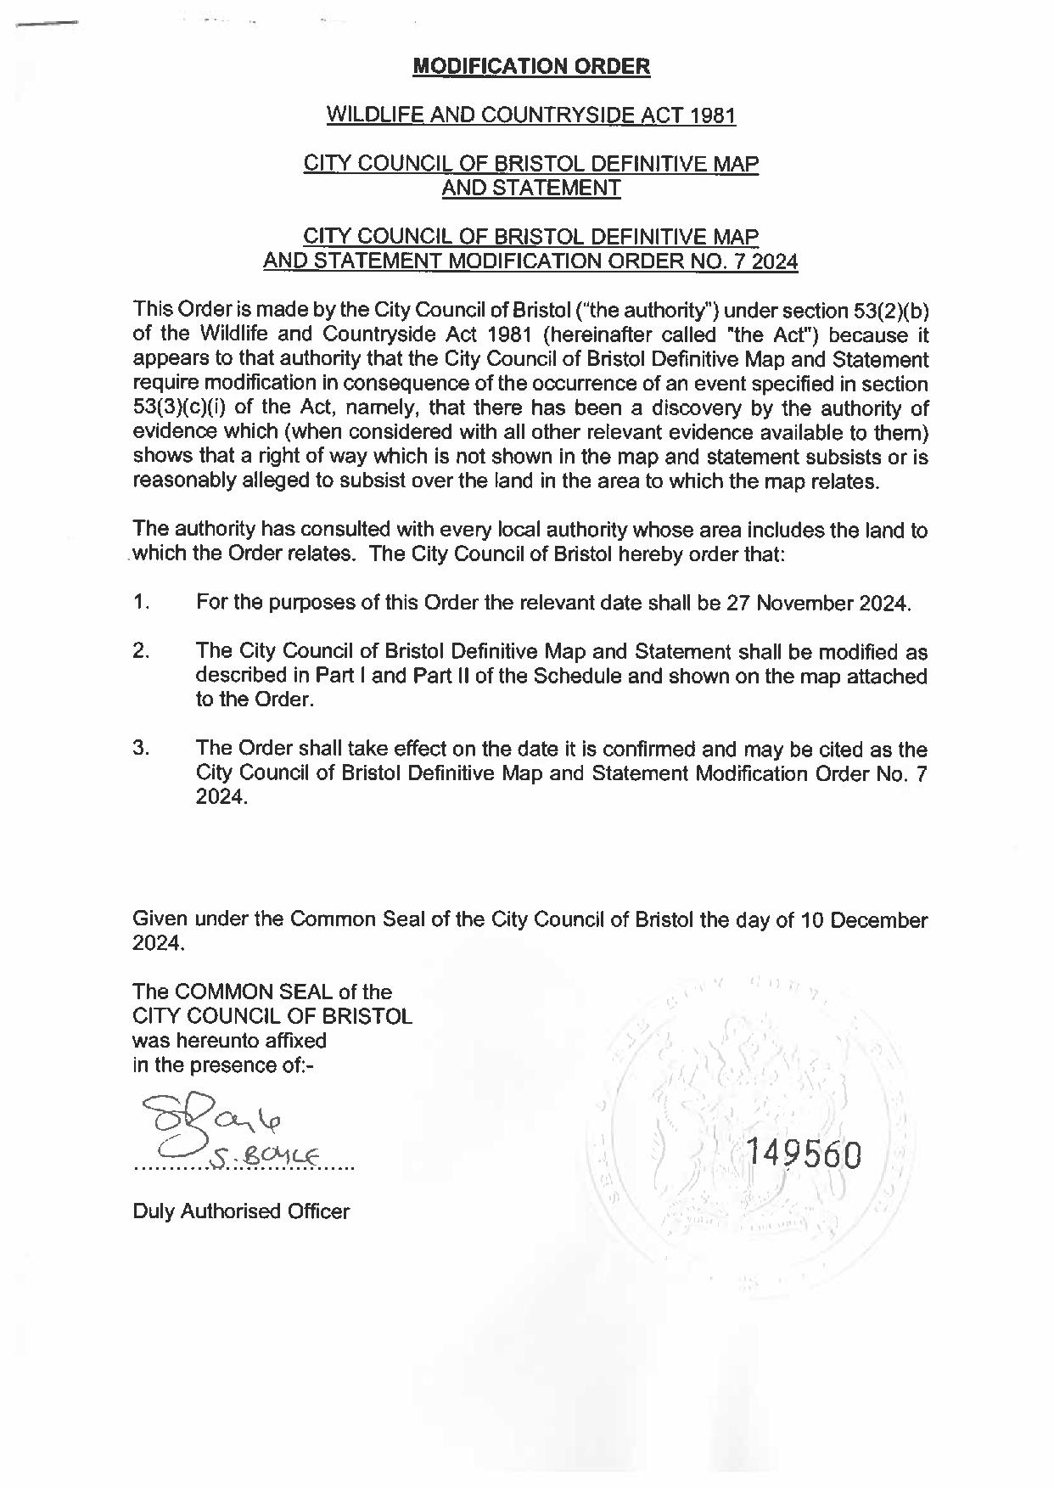

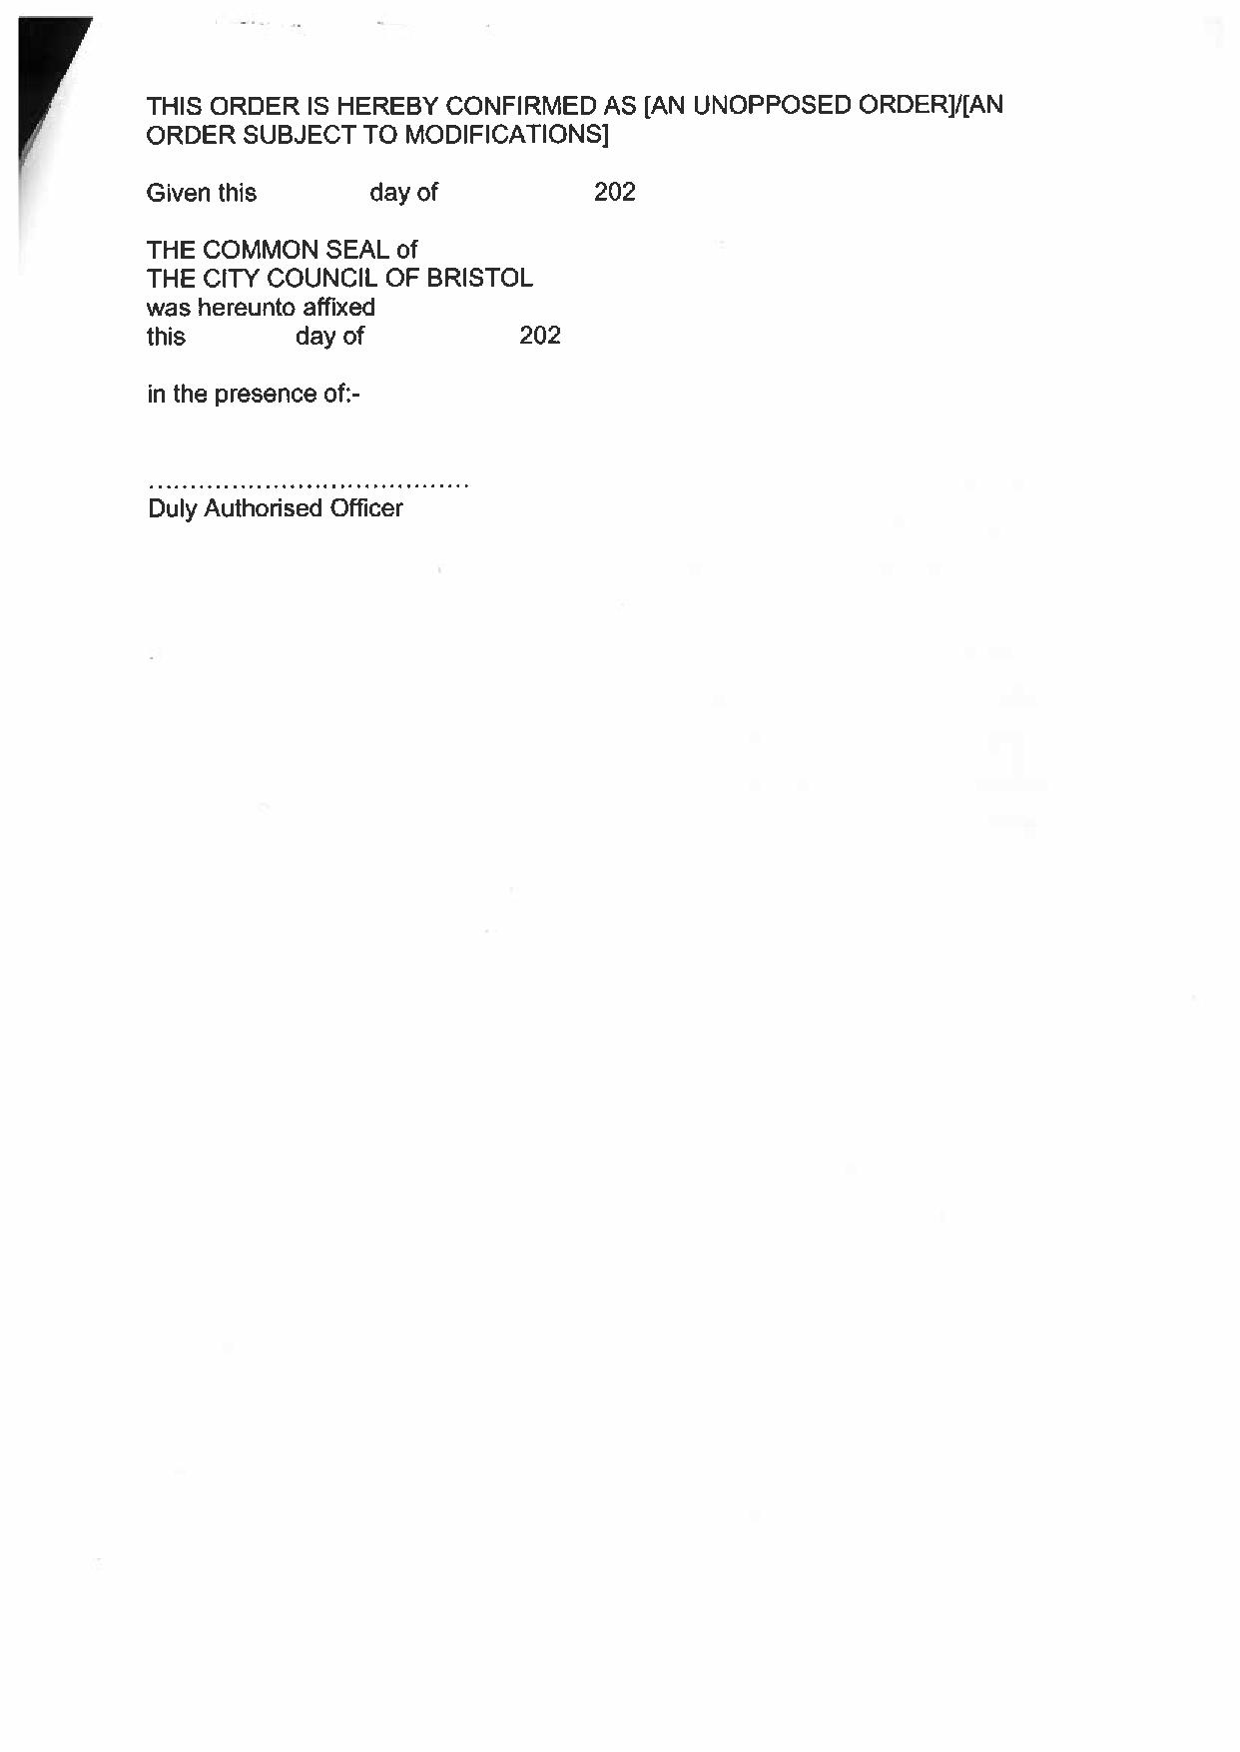

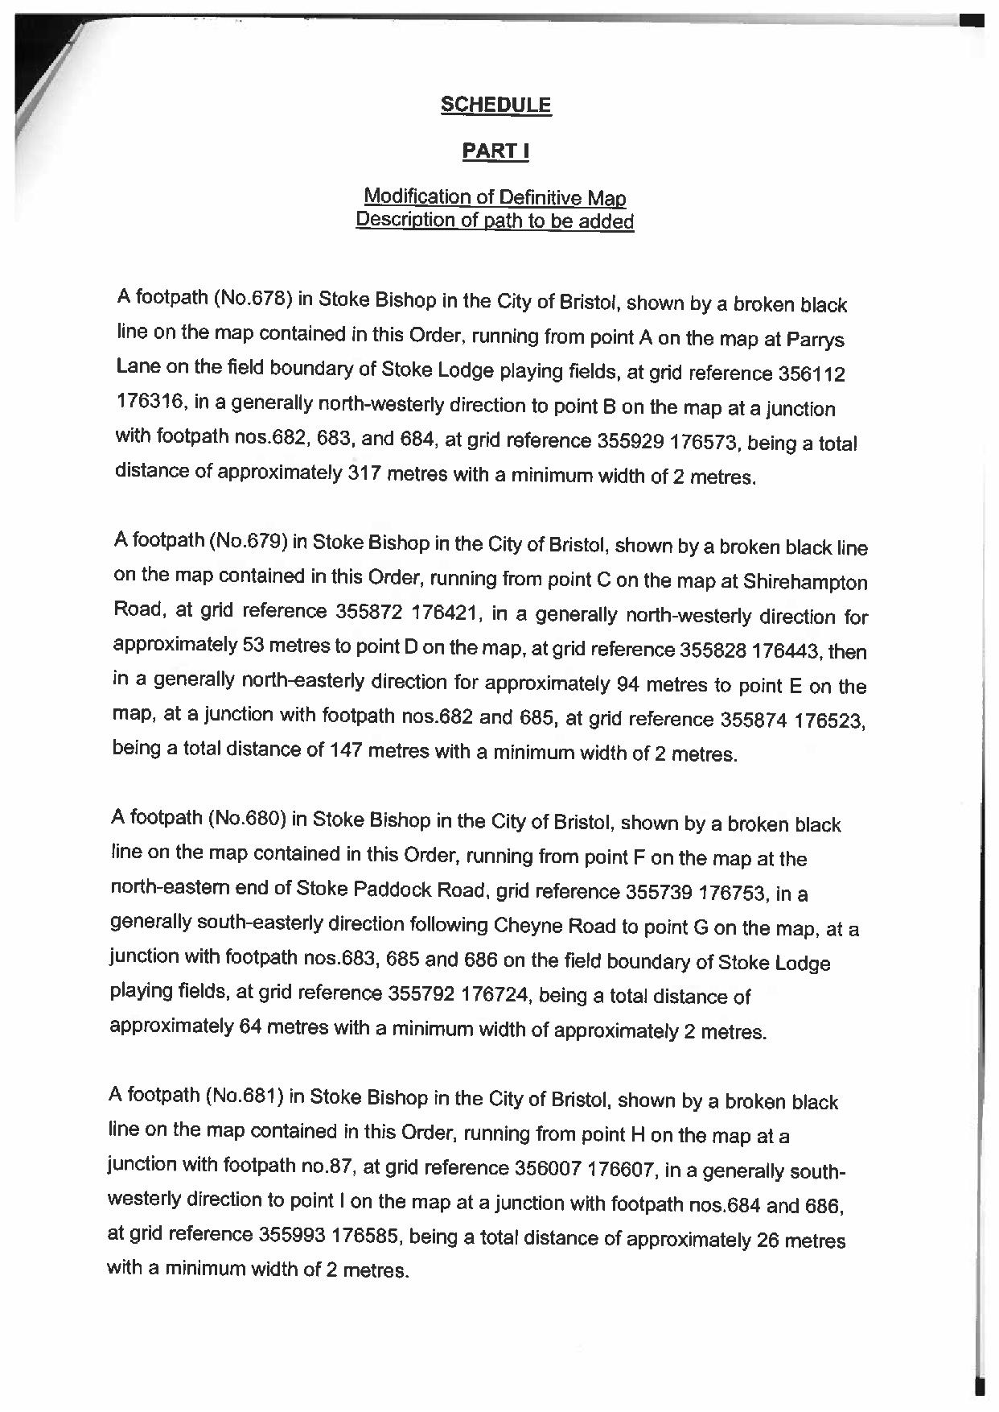

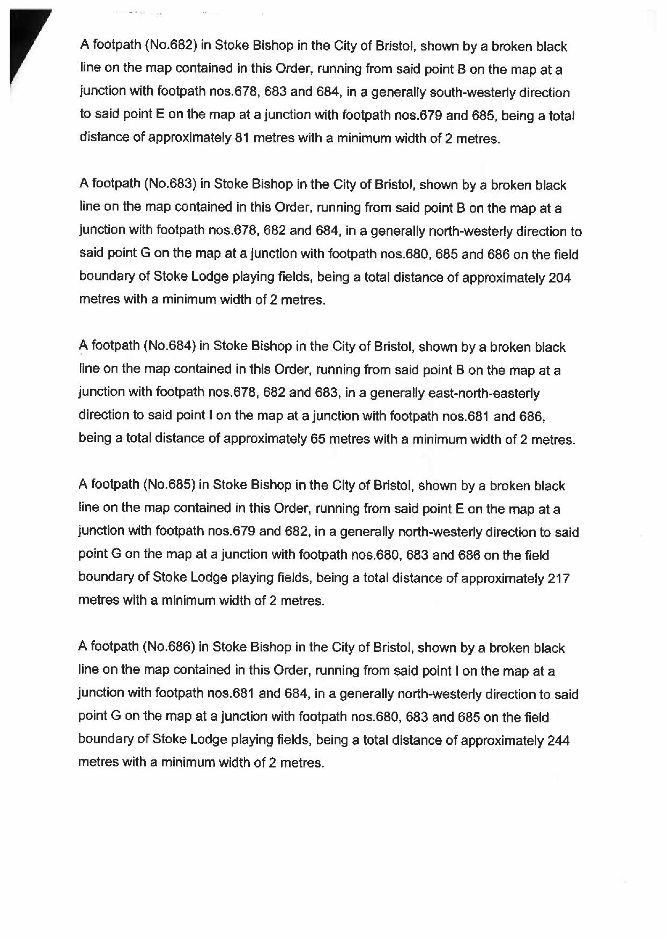

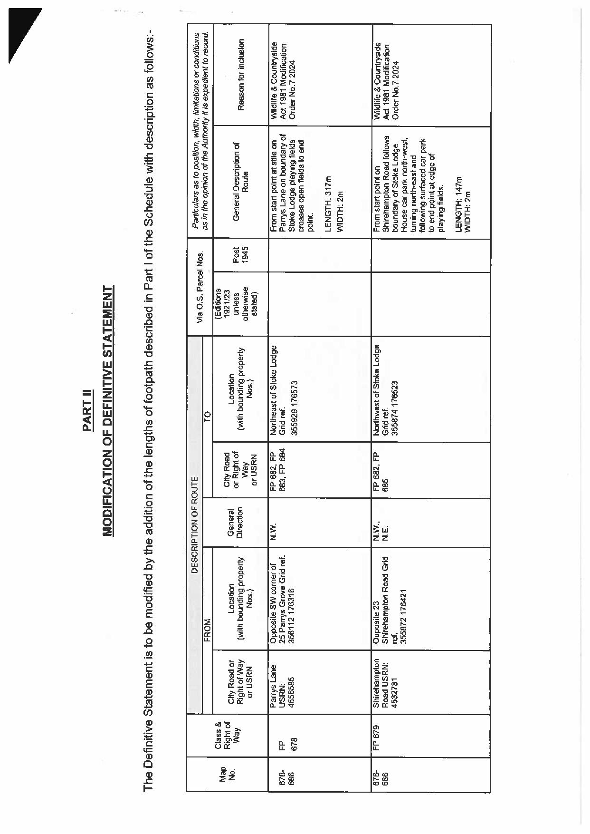

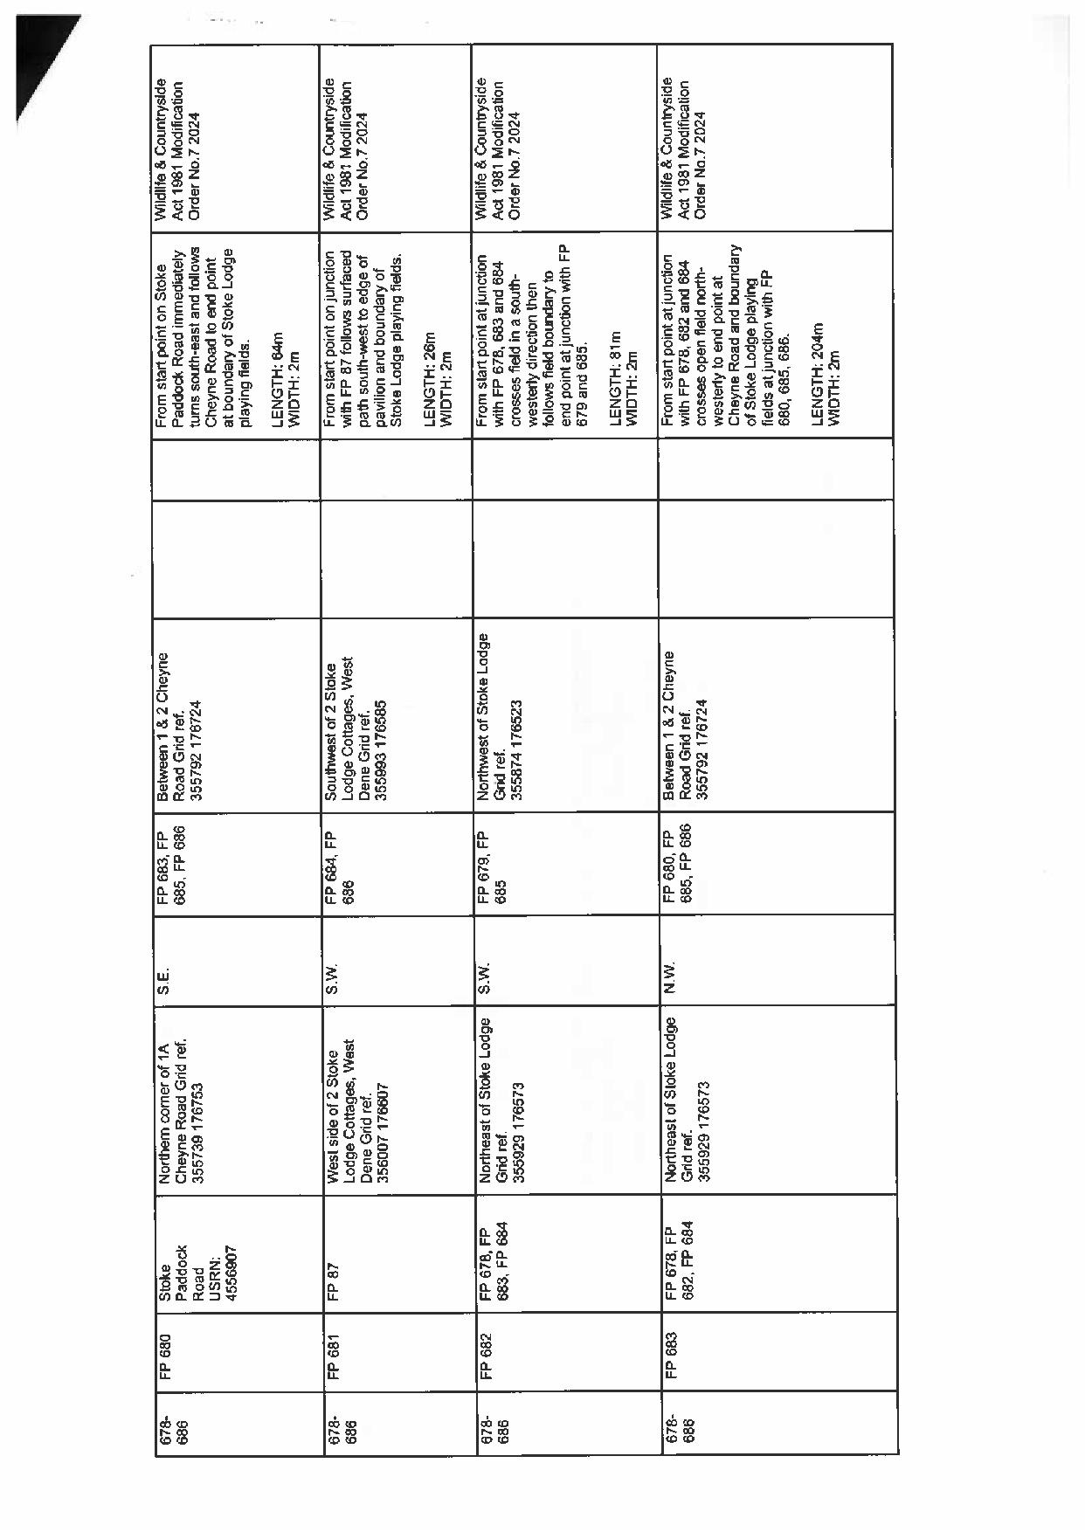

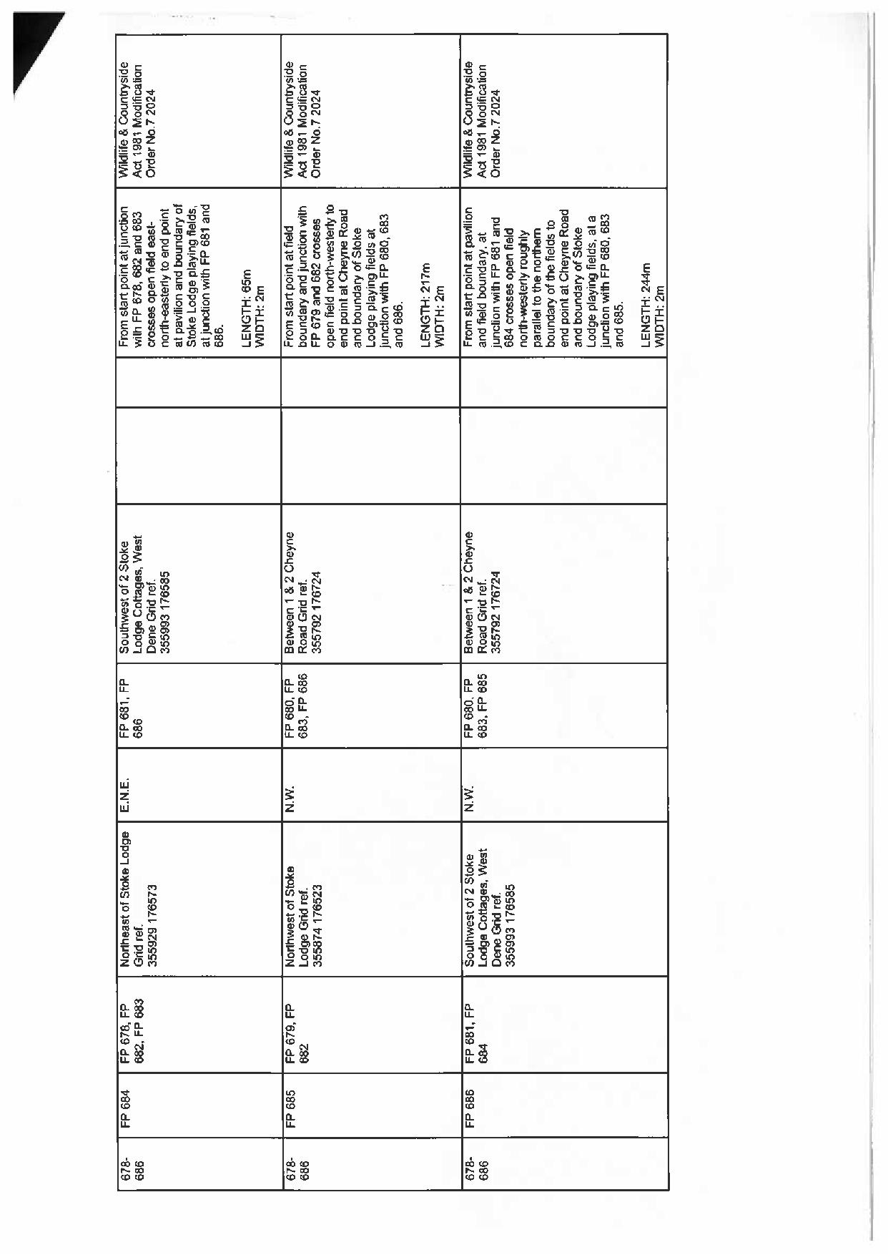

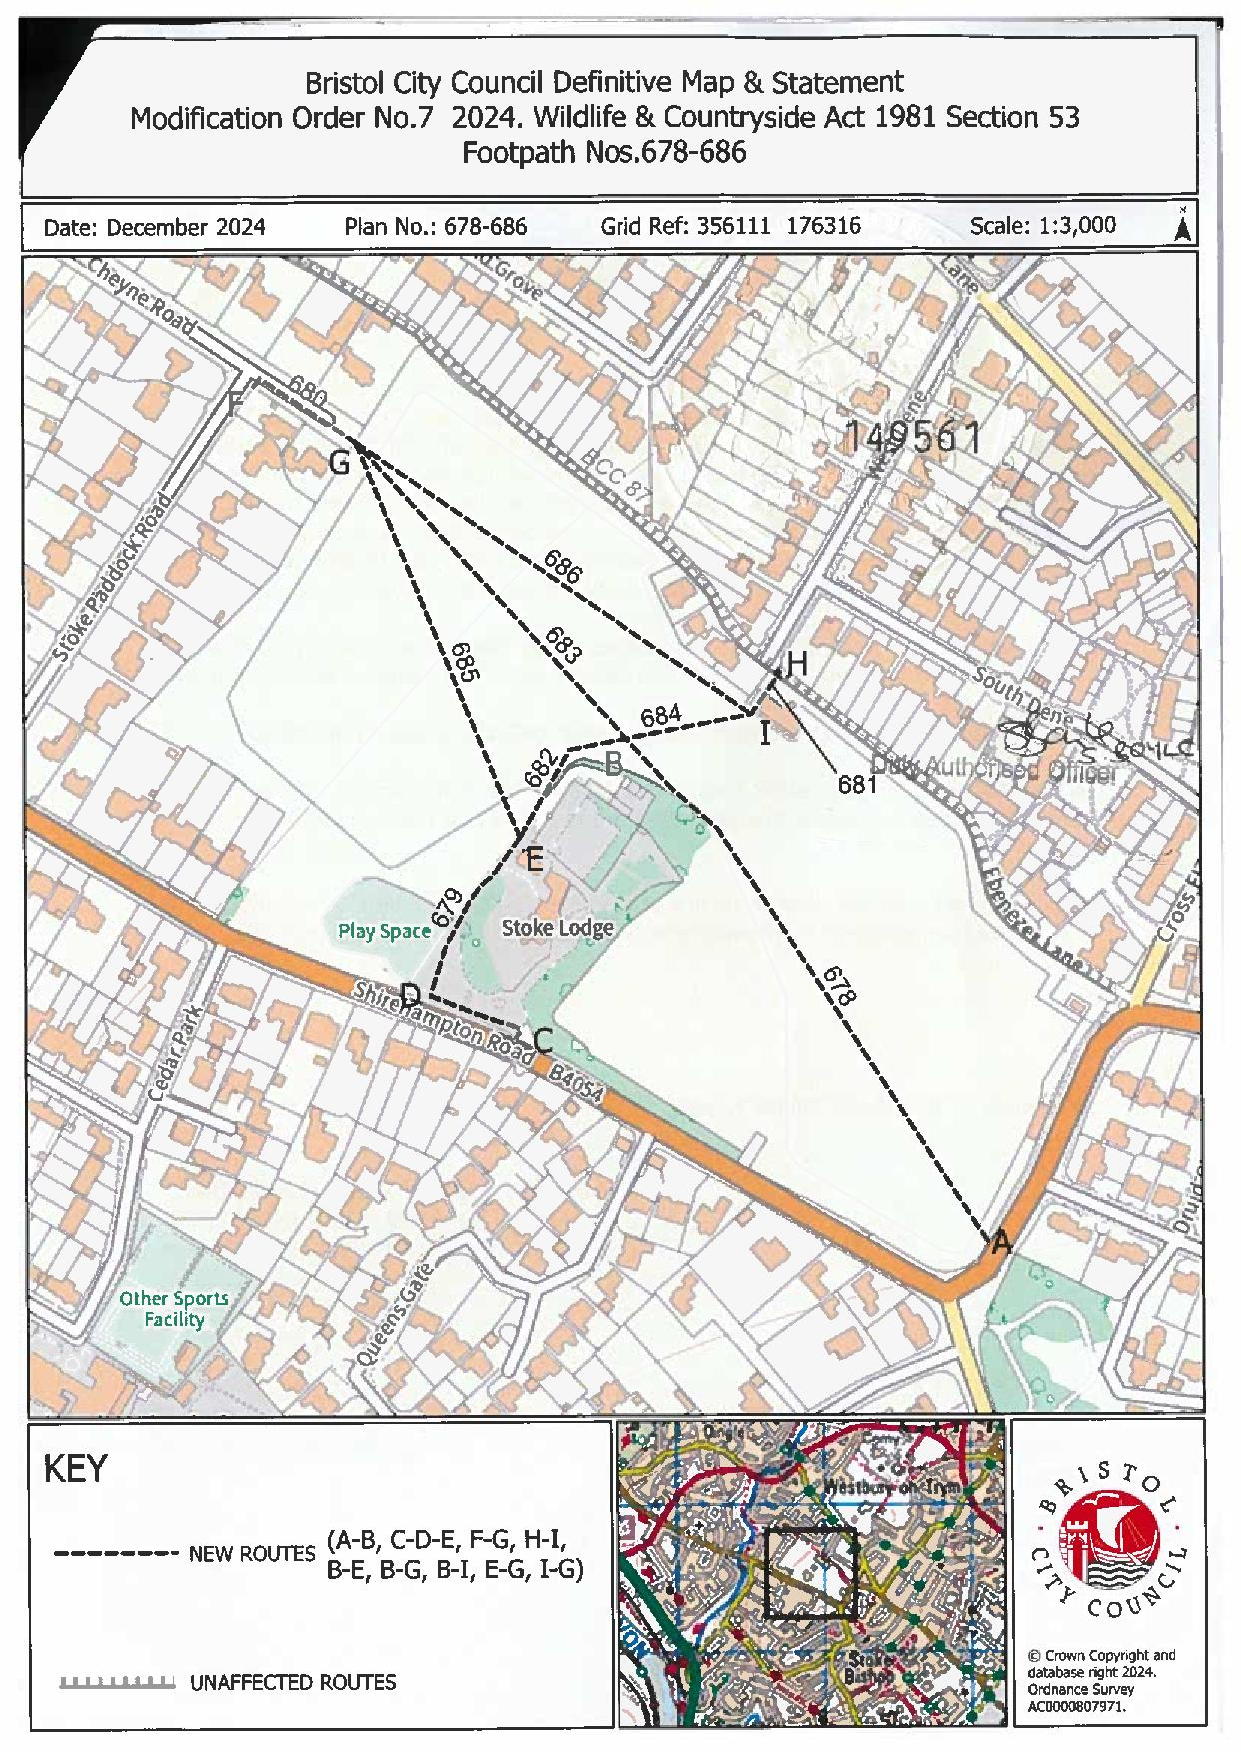

If you wish to make a legal submission, this should be submitted at the same time as your statement of case. Otherwise legal submissions will have to be submitted in writing on the day of the inquiry.

