

Appeal Decision
by K Taylor BSc (Hons) PGDip MRTPI
An Inspector on the direction of the Secretary of State for Environment, Food and Rural Affairs
Decision date: 18 March 2026

Appeal Ref: ROW/3365053

- This appeal is made under Section 53(5) and Paragraph 4(1) of Schedule 14 of the Wildlife and Countryside Act 1981 (the 1981 Act) against the decision of the Borough Council of Gateshead not to make an Order under section 53(2) of that Act.
- The application was dated 14 August 2020 and this appeal relates to the Council’s decision of 14 April 2025 to not make an order.
- The application was made to upgrade Footpaths BL/11/1, BL/19/1, BL/19/2 and BL/19/3 to a bridleway from Blackhall Mill to Chopwell Mill.
Summary of Decision: The appeal allowed.

Preliminary Matters
- I have been directed by the Secretary of State for Environment, Food and Rural Affairs to determine the appeal under Section 53(5) and Paragraph 4(1) of Schedule 14 of the Wildlife and Countryside Act 1981 (the 1981 Act).
- Written submissions have been received from the appellant, the Council and 2 other parties who are opposed to the appeal. I have not visited the site, but I am satisfied that I can make my decision without the need to do so.
- I have found it convenient to refer to the existing highway routes with reference to the ‘plan of claimed route’ provided by the Council. It is attached to the end of this decision. The claimed route forms a continuous way approximately 1085 metres in length from Whinney Leas, close to South View, in the north (point A) to Riverview, close to Fife Terrace, in the south (point B). The Northumberland Tynedale District Bridleway number 014 is located close to the claimed route within the neighbouring administrative area. This is not indicated on the ‘plan of claimed route’ but starts at the confluence of BL/11/1 and BL/124/1. An extract of an OS map with this bridleway shown close to the annotation ‘Fords’ is also provided at the end of this decision.

Main Issues
- The application was made under section 53(2) of the 1981 Act which requires the surveying authority to keep their Definitive Map and Statement (‘DMS’) under continuous review, and to modify them upon the occurrence of specific events cited in section 53(3).
- Section 53(3)(c)(ii) of the 1981 Act specifies that an order should be made on the discovery of evidence which, when considered with all other relevant evidence available, shows that a highway shown in the map and statement as a highway of a particular description ought to be shown as a highway of a different description.
- The evidence adduced is primarily documentary. Section 32 of the Highways Act 1980 requires a court or tribunal to take into consideration any map, plan or history of the locality, or other relevant document, which is tendered in evidence, giving it such weight as is appropriate, before determining whether a way has been dedicated as a highway.
- It is an objector’s view that the evidence submitted as part of the application does not amount to the discovery of evidence required under section 53(3)(c) of the 1981 Act. Their view is that, for this reason, the Order should not be made, and the appeal should be dismissed.
- Therefore, the main issues in this appeal are:
- whether the evidence submitted with the application amounts to the discovery of evidence within the meaning of section 53(3)(c) of the 1981 Act; and
- if the evidence submitted amounts to the discovery of evidence, whether the highway, shown as a public footpath, ought to be shown as a higher status route.

Reasons

Discovery of Evidence
- There is little information to indicate what evidence was taken into account when the claimed route was first considered and then recorded on the Council’s DMS as footpaths. The vast majority of the evidence submitted by the appellant pre-dates the establishment of the DMS. Most of this evidence would have been theoretically available at the time, but there is no certainty that it was all considered. In any event, the Finance Act plans and related documentation did not become publicly available until the late 1960s and 1970s. The Finance Act plans show parts of the claimed route as being located outside of any hereditament, which may suggest a route with public rights. Therefore, this is documentation of some evidential value.
- In itself, this amounts to the discovery of new evidence which should be considered with all other relevant evidence.

Documentary Evidence

Tithe Maps
- The Hedley Woodside Tithe map from 1845 does not cover the area of the claimed route and is focused on land to the west in Northumberland. ‘Milkwell Burn’ is labelled. There is a route in a similar alignment to Bridleway number 14 which appears to show its continuance onto the claimed route. The Chopwell Tithe Map from 1852 does not show any routes. Collectively, these maps do not show any substantive evidence of the claimed route or its status.

Commercial Maps
- On Armstrong’s map from 1768, a route is shown to the west of ‘Black Hall Mills’. From the River Derwent it heads north passing a collection of ‘Farms or Cottages’ marked as ‘Milk House’ then passes a settlement marked as ‘Chopwell’. The route is indicated as ‘Roads’ in the explanatory key. This is a simple map and although the route is similar in alignment to the claimed route, being to the west of Black Hall Mills and on a north south alignment, the southern section in particular sits significantly to the east of the claimed route and does not follow the watercourse as closely as Footpath BL/11/1.
- Armstrong’s map from 1791 is very similar to the earlier map but the document provided lacks an explanation key. It similarly indicates a route in the same broad alignment, and with the southern section significantly to the east of the watercourse than the claimed route.
- Hobson’s map from 1839 shows ‘Black Hall Mills’, ‘Milkwell Burn’, and ‘Chopwell Mill’. A route that approximately aligns with the claimed route is shown as is a part of what maybe the now Bridleway number 14. These routes are all identified as ‘Cross Roads’. The southern section of the route appears to be to the east of the claimed route.
- On Greenwood’s map from 1850, a route following a similar alignment as the claimed route appears to be shown as an enclosed uncoloured route identified as ‘cross roads’ in the explanation key. It is similar to other routes on the map. The southern section of the route appears to be to the east of the alignment of the claimed route. A route heading off the map to the west across the county boundary is shown approximately where Bridleway number 14 is currently located. Higher status routes, indicated as turnpike roads on the explanation key, are also drawn on this map.
- Bell’s map of the Great Northern Coalfield from 1850 shows a route following a similar alignment as the claimed route as enclosed and uncoloured with solid double lines. This is noted as a ‘cross road’ in the explanation key. The southern section appears to be located further to the east than the claimed route. Other routes on the map are drawn in a similar manner. The map also includes routes indicated with pecked double lines and solid double lines with one heavier line which is noted to be a turnpike road in the explanation key. A route heading west (in the approximate location of Bridleway number 14) is also present.
- Oliver’s map from 1851 shows a route in a broadly similar alignment to the claimed route, and a route that is in a similar position to Bridleway number 14 crossing into the neighbouring county. ‘Chopwell Mill’ is labelled. The southern section appears to be further to the east than the claimed route.
- Bell’s Plan of the Western Coal District from 1861 shows a route following a similar alignment to the claimed route which is primarily indicated in solid double lines, with some sections indicated with a pecked line to one edge. A route that follows the alignment in the southern section of the claimed route is shown as well as a route a little to the east. Annotations for ‘Whinneyleas’, ‘Black Hall’, ‘Milkwell Burn’, and ‘Blackhall Mill’ are shown which assist with the orientation of the mapping evidence.
- The Armstrong Maps (1768 and 1791), Hobson Map (1837), Greenwood Map (1850), Bell Map of the Great Northern Coalfield (1850) and the Oliver Map (1851) all show a route that is similar to the alignment of the central and northern section of the claimed route. However, all of these maps do not show the southern section of the route where it is located close to the watercourse. Rather the southern section of the route shown follows a route that is a little further to the east than the claimed route, approximately where there is now an existing alley at the end of the gardens for the dwellings on the western side of Fife Terrace. These maps indicate that there was a route which broadly aligns with the central and northern parts of the claimed route which are indicated in a manner similar to other routes which are now public routes many with vehicular rights.
- The Bell Map (1861) indicates the whole of the claimed route including the southern section along a similar alignment to the claimed route. This is modest evidence that the claimed route may have a similar status to other routes drawn in a similar manner.

Ordnance Survey (OS) Maps and Related Documents
- The Ryton Book of Reference from 1864 lists plot 409 as a ‘Public road’. On the related map, plot 409 relates to part of the claimed route. The extracts provided are not very clear and the full extent of the route is not on the sheet provided. However, it appears that plot 409 continues to the south and includes the claimed route in this direction. It does not appear to relate to the northern most section which is within plot 383 listed as ‘Arable, &c.’.
- Most of the claimed route is shown in the extracts across several sheets of the 25 inch 1895 map, although some sections are not fully shown given the route is close to the edges of the sheets. The southern section is shown with solid and pecked lines absent any colour. Sections further to the north, for example around ‘Black Hall’ are colour washed in sienna. The very northern section of the route is only partially shown on the sheet where the width of the route narrows.
- The whole of the route is shown on the 1896 map. A route marked as ‘F.P’ is shown to the east of the southern section approximately in the location of the rear/ west of the properties in Fife Terrace. What are now Footpaths BL/20/1 and BL/18/2 near the northern section of the claimed route are similarly marked as ‘F.P’.
- The whole of the route is shown on the 1898 map primarily in double solid lines with some sections in pecked lines. A route marked as ‘F.P’ is shown to the east of the southern section approximately in the location of the rear/ west of the properties in Fife Terrace. What are now Footpaths BL/20/1 and BL/18/2 near the northern section of the claimed route are similarly marked as ‘F.P’. The route is also shown on the smaller scale version of the 1898 map but, possibly due to its scale, it does not include the routes indicated as footpaths.
- The whole of the route is also shown on the 1919-20, the 25 inch 1920 and the 1952 maps along with the footpaths which spur from the claimed route.
- Since the late 19th century, OS maps have carried a disclaimer stating that tracks and paths shown provide no evidence of public rights. Nevertheless, these maps may indicate the nature of the use of a route that was generally accepted at the time of the relevant survey. In this case the claimed route is consistently shown for its full length. The listing of part of the route as a public road in the book of reference also indicates how it was considered by the surveyor.
- Several other routes which spur from the claimed route are shown and marked with ‘F.P’ indicating a footpath. These include what is now footpath BL/18/2 and BL/20/1. These footpaths would be cul-de-sac routes if they did not link to the claimed route. As the claimed route is not marked with the F.P symbol it indicates that the surveyor considered that at least part of the claimed route had public rights which were higher than footpath rights.

Finance Act Maps 1910
- Given its location close to the edge of the sheets, most, but not all of the claimed route is shown on the sheets provided. The southern section is part of plot 984 and it is not excluded from the hereditaments. The central section, around Blackhall Farm, and most of the northern section is shown as being excluded from the relevant hereditament (plot 1306). The lower part of the very northern section of the route is shown on the map, with the very top section not on the sheet. From where what is now Footpath BL/18/2 spurs from the claimed route, it remains part of plot 1306 and it is not excluded from the hereditaments.
- The central and part of the northern section of the route is not included in any hereditament. This is likely to indicate public rights greater than footpath rights and it is likely the rights were vehicular. The inclusion of the northern most section and the southern section in the hereditaments may be suggestive that these sections of the route did not have public vehicular rights. However, lower public rights may have been represented as a deduction. The purpose of the Finance Act documentation was not to record public rights of way or their status. However, public rights of way could lead to deductions or routes being excluded from being eligible from taxation. In this case the exclusion of part of the route is suggestive that it had public rights which were likely vehicular.

Other Maps
- The Stopwith Plan of the Vale of Derwent 1832 appears to be for the purpose of identifying the route of a proposed road. A route that approximately equates to the alignment of the claimed route is indicated on this map. Buildings labelled ‘Paper Mill’ are likely Blackhall Mill with the route to the west. The central and northern section is broadly on a similar alignment as the claimed route. However, the southern section appears to be further to the east of the watercourse. A route to the west appears to be indicated with a solid line to one side and a pecked line to the other. It does not however link from what is now Riverview (close to the now Fife Terrace) and there also is no link close to Blackhall Mill, so it does not form part of a continuous route with the remainder of the claimed route. This map is good evidence for the physical existence of much of the claimed route, but it is of little assistance in terms of its status.
- The Blackhall Farm Map (from the Gibson Collection) is undated. This map covers much of the area of the claimed route although the area where the southern section (approximately what is now Footpath BL/1/11) is not included on this map. The route is mostly shown enclosed with a solid line to either side, with sections in pecked lines. The route is labelled ‘Road from Blackhall’, to the north of a collection of buildings labelled ‘BLACKHALL’. The top section of the claimed route (close to what is now Whinney Leas) does not appear to be shown as a marked route. This map is good evidence for the physical existence of the route, and the labelling of the route is very modest evidence that part of the route could have had public rights.
- The highway adoption records from 1985 show the entirety of the claimed route on the base maps, but none of the claimed route is part of the adopted highway. These records are of little assistance other than to show that at the time they were prepared the route was not part of the adopted highway network.
- On the recent land registry maps, much of the claimed route appears to be shown as unregistered land and is distinct from the adjacent registered parcels of land. However, a portion of the northern section is within a parcel of registered land. This could indicate historic public rights, which could be vehicular over much of the route, but in itself this is evidence of limited weight.

Bridleway Number 14 Within Northumberland
- Bridleway number 14 is located within the neighbouring authority area of Northumberland. At its eastern terminus, it results in a cul-de-sac for bridleway rights at the county boundary where it meets the claimed route. There is nothing at the eastern end of the bridleway that indicates that this is a place of public interest for bridleway users (such as horse riders and cyclists). Therefore, the termination of the bridleway rights in this location is an anomaly and strongly suggests that such rights are likely to continue to the east to link to another highway of bridleway status or higher. In this case, this could be along the claimed route heading north, or heading south, or both.

Documentation of Recent Use
- Strava data has been provided which relates to a route between Blackhall Mill to Milkwellburn Wood. This includes a part of the southern section of the claimed route. Data for the years 2021 to 2024 are provided which indicates trip numbers in the high 400s to mid 500s each year relating to low to mid 200s of individual users.
- This indicates that a part of the claimed route is being used by cyclists in significant numbers. The actual number of cyclists is likely to be higher as not all users would regularly use Strava to log their journeys. This could indicate a continuation of the use of this part of the claimed route for historic rights which may have existed.

Conclusions on the Documentary Evidence
- The route, in its entirety is not shown in the earliest maps with the southern section absent. However, the evidence indicates that the full length of the route has physically existed since the 1860s.
- The termination of Bridleway number 14 in a cul-de-sac and also that early OS maps show footpaths as spurs from the claimed route, and would otherwise be cul-de-sac routes, strongly indicates that a route with higher rights subsists.
- The Finance Act maps and the indication that a significant portion of the claimed route was a public road in the Royton Book of Reference both are evidence that parts of the routes have higher public rights with the unregistered land adding weight to this. The evidence is weaker for the very northern section of the claimed route. However, there is no rationale for the termination of a route at this point and so it is likely that a highway of the same status would continue along this section. The recent documentary evidence of cycle use over part of the route suggests a continuation of historic rights. Other maps show much or all of the claimed route of a similar status to other routes which now have rights higher than a footpath.
- There is some evidence which indicate that vehicular rights may subsist, however, this is not sufficiently coherent to indicate that an Order should be made for the route as a restricted byway. Taking account of the existence of Bridleway number 14, the evidence does indicate that, on the balance of probabilities, bridleway rights subsist along the claimed route. There is not strong evidence to indicate that such rights only continue in one direction from Bridleway number 14.

Other Matters
- A number of issues were raised that are not a relevant consideration for the purpose of the 1981 Act. These include the current nature of the route, its suitability for bridleway users, the ecological impact associated with the use of the route and the availability of other nearby bridleway routes.

Conclusion
- Having regard to these and all other matters raised in the written representations, I conclude that the evidence shows that, on the balance of probabilities, bridleway rights along the claimed route subsist.

Formal Decision
- The appeal is allowed.
- In accordance with paragraph 4(2) of Schedule 14 to the 1981 Act the Borough Council of Gateshead is directed to make an Order under section 53(2) and Schedule 15 of the 1981 Act within 3 months of the date of this decision to add a bridleway along the appeal route indicated on the application dated 14 August 2020 and shown on the plan appended to this decision.
- This decision is made without prejudice to any decisions that may be given by the Secretary of State in accordance with the powers under Schedule 15 of the 1981 Act.

K Taylor

Inspector

Plan of claimed route

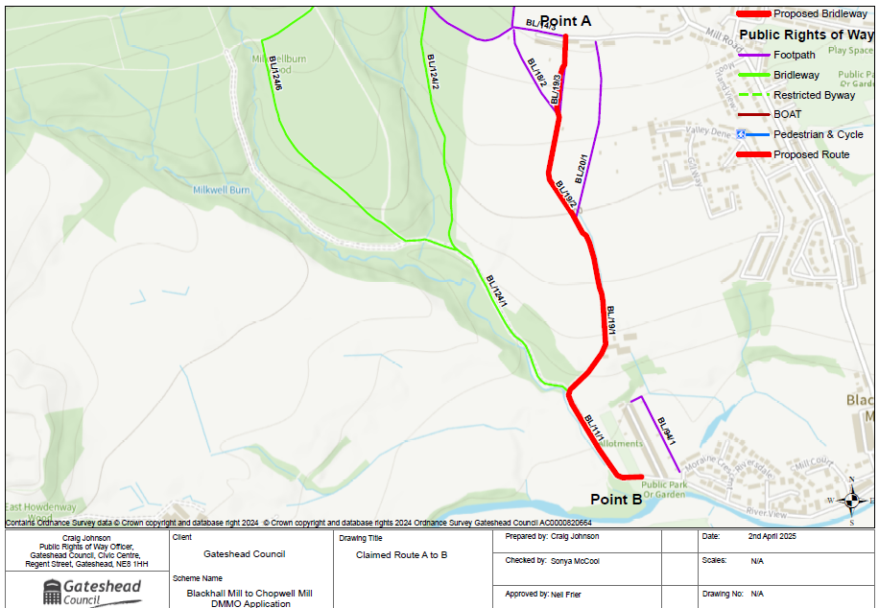

OS Map of claimed route

