Government Legal Department
Gender Pay Gap Report 2025



Contents

Summary 3
Gender Pay Gap 3
Bonus Pay Gap 3
Proportion of Males and Females receiving a Bonus payment 3
Hourly Pay Quartiles 3
Introduction 4
What is the legislative requirement? 4
Definitions 4
Organisational Context 5
Our structure 5
Our approach 6
Gender Pay Gap Report 6
Gender Pay Gap 6
Hourly pay quartiles 7
Bonus Pay Gap 8
Proportion of men and women paid a bonus 9
Actions 9
Declaration 11

Summary

Gender Pay Gap
Year | Mean Pay Gap | Median Pay Gap
2025 | -3.0% | -3.6%
2024 | 1.9% | 0.8%
2023 | 1.8% | 2.2%

Bonus Pay Gap
Year | Mean Bonus Pay Gap | Median Bonus Pay Gap
2025 | 2.6% | 6.3%
2024 | -0.9% | 0.0%
2023 | 8.2% | 0.0%

Proportion of Males and Females receiving a Bonus payment
Year | Female | Male
2025 | 74.4% | 76.6%
2024 | 73.4% | 76.8%
2023 | 91.5% | 90.8%

Hourly Pay Quartiles
Quartile | Female | Male
Upper Quartile | 73.7% | 26.3%
Upper Middle Quartile | 63.7% | 36.3%
Lower Middle Quartile | 62.4% | 37.6%
Lower Quartile | 66.6% | 33.4%

Introduction
The reporting period for this publication covers 1 April 2024 to 31 March 2025.
GLD has prepared this report as part of the legal requirement for public authorities to publish its gender pay gap on an annual basis.
This report outlines GLD’s gender pay gap figures, analyses the causes of any disparities, and sets out the strategies to address any gender pay gap differences.

What is the legislative requirement?
In 2017, the Government introduced world-leading legislation that made it a statutory requirement for organisations with 250 or more employees to report annually on their gender pay gap.
Government departments are covered by the Equality Act 2010 (Specific Duties and Public Authorities) Regulations 2017, which came into force on 31 March 2017.
These regulations require Government Legal Department (GLD) to publish their gender pay gap data by 30 March annually. This includes the:
- mean and median gender pay gaps based on basic pay
- mean and median gender bonus gaps
- the proportion of men and women who received bonuses in the reporting period
- the proportions of men and women in each pay quartile.
The gender pay gap is a high-level snapshot of pay within an organisation and measures the difference in the average pay between men and women in a workforce. A positive gender pay gap value indicates men are paid more than women, while a negative gender pay gap value indicates that women are paid more than men. If a workforce has a particularly high gender pay gap, this can indicate there may be one or more issues driving disparity in an organisation’s structure or policies.
The gender pay gap is different to equal pay. Equal pay deals with the pay differences between men and women who carry out the same jobs, similar jobs or work of equal value. It is unlawful to pay people unequally because they are a man or a woman.

Definitions
The Regulations introduce two new concepts:
- “relevant employee” - this is an employee on the snapshot date, 31 March 2025. The number of relevant employees is used in some of the calculations;
- “full pay relevant employee” – this is an employee on the snapshot date, 31 March 2025 who receives their normal March salary. This is not the same as full time equivalent.
Employees who are either not being paid or are on reduced, statutory or nil pay during March 2025 are not “full pay relevant employees”. For example, an employee on maternity leave whose occupational maternity pay runs out on 15 March and starts to receive statutory maternity pay will be a “relevant employee”, but not a “full pay relevant employee”.
The Regulations also require information to be reported under the following definitions:
- The mean average is calculated by adding together all the values and dividing by the number of values. In this case a mean average is calculated for men, a mean average is calculated for women, and the two mean averages are compared.
- The median average is calculated by sorting the values into an order from lowest to highest, and then finding the value that is in the middle of that sorted list. In this case a median average is calculated for men, a median average is calculated for women, and the two median averages are compared.
- The pay quartiles are hourly pay for all staff that are sorted into order from the lowest amount to the highest amount. This ordered list is then split into four equal parts, known as quartiles. The lowest pay quartile contains the first quarter of the ordered list, i.e. the 25% of the list with the lowest hourly rates of pay. The upper quartile contains the 25% of staff whose hourly rates of pay are the highest. Quartiles are related to the median average, as the median average marks the point between the second and third quartile.

Organisational Context

Our structure
GLD uses Civil Service grades Administrative Officer (AO) to SCS with two additional grades, Legal Trainee (LT) and Legal Officer (LO).
The grades are split into two groups:
- SCS whose pay and grading structures are determined by the Cabinet Office. The grading structure is underpinned by the analytical Job Evaluation for Senior Posts (JESP) system;
- Delegated grades AO to Grade 6 where GLD has the ability, within the frameworks set by HM Treasury and Cabinet Office, to determine its pay and grading structures. GLD’s grading structure is underpinned by an analytical Job Evaluation and Grading System (JEGS).
On 31 March 2025, GLD had 3,243 relevant employees of which 67.2% were women. GLD had 3,162 full pay relevant employees of which 67% were women
Analysing gender representation across grades, there is a higher proportion of relevant female employees in all grades. The percentage of women in the SCS has increased from 66.8% to 67.5%.
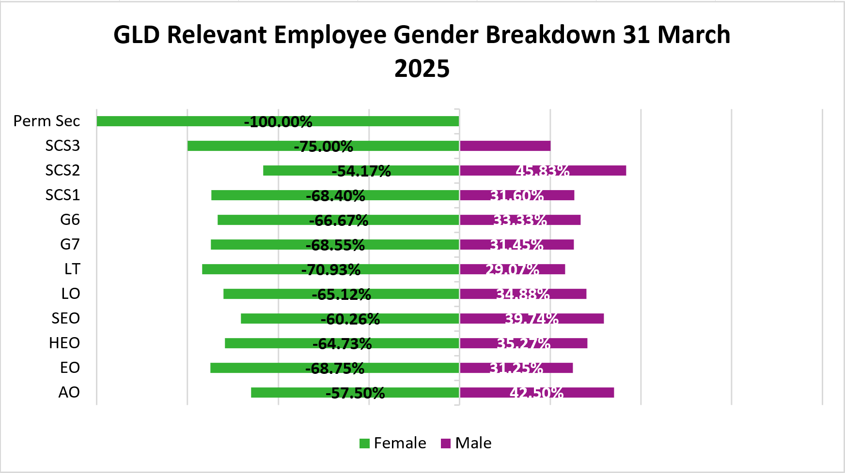

Our approach
We are committed to meaningful and sustained efforts to reduce our gender pay gap. In February 2025 , we published the refresh of our People Strategy covering 2025-2028. Our People Strategy recognises the centrality of our people to delivering much more than law and the importance of our Values in how we work. It sets out:
- How we will continue building the culture, capabilities and relationships between GLD and our current employees.
- The ambitions for people in GLD that will attract, retain and develop the talent we need to succeed: fostering Diversity and Inclusion, and Wellbeing, enhancing our Collective Leadership, growing a Learning and Performance Culture, building Inclusive Talent and furthering our Connection and Engagement.

Gender Pay Gap Report
The following gender pay gap analysis is based on the methodology set out in the Equality Act (Specific Duties and Public Authorities) Regulations 2017.

Gender Pay Gap
The mean gender pay gap is the difference between men and women’s average hourly pay. For GLD’s full pay relevant employees the mean gender pay gap is 3% in favour of women. The median gender pay gap is 3.6% in favour of women.
GLD’s gender pay gap continues to compare favourably with the wider civil service (see Civil Service Gender Pay Gap Report 2025).
Year | Mean Pay Gap | Median Pay Gap
2025 | -3.0% | -3.6%
2024 | 1.9% | 0.8%
2023 | 1.8% | 2.2%
2022 | 0.7% | 1.6%

Hourly pay quartiles
The hourly pay quartiles show the proportion of male and female full pay relevant employees in each quartile, when they are arranged in order of hourly pay rate.
Quartile | Female | Male
Upper Quartile | 73.7% | 26.3%
Upper Middle Quartile | 63.7% | 36.3%
Lower Middle Quartile | 62.4% | 37.6%
Lower Quartile | 66.6% | 33.4%
As was the case in 2024, the gender composition of all four quartiles is very similar to GLD’s relevant employee gender composition. The relatively static ratio of women to men at all levels in the organisation is why GLD’s mean and median gender pay gaps remain low. The most significant difference from 2024 is that the proportion of women in the upper quartile has increased resulting in a negative pay gap meaning that the average salary is slightly higher in favour of women in GLD in 2025.
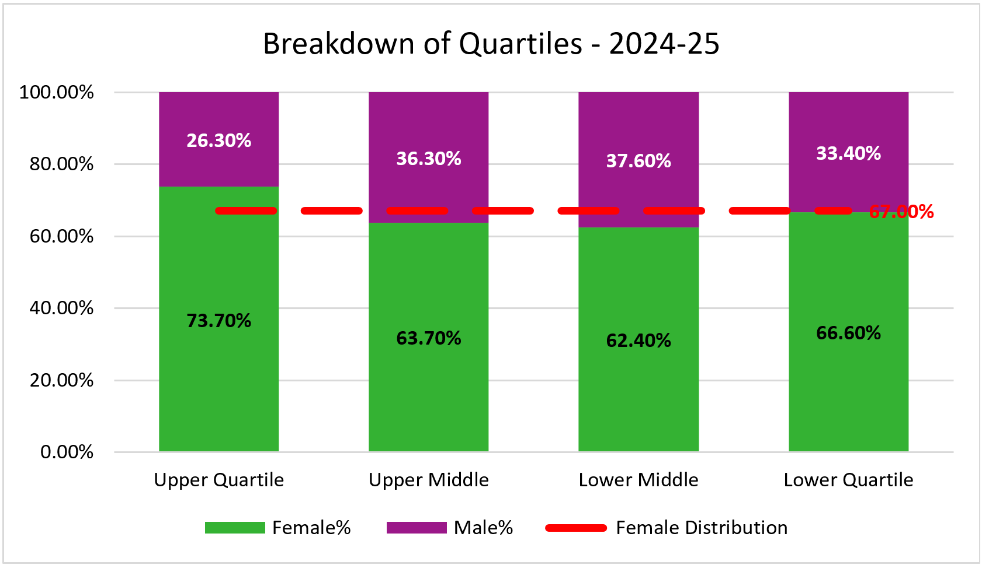

Bonus Pay Gap
Analysis revealed that the mean bonus gap increased in favour of men in 2025. The median bonus gap is increased to 6.3% from 0% in 2024.
Year | Mean Bonus Pay Gap | Median Bonus Pay Gap
2025 | 2.6% | 6.3%
2024 | -0.9% | 0.0%
2023 | 8.2% | 0.0%
During 2024-25, GLD operated three different bonus schemes, as follows:-
- Delegated Grades Special Bonus Scheme
- SCS In-Year Bonus
- SCS End-Of-Year Bonus
The rules and funding for the SCS schemes follow Cabinet Office guidance and are different to those in delegated grades. This means in one scheme an employee could receive a bonus of £25 (Delegated Grades Special Bonus Scheme) and, in another, an employee could receive a bonus of £12,500 (SCS end-of-year awards). Calculating the mean and median with such widely disparate figures can lead to significant disparities.

Proportion of men and women paid a bonus
GLD has 2,203 female relevant employees, of these 1,639 received a bonus, which is a proportion of 74.4%. GLD has 1,071 male relevant employees, of these 820 received a bonus, which is a proportion of 76.6%. This represents minor differences of a 1% increase in the proportion of women receiving a bonus and a 0.2% decrease in men receiving a bonus compared to 2024.
Quartile | Female | Male
2025 | 74.4% | 76.6%
2024 | 73.4% | 76.8%
2023 | 91.5% | 90.8%

Actions
The Civil Service is a modern and diverse workplace, committed to promoting and ensuring equality and valuing diversity. We want the Civil Service to reflect the diversity of the communities we serve. The Civil Service is at its best when it reflects the diversity of the country as a whole and is able to understand what the public needs. Whilst GLD has a negligible gender pay gap in relation to ordinary pay, we recognise the importance of existing initiatives and seek to continuously improve the diversity of our workforce. Our current initiatives include:
Bonuses: In April 2023, changes were introduced to the special bonus scheme as a result of a savings commitment to reduce GLD’s non-consolidated reward budget in GLD’s pay case to introduce the Legal Capability Framework. In order to meet the necessary saving and so as to not adversely impact those staff in cross functional professions who were not in scope of the enhanced pay offer, the overall bonus budget was split between those in scope of the Legal Capability Framework, and those in cross functional professions. The bonus budget for employees in scope of Legal Capability Framework was then reduced to meet our savings commitment. Alongside this, a percentage of the available budget for those in scope of Legal Capability Framework, was moved to the budget for Cross Functional professions. We anticipate this change will have continued to impact the bonus pay gap through to 2026, as more money is made available to employees in cross functional professions.
GLD will be reviewing the approach to the monitoring of bonus spend, from a D&I perspective, in 2026, with the aim of improving the current process and reporting.
Reward: GLD’s reward strategy includes equality as a key priority. We monitor the impact of the annual pay review to ensure that, where possible, gender pay differences are addressed.
Flexible working: GLD recognises the importance of flexible working in enabling employees to balance family commitments with work. In particular, flexible working can help to reduce the gender pay gap in GLD by enabling more women to move into senior roles. Our policy is to look favourably on flexible working arrangement requests at all levels of the organisation provided that the needs and objectives of both the organisation and the employee can be met. We offer a wide range of options including reduced hours, compressed hours, job share, flexi time, working from home, annualised hours and hybrid working (60% time spent in the office). Since October 2020, GLD offers carers up to 5 days paid special leave per rolling 12 month period in order to support them in managing their caring responsibilities whilst continue to being engaged in their work.
Recruitment practices: GLD seeks to recruit a diverse workforce. We use non-discriminatory job descriptions, analytical job evaluation and name blind recruitment practices to eliminate potential bias in the recruitment process. All interview panel members undertake mandatory Success Profiles training along with compliance training to ensure consistency and fairness throughout the recruitment process. Since 2018, GLD has used the new Civil Service-wide Success Profiles recruitment framework which is a more flexible, inclusive and holistic selection approach than the previous competency framework.
Since February 2021, GLD has introduced a new policy aimed at ensuring the department’s recruitment practices are more inclusive. GLD now requires all interview panels to include at least one person who is from an ethnic minority background and/or has a disability, whilst maintaining a gender mix. In addition, GLD is identifying ways in which we can demonstrate our commitment to attracting and promoting diverse, talent regardless of protected characteristic. GLD has an increasingly prominent presence on social media channels such as Instagram and LinkedIn, and we continue to have a micro-site for external recruitment. GLD advertises all external legal roles on a diversity job board. GLD also analyses D&I data from recruitment campaigns and makes interventions where appropriate to meet D&I aspirations. This may include, for example adjusting attraction strategies to ensure we have good pipelines of underrepresented groups to boost their chance of success and improve outcomes.”

Performance Management: In September 2020, GLD implemented its new Performance Management Policy, removing mid-year and end-of-year reviews and performance descriptors along with a renewed emphasis on high quality conversations between individuals and their line manager. With the removal of end-of-year reviews and performance descriptors, all reward and recognition will take place through in-year bonuses, regularly monitored (including from a diversity angle) by the senior leaders in divisional quarterly sense check meetings.
Career Paths: GLD offers a number of leadership and development programmes supporting people into roles that provide access to the right opportunities, exposure, stretch and development to reach their potential. These include: Beyond Boundaries, Future Leaders Scheme, Crossing Thresholds, Cross Catapult mentoring and Apprenticeships. For SCS we have the Senior Leaders Scheme and the Director Leadership Programme. GLD’s aim is to help tackle the under-representation of certain groups in senior management positions.
GLD’s Stephen Amos Mentoring Scheme, it was first introduced in 2020. Colleagues from a range of diverse backgrounds, up to Grade 6 (mentees/reverse mentors), are matched with a colleague who is at least one grade above them (mentors/reverse mentees). The aim of the scheme is to empower colleagues to have mutually beneficial relationships in which skills and development goals can be achieved.
The Early Talent Programme in GLD focuses on Legal Trainees, Apprentices, Paralegals and Outreach to schools and universities. The overall aim is to provide development, support and career interventions for GLD employees in all professions and roles from grades AO to LO. In 2023, GLD launched the GLD Graduate Solicitor Apprenticeship and Solicitor Apprenticeship offers under the programme, the aim of which is to provide new career development opportunities, diversify routes into the legal profession and increase social mobility within GLD. All GLD colleagues who hold the necessary qualifications, including those on fixed term contracts and agency workers, are eligible to apply.
GLD also offers a range of work experience through our Diversity Summer Scheme and the Sutton Trust Pathways to Law scheme, both of which aim to provide work experience opportunities in GLD to individuals from underrepresented groups. We offer sandwich placements to law students in our London, Leeds, Bristol and Salford offices.
Diversity and Inclusion (D&I): In harnessing the positive benefits of an increasingly diverse and inclusive workforce, our commitments to D&I run through our Values and embedded in GLD’s People Strategy 2025-28. Our five People Ambitions continue to align to work on the gender pay gap: Fostering D&I and Wellbeing, enhancing our Collective Leadership, growing a Learning and Performance Culture, building Inclusive Talent and furthering our Connection and Engagement.
We have 11 active diversity networks including Gender Equality, Race, Carers and Parents Each network has a diversity champion at SCS level who supports the Director General Diversity Champion, Mel Nebhrajani CB. Their role is to promote the work of the diversity networks and provide challenge and support for the organisation in reaching its diversity aims. The networks provide a forum to discuss, and provide mutual support, for those with a common interest and are available to all employees within GLD.
With these initiatives in place, there is still more to do. We will continue to raise awareness, highlight barriers and influence actions that can help further reduce these gaps across the department.

Declaration
We confirm that data reported by the Government Legal Department is accurate and has been calculated according to the requirements and methodology set out in the Equality Act 2010 (Specific Duties and Public Authorities) Regulations 2017
Richard Cornish, Director General & Chief Operating Officer

