

Order Decision
Papers on File
by Claire Tregembo BA (Hons) MIPROW
An Inspector appointed by the Secretary of State for Environment, Food and Rural Affairs
Decision date: 11 March 2026

Order Ref: ROW/3370760
- This Order is made under section 53(2)(b) of the Wildlife and Countryside Act 1981 and is known as the Somerset County Council (No. 4) Modification Order, 2021.
- The Order is dated 30 April 2021 and proposes to modify the Definitive Map and Statement for the area by adding two restricted byways as shown in the Order plan and described in the Order Schedule.
- There was one objection outstanding when Somerset Council submitted the Order to the Secretary of State for Environment, Food and Rural Affairs for confirmation.
Summary of Decision: The Order is confirmed.

Procedural Matters
- In addition to the duly made objection, Sparkford Parish Council also submitted an objection outside of the objection period. The matters raised in both objections relate to the suitability and desirability of the Order routes such as use by motorcycles, road safety, privacy, security, conservation, and the cost of reinstating and maintaining the routes. Similar matters along with a lack of recent use of the Order routes were also raised by landowners during the pre-order consultation period. These issues are not matters I can legally take into account when determining Modification Orders.
- I am satisfied I can make a decision based on the documents submitted and without making a site visit. I will refer to points shown on the Order plan in my decision and I have appended a copy to my decision for ease of reference.

The Main Issues
- The Order has been made under section 53(2)(b) of the Wildlife and Countryside Act 1981 in consequence of an event under section 53(3)(c)(i) which requires me to consider if, on the balance of probabilities, the evidence shows that public vehicular rights subsist along the Order routes. This is a higher standard of proof than the reasonably alleged to subsist test to determine if an Order should be made.
- The Order has been made on the basis of documentary evidence. Section 32 of the Highways Act 1980 requires me to take into consideration any map, plan, or history of the locality, or other relevant document provided, giving it such weight as is appropriate, before determining whether or not a way has been dedicated as a highway.
- I shall examine the evidence as a whole to establish whether public rights for vehicles exist along the Order routes. However, the Natural Environment and Rural Communities Act 2006 (the 2006 Act) extinguished rights for mechanically propelled vehicles (MPVs) subject to certain exceptions set out in section 67 of that Act. In this case, it is not argued they have been saved by any of the exceptions set out in section 67 of that Act. Accordingly, should I find public vehicular rights exist, the ways should be recorded as Restricted Byways.

Reasons
- The Order routes run on either side of the A303 with route G to H being on the south side and routes J to L being on the north side.

Quarter Session Records
- Quarter Session records from 1873 and 1874 refer to the ‘stopping up, diverting, and turning part of a highway’. The ‘Plan of Proposed Alteration of Roads’ shows a continuous route between points G and L which is coloured pink and labelled E at the south eastern end and B at the north western end. Public footpath WN23/12 which runs south west from point L is shown coloured green and labelled D where it joins the A303. The ‘Explanation’ states ‘The Road proposed to be stopped up is coloured… Green. The proposed New road is coloured… Pink.’ A note on the plan states ‘Average width of the road proposed to be stopped…13 feet’ and ‘Width throughout of proposed New road… 14 feet’.
- The Quarter Session records state the old road would be reserved as a public footway, the proposed alterations were viewed and certified by the Justices, and the owner of the new highway consented to the diversion. Notice of the diversion was printed in the Western Gazette and given to the Highway Board, Sparkford Waywarden, and Sparkford Churchwardens, with Resolution given by the Sparkford Vestry meeting.
- The justices found the new route would be more commodious to the public ‘because the said new road is much wider than the said old road and the new road is a hard level and well constructed road and will at all seasons of the year be a firm and good road and open to the public and all Her Majesty’s liege subjects to use and pass along the same with and without horses, carts, and carriages or otherwise to use the same as a public highway’.
- The Quarter Session Roll dated 7 April 1875 confirms the Justices viewed the new road and certified that ‘the new road or highway so ordered to be substituted… is now completed and put into good condition and repair’.

Ordnance Survey Maps
- The Order routes are shown as a continuous route between points G and L on the 1:2,500 first edition Ordnance Survey (OS) map of 1887 with double solid edges and numbered 99. The A359 at point G and Hazelgrove Lane (WN/23/38) north east of point L are shown coloured sienna and have thicker lines along their southern edge whilst WN23/12 is uncoloured. There is a line across this route at point G which could indicate a gate. The Order routes are shown in the same way on the 1:2,500 second edition OS map of 1903 and there is a line across it near point L. The routes at either end are no longer coloured but are otherwise shown in the same way and WN23/12 is labelled ‘F.P.’.
- Thicker lines along one edge are used on historic OS maps to indicate main roads, whilst minor roads are shown with equal width lines. Solid lines on either side of a road are used to indicate a route enclosed by walls, hedges, or fences. Public roads can be subject to limitations such as gates or cattlegrids. Somerset Council states other public roads are shown in the same way as the Order routes.

Definitive Map Records
- The Order routes were not claimed by Sparkford Parish Council when the Definitive Map and Statement was produced. The Order routes are shown as a continuous route with double solid edges between points G and L on the OS base maps used for the Parish Surveys, but I am not advised of its date.
- The Queen Camel Parish Survey card for footpath WN23/12 states it should pass through the narrow strip of woodland on the south western side of Order route G to H, but it was obstructed by a wired shut gate and a fence. It states the ‘path here joins Sparkford Green Lane & ends’. The Queen Camel Parish Survey card for footpath WN23/38 states it ‘starts at edge of copse in Hazel Grove Park continuing path starting in Sparkford Parish’. The Parish Survey cards suggest the Order routes are called ‘Sparkford Green Lane’ and WN23/38 is a continuation of it, although Sparkford Parish Council did not claim it. No dates are shown on the Parish Surveys, but they are likely to have been carried out in the early 1950s.

Physical Evidence
- I am advised that Order route G to H is bounded on the south side by an uneven tree line and on the north side by the boundary fences of a new residential development. Order route J to L is bounded on both sides by a clear line of trees. Photographs show there are patches of cobbles visible under the soil.

Conclusions on the Documentary Evidence
- The Quarter Session records show a public road with full vehicular rights was diverted onto the Order routes in 1875 with a width of 14 feet (2.26 metres). All necessary legal procedures were followed and the new road set out and made available for public use. The OS maps indicate the Order routes still existed and provided a link between two main roads in 1887 and 1903. One of the Parish Schedules refers to it as a named lane and suggest public rights when the Definitive Map and Statement was produced, and signs of the original surface are still visible.
- Public highways can only be extinguished by due legal procedure, and there is no evidence to show that public rights, other than those for MPVs under the 2006 Act, have been extinguished.
- The Order routes were originally one continuous route between points G and L. However, the A303 now crosses it between points H and J. As this is a dual carriageway with full vehicular rights, this section cannot be shown on the Definitive Map and Statement.
- I consider the evidence shows, on the balance of probabilities, that public vehicular rights exist over the Order routes.

Conclusions
- Having regard to these and all other matters raised in the written representations, I conclude that the Order should be confirmed.

Formal Decision
- I confirm the Order.

Claire Tregembo

INSPECTOR

Order Map

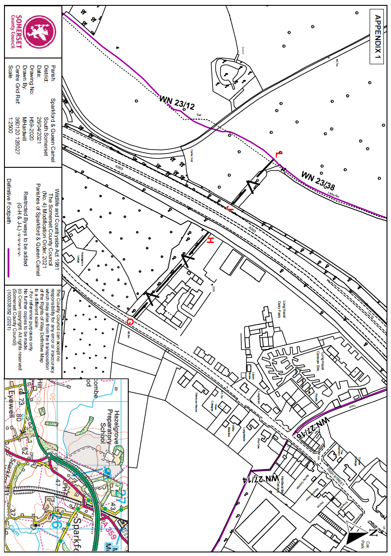
Not to Scale

