

Order Decisions
Site visit made on 9 March 2026
by Claire Tregembo BA (Hons) MIPROW
An Inspector appointed by the Secretary of State for Environment, Food and Rural Affairs
Decision date: 16 March 2026

Order Ref: ROW/3357717 The Creation Order
- This Order is made under section 26 of the Highways Act 1980 and section 53A(2) of the Wildlife and Countryside Act 1981. It is known as the Metropolitan Borough Council of Stockport (Section of Footpath 16 Hazel Grove and Bramhall) Public Path Creation and Definitive Map and Statement Modification Order 2024.
- The Order is dated 21 June 2024 and proposes to create a public bridleway shown on the Order plan and described in the Order Schedule.
- There were three objections outstanding when the Metropolitan Borough Council of Stockport submitted the Order to the Secretary of State for Environment, Food and Rural Affairs for confirmation.
Summary of Decision: The Order is confirmed.
Order Ref: ROW/3357721 The Extinguishment Order
- This Order is made under section 26 of the Highways Act 1980 and section 53A(2) of the Wildlife and Countryside Act 1981. It is known as the Metropolitan Borough Council of Stockport (Section of Footpath 16 Hazel Grove and Bramhall) Public Path Extinguishment and Definitive Map and Statement Modification Order 2024.
- The Order is dated 21 June 2024 and proposes to extinguish a public footpath shown on the Order plan and described in the Order Schedule.
- There were three objections outstanding when the Metropolitan Borough Council of Stockport submitted the Order to the Secretary of State for Environment, Food and Rural Affairs for confirmation.
Summary of Decision: The Order is confirmed.

Procedural Matters
- There were three objections outstanding when the Order was submitted for determination, one of the objectors withdrew their objection and the others did not provide statements of case when requested to do so. Therefore, I have determined the Orders using the documents submitted by the Metropolitan Borough Council of Stockport (the Council).
- Both Orders use the same plan, and I will refer to various points shown on it, and I have appended a copy to the end of my decision for ease of reference.

Preliminary Matters
- Some parties claim the notices displayed on site were not always legible, were torn down, or not easily accessible. The Council state the notices were regularly checked and found to be in position except for one which was missing when they went to remove them at the end of the objection period. Photographs clearly show the notices displayed on site on several occasions and they appear to be legible. As the objectors objected to the Order after seeing the notices on site, it is clear that the Order was sufficiently advertised and no one was prejudiced by one notice going missing during the last week of the objection period.

The Main Issues

The Creation Order
- Under section 26 of the Highways Act 1980 (the 1980 Act), if I am to confirm the Creation Order, I need to be satisfied there is a need for the bridleway and that it is expedient it should be created having regard to:
- the extent to which the paths would add to the convenience or enjoyment of a substantial section of the public, or the convenience of persons resident in the area; and
- the effect which the creation of the paths would have on the rights of persons interested in the land, account being taken of the provisions for compensation.
The Extinguishment Order
- The Extinguishment Order is made on the grounds that the path is not needed for public use. By virtue of section 118(2) of the 1980 Act, if I am to confirm the Order, I must be satisfied that it is expedient to extinguish the path having regard to:
- the extent, (if any) to which it appears that the path would, apart from the Order, be likely to be used by the public; and
- the effect the extinguishment of the right of way would have as respects land served by the path, account being taken of the provisions for compensation.
- In accordance with section 118(6), any temporary circumstances preventing or diminishing the use of the path or way by the public shall be disregarded.
- I have had regard to the judgements of R v SSE ex parte Stewart [1980] KPL 537 and R v SSE (ex parte Cheshire County Council [1991] JPL537 which clarified the relevant tests to be applied. Whilst the Council must consider the need for the path for public use when making the Order, I must look at its likely future use.
- Where an extinguishment is being considered concurrently with a creation, Section 118(5) provides that I may have regard to the extent to which a path provided by the Creation Order would provide an alternative path or way when considering the likely future use of the path proposed for extinguishment.

Both Orders
- I also need to have regard to any material provision of any rights of way improvement plan (ROWIP) prepared by any local highway authority whose area includes land over which the Order relates.

Reasons
- The proposed bridleway runs along an existing unrecorded path between 115 and 116 Meadway (section A to B). It then continues south east along Footpath 16 Hazel Grove and Bramhall (FP16) to a corner in FP16 (section B to C). This section of footpath is proposed to be upgraded to bridleway. From here it continues south east across a field to a multi-user path just north of the A555 (section C to D).
- The section of FP16 proposed to be extinguished runs from the junction with Footpath 19 Hazel Grove and Bramhall (FP19) (point E). It runs through a small paddock behind farm buildings at Ashmead Farm then across a field to a shared footway and cycleway on Ashmead Lane (point F).

The Creation Order

The need for the proposed bridleway
- The A555 was completed in October 2018 along with a multi-user path running alongside it. A number of links were created to improve the active travel network in the area and achieve the scheme’s ambitions to provide new cycleways and footpaths to link the existing network to the new segregated cycleway, and the enhancement of the existing networks for pedestrians, cyclists, and horse riders.
- The Council considers there is a need for a bridleway between Meadway and the multi-use path along the A555 to improve access for the benefit of pedestrians, cyclists, and horse riders. The proposed bridleway would provide a useful link due to the distance to other multi-user links and increased use due to the development of 4,000 dwellings in the Woodford Garden Village on the south side of the A555.
- Originally the Council considered upgrading and improving a longer length of FP16 and FP19 from Adelaide Road to the entrance of the oil depot at the end of Ashford Lane but there were concerns about the width of this route.
- The route proposed by the Creation Order is much shorter and more direct than the route originally proposed to be upgraded. It also means path users would not have to travel along Ashmead Lane which is frequently used by large oil tankers.
- FP16 between points E and F provides a similar route for pedestrians to the proposed bridleway. However, it does not allow use by cyclists, horse riders, or pedestrians who are unable to negotiate stiles. The existing links to the A555 for these path users are off Albany Road and requires them to take a much longer, more convoluted route through a housing estate.
- I consider the proposed bridleway would provide a useful, shorter, more direct, and accessible link to the A555 and the new developments on the south side. Therefore, I consider it is needed for all users but particularly for those using mobility aids, families with prams and pushchairs, cyclists, and horse riders who cannot access the field section of FP16 between Meadway and the A555.

The extent to which the path would add to the convenience or enjoyment of the public or the convenience of residents
- I have already concluded above that the proposed bridleway would be a shorter more direct link for walkers, cyclists, and horse riders. The proposed bridleway would also allow those living on both sides of the A555 to access facilities and services in the area. Therefore, it would add to the convenience of residents.
- The existing section of FP16 between points E and F has stiles at each end and a narrow chicane in the boundary fence between the paddock and field. There are materials stored in the paddock and vehicles load and unload here. The field where the existing footpath runs is very waterlogged and muddy, and it was clear that horse often gather on this side of the field. The proposed bridleway would be surfaced and meet the Council’s Access Control Policy standards. Therefore, it would be safer, easier to use, and more accessible than the existing footpath, and would allow use by path users who cannot negotiate stiles. Therefore, it would add to the convenience and enjoyment of these path users.
- Some parties consider the proposed bridleway would encourage anti-social behaviour, have a negative impact on the green space, and shorten the riding arena resulting in a loss of enjoyment.
- The section of FP16 proposed to be extinguished crosses the same field as the bridleway proposed to be created and both have a similar length. If the Creation Order and Extinguishment Order are both confirmed, I consider there would be limited impact on anti-social behaviour or the green space because a similar length of path would still exist through the same field. The Council also have powers to deal with anti-social behaviour if it becomes an issue.
- FP16 between points C and E runs directly alongside the riding arena and this would remain the case. Part of FP16 south of point E runs parallel to the arena but not directly alongside it. The proposed bridleway would run directly alongside it. Therefore, anyone who finds enjoyment in the existing footpaths due to their proximity to the arena would be able to walk alongside it for a greater distance.
- Overall, I consider the proposed bridleway would add to the convenience and enjoyment of the public and residents by providing a more direct and accessible route that would be available to a wider range of path users.

The effect on persons with an interest in the land
- Some parties claim the proposed creation would have a negative impact on persons with an interest in the land due to the loss of part of the riding arena, the impact on the field, and its use. However, the proposed bridleway and extinguishment were suggested by the landowner who continues to support the Orders. I consider the landowner is best placed to evaluate their interest in the land and there are no objections from any owners or occupiers of the land.

Conclusions on whether it is expedient to confirm the Creation Order
- I consider the proposed bridleway is needed for public use and would add to the convenience and enjoyment of the public and residents. The landowner suggested the proposed bridleway and supports both Orders, so it is likely they consider the Creation Order has benefits. Having regard to these and all other matters, I consider it is expedient to confirm the Creation Order.

The Extinguishment Order

The extent to which it appears that the path would, apart from the Order, be likely to be used by the public
- There are stiles at either end of the section of FP16 proposed to be extinguished. This means pedestrians who cannot negotiate the stiles are unable to use it. At the time of my site visit, the footpath was waterlogged and muddy making it difficult to use. I could not see any footprints or worn lines suggesting it has little use.
- Due to the surface conditions and access controls, I consider the section of FP16 proposed to be extinguished currently has limited use by the public, particularly in winter, and this is unlikely to change in the future.

The extent to which the Creation Order would provide alternative paths
- The proposed bridleway runs directly parallel to the section of FP16 proposed to be extinguished. These paths have similar lengths, cross the same field, and provide similar links. However, the proposed bridleway would provide a more direct route to the A555 with a firm surface so would be easier to use and more accessible.
- If the Creation Order is confirmed, I consider the proposed bridleway would provide a suitable, more accessible, and more direct alternative to the section of FP16 to be extinguished. I consider this section of FP16 would be unlikely to be used if the Creation Order is confirmed.

The effect the extinguishment of the path would have as respects land served by the path, account being taken to the provisions as to compensation
- The landowner proposed the extinguishment of this section of FP16. It runs directly alongside farm buildings, and the paddock is used to store materials and horse boxes. Therefore, the extinguishment is likely to increase farm security. The section of FP16 proposed to be extinguished runs between stables and a field where they graze and vehicles are unloaded in the paddock. Therefore, the extinguishment of the footpath is likely to aid the movement of horses and the unloading of vehicles.
- Therefore, I consider the extinguishment would have a positive impact on land served by the footpath.

Whether it is expedient that the path should be stopped up
- I consider there is currently limited use of the footpath proposed to be extinguished, and stiles prevent use by some walkers. Use is unlikely to increase in the future. The alternative bridleway would be more direct and accessible as well as being available to cyclists, horse riders, and pedestrians who cannot negotiate the existing stiles. I consider the proposed bridleway would mean even less use of the section of FP16 proposed to be extinguished. I have already concluded in paragraph 26 above that it is expedient to confirm the Creation Order. Accordingly, I conclude it is expedient to confirm the Extinguishment Order.

Rights of Way Improvement Plan
- The ROWIP finds that people with all types of access needs have limited access to the path network, both physically and in terms of information, and this needs to be addressed. The ROWIP considers it is necessary to update the network to reflect current needs and usage, and additional off-road routes are required to address the needs of a range of specific user types. The ROWIP includes aims to provide and upgrade paths away from the roadside to allow access to wider user groups providing benefits to cyclists and users with mobility needs.
- The provision of a more accessible route for a wider range of path users would help achieve the aims and objectives of the ROWIP and address the access and network issues identified in it.

Overall Conclusion
- Having regard to these and all other matters raised in the written representations I conclude that the Creation Order and Extinguishment Order should be confirmed.

Formal Decision

The Creation Order
- I confirm the Order.

The Extinguishment Order
- I confirm the Order.

Claire Tregembo

INSPECTOR

Order Map

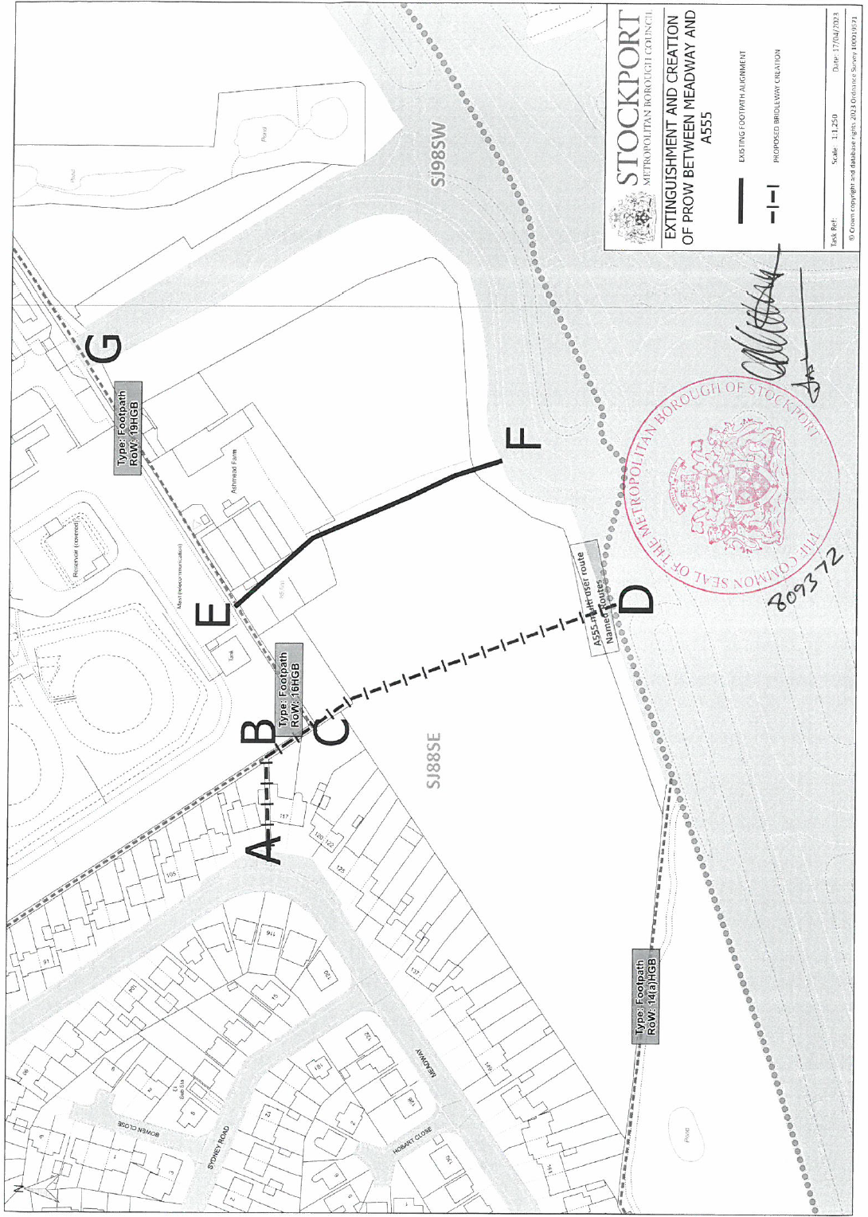

Not to Scale

