

Order Decision
Papers on file
by Claire Tregembo BA(Hons) MIPROW
An Inspector appointed by the Secretary of State for Environment, Food and Rural Affairs
Decision date: 04 March 2026

Order Ref: ROW/3359401
- This Order is made under section 53(2)(b) of the Wildlife and Countryside Act 1981 and is known as the City of Bristol Definitive Map and Statement Modification Order No. 1, 2024.
- The Order is dated 10 September 2024 and proposes to modify the Definitive Map and Statement for the area by adding three footpaths as shown on the Order plan and described in the Order Schedule.
- There were two objections outstanding when the City Council of Bristol submitted the Order to the Secretary of State for Environment, Food and Rural Affairs for confirmation.
Summary of Decision: The Order is confirmed.

Procedural Matters
- After the Order was submitted to the Secretary of State for Environment, Food and Rural Affairs, the objections to the Order were withdrawn. Nevertheless, I must consider the merits of the Order and make a decision based on the evidence before me.
- I refer to the proposed footpath numbers and various points shown on the Order plan in my decision. I have appended a copy of it to the end of my decision for ease of reference.

The Main Issues
- The Order has been made under section 53(2)(b) of the Wildlife and Countryside Act 1981 in consequence of the occurrence of an event specified in section 53(3)(b). This requires me to consider if the Order routes have been enjoyed by the public for a period that raises a presumption of dedication as public footpaths.
- The evidence submitted in support of the Order relies on the presumption of dedication arising from tests laid out in section 31 of the Highways Act 1980 (the 1980 Act). This requires me to consider if the public have used the routes as of right and without interruption, for a period of twenty years immediately prior to its status being brought into question. I must establish the date when the public’s right to use the Order routes was brought into question and determine if use by the public occurred for a twenty year period prior to this that is sufficient to raise a presumption of dedication. If this is the case, I must then consider if there is sufficient evidence that there was no intention on the part of the landowner to dedicate public footpaths during this period.
- Section 32 the 1980 Act also requires me to take into consideration any map, plan, or history of the locality, or other relevant document provided, giving it such weight as is appropriate, before determining whether or not a way has been dedicated as a highway.

Reasons

Documentary Evidence
- The Order routes are not shown on the 1839 Tithe map for the parish of Stapleton, maps of Stoke Park from the 1700s, Ordnance Survey (OS) maps between 1800s and 2000s, or a 1932 Deed plan. Heath House Lane first appears on OS maps in the 1930s and South Hayes and Parkside Gardens first appear in the early 1970s. None of these documents indicate public rights over the Order routes.

User Evidence

Bringing into question
- To bring into question the right of the public to use the Order routes some actions or events must have occurred that brought home to at least some of those using it that their right to do so was being challenged. These must have been sufficiently overt to bring that challenge to the attention of the public using the routes.
- Use of the Order routes was brought into question in July 2005 when the new owner of the field south of point Y erected locked gates off South Hayes and Parkside Gardens (points A and B) and fenced the gap between the fields (point Y). The owner also state they erected notices stating ‘Private No Public Rights of Way’ on the gates on 9 September 2005.
- There is nothing to indicate that use was brought into question prior to this. Therefore, I consider the Order routes were brought into question in July 2005 with the relevant 20 year period of use being July 1985 to July 2005.

Analysis of use
- To satisfy the requirements of section 31, use must be by those who can be regarded as the public. For use to be as of right it must be without force, secrecy, or permission. Use should be without interruption, and to be effective, any interruption must be by the landowner, or someone acting on their behalf. I must also be satisfied that there was sufficient use by the public to raise a presumption of dedication.
- Thirteen user evidence forms (UEFs) show use of the Order routes between 1955 and 2005. Eight people used the Order routes for the full twenty year relevant period with three others using it for either seven or fifteen years during the relevant period. Everyone used Footpath 676 (C to D), but some people only used Footpath 674 (C to A) and others only used Footpath 675 (C to B). At least eight people used each footpath. Two people also used Footpaths 675 and 676 for 19 years prior to 1980 but did not indicate use during the relevant twenty year period.
- Use was predominantly for leisure with some people also using it to visit friends or family. Frequency of use varied from occasionally to daily. Everyone used the Order routes on foot, with one person also claiming use on horseback and on a bicycle. One person refers to the Order routes as bridleways and everyone else refers to them as footpaths. Those using the Order routes refer to seeing others including named persons who did not complete UEFs. Use appears to have been open, without permission, secrecy, or force.
- No one was challenged when using the Order route and no obstructions were encountered before July 2005. Most people refer to gates off Heath House Lane. Many also refer to gates at points A and B but state they were not erected until July or August 2005. A letter from the applicant for the Order states there was always a gate off Heath House Lane, but they were always able to open it to gain access. They also state the Order routes from South Hayes and Parkside Gardens ‘have always been open but are now gated and fenced by the new owner’.
- Photographs of the Order routes taken in October 2005 show clear worn lines along them. Footpath 674 is less clear and there is evidence the ground was recently cleared suggesting it may have been overgrown. Aerial photographs from 1975, 1991, 1999, 2004 and 2005 appear to show a gap in the field boundary at point Y. Worn lines can also be seen on the 2004 and 2005 aerial photographs but the worn lines are less visible on Footpath 674.
- Although there is a limited number of user evidence forms, I consider there is sufficient evidence of uninterrupted use of the Order routes during the relevant twenty year period without permission, secrecy, or force, to demonstrate a presumption of dedication of public footpaths.

Lack of intention to dedicate
- To demonstrate a lack of intention to dedicate, a landowner must take action to make the public aware that they have no intention of dedicating a public right of way. There are various ways of demonstrating this, but the most common ways are erecting notices denying public rights or granting permission, physical obstructions, or verbal challenges.
- The owners of the southern field claim it was surrounded by secure fences, locked gates, and overgrown when they purchased it in 2005. They cleared the land which had been dumped on, surrounded it with secure fences and gates, and erected notices denying public rights of way. They state that locks were broken and notices removed. Those using the Order routes do not refer to any fencing or locked gates before July 2005 and there is nothing to indicate use was prevented by overgrown vegetation. The landowner of the northern field states they were not aware of any barriers on their land to prevent pedestrian access in May 2006.
- Therefore, I consider there is insufficient evidence to demonstrate a lack of intention to dedicate public rights by the landowners during the relevant twenty year period.

Conclusions on section 31
- I have considered above that the relevant twenty year period is July 1985 to July 2005. I consider there is sufficient evidence of use of the Order routes as of right and without interruption, challenge, permission, secrecy, or force during the relevant twenty year period. I have not seen sufficient evidence of any actions by the landowners during the relevant period to demonstrate that they had no intention of dedicating public footpaths. Therefore, I am satisfied the evidence before me is sufficient to show, on the balance of probabilities, that the tests under section 31 of the 1980 Act are met and public footpaths subsist over the Order routes.

Conclusions
- Having regard to these and all other matters raised in the written representations I conclude that the Order should be confirmed.

Formal Decision
- I confirm the Order.

Claire Tregembo

INSPECTOR

Order Map
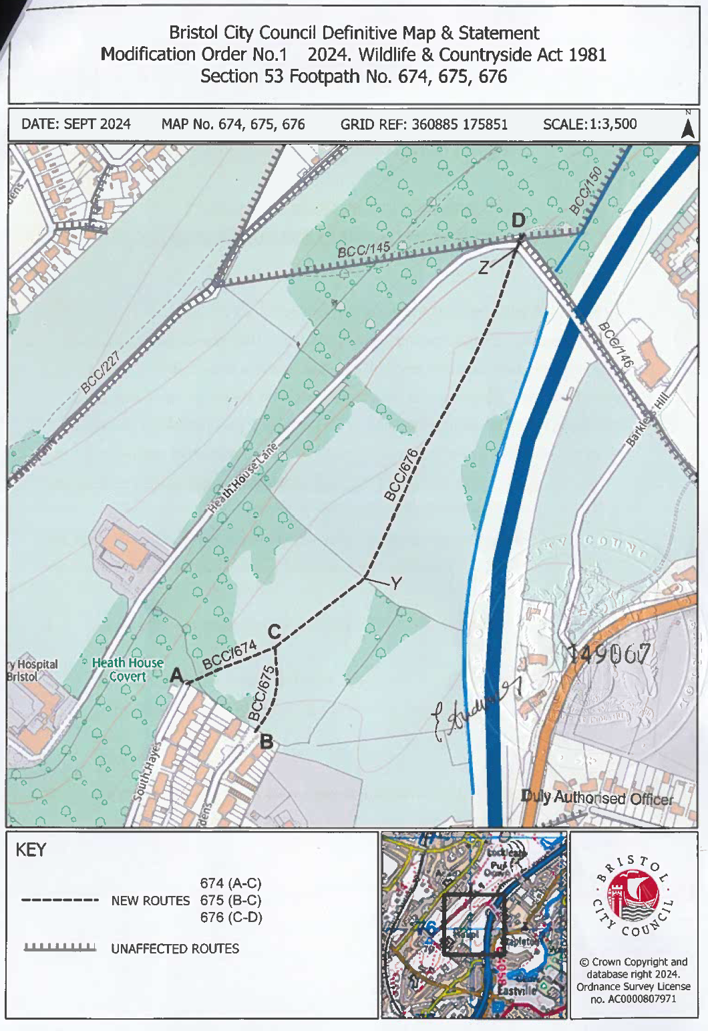
Not to Scale

