
Order Decision
Papers on file
By Harry Wood BA (Hons) MA PhD MIPROW
an Inspector appointed by the Secretary of State for Environment, Food and Rural Affairs
Decision date: 03 March 2026

Order Reference: ROW/3348617

- This Order is made under Section 53(2)(b) of the Wildlife and Countryside Act 1981 and is known as The Lancashire County Council (Definitive Map and Statement of Public Rights of Way) (Definitive Map Modification) (No.11) Order 2007.
- The Order is dated 5 December 2007 and proposes to modify the Definitive Map and Statement for the area by adding a public footpath as shown on the Order Plan and described in the Order Schedule.
- There was one objection outstanding when Lancashire County Council submitted the Order to the Secretary of State for Environment, Food and Rural Affairs for confirmation.

Summary of Decision: The Order is confirmed.

Procedural Matters
- I am satisfied that I can make my decision based upon the documents submitted by the order making authority (OMA), and I have therefore not undertaken a site visit. I have found it convenient to refer to points marked on the Order Plan and have attached a copy of it to this decision, for reference.
- When the Order was made in 2007, the sole objector was the owner of the land over which the Order route runs. This land has since been sold, and the current owners have advised the local authority that they wish to maintain the objection raised by the previous owners. However, Schedule 15 of the Wildlife and Countryside Act 1981 (the 1981 Act) makes clear that objections to Definitive Map Modification Orders have to be lodged within a specific timeframe (as set out by the OMA’s Notice of 13 December 2007). As the current owners did not lodge an objection during this period, they cannot be treated as statutory objectors and will instead be treated as an interested party. The objection lodged by the original landowner has not been withdrawn and I am satisfied that the Order remains an opposed one.
Main Issues
- The Order has been made under Section 53(2)(b) of the 1981 Act in consequence of the occurrence of an event specified in Section 53(3)(c)(i), namely that a right of way which is not shown in the map and statement subsists or is reasonably alleged to subsist. The legal test I am required to deploy is the balance of probability test. This is a stronger test than the reasonably alleged to subsist test, which is used to determine if an order should be made.
- I will consider the Order against the tests laid down in Section 31 of the Highways Act 1980 (the 1980 Act). I must establish the date when the public’s right to use the Order route was brought into question. The evidence can then be examined to determine whether use by the public has been as of right and without interruption for a period of not less than 20 years. It is also necessary to consider whether there is sufficient evidence that there was no intention on the part of the landowners to dedicate public footpath rights during the relevant 20-year period.
- Section 32 of the Highways Act 1980 requires that documentary evidence is taken into consideration “before determining whether a way has or has not been dedicated as a highway”, and that such weight is given to the evidence as “justified by the circumstances, including the antiquity of the tendered document, the status of the person by whom and the purpose for which it was made or compiled, and the custody in which it has been kept and from which it was produced.”

Reasons

Documentary Evidence
- The documents submitted by the OMA do not provide evidence of the Order route’s legal status, but they do offer useful background regarding the development of the Walton Summit Industrial Estate (the Estate). Extracts from the Definitive Map and Statement (DMS), records from the DMS preparation process, and an Ordnance Survey (OS) map from the 1960s indicate that the land surrounding the Order route was farmland crossed by numerous footpaths. These were stopped up by an Extinguishment Order in 1976, made under the New Towns Act 1965. The Estate was built by the Central Lancashire New Town Development Corporation (the Corporation), who subsequently transferred ownership to the Commission for the New Towns (the Commission). Finally, a conveyance document from 1987 illustrates that 429 Ranglet Road (over which the Order route runs) was sold to L.C. Automation, who had leased the property since 1980.

User Evidence

When use of the claimed route was brought into question
- It is not disputed that public use of the claimed route was challenged in June 2006, when a notice was posted on the Order route advising of the landowner’s intention to close said route on 31 August 2006. A fence was shortly thereafter constructed at point C curtailing travel on foot between Ranglet Road and Kellet Lane. This constitutes a bringing into question for the purposes of Section 31 of the 1980 Act.
- Taking June 2006 as the appropriate date means that the relevant 20-year period is June 1986 to June 2006.

Whether the claimed route was used by the public as of right and without interruption
- Eight user evidence forms (UEFs) have been completed, one of which describes the use of two people (a married couple). Of these, three provided letters that elaborated on their claimed use. One of these letters included an informal petition, with the signatures of 44 “residents of Kellet Lane and Brindle Road who fully agree that this footpath needs to be reinstated”. Some of these signatures overlap with those who completed UEFs.
- Claimed use included people walking to work, taking children to nursery, general exercise and recreation, dog walking, as a short cut to Bamber Bridge, and accessing local amenities such as the bus stop.
- The claimed use began in the 1940s, well before the 20-year period under consideration. However, this was before the development of the Estate and may have related to public footpaths that were extinguished by the 1976 Extinguishment Order. Though it is unclear exactly when the road and footpath network within the Estate was constructed, it is probable that it was substantially complete by the point 429 Ranglet Road was leased to L. C. Automation in 1980. As such, I am satisfied that claimed use from 1980 onwards was over the Order route itself.
- The frequency of use varied and included daily, weekly, biweekly, and monthly use. Some users were not specific about the regularity of their use, and one user did not provide a clear explanation of the years in which their use occurred. Two of the witnesses referred to the route being used by “lots” or “many” people.
- Although the number of UEFs submitted is relatively low, the volume of use described is what might be expected for a footpath from a part residential, part commercial area (Kellet Lane) to an industrial estate (Ranglet Road). The indirect evidence of the petition, and of users referring to seeing others on the route, both suggest that the Order route was well-used.
- I have seen no evidence that indicates this use was by force or by stealth, nor is there any suggestion that the use was interrupted during the 20-year period.
- The objector raises concerns over the veracity of the user evidence, questioning the likelihood of the use described given the location of the users’ destinations and suggesting other routes that would have been more direct. While their comments are not unreasonable, they are inherently speculative in nature. There are various reasons why someone might choose a less direct route, such as the desire to avoid walking along major carriageways. I have not seen any evidence that suggests the use described in the UEFs could not have occurred.
- The objector additionally argues that none of the users needed to use the claimed footpath, and that none have suffered any hardship following the closure. Although I note these comments, they have no bearing on the legal tests set out above.

Whether there was no intention to dedicate a public right of way
- The objector states that they posted several notices on site from September 2001 onwards advising the public that the area between 429 and 468 Ranglet Road was private land. This was primarily to try and reduce fly tipping. There is no record as to the wording of these signs, and no suggestion is made by the objector that they indicated a lack of intention to dedicate a public right of way.
- The objector asserts that the Order route was obstructed annually from 1999 on Christmas Day and Boxing Day. No details are provided as to the nature of these obstructions, though it is made clear that the obstructions “prevented members of the public from using the path”. In order to effectively demonstrate a lack of intention to dedicate, a landowner must challenge use in a manner that makes it clear to the public that their right to use a way is being called into question. Given that none of the UEFs refer to obstructions on the route prior to 2006, my view is that these annual closures were not sufficiently overt to come to the attention of the public. As such, I do not consider that these actions successfully communicated a lack of intention on the part of the landowner to dedicate a public right of way over the Order route.
- It is also suggested by the objector that the Order route was “stopped up” on numerous occasions during the relevant period so that utility companies could carry out works. No documentary evidence has been seen that supports this contention, though photographs provided by the OMA highlight that the surface of the route does appear to have been dug up and re-surfaced. It is not clear how long the Order route was obstructed for on these occasions, but none of the UEFs refer to building works or equivalent activities. Public rights of way can be closed temporarily to allow for maintenance works. Closures of this nature would normally be for public safety reasons rather than with the intention of preventing use by the public. Therefore, this would not demonstrate a landowner’s lack of intention to dedicate. It is my view that temporary obstructions caused by a third party were not indicative of the landowner’s lack of intention to dedicate a public right of way.
- The objector’s written submissions contain several passages that suggest they were aware of and acquiesced in public use of the Order route. In their response to the OMA’s pre-order consultation process, the objector asserted that they had “never formally given anyone permission to use the pathway”, further stating that they “had no great objections to individuals taking a shortcut provided they did not cause any damage”. The objector also details a degree of maintenance of the route from 1998 onwards, including trimming hedges adjacent to the pathway and removing rubbish. These statements suggest that the objector was aware of public use during the relevant 20-year period, that this use was not permissive in nature, and that they engaged in maintenance that helped to facilitate public use of the Order route.
- The actions of previous landowners are also of significance, albeit largely outside of the relevant period. The Corporation owned the land between 1974 and 1985 and were responsible for setting out the carriageways and footways on the Estate. The metal barriers and dropped kerb at point A strongly suggest that the Order route was built with public use in mind. There is no documentary evidence confirming the legal status of the Order route at the point it was built. However, a letter from English Partnerships (the successor body to the Commission) sent to the OMA during its pre-order consultation process states that “it was always believed that the land in question formed a route of footpath during the period (at least) of the commercial development”.

Conclusions on the Section 31 tests
- I have concluded that the relevant period is 1986 to 2006. Although the user evidence is limited in volume and detail, I am satisfied that it is credible and indicative of regular public use of the Order route. There is no evidence to suggest that this use was anything other than as of right, and there is no indication of interruption prior to 2006. There is no evidence of any actions by or on behalf of the landowner sufficient to convey to the public that there was no intention to dedicate a public right of way over the Order route. Furthermore, there is evidence that indicates the objector was aware of and acquiesced in public use of the Order route, and that previous landowners understood the route to be a public footpath. Accordingly, I conclude that the tests are met and a public right of way subsists.

Other Matters
- The report from Lancashire County Council’s Regulatory Committee explains that the Committee’s decision to make an order was based on an inference of dedication at common law. I am satisfied that the relevant statutory tests have been met. I nonetheless record my view that the Order could also have been confirmed at common law.

Overall Conclusion
- Based on all of the evidence before me I am satisfied, on the balance of probability, that a public footpath subsists along the entirety of the Order route and that the DMS should be modified accordingly.

Formal Decision
- I confirm the Order.

Harry Wood

INSPECTOR

Order Map
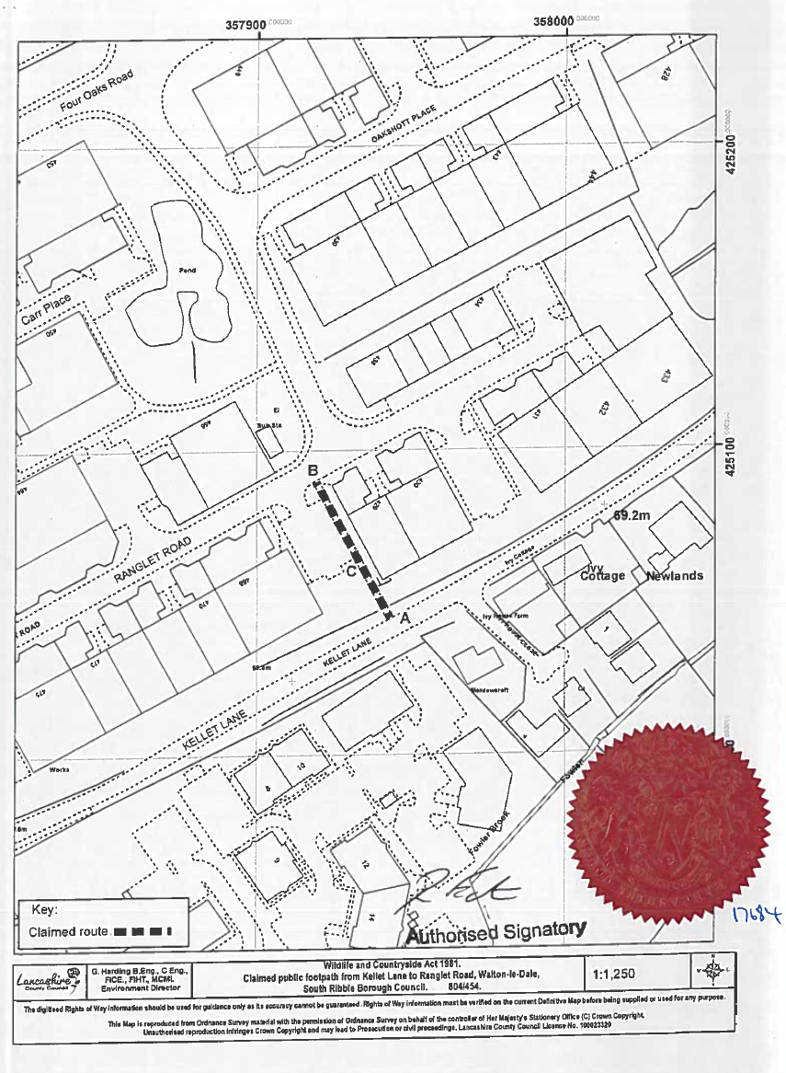
Not to scale

