
Weatherbury College
Model management accounts
For the period to 31 January 202X
Contents
Instructions for using this management accounts model 3
Summary Income and Expenditure Account 4
Summary KPIs 4
1. Executive Summary 5
2. Financial Health 7
3. Income & Expenditure 8
Forecast position 9
Income 9
Pay Costs 10
Non-pay costs 10
EBITDA 11
Learner Numbers 11
4. Balance Sheet 12
5. Cash 14
6. Loans 16
7. KPIs 17
8. Capital 18
9. Risks and Sensitivities 19
10. Issues for further review 20

Instructions for using this management accounts model

Delete this page before producing your accounts.
- If you want to use the example tables given in this document, these can be found in the separate excel file called Management accounts – tables. These tables currently contain the exemplar data. You should link this excel file to your own management accounts to show your own data instead.

- To insert tables into this Word document, find the relevant table in the excel file called Management accounts – tables. The name of the excel worksheet where the table is located is shown above each table in this document.

- Select the table in the excel worksheet, copy it, and in the Word document, use Paste Special ‘as picture’. You can also paste it as an embedded spreadsheet instead of a picture, but this will require adjustment of the size and format of the embedded sheet to fit the document.
This model can be amended throughout to suit your college’s particular operating characteristics.

Summary Income and Expenditure Account

The table below can be found in the Management accounts – tables spreadsheets, in the worksheet titled: Summary I&E

Summary KPIs
The table below can be found in the Management accounts – tables spreadsheets, in the worksheet titled: Summary KPIs

Executive Summary
Income and Expenditure Account
Indicator | Current Status | RAG | Change
Operating surplus/ deficit | Forecast outturn is £242k behind budget at £262k deficit. | ●  Red | Decreased
Income | Total income is £202k lower than budget and forecast to be £356k lower than budget by the end of the year. Main issues are ASF and HE. | ●  Red | No change
Pay costs | Total pay costs are £84k less than budget after 6 months and this is forecast to further improve to £216k under budget by the end of the year. | ●  Amber | Increased
Non-pay costs | Non-pay costs currently £28k over budget and forecast to be £110k higher than the budget by the end of the year. Small overspends forecast on several lines. | ●  Amber | Decreased
EBITDA | EBITDA is a £37k deficit at 31 January 202X. Forecast for the year is a surplus of £655k (3.2% of income) which is £250k worse than budget. | ●  Red | Decreased

Balance Sheet
Indicator | Current Status | RAG | Change
Cash | Year-end balance will reduce by £700k as insufficient cash being generated to cover debt servicing and planned capital expenditure. Cash will be £200k lower than budget. | ●  Amber | Decreased
Capital Programme | All planned capital expenditure on track. | ●  Amber | No change
Asset Disposals | No major asset disposals planned. | ●  Amber | No change
Covenant compliance | Current full year forecast indicates that the college will breach two of the three covenants. The DfE has been informed of the risk. Discussions are on-going with the bank and external auditors. | ●  Red | Decreased

Financial Health
Indicator |  | Current Status | RAG |  | Change
Financial Health | Full year forecast is for 120 points and results in a grade of ‘Requires Improvement’. A further small worsening of the EBITDA position for the year could cause the financial health grade to slip to ‘Inadequate’. |  |  | ●  Red | Decreased

The operating performance for the year to date is a deficit of £575,000, which is £150,000 worse than the budget. This is principally accounted for by a shortfall in income to date of £202,000. The adverse performance to date is forecast to continue to the year-end; the base case estimate is a forecast operating deficit for the year of £262,000 (£242,000 adverse to budget). Pay costs although lower than budget are forecast to be c.68% of total income which is higher than the FEC financial benchmark of 65%.
The forecast deficit is projected to result in a breach of loan covenants at year-end. The college has informed the DfE of the risk and is also actively engaged with the bank to secure a waiver, pending further dialogue to review the current covenants. If agreement cannot be reached with the bank to maintain existing terms, including the interest rate, the reclassification of colleges into the public sector means that the DfE will need to be informed. No new interest rate agreement can be entered into without their consent.
Financial health is forecast to remain requires improvement, though with minimal headroom above the threshold for inadequate. Failure to secure timely agreement with the bank and external auditors regarding the loan covenant would mean that the debt is reclassified as a current liability and almost certainly result in a decline in the financial health grade to inadequate.
Since reclassification, the college’s key income monthly streams are now received in a ‘flatter’ annual profile, which has led to a more stable cash position, although some monthly fluctuation remains. Cash reserves are relatively healthy at £2.09 million at the end of January 202X and remain adequate to the year end. However, the weak operating performance remains a serious concern, and, despite the flatter profile, cash reserves will steadily erode over time unless the college can improve its underlying operating performance.
As noted, the forecast operating deficit is £262,000. Targeted actions are being implemented aimed at reducing costs in-year by £242,000 and closing the projected £139,000 shortfall in the Adult Skills Fund (ASF) income. Taken together these could achieve a small operating surplus by year-end of £119,000 (best case). However, in the event that further possible shortfalls in income by year-end materialise, there is a risk (worst case) of the operating deficit increasing to £472,000. Please refer to section 9 to see these best case and worst case operating scenarios modelled in full.

Financial Health
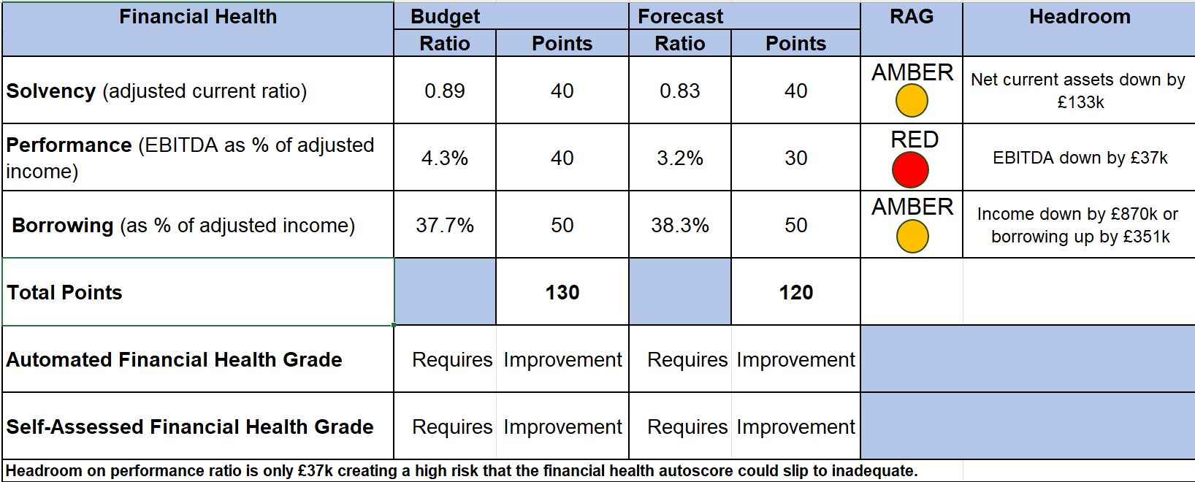
The table below can be found in the Management accounts – tables spreadsheets, in the worksheet titled: Fin Health

The full year forecast predicts a financial health score of 120 points, which is at the low end for being assessed as ‘requires improvement’. Again, it is the adverse EBITDA performance which has reduced the autoscore from the budgeted position. The significant concern as shown in the headroom column above is the very high risk that any further slippage will cause the college to be assessed as inadequate. A further deterioration in the EBITDA performance of just £37,000 could trigger this.

Income & Expenditure
The table below can be found in the Management accounts – tables spreadsheets, in the worksheet titled: I&E
Currently, total income is £202,000 lower than the year-to-date budget but is partially offset by an underspend on pay expenditure of £84,000. Total non-pay expenditure is slightly overspent by £28,000. This means that the year-to-date operating deficit is c.£150,000 worse than budget.

Forecast position
The table below can be found in the Management accounts – tables spreadsheets, in the worksheet titled: I&E Bridge

Income
Total income for the year is forecast to be £356,000 lower than budget, a shortfall of approximately 1.7% of total budgeted income. The two main issues on income so far are in ASF and HE fee income.
A summary of the position with ASF funding is as follows (note the different reconciliation tolerances applicable to each of our contracts):
The table below can be found in the Management accounts – tables spreadsheets, in the worksheet titled: ASF
Despite increased marketing of the ASF offer, the competitive nature of the local market has created difficulties in recruiting learners to some of our courses, resulting in a forecast claw back of £139k.
With a slight increase in forecast recruitment in the remainder of the year, it should be possible to deliver above the reconciliation tolerances on both contracts, meaning that there is then no liability to return any funding, and this will be kept under close review in future months. Until this improvement is secured, however, the full £139k current forecast of claw back has been included in the forward cash flow forecast.
The HE fees income is currently £45,000 below the budget, and as there is no further in year recruitment of full-time learners, the shortfall of income is expected to increase to £92,000 by the end of the year. The full-time learners are forecast to be 10 fewer than our target.

Pay Costs
Total teaching staff costs are forecast to be £88,000 (1%) underspent by the end of the year, due to unfilled vacancies partially offset by higher sessional staff, combined with actions planned to minimise costs on remaining ASF delivery where possible. There is also an underspend in non-teaching staff.
The budget was prepared on the assumption that all establishment roles would be fully occupied during the year, but some cost savings have arisen due to vacancies.
Total pay costs as a percentage of turnover are forecast to be c68%. This is 3% over the FEC financial benchmark. We will be focusing on how we can improve this ratio as part of our budget planning for next year and have targeted a further £82k of in year cost savings through a temporary recruitment freeze unless it is a critical post.

Non-pay costs
The total non-pay expenditure is expected to finish the year £110,000 worse than the budget. This is due to several different areas including:
- Central admin - forecast £30k overspend on photocopying and stationery;
- Marketing – forecast £15k overspend on an additional radio campaign to try and make up ASF student target shortfall;
- Premises – forecast £33k overspend due to higher than expected increases in utility charges, and some urgent maintenance work on the main site;
- IT – forecast £31k overspend due to an increased requirement for additional student laptops. This has been offset fully by a saving on education supplies and services. We have requested all budget holders try to identify in year savings from their remaining budgets, with a college-wide target of £160k. We will report on progress with this initiative in the February management accounts.

EBITDA
Total EBITDA is currently showing a deficit of £37,000 for the year-to-date and is forecast to be a £655,000 (3.2% of total income) surplus by the end of the year. This is against a full year budget target of £905,000 (4.3% of income), a shortfall of £250,000, and over £1m lower than last year. The additional targeted cost savings on both pay and non-pay are not included in the full year forecast as we do not yet have certainty on whether they can be delivered.

Learner Numbers
The table below can be found in the Management accounts – tables spreadsheets, in the worksheet titled: Learner numbers

Balance Sheet
The table below can be found in the Management accounts – tables spreadsheets, in the worksheet titled: Bal Sheet
The balance sheet as of 31 January 202X has net current liabilities of £1.04m, giving an adjusted current ratio of 0.82. This is a significant movement from the opening balance sheet position, which had net current liabilities of £256,000. The main reason is a reduction in the current assets balance due to less cash, and lower debtors.
By the end of the year, we expect net current liabilities to be £992,000 against a budget of £755,000, which is £237,000 worse than expected. The primary reason for this is the expected under performance as highlighted above causing a lower than planned cash balance at the year end. The forecast current ratio is 0.83 against the budget of 0.89. This shows a deterioration in the solvency position from the start of the year when the adjusted current ratio was just over 1.
The tables below can be found in the Management accounts – tables spreadsheets, in worksheet titled: Drs & Crs
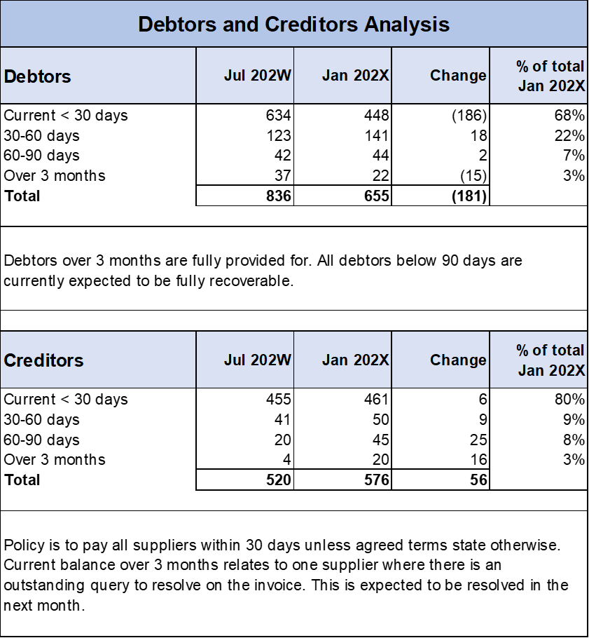

Cash

The graph below can be found in the Management accounts – tables spreadsheets, in worksheet titled: Cash graph

The deterioration in solvency above is a direct impact of reducing cash balances. The current cash balance is c£2.09m, which represents 38 days cash in hand. Whilst this is still a relatively healthy level of cash, it is declining, and that is not a sustainable position for future planning.
The projected cash balance at the year-end is just under £2.1m. This will mean that overall cash balances will have reduced by c£700,000 for the full year. The low point in the cash forecast is expected to be at the end of April, with a projected balance of around £1.5m, representing 27 days cash in hand.
The budget plan for the year committed to utilising some of the cash reserve to provide much needed investment in capital equipment. The budget had planned to generate just over £900,000 of cash from operations during the year, with the majority of this cash (£720,000) being required to meet the loan repayments. The capital budget agreed for the year was £700,000 meaning that we would need to dip into cash reserves by around £500,000 this year.
The underperformance on some income lines means that we will now only generate enough cash in year to meet our debt servicing, with nothing left to go towards our planned capital expenditure. Therefore, we will require c£700,000 of our cash reserves this year to fund the capital. This underlines the need to improve EBITDA performance going forward to avoid a continuing decline in cash reserves.

The table below can be found in the Management accounts – tables spreadsheets, in the worksheet titled: Cash use

The cashflow reflects the forecast position in the income and expenditure schedule, including a potential total repayment of ASF funding of £139,000; this is shown in December 202X.

The table below can be found in the Management accounts – tables spreadsheets, in the worksheet titled: Cash
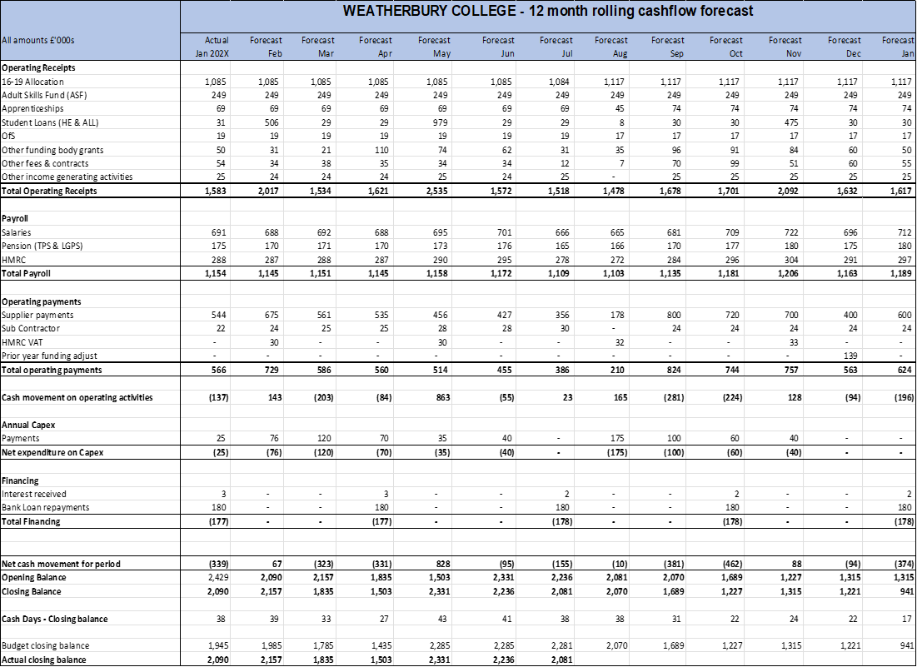

Loans
The table below can be found in the Management accounts – tables spreadsheets, in the worksheet titled: Loans

The long-term loan, which currently has an outstanding balance of c£8m is being repaid at a rate of £180,000 per quarter. The full year forecast is projecting that two of the three covenants will be breached.
You will recall when the budget was agreed the debt service cover covenants was highlighted as a major risk, as there was virtually no headroom in the ratio. Given the adverse performance, it is now very unlikely that we will be able meet that covenant test. In addition, the forecast EBITDA means that we are also likely to breach the net borrowings to EBITDA ratio.
Dialogue is ongoing with the bank to secure a waiver or agreement not to measure covenants at year-end and retain existing terms. If agreement cannot be reached, and the bank loan has to be re-classified as a current liability, this will impact adversely on the solvency ratio and almost certainly push the financial health into inadequate. The DfE has been informed of this risk, since due to sector reclassification, the college will need to seek permission from the DfE for refinancing if the bank is unwilling to retain existing terms following the breach of covenant.

KPIs
The table below can be found in the Management accounts – tables spreadsheets, in the worksheet titled: KPIs
It is worth noting that the college is not expecting to meet any of the Further Education Commissioner (FEC), financial benchmarks with the exception of cash days if we achieve budget. Whilst these are issued as target financial indicators and are for guidance only, it does signal that the college has some underlying financial weaknesses that we need to address with future financial plans. The KPI schedule also highlights that we are operating average class sizes that are too small, and this must be a key priority to address in curriculum planning for 202X/2Y to help improve underlying efficiency.
An analysis of forecast contribution for the current year by curriculum area is available in the appendices.

Capital
The table below can be found in the Management accounts – tables spreadsheets, in the worksheet titled: Capital
The capital expenditure plan for the year is largely on track, with a small projected underspend of £10k for the year. The refectory upgrade is progressing well and is expected to be ready for full operation after the February half term, as planned. There has been a delay to the relocation of electrical due to a supplier issue, and this work will now be completed during the Easter holiday period.

Risks and Sensitivities

The table below can be found in the Management accounts – tables spreadsheets, in the worksheet titled: Risks & Sensitivities
The above schedule shows some scenario planning for three key variables in the full year forecast. The best case scenario assumes that we can find the additional costs savings referred to earlier and manage to deliver above respective reconciliation thresholds for both grant-funded and devolved elements of ASF. In this scenario EBITDA would be slightly better than budget, and the college would not be in breach of its loan covenants and financial health would remain as ‘requires improvement’. In the worst case scenario, where additional cost savings are not achieved and we suffer further income reductions, the EBITDA position would worsen, cash balances would fall below £2m, and financial health will be ‘inadequate’.

Issues for further review

The table below can be found in the Management accounts – tables spreadsheets, in the worksheet titled: Issues for further review

Footnote on appendices.
There are four further tables that can be included to cover:
- Contribution analysis
- Staff numbers
- Sub-contracting activity
- Trading activities & projects
The tables for these schedules can be found in the Management accounts – tables spreadsheets. The worksheets are named to match the tables.

© Crown copyright 2026
This publication is licensed under the terms of the Open Government Licence v3.0, except where otherwise stated. To view this licence, visit nationalarchives.gov.uk/doc/open-government-licence/version/3.

Where we have identified any third-party copyright information, you will need to obtain permission from the copyright holders concerned.

About this publication:

enquiries https://www.gov.uk/contact-dfe
download www.gov.uk/government/publications
Follow us on X: @educationgovuk
Connect with us on Facebook: facebook.com/educationgovuk

