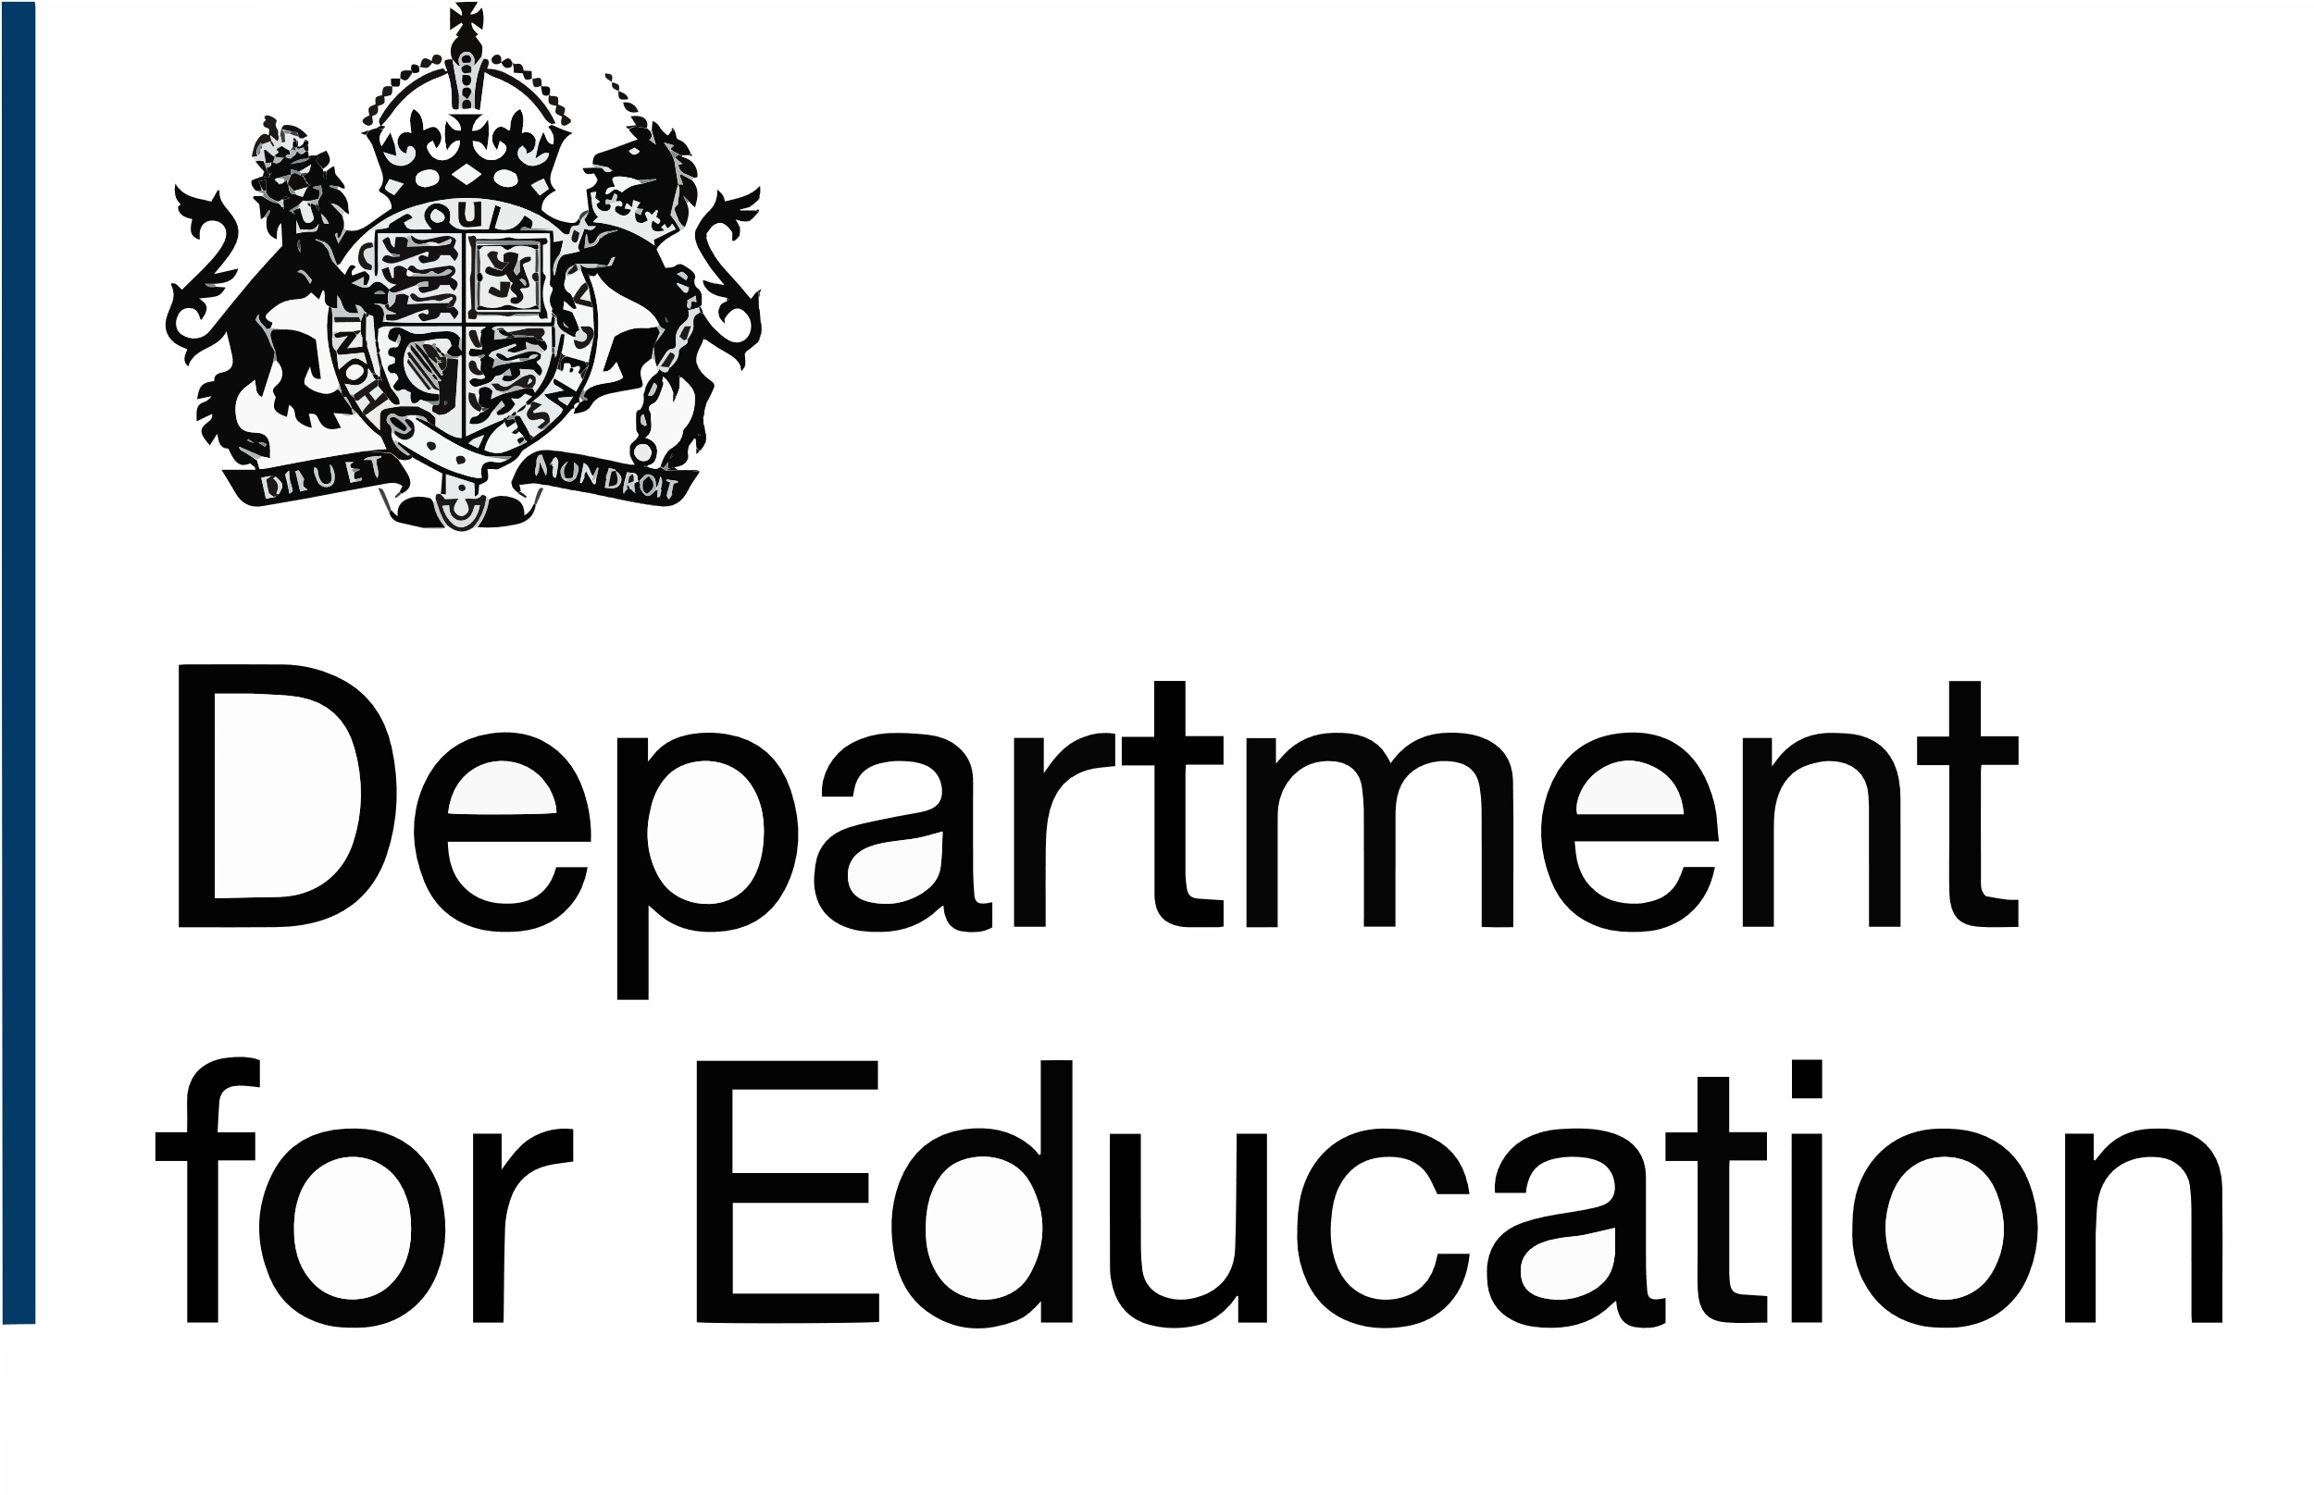

Child and Family Assessed and Supported Year in Employment (ASYE): Professional development plan (PDP) (0 to 3 months)
To be completed by the NQSW:
- Consult your final PDP from your pre-qualifying/university course (if you have one) to help you self-assess against the Post qualifying standards (PQS): knowledge and skills statements (KSS) and Professional capabilities framework (PCF) as this will enable you to identify your learning objectives in this first ASYE PDP
- Write a minimum of three and a maximum of five learning objectives in a SMART way (i.e., Specific, Measurable, Achievable, Realistic and Time-bound)
- Your learning objectives could relate to your practice, the legislation/policy/procedures, development of critical reflection and analysis, development of self (your experience, knowledge, values, confidence, resilience, emotional wellbeing)
- The evidence for the fourth column (‘Using a specific example from practice…’), should be completed at the end of the review period. By this time, you’re likely to have undertaken a piece of practice that will demonstrate how your learning has changed your practice and impacted people you were supporting.

Period covered (for example, first quarter 2026]:
Learning objective | Links to PQS and PCF | How will I meet the objective and what support will I need to meet this?  Development activity and planned action(s) | Learning objective achieved.  Using a specific example from your practice, show what you did differently (because of your learning activity) and the impact on the people you were supporting | Timescale:  Expected date for completion/review
© Crown copyright 2026

