PFI Contract
Management Guidance

Contract Management Plan
Toolkit 1: CMP Template – An annotated template to support the development of a CMP for your PFI contract
PFI Centre of Excellence
Published 2026

Contract Management Plan
Toolkit 1: Contract Management Plan Template
This Contract Management Plan (CMP) template is designed to support PFI contract managers and their teams in developing a structured, practical plan for managing their contract.
The CMP is not a one-size-fits-all document. It should be tailored to reflect the specific characteristics of your contract, its complexity, maturity, risk profile, and available resources. You are encouraged to build the CMP in layers, starting with the most critical sections and expanding over time.
Key Principles for Using This Template
- Start with what you know: Use existing documentation, contract reviews, and team knowledge to populate the template.
- Be proportionate: Not every section needs to be completed in full. Focus on what matters most for your current priorities.
  - Phased: Start with the most critical sections.
  - Event-Drive: Use key events as triggers to develop or update.
  - Comprehensive: Develop the CMP in a coordinated approach.
- Use it actively: The CMP is a live document. It should be reviewed regularly and updated following key events (e.g. variations, refinancing, expiry planning).
- Support continuity: The CMP helps ensure that knowledge is retained and shared across the team, especially during staff changes or transitions.
- Reference, don’t repeat: Where possible, link to source documents (e.g. contract schedules, risk registers) rather than duplicating content.
✅ Alignment and Deliverability Checklist
- Does the CMP reflect the strategic intent and priorities set out in your CM Strategy.
- Does the Intelligent Client Function have the capacity and capability to implement?
- Are the governance arrangements well defined, practical and proportionate?
- Have you been transparent about any rights or activities that won’t be exercised and explain why.
This template includes:
🎯 Purpose of this Section
📄 What to Include
🔍 Where to Find the Information: including references to the contract or guidance
🧰 Template Text: suggested text which you may wish to edit and included in your CMP. Note this is only provided for some section where it enhances the ‘What to Include’ section
Red text provides guidance on what to include or where to find information
Blue text provides draft text or example text
This template does not replace the Project Agreement or other contractual documents. It is a tool to support their effective implementation.

[Insert Logo]

[Project Name] PFI Contract

Contract Management Plan
[Insert Site Image]

Version Number:
Date:

Version Control

Version Number | Changes | Author | Approver | Date Approved

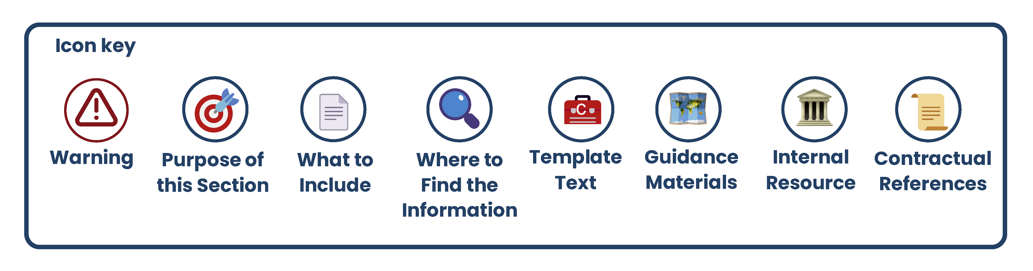

Contents
1. Introduction and Purpose 7
2. Contract Summary and Overview 8
3. Governance, Roles, and Stakeholder Interfaces 15
4. Intelligent Client Function 17
5. Stakeholder Engagement and Communications 19
6. Knowledge Management and Continuity Planning 21
7. Management Information and Authority Information Rights 23
8. Performance Management 25
9. Asset and Environmental Management 27
10. Operational Risk, Contingency Planning, and Service Continuity 29
11. Financial Management 31
12. Refinancing 33
13. Change Management and Variations 35
14. Benchmarking, Market Testing, and Value for Money 37
15. Legal and Regulatory Compliance 39
16. Contractual Protections 40
17. Insurance Management 41
18. Land, Lease and Property Arrangements 42
19. Contractual Interfaces and Dependencies 43
20. Workforce and Employment Matters 44
21. Intellectual Property and Information Management 46
22. Disputes Resolution 47
23. Exit, Termination and Expiry Planning 48

- Introduction and Purpose
🎯 Purpose of this Section
To explain the role of the CMP, its relationship to the CMS, and how it supports effective contract management.
📄 What to Include
Items to Include | Included? | Notes / File Reference
Purpose and scope of the CMP
Link to the Contract Management Strategy (CMS)
Live and evolving nature of the CMP
Intended users of the CMP
Review and update process
🔍 Where to Find the Information
- Your Contract Management Strategy (and CMS Guidance).
- Contract Management Plan Guidance.
🧰 Template Text
This Contract Management Plan (CMP) sets out how the [Project Name] PFI contract will be managed throughout its life. It provides a structured, operational plan for delivering the contract effectively and consistently, and is intended to be used by the contract management team and wider stakeholders.
The CMP is developed in alignment with the Contract Management Strategy (CMS) and translates its strategic intent into day-to-day delivery. It supports key contract management activities such as governance, performance monitoring, risk management, financial oversight, and change control.
The CMP is a working document that supports the contract team in their day-to-day responsibilities. It provides a single reference point for how the contract is managed, helping to ensure continuity, consistency, and informed decision-making. It should be used actively to guide meetings, track obligations, respond to issues, and onboard new team members.
This CMP will be reviewed annually by the Contract Manager and updated as required. Updates may also be triggered by significant events such as variations, refinancing, expiry planning, or changes in personnel. All updates will be subject to approval by the Senior Responsible Owner (SRO). Version control is maintained to ensure users are working from the most current version.
⚠️ This CMP does not override the Project Agreement. The Project Agreement is the legally binding document and takes precedence in all cases. The CMP is a practical tool to support its implementation—not a substitute for it.
- Contract Summary and Overview
🎯 Purpose of this Section
To provide a concise overview of the contract, including key facts, parties, and structure. This helps orient new users, supports continuity, and provides a reference point for key contractual information.
📄 What to Include (see templates below for more details)
Items to Include | Included? | Notes / File Reference
Project name and summary
Key dates and milestones
Financial overview
Contracting parties and key personnel
Occupiers and users
Contract structure and timeline
Linked agreements or third-party arrangements
🔍 Where to Find the Information
- Document Stocktake outputs.
- Project Agreement and Schedules, and the Contract Review output if completed.
- Project Financial Model.
- Companies House for information about the PFI Co.
- HMT PFI Data Return.
- Other internal stakeholders (you may also ask the PFI Co or Service Providers if you cannot locate the information internally).

🧰 Template Key Information Table
Note that this table is the same as the one found in Toolkit 2 (Based Data) in the Contract Review Guidance. Blue text provides illustrative examples.
Key Contract Information
HMT ID number | The HMT code and name used against reference. If unsure, then can be sought via www.gov.uk
Project Name
Project Summary | Provide a summary of the key elements of the contract purpose, assets and services  The contract provides for the build of 5 new secondary schools and ongoing maintenance and facility management services. Additional service provided to manage the school library services.  The schools are located as follows:  John Inverdale School – Ox Lane, DS1 3PX  Anaheim School, Sea Road DS23 2LM etc.
Date of Financial Close
Date of Construction Completion | Usually the construction period end date (completion certification may have been issued). If construction end was phased, you may wish to include these dates too)
First Date of Operations | Usually the Service Commencement Date. This may be the last date of the construction phase. Where construction end was phased then you may wish to include subsequent phases of service commencement.
Date of 1st Operations | The date where the construction phase is complete, and all requirements have been met to enable the facility to move into the operational phase, including the issuing of the certificate of Availability.
Expiry Date | The date at which the contract expires through the effluxion of time. If there are break clauses you may wish to capture these here
Capital Value £m | This is the total nominal capitalised costs of the project as recorded in the financial model at financial close and forecast to be incurred during the core investment period. This should equate to the total project company debt plus total shareholder financing (equity and shareholder loans) plus any Authority capital contribution, all as committed at financial close.
Total Forecast Annual Unitary Charge (£m) | Insert the total forecast annual UC payment, make a note of whether this is nominal or outturn.
Remaining UC (£m) | Insert the remaining UC payable from the start of the FY to expiry, make a note of the current FY and whether the UC is nominal or outturn
Index Regime | Insert details of the index regime use to calculate future unitary charge payments e.g. CPI, RPI, AWE
On/Off Balance Sheet (IFRS) | International Financial Reporting Standards (IFRS) are a set of accounting standards developed by the International Accounting Standards Board (IASB) that provide guidance on how to prepare and present financial statements.
On/Off Balance Sheet (ESA) | Each PFI / PF2 is assessed under the ESA rules applying at the time it reached financial close. Eurostat has not, to date, required older PFIs recording to be reassessed under the latest rules unless contractual changes have occurred that would change the recording under ESA. Where contractual changes have occurred, the contract should be reassessed under the rules applying when the contract changes took place. A Guide to the Statistical Treatment of PPPs is available here
Bond or Debt Financed | Insert details of financing arrangements. You may wish to include the size of the bond/debt, its final repayment dates and interest/coupon rate.
Payment Mechanism Type
Benchmarking/Market Testing Frequency
Insurance Review Frequency
Other periodic events | Insert other key periodic contract events
Contracting Authority’s Information
Contracting Authority | Insert the contracting authority’s name – this is typically the public body who is party to the PA
CA’s Senior Responsible Owner | Insert name and role
Authority Representative | This role is typically defined in the Project Agreement and is generally the contract manager.
Contract Manager | Insert name and role
Key People | Insert the names/role of key people in the contracting authority including service lead, finance manager, commercial lead, health & safety lead etc.
Sponsoring Department
Sponsoring Department
Department Sponsor Contact | Insert name and role
User Details
Senior User Representative(s) | Insert name and role of senior user representatives. This may be people in your organisation or external organisation e.g. Academy Trust
Occupiers | Insert details of occupiers and the scale of their occupation e.g. % of building, number of desks.
PFI Project Company (also known as SPV)
Company Name | This is the name of the counter party to the Project Agreement. Note it is not the service provider.
Company’s House Number | An 8-digit number for the PFI Project Company available from Company’s House where you can find statutory company records including accounts and ownership details.
Company Directors | Include the names of company directors and which shareholder they represent.
General Manager | Insert name and role
Key Personnel | Insert the names/role of key people including finance manager, commercial lead, lifecycle lead etc.
Management Service Provider | Insert the name of the management service provider to the PFI Project Company. The MSP typically provides staff and services to allow the PFI Project Company to carry out its duties. You should also note any common ownership between the PFI Project Company and the MSP.
Service Provider
Services Provider(s) | Insert the name of the service provider(s) to the PFI Project Company. This may include FM companies, housing management providers, care providers etc.
Key Personnel in Service Provider | Insert name and role. This may include general managers and leads for key service lines
Key Sub-contractors | Add details of any key sub-contractors – this may include OEM providers or those required to run the services day to day e.g. catering provider, fire systems companies  Security – Night Owl Ltd – 0135 754 254  Catering – Good Food Plc – 0164 247 259
Interfaces and Third Pary Agreements
Share Access | Littlemore Leisure Centre – shared access road
Utility Supply | Clean Power Ltd – supply of gas and electricity
Utility Network Provider | Network SW Ltd – gas networks provider
Contracting authority’s Sub-Tenant | Happy Nursery – tenant on adjoining authority land (not PFI) but catering provided

🧰 Template Contract Parties Diagram
You may wish to insert a diagram of the project structure like the example below.
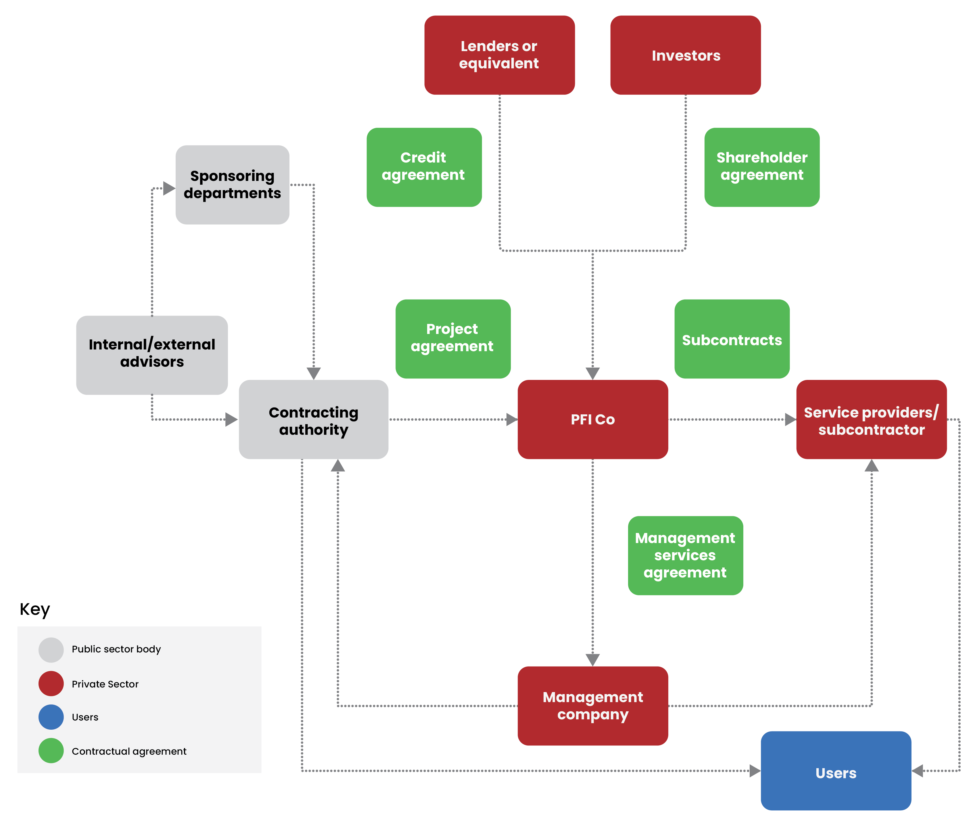

🧰 Template Contract Timelines
You may wish to insert a timeline of key historic and future contract events to serve both as a record of major events and to help with planning for future activity.
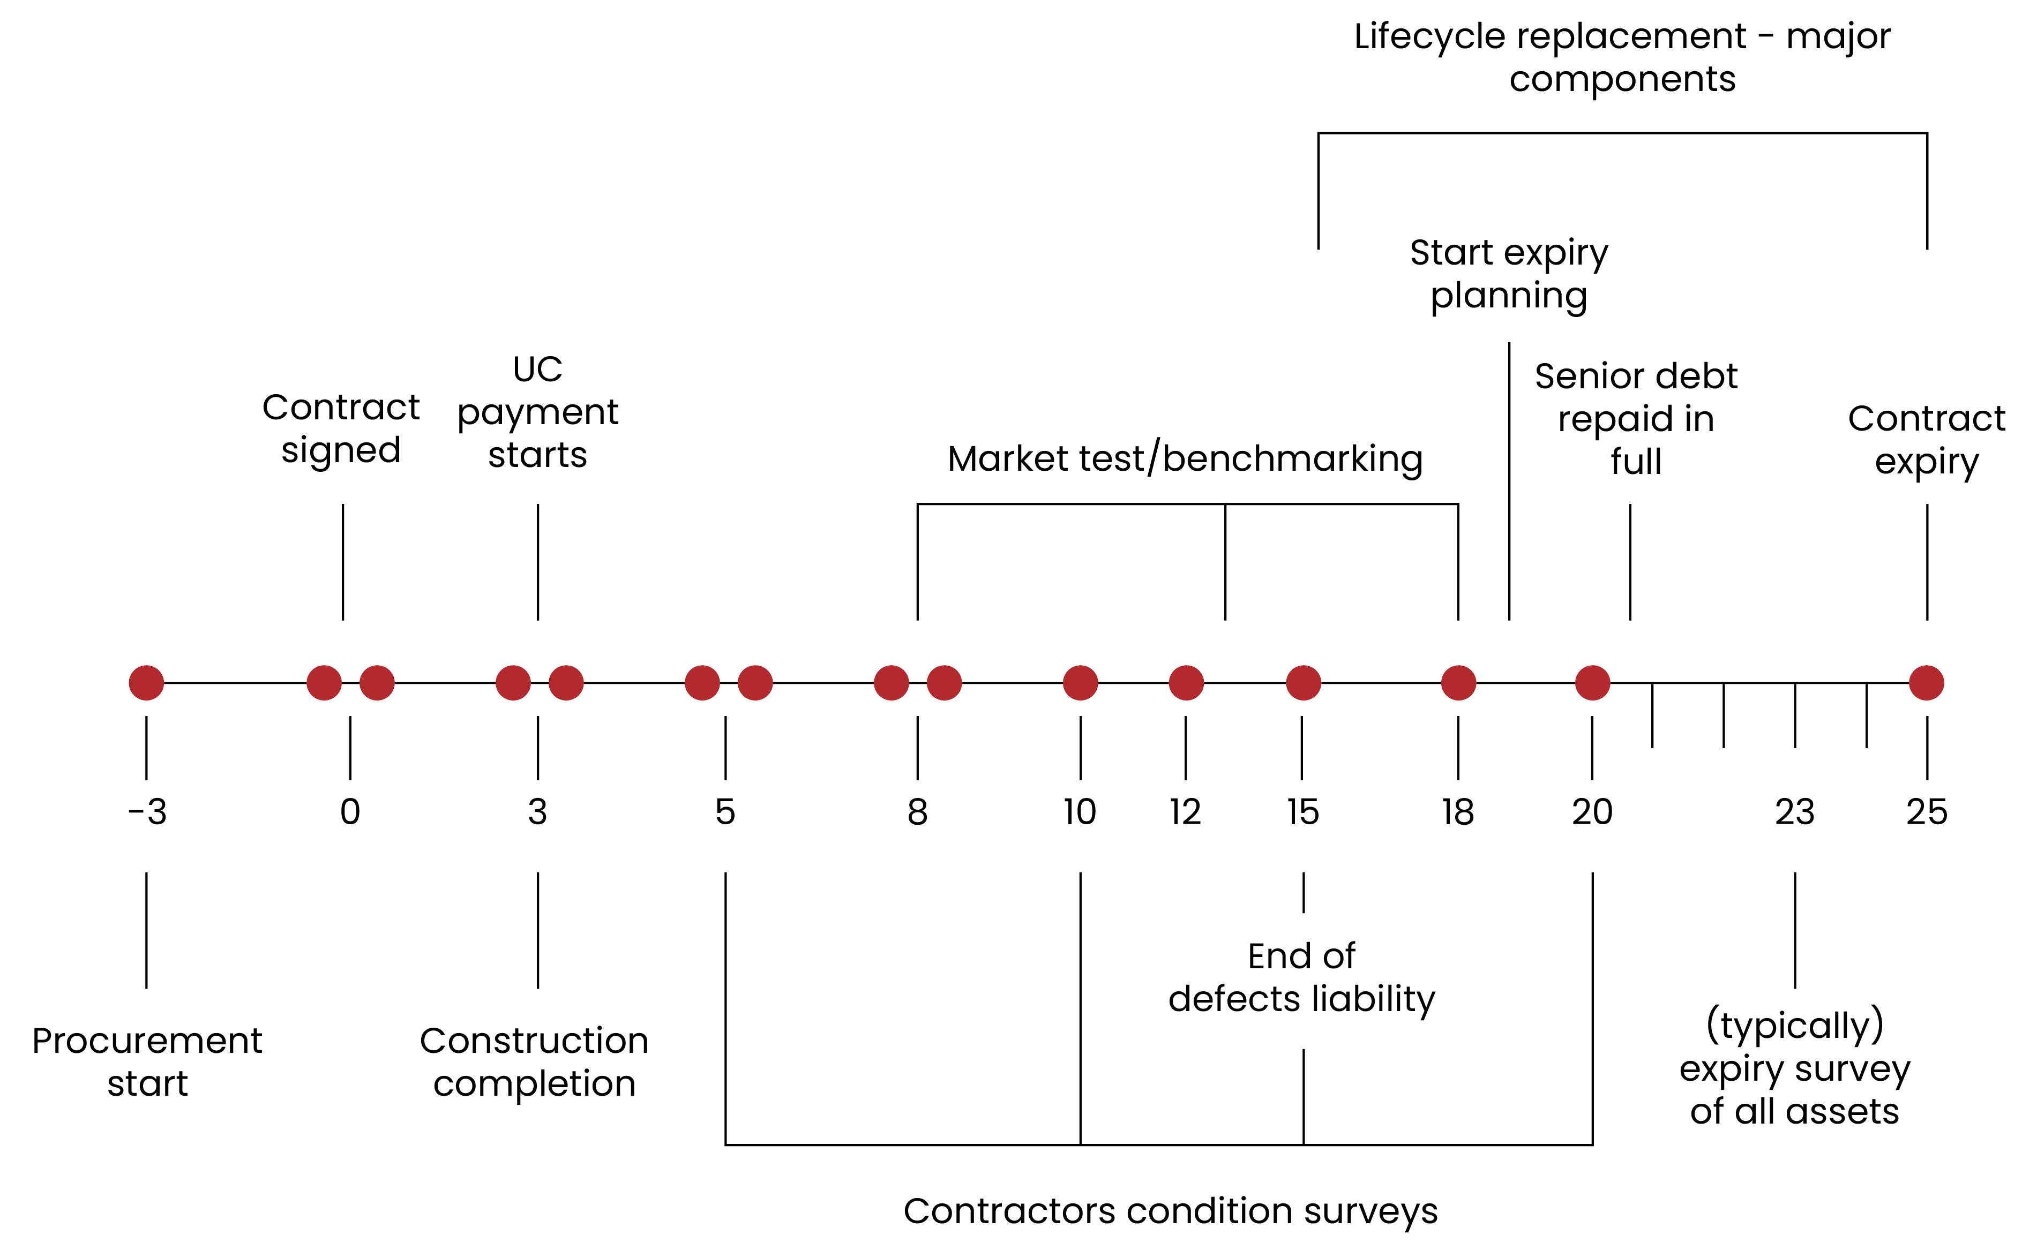
Milestone | Date | Notes
Financial Close | [dd/mm/yyyy] | Contract signed and funding secured
Construction Completion | [dd/mm/yyyy] | Practical completion achieved
Service Commencement | [dd/mm/yyyy] | Availability certificate issued
End of Latent Defects Period | [dd/mm/yyyy] | As defined in the contract
Expiry Planning Start | [dd/mm/yyyy] | Typically, 7 years before expiry
Contract Expiry | [dd/mm/yyyy] | End of contract term
🧰 Template Location of Key Documents
You may wish to add key documents; their location and date they were last update or current version number.
Document Title | File Location | Date
Project Agreement & Schedules | \SharedDrive\PFI\Legal\PA | 01/04/2020
Financial Model (Base Case) | \SharedDrive\PFI\Finance\Models\BaseCase.xlsx | 01/04/2020
Variations Register | \SharedDrive\PFI\Legal\Variations\Register.xlsx | 15/03/2025
Risk Register | \SharedDrive\PFI\Governance\RiskRegister.xlsx | 01/06/2025
Exit Plan | \SharedDrive\PFI\Expiry\ExitPlan.docx | 01/01/2025

- Governance, Roles, and Stakeholder Interfaces
🎯 Purpose of this Section
To describe how the contracting authority manages the contract through a structured governance framework, clearly defined roles and responsibilities, and a robust approach to risk and issue management. This section ensures that all parties understand who is responsible for what, how decisions are made, and how performance, compliance, and risks are monitored and escalated.
📄 What to Include
Items to Include | Included? | Notes / File Reference
Roles and Responsibilities
Key roles within the contracting authority
e.g. Authority’s representative, SRO, Contract Manager, Finance Lead
Key roles within the PFI Co and service providers
e.g. General Manager, Lifecycle Lead
Key users and tenants
Third parties and external stakeholders
e.g. Lenders, Government Departments
A RACI matrix or similar tool to clarify accountability and decision-making responsibilities
Governance Structures
Description of governance forums
Meeting schedules and frequency
Terms of reference and escalation routes
Delegated authority and decision-making protocols
Risk Management
How risks are identified, owned, mitigated, and reviewed
Use of internal and joint risk registers
Escalation and reporting processes
Links to governance meetings and assurance processes
🔍 Where to Find the Information
📜 Contractual References
- Authority’s Rights – for oversight, enforcement, and access powers
- Contractor’s Obligations – for service delivery, reporting, and cooperation
- Authority’s Representative and Contractor’s Representative – for formal roles and delegated authority
- Governance-related provisions, covering:
  - Joint liaison boards or governance groups
  - Meeting structures, escalation routes, and decision-making protocols
  - Risk allocation and issue management responsibilities
🗺️ Guidance Materials
- Governance Guidance
  - Appendix 1: Governance Elements – What Good Looks Like
  - Toolkit 2: Governance Mapping – to document current structures
  - Toolkit 3: Governance Effectiveness Review – to assess and improve arrangements
- Intelligent Client Function Guidance
  - Appendix 1: Core ICF Functions – for defining internal roles
  - Toolkit 2: ICF Capability Diagnostic – to assess capacity and resilience
- Contract Management Strategy
  - Sections on strategic leadership, stakeholder engagement, and risk appetite
- Contract Review Guidance
  - Toolkit 3: Clause Tracker – to extract and summarise relevant contractual provisions
- Gaps and Ambiguities Guidance
  - For identifying unclear or missing role definitions or governance mechanisms
🏛️ Internal Resources
- Organisational charts and team structures
- Internal RACI matrices and role descriptions
- Internal governance frameworks or escalation protocols
- Risk registers and issue logs
- Local policies on risk management, assurance, or decision-making

- Intelligent Client Function
🎯 Purpose
To describe the Intelligent Client Function (ICF) as the internal capability that enables the contracting authority to act as a strategic, informed, and empowered client in managing the PFI contract. This section outlines how the ICF supports both day-to-day contract delivery and long-term outcomes through commercial, technical, legal, financial, and operational functions.
📄 What to Include
Items to Include | Included? | Notes / File Reference
Definition of the ICF and its purpose
Summary of the ICF’s core functions
How the ICF supports governance, performance monitoring and contract events
Description of ICF structure and resourcing
Alignment with wider contract management framework
🔍 Where to Find the Information
📜 Contractual References
- Authority’s Representative – defines the formal role and delegated authority typically associated with the ICF lead
🗺️ Guidance Materials
- Intelligent Client Function Guidance
  - Appendix 1: Core ICF Functions – defines the full range of ICF responsibilities
  - Toolkit 1: Context Mapping Worksheet – to align the ICF with contract needs
  - Toolkit 2: ICF Capability Diagnostic – to assess current maturity and gaps
  - Toolkit 3: ICF Calculator – to estimate required FTEs and sourcing strategies
- Contract Management Strategy
  - Sections on resourcing, capability, and strategic alignment of the ICF
- Governance Guidance
  - For how the ICF supports governance structures and decision-making

🏛️ Internal Resources
- ICF team structure and job descriptions
- Internal workforce plans
- Training and succession planning materials
- Local sourcing strategies (e.g. make/buy/borrow models)

- Stakeholder Engagement and Communications
🎯 Purpose of this Section
To describe how the contracting authority engages with internal and external stakeholders, including service users, to support effective contract management. This includes defining communication protocols, engagement methods, and how stakeholder feedback informs performance monitoring and service improvement.
📄 What to Include
Items to Include | Included? | Notes / File Reference
Stakeholder Identification
Identification of internal and external stakeholders
e.g. internal: SRO, Contract Manager, ICF, service users, sponsoring departments
e.g. external: PFI Co, service providers, lenders, regulators
Consider tools such as:
- A stakeholder map to visualise relationships and influence.
- A stakeholder register to track contact details, roles, and engagement needs.
- A power-interest matrix to prioritise engagement strategies.
Engagement and Communications Protocols
Internal and external engagement methods, such as:
- Internal methods: team briefings, dashboards, shared drives, internal newsletters.
- External methods: governance meetings, site visits, user forums, formal correspondence.
Define escalation routes and feedback loops
Cross reference relevant governance forums (see section 3)
Feedback Mechanisms
Outline how feedback is gathered
e.g. surveys, complaints, user forums
Explain how feedback is reviewed, escalated, and used to inform performance monitoring and service improvement
Explain linkage to performance management and change control processes
Integration with Governance
Describe how stakeholder engagement supports transparency, accountability, and continuous improvement
Reference governance documents, terms of reference, and reporting structures
🔍 Where to Find the Information
📜 Contractual References
- Monitoring Schedule – for provisions on user involvement in service monitoring or feedback
- Payment Mechanism Schedule – where user satisfaction or service quality may influence deductions or incentives
- Governance-related provisions – for escalation routes and joint communication forums
🗺️ Guidance Materials
- Governance Guidance
  - Appendix 1: Governance Elements – What Good Looks Like – includes stakeholder engagement as a core governance element
  - Toolkit 2: Governance Mapping – to identify internal and external engagement structures
- Intelligent Client Function Guidance
  - For how the ICF supports stakeholder engagement and communication
- Performance Management Guidance (if available)
  - For how stakeholder feedback informs service monitoring and improvement
🏛️ Internal Resources
- Stakeholder maps or engagement plans
- Communication protocols or templates
- Records of user feedback, surveys, or complaints
- Escalation procedures and contact directories
- Meeting schedules and terms of reference for stakeholder forums

- Knowledge Management and Continuity Planning
🎯 Purpose of this Section
To describe how the contracting authority manages contract-related knowledge, documentation, and continuity planning. This includes protocols for document management, onboarding, succession planning, and lessons learned, ensuring that knowledge is retained and accessible throughout the contract term.
📄 What to Include
Items to Include | Included? | Notes / File Reference
Document and Records Management
Systems and tools used
e.g. shared drives, document management systems
File naming conventions, version control, and access protocols
Location of key documents
e.g. Project Agreement, risk register, variation log
Knowledge Retention and Transfer
How contract-specific knowledge is captured and shared
e.g. handover notes, knowledge hubs, user guides
Use of lessons learned logs or post-incident reviews
Succession Planning and Onboarding
Processes for onboarding new team members
e.g. induction packs, shadowing
Succession planning for key roles
e.g. Contract Manager, SRO
Use of role profiles and capability frameworks
Training and Capability Development
Reference to ICF capability development plans
Internal or external training resources
e.g. PFI Centre of Excellence materials
Continuity Planning
How continuity is maintained during staff turnover or organisational change
–Links to business continuity or disaster recovery plans
🔍 Where to Find the Information
📜 Contractual References
- Confidentiality and Data Protection clauses – for requirements on information handling and access
- Expiry and Handover provisions – for expectations around knowledge transfer and documentation at contract end
🗺️ Guidance Materials
- Intelligent Client Function Guidance
  - Appendix 1: Core ICF Functions – includes knowledge management and succession planning
  - Toolkit 2: ICF Capability Diagnostic – to assess continuity risks and capability gaps
- Contract Management Strategy
  - Sections on knowledge management, succession planning, and strategic resilience
- Governance Guidance
  - For how governance structures support knowledge retention and handover
🏛️ Internal Resources
- Document management systems and file structures
- Onboarding materials and role handover notes
- Succession plans and training records, or HR support
- Lessons learned logs or post-event reviews
- Policies on data retention, access, and confidentiality

- Management Information and Authority Information Rights
🎯 Purpose of this Section
To describe how the contracting authority’s rights to receive and request Management Information (MI) are exercised under the contract. This includes identifying what information is required, how it is used to support contract management, and how compliance with these obligations is monitored and assured.
This section ensures that the contracting authority’s contractual rights to information are clearly understood, actively used, and embedded in governance, performance, financial, and risk management processes.
📄 What to Include
Item | Included? | Notes / File Reference
Summary of MI obligations under the contract
e.g. monthly reports, helpdesk logs, lifecycle updates, insurance certificates
Authority’s rights to request additional information
e.g. audit, inspection, FOI, data access
How MI is used in governance and decision-making
e.g. dashboards, meeting packs, assurance reviews
Escalation routes for non-compliance or missing MI
Table or diagram of key MI flows
Include frequency, format, responsible party
Cross-references to related CMP sections (e.g. Performance, Financial, Risk, Expiry) to show how MI supports those areas
🔍 Where to Find the Information
📜 Contractual References
- Audit and Records Clauses – define the contracting authority’s rights to inspect, request, and audit information.
- Monitoring and Reporting Schedules – set out the frequency, format, and content of required reports (e.g. performance, lifecycle, insurance).
- Data Protection and FOI Clauses – outline obligations for handling, storing, and disclosing information.
- Refinancing, Insurance, and Lifecycle Clauses – may include specific MI obligations or notification requirements.
🗺️ Guidance Materials
- Contract Review Guidance
  - Use the clause tracker to identify MI related provisions

- Performance Management
🎯 Purpose of this Section
To describe how the contracting authority monitors, assures and manages service performance under the PFI contract. This includes how performance data is used to:
- Ensure services are delivered to the required standard.
- Identify and address risks early.
- Apply deductions or incentives in line with the contract.
- Inform governance, decision-making, and continuous improvement.
Performance management supports both day-to-day operations and strategic oversight. It is a key enabler of effective contract management and value for money.
📄 What to Include
Items to Include | Included? | Notes / File Reference
Performance Management Framework
Overview of how performance is monitored, assured and managed
Reference to relevant contract schedules (e.g. Schedule 5: Payment Mechanism)
Key Performance Indicators (KPIs) and Service Level Agreements (SLAs)
Description of the KPIs and SLAs used to assess service delivery
How these are measured, reported, and reviewed
Assurance Arrangements
Describe the PFI Co’s internal assurance regime (e.g. quality management systems, internal audits)
Describe the contracting authority’s own assurance activities (e.g. spot checks, independent audits, third-party validation).
Monitoring and Reporting Arrangements
Frequency and format of performance reporting
Roles and responsibilities for reviewing and validating performance data
Use of dashboards, helpdesk systems, or audit tools
Escalation and Issue Resolution
How underperformance is identified, escalated, and addressed
Links to governance forums (e.g. Operational Review, Management Meeting)
Deductions and Incentives
How deductions are calculated and validated
Any incentive mechanisms in place (if applicable)
Integration with Other Sections
Reference to lifecycle and asset performance (see Section 9)
Link to change control (Section 13) and risk management (Section 3 & 10)
🔍 Where to Find the Information
📜 Contractual References
- Monitoring Schedule – defines KPIs, SLAs, and performance monitoring obligations
- Payment Mechanism Schedule – outlines how deductions and incentives are applied
- Authority’s Rights and Contractor’s Obligations – establish oversight and reporting duties
- Helpdesk and Reporting Clauses – may be found in service-specific schedules
🗺️ Guidance Materials
- Document Stocktake Guidance
  - Toolkit 2: lists operational documents such as monthly reports, helpdesk logs, and annual service reports
- Intelligent Client Function Guidance
  - Appendix 1: Core ICF Functions – defines the ICF’s role in performance oversight
  - Toolkit 2: ICF Capability Diagnostic – to assess performance management capacity
- Governance Guidance
  - Appendix 1: Governance Elements – describes how performance is reviewed through governance
  - Toolkit 4: Operational Review Meeting Terms of Reference
- Performance Management Guidance suite
🏛️ Internal Resources
- Locally maintained trackers or dashboards (where used) to support performance oversight

- Asset and Environmental Management
🎯 Purpose of this Section
To describe how the contracting authority oversees the PFI Co’s responsibilities for maintaining asset condition, ensuring statutory compliance, and supporting environmental and sustainability objectives. This includes how lifecycle planning is monitored, how asset data is reviewed, and how environmental performance is integrated into contract management.
📄 What to Include
Items to Include | Included? | Notes / File Reference
Asset Management Oversight
How the contracting authority monitors the condition, performance, and statutory compliance of assets
Reference to asset condition surveys, maintenance schedules, and statutory testing
Lifecycle Planning and Capital Replacement
How lifecycle plans are reviewed and challenged
How the contracting authority ensures alignment between lifecycle delivery, asset condition, and the payment mechanism
Use of forward maintenance plans and independent surveys
Data and Reporting
What asset data is provided by the PFI Co and how it is reviewed
Use of asset registers, condition reports, and performance dashboards
Environmental and Sustainability Considerations
How environmental obligations are monitored (e.g. energy use, waste, emissions)
How the contracting authority supports or leads decarbonisation or sustainability initiatives
Reference to any local or national environmental targets
Integration with Expiry Planning
How asset condition and lifecycle delivery are linked to handback planning (see Section 23)
🔍 Where to Find the Information
📜 Contractual References
- Maintenance Schedule – sets out the PFI Co’s obligations for planned and reactive maintenance
- Lifecycle Schedule – defines lifecycle responsibilities, planning, and funding
- Environmental Obligations – may be included in the Output Specification or Contractor’s Proposals
- Construction Requirements / Contractor’s Proposals – describe the original asset design and performance expectations
- Payment Mechanism Schedule – links asset condition and availability to deductions
- Expiry and Handover provisions – define asset condition requirements at contract end
🗺️ Guidance Materials
- Performance Management Guidance: For monitoring asset-related KPIs and statutory compliance
- Asset Condition Playbook: Provides guidance on assessing and managing asset condition throughout the contract term.
- Expiry Guidance: Covers asset handback standards and alignment with lifecycle delivery
- Intelligent Client Function Guidance Appendix 1: Core ICF Functions – includes technical oversight and lifecycle planning
- Decarbonisation Guidance: For integrating environmental and sustainability objectives into contract management
🏛️ Internal Resources
- Locally maintained asset registers, condition surveys, or lifecycle trackers (where used) to support oversight and planning

- Operational Risk, Contingency Planning, and Service Continuity
🎯 Purpose of this Section
To describe how operational risks are identified, managed, and mitigated, and how contingency and continuity plans are developed and maintained. This includes the roles of both the contracting authority and the PFI Co in ensuring service continuity during disruptions, emergencies, or other unplanned events.
📄 What to Include
Items to Include | Included? | Notes / File Reference
Operational Risk Management
Reference Section 3 (Governance) for the overall risk management framework
Describe how operational risks are identified, categorised, and monitored
e.g. service disruptions, system failures, staffing shortages
Explain how these risks are linked to contingency and continuity planning
Contingency Planning
PFI Co’s obligations for business continuity and disaster recovery
Contracting authority’s role in reviewing, approving, and testing contingency plans
Frequency of plan reviews and updates, and how they are documented
Service Continuity Protocols
How continuity of service is maintained during disruptions
e.g. strikes, IT failures, extreme weather
Escalation routes and communication protocols during incidents
Links to statutory requirements
e.g. emergency planning, health and safety
Assurance and Testing
How contingency plans are tested
e.g. tabletop exercises, live drills
How lessons learned are captured and used to improve future planning
Integration with Governance
How risks and continuity planning are reported through governance forums
Links to audit, assurance, and performance management processes
🔍 Where to Find the Information
📜 Contractual References
- Maintenance Schedule – may include obligations for business continuity and emergency response
- Authority Step-In provisions – define the contracting authority’s rights in the event of service failure (also see Section 16 for step-in)
- Business Continuity and Emergency Planning clauses – set out the PFI Co’s contingency planning responsibilities
- Dispute Resolution and Escalation clauses – may define how issues are raised and managed during operational disruption (also see Section 22)
🏛️ Internal Resources
- Locally maintained risk registers or business continuity plans (where used) to support operational resilience

- Financial Management
🎯 Purpose of this Section
To describe how the contracting authority manages the financial aspects of the PFI contract, including the unitary charge, deductions, approvals, and internal financial governance. This section supports transparency, accountability, and value for money throughout the contract term.
📄 What to Include
Items to Include | Included? | Notes / File Reference
Unitary Charge Management
How the contracting authority reviews and approves monthly invoices including time scales for payment
Calculation of the unitary payment including indexation of the unitary charge
How deductions are calculated and validated (see section 11 also) e.g. for performance or availability failures
How to manage disputed amounts
Reference to the Unitary Payment clauses and Payment Mechanism schedule in the contract
Financial Governance and Controls
Internal processes for financial approvals, budget forecasting, and affordability tracking
Roles and responsibilities (see Section 3 & 4 also)
e.g. Contract Manager, Finance Lead, SRO
Use of financial systems or tools
e.g. finance dashboards, payment trackers
Audit and Compliance
How financial records are maintained and audited
Compliance with internal audit requirements and external reporting obligations
Risk and Exception Management
How financial risks are identified and managed
e.g. affordability pressures, payment disputes
Escalation routes for financial issues
Integration with Other Sections
Link to performance management (Section 8) for deductions
Link to change control (Section 13) for financial implications of variations

🔍 Where to Find the Information
📜 Contractual References
- Payment Mechanism Schedule – defines how the Unitary Charge is calculated, including deductions and adjustments
- Invoicing and Payment Clauses – set out the process for submitting, validating, and approving payments
- Audit and Records Clauses – define the contracting authority’s rights to review financial information
- Change Protocol – may include provisions for financial adjustments linked to variations
- Benchmarking and Market Testing Schedule – may result in price changes affecting the Unitary Charge
- Insurance Schedule – may include cost-sharing arrangements or financial recoveries
🏛️ Internal Resources
- Locally maintained payment trackers, deduction logs, or financial dashboards (where used) to support financial oversight
- Internal finance policies and procedures for approvals, controls and audit requirements

- Refinancing
🎯 Purpose of this Section
To describe how the contracting authority manages refinancing events under the PFI contract. This includes understanding its contractual rights, gain share mechanisms, and the governance processes for reviewing and approving refinancing proposals.
📄 What to Include
Items to Include | Included? | Notes / File Reference
Contractual Rights and Obligations
Summary of the contracting authority’s rights under the refinancing provisions
e.g. consent, notification, gain share
Reference to the relevant clauses in the Project Agreement
Governance and Decision-Making
Internal process for reviewing refinancing proposals
Roles and responsibilities
e.g. Contract Manager, Finance Lead, Legal Advisor, SRO
Need for external advisors to support assessment
e.g. financial or legal
Gain Share Mechanism
How financial benefits from refinancing are calculated and shared
How the contracting authority ensures transparency and compliance with the mechanism
Triggers and Monitoring
How refinancing events are identified or triggered
e.g. voluntary refinancing, changes in funding structure
How the contracting authority monitors for potential refinancing activity
Integration with Other Sections
Link to financial management (Section 10) and governance (Section 4)
🔍 Where to Find the Information
📜 Contractual References
- Refinancing Clause – defines the contracting authority’s rights, including consent, notification, and gain share mechanisms
- Financial Model Schedule – may be referenced for baseline assumptions and financial structure
- Audit and Records Clauses – may support access to refinancing-related information
- Change Protocol – may apply if refinancing results in contractual amendments
🏛️ Internal Resources
- Locally maintained records of past refinancing events, gain share calculations, or legal/financial advice (where used) to support future assessments

- Change Management and Variations
🎯 Purpose of this Section
To describe how changes to the PFI contract are initiated, assessed, approved, and implemented. This includes the contractual change protocol, internal governance arrangements, and how changes are documented and communicated.
📄 What to Include
Item to Include | Included? | Notes / File Reference
Contractual Change Protocol
Summary of the change mechanism set out in the Project Agreement
Steps for initiating, assessing, and agreeing changes
Roles of the contracting authority, PFI Co and services provider, and any other parties
Internal Governance and Approvals
How the contracting authority assesses proposed changes
e.g. legal, financial, operational impact
Approval routes and delegated authority levels
Use of internal change request forms or templates
Documentation and Audit Trail
How changes are recorded, tracked, and version controlled
Where variation agreements and supporting documents are stored
How and when the contract documentation is updated
How changes are communicated to stakeholders
Types of Changes
Examples of common changes e.g. service adjustments, asset modifications, policy-driven changes
Distinction between material and minor changes, if applicable
Integration with Other Sections
Link to financial management (Section 11) for cost implications
Link to performance management (Section 8) if changes affect KPIs or SLAs
Link to expiry planning (Section 23) for changes with long-term impact
🔍 Where to Find the Information
📜 Contractual References
- Variation Clause – defines the contracting authority’s right to request changes and the scope of permissible variations
- Change Protocol – sets out the formal process for initiating, assessing, approving, and implementing changes
- Audit and Records Clauses – support tracking and validation of changes
🏛️ Internal Resources
- Locally maintained variations register, change request forms, or approval records (where used) to support auditability and governance

- Benchmarking, Market Testing, and Value for Money
🎯 Purpose of this Section
To describe how the contracting authority uses benchmarking, market testing, and other value testing mechanisms to assess and improve the cost efficiency and quality of services delivered under the PFI contract. This includes how these processes are governed, implemented, and used to inform decision-making.
📄 What to Include
Items to Include | Included? | Notes / File Reference
Contractual Requirements
Summary of the benchmarking / market testing provisions in the Project Agreement
Frequency and scope of required value testing
e.g. soft FM services every 5–7 years
Governance and Oversight
Internal processes for planning, approving, and overseeing value testing exercises
Roles and responsibilities
e.g. Contract Manager, Commercial Lead, Legal, Finance
Use of external advisors to support analysis and negotiation
Implementation and Outcomes
How benchmarking or market testing is conducted (e.g. data collection, comparator selection, tendering)
How results are assessed and agreed with the PFI Co
How outcomes are implemented (e.g. price adjustments, service changes)
Other VfM Mechanisms
Use of Best Value Reviews, service redesign, or continuous improvement initiatives
How user feedback and performance data inform VfM assessments
Integration with Other Sections
Link to performance management (Section 8), change control (Section 13), and financial management (Section 11)

🔍 Where to Find the Information
📜 Contractual Reference
- Benchmarking and Market Testing Schedule – sets out the frequency, scope, and process for value testing (typically for soft FM services)
- Value for Money or Best Value Clauses – may define additional mechanisms such as Best Value Reviews or continuous improvement obligations
- Audit and Records Clauses – may support access to comparator data or financial information
🏛️ Internal Resources
- Locally maintained benchmarking reports, market testing records, or value for money assessments (where used) to support planning and implementation

- Legal and Regulatory Compliance
🎯 Purpose of this Section
To ensure that the contracting authority has robust processes in place to monitor and enforce the PFI Co’s compliance with all applicable legal and regulatory obligations. This includes statutory requirements (e.g. health and safety, planning, environmental law), sector-specific regulations, and any obligations arising from changes in law. It also supports the contracting authority’s own compliance responsibilities and helps mitigate legal and reputational risks.
📄 What to Include
Items to Include | Included? | Notes / File Reference
Summary of key legal and regulatory obligations under the contract
e.g. statutory compliance, planning permissions, environmental law
How the PFI Co demonstrates compliance (e.g. certifications, audit reports, statutory testing)
The contracting authority’s internal processes for monitoring and verifying compliance
Escalation routes and governance oversight for non-compliance
Integration with performance management, audit, assurance, and risk management processes
Reference to relevant clauses in the Project Agreement and supporting documentation

🔍 Where to Find the Information
📜 Contractual References
- Statutory Requirements Clause – sets out the PFI Co’s obligations to comply with applicable laws and regulations
- Audit and Inspection Clauses – define the contracting authority’s rights to verify compliance
- Health and Safety, Environmental, and Planning Clauses – may be included in the Output Specification or Contractor’s Proposals
- Change in Law Clauses – define how legal or regulatory changes are managed and whether they trigger compensation or variation
🏛️ Internal Resources
- Locally maintained compliance reports, certificates, or legal advice (where used) to support monitoring and assurance

- Contractual Protections
🎯 Purpose of this Section
To summarise the key contractual protections available to the contracting authority, such as warranties, indemnities, guarantees, and step-in rights, and explain how these are monitored, enforced, and used to manage risk. This section helps ensure that the contracting authority is aware of its rights and has processes in place to act on them when needed.
📄 What to Include
Items to Include | Included? | Notes / File Reference
Overview of key protections
e.g. warranties on construction, indemnities for third-party claims, guarantees from parent companies
How these protections are tracked
e.g. registers, contract summaries
How and when these protections may be invoked
Roles and responsibilities for monitoring and enforcement
Processes for managing claims and disputes related to these protections
Reference to relevant contract clauses and supporting legal advice

🔍 Where to Find the Information
📜 Contractual References
- Warranties Clause – outlines the warranties provided by the PFI Co, service provider, construction contractor or third parties
- Indemnities Clause – defines the scope of indemnification for losses, liabilities, or claims
- Guarantees Clause – may include parent company guarantees or performance bonds
- Claims and Dispute Clauses – may set out procedures for enforcing contractual protections
- Audit and Records Clauses – support evidence gathering for enforcement or claims
🏛️ Internal Resources
- Locally maintained claims logs, legal advice, or warranty registers (where used) to support monitoring and enforcement

- Insurance Management
🎯 Purpose of this Section
To describe how the contracting authority oversees the PFI Co’s insurance obligations, ensuring that appropriate coverage is maintained throughout the contract term. This includes monitoring renewals, verifying compliance, and managing claims and cost-sharing arrangements.
📄 What to Include
Item to Include | Included? | Notes / File Reference
Summary of insurance obligations under the contract
How insurance coverage is monitored and verified
How renewals and compliance are tracked
Roles and responsibilities for insurance oversight
Processes for managing claims and cost-sharing arrangements
Reference to relevant contract clauses and supporting legal advice

🔍 Where to Find the Information
📜 Contractual References
- Insurance Schedule – sets out the PFI Co’s insurance obligations, including required cover types, limits, and renewal processes
- Insurance Clauses – may define evidence requirements, cost-sharing arrangements, and rights to review or approve policies
- Claims and Notification Clauses – outline procedures for reporting and managing insurance claims
- Audit and Records Clauses – support verification of insurance compliance
🏛️ Internal Resources
- Locally maintained insurance certificates, claims records, or cost-sharing calculations (where used) to support oversight and assurance

- Land, Lease and Property Arrangements
🎯 Purpose of this Section
To summarises the land, lease, and property arrangements that underpin the PFI contract, including the ownership structure, lease or licence terms, access rights, and any third-party interfaces. This supports understanding the legal and operational responsibilities of the contracting authority, the PFI Co, and any third parties. Clear documentation of these arrangements supports effective management of access, maintenance, compliance, and expiry planning.
📄 What to Include
Item to Include | Included? | Notes / File Reference
Summary of land, lease, and property arrangements
Ownership structure and lease/licence terms
Access rights and third-party interfaces
Roles and responsibilities for property management
Processes for managing compliance and maintenance
Reference to relevant contract clauses and legal documents

🔍 Where to Find the Information
📜 Contractual References
- Site and Land Clauses – define the contracting authority’s property interests, including ownership, lease/licence arrangements, and access rights
- The Site Schedule – may include boundaries, legal interfaces, and site-specific responsibilities
- Planning and Environmental Clauses – may relate to land use, statutory consents, or third-party obligations
- See also Section 19 for third-party Interface Agreements where relevant to land or access
🏛️ Internal Resources
- Locally maintained land registry records, lease documents, or site plans (where used) to support property oversight

- Contractual Interfaces and Dependencies
🎯 Purpose of this Section
To identify and manage key contractual interfaces and dependencies with third parties that affect the delivery of services under the PFI contract. This includes linked agreements (e.g. utilities, local authorities, funders) and coordination protocols to ensure continuity and mitigate risks.
📄 What to Include
Items to Include | Included? | Notes / File Reference
List of key third-party agreements and dependencies e.g. utility providers, shared services
Roles and responsibilities for managing these interfaces
Coordination and communication protocols
Risk mitigation strategies for interface failures or disputes
Escalation routes and governance oversight
Reference to interface clauses in the Project Agreement and linked contracts

🔍 Where to Find the Information
📜 Contractual References
- Interface Agreements – define relationships with third parties such as utility providers, local authorities, or funders
- The Site Schedule – may include shared access or boundary responsibilities
- Linked Agreements – may be referenced in the Project Agreement or its schedules
- Dispute Resolution Clauses – may apply where interface issues arise
🏛️ Internal Resources
Locally maintained interface maps, third-party agreements, or contact records (where used) to support coordination and risk management

- Workforce and Employment Matters
🎯 Purpose of this Section
To describe how the contracting authority monitors the PFI Co’s workforce arrangements, including staffing continuity, compliance with employment obligations, and planning for contract expiry. This includes oversight of TUPE processes, workforce-related risks, and assurance that appropriate checks and vetting procedures are in place to protect service users and ensure legal compliance.
📄 What to Include
Items to Include | Included? | Notes / File Reference
PFI Co’s staffing obligations under the contract, including minimum staffing levels or key personnel requirements
Authority’s rights to approve or veto PFI Co and service provider staff, require investigations (e.g. conduct), remove from site.
Requirements for clearance and other checks including maintenance of records etc.
How workforce continuity and performance are monitored (e.g. turnover rates, absence, training)
TUPE planning and coordination for contract expiry or service transfer
Workforce-related risks that may impact service delivery or continuity
Requirements for staff checks, including right to work, DBS checks, security clearance, health & safety training
How the contracting authority assures itself that these checks are being carried out e.g. audit rights, spot checks, reporting
Reference to employment clauses in the Project Agreement and relevant HR or safeguarding policies
🔍 Where to Find the Information
📜 Contractual References
- Employment and Staffing Clauses – define the PFI Co’s obligations regarding workforce continuity, key personnel, and staffing levels
- TUPE Clauses – set out requirements for staff transfer at contract expiry or service change
- Health and Safety Clauses – may include training and vetting requirements
- Expiry and Handover Clauses – may reference workforce transition planning
🏛️ Internal Resources
- Locally maintained workforce transition plans, TUPE logs, or staff compliance records (where used) to support assurance and expiry readiness

- Intellectual Property and Information Management
- 🎯 Purpose of this Section
To ensure that intellectual property (IP), digital systems, and data are managed in accordance with contractual and legal requirements. This includes ownership, licensing, access rights, and compliance with data protection and freedom of information (FOI) obligations.
📄 What to Include
Items to Include | Included? | Notes / File Reference
Ownership and licensing arrangements for IP and digital systems
Access and usage rights for the contracting authority and third parties
Data storage, security, and retention protocols
Compliance with GDPR, FOI, and confidentiality clauses
Roles and responsibilities for managing IP and information
Reference to relevant contract clauses and internal policies
🔍 Where to Find the Information
📜 Contractual References
- Intellectual Property Clauses – define ownership, licensing, and usage rights for IP and digital systems
- Confidentiality Clauses – set out obligations for handling sensitive information
- Data Protection Clauses – define responsibilities under applicable data protection laws
- Freedom of Information (FOI) Clauses – outline procedures for supporting/ responding to FOI requests
🏛️ Internal Resources
- Locally maintained IP registers, data access logs, or FOI response records (where used) to support compliance and continuity

- Disputes Resolution
🎯 Purpose of this Section
To outline how disputes are managed under the PFI contract, including the formal resolution process and supporting governance arrangements. This ensures disputes are handled consistently and in line with contractual obligations.
📄 What to Include
Items to Include | Included? | Notes / File Reference
Contractual dispute resolution process (e.g. mediation, adjudication).
Internal governance and legal support for disputes.
Documentation and record retention.
Expiry-related disputes that may be anticipated and approaches for mitigating through contract management or early expiry activity.
🔍 Where to Find the Information
📜 Contractual References
- Dispute Resolution Clause – sets out the formal process for resolving disputes, including escalation, mediation, adjudication, and arbitration
- Governance Clauses – may define informal resolution routes or escalation protocols
🏛️ Internal Resources
- Locally maintained dispute logs, legal correspondence, or resolution records (where used) to support risk management and continuity

- Exit, Termination and Expiry Planning
🎯 Purpose of this Section
To describe how the contracting authority plans for contract expiry or early termination, including asset handback, knowledge transfer, and service continuity.
📄 What to Include
Items to Include | Included? | Notes / File Reference
Overview of the different exit scenarios: natural expiry, early termination
e.g. default, voluntary termination, force majeure
PFI Co’s obligations for developing and implementing exit and handback plans
The contracting authority’s approach to planning and governance for each scenario
Knowledge transfer protocols, including documentation, systems access, and staff briefings
Asset handback requirements, including condition surveys and lifecycle delivery
TUPE and workforce transition planning
Service continuity arrangements during transition or handover
Legal and commercial considerations, including dispute resolution and claims management
Reference to relevant clauses in the Project Agreement and supporting guidance

🔍 Where to Find the Information
📜 Contractual References
- Expiry and Handover Clauses – define the PFI Co’s obligations for asset handback, knowledge transfer, and service continuity
- Termination Clauses – set out early termination scenarios and associated rights and responsibilities
- Authority Step-In Clauses – define the contracting authority’s rights in the event of service failure or early exit
- TUPE and Workforce Clauses – may include staff transition requirements
- Audit and Records Clauses – support documentation and knowledge transfer

🏛️ Internal Resources
- Locally maintained exit/expiry plans, asset condition surveys, or contingency plans

