NOTICE OF ORDER

Wildlife and Countryside Act 1981
Telford and Wrekin Council

APPLICATION TO MODIFY THE DEFINTIVE MAP AND STATEMENT OF PUBLIC RIGHTS OF WAY FOR SHROPSHIRE

UPGRADING FOOTPATH 18 TO BRIDLEWAY (Wrekin Hill) Order No. 1 UPGRADING FOOTPATH 18 TO BRIDLEWAY (Wrekin Hill) Order No. 2 UPGRADING FOOTPATH 18 TO BRIDLEWAY (Wrekin Hill) Order No. 3
BRIDLEWAY ADDITION (Wrekin Hill) Order No. 4

BRIDLEWAY ADDITION (Wrekin Hill) Order No. 5 UPGRADING FOOTPATH 74 TO BRIDLEWAY (Wrekin Hill) Order No. 6 UPGRADING FOOTPATH 69 TO BRIDLEWAY (Wrekin Hill) Order No. 7 UPGRADING
FOOTPATH 75 TO BRIDLEWAY (Wrekin Hill) Order No. 8

Notice is hereby given that the above referenced Orders have been submitted to the Secretary of State for Environment, Food and Rural Affairs for determination. An Inspector will be appointed by the Secretary of State to determine the Orders.
The start date for the above Orders is 24th March 2026.

Consideration of the Orders will take the form of a public local inquiry. The Inquiry will be held at Ramada by Wyndham Telford, Callow Suite, Ironbridge, Shropshire, TF3 4NA on 8th September 2026 at 10.00am.
The effect of the Orders, if confirmed without modifications, will be to modify the definitive map and statement for the area by:
Footpath 18 upgrade to Bridleway (Wrekin Hill) Order No. 1 2024 - upgrading Footpath 18 to a Bridleway, commencing at point A on the plan (SJ 61320 07413) at the junction with the publically maintainable, all purpose highway (Upper Farm Junction to Spout Lane) to the north of Rushton Cottages, the route being a stone path having a width of 2.5 metres continuing north-east for a distance of 810 metres to point B (SJ 61967 07866) then continuing north-north-east for a distance of 130 metres to point C (SJ 61999 07978) then continuing in a general easterly direction for a distance of 95 metres to point D (SJ 62082 07963) then continuing north-east for a distance of 520 metres to the junction with a public right of way at point E (SJ 62407 08378), shall be upgraded to the status of public bridleway.
Footpath 18 upgrade to Bridleway (Wrekin Hill) Order No. 2 2024 - upgrading Footpath 18 to a Bridleway, commencing at point F on the plan grid ref SJ 6142807065 at the junction with Spout Lane the route being a stone path having a width of 2.5 metres continuing in a general north-easterly direction for a distance of 1,930 metres to the junction with a public right of way at point G grid ref: SJ 62741 08022 near the summit of The Wrekin shall be upgraded to the status of public bridleway.
Footpath 18 upgrade to Bridleway (Wrekin Hill) Order No. 3 2024 - upgrading Footpath 18 to a Bridleway commencing at point H on the plan (SJ61586 07026) at the junction with Spout Lane, the route being a stone path having a width of 2.5 metres continuing in a north-east direction for a distance of 1,600 metres to the junction with a public right of way at point I (SJ 62935 07768), shall be upgraded to the status of public bridleway.
Bridleway Addition (Wrekin Hill) Order No.4 2024 - adding a Bridleway commencing at point A on the plan (SJ 61468 07736) at the junction with the publically maintainable, all purpose highway (Upper Farm Junction to Spout Lane) the route being a stone path having a width of 2 metres continues south-east for a distance of 255 metres to the junction with a public right of way at point B (SJ 61594 07526) then continues south-east for a distance of 200 metres to the junction with a public right of way at point C (SJ 61727 07385) then continues south-east for a distance of 70 metres to point D (SJ 61787 07347) then continues east-north-east for a distance of 205 metres to point E (SJ 61984 07383) then continues north-east for a distance of 115 metres to point F (SJ 62064 07450) then continues south-east for a distance of 220 metres to the junction with a public right of way at point G (SJ 62217 07339).
Bridleway Addition (Wrekin Hill) Order No.5 2024 - adding a Bridleway commencing at point A on the plan (SJ 62542 07495) at the junction with a public right of way the route being a stone path having a width of 2.5 metres continues south for a distance of 430 metres to the junction with Spout Lane to the west of Gibbons Farm at point B (SJ 62564 07058).
Footpath 74 upgrade to Bridleway (Wrekin Hill) Order No. 6 2024 - upgrading Footpath 74 commencing at point A on the plan (Ordnance Survey Grid Reference (“OSGR”) SJ 63231 09166) at the junction with a public right of way the route being a stone path having a width of 2.5 metres continues south-east for a distance of 195 metres to point B (OSGR SJ 63336 09002) then continues north-north-east for a distance of 95 metres to point C (OSGR SJ 63380 09093) then continues in a general easterly direction for 50 metres to point D (OSGR SJ 63432 09084) then continues south for a distance of 60 metres to point E (OSGR SJ 63433 09043) then continues in a general easterly direction for a distance of 270 metres to point F (OSGR SJ 63695 09094) then continues south for a distance of 20 metres to the junction with a public right of way at point G
(OSGR SJ 63712 09064) then continues south for a distance of 60 metres to the junction with Footpath 66 and Footpath 67 at point H (OSGR SJ 63711 09026) then continues south for a distance of 140 metres to the junction with Footpath 71 at point I (OSGR SJ 63691 08900) then continues south for a distance of 40 metres to the junction with Bridleway 64 at point J (OSGR SJ 63687 08841).
Footpath 69 upgrade to Bridleway (Wrekin Hill) Order No. 7 2024 - upgrading Footpath 69 commencing at point A on the plan (Ordnance Survey Grid Reference (“OSGR”) SJ 63689 08843) at the junction with Bridleway 64 the route being a stone path having a width of 2.5 metres continues south-south-west for a distance of 255 metres to point B (OSGR SJ 63575 08614) then continues south-south-east for a distance of 140 metres to point C (OSGR SJ 63636 08513) then continues south-west for a distance of 150 metres to the junction with Footpath 186 at point D
(OSGR SJ 63561 08372) then continues south-west for a distance of 840 metres to the junction with a public right of way at point E (OSGR SJ 62935 07768).
Footpath 75 upgrade to Bridleway (Wrekin Hill) Order No. 8 2024 - The above Order, made on 22 August 2024, under Section 53 (2) (b) of the Wildlife and Countryside Act 1981, if confirmed as made will modify the definitive map and statement for the area by upgrading Footpath 75 commencing at point A on the plan (Ordnance Survey Grid Reference (OSGR) SJ 63395 09393) at the junction with Wrekin Course the route being a stone path having a width of approximately 2.5 metres continues south-west for a distance of 265 metres to the junction with Footpath 84 at point B (OSGR SJ 63239 09193) then continues south west for a distance of 22 metres to the junction with Footpath 74 at point C (OSGR SJ 63231 09166) then continues south west for a distance of 1,160 metres to the junction with Footpath 18 at point D (OSGR SJ 62407 08378).
Any queries relating to these Orders should be referred to Paul Scrivener by email: paul.scrivener@planninginspectorate.gov.uk quoting reference number ROW/3363819 on all correspondence. Alternatively, queries may be sent in writing to The Planning Inspectorate, Rights of Way Section, c/o QUADIENT, 69 Buckingham Avenue, Slough, SL1 4PN. Telephone: 0303 444 5000.
Any person wishing to view the statements of case and other documents relating to these Orders may do so by appointment at Telford & Wrekin Council, Darby House, Lawn Central, Telford Town Centre, TF3 4JA between 9am and 5pm Monday to Friday, by visiting Telford & Wrekin online planning portal Telford and entering the DMMO reference (DMMO/1999/0001) or by emailing PRW@telford.gov.uk
Timetable for sending in statements of case and proofs of evidence Within 8 weeks of the start date by 19th May 2026.
The Order Making Authority, or where the Order Making Authority is taking a neutral stance and the applicant or other party are taking the case forward in support of the orders, must ensure their statement of case is received by the Secretary of State. As soon as possible after the deadline, the Secretary of State will send a copy (excluding copies of any supporting documents - these will be available to view at the Authority’s offices) to everyone who has made an objection or representation and the applicant and any other person who has written to us in respect of the Orders.
Within 14 weeks of the start date by 30th June 2026.
Everyone who has made an objection or representation and anyone who wishes to give evidence at the Inquiry must ensure their statement of case1 is received by the Secretary of State. As soon as possible after the deadline, the Secretary of State will send full copies to the Authority.
Copies will also be sent to the applicant, every person who has made an objection or representation and any other person who has written to us in respect of the Orders (excluding copies of any supporting documents - these will be available to view at the Authority’s offices).
Within the same period the applicant (if applicable) must ensure their statement of case is received by the Secretary of State. As soon as possible after the deadline, the Secretary of State will send a full copy to the Authority. Copies will also be sent to everyone who has made an objection or representation and any other person who has written to us in respect of the Orders (excluding copies of any supporting documents - these will be available to view at the Authority’s offices).
4 weeks before the date of the inquiry by 11th August 2026.
The Authority, everyone who has made an objection or representation, the applicant (if applicable) and anyone who wishes to give evidence at the Inquiry must ensure their proof of evidence (together with any summary) is received by the Secretary of State. As soon as possible after the deadline, the Secretary of State will send copies of:

- the Authority’s proof of evidence to everyone who has made anobjection or representation, the applicant and anyone who has submitted a statement of case (including copies of any supporting documents – although none should be submitted with a proof of evidence);
- the applicant’s proof of evidence to the Authority, everyone who has made an objection or
representation and anyone else who has submitted a statement of case (including copies of any
supporting documents – although none should be submitted with a proof of evidence); and
- all other proofs of evidence to the Authority, the applicant, everyone who has made an objection
or representation and anyone else who has submitted a statement of case (including copies of any
supporting documents – although none should not be submitted with a proof of evidence).

All parties must keep to the timetable set out above and ensure that statements of case and proofs of evidence are received by the Secretary of State on time. Late documents will be returned.
We cannot accept any inflammatory, discriminatory or abusive comments. Any documents containing such comments will be returned.
If you use Artificial Intelligence (AI) to create or alter any part of your documents, information or data, you should tell us that you have done this when you provide the material to us. See the detailed guidance for further information.

Notice of order for inquiry

1 If you wish to make a legal submission, this should be submitted at the same time as your statement of case. Otherwise legal submissions will have to be submitted in writing on the day of the inquiry.

,r V'JILDLIFE A

�;PARISH OF
�--GRADE 0
�
7 � I I l

COUtJTRYSIDE A'Cl 1981,/S53 .//
ROX8TER & UPPINGTO, --:! ../
F007TPATH 18 TO BRID .EVV�/
! ' -·

FO,

d

�,,
\
\

\
.('.I..\ \
-:i:: \
�\

00- '
0u-
,/�

....-..--..·.••'
. �.�
��
;-.N'C'
sf>.�\\;tr,_�\:.�
\-0" �o�\:.G
,f>,1\0(. \,--\ \,\

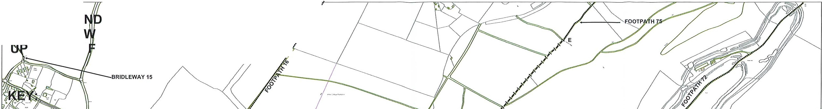
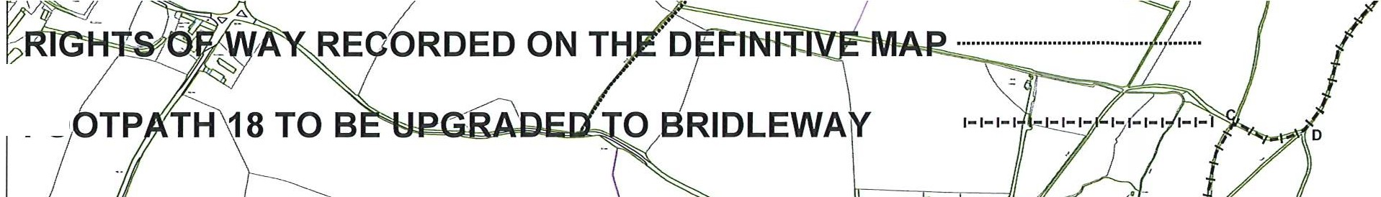
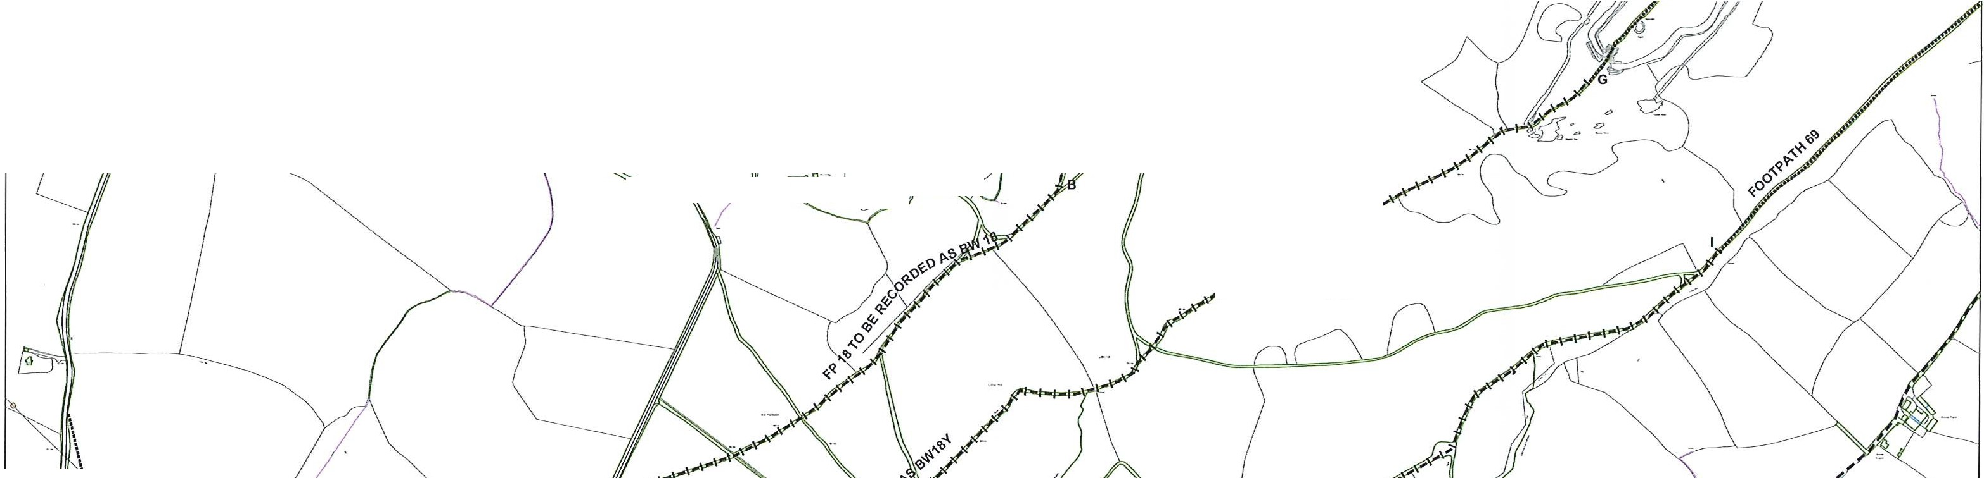
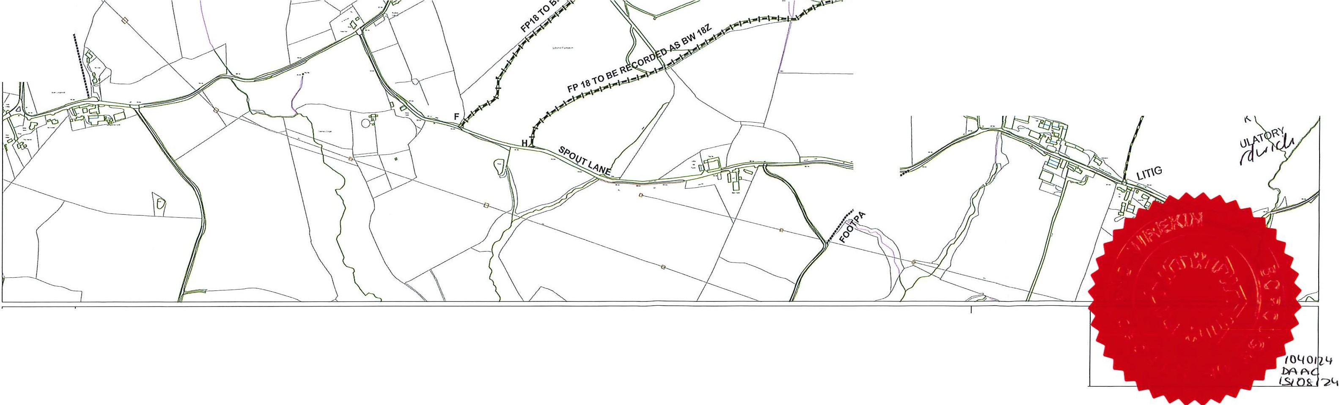
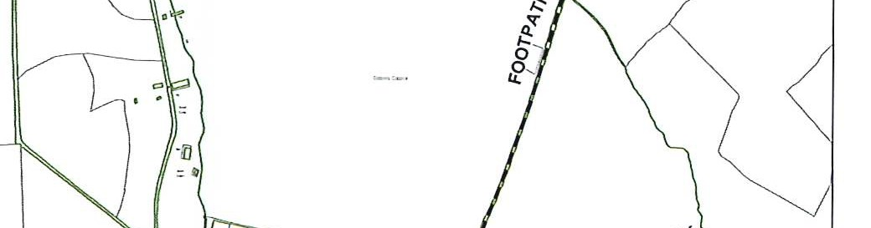
N Title:
DrawnBy:
w E Scale: 1:2,soQ)ate:
Reproduced from the Ordnance Survey mapping with the permission of the Controller of Her Majesty's
�
s Stationery Office© Crown copyright. Unauthorised reproduction infringes Crown copyright and may
lead to prosecution or civil proceedings Borough of Telford & Wrekin Licence No 100019694. Date. 2012

Borough of Telford & Wrekin Darby House
Lawn Central
Telford TF3 4LB
/
l

WILDLIFE Ari COUtJTRYSIDE A'Ef 1981,/553), ,.
''if ARISH OF ROXBTER & UPPINGTO '--:-l._ ll

r1PGRADE O·Foo
7
TPATH 18 TO BRID .E\N�·
J ".,

/··
/-
-�

\�
\
-t
�.... \\
� \
'a0. '

'o
0
u-

..�,1,�-��-�---..,. <

.... ....
.... "�•····
,.•.,�
SARAH HARDW16K LEAD LAWYER
LITIGATION AND REGULATO
s � a
l-.J(

N Title:
DrawnBy:
-<>-
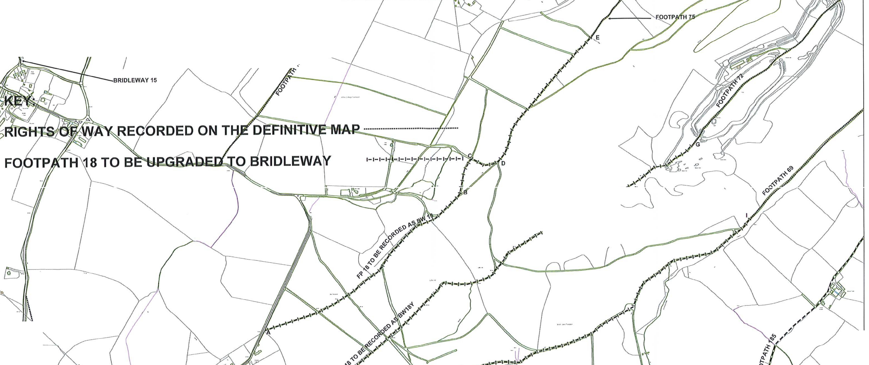
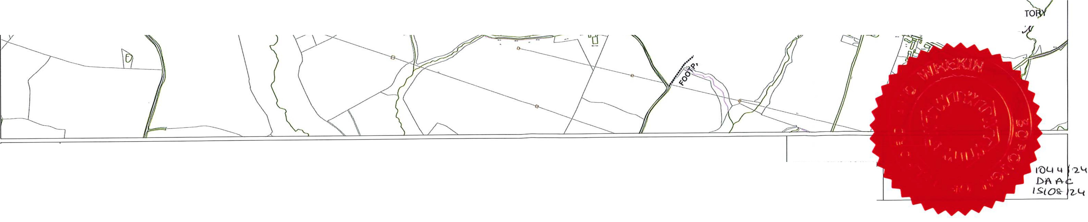
w E Scale: 1:2,socDate:
Reproduced from the Ordnance Survey mapping with the permission of the Controller of Her Majesty's
s Stationery Office© Crown copyright. Unauthorised reproduction infringes Crown copyright and may
lead to prosecution or civil proceedings_Borough ofTelford & Wrekin Licence No 100019694. Date. 2012
Borough of Telford & Wrek Darby House
Lawn Central Telford
TF3 4LB
ILDLIFE Ari COUtJTRYSIDE AGT�981/S53 ISH OF ROX8TER & UPPINGT
RADE O F0�1°PATH 18 TO BRI

\
...
('l \
\
:r. \
'a \
0- '

'o
0�

"1.0��"·"

..-�
�y::--
<

....•···•'
...•·;·�··�',
H HARDWICK EADLAWYER
NANQREGULA

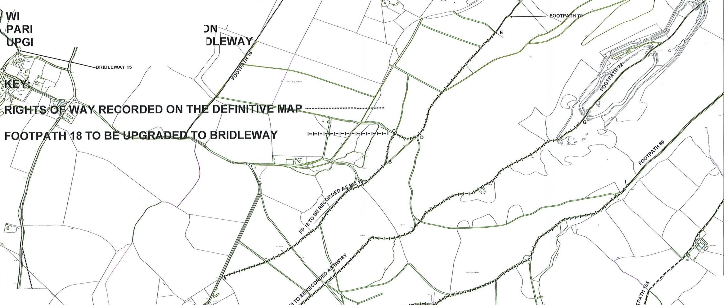

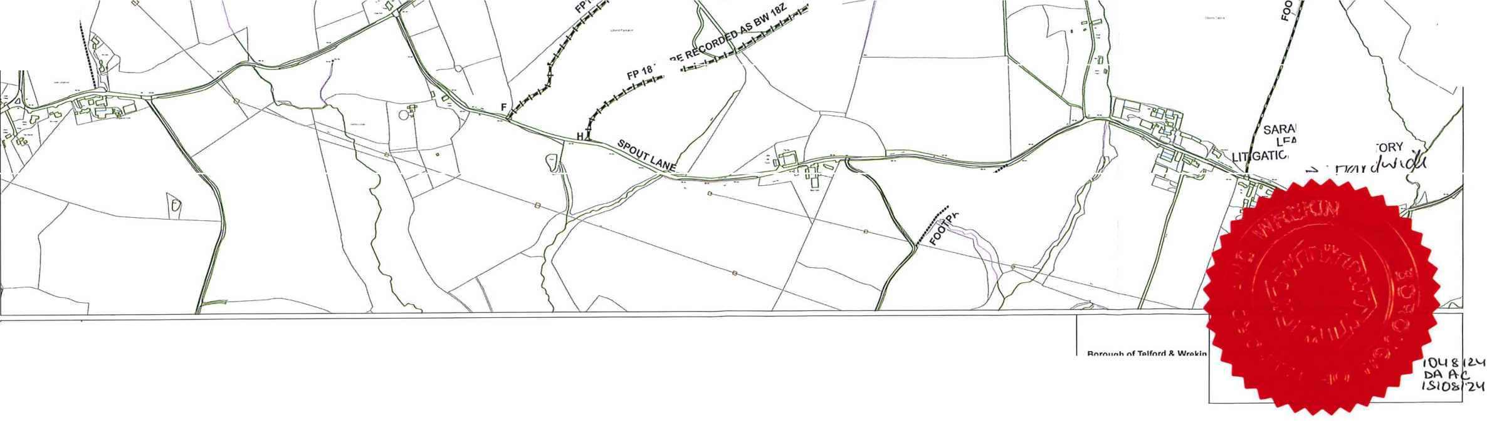
N Title:
-<r
DrawnBy:
w E Scale: 1:2,so<Date:
Reproduced from the Ordnance Survey mapping with the permission of the Controller of Her Majesty's S Stationery Office© Crown copyright. Unauthorised reproduction infringes Crown copyright and may
lead to prosecution or civil proceedilllJSBorough ofTelford & 1/vrekin Licence No 100019694. Date. 2012

Borough of Telford & Wrekin Darby House
Lawn Central Telford
TF3 4LB
D COUNTR'?SlE>
& UPPINGT ADD�IDLEWAY

S OF WAY REO,ORDED ON T
rc,OJ
�X'
�q�
«.00

- • .,t
.
•
♦+;,····
••♦•·'
•♦
.�
....

SA
L
LITIGATION ANLJ R�UL.ATPRY
5·.

...


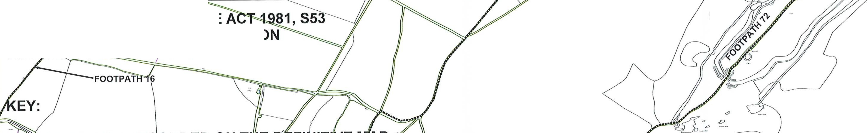
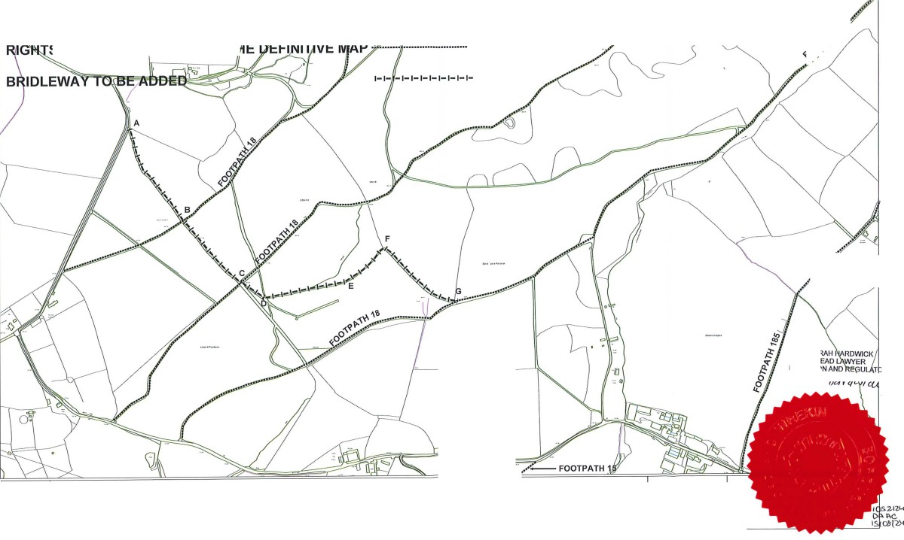
N Title:
DrawnBy:
-<>-
w E Scale: 1:2,socOate:
Reproduced from the Ordnance Survey mapping with the permission of the Controller of Her Majesty's
s Stationery Office© Crown copyright Unauthorised reproduction infringes Crown copyright and may lead to prosecution or civil proceedings Borough of Telford & Wrekin Licence No 100019694. Date. 2012

Borough of Telford & Wrekin Darby House
Lawn Central Telford
TF3 4LB

D COUNTRY-SIB

=::::::::,.
81, S53

& UPPINGTON 'AY

S OF WAY REOORDED ON T

-\�
�q_'t/-
00
'<
'oO:,

.�.•.♦
. �..,.,
......
••••,
.�
••♦♦•'

00R'<
,,,u
"

,.,_

N
DrawnBy:
-<>-
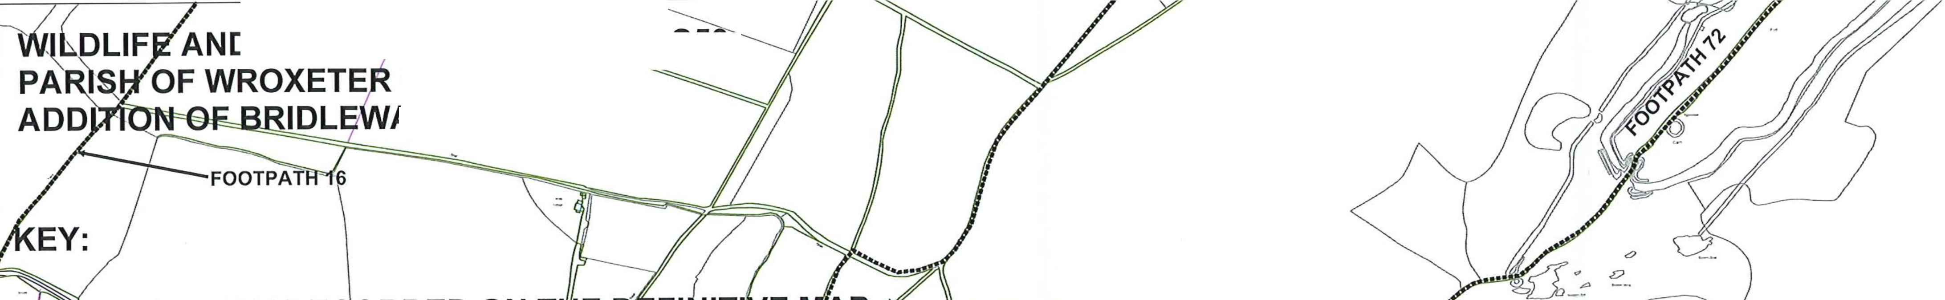
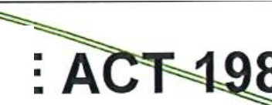
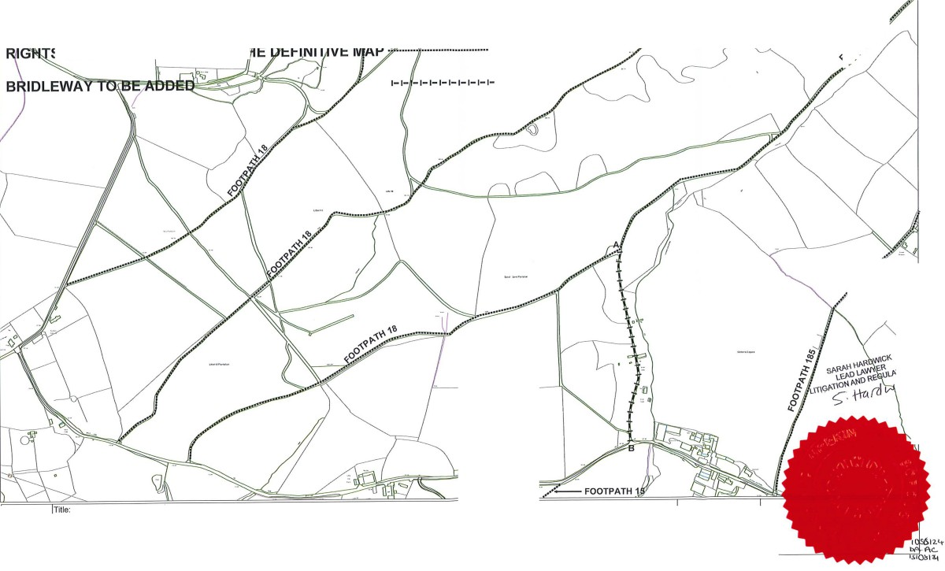
w E Scale: 1:2,socOate:
Reproduced from the Ordnance Survey mapping with the permission of the Controller of Her Majesty's S Stationery Office© Crown copyright. Unauthorised reproduction infringes Crown copyright and may
lea�rosecution or civil proceedings Borough ofTelford & Wrekin Licence No 100019694. Date. 2012
Borough of Telford & Wrekin Darby House
Lawn Central Telford
TF3 4LB
WILDLl�/AND C - · • · -IOE�CT 1981, S53
PA�SFI OF LE NLOCKJP)�SH OF WROCKWA
---lJPGR OF FOOTP JH 74 TO BRI.OLEWAY

'(Jl·�.
:,..\
\
�'\
��;
���

'AY RECOR�o'ON THE DEFINIT--t"• AP ••••••••••••••••••••••••••••••••••••

74 To s�dPGRADED TO BRl·DLEWAY

���

«oO

�'o�
FOOTPATH FOOTPATH 6

"'�"\�
(-.��
«00

�
-<.v:"
(-.�� '\�
«00
-<._v:"
q_t.r-
v-f(d}.
«oo"

�
�
<(

The 'lltekin
w

�o
O,.y
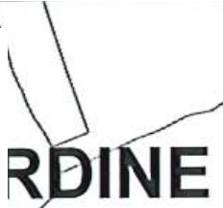
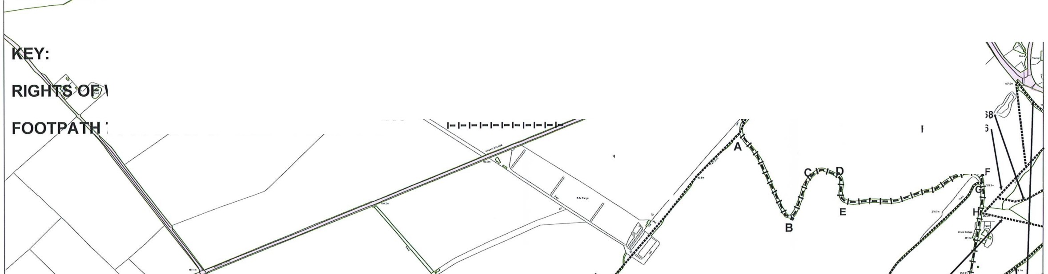
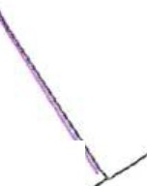
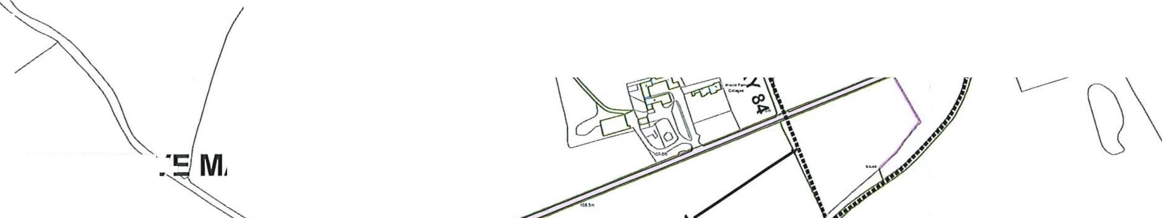
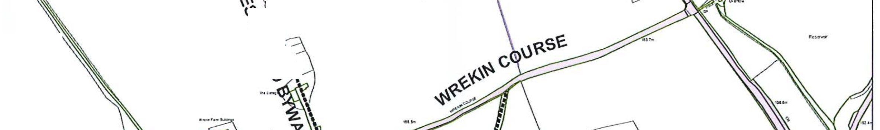
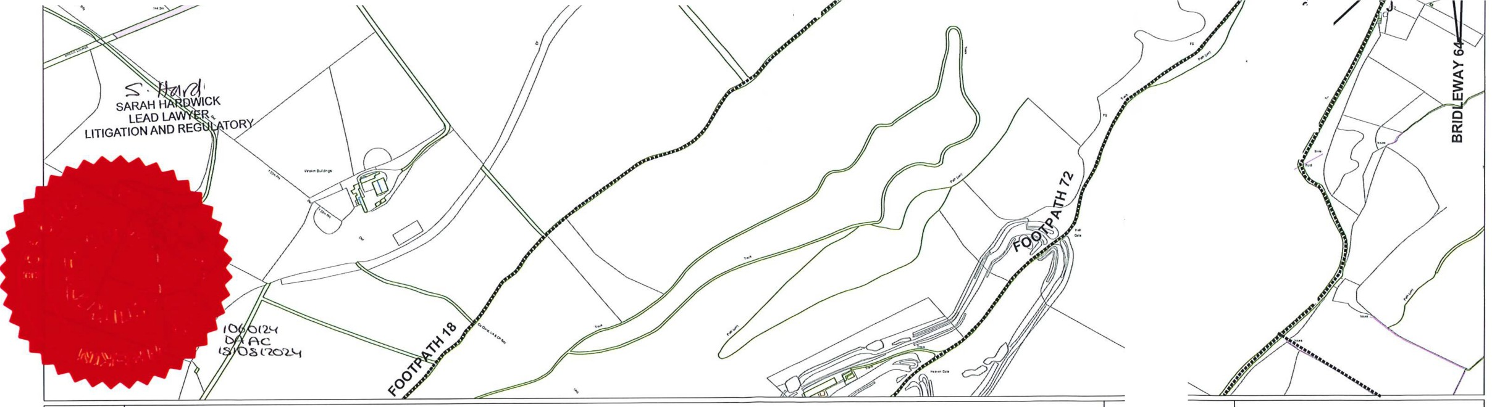

N Title:  DrawnBy:  w E Scale: 1:2,socOate:  � s Reproduced from the Ordnance Survey mapping with the pem1ission of the Controller of Her Majesty's Stationery Office© Crown copyright. Unauthorised reproduction infringes Crown copyright and may  lead to prosecution or civil proceedings Borough of Telford & Wrekin Licence No 100019694. Date. 2012 | Borough of Telford & Wrekin  Darby House Lawn Central Telford  TF3 4LB

COUNTRYSIDE �JJUJ-Sl, S53
'

ITTLE WENLO OF FOOTPATH
SH OF WROCKWAR,., LEWAY

«00

"'��
�q_�
�·

ED ON THE
�··
�·•·
.•

� 0 BRIDLEWAY

The V-.tekin

"
�
�.
�
0r.-.
0
fO

N Title:
❖
DrawnBy:

<(
a.
6
A.�,._'o 0
LL
�q_"<'
'<00
�� ,
'lvr '
Ck
d1
''
LATORy
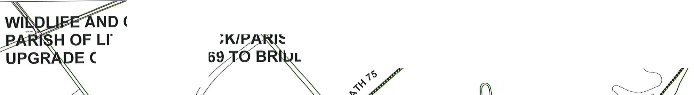

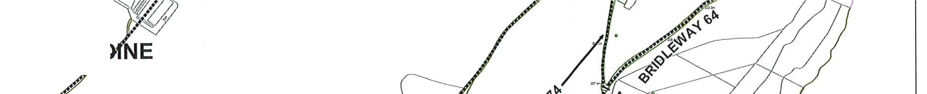
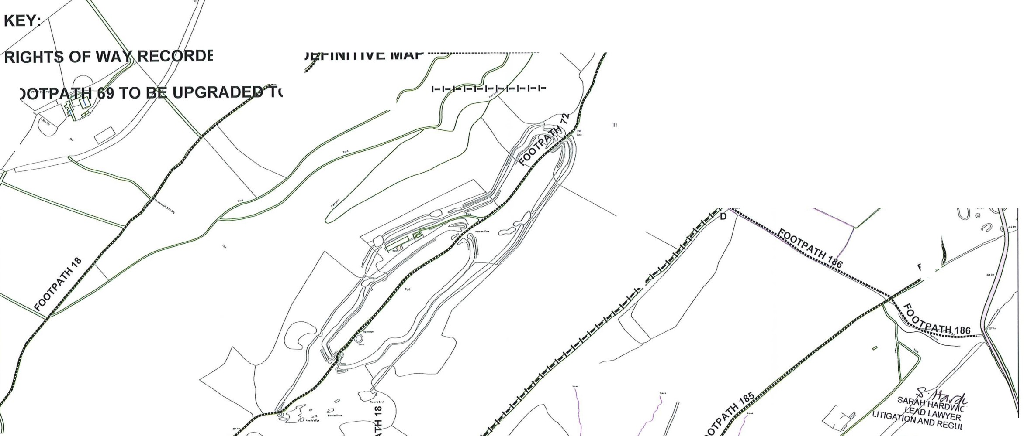
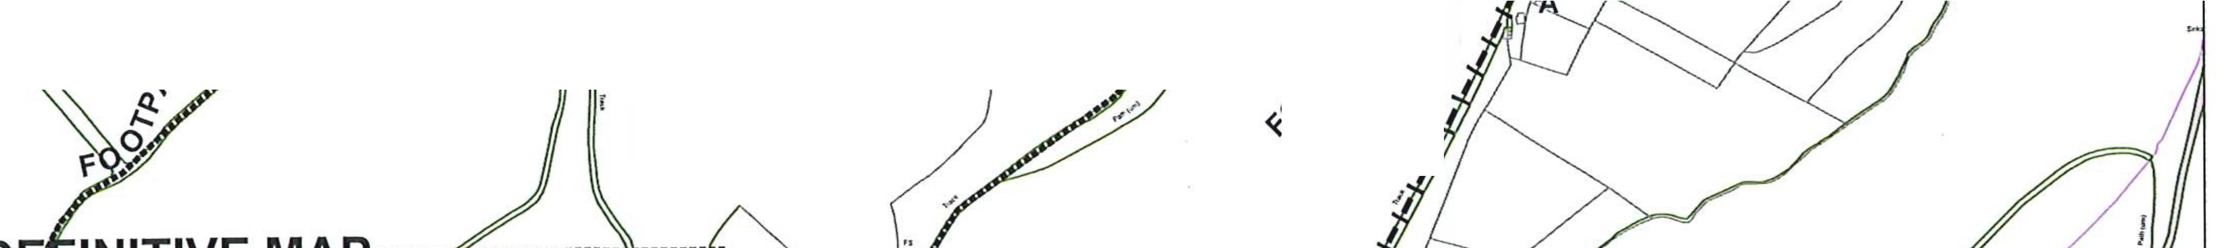
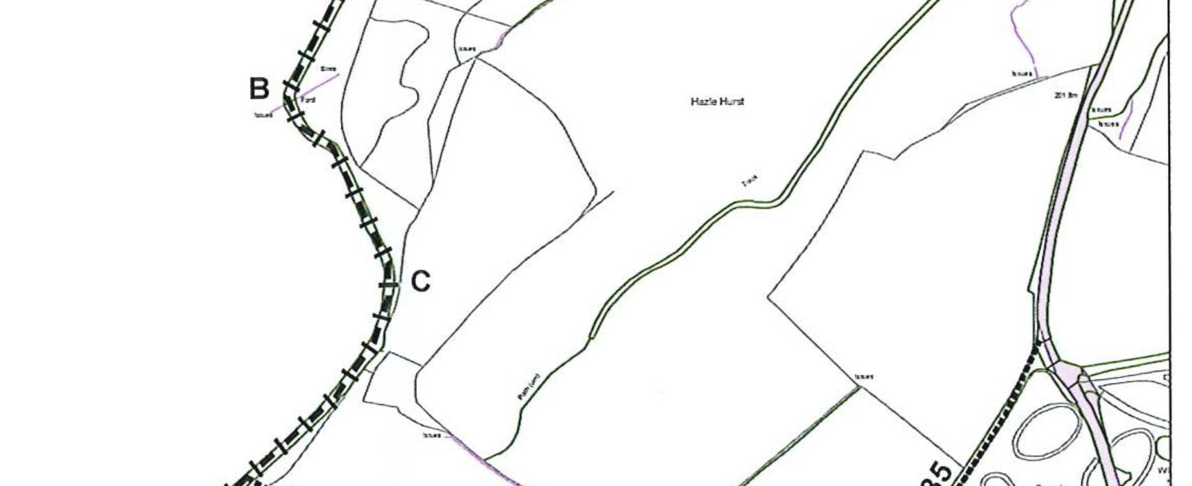
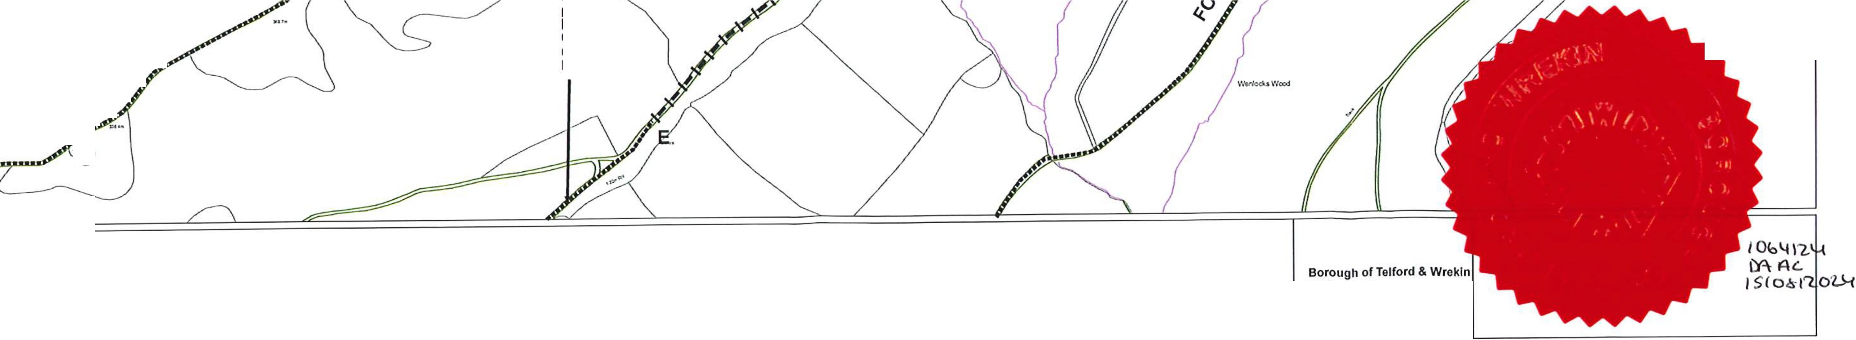
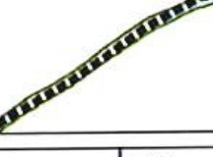
w E Scale: 1:2,socDate:
Reproduced from the Ordnance Survey mapping with the permission of the Controller of Her Majesty's
S Stationery Office© Crown copyright. Unauthorised reproduction infringes Crown copyright and may lead to prosecution or civil proceedings_Borough_of Telford & Wrekin Licence No 100019694. Date. 2012
Borough of Telford & Wrekin
Darby House Lawn Central Telford
TF3 4LB

WILDLIFYAND c..·--
PA�JSH OF /. /. LE
-U'PGR OF FOOTP
.�CT 1981, 553
,OCKIPA\�ISH OF WROCKWA H 75 TO BRJOLEWAY

�:.>. \,
'6;..>�.•�.
·��-
� •i

rAY RECOR�l1ON THE DEFINllP' 75 TO B�efpGRADED TO BRIDLEWAY
A p ...................................

�00

y.'o�·
�<?�-<;.

FOOTPATH 6
FOOTPATH 6

1b. fOO'�r>,.i�

�
A...�
�q_'?- ""
00 A...�
«
�'?-

o"

«.o

�
�

The'Atei<in
<( IJJ.'"
0-�
'<'o
O..y

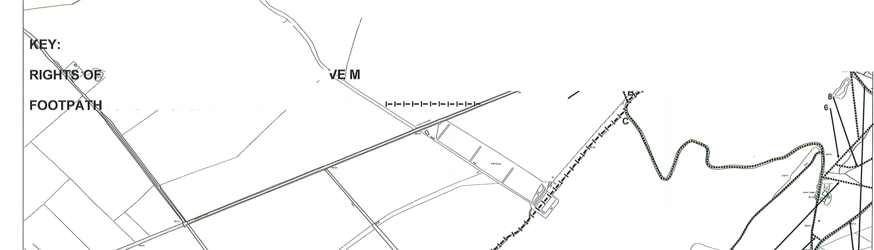
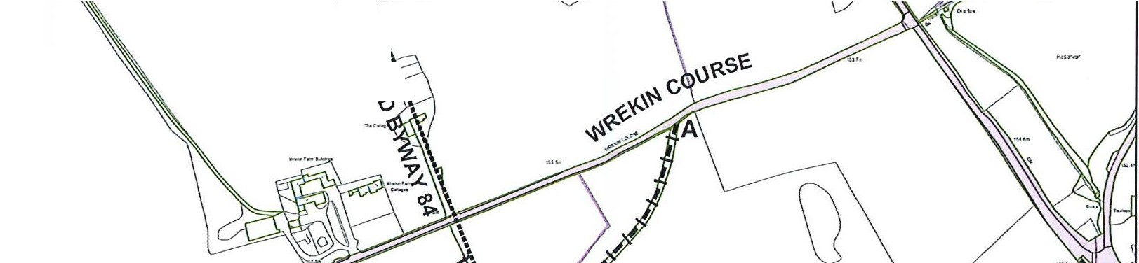
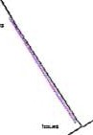
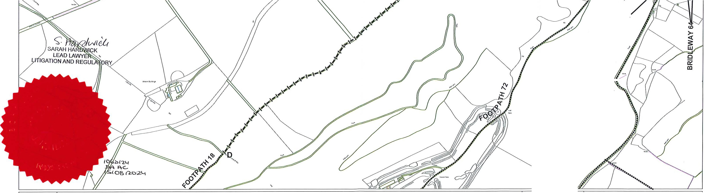

- N Title:  DrawnBy:  w E Scale: 1:2.s01Date:  Reproduced from the Ordnance Survey mapping with the permission of the Controller of Her Majesty's  s Stationery Office© Crown copyright. Unauthorised reproduction infringes Crown copyright and may  lead to prosecution or civil proceedings Borough of Telford & Wrekin Licence No 100019694. Date. 2012 | Borough of Telford & Wrekin Darby House  Lawn Central Telford  TF3 4LB

