NOTICE OF ORDER

Wildlife and Countryside Act 1981
Lancashire County Council
The Lancashire CC - Definitive Map Modification No3 Order 2011

Notice is hereby given that the above referenced Order has been submitted to the Secretary of State for Environment, Food and Rural Affairs for determination. An Inspector will be appointed by the Secretary of State to determine the Order.

The start date for the above Order is 19 March 2026.
Consideration of the Order will take the form of a public local inquiry.

The Inquiry will be held at Tanhouse Community Centre, Ennerdale, Skelmersdale, WN8 6AN on 25 August 2026 at 10.00am.

The effect of the Order, if confirmed without modifications, will be to modify the Definitive Map and Statement of Public Rights of Way for the area, by adding to them the footpath from a point on Public Footpath No. 39 Newburgh, West Lancashire Borough at grid reference SD 4889 0906 to Public Footpath No. 40 Newburgh at grid reference SD 4869 0931.
Any queries relating to this Order should be referred to Paul Scrivener by email: paul.scrivener@planninginspectorate.gov.uk quoting reference number ROW/3351339 on all correspondence. Alternatively, queries may be sent in writing to The Planning Inspectorate, Rights of Way Section, c/o QUADIENT, 69 Buckingham Avenue, Slough, SL1 4PN. Telephone: 0303 444 5000.

Any person wishing to view the statements of case and other documents relating to this Order may do so by appointment at County Hall, Fishergate, Preston, PR1 0LD, for further information please contact Ansar Sadiq at ansar.sadiq@lancashire.gov.uk or on 01772 532435.
Documents have also been made available online. To access the documents, please use the following URL address: http://www.lancashire.gov.uk/council/transparency/dmmos/no3-order-2011/

Timetable for sending in statements of case and proofs of evidence

Within 8 weeks of the start date by 14 May 2026.
The Order Making Authority, or where the Order Making Authority is taking a neutral stance and the applicant or other party are taking the case forward in support of the order, must ensure their statement of case is received by the Secretary of State. As soon as possible after the deadline, the Secretary of State will send a copy (excluding copies of any supporting documents - these will be available to view at the Authority’s offices) to everyone who has made an objection or representation and the applicant and any other person who has written to us in respect of the Order.

Within 14 weeks of the start date by 25 June 2026.
Everyone who has made an objection or representation and anyone who wishes to give evidence at the Inquiry must ensure their statement of case1 is received by the Secretary of State. As soon as possible after the deadline, the Secretary of State will send full copies to the Authority. Copies will also be sent to the applicant, every person who has made an objection or representation and any other person who has written to us in respect of the Order (excluding copies of any supporting documents - these will be available to view at the Authority’s offices).

Within the same period the applicant (if applicable) must ensure their statement of case is received by the Secretary of State. As soon as possible after the deadline, the Secretary of State will send a full copy to the Authority. Copies will also be sent to everyone who has made an objection or representation and any other person who has written to us in respect of the Order (excluding copies of any supporting documents - these will be available to view at the Authority’s offices).

4 weeks before the date of the inquiry by 28 July 2026.

The Authority, everyone who has made an objection or representation, the applicant (if applicable) and anyone who wishes to give evidence at the Inquiry must ensure their proof of evidence (together with any summary) is received by the Secretary of State. As soon as possible after the deadline, the Secretary of State will send copies of:
- the Authority’s proof of evidence to everyone who has made an objection or representation, the applicant and anyone who has submitted a statement of case (including copies of any supporting documents – although none should be submitted with a proof of evidence);
- the applicant’s proof of evidence to the Authority, everyone who has made an objection or representation and anyone else who has submitted a statement of case (including copies of any supporting documents – although none should be submitted with a proof of evidence); and

1 If you wish to make a legal submission, this should be submitted at the same time as your statement of case. Otherwise legal submissions will have to be submitted in writing on the day of the inquiry.
- all other proofs of evidence to the Authority, the applicant, everyone who has made an objection or representation and anyone else who has submitted a statement of case (including copies of any supporting documents – although none should not be submitted with a proof of evidence).
All parties must keep to the timetable set out above and ensure that statements of case and proofs of evidence are received by the Secretary of State on time. Late documents will be returned.
We cannot accept any inflammatory, discriminatory or abusive comments. Any documents containing such comments will be returned.

If you use Artificial Intelligence (AI) to create or alter any part of your documents, information or data, you should tell us that you have done this when you provide the material to us. See the detailed guidance for further information.

Notice of order for inquiry

WILDLIFE AND COUNTRYSIDE ACT 1981

THE DEFINITIVE MAP AND STATEMENT OF PUBLIC RIGHTS OF WAY FOR THE COUNTY OF LANCASHIRE

THE LANCASHIRE COUNTY COUNCIL DEFINITIVE MAP AND STATEMENT OF PUBLIC RIGHTS OF WAY (DEFINITIVE MAP MODIFICATION) (NO.3) ORDER 2011

This Order is made by Lancashire County Council ("the Authority") under Section 53(2)(b) of the Wildlife and Countryside Act, 1981 ("the Act") because it appears to that Authority that The Definitive Map and Statement of Public Rights of Way for the County of Lancashire require modification in consequence of the occurrence of an event specified in Section 53(3)(c)(i) namely the discovery by the Surveying Authority of evidence which (when considered with all other relevant evidence available to them) shows that a right of way which is not shown in the map and statement subsists or is reasonably alleged to subsist over land in the area to which the map relates, namely a public footpath.

The Authority have consulted with every local authority whose area includes the land to which the Order relates. Lancashire County Council hereby order that:

  - For the purposes of this Order, the "relevant date" is the 12 January 2011.

  - The Definitive Map and Statement of Public Rights of Way for the County of Lancashire shall be modified as described in Part I and Part II of the Schedule and shown on the map attached to the Order.

  - This Order shall take effect on the date it is confirmed and may be cited as The Lancashire County Council Definitive Map and Statement of Public Rights of Way (Definitive Map Modification) (No.3) Order 2011.

Dated this 12 day of January 2011

THE COMMON SEAL of the )
Lancashire County Council ) was hereunto affixed in the presence of )

Authorised Signatory

SCHEDULE

PART I

MODIFICATION OF THE DEFINITIVE MAP

DESCRIPTION OF PATH TO BE ADDED

A Public Footpath from a point on Public Footpath No. 39 Newburgh, approximately 356 metres from Cobbs Brow Lane; continuing in a general north westerly direction following the eastern edge of the field and continuing around the edge of the field along an unsurfaced track and then running in a north, north westerly direction to join Public Footpath No. 40 Newburgh, a total distance of approximately 330 metres and shown as bold broken lines marked A- B - C.
PARTII

MODIFICATION OF DEFINITIVE STATEMENT

The following entry be added:

"Public Footpath from a point on Public Footpath No. 39 Newburgh approximately 356 metres from Cobbs Brow Lane at grid reference SD 4889 0906, running with a width of 2 metres and continuing in a general north westerly direction following the eastern edge of the field and continuing around the edge of the field along an unsurfaced track to join Public Footpath No. 40 Newburgh, a point approximately 261 metres from its junction with
Cobbs Brow Lane at grid reference SD 4869 0931, a total distance of approximately 330 metres.

The route is not subject to any limitations."

0
0
M
a,
0
'<t
348500 348600 348700

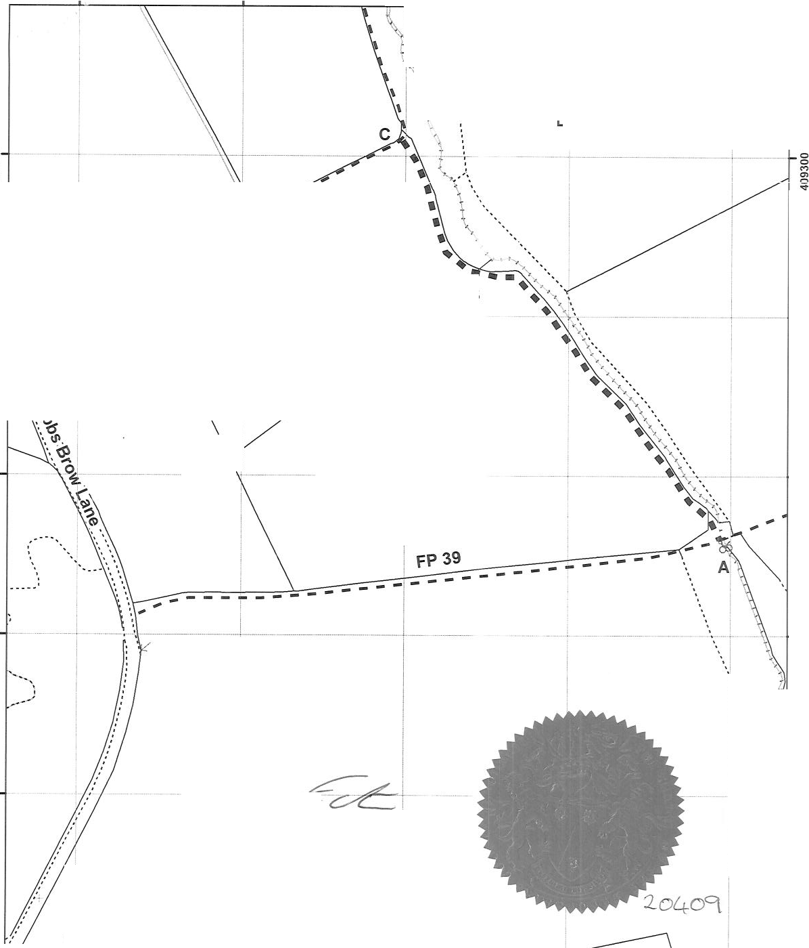
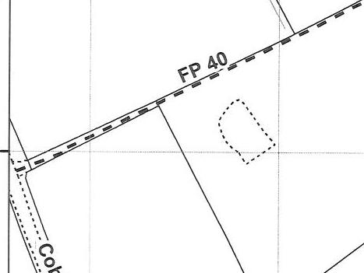
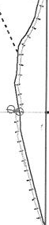
I
..

'-,),
.
�
tl
\
348800 348900

- • • Claimed route
Public Footpath
'

0
0
N
a,
0
'<t
B
_J_
i

0
0
N C> 0
'<t

I

I

0
0.....
a,
0
'<t

0
0
0
a,
0
'<t

0
0
C> CIC 0
'<t
-------

;:? �
Aut ·orized Signatory

0
0
oi
0
'<t

0
0
0
.
a,
0
st
I\

0
0
C> CIC 0
'<t

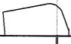

0 ,�35 70

I -····--·· ---------·· 0
0
CIC CIC 0
st
1�0 Meters

348500 348600 348700 348800 348900

0
CIC CIC 0
'<t
Jo Turton Executive Oiroctor for tho Environment
Wildlife and Countryside Act 1981
Claimed public tootp�h from Public:Footpath no. 39 Newburgh, to Public Footpath No. 40 Newburgh, WostUncashire District
ClaimNo. 8041491
1:2,500

The digitisedRights of Way information should be used for guidance onty asits accuracy cannotbe guaranteed. Rightsof Way information mustbe verified on thecurrent Definitive Mapbefore being supplied or used for any purpose.

This Mapis reproduced fromOrdnance Survey material withthepermission of Ordnance Survey on behalf of the controller of Her Majesty's Stationery Office{C) Crown Copyright.
Unauthorised reproduction infringes Crown Copyright andmayleadto Prosecution or civilproceedings, Lancashire County Council Licence No,100023320

