NOTICE OF ORDER

Section 53 - Wildlife and Countryside Act 1981
West Sussex County Council
West Sussex County Council - Chanctonbury No.1 - Steyning (Addition of a Footpath) Definitive Map Modification Order 2024

Notice is hereby given that the above referenced Order has been submitted to the Secretary of State for Environment, Food and Rural Affairs for determination. An Inspector will be appointed by the Secretary of State to determine the Order.

The start date for the above Order is 7 October 2025.

Consideration of the Order will take the form of a virtual public inquiry.

Please contact West Sussex County Council for the inquiry teams link.

The Inquiry will be held virtually on 4 March 2026 at 10.00am.

The effect of the Order, if confirmed without modifications, will be to
modify the Definitive Map and Statement for the area by:

Description of Path A to be added

A footpath commencing at Mouse Lane (grid reference 517275, 111572) and proceeding in a south-westerly direction for approximately 481 metres (grid reference 516857, 111340) with a minimum width of 2.25 metres as depicted by use on the ground. The footpath continues in a south-westerly direction for 223 metres with a minimum width of 1.5 metres as depicted by use on the ground to grid reference 516646, 111272. The footpath continues south for approximately 20 metres to grid reference 516650, 111252 and then in a south-easterly direction for approximately 308 metres to grid reference 516943, 111280. The footpath then continues in a southerly direction for approximately 135 metres to footpath 2715 (grid reference 516999, 111167) as shown by the broken black line on plan numbered 01830 and marked Plan A and with a minimum width of 1.5 metres as depicted by use on the ground.

Description of Extension 1 to be added

A footpath commencing at Path A grid reference 516663, 111285 and proceeding in a northerly direction for approximately 168 metres with a minimum width of 1.5 metres as depicted by use on the ground until it reaches a gate. The path then proceeds in a north-westerly direction with a minimum width of 0.8metres as depicted by use on the ground until reaching bridleway 2714 as shown by the broken black line on plan numbered 01830 and marked Extension 1.

Description of Extension 2 to be added

A footpath commencing at Path A grid reference 516649, 111255 and proceeding in a westerly direction for approximately 265 metres to the historic Rifle Range Target (grid reference 516399, 111171) as shown by the broken black line on plan numbered 01830 and marked Extension 2 and with a minimum width of 1.5 metres as depicted by use on the ground.

Any queries relating to this Order should be referred to Joanne Reid by email: rightsofway2@planninginspectorate.gov.uk quoting reference number ROW/3349228 on all correspondence. Alternatively, queries may be sent in writing to The Planning Inspectorate, Rights of Way Section, Room 3/A Eagle Wing, Temple Quay House, 2 The Square, Temple Quay, Bristol, BS1 6PN. Telephone: 0303 444 5136.

Any person wishing to view the statements of case and other documents relating to this Order may do so by appointment at County Hall, West Street, Chichester, West Sussex PO19 1RQ by appointment only. Please contact Charlotte Nash, email: Charlotte.Nash@westsussex.gov.uk or legal.services@westsussex.gov.uk. Alternatively please tel: 0330 2226934

Timetable for sending in statements of case and proofs of evidence

Within 8 weeks of the start date by [by 2 December 2025]

The Order Making Authority must ensure their statement of case is received by the Secretary of State. As soon as possible after the deadline, the Secretary of State will send a copy (excluding copies of any supporting documents - these will be available to view at the Authority’s offices) to everyone who has made an objection or representation and the applicant and any other person who has written to us in respect of the Order.

Within 14 weeks of the start date [by 13 January 2026]

Everyone who has made an objection or representation and anyone who wishes to give evidence at the Inquiry must ensure their statement of case is received by the Secretary of State. As soon as possible after the deadline, the Secretary of State will send full copies to the Authority. Copies will also be sent to the applicant, every person who has made an objection or representation and any other person who has written to us in respect of the Order (excluding copies of any supporting documents - these will be available to view at the Authority’s offices).

Within the same period the applicant (if applicable) must ensure their statement of case is received by the Secretary of State. As soon as possible after the deadline, the Secretary of State will send a full copy to the Authority. Copies will also be sent to everyone who has made an objection or representation and any other person who has written to us in respect of the Order (excluding copies of any supporting documents - these will be available to view at the Authority’s offices).

4 weeks before the date of the inquiry [by 4 February 2026]

The Authority, everyone who has made an objection or representation, the applicant (if applicable) and anyone who wishes to give evidence at the Inquiry must ensure their proof of evidence (together with any summary) is received by the Secretary of State. As soon as possible after the deadline, the Secretary of State will send copies of:

- the Authority’s proof of evidence to everyone who has made an objection or representation, the applicant and anyone who has submitted a statement of case (including copies of any supporting documents – although none should be submitted with a proof of evidence);

- the applicant’s proof of evidence to the Authority, everyone who has made an objection or representation and anyone else who has submitted a statement of case (including copies of any supporting documents – although none should be submitted with a proof of evidence); and

- all other proofs of evidence to the Authority, the applicant, everyone who has made an objection or representation and anyone else who has submitted a statement of case (including copies of any supporting documents – although none should not be submitted with a proof of evidence).

All parties must keep to the timetable set out above and ensure that statements of case and proofs of evidence are received by the Secretary of State on time. Late documents will be returned.

NOTE: If you use Artificial Intelligence (AI) to create or alter any part of your documents, information or data, you should tell us that you have done this when you provide the material to us. See the detailed guidance for further information.

We cannot accept any inflammatory, discriminatory or abusive comments. Any documents containing such comments will be returned.

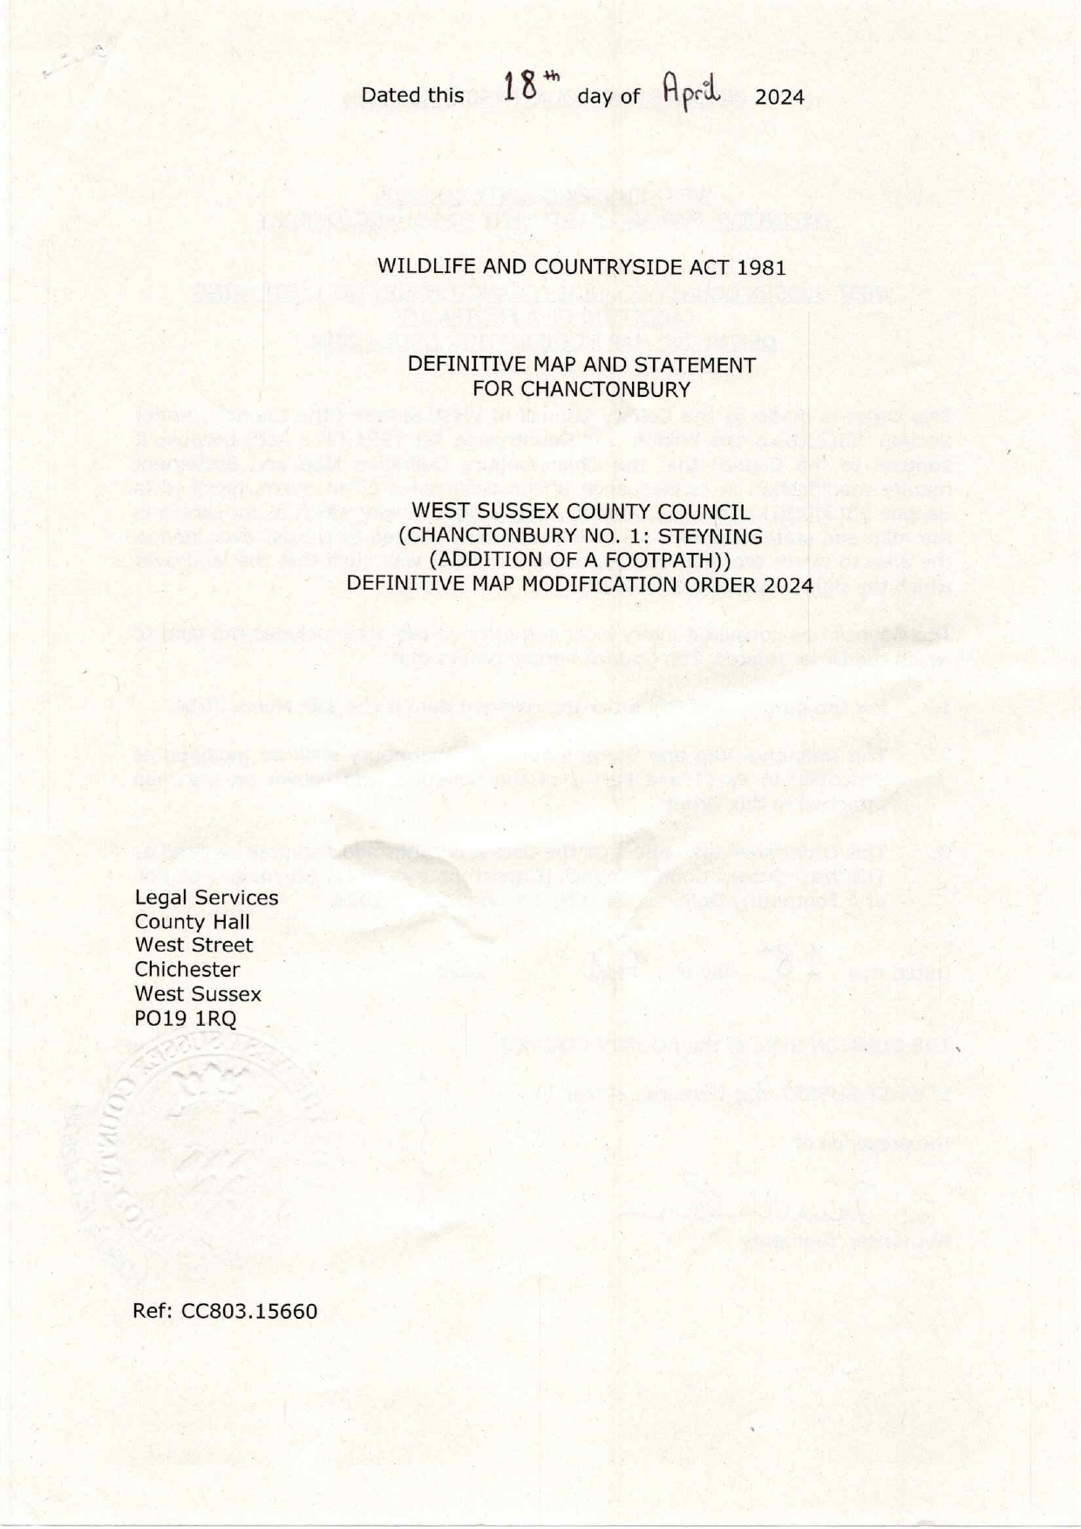

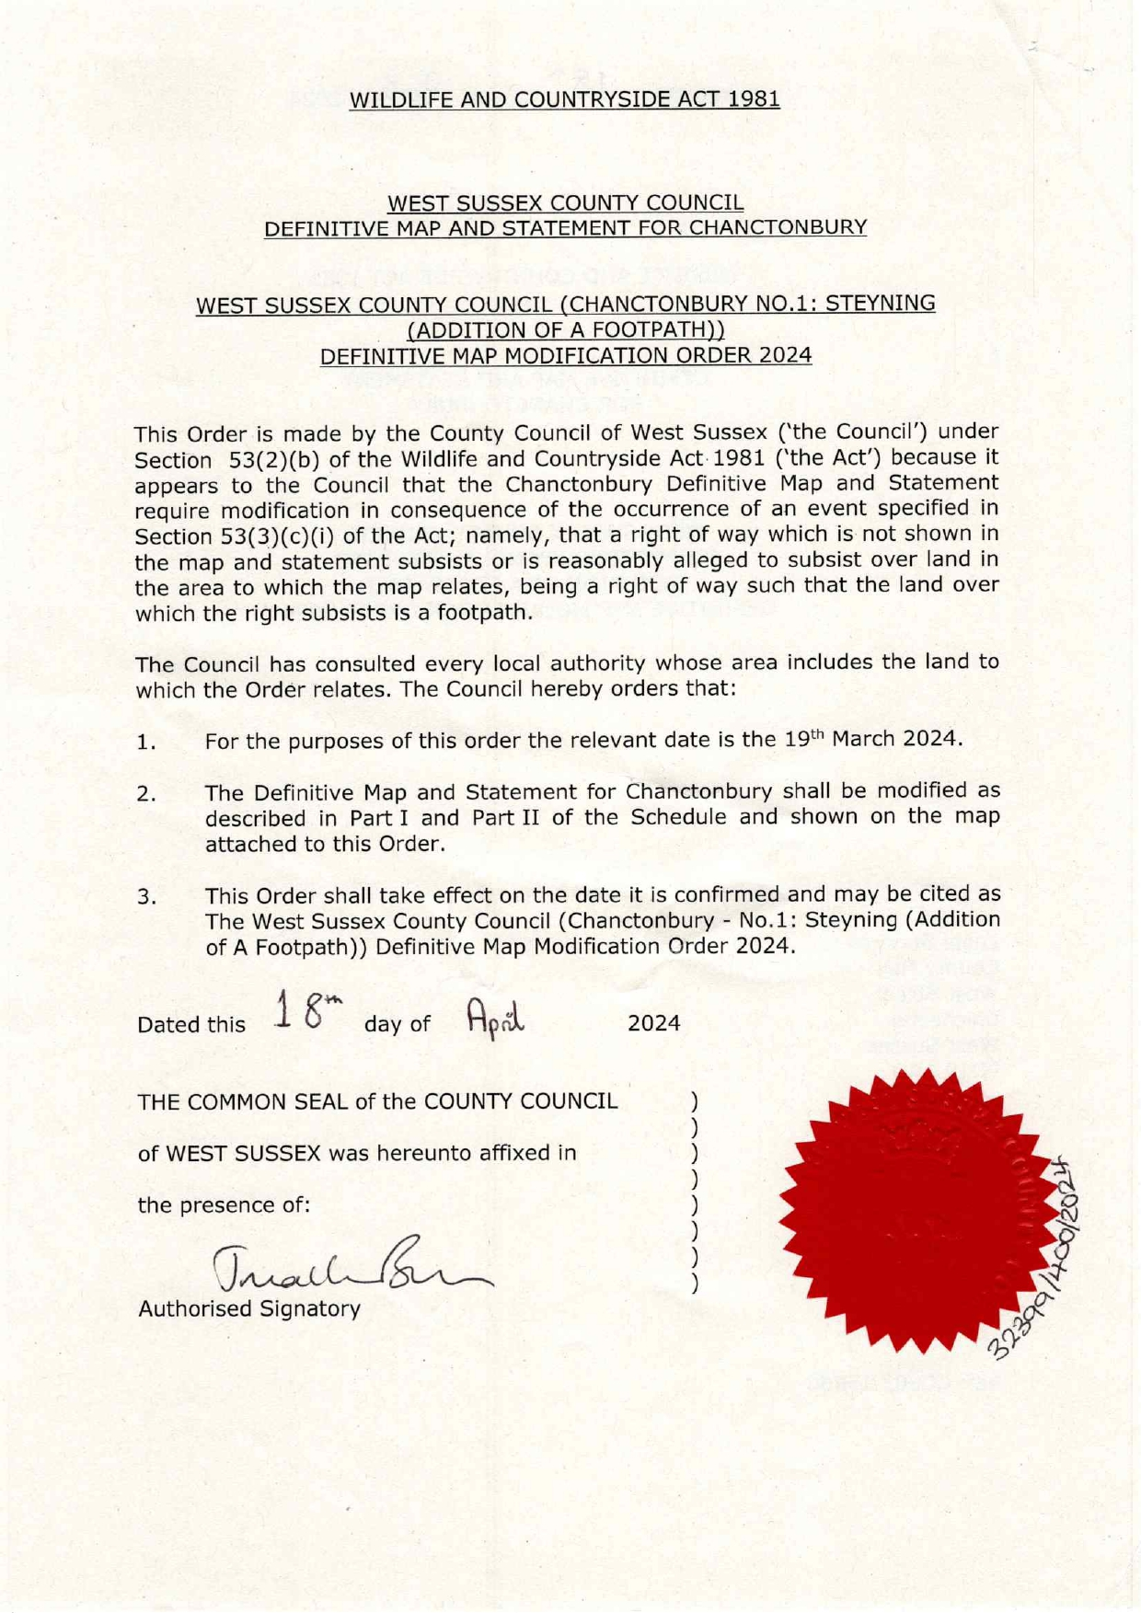

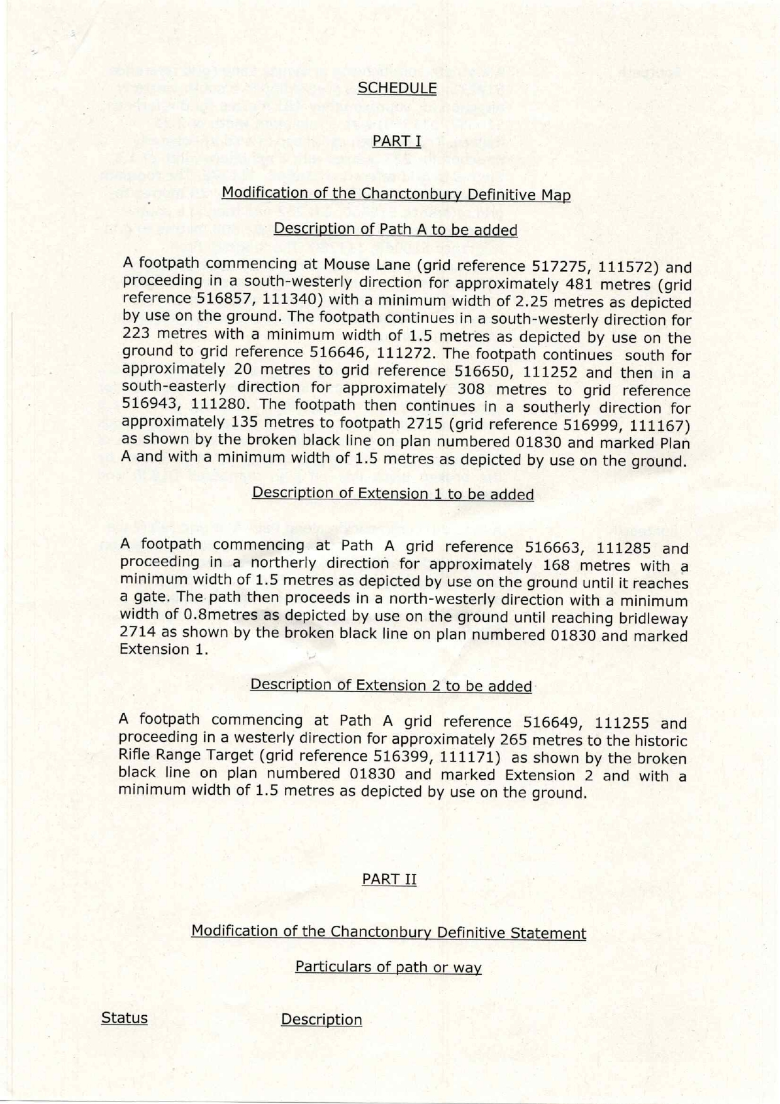

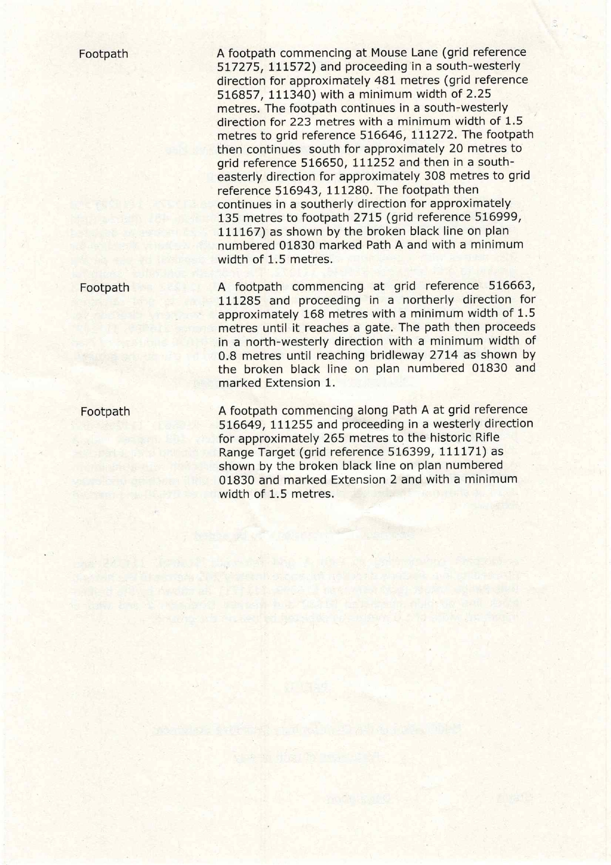

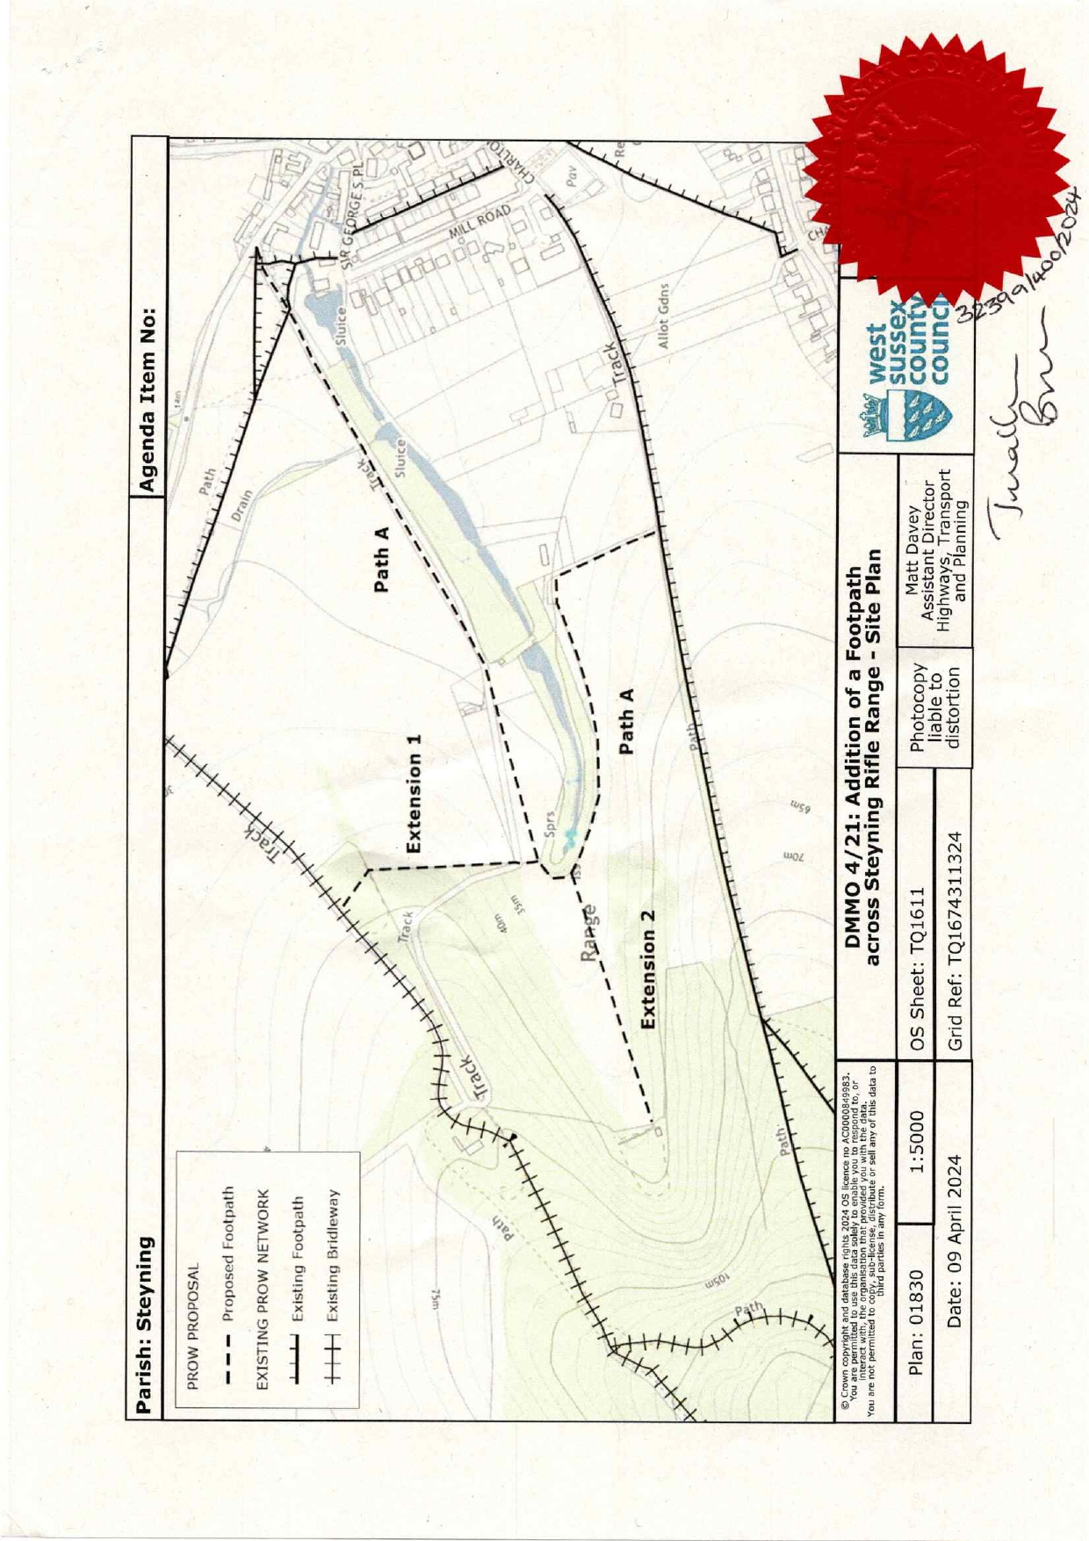

If you wish to make a legal submission, this should be submitted at the same time as your statement of case. Otherwise legal submissions will have to be submitted in writing on the day of the inquiry.

