Decarbonisation
of operational
PFI projects

Template terms of reference for a
PFI project decarbonisation group
PFI Centre of Excellence
GUIDANCE / TOOLKITS
Published 2026

Recommended approach
NISTA recommends the collaboration between PFI project parties to develop a plan that will support the reduction of carbon emissions from operational PFI projects and contribute to wider government decarbonisation goals and commitments.
This template terms of reference is offered as a guide to support the set-up of a project stakeholder forum that can discuss and agree project decarbonisation goals and develop recommendations to implement them. A template actions checklist has also been made available to support contracting authorities to work with project stakeholders to develop a project action plan, working through the recommended five steps:
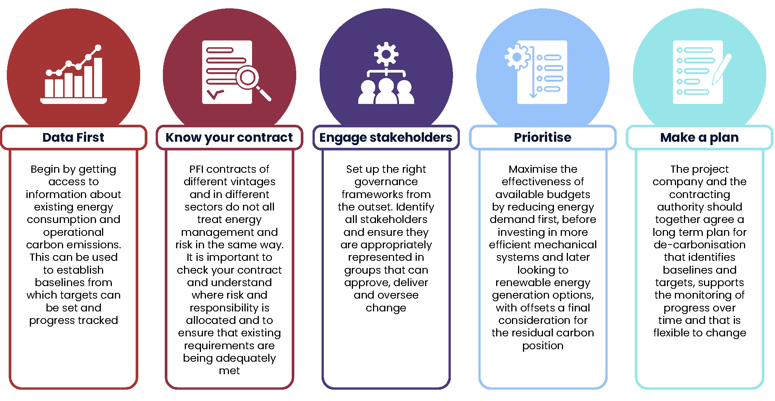
Where possible and to minimise administrative burdens, it is recommended that activities be joined up with existing project engagement and reporting. For example:
- joint decarbonisation group discussions could be scheduled as a regular standing agenda item at monthly contract liaison or performance meetings, rather than requiring a separate meeting
- for projects with ISO14001 (Environmental Management Certification) obligations, joint decarbonisation group meetings could fulfil the requirement for stakeholder engagement as well as regular management and continual improvement of the environmental management system, rather than additional ISO14001-specific meetings being required
- decarbonisation progress reports could be built into existing reporting (e.g. the annual performance report), rather than requiring a new document to be produced.
It is recommended that the project parties consider the appropriate governance structure for their decarbonisation group and whether this should be set up a project or site level. For smaller projects with a single site or where the same delivery partners cover multiple sites, a single decarbonisation group could be established to develop a decarbonisation plan that covers all project sites and assets. For some larger multi-site projects it may be more appropriate to set up a decarbonisation group for each site. In this case, a clear governance framework will be needed to support the delivery of an overarching decarbonisation strategy and ensure that each site’s decarbonisation plan fits into this strategy. Illustrative governance charts are offered in an appendix to this document.
Template terms of reference
Title: | Joint decarbonisation group
PFI Project: | [Enter PFI project name here]
Site: | [Input site name here]
Purpose: | To develop a decarbonisation strategy that will support the contracting authority’s decarbonisation targets and make recommendations for delivery of that strategy.
Objectives: | The group will work together proactively and collaboratively to:  - Develop a decarbonisation plan for the project [or project site]  - Identify and recommend processes for regular energy reporting, with full consideration of metering and submetering, where not already in place.  - Consider energy conservation, energy efficiency and renewable energy opportunities as part of the decarbonisation plan and make recommendations for implementation.  - Identify opportunities for innovation within the contract to support decarbonisation goals.  - Identify, mitigate and monitor risks associated with the decarbonisation plan.  - Track and report annually on progress with delivery of the decarbonisation plan  - Engage with project stakeholders to support implementation
Outputs: | - PFI project or site-specific decarbonisation plan  - Annual progress report
Underpinning strategy | [Link the relevant contracting authority or sponsoring public sector body decarbonisation or net zero strategy]
Membership: | - Contracting authority contract management lead  - Contracting authority energy management lead (where applicable)  - SPV contract representative  - Soft FM contract management lead  - Hard FM contract management lead  - FM energy lead (where applicable)  - Building user lead (e.g. school head teacher or business manager)  - SPV/FM lifecycle manager  In attendance: specialists or consultants as appropriate
Reporting to: | Project client liaison or contract monitoring meeting
Reporting methodology: | [To be agreed at the first meeting]
Chair: | [To be agreed at the first meeting]
Minutes by: | [To be agreed at the first meeting]
Meeting frequency: | Monthly/ Quarterly [To be agreed at the first meeting]
Typical agenda | Project name:  Site Reference:  Date:  Time:  Location:  - Attendance and apologies  - Minutes of the last meeting and actions tracker  - Contracting authority strategic update  - Progress update on the [Project/Site] Decarbonisation Plan  - Item x for [discussion][decision][action]  - Item y for [discussion][decision][action]  - Date of next meeting
Linked groups: | [Progress made at the joint decarbonisation group should be shared at the PFI monthly client liaison or contract monitoring meeting. Any actions for agreement should be minuted within the monthly contract meeting minutes.  The contracting authority contract management lead will engage building users in a separate forum (e.g. building user group) to ensure collaborative engagement is secured from building users.  Where pre-existing environmental groups are established on the contract (for example to manage ISO 14001 obligations), this group should support and align with those groups, and where appropriate the meetings could be joined together.  Any variation works scope recommendations raised within this forum will then follow the contractual variation processes to request, cost and agree works.  Any proposals for adjustment to lifecycle plans will be subject to agreement by the contract parties and where appropriate contractual variation or change management processes are to be followed.  Any relevant senior strategic stakeholders (e.g. SPV Board members and senior contracting authority officers) to be informed of this group’s progress, and support to be sought for recommended decarbonisation measures.]
Supporting documentation | - Project agreement and associated schedules  - Contracting authority or sponsoring public sector body decarbonisation strategy  - Any existing project decarbonisation plan  - Monthly energy and utilities management report  - Current annual / 5yr lifecycle plans  Any other relevant reports (e.g. proposals for variation works; technical or feasibility studies; site surveys)

Appendix: Illustrative governance charts

