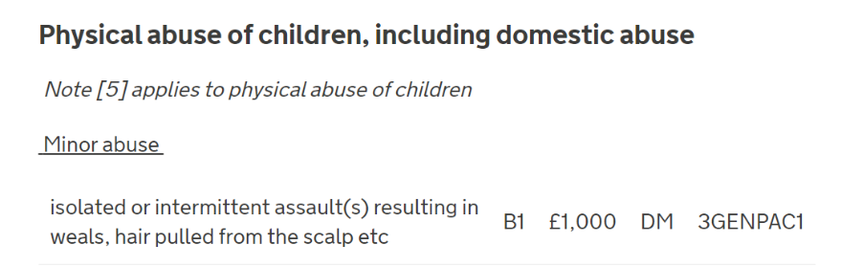
- An award of £1000 can be made where a child was the victim of isolated or intermittent assault(s) which resulted in weals (red swollen marks left on the skin by a blow or pressure), hair pulled from scalp etc.

- ‘Isolated’ means an award may be made for one incident as long as this results in weals, hair pulled from scalp or an injury of a similar level of severity to these. This is also supported by the wording assault(s) which indicates that the tariff banding may be met following a singular assault

.
- The Scheme explicitly states that weals and hair pulled from scalp will attract an award. The banding also leaves it open for other minor injuries which are not specifically listed to attract an award.

- It will be for the decision maker, taking account of the facts and circumstances of each individual case, to use their discretion in accepting other minor injuries not explicitly listed in the banding. They must also record their rationale for accepting other minor injuries for quality assurance purposes.

