


Submit a Bulk Claim (SaBC)
  - Bulkload Spreadsheet User Guide
For use with MacBook only

Ownership

Role | Job/role title | Current post holder
Policy owner | National Contract Manager | Nicole Mason
Policy lead | National Contract Manager | Nicole Mason
Approval body | Contract Management & Assurance | Nicole Mason

Current version | 1.01
Last review date | 24 February 2026
Next review date | May 2026

Version history

Version | Date | Reason
1.00 | January 2026 | New version of the document for use with Submit a Bulk Claim (SaBC) – for use with MacBooks
1.01 | February 2026 | Updated version to include section on nil submissions and highlight guidance on initial saving of file, pasting information and generating export
Contents
1. Introduction 5
2. Downloading the spreadsheet 8
3. Opening the spreadsheet in Excel 9
4. Entering submission details 10
5. Entering Civil data 12
6. Entering New Matter Starts 14
7. New Matter Start Form 15
8. CLR - controlled legal representation data (Immigration only) 17
9. Entering Criminal data 18
10. Entering Mediation data 20
11. Saving your work 23
12. Checking your submission 25
13. Printing the Bulkload spreadsheet 27
14. Creating the Bulkload csv file 28
15. Alternative methods of submission 31
16. Creating a “nil submission” or NMS only 32
17. Points to note 33
18. Troubleshooting 35

Introduction
- The Bulkload spreadsheet provides an alternative way to upload your outcomes into Submit a Bulk Claim (SaBC) if you do not have a compatible case management service that produces a file for loading. You can input your outcomes onto a spreadsheet and then create a csv file and Bulkload when convenient.
PLEASE NOTE: The Bulkload spreadsheet is used to generate the csv format export file for uploading into SaBC – you cannot just save the Bulkload spreadsheet as a CSV file or try to upload the Bulkload spreadsheet itself. Please refer to section 14 of this guide.
- You can enter civil, crime, and mediation data for the same office account number on the same spreadsheet; there are different sections for each area of law. If you only cover civil, crime, or mediation, you can leave the other sections blank. If you have more than one office (account/provider number), you will need to complete a separate spreadsheet for each office.
- If you only have new matter starts to submit, and no controlled work or mediation outcomes to report, you can still upload a submission purely to report those new matter starts. You will need to complete the front page of the Bulkload Spreadsheet but can leave the Civil or Mediation Outcome tabs blank.
PLEASE NOTE: If you do seek to copy and paste data into the spreadsheet, please ensure that you only “paste values” – if you paste including formats or formulas, it will corrupt the existing validation in those cells and may lead you to need to start a new spreadsheet.
Compatibility
- The spreadsheet works best on a Windows operating service. Please note that the output should be saved as a .csv file.
- The Bulkload Spreadsheet is a *.xlsm file – Microsoft Excel Macro-Enabled Workbook.
- This guidance document is specific to using the Bulkload Spreadsheet version that has been adapted for use with MacBooks. There are some differences, for instance in how to save the spreadsheet, and providers should ensure that they refer to the applicable guide for their operating system.
Accessibility
PLEASE NOTE: that when you click the button to create the bulkload file, the screen will flicker multiple times as the spreadsheet processes the data. We are working on adding code to prevent this from happening, but if you have any medical conditions which may be triggered by this, please minimise the screen and you will see the excel application symbol in your taskbar flash once the processing is completed.

2. Downloading the spreadsheet
- The Bulkload spreadsheet can be downloaded from the GOV.UK website:
Submit a Bulk Claim (SaBC) - GOV.UK
Please note, there are two versions of the spreadsheet:
- One that is compatible for use with Windows devices
- Another that is compatible for use with MacBooks
Please ensure that when opening the spreadsheet, it is opened in the Excel application rather than in a browser – you may encounter issues with functionality if not.
PLEASE NOTE: Ensure that you follow the steps below – if the file is simply opened from a browser or is downloaded and opened, you will be unable to Enable Macros until you have saved it locally and opened that saved version.
- The spreadsheet must be downloaded to your local drive to ensure it works correctly. Do not use a shared version.
- If you have any problems downloading the spreadsheet, please contact the Online Support Team.
Email: online-support@justice.gov.uk
Telephone: 0300 200 2020

3. Opening the spreadsheet in Excel
- To open the spreadsheet, you will need to go to the location where you saved it on your computer.
- You will need to close all other Excel files before opening the spreadsheet and quit the Excel application. This is to ensure the spreadsheet works as expected.
- You will use this original spreadsheet each month when you start a new period. When you use the save progress button, it will not overwrite this spreadsheet.
- When you open the file, a message will be displayed about macros. You will need to click ‘Enable Macros’ for this spreadsheet to work.
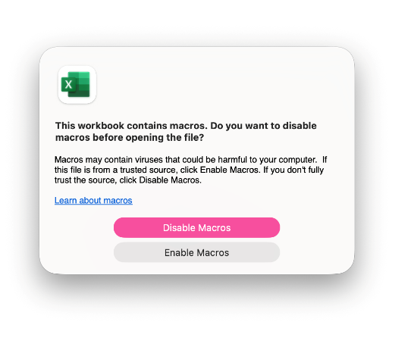

Entering submission details
- 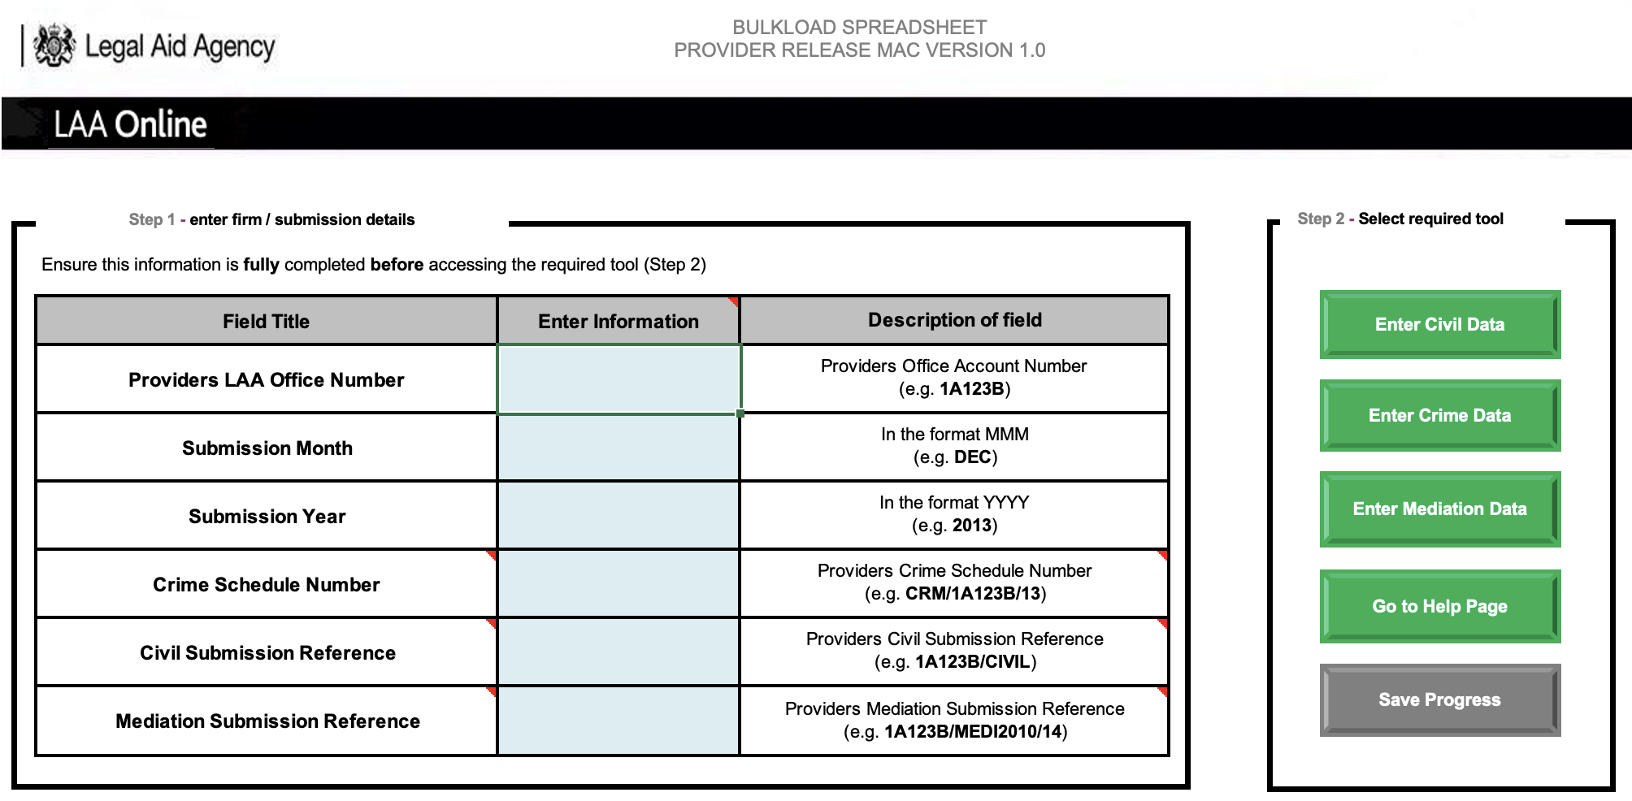When you first open the spreadsheet, the main page will appear. Here you need to enter information on which account, schedule, and submission period you are submitting for. You will need to click into the relevant green box to input the information.

- Please make sure the information is input in the correct format as indicated in the “Description of field” column. The month can be chosen from a drop-down menu.
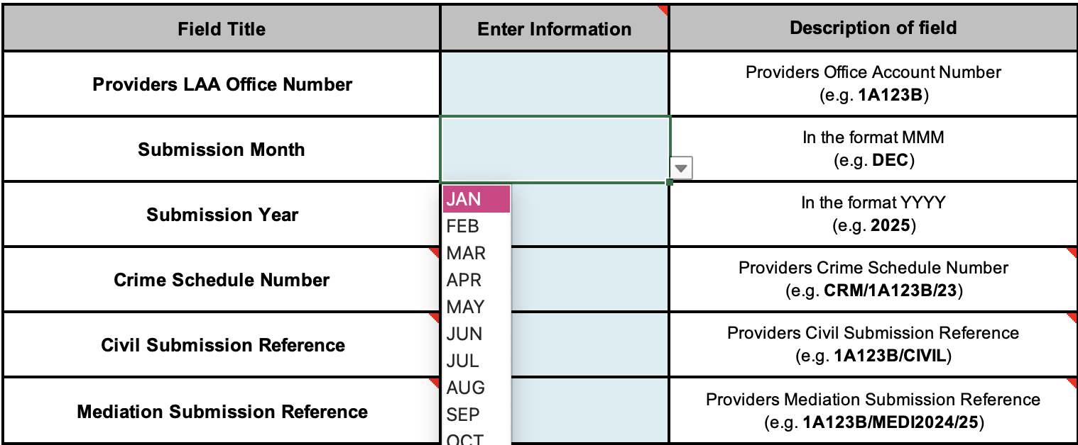

Criminal schedule number:
CRM/AccountNumber/schedule number (e.g. CRM/1A123B/13)
Civil Submission Reference:
AccountNumber/CIVIL (e.g. 1A123B/CIVIL)
Mediation Submission Reference:
AccountNumber/MEDI/Contract year/schedule number (e.g. 1A123B/MEDI2024/02)
- Please note that these formats may change in the future.
- If you do not have a crime schedule, leave the ‘Crime Schedule Number’ blank.
- If you do not have a civil schedule, leave the ‘Civil Submission Reference’ blank.
- If you do not have a mediation schedule, leave the ‘Mediation Submission Reference’ blank.
- When reporting civil submission data, it is only necessary to report your account number plus “/CIVIL” against the Civil Submission Reference as it is possible to report work that is authorised by more than one Civil Schedule that is concurrently active. The Schedule Reference of the Schedule under which work has been conducted is recorded against individual outcomes or new matter starts information (see below).

Entering Civil data

Enter Civil Data

- 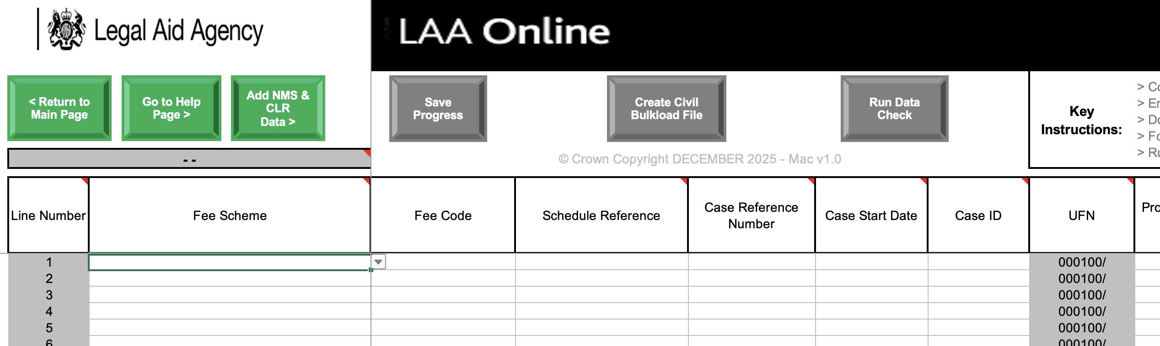Once you have entered your submission details, the next step is to choose which type of data you wish to enter. To enter civil data, click on the ‘Enter Civil Data’ button. Here you can type in your civil outcomes.
- You add the data for one outcome to one row. Once the row is complete, you can move down and start a new outcome on the next row. Do not leave any gaps (blank lines) in the data. If you wish to remove a line, please choose the VOID option in the fee scheme (see the image below); this will grey out the line ensuring it is safely removed.
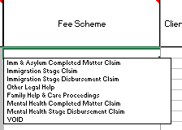

- You will first need to select which fee scheme the outcome belongs to from the drop-down menu. Once you have chosen this, some fields will be greyed out. These are not needed for this outcome, and you will not be able to enter any information in these fields. The ‘VOID’ option is to remove an outcome entered in error.
You must enter data in each field, working from left to right, to make sure the spreadsheet functions correctly. Always have caps lock on when entering data.
- Some fields may be highlighted in yellow - these are optional fields. If they are not applicable to the specific case, you do not need to fill these fields in.

- All other fields MUST be completed. You cannot leave any fields blank. If there are no costs to claim or time to report for a field, you must enter 0.

- Further guidance on the single Fee Code and all of the fields required to be completed in relation to a Civil submission, can be found in the ‘Guidance for SaBC Claims’ Submit a Bulk Claim (SaBC) - GOV.UK:

NB: The UFN and the UCN will be automatically generated for you, from other fields that you have filled in.

- The information MUST be input in the correct format to be accepted by SaBC. To find out what the format is, hold the mouse cursor over the field heading. An example for the schedule reference is given below. Some fields have drop-down menus; here you may only choose what is on the drop-down menu.

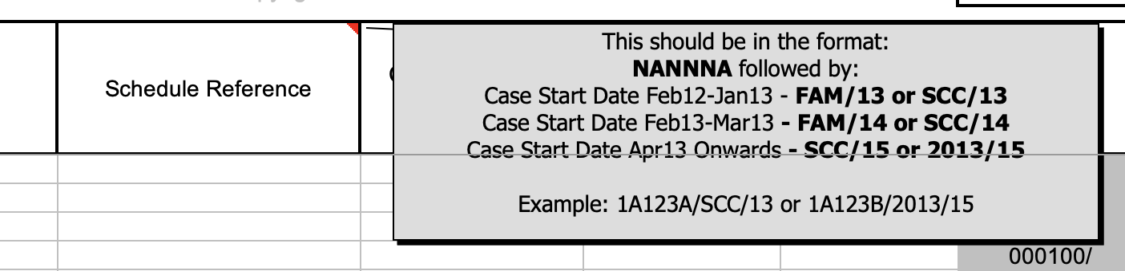

Single Fee Code
- A new field has been created to allow providers to enter the single Fee Code (Fee Code) relevant to each individual claim. The Fee Code creates a uniform way of pricing a case in SaBC; CWA used a range of information from different fields to calculate the relevant fee, escape fee threshold, and cost limits (where relevant) in each category of law. In some cases, it referred to several different fields. The new single Fee Code incorporates information in one data field, creating a uniform way of pricing a case, which has significantly simplified the digital build time for the service.

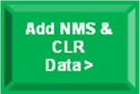
Entering New Matter Starts

- By clicking the ‘Add NMS & CLR Data’ button found in the civil screen (next to the ‘Go to Help Page’ button) you can add matter starts data and controlled legal representation data (immigration only) to your submission.
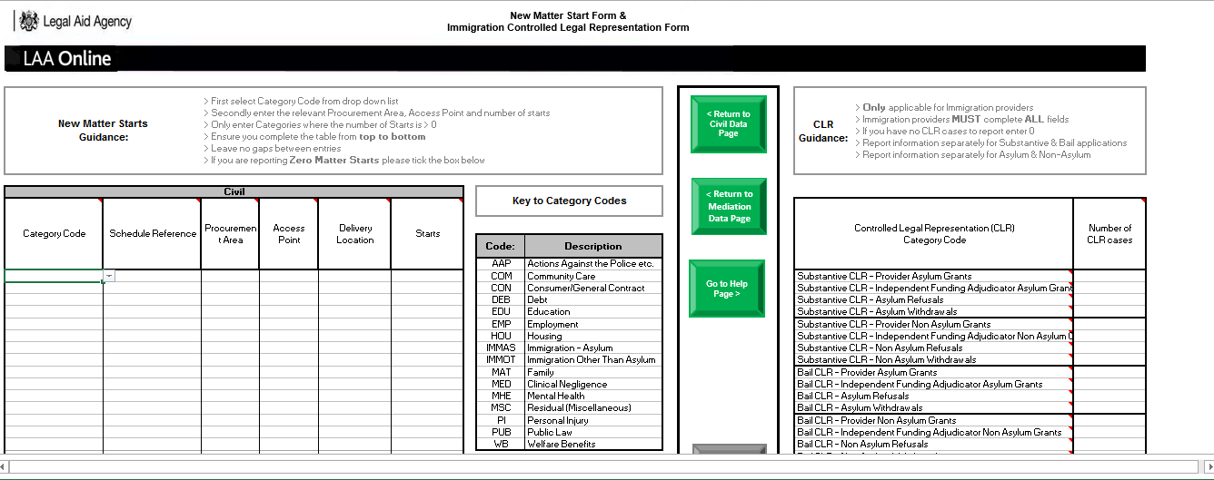

New Matter Start Form
- Enter the Category Code, Schedule Reference, Procurement Area, Access Point and Delivery Location codes, and the number of starts. Ensure you complete the table starting at the top and working down, leaving no gaps between lines. You must fill out every column for each category. Do not enter a category code if you have no starts in that category.
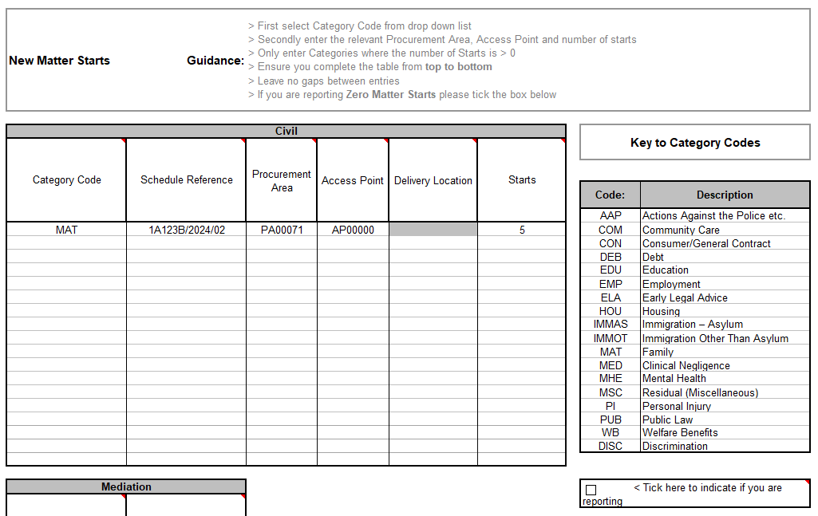
If you have no matter starts, please tick the Zero Matter Starts Indicator.
Enter each category on a separate row and complete every column

- If you have no new matter starts to report, please leave the matter starts table blank and tick the ‘Zero Matter Starts’ Indicator as highlighted above. When the indicator is ticked, the table turns grey and you will be unable to enter information into the fields.

3. If you only have new matter starts to submit, and no controlled work or mediation outcomes to report, you can still upload a submission purely to report those new matter starts. You will need to complete the front page of the Bulkload Spreadsheet but can leave the Civil or Mediation Outcome tabs blank.
- NB: Any data entered on the New Matter Start form will be added to the civil Bulkload file when it is created by clicking the ‘Create Civil Bulkload’ button in the New Matter Start form. Therefore, you should only create the civil Bulkload when both the civil data and New Matter Start forms are complete.

Once you have uploaded your file into SaBC and it has been checked and priced, it cannot be amended. Any amendments required after submission will be subject to a ‘Claim amendment’ request.

CLR - controlled legal representation data (Immigration only)
1. This section of the Bulkload Spreadsheet no longer requires completion. It will be removed in a subsequent version of the file.
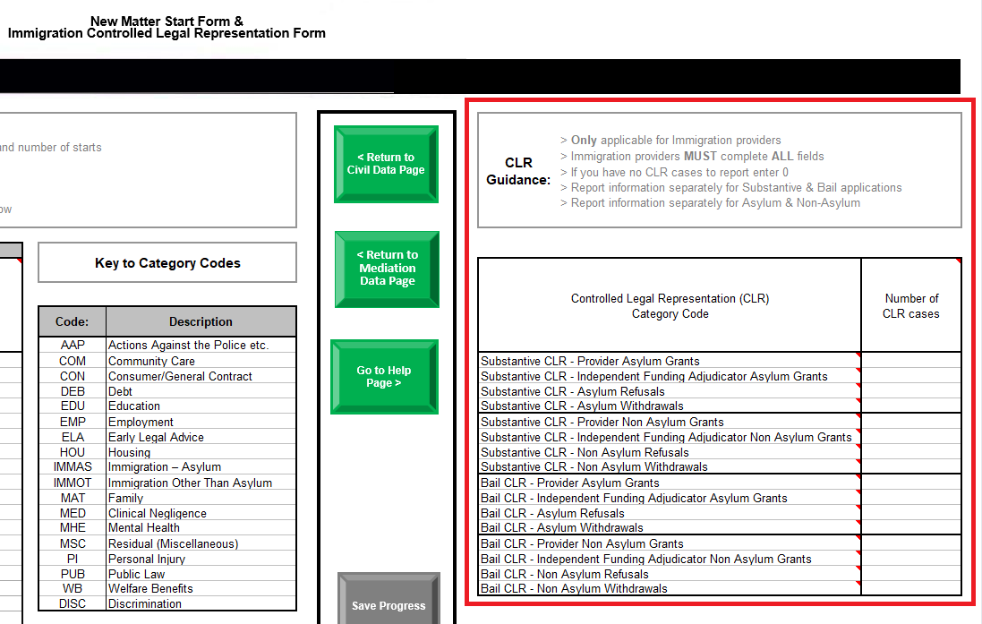

Entering Criminal data
Enter Crime Data

- 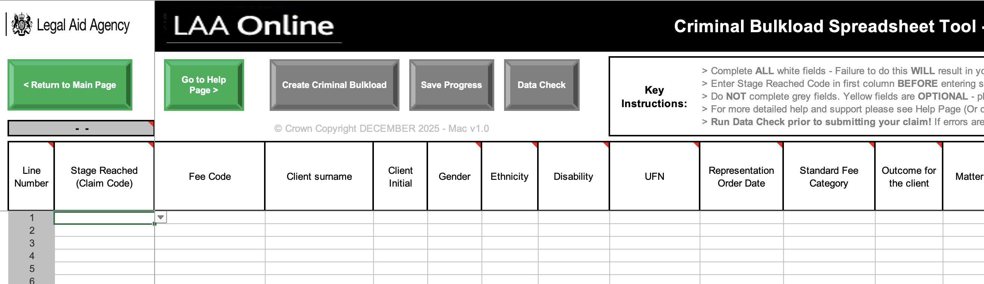To enter criminal data, click on the ‘Enter Crime Data’ button. Here you can type in your criminal outcomes. The columns relate to the different fields on a monthly crime lower submission form.

- You add the data for one outcome onto one row. Once the row is complete, you can move down and start a new outcome on the next row. Do not leave any gaps (blank lines) in the data. If you wish to remove a line, please choose the VOID option in the ‘Stage Reached’ column and this will grey out the line ensuring it is safely removed.
You must enter data in each field, working from left to right, to make sure the spreadsheet functions correctly. Always have caps lock on when entering data.
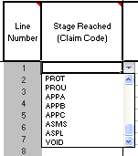

- You will first need to select the stage reached from the drop-down menu. Once you have chosen this, some fields may be greyed out. These are not needed for this outcome, and you will not be able to enter any information in these fields. The ‘VOID’ option is to remove an outcome that has been entered in error.
- All other fields MUST be completed. You cannot leave any blanks. If there are no costs to claim or time to report for a field, you must enter 0.
- NB: Some claim codes require very little information, so most of the fields will be greyed out as they are not needed.
- The information MUST be input in the correct format for the spreadsheet to work. To find out what the format is, hold the mouse over the field heading.
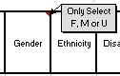
- Some fields have drop-down menus; here you may only choose what is on the drop-down menu.

Single Fee Code
- A new field has been created to allow providers to enter the single Fee Code (Fee Code) relevant to each individual claim. The Fee Code creates a uniform way of pricing a case in SaBC; CWA used a range of information from different fields to calculate the relevant fee, escape fee threshold, and cost limits (where relevant) in each category of law. In some cases, it referred to several different fields. The new single Fee Code incorporates information in one data field, creating a uniform way of pricing a case, which has significantly simplified the digital build time for the service.

10. Entering Mediation data

- 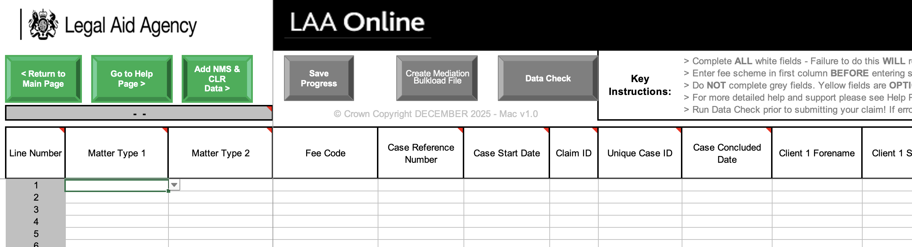Once you have entered your submission details, the next step is to choose which type of data you wish to enter. To enter mediation data, click on the ‘Enter Mediation Data’ button. Here you can type in your mediation outcomes.

- You add the data for one outcome to one row. Once the row is complete, you can move down and start a new outcome on the next row. Do not leave any gaps (blank lines) in the data. If you wish to remove a line, please choose the VOID option in the fee scheme (see the image below); this will grey out the line ensuring it is safely removed.
You must enter data in each field, working from left to right, to make sure the spreadsheet functions correctly. Always have caps lock on when entering data.

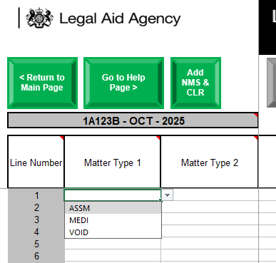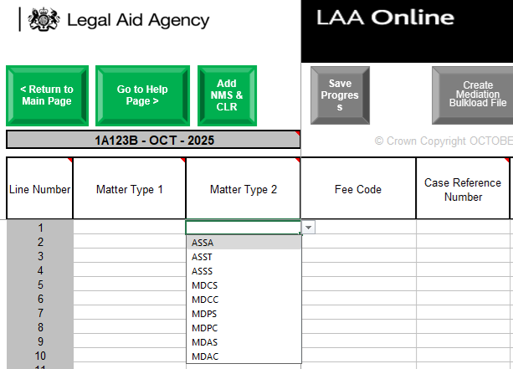
- You will first need to select which Matter Types the outcome belongs to from the drop-down menu. Once you have chosen this, some fields will be greyed out. These are not needed for this outcome, and you will not be able to enter any information in these fields. The ‘VOID’ option is to remove an outcome entered in error.
- Some fields may be highlighted in yellow - these are optional fields. If they are not applicable to the specific case, you do not need to fill these fields in.
- All other fields MUST be completed. You cannot leave any blank fields. If there are no costs to claim or time to report for a field, you must enter 0.

Single Fee Code
- A new field has been created to allow providers to enter the single Fee Code relevant to each individual claim. The single Fee Code creates a uniform way of pricing a case in SaBC; CWA used a range of information from different fields to calculate the relevant fee, escape fee threshold, and cost limits (where relevant) in each category of law. In some cases, it used a number of different fields. The new single Fee Code incorporates information in one data field, creating a uniform way of the service pricing a case, which has significantly simplified the digital build time for the service.

- Further guidance on the single Fee Code and all of the fields required to be completed in relation to a Mediation submission, can be found in the ‘Guidance for SaBC Claims’ on Submit a Bulk Claim (SaBC) - GOV.UK.
- NB: The UCN will be automatically generated for you from other fields that you have completed.
- The information MUST be input in the correct format to be accepted by SaBC. To find out what the format is, hold the mouse cursor over the field heading. An example of the Case Reference Number is given below. Some fields have drop-down menus; here you may only choose what is on the drop-down menu.
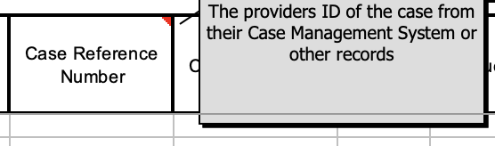


11. Saving your work

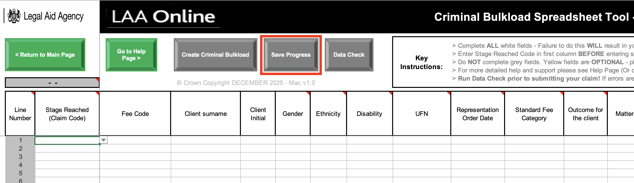
- You can save your progress at any time by clicking ‘Save Progress’ from any page. Each time you click save, this will create a folder. The folder name will be in the following format:
Bulkload_Progress<submission month><submission year><current day>_<save time in hours_minutes_seconds>
e.g. Bulkload_ProgressDEC202510_08_26_03
The folder will be created in the following location:
/Users/<username>/Library/Group Containers/UBF8T346G9.Office
- The file will be saved within this folder. The file name will be in the following format:
Bulkload_Progress<account number><submission month><submission year>
e.g. Bulkload_Progress1A123BDEC2024
- The folder will be created automatically; you do not need to create any folders. You will not be able to set a custom file path to save to a different location or shared network. This functionality will not work on the spreadsheet.
Please note that the guidance on the bulk upload spreadsheet has not yet been updated to reflect the correct guidance for saving and still contains the guidance for saving the Windows version. You should ignore this for now.
- A new folder will be created each time you save progress containing the saved file.
- We recommend that you do not create, amend, or delete the folders within the save file path. Instead, you can copy files to a different location on your computer if needed.
- We recommend saving your progress regularly to minimise the chance of losing your data.
- A message will appear and confirm whether the spreadsheet has been saved successfully:
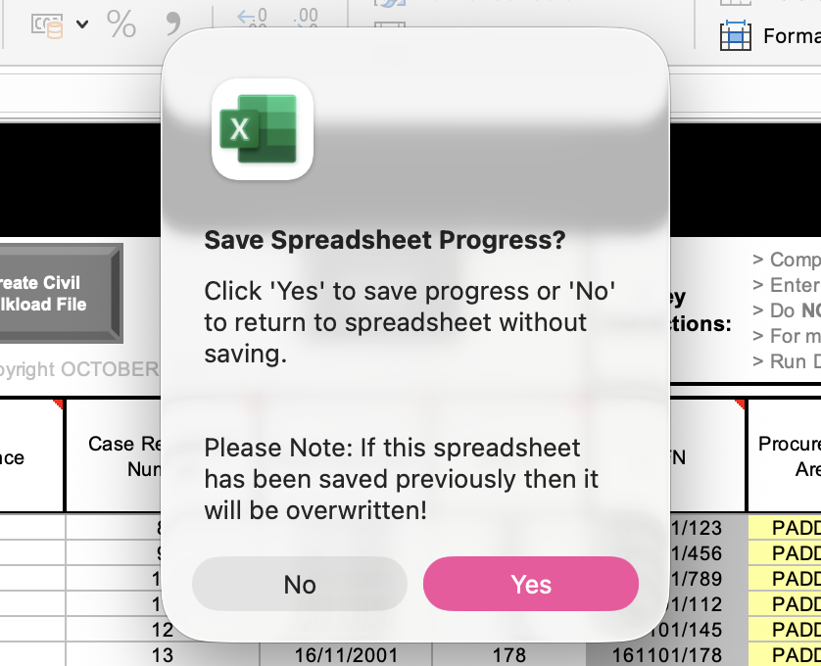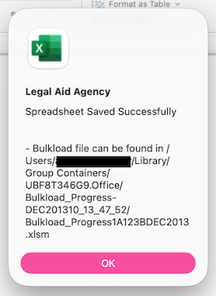

12. Checking your submission
- When you have completed your spreadsheet, you can run a check to see if you have entered information in all of the necessary fields by clicking on ‘Run Data Check’.

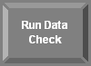
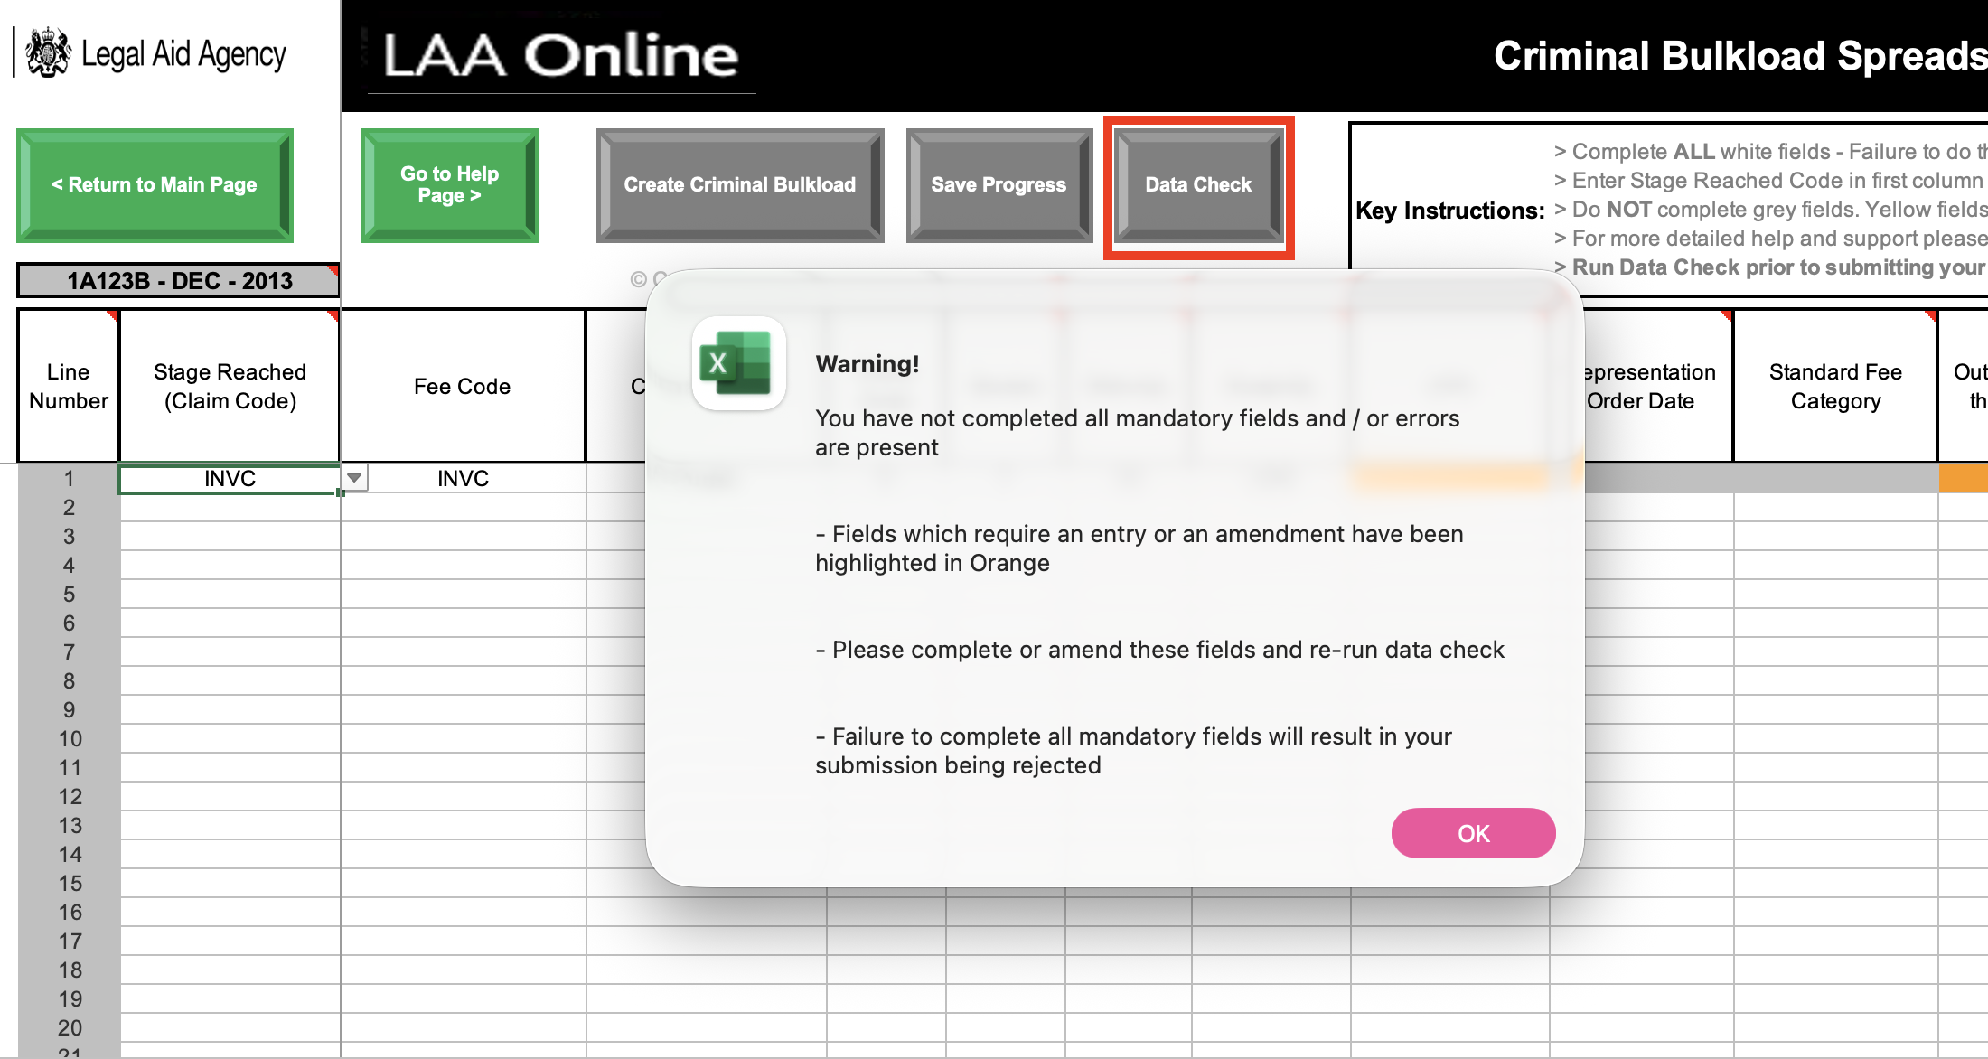
- Any fields that are missing essential data will be highlighted in orange. You can then go back and fill these fields in.
- When all the fields are filled in and the ‘Run Data Check’ button is pressed, the check will display a successful message.
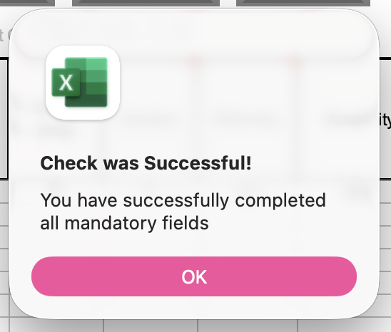

- The Data check is automatically run whenever you create a Bulkload .csv file. This is to help ensure that the file you create can be loaded into SaBC.
- NB: The data check does not check the validity of codes, only that you have completed all the mandatory fields. Please ensure that you are using the most up-to-date codes. These can be found on the gov.uk website alongside the Criminal, Civil & Mediation code guidance: Submit a Bulk Claim (SaBC) - GOV.UK
- A link to this guidance can also be found on the ‘Help Page’ of the Bulkload spreadsheet.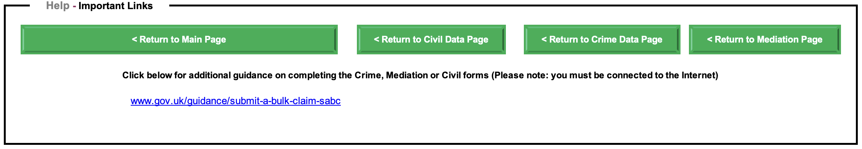

13. Printing the Bulkload spreadsheet
- You can print a summary of the Bulkload spreadsheet for your records by clicking on the ‘Print Preview’ button.


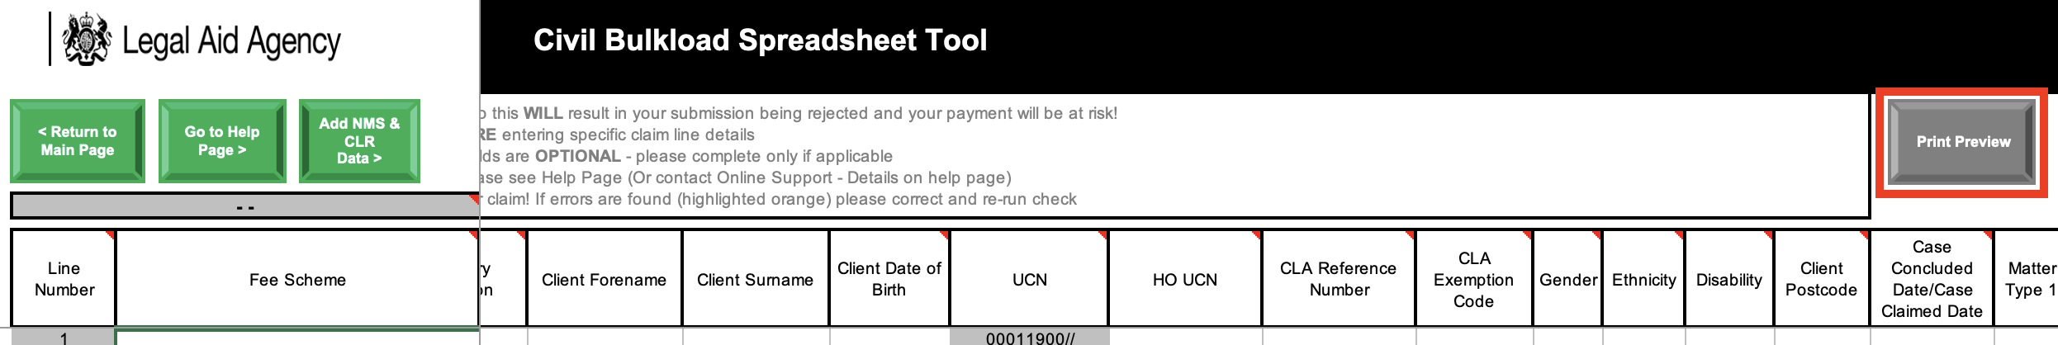

- 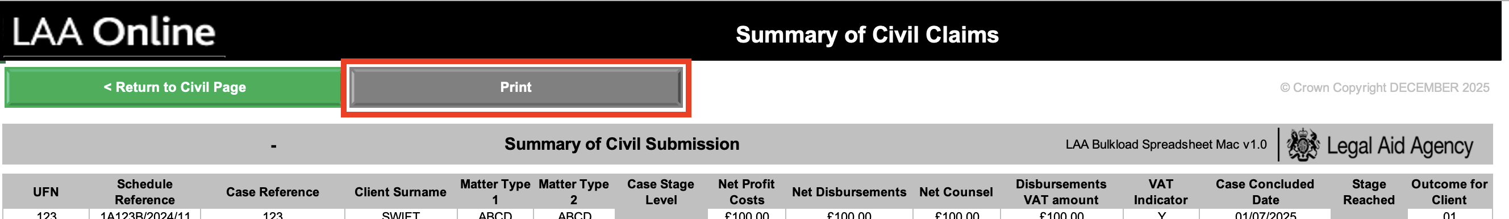
This will bring up the print preview screen. To print the summary, click on the ‘Print’ button. The summary will print in black and white; you can print both the civil and criminal areas of the spreadsheet.

14. Creating the Bulkload csv file
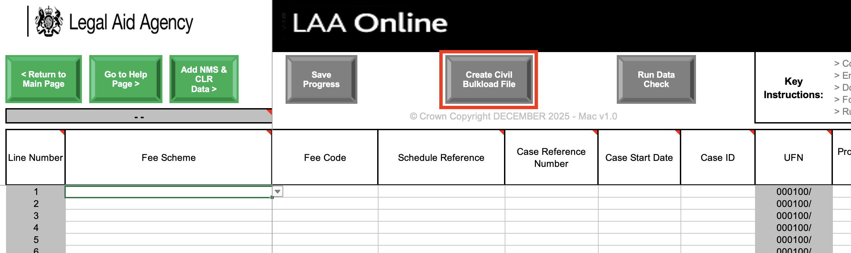
- When you have finished inputting all your outcomes, you can then create the csv file for Bulkloading into SaBC. You will need to do this separately for your criminal, civil, and mediation submissions. The button can be found on criminal, civil, and mediation pages next to the ‘Save Progress’ button.

All providers must submit using SaBC via the Sign in to Legal Aid Services (SILAS) unless they have received special dispensation from their contract manager allowing them to submit by any other method.

3. You will need to select Create file for civil, crime and mediation separately (where applicable). Each time you do this will create a new folder containing the file. The folder name will be in the following format:
<area of law>_Bulkload<submission month><submission year><current day>_<creation time in hours_minutes_seconds>
eg Civil_BulkloadDEC202510_08_26_03
The folder will be created in the following location:
/Users/<username>/Library/Group Containers/UBF8T346G9.Office
- The file will be saved within this folder. The file name will be in the following format:
<area of law>_Bulkload<account number><submission month><submission year>
e.g. Civil_Bulkload1A123BDEC2024
- The folder will be created automatically; you do not need to create any folders. You will not be able to set a custom file path to save to a different location or shared network. This functionality will not work on the spreadsheet.
- A new folder will be created each time you create a file.
- We recommend that you do not create, amend, or delete folders within the save file path. Instead, you can copy files to a different location on your computer if needed.
- To locate the folder containing the file, follow these steps:
  - Open Finder
  - Click on Go in the menu bar
  - Select Go to Folder
  - Type in ~Library/Group Containers/UBF8T346G9.Office
This will take you to the folder where you will find your file.
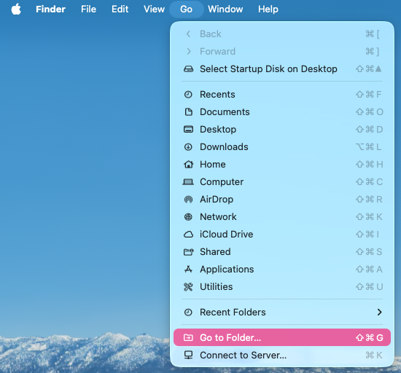
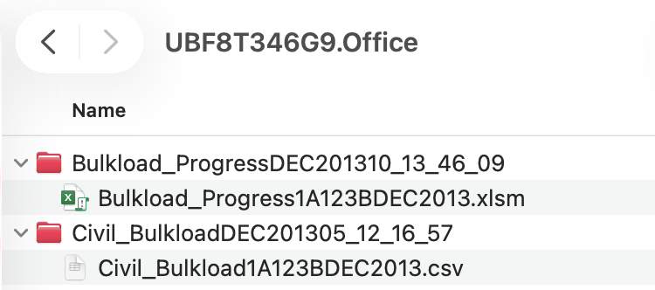

- NB: You do not need to create any folders or files manually; they will be created by pressing the ‘create civil/criminal Bulkload’ button.
- These are the files you will need to upload when you sign in to SaBC. For guidance on how to do this, please see the SaBC ‘User Guide’, which will be available on this page: Submit a Bulk Claim (SaBC) - GOV.UK .
- Once you have uploaded your file into SaBC and it has been checked and priced, it cannot be amended. Any amendments required after submission will be subject to a ‘Claim amendment’ request.

15. Alternative methods of submission
- All providers must submit using SaBC, which is accessed via Sign in to Legal Aid Services (SILAS) unless they have received special dispensation from their contract manager allowing them to submit by any other method. For more information, please contact your contract manager. Please note that the submission deadline rules still apply.
- Providers are unable to enter their submissions line by line, directly into SaBC.
- Providers are also able to upload a file exported from their Case Management System in CSV, XML, and TXT formats.

16. Creating a “nil submission” or NMS only
- If you have no new matter starts to report, please leave the matter starts table blank and tick the ‘Zero Matter Starts’ Indicator as highlighted in section 7 of this guide. When the indicator is ticked the table turns grey and you will be unable to enter information into the fields.

If you only have new matter starts to submit, and no controlled work or mediation outcomes to report, you can still upload a submission purely to report those new matter starts. You will need to complete the front page of the Bulkload Spreadsheet (see section 4 of this guide) but can leave the Civil or Mediation Outcome tabs blank or tick the “Zero Matter starts’ indicator boxes as above.

17. Points to note
- The spreadsheet must be downloaded to your local drive to ensure it works correctly. Do not use a shared version.
- Always have caps lock on when entering data.
- The copy and paste functions (command + 'C' and command + 'V') have been disabled on the spreadsheet so that formatting and any set conditions do not get copied by mistake. If you need to use the copy and paste functions, please select ‘Edit’ then select 'paste values'.
- The front page MUST be completed in full.
- Always choose the ‘Fee Scheme’ (civil), Matter Type 1 (mediation) or ‘Stage Reached Code’ (crime) prior to entering any other data on that line.
- Always enter data in each field, working from left to right to make sure the spreadsheet works correctly.
- Ensure that the correct single Fee Code for that claim has been entered – this will determine how the claim is priced once uploaded to SaBC.
- Complete the civil/criminal data pages from top to bottom leaving no gaps (blank lines). If you need to remove a line, choose the VOID option from the ‘Fee Scheme’ or ‘Stage Reached’ field.
- You cannot and do not need to enter any information into greyed out fields.
- The CLR information section does not require completion, including by Immigration providers.
- ‘Save progress’ regularly to avoid loss of data.
- You can only change the location of the files saved or created if you are using the Windows version of the spreadsheet on a Windows device. If you need to change the location of the files saved or created, go to the help page where you can change the file path. This cannot be done if you are using the MacBook version of the spreadsheet on a MacBook
- If you do not complete all the entries for your submission, remember to save your progress before you close the spreadsheet. When you return to the task, open the backup file from Bulkload backup folder (for Windows) or the Bulkload folder (for MacBook).
- Once you have created the Bulkload csv file you CANNOT edit or amend it in Excel. To make any changes you will need to open the backup spreadsheet (for Windows) or the Bulkload Progress file (for MacBook) that you created when clicking ‘Save Progress’. Then make the changes, click on ‘Save Progress’ and then click on ‘Create Civil/Criminal Bulkload’ to recreate the Bulkload file. This will create a new folder containing a new Bulkload file.
- Click ‘Go to Help Page’ at any time to display the help page. Here you can also find the ‘Ethnicity’ check box to check if your ethnicity codes are correct.
- For help regarding code guidance or payment issues, please contact your contract manager.
- For further technical help contact the Online Support Team on:

0300 200 200 or online-support@justice.gov.uk

18. Troubleshooting

Q. My macros are disabled – I can’t save my progress or create a file.
A. If your macros are disabled the security settings may be too high. To change the security settings, you will need to go to the Excel menu at the top of the spreadsheet and choose - Tools - Macro - Security. Select medium from the options and choose OK. If you then close the spreadsheet and open it again you should then be able to choose ‘enable macros’. The ‘save progress’ button should then work.

Q. My macros are enabled but the buttons still don’t work.
A. If you are editing a cell the navigation buttons will not function. Try pressing the tab key to come out of the cell edit and move to the next cell. The buttons should now work.
Q. An error message keeps appearing stating that the save method is disabled. How can I stop this?
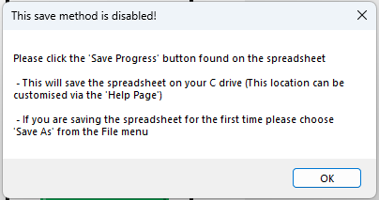
A. This message appears because the auto-save functionality in Excel is switched on. You will need to disable auto-save to stop the message from appearing. You can do this by going turning off the toggle switch in the top-left corner for individual files, or for a default setting, go to File > Options > Save and uncheck "AutoSave OneDrive and SharePoint Online files by default," then restart Excel for the change to apply to new files.
Q. I have opened the Bulkload spreadsheet and work I entered is missing.
A. After you have saved progress for the month’s submission a new file is created. . If you are using a Windows device, you will find this on your computer at C:\Bulkload\Backup\month, where the month is the current period, you are preparing, e.g. OCT2025. If you are using a MacBook, you will find this on your computer at:
/Users/<username>/Library/Group Containers/UBF8T346G9.Office
To enter additional data, open the backup file and enter it here. Saving progress overwrites the file, updating the data.

Q. Another person is trying to enter data into the same file but cannot do so.
A. The normal rules for Excel apply. Only one person can actively work on a file at the same time.

© Crown copyright
Produced by Legal Aid Agency


© Crown copyright 2024
This publication is licensed under the terms of the Open Government Licence v3.0
except where otherwise stated. To view this licence, visit nationalarchives.gov.uk/doc/open-government-licence/version/3
Where we have identified any third-party copyright information you
will need to obtain permission from the copyright holders concerned.



