May 2025
Customs Admin Burden research wave 2
Summary report
HM Revenue and Customs Research Report

Disclaimer

The views in this report are the author’s own and do not necessarily reflect those of HM Revenue and Customs.

Contents
Glossary and abbreviations 1
1 Executive summary 1
2 Introduction 3
3 Customs process usage 6
4 Customs process level data 8
5 Using software for completing customs processes 17
6 Awareness and understanding of changes to Safety and Security Declarations 19
7 Annex A: Technical details 23
8 Annex B: Additional supporting tables 31

Glossary and abbreviations
Term | Definition
Annual Survey of Hours and Earnings (ASHE) | The Annual Survey of Hours and Earnings (ASHE) is carried out in April each year and is the most comprehensive source of information on the structure and distribution of earnings in the UK. ASHE provides information about the levels, distribution and make-up of earnings and paid hours worked for employees in all industries and occupations.
Customs agent or broker | Customs agents complete declaration forms on behalf of businesses importing and/or exporting goods, ensuring goods moving to and from the country are accurately declared for customs. They do not primarily deal with the physical movement of goods.
Customs declaration | An official document listing the details of all goods being imported or exported to be submitted to the Customs authority.
Customs Declaration Service (CDS) | The Customs Declaration Service (CDS) is the UK government’s electronic system for handling customs declaration processes.
Customs intermediary | Someone that a trader hires to deal with customs on their behalf. Options for customs intermediaries include freight forwarders, customs agents, brokers or fast parcel operators.
Customs warehouse | Customs warehouses are used to store imported goods to delay duty payment. To use customs warehouses, businesses have to declare goods correctly.
Declarants | The person lodging the declaration including customs declarations and the other processes by which import and export information is provided to HMRC (such as the ENS and making entries in NCTS). The person legally responsible for the accuracy of the information given in the declaration, the authenticity of the documents which relate to it, and compliance with all the obligations relating to the entry of the goods under the procedure concerned. This can apply to both traders and customs intermediaries.
Demurrage charges | Demurrage charges are fees imposed by shipping lines or other carriers when cargo or containers are not loaded or unloaded within the agreed timeframe, known as “free time”. These charges incentivise the prompt movement of cargo, preventing congestion and ensuring efficient use of port resources.
Entry Summary Declaration (ENS) | An Entry Summary Declaration (ENS) is submitted before goods are moved into Great Britain. It includes basic information about shipment so that a safety and security assessment can be made.
European Union (EU) | The EU is a political and economic union of 27 European countries. It operates as an internal market, facilitating the free movement of goods, capital, services and people between member states. The EU countries are Austria, Belgium, Bulgaria, Croatia, Cyprus, Czech Republic, Denmark, Estonia, Finland, France, Germany, Greece, Hungary, Ireland, Italy, Latvia, Lithuania, Luxembourg, Malta, Netherlands, Poland, Portugal, Romania, Slovakia, Slovenia, Spain, and Sweden.
Export(ing) | Selling goods or services to a customer in a different country. This research focused purely on goods as customs declarations are not required for services.
Fast Parcel Operator (FPO) or Express Operator (EO) | Fast Parcel and Express Operators provide timely and tracked movement of goods.
Goods Movement Reference (GMR) | A Goods Movement Reference (GMR) is created using the GVMS. This links together all pre-lodged declarations for one shipment into a single number. This number references the vehicle moving the goods and can only be used for a single crossing.
Goods Vehicle Movement Service (GVMS) | The Goods Vehicle Movement Service, or GVMS, is used for imports, exports, and transit with pre-lodged declarations. GVMS allows for the immediate release of goods with pre-lodged declarations as soon as they arrive in the UK. Using the GVMS requires the completion of certain additional customs processes, such as creating Goods Movement References (GMRs).
Import(ing) | Purchasing goods or services from sellers in a different country. This research focused purely on goods as customs declarations are not required for services.
Last mile delivery | Last-mile delivery, sometimes referred to as ‘final mile’, is the movement of goods from a transportation hub to their final destination, typically a customer’s home address.
Large business | Firms with 250+ employees.
Medium business | Firms with 50 to 249 employees.
Micro business | Firms with 1 to 9 employees.
Movement Reference Numbers (MRNs) | Movement Reference Numbers (MRNs) are customs identification numbers created each time a declaration is submitted for importing or exporting goods through the Customs Declaration Service (CDS).
New Computerised Transit System (NCTS) | Transit is a customs facilitation that enables movement of goods across multiple customs borders without declarations being required at each customs boundary. It also delays customs duties until the goods arrive at their final destination. However, some obligations must be carried out when the goods move from one customs territory to the next. Transit movements must be started and ended on the New Computerised Transit System (NCTS), an electronic portal for completing transit declarations.
Office for Transit | The Office for Transit process is completed when crossing the border between different customs territories as part of the transit movement. The Customs Office is in the port the goods arrive into and certify the entry and exit of the goods using either a paper-based document or a digital office where the document arrives electronically. The haulier must be instructed of these processes for every Office of Transit listed on the transit declaration.
Safety and Security process (S&S GB) | Goods being moved into Great Britain must be covered by a Safety and Security declaration. This must be submitted before goods arrive at the border and can be amended at any time before the goods arrive at the UK border. The Safety and Security declaration includes information needed for risk assessment in GB, such as the vessel, route it has taken, and some details on the goods themselves. This is submitted via an Entry Summary Declaration (ENS). This is additional and separate to the customs declaration process.
Safety and Security Great Britain (S&S GB) system | The S&S GB system is a government online platform for processing ENS declarations. It does not have an online user interface, and so information is transferred to the system by a piece of software.
Small business | Firms with 10-49 employees.
Sole trader | A person who is the exclusive owner of a business. They are entitled to keep all profits after tax has been paid but are liable for all losses.
Supplementary Declaration for Warehousing | A SDW is normally required for goods released from a customs warehouse using the Simplified Customs Declaration Process (SCDP). It provides CDS with the necessary data and is essentially a full declaration. A standard declaration is not required at the point of releasing the goods but at a later date.
Trader | Businesses who import goods or services to the UK and/or export to other countries.
Transit | Transit is a customs facilitation that enables movement of goods across multiple customs borders without declarations being required in each country. It also delays customs duties until the goods arrive at their final destination. However, some obligations must be carried out when the goods move from one customs territory to the next. Transit movements must be started and ended on the New Computerised Transit System (NCTS), an electronic portal for completing transit declarations.
Turnover | Turnover is the total amount of money generated in the business from all sales of goods and services from businesses based in the UK or other countries, before any deductions.

- Executive summary
  - Customs process data
This study examined the administrative burden for declarants undertaking different customs processes. The term declarant is used to describe the individual logging the declaration including customs declarations and other processes by which import and export information is provided to HMRC. Declarants are responsible for the accuracy of information included within a customs declaration or other customs process. Most declarants (70% of those surveyed) were customs intermediaries, with a minority (30%) being traders. The time required to complete activities associated with customs processes varied by process type, with businesses spending 19-28 minutes on average per typical process. New Computerised Transit System (NCTS) import declarations required the most time (28 minutes), while Goods Vehicle Movement Service (GVMS) export declarations were the least time-intensive (19minutes).
Most processes required only 1-2 staff members, with a median of 1 person across all process types. Around half of staff members typically working with customs processes were in administrative roles. The internal cost per process was consistent across different processes, ranging from £5 for GVMS exports to £7 for other process types.
To reduce the amount of time spent to complete customs processes, businesses indicated that automated solutions would help data entry (approximately 70% across all process types). Only a small minority – at most one in five businesses – felt that no changes were necessary or that the current process was already efficient.
  - Awareness and understanding of changes to Safety and Security declarations
The study included 15 follow-up qualitative interviews with businesses who had completed a Safety and Security (S&S) declaration process in 2023. These interviews were conducted to discuss the S&S process in more depth and knowledge of changes to the process introduced in January 2025. Participants interviewed demonstrated good awareness of the new requirement for S&S declarations on EU imports. However, awareness of the reduced dataset requirement was lower.
Confidence levels varied significantly based on technology capabilities. Businesses with software solutions that auto-populated S&S declarations expressed high confidence, while those relying on manual processes anticipated substantial, one-off administrative burden to prepare for this. Preparation activities included voluntary test submissions, supply chain communication (particularly with EU hauliers), development of guidance materials, and staff training. Despite expected increases in declaration volumes, declarants planned to absorb the additional workload without expanding headcount.
Beyond administrative burden, participants anticipated potential border delays during implementation. Businesses also expressed concerns around the increased liability intermediaries may face due to the increased need for S&S declarations, as intermediaries often complete declarations for goods they have not seen.
- Introduction
HMRC commissioned Ipsos to conduct a telephone survey among trader and customs intermediary declarants focusing on six customs processes to help update HMRC’s customs administrative burden estimates. The term declarant is used to describe the individual logging the declaration including customs declarations and other processes by which import and export information is provided to HMRC. The study builds on a survey conducted by Ipsos in 2023 examining the time and cost spent by traders submitting different customs declarations.
The customs processes in scope of this survey were:
- Goods Vehicle Movement Service (GVMS) used for imports and exports
- Transit movements in the New Computerised Transit System (NCTS) for imports and exports
- Supplementary Declarations for Warehousing (SDW) usually used when releasing duty suspended goods from a customs warehouses
- Safety and Security Declaration (S&S) process for importing goods into the UK with an origin outside of the EU
The survey focused on understanding the processes involved, the administrative and internal financial costs and burden to declarants of complying with HMRC customs processes. This included the activities that businesses are required to do and how long these take, as well as those outsourced to other businesses.
The study also included a qualitative phase exploring knowledge of changes to the S&S process introduced on 31 January 2025. These changes meant that any goods imported from the EU to Great Britain must be covered by a S&S declaration, also known as an Entry Summary Declaration (ENS). The amount of safety and security data required on an ENS will be reduced.
  - Methodology
There were two main strands to the study: a random probability telephone survey of 460 declarants conducted between 21 October 2024 and 17 January 2025; and 15 in-depth telephone interviews between 10 December 2024 and 12 February 2025 providing qualitative insights. The sample of traders and customs intermediaries for this survey was drawn from a database of declarants provided by HMRC.
To ensure the survey delivered robust findings, Ipsos incorporated lessons learnt from the 2023 Customs Administrative Burden survey and undertook cognitive interviews and a pilot stage with traders and customs intermediaries to test the questionnaire and the sample quality for this survey. In addition, respondents giving permission at the end of the telephone interview were invited to a short online validation survey where they could check and, if necessary, edit their answers to numeric questions.
To avoid respondent fatigue, the survey was designed to collect data on up to three customs processes per respondent. If respondents were eligible to be asked about more than three processes, processes were selected in an order of priority. Less common processes, like Safety and Security declarations, were prioritised above more common processes, like imports and exports using GVMS. The order of priority was changed during fieldwork to ensure that base sizes would be sufficient for analysis across all process types. The order of priority used for each wave of fieldwork is shown in Table 2.1.
Table 2.1: Priority order for process types
Priority order (Highest to lowest) | First wave of fieldwork before pause in survey fieldwork (4th November 2024 – 15th November 2024) | Second wave of fieldwork following pause in survey fieldwork (25th November 2024 – 17th January 2025)
1 | Safety and Security Declarations Import | Safety and Security Declarations Import
2 | NCTS export Declaration | Supplementary Declaration for Warehousing Import
3 | NCTS import Declaration | NCTS import Declaration
4 | Supplementary Declaration for Warehousing Import | NCTS export Declaration
5 | GVMS export | GVMS export
6 | GVMS import | GVMS import

Participants were asked about a “typical” import or export process. This meant one without major issues. For brevity, we have not referred to all processes as “typical” in this report.
Weights have been applied to the data to ensure the survey is representative of the declarant population completing the six customs processes. A more detailed account of the methodology, including the response rate, data cleaning and weighting is included in Annex A.
  - Reporting notes
This summary report provides the key findings from the survey. Due to changes in methodology and different customs processes covered, the figures in this report should be viewed as standalone and not directly comparable to the 2023 survey.
Where possible, findings are reported separately for traders and intermediaries. Due to the smaller number of traders completing the survey, it was not always possible to report data separately for less common processes. This means that some data is analysed at the declarant level, rather than at the trader or intermediary level.
Survey results are subject to margins of error, which vary with the sample size and the percentage figure concerned. Findings with base sizes less than 50 are not shown. Additionally, where results are reported at a declarant level, this is because the sample sizes are too low to report them separately. Where base sizes are less than 100, findings should be treated with caution. All findings are aggregated, and no individual participant can be identified. There is a further guide to statistical reliability in Annex A.
Where figures do not sum to 100% this is due to rounding of percentages or because the questions allowed more than one response. Similarly, figures based on aggregating categories may not always reflect the sum of the individual answer categories due to rounding. Figures between 0% and 0.5% are denoted by +.
Average figures are reported using mean (and median values for some findings) to demonstrate the full scale of responses. Mean values were derived by taking the average of the actual figure given or the midpoint of banded responses. Median values were derived by taking the midpoint of the frequency distribution of the values. Median figures are useful where very high or low outlying figures were reported, to provide a more accurate and balanced account.
Outliers in the dataset were excluded and trimmed mean averages calculated for the time and cost data. More details are provided in Annex A.
This report also contains qualitative findings from the 15 in-depth interviews exploring upcoming changes to the S&S declaration process. Qualitative approaches are used to explore the nuances and diversity of views and are not designed to be statistically representative. Verbatim comments are included to illustrate key points. Where quotes are used, they have been anonymised and attributed with the participant type and key characteristics.
- Customs process usage
- This section provides an overview of the characteristics of the declarants in the sample and their use of third parties to handle trading requirements.
  - Business characteristics
Among the declarants surveyed, 70% were intermediaries and 30% were traders (see Figure 3.1). Intermediaries tended to be smaller than traders, with 42% of intermediaries being micro businesses, compared to 17% of traders. Around a third of traders (32%) were large businesses, compared to 8% of intermediaries.
Figure 3.1: Size of declarants
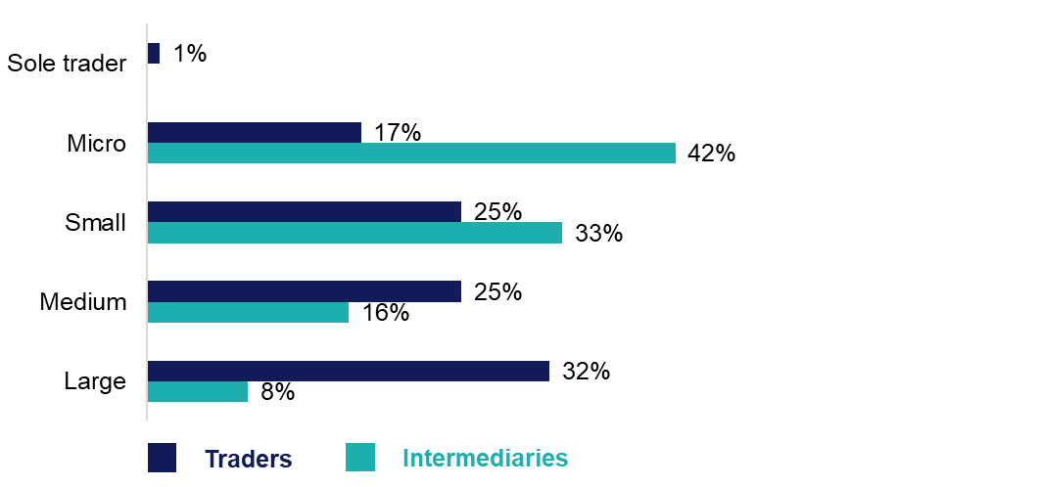Base: All traders (94); All intermediaries (366).
Traders also tended to have a high turnover, with more than half (57%) having a turnover of £5 million or more. Intermediaries were most likely to have a turnover between £1 million and £5 million (24%).
Nearly all (96%) intermediaries said they assisted with both importing and exporting goods outside the UK. This was also true for eight in ten (80%) traders. Just over one in ten (13%) traders said they only imported goods, and 6% only exported goods to other countries.
Declarants were asked what the main activity of their business was. Intermediaries were most likely to be freight forwarders (41%) or customs brokers/agents (25%). Among traders, this was classified by sector. Around a quarter of traders were in the agriculture and food sector (24%) and another quarter in the manufacturing (23%) sector.
As outlined in Figure 3.2, the most common types of products exported or imported were food or drink products (40% among intermediaries, 31% among traders), motor vehicles or transport equipment (25% intermediaries,14% traders) and furniture or homeware (23% intermediaries, 9% traders).
Figure 3.2: Types of goods moved and cleared by declarants
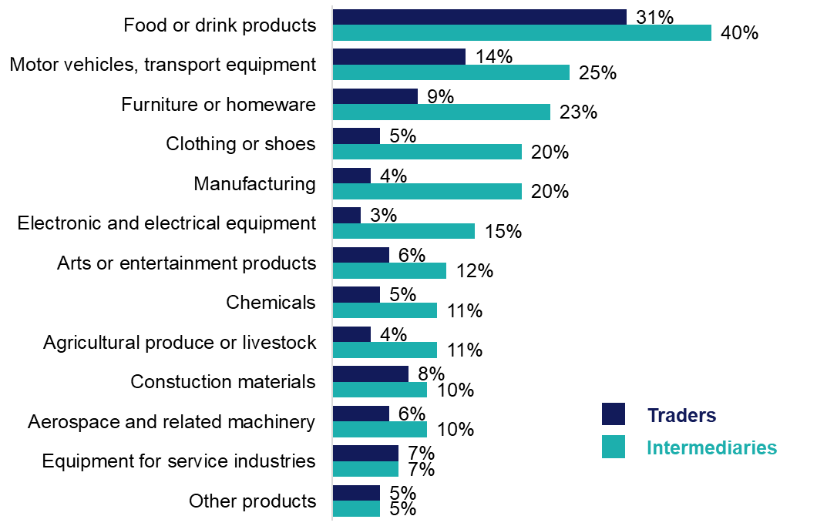Base: All traders (94); All intermediaries (366).
  - Use of third parties
While intermediaries specialise in customs processes, as processes include a multitude of activities, they often make use of third parties for specific tasks within the broader customs process, such as transportation or specialised documentation. The majority of traders and intermediaries reported using another business to handle their customs requirements when trading internationally (94% of traders, 85% of intermediaries). The most common type of third party used were freight forwarders (used by 78% of traders and 56% of intermediaries), customs agents or brokers (used by 73% of traders and 62% of intermediaries), and haulier/drivers (used by 69% of traders and 63% of intermediaries).
The most common type of service used by these third-party businesses was handling customs documentation and clearance (used by 93% of traders and 84% of intermediaries), shipping or moving goods (used by 88% of traders and 67% of intermediaries), and last mile delivery (used by 44% of traders and 49% of intermediaries).

- Customs process level data
This section examines the key activities associated with completing different customs processes. It then considers characteristics relating to these activities, including how long they took to complete, who completed them, and whether any third parties were used.
As set out in section 2, the survey was designed to collect data on up to three customs processes per respondent. Where possible, findings are reported separately for traders and intermediaries. Due to the smaller number of traders completing the survey, some data in this section is analysed at the declarant level.
  - Activities completed for each customs process
Prior to survey fieldwork, HMRC and Ipsos developed a list of key activities associated with completing a given customs process. Declarants were then asked to select which of these activities, if any, their business completed. Declarants were asked not to include any activities entirely managed by a third party. Declarants reported completing most of the activities associated with a typical GVMS process (see Figure 4.1). At least four in five collected or collated the information needed to obtain a GMR (86% and 80% for exports and imports respectively). A similar proportion (81%) generated a GMR in the GVMS system for exports, with two-thirds (66%) completing this activity for imports.
Figure 4.1: Activities declarants undertook for a typical GVMS process*
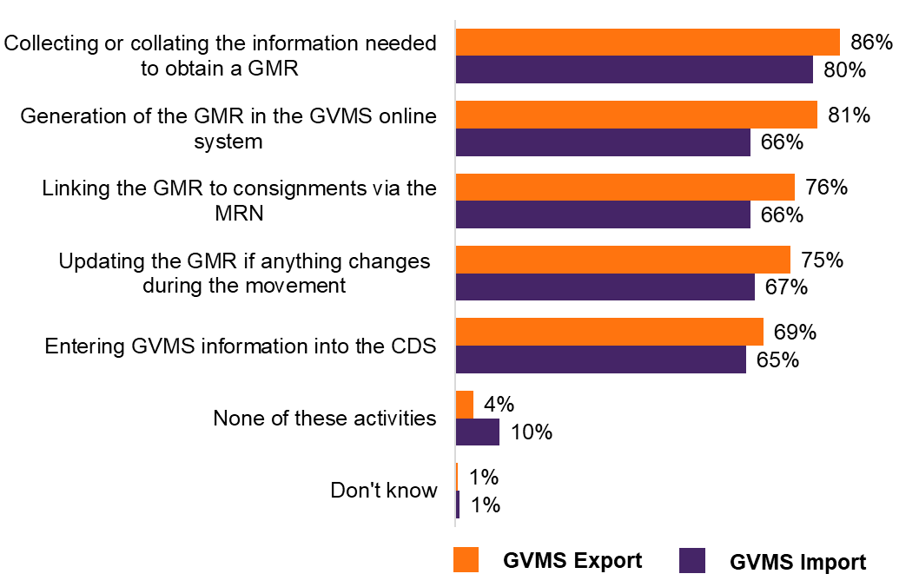
Base: Declarants who were prioritised for the GVMS export (279) or import (211) process. * During the pilot, respondents could answer “other” and input a different activity. This option was removed for the main survey and associated codes have been removed from the data.
Customs intermediaries were significantly more likely than traders to complete activities associated with putting information into an online system. Overall, 86% of intermediaries generated the GMR in the GVMS online system for a typical GVMS export, compared to 61% of traders. Likewise, around three-quarters of intermediaries (74%) entered GVMS information into the Customs Declaration Service (CDS), compared to 50% of traders.
As seen in Figure 4.2 below, considering the NCTS process, the most common activity completed by declarants was collecting or collating information to lodge a transit declaration (88% for exports, 77% for imports). The least common activity, though still carried out by around six in ten businesses, was completing the Office of Transit (64% for exports, 58% for imports). The small number of traders completing the NCTS process limits subgroup analysis for this process type.
Figure 4.2: Activities declarants undertook for a typical NCTS process*

Base: Declarants who were prioritised for the GVMS export (279) or import (211) process. + Represents a value between 0% and 0.5%.
The Supplementary Declaration for Warehousing (SDW) and Safety and Security (S&S) processes showed similar patterns, outlined in Figure 4.3 below, with around eight in ten (82% and 77% respectively) collecting or collating information for the process. Around three-quarters of those involved in SDW declarations (73%) submitted this information into the CDS system. A smaller proportion of those involved in S&S declarations submitted information into the S&S GB system (56%).
Figure 4.3: Activities declarants undertook for a typical SDW and S&S process

Base: Declarants who were prioritised for the SDW import (146) and S&S import (99) process.
  - Time spent per declaration
Declarants were asked how long, in total, it would take to complete the activities they undertook for a given customs process. They were asked only to consider the time spent actively working on these activities, not the time taken for them to complete. For example, this would include entering or collecting information, but not waiting for another business to pass that information to them.
As shown in Figure 4.4, businesses spent between 19 and 28 minutes on average to complete all activities associated with a given customs process. The time taken at the declarant level was highest for NCTS import and export declarations (28 and 27 minutes respectively) and SDW imports (27 minutes), and lowest for GVMS exports (19 minutes).

Figure 4.4: Average time taken by declarants to complete activities associated with a typical customs process (minutes)

Base: All who completed at least one activity for each customs process. Values presented are trimmed means. For more detail on trimmed means, see Annex A. Base sizes are shown after trimming.
GVMS export: 234; GVMS import: 166; NCTS export: 186; NCTS import: 126; SDW import: 112; S&S import: 70.
  - Number of staff required to complete declaration
Declarants were asked how many staff members were involved in completing activities for one typical process, as shown in Figure 4.5. The mean number of staff members was consistent across process types at between 1 and 2. The median number of staff members for all process types was 1.
Figure 4.5: Number of staff members involved in completing tasks for one typical process
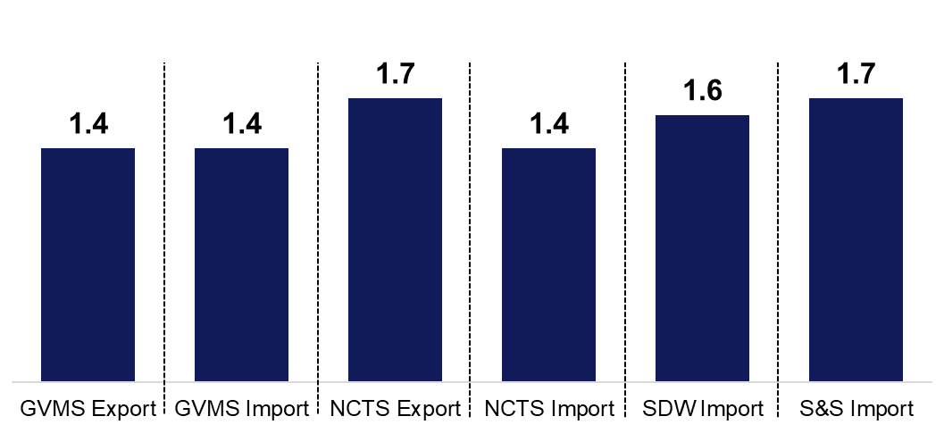Base: All who completed at least one activity for each customs process. GVMS export (263); GVMS import (188); NCTS export (209); NCTS import (141); SDW import (126); S&S import (79).
The numbers in the chart refer to the mean number of staff involved in completing a task.
  - Job role of staff completing declarations
Declarants were asked the job title of the staff member mainly responsible for completing the activities associated with a given customs process. These were mapped to the Annual Survey of Hours and Earnings (ASHE) labels during the data analysis phase. ASHE labels have a corresponding median wage which was used to calculate the cost per process. For more information on how responses were mapped onto ASHE labels, see Annex A.
Table 4.1 shows the most common occupations (based on ASHE labels) of staff members involved in customs processes. Staff tended to be in administrative roles (ranging from 42% for GVMS import to 55% for NCTS export) or managers in logistics, warehousing and transport (ranging from 21% for NCTS import and SDW import to 25% for GVMS import).

Table 4.1: Staff member mainly responsible for completing activities
Activity completed | Other administrative occupations | Managers in logistics, warehousing and transport | Chief executives and senior officials | Office managers | Functional managers and directors | All other roles
GVMS export | 44% | 24% | 9% | 8% | 6% | 8%
GVMS import | 42% | 25% | 9% | 9% | 6% | 9%
NCTS export | 52% | 24% | 8% | 7% | 1% | 9%
NCTS import | 55% | 21% | 8% | 6% | 1% | 9%
SDW import | 43% | 21% | 9% | 3% | 3% | 21%
S&S import | 49% | 23% | 12% | 5% | 3% | 8%
Base: All who gave valid job title. GVMS export (255); GVMS import (183); NCTS export (207); NCTS import (140); SDW import (126); S&S Import (76).
For a full set of responses, see the additional tables in Annex B.
  - Cost per typical process
A key aim of this study was to estimate the internal cost associated with completing customs processes. This was calculated using the mean time taken to complete activities and the mean hourly wage rate matched from the ASHE data. The means have been trimmed to exclude the top and bottom 5% to account for extreme values. More detail on this process is available in Annex A.
The average cost was consistent between process types, ranging from £5 to £7 on average (see Figure 4.6). GVMS exports had the lowest average cost at £5, but this was not significantly different from the costs for other processes.
Figure 4.6: Average internal cost (£) for declarants completing activities associated with a typical customs process

Base: All who gave a valid time and role response. Values presented are trimmed means. For more detail on trimmed means, see Annex A. Base sizes are shown after trimming. GVMS export: 226,; GVMS import: 162; NCTS export: 183; NCTS import: 125; SDW import: 109; S&S import: 66).
  - Using third parties for each customs process
Survey respondents were asked to identify the customs activities they handled internally. For these specific internal activities, they were then asked whether they also used a third-party provider for assistance, and if so, how much they paid for these services.
Table 4.2 shows the proportion of businesses using a third party to help with at least some aspect of an activity they completed. Around a third of businesses used another business or third party. This was consistent across process types.
Table 4.2: Use of third parties to help with activities declarants completed internally*
Third party use | GVMS export | GVMS import | NCTS export | NCTS import | SDW import | S&S import
Used a third party to help with some aspect of the activity | 30% | 31% | 30% | 32% | 33% | 36%
Did not use a third party to help with some aspect of the activity | 69% | 69% | 69% | 67% | 67% | 64%
Don’t know | 1% | N/A | 1% | 1% | N/A | N/A
Base: All declarants who completed at least one activity for a GVMS export (265); GVMS import (189); NCTS export (210); NCTS import (144); SDW import (130); S&S import (80).
* During the pilot, respondents could answer “other” and input a different activity. This option was removed for the main survey. This only affected NCTS import, where the percentage that chose “other” was 2%.

  - Aspects that would help reduce the amount of time businesses spend on customs processes
Businesses were asked what would reduce the amount of time they spent on customs processes. The most common response was automating solutions for data entry – around seven in ten businesses reported this across all process types (as shown in Figure 4.7). For example, three-quarters (75%) of declarants who completed the SDW process reported that automated solutions would reduce the time spent. The second most common response, selected by at least six in ten declarants across all process types, was reducing the volume of data to be submitted into the relevant customs system.
Across declaration types, a minority thought no changes were necessary, or that the process was already efficient. Of businesses that complete declarations for SDW, S&S, or NCTS import and export declarations, only one in ten felt the process could not be improved.
Figure 4.7: Reducing the amount of time on customs processes

Base: All who knew how long activities associated with each customs process took. GVMS export (260); GVMS import (184); NCTS export (206); NCTS import (140); SDW import (124); S&S import (76). For a full set of responses, see the additional tables section in Annex B.
- Using software for completing customs processes
This section examines the types of third-party software businesses used to submit information relating to any customs processes.
  - Use of third-party software for internal customs processing
Declarants were asked whether they used third-party software to complete customs processes, specifically for internal processing rather than for the submission of the declarations (see Figure 5.1). Overall, 73% reported using third-party software, 75% among intermediaries and 71% among traders. Logistics and haulier firms were significantly less likely to use software than other intermediary types (64% compared to 77% of freight forwarders and 84% of customs brokers or agents).
Figure 5.1: Use of third-party software to submit information relating to customs processes
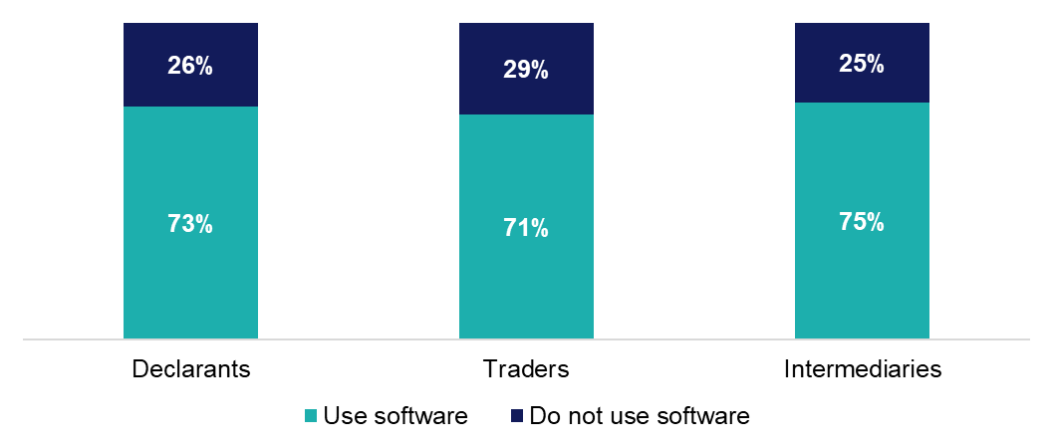Base: All declarants (460); All traders (94); All intermediaries (366)
  - Types of third-party software used by businesses
As outlined in Figure 5.2, the most common type of software used was Descartes and ASM Seqouia among intermediaries (27% and 23% respectively) and Descartes, AEB and Ricardo among traders (16%, 11% and 10%).

Figure 5.2: Types of third-party software used by businesses

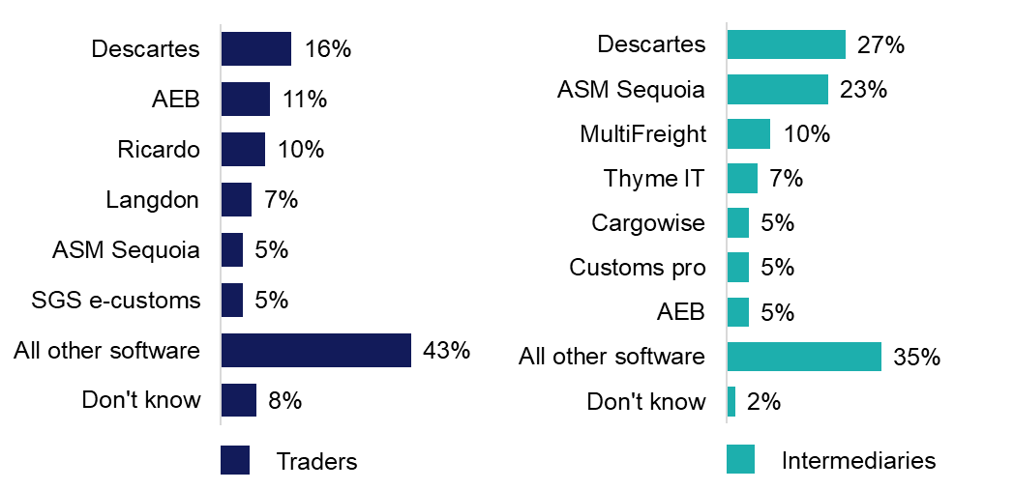

Base: All who use software: Traders (64) Intermediaries (272). Other than ‘Don’t know’ responses, only values of 5% or more shown. For a full set of responses, see the additional tables section in Annex B.

- Awareness and understanding of changes to Safety and Security Declarations
One of the main aims of the study was to explore businesses’ awareness and understanding of the changes to Safety and Security (S&S) declarations that were implemented on the 31 January 2025. From this date, any goods imported from the EU to Great Britain must be covered by an S&S declaration, also known as an Entry Summary Declaration. The amount of data required on an Entry Summary Declaration was also reduced. This includes 20 mandatory fields which must be completed for all declarations, 8 conditional fields which only need to be completed in certain circumstances, and 9 fields which are now optional to complete.
The qualitative findings were intended to provide insight into the behaviours, views, and experiences of specific businesses. This research did not set out to determine the prevalence of these experiences.
Findings cannot be considered representative of the entire Safety and Security declarant population and should not be interpreted as generalisable to the entire population.
  - Awareness of upcoming changes
Participants generally had good awareness that S&S Entry Summary Declarations (ENS) would be required for all EU imports from the 31 January 2025. They understood what types of goods and movements would require S&S declarations and had a sense of how this might impact their business. Where participants were not aware of these changes, this was driven by relying more heavily on outsourcing. This reduced their incentive to stay informed about upcoming changes to the process.
Participants kept up-to-date on these changes through a variety of channels. These included: communication from HMRC where participants actively sought out information from official sources like GOV.UK email alerts, HMRC notices, and webinars; trade associations and professional bodies disseminating relevant information to their members; and word of mouth communication from their business ecosystem and wider supply chain, including customers, software providers, hauliers, and ports.
“(Software provider) gave us a pretty good guide… the information was provided more from the software provider than HMRC.”
Intermediary, Micro business
There was, however, less awareness that from 31 January 2025, the amount of safety and security data required on the ENS would be reduced. This was driven by two key factors. Firstly, businesses completing S&S declarations using automation did not manually complete S&S forms but tended to auto complete most fields from the import declaration. This reduced their familiarity with the size of the dataset. Secondly, similar to those using automation, businesses outsourcing the completion of the S&S declaration did not manually complete the S&S forms, reducing their familiarity with the details of the dataset.
  - Actions taken ahead of the changes
Participants took a range of actions ahead of the changes to prepare. This included formal training with external suppliers and informal training such as running tests in-house. Some participants considered voluntary submitting S&S import declarations as training, with the volume ranging from just one declaration to more than twenty declarations. Participants explained they had encountered minimal issues when voluntarily submitting declarations in the testing phase. Some chose to not run “live” tests (i.e. submitting an actual S&S declaration) but tested within their existing software systems.
Another common action among participants was informing the supply chain about the changes that were being introduced from 31 January 2025. Participants generally had strong communication networks with their supply chain, driven by the volume of changes to customs processes in recent years. There was a particular focus on informing or educating some EU hauliers, who tended to be less familiar with customs processes. Some participants had developed additional materials and often shared these resources with their supply chain. This ranged from S&S written guidance documentation to custom portals for hauliers which enabled them to submit S&S declarations directly to HMRC.
  - Drivers of confidence and concern
Participants expressed different levels of confidence or concern around the upcoming changes. Businesses with software solutions that can copy relevant data from import declarations and auto-fill S&S declarations felt more prepared.
“The actual safety and security declaration itself is quite easy because a lot of the stuff is auto generated from the import entry that we've done.”
Intermediary, Medium business
Businesses also expressed more confidence when they had prepared for the transition, such as through testing, training or informing their supply chain. Some businesses had conducted live tests or voluntarily submitted S&S declarations ahead of the 31 January deadline. This left them feeling more assured the process would be smooth when rolled out.
Confidence was also higher among those with established relationships with suppliers and in-depth knowledge of their goods, Harmonised System (HS) codes, and supply chain processes. This increased confidence that businesses could be flexible or adaptable were any issues to arise.
“We know our product, our HS codes, the people that we purchase from are long-standing vendors, so we're pretty confident with the process of everything being cleared.”
Trader, Large business
On the other hand, there were several factors that drove concern regarding the changes. Some businesses without software feared the administrative workload of manually entering data for S&S declarations, especially for shipments with multiple consignors/consignees.
“If it's an extra 15 minutes per entry, you know, I say we're doing 100 entries a day. That's 15 times 100 minutes. You're talking 1,500 minutes of extra time spread around our workforce.”
Intermediary, Large business
Businesses also expressed frustration at the duplication of data between S&S declarations and full import declarations. This was felt to be particularly burdensome where businesses did not have software to automate completion. These participants were concerned that this could create significant extra burden without adding much value to HMRC.
  - Expected impact of the changes
Participants expected a significant increase in the volume of S&S declarations submitted.
“They’ll increase dramatically… We’re probably going from not even one a month to past 50 plus.”
Intermediary, Small business
The time and cost impact of this increased volume was expected to vary depending on how long it takes each business to complete an S&S declaration. Those relying on manual data entry foresaw a more significant burden. Business that used automation expected to see less increase in burden. The reduction in dataset size was not expected to offset the increase in overall declaration volume.
Despite this extra burden, participants demonstrated little appetite to expand headcount, preferring to absorb the added work in-house at current staffing levels. Participants explained moving more of the S&S process in-house would reduce costs, as even small additional outsourcing fees could become significant costs with expected increases in volume. Some businesses felt this change was relatively minimal compared to changes to customs processes in the past five years, and so wanted to limit wage bill increases.
“We're looking to do it at the same resources, but it'd be something that's monitored and obviously if our customer service falls because of the additional work, and it will be something that we look at our staffing levels.”
Intermediary, Medium business
  - Expected wider impacts of the changes
Beyond impacts relating directly to time and cost burden of completing additional S&S declarations, participants discussed a wider set of impacts that might result from the changes. These included concern about potential customs clearance delays, missed ferry/Eurotunnel crossings, and demurrage charges, particularly in the early days of implementation. Some participants noted that any update to customs processes tended to lead to some initial unintended non-compliance, which could be significantly more costly than the time burden in terms of costs, such as demurrage charges.
Some participants expected hauliers would be less willing to work with the UK. They explained that the number of changes to customs processes and procedures since EU Exit have made it more costly and risky for EU hauliers moving goods to the UK and as a result are less willing to work on UK deliveries. The interviews also raised some questions around groupage loads compared with single declaration loads. It was noted that groupage vehicles carrying lots of different consignments will need to complete different S&S declarations per consignment, reducing the effectiveness of automation. As such, it was suggested the burden of additional S&S declarations may disproportionately impact businesses operating groupage load models.
A further challenge raised by some participants was the potential liability exposure when submitting S&S declarations for goods they have not physically inspected. This put intermediaries in a difficult position, relying on the accuracy and completeness of information provided by customers. Inaccuracies, even if unintentional, could leave the declarant liable for any safety or security breaches.
“When we're doing a safety and security declaration, we're kind of confirming that the goods are safe, whereas sometimes we're not actually physically seeing these goods.”
Intermediary, Medium business
One potential upside of the changes was increased revenue opportunity for intermediaries who complete S&S import declarations from completing these processes for businesses not yet familiar with them. However, participants generally expected this to be a temporary upside, as the additional payment brought with it an incentive for businesses to learn to do these processes in-house.

- Annex A: Technical details
  - Sampling and weighting
The sample of traders and customs intermediaries was drawn from a database of declarants provided by HMRC. A census approach was adopted, meaning that all traders and intermediaries in the database were included in the sample. Prior to contacting the sample, a preparation stage was undertaken, specifically checking for and removing any duplicate entries. Following this preparation, all traders and intermediaries were sent an advance letter explaining the purpose of the survey and providing an opportunity to opt-out of the survey.
Weights have been applied to the data to ensure the survey is representative and to reduce potential biases caused by non-participation. Separate sets of weights were produced for analyses of the two groups: traders and intermediaries. An additional set was produced for analyses of the combined sample.
Random Iterative Method (RIM) weighting was used to correct the profile of achieved interviews by business size and sector, relative to the profile of the original HMRC-provided sample. These weights adjusted the sample to ensure the profile of the weighted sample matches that of the population figures. There are no population figures relating to this specific population of businesses that import and/or export (if traders) or assisted with the import or export of goods (if intermediaries) in 2023 and with the level of understanding of the customs processes that was required to participate in the survey.
As a result, it is not possible to weight directly to the corresponding population. The screened sample – cases that completed the screener questionnaire – is comparable with the sampling frame as it comprises both eligible responding cases (who go on to complete the questionnaire) and ineligible cases (who were present on the sampling frame but deemed ineligible and screened out of the survey). This screened sample was weighted to the population targets taken from the sampling frame. These weights reduce bias caused by non-response to the screener questions, which forms the bulk of non-response to the survey, since the majority of refusals occur before the screener questions are asked. It is not unreasonable to assume that screened cases will go on to be full respondents.
All screened cases were therefore given a non-response weight to reflect the profile of the HMRC sample frame and compensate for under- or over- representation of certain groups. The ineligible cases were later excluded from the final data, whilst the eligible cases with completed interviews are retained along with their weights to create the final, weighted datasets.
The combined weights were produced by combining the screened samples for traders and intermediaries in their proportion in the sampling frame.

Figure 7.1 summarises the weighting approach, with the first bar representing the sampling frame, the second bar representing the screened sample, and the third bar representing the final achieved sample.
Figure 7.1: Summary of weighting approach

The profile from the sampling frame that were used in the RIM weighting are shown in Tables 7.1.
Table 7.1.1: Weighting totals
Table 7.1.2: Company size
Table 7.1.3: Sector (Trader)
Table 7.1.4: Sector (Intermediaries)
Sector (intermediaries) | Traders (amount) | Traders (%) | Intermediaries (amount) | Intermediaries (%)
Transportation and storage | No data | No data | 918 | 77.7
Other | No data | No data | 263 | 22.3

7.2 Sample outcomes
Table 7.2 outlines the sample outcomes, calculating unadjusted and adjusted response rates, as well as cooperation rates.
Table 7.2: Sample outcomes
- Outcome | Total | Traders | Intermediaries
- Completed interviews | - 460 | - 94 | - 366
- Ineligible leads | - 40 | - 21 | - 19
- Refusals | - 323 | - 116 | - 206
- Unusable leads with working numbers | - 140 | - 51 | - 89
- Unusable numbers | - 166 | - 53 | - 113
- Working numbers with unknown eligibility | - 381 | - 160 | - 221
- Appointments | - 72 | - 17 | - 55
- Eligibility of screened respondents | - 92% | - 82% | - 95%
- Unadjusted response rate | - 29% | - 18% | - 34%
- Adjusted response rate | - 44% | - 34% | - 49%
- Cooperation rate | - 59% | - 45% | - 64%
Eligibility has been calculated as: (completed interviews) / (completed interviews + leads established as ineligible during screener).
2 The unadjusted response rate has been calculated as completed interviews / total sample loaded.
3 The adjusted response rate has been calculated as completed interviews / (completed interviews + incomplete interviews + (refusals x eligibility) + (working numbers with unknown eligibility x eligibility))
4 The cooperation rate has been calculated as: (completed interviews) / (completed interviews + refusals). Refusals have been based on expected eligibility.
Unusable leads with working numbers includes sample where there was communication difficulty making it impossible to carry out the survey (either a bad line, or language difficulty), numbers called 7 or more times over fieldwork without ever being picked up and numbers called at least 12 times without a definitive outcome.
Unusable numbers are businesses in the sample where the number was in a valid format, so was loaded into the main survey sample batches, but which turned out to be wrong numbers, fax numbers or disconnected.
Working numbers with unknown eligibility includes sample that had a working telephone number but where the respondent was unreachable or unavailable for an interview during the fieldwork period, so eligibility could not be assessed.
  - Data processing and editing / cleaning
Following fieldwork, data editing and cleaning was undertaken reviewing potential data errors and outliers.
7.3.1 Potential errors
The initial approach taken to review potential errors was to examine the top 10% and bottom 10% of values to numeric questions. This helped to identify any values that were very different to other businesses answers within the same question. The data was also manually examined to identify unusual values– for example, values between 0 and 1 for time taken or cost. Each potential error was then reviewed within the context of the respondent’s other answers to ensure logical consistency. Where data was felt to be inconsistent or not explainable, this data was removed from the dataset.
7.3.2 Outliers
Similar to potential errors, the initial approach taken to review outliers was to flag cases that were greater than 3 standard deviations away from the mean. The flagged values were then reviewed manually. Each potential outlier was compared to other answers that respondents had provided to make sure that they made logical sense given context. Therefore, outliers were removed from the data set if substantially different from the overall mean and misaligned from other results. The extent to which these corrections were needed covered a relatively small number of cases, typically around 5 to 10, depending on the number completing each customs process. Outliers were kept in the dataset if the response was logical in relation to other answers and in agreement with HMRC.
7.3.3 Trimmed means
The time and cost data are presented as a 5% trimmed mean, reflecting a total trimming of 10% from the dataset (5% from each tail, which is a standard amount used in trimming to retain the bulk of the data). Trimmed means remove the top and bottom percentage of a dataset before calculating the mean. Using the trimmed mean reduces the impact of outliers in the data. Means are trimmed via the following process: outliers are removed; a small, uniform, random value (between 0 and 0.001) is applied to each data point enabling data points to be ordered even where large proportions of the data have the same value; these data points are ordered and split into vigintiles (20 percentiles each containing 5% of the data); the top and bottom vigintile are removed; and the mean is calculated with the new data.
  - ASHE matching process
The Annual Survey of Hours and Earnings (ASHE), carried out in April each year, is the most comprehensive source of information on the structure and distribution of earnings in the UK. ASHE provides information about the levels, distribution and make-up of earnings and paid hours worked for employees in all industries and occupations.
To determine the cost associated with completing certain customs processes, the reported time taken was multiplied by the hourly earnings specified in the 2023 ASHE data. Table 7.3 shows how questionnaire response codes were matched to ASHE labels.
Table 7.3: Questionnaire response options and corresponding ASHE labels
Response option | Corresponding ASHE label | Corresponding SOC20 Code | 2023 Median (£)
Owner / proprietor | Chief Executives and Senior Officials | 111 | 40.83
Chief Executives and Senior Officials | Chief Executives and Senior Officials | 111 | 40.83
Taxation expert | Taxation experts | 2423 | 22.59
Customs agents / administrators | Other Administrative Occupations | 415 | 13.19
Import / export operator | Managers in Logistics, Warehousing and Transport | 124 | 16.57
Customs clerk | Other Administrative Occupations | 415 | 13.19
Warehouse operatives / administrators | Managers in storage and warehousing | 1242 | 15.00
Logistics staff | Managers in Logistics, Warehousing and Transport | 124 | 16.57
Business or finance professional | Finance Associate Professionals | 353 | 19.89
Sales / accounts professional | Bookkeepers, payroll managers and wages clerks | 4122 | 14.45
Operations manager | Office managers | 4141 | 17.17
Other administrative occupations | Other Administrative Occupations | 415 | 13.19
Don't know | -1 | -1 | -1
Prefer not to say | -1 | -1 | -1
Participants could select “other” when responding to the question about job title. These “other” responses were grouped into a new set of codes after fieldwork. These were then matched to ASHE data labels. This is shown in Table 7.4.

Table 7.4: Other response options and corresponding ASHE labels
Response option | Corresponding ASHE label | Corresponding SOC20 Code | 2023 Median (£)
Consultant | Management consultants and business analysts | 2431 | 24.88
Customer service | Customer service occupations not elsewhere classified (n.e.c.) | 7219 | 12.21
Freight manager / operator / coordinator | Transport and distribution clerks and assistants | 4134 | 13.72
It varies / no one in particular | Other Administrative Occupations | 415 | 13.19
Office manager | Office managers | 4141 | 17.17
Operations clerk / coordinator | Other Administrative Occupations | 415 | 13.19
Project manager / coordinator | Office managers | 4141 | 17.17
Sales / account manager | Bookkeepers, payroll managers and wages clerks | 4122 | 14.45
Shipping manager / agent / coordinator | Managers in Logistics, Warehousing and Transport | 124 | 16.77
Transport manager / planner / administrator | Managers in Logistics, Warehousing and Transport | 124 | 16.77
  - Internal cost calculation
By combining the time taken for businesses to complete activities and the average hourly wage of the business responsible for these activities, we can impute an internal cost. This is simply calculated as: Time taken (hours) X Mean ASHE hourly wage. The average cost for a given process was then calculated using the trimmed mean approach outlined above.
  - Margins of error
The participants were a sample of the total ‘population’ of declarants, so we cannot be certain that the figures obtained are exactly those we would have if all in the population had been interviewed (the ‘true’ values).
However, the variation between the sample results and the ‘true’ values can be predicted from knowing the size of the samples on which the results are based and on the number of times that a particular answer is given. The confidence with which this prediction can be made is usually chosen to be 95% - that is, the chances are 95 in 100 that the ‘true’ value will fall within a specified range.
For example, based on a sample size of 460 declarants, where 50% gave a particular answer, the chances are that the ‘true’ value (which would have been obtained if the whole population had been interviewed) will fall within the range of ± 4.8 percentage points from the sample result (i.e., between 45.2% and 54.8%).Table 7.4 outlines trader sample sizes and 95% confidence intervals for a survey estimate.
Table 7.5.1: Trader sample sizes and 95% confidence intervals
Total: | Unweighted base (N) | Weighted base (N) | Effective base (N) | 95% confidence interval for a survey estimate
Number of declarants | 460 | 460 | 390 | 10%:  2.9 | 30%:  4.4 | 50%:  4.8
Table 7.5.2: Trader size
Size | Unweighted base (N) | Weighted base (N) | Effective base (N) | + / - | + / - | + / -
Sole trader / micro (0 to 9 employees) | 125 | 160 | 115 | 5.4 | 8.3 | 9.1
Small (10 to 49 employees) | 169 | 140 | 159 | 4.6 | 7.0 | 7.7
Medium (50 to 249 employees) | 115 | 87 | 100 | 5.8 | 8.9 | 9.7
Large (250+) | 46 | 59 | 40 | 9.3 | 14.2 | 15.4
Table 7.5.3: Business type
Business type | Unweighted base (N) | Weighted base (N) | Effective base (N) | + / - | + / - | + / -
Trader | 94 | 136 | 87 | 6.3 | 9.6 | 10.4
Intermediary | 366 | 324 | 318 | 3.2 | 4.9 | 5.3
- Annex B: Additional supporting tables
Table 8.1: GVMS export ASHE label descriptors*
ASHE label description | Percentage
Other Administrative Occupations | 44%
Managers in Logistics, Warehousing and Transport | 24%
Chief Executives and Senior Officials | 9%
Office managers | 8%
Functional Managers and Directors | 6%
Bookkeepers, payroll managers and wages clerks | 2%
Warehouse operatives | 1%
Management consultants and business analysts | 1%
Customer service occupations n.e.c. | 1%
Sales accounts and business development managers | 1%
Other administrative occupations n.e.c. | 1%
Managers in logistics | 1%
Brokers | +
Transport and distribution clerks and assistants | +
Managers in storage and warehousing | +
Base = All who undertook GVMS export activities and could give a valid job title for staff members (255). *Note that “don’t know” has been excluded from the base, as those saying “don’t know” could not be ascribed an ASHE label.

Table 8.2: GVMS import ASHE label descriptors*
ASHE label description | Percentage
Other Administrative Occupations | 42%
Managers in Logistics, Warehousing and Transport | 25%
Chief Executives and Senior Officials | 9%
Office managers | 9%
Functional Managers and Directors | 6%
Bookkeepers, payroll managers and wages clerks | 2%
Other administrative occupations n.e.c. | 2%
Management consultants and business analysts | 2%
Sales accounts and business development managers | 2%
Buyers and procurement officers | 1%
Customer service occupations n.e.c. | 1%
Managers in storage and warehousing | +
Base = All who undertook GVMS import activities and could give a valid job title for staff members (183). *Note that “don’t know” has been excluded from the base, as those saying “don’t know” could not be ascribed an ASHE label.

Table 8.3: NCTS export ASHE label descriptors*
ASHE label description | Percentage
Other Administrative Occupations | 52%
Managers in Logistics, Warehousing and Transport | 24%
Chief Executives and Senior Officials | 8%
Office managers | 7%
Warehouse operatives | 2%
Bookkeepers, payroll managers and wages clerks | 1%
Other administrative occupations n.e.c. | 1%
Customer service occupations n.e.c. | 1%
Functional Managers and Directors | 1%
Buyers and procurement officers | 1%
Stock control clerks and assistants | 1%
Transport and distribution clerks and assistants | 1%
Brokers | 1%
Finance Associate Professionals | +
Sales accounts and business development managers | +
Marketing and commercial managers | +
Base = All who undertook NCTS export activities and could give a valid job title for staff members (207). *Note that “don’t know” has been excluded from the base, as those saying “don’t know” could not be ascribed an ASHE label.

Table 8.4: NCTS import ASHE label descriptors*
ASHE label description | Percentage
Other Administrative Occupations | 55%
Managers in Logistics, Warehousing and Transport | 21%
Chief Executives and Senior Officials | 8%
Office managers | 6%
Book-keepers, payroll managers and wages clerks | 2%
Customer service occupations n.e.c. | 2%
Other administrative occupations n.e.c. | 2%
Functional Managers and Directors | 1%
Brokers | 1%
Transport and distribution clerks and assistants | 1%
Finance Associate Professionals | 1%
Marketing and commercial managers | 1%
Base = All who undertook NCTS import activities and could give a valid job title for staff members (140). *Note that “don’t know” has been excluded from the base, as those saying “don’t know” could not be ascribed an ASHE label.

Table 8.5: SDW import ASHE label descriptors*
ASHE label description | Percentage
Other Administrative Occupations | 43%
Managers in Logistics, Warehousing and Transport | 21%
Office managers | 9%
Other administrative occupations n.e.c. | 6%
Buyers and procurement officers | 3%
Managers in storage and warehousing | 3%
Chief Executives and Senior Officials | 3%
Finance Associate Professionals | 3%
Brokers | 2%
Customer service occupations n.e.c. | 2%
Sales accounts and business development managers | 1%
Functional Managers and Directors | 1%
Warehouse operatives | 1%
Bookkeepers, payroll managers and wages clerks | 1%
Stock control clerks and assistants | +
Base = All who undertook SDW import activities and could give a valid job title for staff members (126). *Note that “don’t know” has been excluded from the base, as those saying “don’t know” could not be ascribed an ASHE label.

Table 8.6: S&S import ASHE label descriptors*
ASHE label description | Percentage
Other Administrative Occupations | 51%
Managers in Logistics, Warehousing and Transport | 24%
Office managers | 11%
Chief Executives and Senior Officials | 5%
Functional Managers and Directors | 4%
Book-keepers, payroll managers and wages clerks | 1%
Brokers | 1%
Buyers and procurement officers | 1%
Warehouse operatives | 1%
Base = All who undertook S&S import activities and could give a valid job title for staff members (76). *Note that “don’t know” has been excluded from the base, as those saying “don’t know” could not be ascribed an ASHE label.

Table 8.7: GVMS export: what would reduce time spent on associated activities
ASHE label description | Percentage
Introducing automated solutions for data entry | 69%
Reducing the volume of data to be submitted into the CDS | 61%
Improving the software systems used | 56%
More guidance and support on how to complete this process | 45%
No changes needed / the process is already efficient | 18%
Streamlining the process / system / less repetition | 4%
More information / clarity on (error) codes | 1%
Better integration of systems / departments | 1%
Other (specify) | 7%
Don't know | +
Base: All who knew how long activities associated with the GVMS export process took (260).

Table 8.8: GVMS import: what would reduce time spent on associated activities
ASHE label description | Percentage
Introducing automated solutions for data entry | 69%
Reducing the volume of data to be submitted into the CDS | 62%
Improving the software systems used | 53%
More guidance and support on how to complete this process | 46%
No changes needed / the process is already efficient | 19%
Improve accessibility / less expensive | 6%
Better integration of systems / departments | 2%
Other (specify) | 5%
Don't know | 1%
Base: All who knew how long activities associated with the GVMS import process took (184).

Table 8.9: NCTS export: what would reduce time spent on associated activities
ASHE label description | Percentage
Introducing automated solutions for data entry | 71%
Reducing the volume of data needed to submit a transit declaration | 68%
Improving the software systems used | 61%
More guidance and support on how to complete this process | 53%
No changes needed / the process is already efficient | 9%
Streamlining the process / system / less repetition | 5%
More information / clarity on (error) codes | 4%
System being quicker at processing | 3%
Make it easier to cancel / edit entries | 3%
Less jargon / more plain English | 2%
Have a helpline / web chat / be easier to contact | 1%
Better communication of changes in systems | 1%
Other (specify) | 8%
Base: All who knew how long activities associated with the NCTS export process took (206).

Table 8.10: NCTS import: what would reduce time spent on associated activities
ASHE label description | Percentage
Introducing automated solutions for data entry | 72%
Reducing the volume of data needed to submit a transit declaration | 70%
Improving the software systems used | 63%
More guidance and support on how to complete this process | 51%
No changes needed / the process is already efficient | 11%
System being quicker at processing | 3%
Have a helpline / web chat / be easier to contact | 3%
Streamlining the process / system / less repetition | 2%
Other (specify) | 9%
Don't know | 1%
Base: All who knew how long activities associated with the NCTS import process took (140).

Table 8.11: SDW import: what would reduce time spent on associated activities
ASHE label description | Percentage
Introducing automated solutions for data entry | 75%
Reducing the volume of data needed to submit a Supplementary Declaration for Warehousing | 64%
Improving the software systems used | 62%
More guidance and support on Supplementary Declaration for Warehousing | 57%
No changes needed / the process is already efficient | 8%
Streamlining the process / system / less repetition | 5%
Have a helpline / web chat / be easier to contact | 2%
Other (specify) | 10%
Don't know | 1%
Base: All who knew how long activities associated with the SDW import process took (124).

Table 8.12: S&S import: what would reduce time spent on associated activities
ASHE label description | Percentage
Introducing automated solutions for data entry | 69%
Reducing the volume of data needed to submit a Safety and Security declaration | 67%
Improving the software systems used | 57%
More guidance and support on how to complete this process | 52%
No changes needed / the process is already efficient | 10%
Streamlining the process / system / less repetition | 6%
Other (specify) | 15%
Don't know | 3%
Base: All who knew how long activities associated with the S&S import process took (76).

Table 8.13: Types of software used by traders
ASHE label description | Percentage
Descartes | 16%
AEB Customs Management | 11%
Ricardo | 10%
Langdon | 7%
ASM Seqouia | 5%
SGS e-customs | 5%
MIC | 4%
Ashford | 3%
Destin8 | 3%
CAS by Customs4Trade | 2%
Trader Support Service | 2%
Thyme IT | 2%
Tradephlo | 2%
e2open | 1%
MultiFreight | 1%
Customs Declarations UK | 1%
CustomsPro | 1%
iCustoms | 1%
Maritime Cargo Processing (MCP) | 1%
Other (specify) | 18%
Don't know | 8%
Base: All traders that used software (64).
Table 8.14: Types of software used by intermediaries
ASHE label description | Percentage
Descartes | 27%
ASM Seqouia | 23%
MultiFreight | 10%
Thyme IT | 7%
CargoWise | 5%
CustomsPro | 5%
AEB Customs Management | 5%
Destin8 | 3%
SGS e-customs | 2%
Forward Solutions | 2%
Maritime Cargo Processing (MCP) | 2%
Freightfax | 2%
Conex Systems | 1%
Wisetech | 1%
Trader Support Service | 1%
Azyra | 1%
Tradephlo | 1%
Modaltrans | 1%
ClearPort | 1%
Customs Declarations UK | 1%
Shipamax | 1%
Cargoes | 1%
iCustoms | 1%
Ricardo | 1%
J Freight | 1%
Sapphire | 1%
Prefer not to say | 1%
Ecustoms | 1%
CAS by Customs4Trade | +
Customs Declaration Management Software (CDMS) | +
CustomsLink | +
CustUK | +
Other (specify) | 8%
Don't know | 2%
Base: All intermediaries that used software (272).

Table 8.15: Profile of Safety and Security depth interviews
Participant | Micro | Small | Medium | Large | Total
Trader | N/A | N/A | N/A | 1 | 1
Intermediary | 3 | 6 | 3 | 2 | 14
Total | 3 | 6 | 3 | 3 | 15
Our standards and accreditations
Ipsos’s standards and accreditations provide our clients with the peace of mind that they can always depend on us to deliver reliable, sustainable findings. Our focus on quality and continuous improvement means we have embedded a “right first time” approach throughout our organisation.
ISO 20252
This is the international market research specific standard that supersedes
BS 7911/MRQSA and incorporates IQCS (Interviewer Quality Control Scheme). It covers the five stages of a Market Research project. Ipsos was the first company in the world to gain this accreditation.
Market Research Society (MRS) Company Partnership
By being an MRS Company Partner, Ipsos endorses and supports the core MRS brand values of professionalism, research excellence and business effectiveness, and commits to comply with the MRS Code of Conduct throughout the organisation. We were the first company to sign up to the requirements and self-regulation of the MRS Code. More than 350 companies have followed our lead.
ISO 9001
This is the international general company standard with a focus on continual improvement through quality management systems. In 1994, we became one of the early adopters of the ISO 9001 business standard.
ISO 27001
This is the international standard for information security, designed to ensure the selection of adequate and proportionate security controls. Ipsos was the first research company in the UK to be awarded this in August 2008.
 | The UK General Data Protection Regulation (GDPR)  and the UK Data Protection Act (DPA) 2018  Ipsos is required to comply with the UK GDPR and the UK DPA. It covers the processing of personal data and the protection of privacy.
 | HMG Cyber Essentials  This is a government-backed scheme and a key deliverable of the UK’s National Cyber Security Programme. Ipsos was assessment-validated for Cyber Essentials certification in 2016. Cyber Essentials defines a set of controls which, when properly implemented, provide organisations with basic protection from the most prevalent forms of threat coming from the internet.
 | Fair Data  Ipsos is signed up as a “Fair Data” company, agreeing to adhere to 10 core principles. The principles support and complement other standards such as ISOs, and the requirements of Data Protection legislation.

For more information
3 Thomas More Square
London
E1W 1YW
t: +44 (0)20 3059 5000
www.ipsos.com
http://twitter.com/Ipsos
About Ipsos Public Affairs
Ipsos Public Affairs works closely with national governments, local public services and the not-for-profit sector. Its c.200 research staff focus on public service and policy issues. Each has expertise in a particular part of the public sector, ensuring we have a detailed understanding of specific sectors and policy challenges. Combined with our methods and communications expertise, this helps ensure that our research makes a difference for decision makers and communities.

The Standard Occupational Classification 2020 (SOC20) is a classification system used to categorise occupations in the UK, focusing on skill level and job content.

