

Interim Order Decision
On papers on file
by Nigel Farthing LLB
An Inspector appointed by the Secretary of State for Environment, Food and Rural Affairs
Decision date: 10 February 2026

Order Ref: ROW/3367403
- This Order is made under Section 53(2)(b) of the Wildlife and Countryside Act 1981 (the 1981 Act) and is known as the East Sussex (Public Footpath Telscombe 18, Telscombe 19, Telscombe 20) Definitive Map Modification Order 2024.
- The Order is dated 8 November 2024 and proposes to modify the Definitive Map and Statement (DMS) for the area by adding three footpaths as shown on the Order map and described in the Order Schedule.
- There were two objections outstanding at the date of submission of the Order for confirmation.
Summary of Decision: The Order is proposed for confirmation subject to modifications which require advertising as set out below in the Formal Decision.

Preliminary Matters
- Two objections to confirmation of the Order were outstanding at the time of submission for confirmation. One objection was made by the original applicant, the other by the representative of the Open Spaces Society (OSS). Both objections raised the same two points; the first concerned the decision of the Council not to make an order in respect of two further claimed public footpaths, the second concerned the width of the Order routes.
- Following making of the Order, the Applicant submitted additional evidence which caused East Sussex County Council (the Council) to conclude that the two omitted routes merit inclusion in the Order and that the widths shown in the Order should be modified. The Council has requested that the Order be modified accordingly.
- In the light of the Council’s request that the Order be modified, both the Applicant and OSS have withdrawn their objections to confirmation of the Order.
- The objections to confirmation having been withdrawn, I shall determine the matter on the basis of the papers on file. I am satisfied that I can make a proper determination without the need for a site visit.
- In this decision I have found it convenient to refer to the Order map and for ease of reference a copy is attached. The Order map is annotated with points A to H which I shall refer to in this decision. I have added to the Order Map the further points J – M to facilitate identification of the two further routes I am invited to add to the Order.
- The Order seeks to add to the DMS three public footpaths, the first between Ambleside Avenue (point A) and Central Avenue (point B), the second between Central Avenue (point C) and Telscombe Cliffs Way (point F) and the third between Telscombe Cliffs Way (point G) and Fairlight Avenue (point H), all as shown on the Order map and described in the Order schedule.
- The two additional routes which I am invited to include by way of modification are, first from Fairlight Avenue (point I) to Cliff Gardens (point K) and second, from Cliff Gardens (point L) to Grassmere Avenue (point M).
- Although there are no relevant objections to confirmation of the Order it is necessary for me to be satisfied that the requirements for confirmation are met.

The Main Issues
- The Order has been made under section 53(3)(c)(i) of the 1981 Act which requires the discovery of evidence which (when considered with all other relevant evidence available) shows that a right of way which is not recorded on the DMS subsists or is reasonably alleged to subsist.
- At this confirmation stage of the process, it is necessary for the evidence to show that the right of way subsists, a reasonable allegation is not sufficient.
- The standard of proof to be applied is the balance of probabilities.
- The Council, in making the Order, rely upon a presumption of dedication arising further to the tests laid down in Section 31 of the Highways Act 1980 (the 1980 Act).
- Accordingly, the date when the public’s right to use the Order route was brought into question must be established. The evidence must then be examined to determine whether there has been use by the public and that such use has been as of right and without interruption for a period of not less than 20 years ending on that date. Finally, it is necessary to consider whether there is sufficient evidence that there was no intention on the part of the landowners to dedicate public rights during this 20-year period.
- In the event that the requirements for a presumption of dedication under the 1980 Act are not met, I will need to consider whether there is sufficient evidence for an inference of dedication at common law.

Reasons

Physical features
- The three Order routes and the two additional routes are each a section of alleyway or accessway running between existing properties, mainly residential but some commercial. They are for the most part enclosed by fencing or walls, sometimes the wall being part of a larger structure. Much of the routes are hard surfaced or improved in some way.
- The Order routes are within the town of Telscombe Cliffs which was developed in the twentieth century. It is suggested that these alleyways were laid out to facilitate the emptying of cesspits, and this would seem credible. Certainly, it is likely that their original purpose was to provide rear access to the adjoining properties for some purpose. Locally these alleyways are referred to as ‘twittens’.
- Each of the Order routes, and the additional routes, is open at both ends to a public highway. There is no evidence of any physical impediment or restriction to access, and no evidence of any signage seeking to prevent or control access.

Documentary evidence
- The Order was made under section 53(3)(c)(i) of the 1981 Act on the basis that evidence had been discovered to prove the existence of an unrecorded public right of way. The evidence relied upon in this case is in part documentary evidence and in part evidence of public use.
- In researching the application, the Council has consulted usual archival sources, relevant Ordnance Survey maps and available aerial photography. OS mapping shows no evidence of the Order routes prior to the development of the town in the mid-twentieth century. Later aerial photography, subsequent to the development of the area, shows the network of alleyways as clear physical features.
- The Order route has not previously been claimed for inclusion on the DMS.
- Evidence submitted after the Order had been made includes plans from two separate planning applications relating to property which incorporated part of the Order route C to F. The first plan is believed to date from 1962, the second from 1988. Both refer to the Order route as a ‘proposed right of way’ or a ‘R of way’. In neither case is the reference to the routes being public rights of way, but the evidence is consistent with the claimed status, albeit not determinative of it.
- In 2005 a planning application was made for development of land affecting the Order route A to B. Seven letters objecting to that application have been submitted in evidence. Three of these letters state the author’s belief that the Order route ‘is a right of way’ and all of the letters refer to use of the route by pedestrians, one referring to frequent use and one to use over a long period.

Conclusions on documentary evidence
- The documentary evidence demonstrates that the Order routes and additional routes have existed as physical features since at least the mid-twentieth century and have been used by local people. The evidence is insufficient on its own to give any reliable indication of public status but is not inconsistent with such status.

User Evidence
- The initial application for a modification order was supported by 15 user evidence forms (UEFs) with the earliest evidence of use being from 1960, but with the majority referring to more recent use. A number of those who completed the original forms were interviewed by the Council and their evidence clarified. After the Order was made, omitting the additional routes, a further 16 forms were submitted which covered use of the Order and additional routes.

Twenty-year period
- For the purposes of a statutory presumption of dedication under section 31 of the 1980 Act it is necessary to establish when the right of the public to use the route was first brought into question. In this case there is no evidence of an event or incident which had the effect of bringing into question the right of the public to use the Order routes. In such circumstances the appropriate date to be used is the date of the making of the application to modify the DMS by recording the routes. That application was made in 2016. In consequence the relevant 20-year period is 1996 – 2016.

Use as of right
- Use is only as of right if it is undertaken without force, secrecy or permission. In this case there is no suggestion that use was undertaken in secret. One user refers to having a private easement to use the route which would constitute use with permission. One user refers to having been told that they should not be using the route which could be sufficient to render use by that person contentious. Aside from these two users, whose evidence should be discounted, there is nothing to suggest that the remaining use testified to is other than as of right. In coming to this conclusion, I am reassured by the fact that there has been no substantive objection to the assertion that the routes have been used by the public as of right

Sufficiency of use 1996 to 2016
- For a statutory presumption of dedication to arise the evidence must demonstrate, on a balance of probabilities, that the Order routes, and the additional routes, were throughout the full relevant 20-year period used as of right and without interruption by a sufficient number of people to bring to the attention of a reasonable landowner that a right to use the route was being asserted.

Use of the Order routes
- The interviews conducted by the Council of witnesses providing the initial evidence forms identified some inconsistencies in the detail of the information provided, leading the Council to conclude that the evidence was of low quality. However, in relation to the Order routes, the Council was satisfied that the reliable evidence for each of the three sections was sufficient to sustain a reasonable allegation of presumed dedication.
- For the Order route A to B reliance was placed upon 8 evidence forms, reinforced by the evidence taken from the seven 2005 planning objection letters. Weekly use was reported by three users with a further three reporting monthly use. Six users had used the route for the full 20-year period.
- For the Order route C to F, all 14 initial user evidence forms claimed use, with 8 claiming use for the full 20-year period.
- For the Order route G to H, again all 14 initial user forms claimed use and again 8 referred to use for the full 20-year period.
- Although the established level of use of A to B was relatively sparse, I accept the Council was reasonable in finding it sufficient to give rise to a reasonable allegation of dedication. In the case of the other two routes, C to F and G to H, I accept that the level of use was manifestly sufficient. However, at this confirmation stage of the process a reasonable allegation is not sufficient, and I must be satisfied, on a balance of probabilities, that a presumption of dedication has arisen. In the case of routes C to F and G to H I accept that the original evidence is sufficient to satisfy the balance of probabilities test. In the case of the route A to B, I do not consider the initial evidence on its own sufficient to satisfy the confirmation test. I am however able to bring into account the additional evidence from which a further 12 people claim use of this route for varying lengths of time. Adding the additional evidence to the initial evidence for this route is more than sufficient to allow me to find that the balance of probability test is met.

Use of the additional routes
- The additional routes were included within the 2016 application for a Definitive Map Modification Order, but the Council concluded that the initial evidence was insufficient to support even a reasonable allegation of dedication and they were not included in the Order. The Council has reappraised the position with the benefit of the additional evidence and concluded that it is now sufficient to demonstrate presumed dedication and on this basis request that the Order be modified to include the additional routes, I to K and L to M.
- For the route I to K, the initial evidence included 9 users of whom 6 claimed use throughout the full 20-year period. There was only one user reporting daily use and one whose use was measured in weekly terms. The remaining use was less frequent, and the overall pattern was analysed by the Council as being ‘very limited’. I concur with that conclusion. However, of the 16 additional user evidence forms, 12 refer to use of this route. Although the frequency of such use is varied, the totality of the evidence has persuaded the Council that it is sufficient to give rise to a presumption of dedication, and again I agree with that conclusion.
- For the route L to M the initial evidence was similar to that for the route I to K, with 8 individuals claiming use of which 6 referred to use throughout the 20-year period. No-one claimed daily use, and only one person claimed weekly use. There was no supporting documentary evidence for this route. There was a complicating factor in that the northern end of this route was, at the date of the application, overgrown and some suggested it was impassable. The Applicant stated that the overgrowth was intermittent and was periodically cleared. Whilst the overgrown nature of the route would not constitute an interruption of use (as it was of natural origin) it might colour the interpretation of claimed use. It is unsurprising therefore that the Council found in the case of this route the evidential burden was not met.
- The additional evidence for route L to M included a further 10 users. Of these six claimed daily use and four weekly use. When aggregated with the initial evidence forms, the combined level of use was considered by the Council to be sufficient to support presumed statutory dedication. I do not lose sight of the evidence relating to the route being, at least periodically, overgrown. However, in the absence of any challenge to the evidence of use, and with no continuing objection to confirmation of the Order, I am satisfied that the evidence for this route is sufficient to meet the confirmation test.

Lack of intention to dedicate
- Evidence of a lack of intention on the part of the landowner to dedicate the Order route as a footpath would rebut any statutory presumption of dedication. To constitute an effective demonstration of a lack of intention to dedicate the landowner, during the relevant twenty-year period, must have acted in a way which would have brought home to users of the route that they did not wish it to become a public right of way.
- In this case there is no evidence of any actions by the landowner which could demonstrate a lack of intention to dedicate.

Conclusions on user evidence
- For the reasons given I am satisfied that the evidence meets the threshold for confirmation of the three Order routes. I am also satisfied that the evidence in relation to the additional routes which has been discovered since making of the Order, is sufficient to meet the requirements of section 53(3)(c)(i) of the 1981 Act and that a presumption of dedication arises under section 31 of the 1980 Act. As no Order has been made in respect of the additional routes the appropriate course is for a modification of the Order to be proposed to include the additional routes.

Common law
- Having concluded that the requirements for a statutory presumption of dedication have been met for the Order and additional routes it is not necessary for me to consider the position at common law.

Width
- The Order provides for the Order routes to be recorded with a uniform width of 1.5 metres. The Council accepts the additional evidence is sufficient to demonstrate that the Order and additional routes have in fact been used by the public to the full available width as confined by fencing and walls where such exist.

Overall Conclusion
- Having regard to these and all other matters raised I conclude that the Order should be confirmed subject to modifications to include the additional routes and to provide for the full available width to be recorded.

Formal Decision
- I propose to confirm the Order subject to the following modifications:

Add to the Schedule Part 1: -

FP Telscombe 21

The public footpath Telscombe 21 commences at the extent of public highway Fairlight Avenue, at point I, at TQ 3983 0138. From point I the public footpath continues in a generally west-north-west direction over an existing track for approximately 47 metres to point J, at TQ 3978 0140. From point J the public footpath turns in a north-north-east direction and continues for approximately 130 metres to terminate at the extent of public highway Cliff Gardens, at point K, at TQ 3983 0152.

The width of public footpath Telscombe 21 varies from 3.9 metres to 3.1 metres between point I and point J; and varies from 3.1 metres to 3.9 metres between point J and point K.

FP Telscombe 22

The public footpath Telscombe 22 commences at the extent of public highway Cliff Gardens, at point L, at TQ 3984 0153. From point L the public footpath continues in a north-north-east direction over an existing track for approximately 230 metres to terminate at the extent of public highway Grassmere Avenue, at point M, at TQ 3993 0174.

The width of public footpath Telscombe 22 averages 3 metres from point L at TQ 3984 0153 to TQ 3992 0171. From TQ 3992 0171 to point M at TQ 3993 0174, the width averages 2.4 metres.

Add to the Schedule Part 2 the following details –

Telscombe Path No. 21, Public Footpath, From TQ 3983 0138 Fairlight Avenue to TQ 3983 0152 Cliff Gardens, Length 0.177 kms, 0.109 miles, Remarks A width varying between 3.1 and 3.9 metres

Telscombe Path No. 22, Public Footpath, From TQ 3984 0153 Cliff Gardens to TQ 3993 0174 Grassmere Avenue, Length 0.230 kms, 0.142 miles Remarks A width varying between 3 and 2.4 metres

Amend the Schedule Part 2 as follows: -

Telscombe 18 Remarks – Delete the words ‘A width of 1.5 metres’ and insert ‘The width averaging 3 metres between points A and B.’

Telscombe 19 Remarks – Delete ‘A width of 1.5 metres’ and insert ‘The width averaging 3 metres between points C and F save where the route follows the perimeter of the car park associated with the residential building Dana Lodge where the width is 3 metres.’

Telscombe 20 Remarks – Delete ‘A width of 1.5 metres’ and insert ‘The width averaging 3 metres between points G and H.’

Add to the Order Map the points I to M and the notation for a public path to be shown between points I to K and L to M.
- Since the confirmed Order would affect land not affected by the Order, I am required by virtue of Paragraph 8(2) of Schedule 15 to the 1981 Act to give notice of the proposal to modify the Order and to give an opportunity for objections and representations to be made to the proposed modifications. A letter will be sent to interested persons about the representation procedure.

Nigel Farthing

Inspector

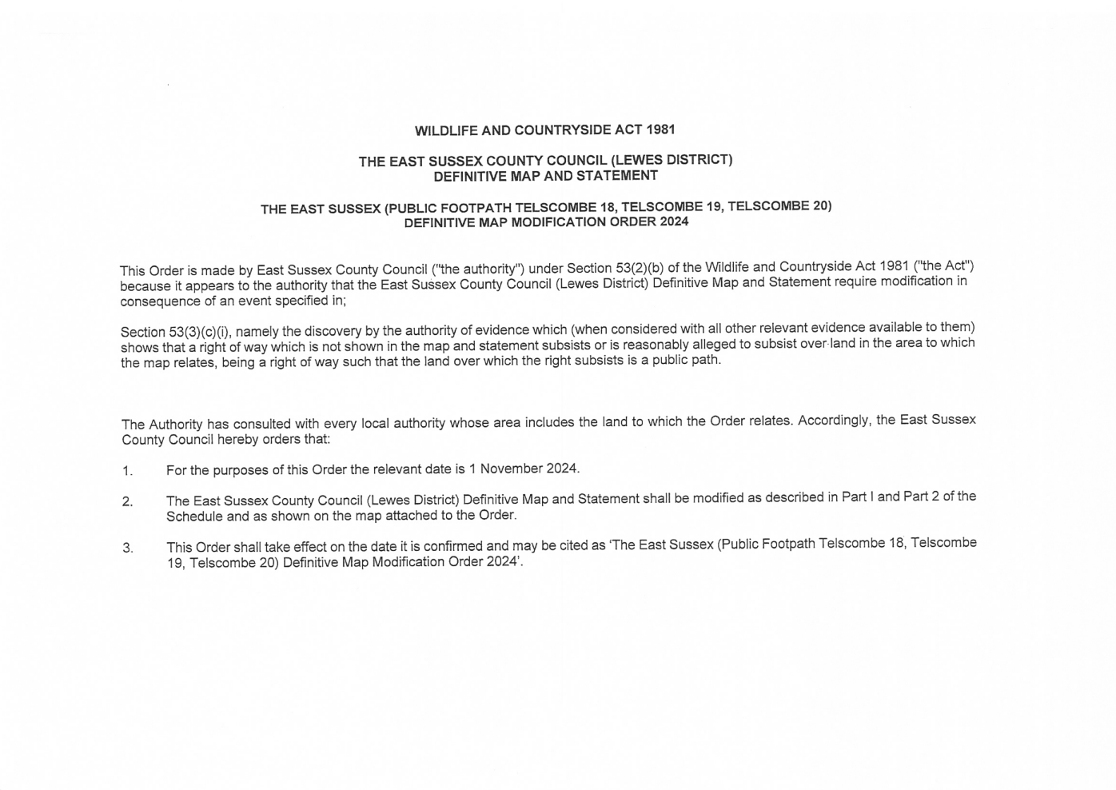

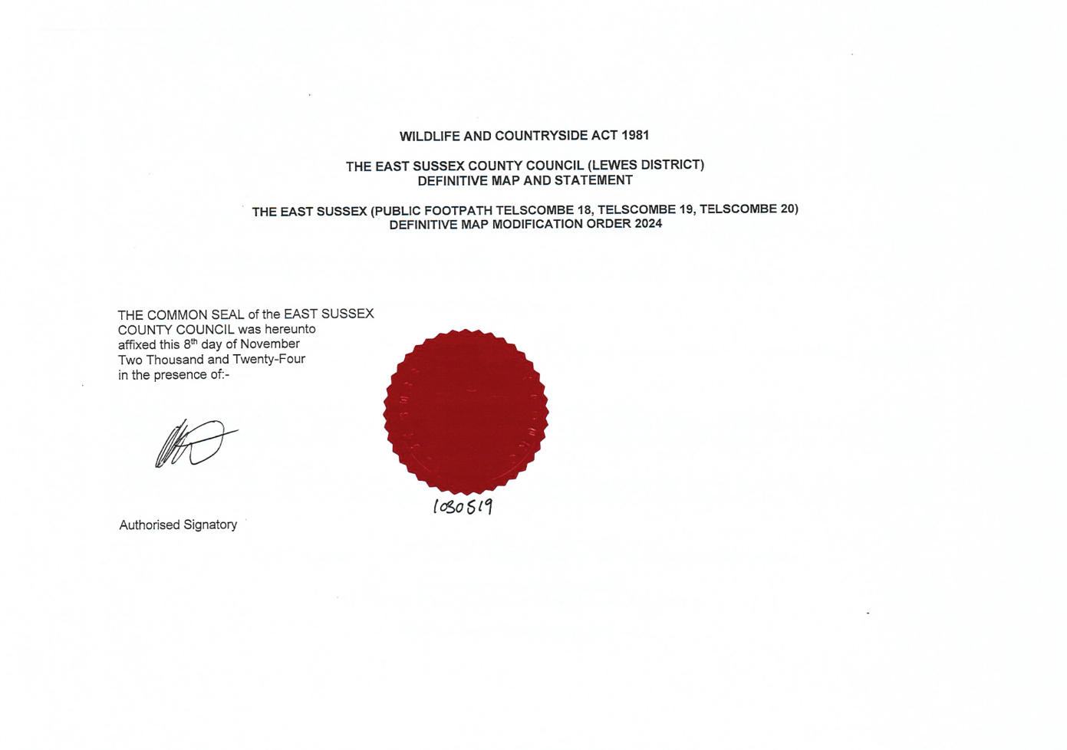

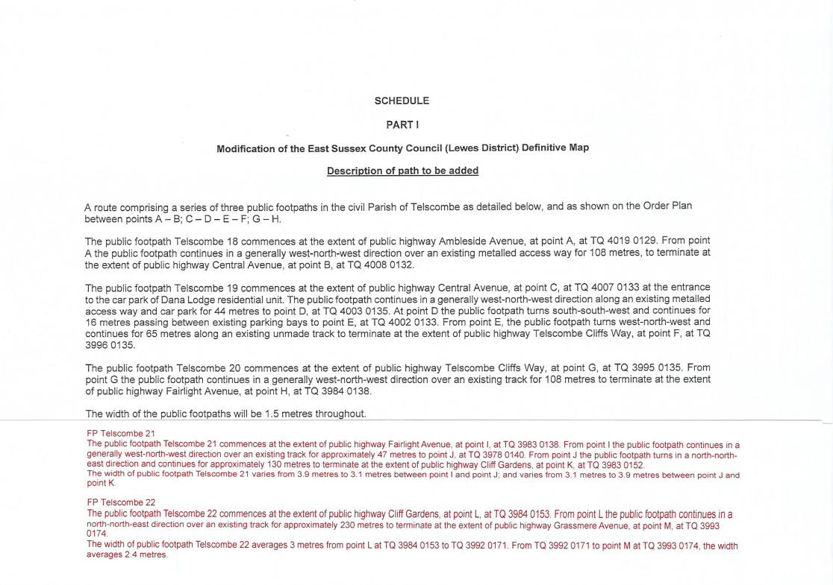

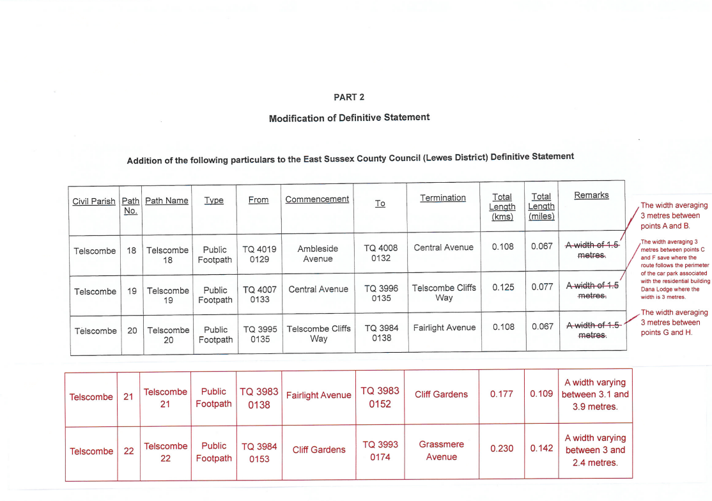

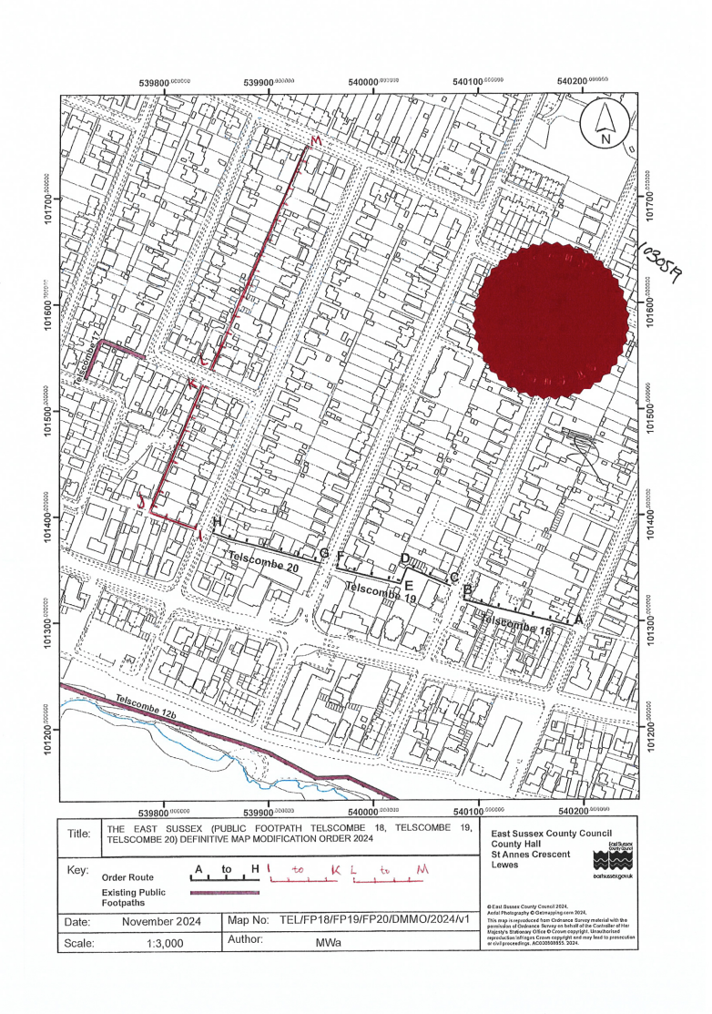

Map of Additional Routes Provided by OMA

