

Order Decision
by D M Young JP BSc (Hons) MPlan MRTPI MIHE
an Inspector appointed by the Secretary of State for Environment, Food and Rural Affairs
Decision date: 12 February 2026

Order Ref: ROW/3325537
- This Order is made under Section 53 (2) of the Wildlife and Countryside Act 1981 (the 1981 Act) and is known as The Wiltshire Council (Parish of Whiteparish) Path no.42 Definitive Map and Statement Modification Order 2022.
- The Order is dated 25 March 2022 and proposes to modify the Definitive Map and Statement for the area by adding a Public Footpath as shown in the Order plan and described in the Order Schedule.
- There were 11 objections outstanding when the Order was submitted to the Secretary of State.
Summary of Decision: The Order is not Confirmed.

Preliminary Matters
- The application to add a public footpath to the Definitive Map and Statement (DMS) between Common Road and public footpath No.6 in Whiteparish was made by Mrs P Woodruffe in July 2020. Mrs Woodruffe has since withdrawn her support for the Order.
- The application was based on the public’s use of the route. Following investigation by Wiltshire Council (the Order Making Authority (OMA)), it was considered there was a reasonable allegation of the route having historic highway rights. The Order was subsequently made on 25 March 2022. Having made the Order, the OMA now adopts a neutral stance regarding its confirmation.
- The Order route, known locally as The Drove, is shown between points A-B on the Order Plan (see Appendix A) and comprises a route of some 330 metres. It commences at point A on Common Road (Grid Ref: SU 2465-2313) and runs in a westerly direction for approximately 180 metres. To the south of Forest View, the route turns southwards for approximately 150 metres to its junction with public footpath No.6 (Grid Ref: SU 2445-2292). The width of the Order route varies between 3-9 metres. The route has an unmade surface and is enclosed for most of its length by fences, mature hedges and trees.
- The land crossed by the Order route is owned by Mrs S Cook, Mr & Mrs Peacop, Mr & Mrs Davies, and Mr H Urquhart (a plan showing the landownership is included at WHIT 20, pg. 381 of the OMA’s Statement of Case and reproduced at Appendix B of this decision).
- With the written agreement of the foregoing, I carried out a site visit on 10 December where I was able to see the majority of the Order route. I did not consider it necessary to view those sections that are currently fenced off and part of residential gardens to Wren House and Warblers Cottage.

Main Issues
- The Order has been made under section 53(2)(b) of the 1981 Act in consequence of an event specified in section 53(3)(c)(i).
- The main issue is whether the discovery by the OMA of evidence, when considered with all other relevant evidence, is sufficient to show that a right of way which is not shown in the DMS subsists over the land in the area to which the map relates. The burden of proof lies with the claimant.
- In making the Order the OMA relies on the statutory dedication of the way under section 31 of the Highways Act 1980 which provides that where a way, other than a way of such a character that use of it could not give rise at common law to any presumption of dedication, has been actually enjoyed by the public, ‘as of right’ and without interruption, for a period of twenty years, the way is deemed to have been dedicated as a highway unless there is sufficient evidence that the landowner demonstrated a lack of any intention during this period to dedicate the route. ‘As of right’ means without force, secrecy and permission. The 20-year period applies retrospectively from the date on which the right of the route was brought into question.
- In relation to documentary evidence, section 32 of the Highways Act 1980 requires a court or tribunal to take into consideration any map, plan or history of the locality, or other relevant document, which is tendered in evidence, giving it such weight as appropriate, before determining whether a way has been dedicated as a highway.
- In addition to considering the user evidence with regard to the provisions of section 31 of the 1980 Act, I am also required to consider whether dedication of the claimed routes has taken place at common law. The evidential test to be applied, at common law or under the statutory provisions, is the civil standard of proof; that is, the balance of probabilities.

Reasons

Documentary evidence
- The OMA sets out the relevant documentary evidence in section 9 of its Committee Report (WHIT 1). As there has been no substantive challenge to the OMA’s assessment of the documentary evidence, I do not consider it necessary to repeat it in this decision, save for the following salient points set out below.
- Whiteparish Parish Council did not include the Order route within its survey pursuant to the National Parks and Access to the Countryside Act 1949. Its exclusion was queried at the time by the Surveying Authority with the parish council responding that the route was not a public right of way.
- Part of the route is shown on the Whiteparish Tithe Award map braced by double broken lines. The route is between double solid lines shown on the Ordnance Survey (OS) base map as well as the 1872 6” map and the 1901 and 1926 editions of the 25” County Series map. With the exception of the 1876 map, none of the foregoing show any connection of the Order route to Common Road.
- The whole route is recorded on the Newton Farm 1797-1853 estate map and shown coloured in sienna, similar to other public rights of way in the area. The route is not shown on subsequent sale maps dated 1856 and 1867. It is also excluded from the 1801 “Map of the parish of Whiteparish which does record other public footpaths in the vicinity. The Order route is not shown on the Andrews and Dury’s maps of Wiltshire of 1773 or 1810, Greenwood’s maps dated 1820 and 1829 or Cary’s map dated 1787 and 1801.
- The Drove is recorded in the “Wiltshire Council Full Monument Report” as Monument no. SU22SW460 – MWI17191 and described as “Medieval Settlement, Common Road”. As the OMA rightly points out, scheduled monument status does not assist in establishing whether public rights exist over the claimed route. Finally, the applicant cites “Roads and Tracks of Britain” by Christopher Taylor, 1979. Fig.74 of this document shows the Order route between double broken lines which depicted a “Track and hollow way” with the exception of the section west of Common Road which is shown as an “existing road”. I concur with the OMA that this does little to support the existence of public rights over the whole of the Order route.

Conclusions on documentary evidence
- The route is recorded only on the Tithe Award map, one estate map and one OS map. The preponderance of documentary evidence does not record the whole of the Order route. The purpose of most of the maps was to show physical features on, and the contours of, the ground at the date of the survey and do not distinguish between public and private rights of way. Since 1888, OS maps have carried a disclaimer to the effect that the representation of a track or way on the map was not evidence of the existence of a public right of way.
- At best, the maps demonstrate the physical existence of parts of the claimed route at specific points in time. When read as a whole, with the user evidence, the documentary evidence points to the Order route being a route for the benefit of local farmers to move cattle between fields. Such use would not be consistent with the public use of the route ‘as of right’.

Statutory dedication – Section 31 of the Highways Act 1980

When the right to use the way was brought into question
- The 20-year period is calculated retrospectively from the date the public’s right to use the route was brought into question. The OMA’s Committee Report considers in some detail when the public’s right to use the route was first brought into question (see paragraphs 5.38-5.65). Having carefully considered all the relevant evidence, I concur with the OMA that the erection of a barbed wire fence across the Order route, in 2003, at point X on the consultation plan (reproduced at Appendix C of this decision) was an overt act on behalf of the landowner (Mrs Cook of Cottage Farm) sufficient to bring home to the public that their right to use the way was being brought into question.
- While some might have continued to use the route after the fence was erected, I am not persuaded that the average user could or would have gone through or over it, something which would have required a reasonable level of athletic ability. In any event, climbing over or stepping through a barb wire fence would be clearly inconsistent with the peaceable use of the route ‘as of right’. There is no substantive evidence to show the barb wire fence was openable akin to a Wiltshire Gate. Some have suggested the barb wire strands were encased in plastic tubing by the landowner to allow public access. However, that amounts to nothing more than speculation and is directly contradicted by the landowner evidence which states the fence was successful in preventing access by children on bikes, which was its intention. Mrs Cook also states:

[the barbed wire fence was] “difficult and dangerous for individuals to pass over … There were no stiles, no gates… [it was] an impassable three-strand barbed wire fence which leads into a field which has on a near constant basis been occupied by a number of cows and/or horses…”

”. We did not put any protection on the wires as that would be defeating the purpose of a stock fence as we need the barbs to deter the livestock – whoever put the plastic on there has done so without our permission and it is deeply annoying and once again trespassing”
- It is clear from the above account that the landowner’s intention was to prevent public access and to contain livestock. Moreover, the landowner did not install or give permission for the protective tubing. Mrs Cook’s evidence is very detailed and specific. Given she had a working knowledge of the land, I am minded to give her evidence significant weight.
- While I have considered earlier actions by the landowner, the evidence for an earlier calling into question is sketchy and inconclusive. Accordingly, I find that the erection of the barb wire fence in 2003 was the first overt act by the landowner which challenged the public’s use of the route ‘as of right’. The 20-year period (the relevant period) under consideration is therefore 1983 to 2003.

Evidence of use 1983 to 2003
- The user evidence is summarised at WHIT 12-13 of the OMA’s Statement of Case and summarised in the table below:

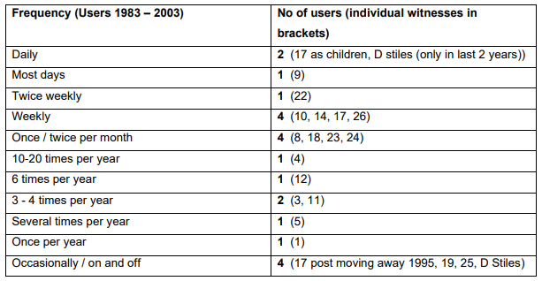
- 18 witnesses claim to have used the Order route during the relevant period but only 4 of them can attest to use over the whole period (Mrs Woodruffe has withdrawn her evidence). All witnesses refer to use of the route by others for leisure purposes.
- As shown in the table above, frequency of use varies. Two witnesses used the route daily (Chris Woodruffe and Darren Stiles). Mr Woodruffe moved away from the area in 1995, and Mr Stiles only used the route from 2001. A further 5 witnesses claim to have used the route at least once a week (Mr Woodruffe is double counted in the above table). However, three of these users (9, 10 and 14) had a private right of access over the central section of the route behind their property and their use was consequently not ‘as of right’.
- That leaves just two users; Elvin Kapp who used the route twice a week between 1987-2020 and Robert Canney who used the route weekly between 1999-2020. Mr Kapp refers to driving tractors along the route ‘every few months’ something which would very clearly have required the consent of the landowner. Both users along with Mr Woodruffe refer to conversations with the landowner which may infer that they had permission to use the route. There are other users who used the route during the relevant period but on an infrequent basis such as Stephen & Jenny Karmy and Christine Ellis.
- Of the 8 users identified in the OMA’s table as using the route regularly (weekly or more), only Mr Kapp and Mr Woodruffe used the route over a sustained part of the relevant period. Others either used the route infrequently, over a limited part of the relevant period or had a private right of access. There is no user that used the route regularly, ‘as of right’ and over the whole of the relevant period. The paucity of the user evidence is supported by Mrs Cook’s evidence who states:

“During the time that I lived and worked on the Farm [1988-2003], I never saw or heard of any incidents of unauthorised third parties walking on The Drove, apart from a group of children for a short period in 2003”.
- For the reasons previously stated, I am inclined to give the landowner evidence significant weight given that Mrs Cook has a very detailed recall of events that took place while she resided at Cottage Farm.

Conclusions on the user evidence
- Even if all the user evidence is aggregated, I consider it insufficient to bring home to the landowners that a right was being asserted against them. Accordingly, it is not necessary for me to consider whether the claimed use was ‘as of right’ or without interruption. Similarly, there is no need for me to consider whether there is sufficient evidence of a lack of intention to dedicate as no presumption of dedication arises which the landowner is required to rebut.

Common law dedication
- For an inference of dedication to be drawn at common law, the burden of proof lies with those who claim the existence of a public right of way to demonstrate that the owner of the land intended to dedicate the route to public use. As the user evidence submitted is insufficient to raise a presumption of dedication under the statutory provisions, it follows that such user evidence is also insufficient to raise an inference of dedication at common law. I therefore conclude that it is not possible to draw an inference of dedication of a public footpath over any part of the claimed route at common law.

Conclusions
- Having regard to above, I conclude that the Order should not be confirmed.

Formal Decision
- The Order is not confirmed.

D M Young

INSPECTOR

Appendix A –Order Plan

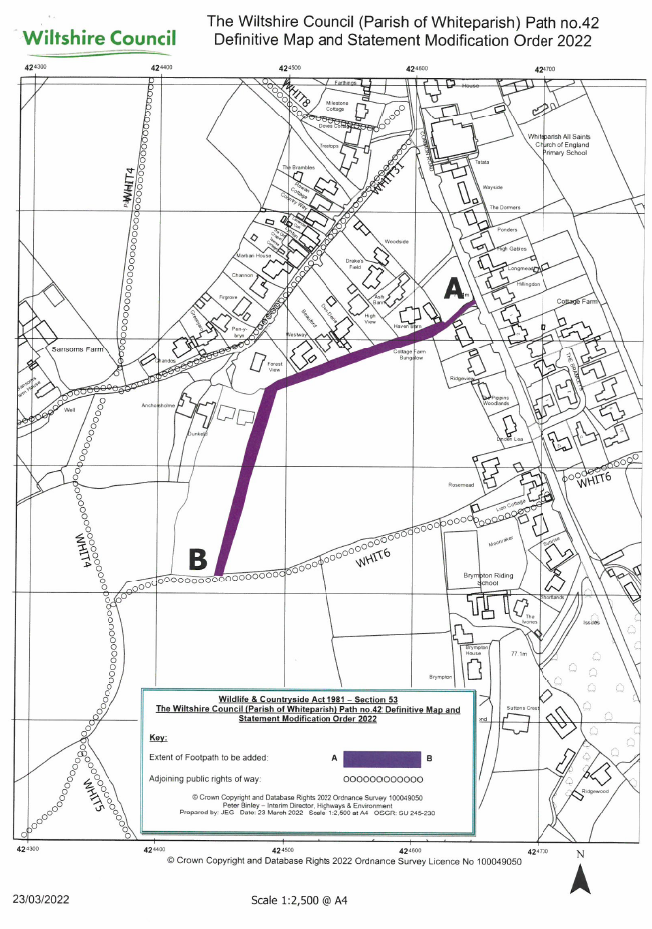

Appendix B – Land Ownership Plan

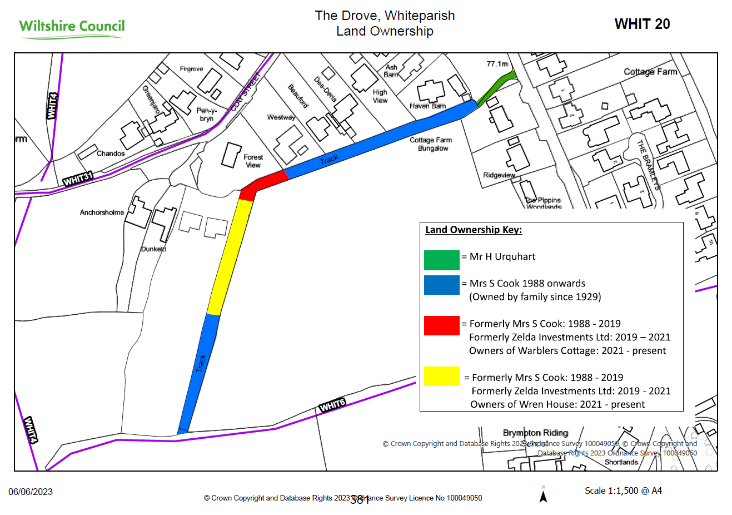

Appendix C – Consultation Plan

