

Order Decisions
by James Blackwell LLB (Hons) PGDip, Solicitor
An Inspector appointed by the Secretary of State for Environment, Food and Rural Affairs
Decision date: 13 February 2026

Order Ref: ROW/3348622 (Creation Order)
- This Order is made under Sections 26 of the Highways Act 1980 and 53A(2) of the Wildlife and Countryside Act 1981 and is known as The Oxfordshire County Council, Bletchingdon Footpath No. 30, Public Path Creation and Definitive Map and Statement Modification Order 2023.
- The Order is dated 21 June 2023 and proposes to create a new footpath as shown on the Order Plan and described in the Order Schedule.
- There was one objection outstanding when Oxfordshire County Council submitted the Order to the Secretary of State for Environment, Food and Rural Affairs for confirmation.
Summary of Decision: The Order is confirmed.
Order Ref: ROW/3348621 (Diversion Order)
- This Order is made under Sections 119 of the Highways Act 1980 and 53A(2) of the Wildlife and Countryside Act 1981 and is known as The Oxfordshire County Council, Bletchingdon Footpaths Nos. 4, 5 & 6 (parts), Public Path Diversion and Definitive Map and Statement Modification Order 2023.
- The Order is dated 21 June 2023 and proposes to divert footpath nos. 4, 5 and (parts of) 6, as shown on the Order Plan and described in the Order Schedule.
- There was one objection outstanding when Oxfordshire County Council submitted the Order to the Secretary of State for Environment, Food and Rural Affairs for confirmation.
Summary of Decision: The Order is confirmed.

Preliminary Matters
- Both Orders relate to a network of footpaths within the Bletchingdon Park Estate. Given the interconnectivity of this footpath network, the Orders have been progressed concurrently as a combined package of modifications. I have therefore addressed them together in the same decision notice.
- Whilst the objection relates to the combined package of modifications, in essence, it is primarily concerned with the Diversion Order, insofar as it affects footpath nos. 4 and 6.
- In terms of the footpaths concerned:
- proposed new footpath no. 30 (FP30) is shown between points E and L on the Creation Order Plan;
- existing footpath no. 4 (FP4) is shown between points A, B, C and D on the Diversion Order Plan, and the proposed new route is shown between points A, J, Y, Z, X and G;
- existing footpath no. 5 (FP5) is shown between points E and F on the Diversion Order Plan, and the proposed new route is shown between points E and K;
- existing footpath no. 6 (FP6) is shown between points G, H and I on the Diversion Order Plan, and the proposed new route is shown between points G, M and I.
- Each of the proposed diverted routes of FP4, FP5 and FP6 are already in use as permissive paths.

CREATION ORDER

Main Issues
- Under Section 26 of the Highways Act 1980 (HA 1980), if I am to confirm the Order, I need to be satisfied that there is a need for the new footpath and that it is expedient that it should be created. In determining the need for the new footpath, I must have regard to:
- the extent to which the footpath would add convenience or enjoyment of a substantial section of the public, or the convenience of persons resident in the area; and
- the effect which the creation of the footpath would have on the rights of the persons with an interest in the land, account being taken of the provisions of compensation.

Reasons

Need for the Footpath
- FP30 would provide a new footpath link between FP5 and FP6. Whilst FP5 and FP6 are already connected, the new route would provide an alternative connection, which would be more direct for users moving between Dogkennels Spinney and Moat Spinney. In turn, there is a justified need for the new footpath.

Extent to which the footpath would add to the convenience or enjoyment of public or the convenience of residents
- Given the footpath would provide a more direction connection between these two points, it would improve the connectivity of the path network.
- The route would pass along the edge of open parkland, which means users would also benefit from open and attractive views of the surrounding landscape.
- Notably, both of the path’s termination points would coincide with clear landscape markers within the estate: point E sits at a ‘T’ junction of an access track along FP5; and point L sits at a gate along a defined boundary between two distinct parts of the estate. The footpath would therefore introduce a clear and legible route to the footpath network, which would add to the convenience and enjoyment of the public.

Effect on persons with interest in land
- The owner of the land is supportive of the Order, and there is nothing before me to suggest the creation of FP30 would lead to any adverse impacts on them nor any other occupier.

Conclusions on whether it is expedient to confirm Order
- There is a justified need for the new footpath, and it would add to the convenience and enjoyment of the public without adverse impact on the owner or occupiers of the land. I therefore consider it expedient to confirm the Creation Order.

Rights of Way Improvement Plan
- The Oxfordshire Rights of Way Management Plan 2015 – 2025 (ROWIP) sets out the Council’s approach to managing and maintaining its public rights of way (PROW) network effectively and efficiently. The ROWIP includes a vision statement, which establishes a number of clear aims:
- ensuring PROWs are recorded, protected, maintained, promoted and improved when opportunities arise;
- creating a public rights of way and countryside access network that adapts to balance the current and future needs of communities and users, farmers and landowners and the natural and historic environment; and
- creating a public rights of way and countryside access network which is reasonably accessible to those with limited mobility, vision or understanding.
- The new footpath would provide an open and attractive route, which would benefit users walking between FP5 and FP6. Given the route is flat and open, it would also be accessible to those with mobility needs. In turn, its creation would reflect the aims set out in the ROWIP’s vision statement.

Other Matters
- The new path would cross grassland within an established parkland estate. There is nothing to suggest it would interfere with any areas of agriculture or forestry, nor any particular flora, fauna, geological or physiological features within the estate.

Overall Conclusion
- Having regard to the above and all other matters raised in the written representations, I conclude that the Creation Order should be confirmed. Given this conclusion, corresponding amendments to the Council’s Definitive Map and Statement should also be made pursuant to Section 53A(2) of the WCA 1981.

Formal Decision
- I confirm the Order.

DIVERSION ORDER

Main Issues
- Section 119 of the HA 1980 involves three separate tests for an Order to be confirmed. These are:
- Test 1: whether it is expedient in the interests of the landowner, occupier or the public for the path to be diverted. This is subject to any altered point of termination of the path being substantially as convenient to the public;
- Test 2: whether the proposed diversion is substantially less convenient to the public; and
- Test 3: whether it is expedient to confirm the Order having regard to the effect which: (a) the diversion would have on public enjoyment of the path as a whole; (b) the coming into operation of the Order would have as respects other land served by the existing public right of way; and (c) any new public right of way created by the Order would have as respects the land over which the right is so created and any land held with it.
- In determining whether to confirm the Order at Test 3 stage, (a) – (c) are mandatory factors. With regard to (b) – (c) of Test 3, the statutory provisions for compensation for diminution in value or disturbance to enjoyment of the land affected by the new paths must be taken into account, where applicable. Regard must also be had to any material provision contained in the Council’s ROWIP for the area under Section 119(6A). Other relevant factors are not excluded from consideration and could, for instance, include those pointing in favour of confirmation.

Reasons

Whether it is expedient in the interests of the owner, lessees or occupiers of the land and/or the public that the paths should be diverted

Footpath 4
- The existing footpath passes between two ponds within Dogkennels Spinney, and continues on through open parkland to the rear of Bletchingdon Park House, which is a historic country manor. This route currently offers open and unobstructed views of the rear of the house and its gardens.
- The diverted route would still run through Dogkennels Spinney and the parkland, but would follow a more northerly alignment which runs further away from the house. This means views of the house and its gardens would be more distant and obstructed by trees.
- This alignment would improve the privacy of the owners and occupiers of the house, as they would be able to enjoy their home without feeling so overlooked. The diversion of FP4 would therefore be in their interests.

Footpath 5
- The current alignment of FP5 means users who wish to connect with Kirtlington footpath no. 3 (FP3) must continue on a straight eastwards trajectory to meet FP6, before turning left and walking in a northerly direction until it connects with FP3. The diverted route would offer a more direct link between these paths. The creation of FP30 would also ensure a direct connection is retained between FP5 and FP6, where it borders Moat Spinney. Overall, the diversion of FP5 would therefore be in the interests of the public users of the footpath network.

Footpath 6
- The existing footpath currently runs in a south-easterly direction from point G, where it passes a ha-ha to the rear of residential properties within the old stables to Bletchingdon Park House. The footpath continues through a gate into the private gardens of these properties, before turning abruptly in a north-easterly direction at a way-marker. The footpath then exits the garden at another gate along the garden’s north-eastern boundary.
- The diverted route would continue along the existing boundary of the parkland with the neighbouring woodland, and would avoid the private residential gardens completely. This would be of significant benefit to the owner and occupiers of these properties, as they would be able to enjoy their gardens privately, without disturbance from footpath users. The diversion would therefore be in their interests.

Whether any new termination point is substantially as convenient to the public

Footpath 4
- The starting point of the proposed diversion of FP4 (at point A) would remain unchanged. In terms of its more easterly termination point, FP4 would still connect with FP6, just slightly further north along its current boundary with the neighbouring woodland. This would be substantially as convenient to the public.

Footpath 5
- Again, the starting point of the proposed diverted section of FP5 (at point E) would remain unchanged. Its proposed new termination at point K would offer a more direct connection with FP3, which would benefit users walking in this direction (and vice versa). Whilst in isolation, the diversion would result in a less direct route to connect with FP6 around Moat Spinney, the creation of FP30 ensures a direct connection would be retained. Overall, the combined package of measures therefore means the new termination point would be substantially as convenient to the public.

Footpath 6
- In terms of FP6, both its termination points would remain unchanged as a consequence of the diversion. Again, its termination points would therefore be substantially as convenient to the public.

Whether the new paths will not be substantially less convenient to the public

Footpath 4
- The proposed diverted route of FP4 is said to be approximately 119 metres shorter than it is currently. However, users would need to walk a greater length of FP6 in order to exit the estate around point I (or similarly if accessing FP4 from this direction). Overall, this means the length of the diverted route is broadly similar, and in turn, would not be substantially less convenient to the public.

Footpath 5
- The proposed diverted route of FP5 is said to be approximately 24 metres longer than the existing section of path. However, for those using FP5 to access FP3 (or vice versa), the diverted route would offer a shorter and more direct connection. Whilst in isolation, the diversion would result in a longer route to meet FP6 at Moat Spinney, the creation of FP30 ensures a shorter and more direct connection would also retained in this direction. Overall, this means the diverted route would not be substantially less convenient to the public.

Footpath 6
- The diverted length of FP6 is said to be approximately 54 metres shorter than existing, with both its termination points remaining unchanged. It would therefore not be substantially less convenient to the public.

The effect of the diversion on public enjoyment of the paths as a whole

Footpath 4
- The existing route begins at Springwell Hill and runs through some open parkland before it meets Dogkennels Spinney, an area characterised by a series of ponds and woodland. Once the path exits Dogkennels Spinney, it then follows a route across the open parkland to the rear of Bletchingdon Park House. This section of the route provides unimpeded views to the rear of the house and its gardens, and also offers views of the ha-ha and drystone wall referred to above.
- The diverted route would also begin at Springwell Hill, but would continue on a slightly different alignment through the parkland and Dogkennels Spinney. Nonetheless, the path would still pass between two well-maintained ponds within the woodland, which would ensure the public’s enjoyment of this section of the route would remain similar.
- As the path exits Dogkennels Spinney, the diverted route would follow a more northerly alignment through the parkland to the rear of Bletchingdon Park House. Given this section of the route would be further away from the house and its gardens, views of these features, including the ha-ha and dry-stone wall to the rear of the house, would be more restricted. This could impact on some users’ enjoyment of the footpath.
- However, the openness of the parkland ensures some views of the house, gardens, ha-ha and dry-stone wall would be retained along the route. Importantly, this means users would still be able to appreciate the architectural significance of these features, as well as their relationship with the surrounding country park. Overall, this would ensure user enjoyment of the path would not be unduly diminished.

Footpath 5
- The diverted route of FP5 would continue to pass through a similar part of open parkland, where views of the surrounding estate are broadly similar. Both termination points would coincide with clearly defined way markers, which would also improve the legibility of the footpath network within this part of the estate. In turn, the diversion would improve public enjoyment of the path.

Footpath 6
- The old stable building, which has been converted into a number of residential properties, retains notable architectural and historical interest, particularly given its relationship with Bletchingdon Park House. Users of FP6 currently benefit from a number of partial views of this building, which the objector highlights as being important to the enjoyment of the footpath.
- Nonetheless, the section of footpath within the residential gardens runs alongside a tall hedgerow, which means views of the building along this part of the footpath are very restricted. In turn, the most valuable views of the stable building are obtained from outside of the gardens, as more of the building can be seen over the top of the hedgerow. Whilst slightly more distant, users of the diverted route would continue to benefit from these views, which would ensure their enjoyment of the footpath (and the stable building) would not be unduly compromised.
- Whilst there is a small hedgerow gap within the private gardens, this only allows glimpsed views of the stable building’s façade, which adds little to the overall appreciation of the building. The loss of this glimpsed view would not materially affect overall enjoyment of the footpath.
- Outside of the gardens, part of the existing footpath runs alongside the ha-ha and dry-stone wall associated within the country estate, which adds some historic and architectural interest to the route. The diverted route would be further away from these features, and therefore views of them would be more distant. However, the greater distance does allow the ha-ha and dry-stone wall to be appreciated in the wider context of the estate and parkland, which means users would benefit from an alternative perspective of these features, which still adds interest to the footpath.
- As discussed, the diverted route would avoid the gardens of the private residential properties within the old stable building. Government Guidance on diversion or extinguishment of public rights of way that pass through private dwellings, their curtilages and gardens (August 2023) provides useful assistance on this point:

“Members of the public may not be comfortable following a path through a contained space of this type because doing so feels like infringing on the privacy of a house owner […]. Such path alignments can deter people from exercising the public’s right to use the path”.
- Reflecting this guidance, the diverted route would likely improve the enjoyment of many users, as it would not impinge on anyone’s personal or private amenity space. It may even result in some people using the diverted route who would otherwise have been deterred.

The effect of the diversions on other land served by the existing paths and the land over which the new paths would be created
- The landowner of the estate supports the proposed diversions, as do the occupiers of the dwellings within the old stables. There is also nothing before me to suggest any of the diversions would have an adverse impact on the land served by the existing paths, nor the land over which the new paths would be created.

Rights of Way Improvement Plan (ROWIP)
- Each of the diversion orders would be consistent with the aims set out in the Council’s vision statement in its ROWIP. As set out above, these seek to promote a public rights of way and countryside access network which: is reasonably accessible to those with limited mobility, vision or understanding; is improved where opportunities arise; and which adapts to balance the current and future needs of communities and users.

Conclusion on whether it is expedient to confirm the Order
- Each of the diversion orders would be in the interests of the landowner of the estate. The proposed diversions of FP4 and FP6 would also be in the interests of the occupiers of dwellings within the old stables. Each of the diversions would be substantially as convenient to the public, and collectively, would add to user enjoyment. There is nothing to suggest any of the diversions would result in adverse impacts on land served by the existing paths, nor on land over which the new paths would be created. The diversions would also reflect the Council’s aims set out in its ROWIP. Overall, it is therefore expedient to confirm the Order.

Other Matters
- As with the Creation Order, there is nothing to suggest any of the diverted routes would interfere with any areas of agriculture or forestry, nor any particular flora, fauna, geological or physiological features within the estate.
- The objector suggests the Council should not have progressed the Order whilst public access to FP6 was obstructed. However, I was able to walk the full length of the existing footpath on my site visit, and was therefore able to assess the merits of the proposed diversion, by comparison to the existing route.
- Parts of the Bletchingdon Park Estate fall within the Bletchingdon Conservation Area (CA). Whilst there appears to be disagreement between the parties as to whether certain features (such as the dry-stone wall and ha-ha) fall inside or outside of the CA, my conclusions would be the same, irrespective of this factor.

Overall Conclusion
- Having regard to the above and all other matters raised in the written representations, I conclude that the Order should be confirmed. Given this conclusion, corresponding amendments to the Council’s Definitive Map and Statement should also be made pursuant to Section 53A(2) of the WCA 1981.

Formal Decision
- I confirm the Order.

James Blackwell

Inspector

Creation Order Plan (ROW/3348622)

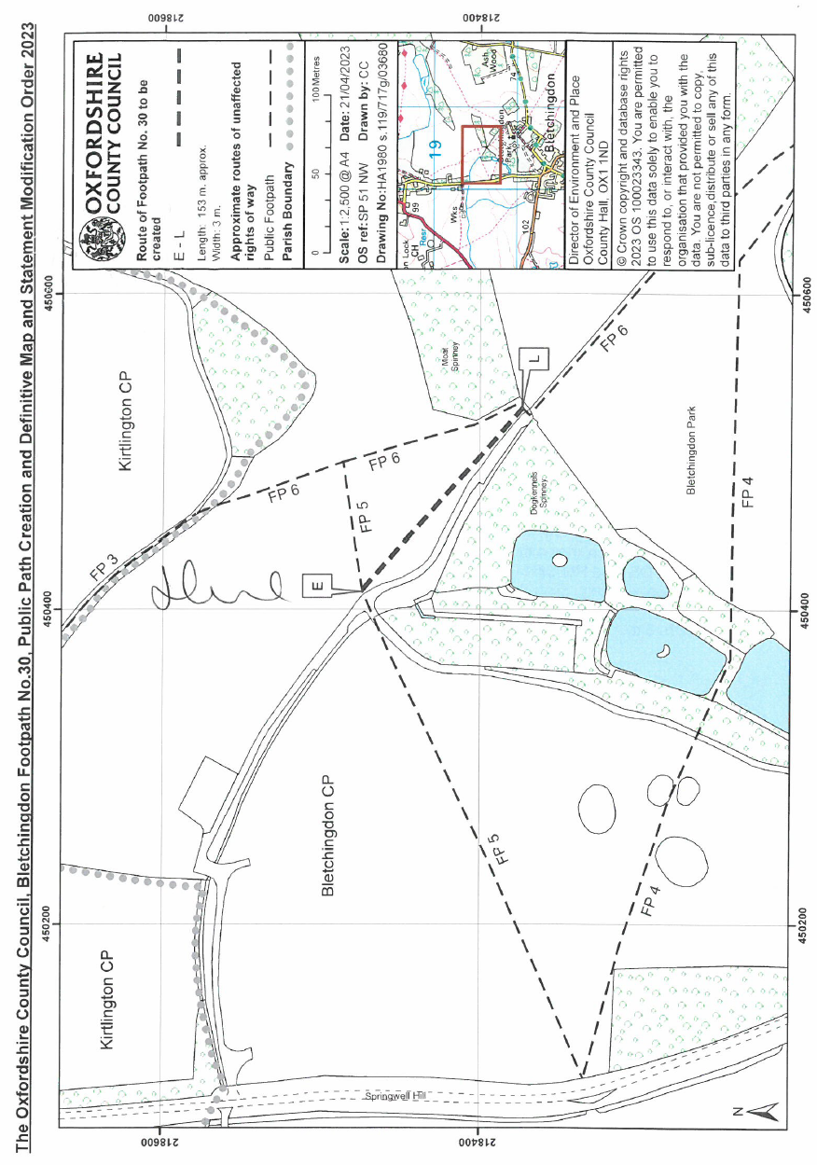

Diversion Order Plan (ROW/3348621)

