

Order Decision
Site visit made on 7 January 2026
by D M Young JP BSc (Hons) MPlan MRTPI MIHE
an Inspector appointed by the Secretary of State for Environment, Food and Rural Affairs
Decision date: 06 February 2026

Order Ref: ROW/3347450
- This Order is made under Section 53 (2) of the Wildlife and Countryside Act 1981 (the 1981 Act) and is known as the Lancashire County Council Footpath from Blackburn Road to Norman Road, Oswaldtwistle Definitive Map Modification Order 2023.
- The Order is dated 12 July 2023 and proposes to modify the Definitive Map and Statement for the area by adding a Public Footpath as shown in the Order plan and described in the Order Schedule.
- There were two objections outstanding when the Order was submitted to the Secretary of State.
Summary of Decision: The Order is Confirmed.

Preliminary Matters
- The application to add a public footpath to the Definitive Map and Statement (DMS) was made by Julie Lois Speak in December 2022. The application was based on documentary and user evidence. Following investigation by Lancashire County Council (the Order Making Authority (OMA)), a Report was considered by its Regulatory Committee on 21 June 2023 (Document 23 to the OMA’s submission bundle). As a result, it was considered there was a reasonable allegation of the route having historic highway rights. The Order was subsequently made on 12 July 2023.
- The Order route which can fairly be described as a rear service road or back alley, is shown between points A-B-C on the Consultation Plan attached as Appendix A (I have used this plan as it is clearer than the Order Plan (Appendix B)). The Order route commences from a junction with Blackburn Road immediately to the east of West End Methodist Church (point A) running south between the eastern boundary of the Methodist Church and the rear boundaries of properties 372 Blackburn Road and 2-12 Norman Road for a distance of 30 metres before turning at point B to continue in a more south easterly and then easterly direction to exit onto Norman Road at point B. The total length of the route is 60 metres with a width of 3 metres.
- Two objections were made by Charlotte Volkert (the occupier of 10 Norman Road) and Deryn Regan-Hitchen (370 Blackburn Road).
- From point A to around halfway between point B and point C, the land is unregistered. From thence to point C the land is registered to LPS Development Group Limited.
- When I carried out my site visit, I was able to walk along the Order route save for the section to the rear of No.10 which has been fenced off.

Main Issues
- The Order has been made under section 53(2)(b) of the 1981 Act in consequence of an event specified in section 53(3)(c)(i). This requires me to consider if, on the balance of probabilities, the evidence shows a public footpath subsists along the Order route. This is a higher standard of proof than the ‘reasonably alleged to subsist’ test to determine if an Order should be made.
- In making the Order the OMA relies historical map and other documentary evidence. The main issue is whether the discovery by the OMA of evidence, when considered with all other relevant evidence, is sufficient to show that a right of way which is not shown in the DMS subsists over the land in the area to which the map relates. The burden of proof lies with the claimant.
- In relation to documentary evidence, section 32 of the Highways Act 1980 requires a court or tribunal to take into consideration any map, plan or history of the locality, or other relevant document, which is tendered in evidence, giving it such weight as appropriate, before determining whether a way has been dedicated as a highway.

Reasons

Documentary Evidence
- The OMA sets out the relevant documentary evidence in its Committee Report (pages 6-47). As there has been no substantive challenge to the OMA’s assessment of the documentary evidence, I do not consider it necessary to repeat all of this information again here, save for the salient points set out below.
- There is a wealth of documentary evidence which indicates the Order route evolved from a footpath linking Blackburn Road to Aspen Lane. This route is shown on the 1848 Ordnance Survey (OS) first edition 6 inch and subsequent 25-inch mapping. The southern part of this wider route (points X-Y on the Committee Report plan) is still accessible today albeit as an unrecorded public route.
- A footpath on the same broad alignment as the Order route was shown on the 1904 conveyancing plan connected to the sale of the land for West End Methodist Church. The accompanying documents specified that a footpath was to be provided along the eastern boundary of the site. The second edition 25-inch OS map revised in 1909 and published in 1911 indicates that this requirement was complied with and the footpath was shown to have been moved to start at point A on Blackburn Road.
- While OS maps strongly support the existence of a route on the same alignment as the Order route, they are less helpful in establishing the nature of rights along it and since 1888, OS maps have carried a disclaimer to the effect that the representation of a track or way on the map was not evidence of the existence of a public right of way.
- Around the same time as the second edition OS map, the row of terrace houses which back onto the Order route (Nos. 2-12) were constructed. The leasehold agreements for these properties refer to the Order route and state that it should be maintained to a suitable standard so that it could become publicly maintainable at some point in the future. Once provided in the early 20th Century, the Order route was consistently shown on OS maps, photographs and other documentation and there is no cogent evidence that access by the public was restricted or prevented until 2020.
- The comprehensive survey carried out for the Finance Act 1910 was for the purposes of land valuation, not recording public rights of way. Nonetheless, they can often provide good evidence as to reputation. An owner of land could claim a reduction in tax if his land was crossed by a public right of way and this can be found in the relevant valuation book. The majority of the Order route between points A-B is shown between plots (5849 and 5682). The section B-C is marked on the OS base map along with the remainder of the wider route to Aspen Lane and included as plot 5618. No deductions are recorded in the District Valuation Book for plots 5618 or 5682. The Finance Act records are therefore of limited assistance.
- As the land crossed by the Order route was within the Urban District of Oswaldtwistle there was no Parish Survey Pursuant to the National Parks and Access to the Countryside Act 1949. A draft map was subsequently prepared by Oswaldtwistle District Council and published in 1953. The Order route was not shown on the draft map or the provisional map published in 1960, and no representations were made to its omission.

Conclusions on Documentary Evidence
- The preponderance of documentary evidence demonstrates that the Order route has existed as a physical feature on the ground since Nos 2-12 Norman Road were constructed in the early part of the 20th Century. The route is on the same general alignment as a footpath shown on the 1911 OS 25-inch map. The conveyancing documents connected to the church and Nos. 2-12, suggest the route was reputed to be public. When read as a whole, there is a clear synergy between the documentary evidence which supports the existence of public rights along the Order route between 1920-2020.

User Evidence

When the right to use the way was brought into question
- Under section 31 of the Highways Act 1980 which provides that where a way, other than a way of such a character that use of it could not give rise at common law to any presumption of dedication, has been actually enjoyed by the public, ‘as of right’ and without interruption, for a period of twenty years, the way is deemed to have been dedicated as a highway unless there is sufficient evidence that the landowner demonstrated a lack of any intention during this period to dedicate the route. ‘As of right’ means without force, secrecy and permission. The 20-year period applies retrospectively from the date on which the right of the route was brought into question. In this case there is no dispute that the public’s right to use the route was first brought into question when the occupier of 10 Norman Road erected fencing across the route in 2020. The 20-year period under consideration is therefore 2000 to 2020.
- Two witness statements have been provided in support of the Order (one from the Applicant and the other from Christine Alderson). The witnesses lived at Nos. 8 and 12 respectively. Both witnesses attest to use of the Order route between 1984 and 2020. There is no indication of any signage or obstruction before 2020 which would have prevented or restricted access by the public at large. Both witnesses refer to use of the Order route by local people as a short-cut between Blackburn and Norman Roads. The Applicant states that the Deeds for Nos 2-12 do not grant a private right of access over the Order route. Ms Alderson explains that West End Methodist Church used the Order route as an access to the church and refers to a gateway from the application route that was historically used for delivering coal to the kitchen.
- While credible, the amount of user evidence in this case is insufficient in itself to give rise to a presumption of dedication.

Other Matters
- Ms Volkert has raised various matters pertaining to the enforcement proceedings that were commenced but discontinued by the Local Planning Authority. However, the outcome of proceedings under planning enforcement legislation is not relevant to the consideration of an Order under the 1981 Act.
- Other issues raised by the objectors include the effect the confirmation of the Order would have on their property, the potential for fly-tipping, anti-social behaviour, noise and disturbance, the effect on local businesses, historical maintenance liabilities and the use of other footpaths in the locality. Whilst I note, and can appreciate some of these concerns, these are not matters which can be taken into consideration under section 53 of the 1981 Act.

Conclusions
- There is credible evidence in the Applicant’s favour that the Order route had the local reputation as a public right of way in the early part of the 20th Century. While I have carefully considered the fact that no challenge was made to the omission of the route at either the draft or provisional Definitive Map stage, I am satisfied, on the balance of probabilities, that the documentary evidence, when read as whole, is sufficient to demonstrate that a public right of way subsists over the Order route. It follows that I conclude that the Order should be confirmed.

Formal Decision
- The Order is confirmed.

D M Young

INSPECTOR

Appendix A – Consultation Plan

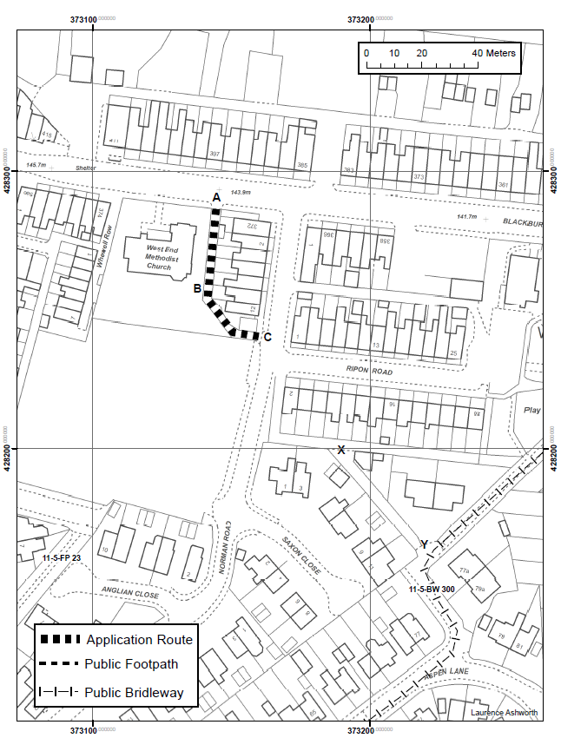

Appendix B – Order Plan

