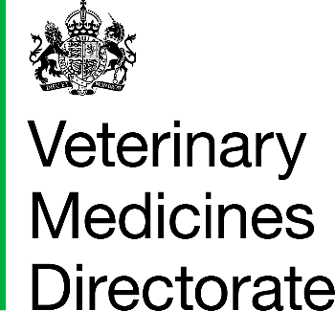 | Promoting animal health and welfare by assuring the safety, quality and efficacy of veterinary medicines |  | 
www.gov.uk/vmd
www.vmdconnect
postmaster@vmd.gov.uk
Welsh Language Policy
Privacy Notice
APPLICATION FOR THE ASSESSMENT OF CONDITIONAL DATA

Please complete this form and submit it alongside the conditional data to be assessed or include all the information required below in a covering letter / email.
1. Product Name:
2. Vm No:
3. Application number identifying the procedure when the condition was set:
AN:
4. Applicant’s Contact Details:
Name:
Email Address:
5. Please include the condition below:
6. Please provide a brief summary of what information / data has been provided in support of this application:

Note: This form should be used for the submission of information / data to satisfy a condition or commitment set upon approval of a previous application, and where the condition does not require the submission of a specific variation application, e.g. submission of mock-ups to be assessed prior to marketing.

