

Application Decisions
Site visit made on 25 November 2025
by R J Perrins MA
an Inspector appointed by the Secretary of State for Environment, Food and Rural Affairs
Decision date: 10 February 2026

Application A Ref: COM/3367704
Midhurst Common, Land at Bepton Road, Midhurst GU29 9QX
- The application, dated 12 June 2025, is made under section 16 of the Commons Act 2006 (‘the 2006 Act’) to deregister and exchange land registered as common land.
- The application is made by Bellway Homes Limited.
- The release land comprises a total of 142m² (CL169)
- The replacement land comprises 142m² of land on the edge of the existing common.
Decision: The application is granted
Application B Ref: COM/3367697
Midhurst Common, Land at Bepton Road, Midhurst GU29 9QX
Register Unit No: CL169
Commons Registration Authority: West Sussex County Council
- The application dated 12 June 2025 is made under Section 38 of the Commons Act
2006 (‘the 2006 Act’) for consent to carry out restricted works on common land.
- The application is made by Bellway Homes Limited.
- The works comprise:-
- March – June 2024 - Minor realignments of kerb radii, resurfacing, some
minor re-levelling to suit drainage and the installation of catch pits for
drainage.
- May – June 2025 - replace a highways surface water pipe that leads to one
of the road gullies and relocate road gullies to suit new radii alignment and
levels.
- Estimated July 2026 - final repairs to wearing course
- At each stage - Temporary fencing around works areas for safety reasons.
Decision: The application is granted

Preliminary Matters – Applications A & B
- I carried out an inspection of the release land and a good part of nearby Common on Tuesday 25 November. I also inspected the land put forward for exchange. I saw that the works proposed under Application B were, in the main, complete; an access road, footpath and sightlines now serve the new housing development.
- Following advertisement of the applications, representations were received from Natural England (‘NE’), South Downs National Park Authority (SDNPA), the Open Spaces Society (‘OSS’). No other representations were received.
- The applications have been determined on the basis of the written evidence and my own observations of the sites and surrounds.
- In determining the applications, I have had regard to the latest edition of Defra’s Common Land Consents Policy (‘the 2015 Policy’) which has been published for the guidance of both the Planning Inspectorate and applicants. However, every application will be considered on its merits and a determination will depart from the policy if it appears appropriate to do so. In such cases, the decision will explain why it has departed from the policy.
- Section 3 of the 2015 Policy sets out the overall policy objectives to safeguard and protect commons and greens. Paragraph 3.2 seeks to ensure that our stock of common land and greens is not diminished so that any deregistration of registered land is balanced by the registration of other land of at least equal benefit. Paragraph 5.2 sets out that even when the land to be deregistered is not more than 200m² the Secretary of State will usually expect land to be offered in exchange for the land being deregistered to not allow our stock of common land and greens to diminish.
- The common covers some 53 hectares and lies to the west of Midhurst and is varied in appearance and management. NE set out that the common is not a statutorily protected site for nature conservation. Helpfully, NE also confirmed that, due to the location and scale of the related development (of which the works on the common form a part) a Screening and Appropriate Assessment were carried out by the relevant Competent Authority under the Conservation of Habitats and Species Regulations 2017 and it was concluded that the proposed mitigation and offsetting measures there would be no adverse effects on the integrity of any European designated and protected nature conservation sites.

Application A the Section 16 Application

The Application
- The application is made in association with a planning permission (ref:SDNP/21/03448/FUL) for construction of 69 dwellings with associated access, parking and landscaping following demolition of the existing buildings, that required the realignment of the existing access to a former Council depot along with associated drainage works. Such works include conditions for final detailing of landscaping within the common land area.
- The area requested to be released is 142m² and was (before the works were carried out) roadside verge and the metalled roadway serving the depot. The proposed replacement land is also 142m² made up of a strip of land running alongside the strip of common that adjoins the south-west of the access. The replacement land reflects the adjoining common and is a strip of predominantly native broadleaf woodland. A dilapidated fence runs along part of the existing boundary between the two parcels of land although, access to the replacement land is readily available.

Main Issues
- Section 16(1) of the Commons Act 2006 (the 2006 Act) provides that the owner of any land registered as common land or village green may apply for the land (the release land) to cease to be so registered. Section 16(3) and (4) of the 2006 Act provide that if the release land is not more than 200 square metres in area, the application may include a proposal to register land in place of the release land.
- I am required by section 16(6) of the 2006 Act to have regard to the following in determining the application:

(a) the interests of persons having rights in relation to, or occupying, the release land (and in particular persons exercising rights of common over it);

(b) the interests of the neighbourhood;

(c) the public interest, which includes the interest in nature conservation, conservation of the landscape, protection of public rights of access and the protection of archaeological remains and features of historic interest;

(d) any other matters considered to be relevant.

Reasons

The interests of those occupying or having rights over the land
- There are no registered rights recorded over the land. Overall, there is nothing before me to suggest that those occupying, or having rights in relation to the release land, would not be adversely affected by the proposal.

The interests of the neighbourhood
- The 2015 policy indicates that the issues to be considered in this context includes whether the exchange would prevent local people from using the common in the way they are used to, and whether or not there would be an interference with the future use and enjoyment of the common.
- The loss of the release land would have no effect on the use as was when the land was roadside verge and the access to the Council depot. That would remain. Furthermore, there is no dispute that the upgraded access has benefited the street scene. In addition, albeit in a small way, the replacement land would add to the area of accessible common land covered by woodland. Realignment of the current delipidated fence would also be an improvement for the locale.
- Considering all of these matters together, I find that the scheme would be in the interests of the neighbourhood.

The public interest

The protection of public rights of access
- The release land is subject to public rights of access under Section 193 of the Law of Property Act 1925. Given the land will remain as part highway verge and part bell mouth, the public would still have the same access. For these reasons I am satisfied that the application would protect the public rights of access and the right to air and exercise, provided on the common.

Nature conservation
- NE have been consulted on the application and do not raise any concerns in respect of nature conservation as set out in paragraph 6 above. Nevertheless, I recognise the replacement land is a very narrow strip with limited opportunity for public access, although it would be open woodland and available to walk through. In addition, the applicants own land elsewhere bordering the Common.
- However, given the limited size of the land being replaced, it seems to me that there would be an inevitability that any land of this size would have limited benefits for nature conservation. Moreover, the replacement land is currently part of a strip of broadleaved woodland with predominantly native trees of varying ages and, which would require little intervention. Furthermore, once designated as common land, it would be protected and continue to be a nature conservation asset alongside the new residential development.
- In addition, the release land is mostly metalled highway or footway, given that, the replacement land would be a positive benefit in nature conservation terms.

Conservation of the landscape
- As set out by the Council the site is within the National Park where there is a duty under S.245 of the 2023 Levelling Up and Regeneration Act to further the purposes of the National Park in respect of; conserving and enhancing the natural beauty, wildlife and cultural heritage of the areas designated; and promoting opportunities for the understanding and enjoyment of the special qualities of those areas by the public.
- As set out above, the new access works would have improved the appearance of what was there before. The replacement land would ensure land, that was historically mostly metalled, is replaced by land with trees and with conservation interest. It seems to me that would be a benefit in terms of conserving and enhancing the National Park. For these reasons I do not consider that the exchange would have any unacceptable effect on the landscape of the common.

Archaeological remains and features of historic interest
- Historic England has not made any comments regarding the exchange. There is no evidence to suggest the proposed exchange will have an adverse effect on any archaeological remains or historic features.

Any other matters
- I recognise that this application has been submitted following the works being carried out and, in many respects, could be viewed as a fait accompli. Whilst such applications are to be discouraged I have made my decision based on the overall merits of the application. The fact that work has already been carried out on the release land has carried no weight in my deliberations.
- The OSS raise concerns regarding the lack of involvement of the highway authority and that the replacement land would be integrated and physically indistinguishable. It seems to me the highway authority would be involved in the usual highway adoption process that is associated with such developments. There is nothing before me to suggest that they have any current interest in the release land. Finally, it is not clear if the OSS has visited the site but once the existing fence is removed, the replacement land would be indistinguishable from the common land to which it would become part.

Conclusion application A
- Having regard to all other matters, and to the criteria in section 16(6) of the 2006 Act, I conclude that granting the application would not be against the interests of those having rights in relation to the release land, or the public interest with regard to nature or landscape conservation, or the protection of archaeological remains, or features of historic interest.
- The exchange would enable the delivery of an improved access of wider public benefit. No issues have been raised which would lead me to conclude that the exchange should not take place. The application will be allowed.

Application B the Section 38 Application

Main Issues
- I am required by section 39 of the 2006 Act to have regard to the following in determining this application:-

a. the interests of persons having rights in relation to, or occupying, the land (and in particular persons exercising rights of common over it);

b. the interests of the neighbourhood;

c. the public interest (Section 39(2) of the 2006 Act provides that the public interest includes the public interest in; nature conservation; the conservation of the landscape; the protection of public rights of access to any area of land; and the protection of archaeological remains and features of historic interest); and

d. any other matter considered to be relevant.
- Section 39(3) provides that consent may be given under Section 38(1) in relation to all or part of the proposed works, and subject to such modifications and conditions relating to the proposed works as are thought to be fit.

Background
- This application seeks permission for various works, some temporary, some permanent and as set out in the final bullet point on Page 1 above. The OSS consider the application form does not appear to describe any permanent works. However, it seems to me from the description and what I saw on site, that much of the realignment, resurfacing and drainage works, are permanent by their very nature. That is corroborated by the applicant’s response.
- The works were needed to carry out minor alterations and repairs to the access way to comply with West Sussex County Council's adoptable standard in order to dedicate the access as highway maintainable at public expense. The works were also required to comply with Condition 22 of the planning permission set out above. That required details of highway improvements to be submitted, approved and carried out before first occupation of the development. They appear to have been mainly completed.

Reasons

The interests of those occupying or having rights over the land
- Nothing has been provided to show that anyone occupying or having rights over the land in question would have been adversely affected by the works or the temporary fencing.

The interests of the neighbourhood and public rights of access
- The interests of the neighbourhood test relates to whether the works would unacceptably interfere with the way the common is used by local people and is closely linked with public rights of access.
- The area was used for access to the Council depot and whilst the access has now changed slightly in terms of layout and what it serves, there is no difference in terms of how the land was and could be accessed. Furthermore, there is no dispute that the works would have improved drainage and the appearance of the access as was.
- Thus, from all that I have seen, and from the evidence before me, I find the proposed works have not had an unacceptable or lasting impact on local and public access rights over the common.

The public interest

Nature conservation and archaeological remains and features of historic interest
- My findings under the Section 16 application are relevant here. That is to say Natural England have no objections and given what was there before, there has been no unacceptable harm to any nature conservation interest. There is also no evidence before me to suggest that the works would, or have, harmed archaeological or historic interests.
- For these reasons I find there would be no adverse implications in respect of nature conservation or historic interest.

Conservation of the landscape
- The proposed works would have had some initial impact on the common given the temporary fencing. Overall though, the works have improved the access and its relationship to the street scene and wider common. Planning conditions relating to landscaping, attached to the extant planning permission, would also ensure soft and hard landscaping along the frontage of the site, in association with the required works to the highway, would result in landscape benefit.
- Thus, I am satisfied that overall, the works would not damage landscape interests and that the landscape of the common would be conserved.

Conclusion application B
- Having regard to the criteria set out above, and all the written representations, I conclude that the works have had no adverse effect on local and public access on foot over the common and are unlikely to harm other interests, as discussed. In addition, the works, which form part of the residential development would be of benefit to the wider public.
- Therefore, I find there would be no harm to the local neighbourhood, public rights of access or the landscape, and the application should succeed. Consent will be granted for the works subject to conditions to ensure the works will progress and reinstatement of the common will be timely.

Formal Decisions

Application A
- The application to deregister and exchange common land at Midhurst Common, Land at Bepton Road, Midhurst GU29 9QX is granted in accordance with the terms of the application (Ref: COM/3367704) dated 12 June 2025 and the accompanying plan numbered 001, showing the areas for deregistration and exchange, is attached to these decisions and an Order of Exchange should be made.

Application B
- Consent is granted for the works in accordance with the application 12 June 2025 and accompanying plans, subject to the following conditions:-

i. the works shall begin no later than three years from the date of this decision; and

ii. the land shall be fully reinstated in accordance with the application within one month from the completion of the works.
- For the purposes of identification only, the location of the works is shown outlined in red with the common land boundary outlined in green on the attached drawing 002.

Richard Perrins

Inspector

Order

On behalf of the Secretary of State for Environment, Food and Rural Affairs and pursuant to section 17(1) and (2) of the Commons Act 2006, I HEREBY ORDER West Sussex County Council, as commons registration authority for the area in which the release land and the replacement land are situated:
- to remove the release land from its register of common land, by amending register unit CL169 to exclude the release land;
- to register the replacement land as common land, by amending register unit CL169 to include the replacement land; and
- to register as exercisable over the replacement land (in addition to remaining exercisable over the remainder of the land comprised in register unit CL169 any rights of common which, immediately before the date on which the release land is removed from the register, are registered as exercisable over the release land and the remainder of the land comprised in register unit CL169.

First Schedule – the release land

Colour On Plan | Description | Extent
Edged and shaded red | Land forming part of register unit CL169 and part of the bell mouth access and adjacent highway verge serving Perceval Grange and opposite access to Pitsham Wood. | 142m²

Second Schedule – the replacement land

Colour On Plan | Description | Extent
Edged and shaded light green | Narrow strip of land to north of Bepton Road adjoining strip of Midhurst Common which fronts onto Bepton | 142m²

RJ Perrins

Inspector

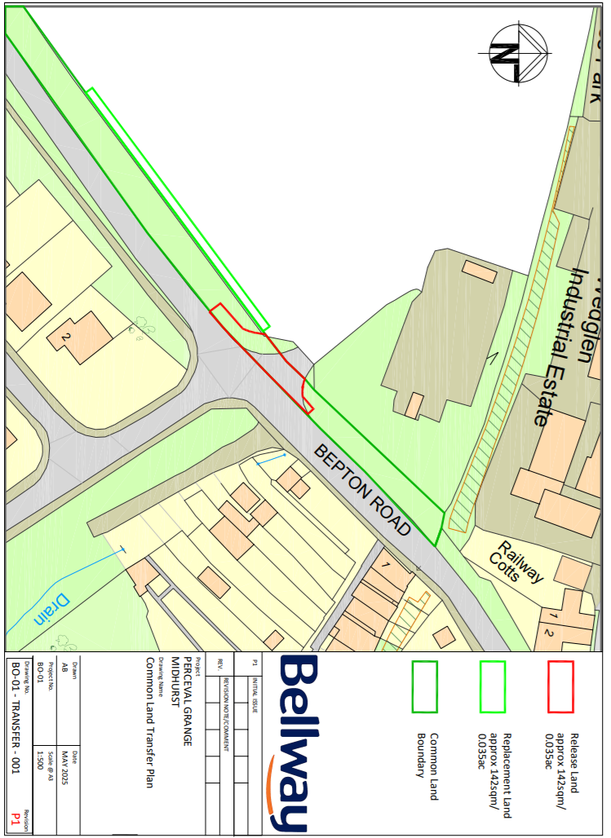
Application A – Drawing 001 – Release Land and Replacement Land

Application B – Drawing 002 – location of works (not to scale)

