

DGSA Annual Report

for the Carriage of Dangerous Goods

  - As required by ADR 1.8.3.3 upheld by UK’s carriage of dangerous goods and transport pressure equipment regulations 2009 (as amended.)
  - December 2025
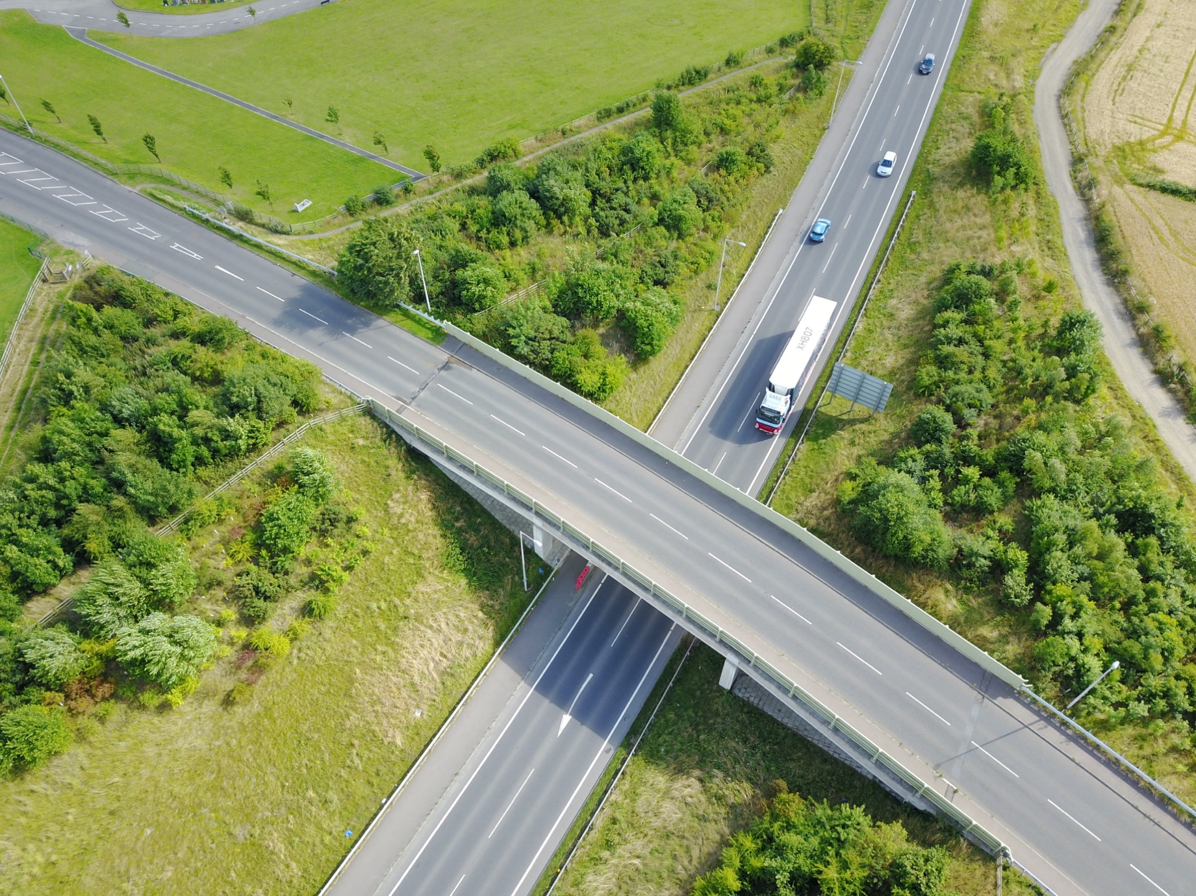

Company details
Company name: | Responsible person (CEO or equivalent):
Registered address:
Date (reporting period/year): | Company type (tick one):
 | Consigner Carrier Consignee

DGSA contact details
DGSA name: | Telephone number:
Email address:

Risk rating
This section affirms the undertaking’s obligation under the requirements of the Dangerous Goods regulations.

Risk descriptor | Required actions | Tick
Fully compliant  All requirements of the DG regulations are met. | Dangerous Goods procedures fully met - No further action required.
Partially Compliant  Some requirements of the DG regulations are met. | Dangerous Goods procedures partially met – Action required. Initiate process review and execute a corrective action plan to address minor non-conformances within a 3-month timeframe.
Non-Compliant  Major requirements of the DG regulations not met. | Dangerous Goods procedures not met – Action required. Conduct a thorough process review and execute a corrective action plan to address major non-conformances within a 1-month timeframe.

Executive summary
Please provide a brief summary of the audit review findings in relation to the undertaking’s adherence to the requirements of Dangerous Goods regulations:

Activities
Are there suitable arrangements in place where the DGSA can consult directly with the responsible person(s) (CEO or equivalent)?
Yes No N/A
Details:

Please provide a brief overview of the activities performed by the undertaking, including any derogations and transitional provisions utilised:

Are there procedures in place for the reporting and investigation of DG incidents, and where appropriate, reporting to HSE serious accidents/incidents?
Yes No N/A
Details:
Have any accidents, incidents or non-compliances (including prosecutions and/or notices served) with the requirements governing the carriage, packing, filling, loading or unloading of dangerous goods been identified as per 1.8.3.3?
Yes No N/A
Date of incident | Place of incident | Brief description of outcome

Training
Are all relevant persons involved in the carriage, packing, filling, loading or unloading of dangerous goods trained in accordance with ADR/RID 1.3 and 1.10.2 (and 8.2, where applicable)?
Yes No N/A
Details:
Has Dangerous Goods Driver Training (initial or refresher) been undertaken during this reporting period?
Yes No N/A
Details:
Are employees properly trained, including updates on any relevant changes to current/forthcoming regulations, and is the maintenance of records of such training adequate?
Yes No N/A
Details:
Is all Dangerous Goods training identified within a detailed training plan that is appropriately managed?
Yes No N/A
Details:

High Consequence Dangerous Goods
Are High Consequence Dangerous Goods carried, as defied in ADR/RID 1.10.3?
Yes No N/A
Details:
Is there a HCDG Security Plan in place?
Yes No N/A
Details:
Has a DfT HCDG Audit been conducted within the reporting period?
Yes No N/A
Details:
Are all relevant staff appropriately trained in the delivery of the Security Plan?
Yes No N/A
Details:
Has a security risk assessment been performed and reviewed at least annually?
Yes No N/A
Details:

Transportation
Information on the type of transport operations and quantities of dangerous goods:
Class | Type of transport operations |  |  |  |  |  |  |  |  |  |  |  |  | Quantity (tonnes/annum) (*Number of packages consigned/annum for Class 7 only)
Class | Consigning | Carriage | Packing | Loading | Filling | Unloading | Consignee | Tank Operator | Designer | Manufacturer | Maintainer/repairer | Other (state): | <5 |  | 5-50 | > 50-100 | >100
1
2
3
4.1
4.2
4.3
5.1
5.2
6.1
6.2
7* |  |  |  |  |  |  |  |  |  |  |  |  | Package Design:
 |  |  |  |  |  |  |  |  |  |  |  |  | Expected |  | IP & Underground | Type A | Type B, Type C & Fissile
8
9

Is there any maintenance performed by the undertaking on vehicles, packaging, conveyances etc?
Yes No N/A
Details:
Method of carriage: (please indicate)
Package Tank Bulk

Practices and procedures
It is recommended that evidence be kept to substantiate answers given below and relevant references are stated, where applicable - as per ADR/RID 1.8.3.3.
Do adequate procedures for compliance with the requirements governing the identification of dangerous goods being transported exist. | Yes | No | Details/reference
When purchasing means of transport, are any special requirements in connection with the dangerous goods being transported considered?
Are adequate procedures in place for checking the equipment used in connection with the carriage, packing, filling, loading or unloading of dangerous goods. E.g. is equipment fit for purpose, in date, calibrated, accessible?
Are written emergency procedures in the event of any accident or incident that may affect safety during the carriage, loading or unloading of dangerous goods in place?
Are there investigations and, where appropriate, preparation of reports on serious accidents, incidents or serious infringements recorded during the carriage, packing, filling, loading or unloading of dangerous goods in place?
Are appropriate measures to avoid the recurrence of accidents, incidents or serious infringements implemented in place?
Do employees involved in the consigning, carriage, packing, filling, loading or unloading of dangerous goods have detailed operational procedures and instructions?
Have adequate measures been introduced to increase awareness of the risks inherent in the carriage, packing, filling, loading or unloading of dangerous goods?
Have adequate verification procedures been implemented to ensure the presence on board the means of transport of the documents and safety equipment which must accompany the transport and the compliance of such documents and equipment with the regulations?
Have adequate verification procedures been implemented to ensure compliance with the requirements governing carriage, packing, filling, loading or unloading?
Does an adequate security plan as indicated in ADR/RID/ADN exist in addition to 1.10.3.2 (HCDG)?
Have any DGSA accident reports been submitted to management?
Have any notifications of occurrences involving dangerous goods been made to the competent authority in accordance with ADR/RID/AND 1.8.5 (and for Class 7 goods, CDG Regulation 24 & Schedule 2), and were they made within the regulatory timescales?
For Class 7 Dangerous Goods only:
Have the emergency procedures that are to be used on more than one occasion been reviewed, and where necessary revised, and adequately tested, as per CDG Regulation 24 & Schedule 2? Has a report on the outcome of the test been produced and sent to ONR?
Has an adequate radiation protection programme which consists of systematic arrangements aimed at providing adequate consideration of radiation protection measures been developed, implemented, reviewed and are they up to date, as per ADR/RID 1.7.2?
Have occupation exposures been assessed to determine whether individual or workplace monitoring needs to be conducted, and an appropriate monitoring regime implemented in accordance with ADR/RID/AND 1.7.2 where necessary? Have they been reviewed and are they up to date? Provide details of the outcome of such an assessment and any relevant monitoring results, where appropriate.
Has a management system been established, implemented, reviewed and is it up to date for all activities within the scope of ADR/RID/ADN, as identified in 1.7.1.3, to ensure compliance with relevant provisions of ADR/RID/AND (and any relevant domestic legislation)?
Is the certification that the design specification has been fully implemented available and valid, as per ADR/RID 1.7.3? Provide details of any designs and/ or special arrangements utilised.
Has any competent authority approved special arrangements been utilised for consignments transported by the undertaking in the reporting period, in accordance with ADR/RID/AND 1.7.4?
Have any Class 7 goods processing other dangerous properties been transported in the reporting period? Provide details of the arrangements in place that ensure compliance with ADR/RID/ADN 1.7.5.
Have any non-compliances with the application radiation and contamination limits occurred during the reporting period? Provide details of the actions taken to ensure compliance with ADR/RID/ADN 1.7.6
Further comments/recommendations and/or conclusions:

This report was prepared by:
Advisors full name:
Advisors company name and address:
Advisors certificate code: | Expiry date:
Advisors signature:
Date of preparation:

Signature of responsible person (CEO equivalent or nominated person):

Acknowledgement of receipt.

Checklist
Dangerous Goods Safety Advisor Annual Report
DGSA1 |  | Name
DGSA2 |  | Year
 | ADR 1.8.3.3 Requirements | Yes, No, N/A | Section of report
DGSA3 | The procedures for compliance with the requirements governing the identification of dangerous goods being transported;
DGSA4 | The undertakings practice in taking account, when purchasing means of transport, of any special requirements in connection with the dangerous goods being transported;
DGSA5 | Investigating and, where appropriate, preparing reports on serious accidents, incidents or serious infringements recorded during the carriage, packing, filling, loading or unloading of dangerous goods;
DGSA6 | The implementation of appropriate measures to avoid the recurrence of accidents, incidents or serious infringements;
DGSA7 | The implementation of proper emergency procedures in the event of any accident or incident that may affect safety during the carriage, packing, filling, loading or unloading of dangerous goods;
DGSA8 | The procedures for checking the equipment used in connection with the carriage, packing, filling, loading or unloading of dangerous goods;
DGSA9 | The implementation of verification procedures to ensure the presence on board the means of transport of the documents and safety equipment which must accompany transport and the compliance of such documents and equipment with the regulations;
DGSA10 | The implementation of verification procedures to ensure compliance with the requirements governing packing, filling, loading and unloading;
DGSA11 | The existence of the security plan indicated in 1.10.3.2.
DGSA12 | The proper training of the undertakings employees, including on the changes to the regulations, and the maintenance of records of such training;
DGSA13 | Verification that employees involved in the consigning, carriage, packing, filling, loading or unloading of dangerous goods have detailed operational procedures and instructions;
DGSA14 | The introduction of measures to increase awareness of the risks inherent in the carriage, packing, filling, loading and unloading of dangerous goods;
DGSA15 | The account taken of the legal prescriptions and special requirements associated with the carriage of dangerous goods in the choice and use of subcontractors or third parties;
Additional Requirements from DVSA
DGSA16 | Confirm annual tonnage of DG
DGSA17 | What, if any, High Consequence DGs do you deal with
DGSA18 | What Security Inspections are undertaken
DGSA19 | What Roadside Inspections are undertaken
DGSA20 | What, if any, Prohibition Notices & Penalties have been issued against the undertaking.
DGSA21 | Other comments

