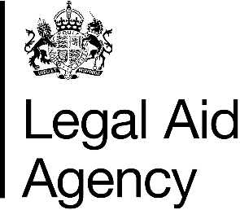

Access to Sign into Legal Aid Services – Independent Bar

Declaration
- I, [Insert Name], Independent Barrister of Organisation Name declare and confirm I have completed my details on the accompanying list of users and require access to Sign into Legal Aid Services to undertake my role.
- I will provide, when requested by Provider Organisations a valid identify check in the form of a passport, driving licence, or other government-issued photo identification.
- I understand that it is my responsibility to ensure that Organisation Name has accurate and up-to-date user account records. When a user account is no longer required—whether due to a change in role or departure from the organisation, or any other reason—I will ensure that access is promptly revoked, and the user account is closed.

Signed:
Name:
Role in Organisation:
Date:

Ownership
Role | Job/role title | Current post holder
Owner | National Contract Manager | Janet Land
Lead | Area Contract Manager | Karl Ford

Current version | 1.0
Last review date | February 2026
Next review date | February 2027

Version history
Version | Date | Reason
1 | February 2026 | Publication on GOV.UK

