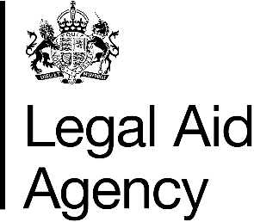

Access to Sign into Legal Aid Services - Chambers

Declaration
I, [Insert Name], acting as the Head of Chambers or other authorised representative of Chambers Name declare and confirm the following:
- The individuals listed in the accompanying 'List of Users' supplied by me will require access to Sign into Legal Aid Services to undertake their roles.
- I have verified the identity of each listed individual by checking a passport, driving licence, or other government-issued photo identification, and I maintain records of this verification which will be made available when requested to provider organisations for audit purposes.
- I understand that it is my responsibility to ensure that Chamber Name maintains accurate and up-to-date user account records. When a user account is no longer required—whether due to a change in role, departure from the organisation, or any other reason—I will ensure that access is promptly revoked, and the user account is closed.
Signed:
Name:
Role in Organisation:
Date:

Ownership
Role | Job/role title | Current post holder
Owner | National Contract Manager | Janet Land
Lead | Area Contract Manager | Karl Ford

Current version | 1.0
Last review date | February 2026
Next review date | February 2027

Version history
Version | Date | Reason
1 | February 2026 | Publication on GOV.UK

