

Submit a Bulk Claim User Guide V1.2
February 2026

This guide contains instructions on how to bulk upload a monthly submission for Civil (Legal Help), Crime Lower or Mediation via Submit a Bulk Claim for legal aid providers.

Contents

Overview of Submit a Bulk Claim 4
What you can do 4
What you cannot do 4
Accessing Submit a Bulk Claim 5
Who can upload bulk claim files 6
Creating a bulk claim file 7
Uploading a bulk claim file 7
‘Nil’ submissions 7
Initial validation 7
What happens next 8
Outcome screen 9
Successful Submission 9
Claims tab 10
Messages tab 12
Matter Starts tab 12
Fee Calculation screen 12
Unsuccessful Submissions 13
Warnings 14
Searching for a previous submission 15
Useful Links 16
Further help and support 17

Overview of Submit a Bulk Claim
Submit a Bulk Claim is an application to enable legal aid providers to submit monthly submissions, including reported Matter Starts, to the Legal Aid Agency (LAA) for Civil (Legal help), Crime Lower or Mediation work. Users will also be able to search for and view submissions for their provider offices that had previously been uploaded to Submit a Bulk Claim.
Submit a Bulk Claim replaces the functionality previously available in CWA that enabled users to submit their monthly submissions either manually or via bulk upload but it will only allow users to submit their submissions via bulk upload.
This application will be available to users from February 2026 and it will accept files in CSV, XML or TXT format created using the LAAs bulk upload spreadsheet or an external Case Management System.

What you can do
- Upload a submission file in csv, xml or txt format for April 2025 onwards including any reported Matter Starts
- Upload a submission file for any provider office account number that is attached to your Sign in to legal aid services (SILAS) profile
- Upload a submission file for one provider office at a time
- Upload a ‘nil submission’ file if there are no claims or new matter starts to report for that month
- Upload a submission file for a month prior to the month in which you upload it (e.g. upload an October 2025 submission during November 2025)
- Upload submission files for a contract in any order you like (e.g. you could upload submissions in the order of June 2025, May 2025 & April 2025 instead of being forced to follow the order of April, May, June)

What you cannot do
- Manually create and submit submissions or manually record Matter Starts within Submit a Bulk Claim
- Upload a file for any provider office account number that is not attached to your profile in Sign in to legal aid services (SILAS)
- View or amend an uploaded submission in Submit a Bulk Claim before you submit it
- Upload a submission file dated prior to April 2025
- Upload a submission file for the same month as the month in which you upload it (e.g. uploading a November 2025 submission during November 2025)
- Upload a submission file containing monthly submissions for multiple offices (if your provider firm has multiple offices who carry out legal aid work)
- Access any submissions uploaded to CWA
We will be adding more features over the coming months.

Accessing Submit a Bulk Claim
To access Submit a Bulk Claim, you will need to have a verified account with Sign in to legal aid services (SILAS) and Submit a Bulk Claim will need to have been added to your profile by somebody in your firm with Firm Admin responsibility. See this guide for more information. https://legalaidlearning.justice.gov.uk/sign-in-to-legal-aid-services/#1-Setupandmanaginguseraccess.
Once this has been done, and you are logged into SILAS, you will be able to click on a link to access the Submit a Bulk Claim landing page. See the Legal Aid Agency training website for guidance on how to create an account with and use SILAS.

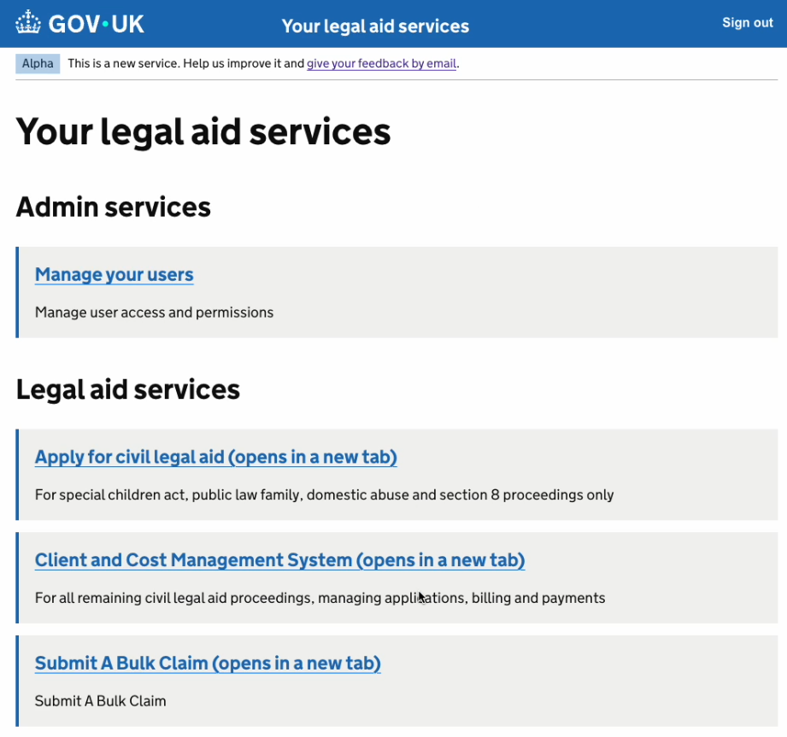
Clicking the link will take you to the Submit a Bulk Claim landing page which contains information about the application and the wider submission process and allows you to begin your user journey.

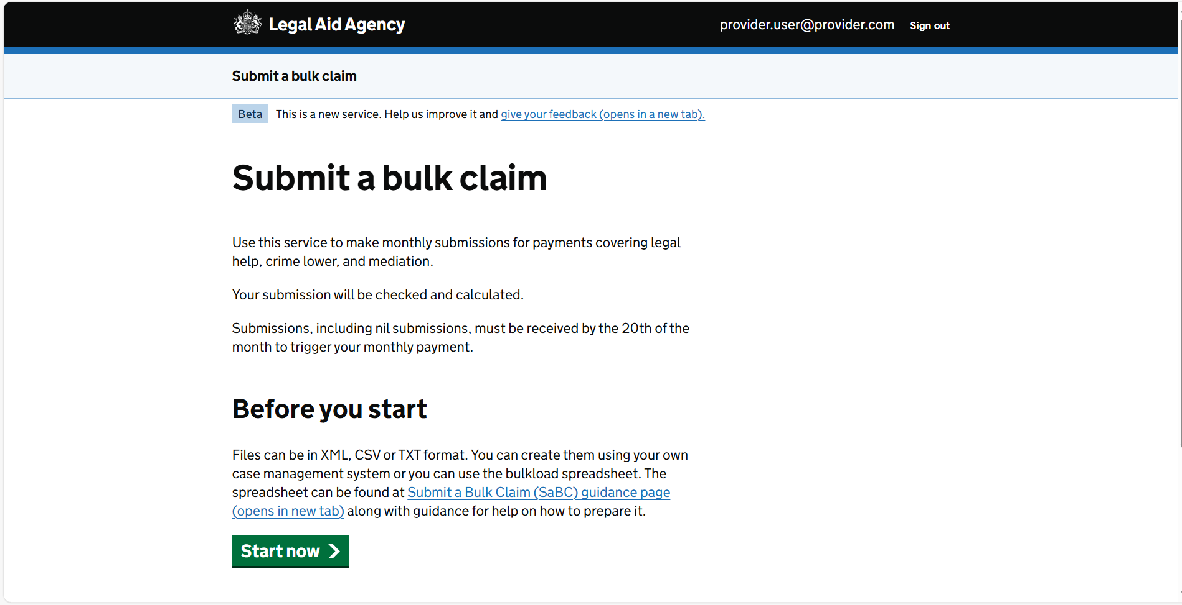
From the landing page, you will be taken to a page entitled ‘Upload a bulk claim file’. The left tab on the page allows you to upload your file.

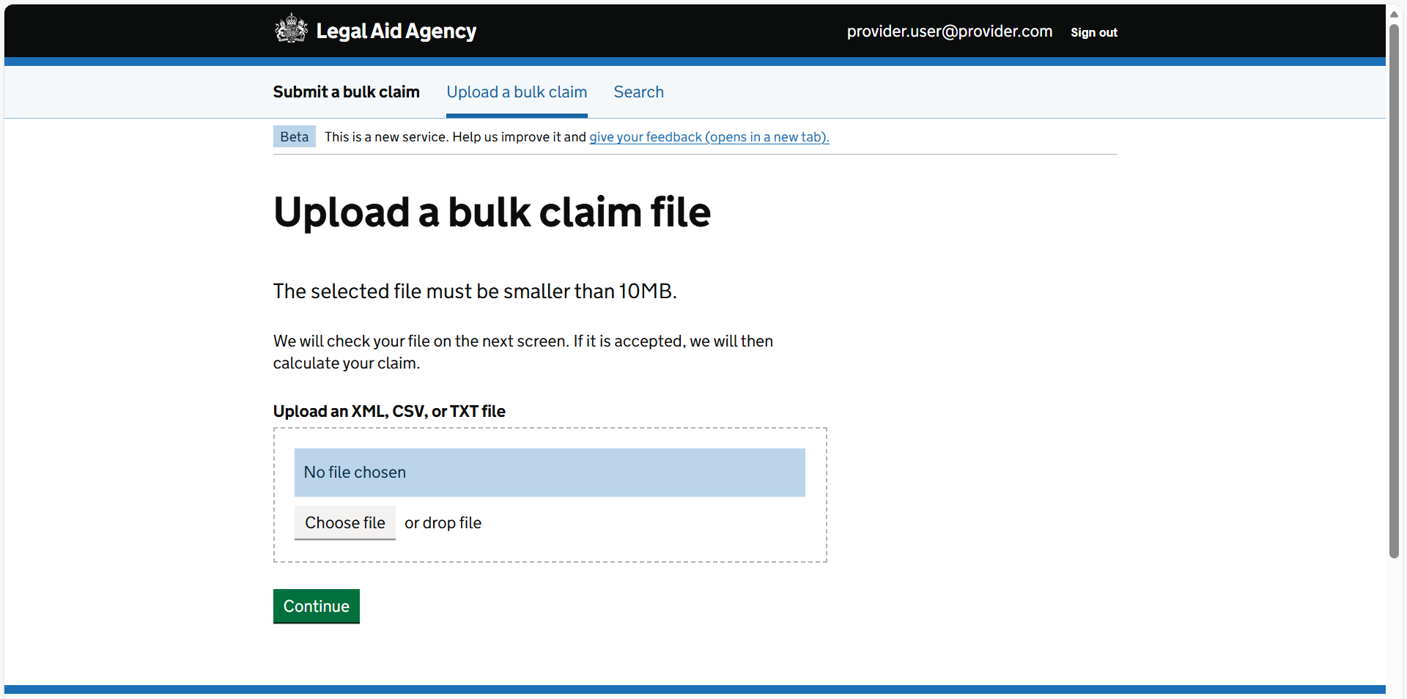

Who can upload bulk claim files
If a provider office has been attached to your SILAS profile, you will be able to:
- Upload a submission file on behalf of that provider office, as long as that office has/had a valid contract and schedule for the relevant area of law in the month that you are uploading for
- Search for and view details for a previously uploaded submission file if the provider office for the submission is attached to your SILAS profile

Creating a bulk claim file
You can use either your own Case Management System or the latest version of the Legal Aid Agency (LAA) bulkload spreadsheet to create a file. Submit a Bulk Claim will only accept files in CSV, TXT or XML format.
You can only upload a submission file for one office at a time. Therefore for each month, if your office has a contract in Civil and Crime you will need a separate spreadsheet for each of these submission files. Mediation will also require its own separate spreadsheet if applicable. If your provider firm has other offices who carry out legal aid work, their submissions will need to be uploaded in separate files.
The latest version of the LAA bulkload spreadsheet and guidance on how to use it to create a bulk upload file can be found at the following location: Submit a Bulk Claim (SaBC) - GOV.UK

Uploading a bulk claim file
To upload, you can either drag and drop your submission file into the large rectangle on the screen or click the ‘Choose File’ button to select a file to upload. You will need to click ‘Continue’ to upload your file.
There is a link to Submit a Bulk Claim (SaBC) - GOV.UK on the landing page which, as mentioned above, contains a link to the LAA bulkload spreadseet and guidance to assist you with using the spreadsheet to create your file.

‘Nil’ submissions
If you do not have any claims to report for the month that you are uploading for, you will still need to create and upload a submission file, containing provider office and submission level information but no claim lines, in order to trigger your monthly payment. If you have matter starts to report for the month, you will need to include them in your file in the usual way.

Initial validation
At this stage, Submit a Bulk Claim will perform some validation checks on the file to validate that:
- it is not an empty file
- its content matches the file extension type (e.g. you have created an xml file and saved it with the extension ‘xml’)
- it is in the correct format i.e. csv, txt or xml and structure
- it does not exceed the current file size limit of 10MB
- it does not contain any viruses
If the file fails any of the above checks, you will see an error message and the application will not accept the file for submission. You will need to correct the error(s) in the file and then upload and submit it again.

What happens next
Once your file has passed all of the above checks and you have clicked Continue, you will see a message telling you that your file is being checked.

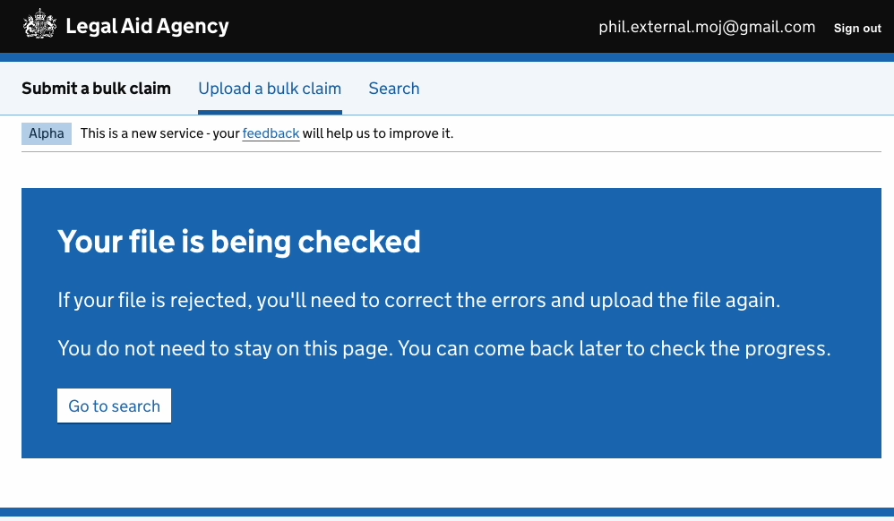
Checks at this stage include whether:
- the provider office holds a valid contract for the submission file area of law
- a submission file for that period and area of law has not already been uploaded to Submit a Bulk Claim, aka it is not a ‘duplicate’ file
- the submission file is for the period April 2025 or later and not for the current month (the month it is being uploaded in) or a future month or year
- claim lines are not duplicated elsewhere in the current submission file or in a submission file previously uploaded to Submit a Bulk Claim (Office account number, Client name, UFN, Fee Code & UCN will be used to compare claim lines and if all match with a claim in a previous submission, the claim will be flagged as a duplicate claim. For claims with the PROD fee code, Office account number, Fee Code & Case concluded date will be used)
- the fee code used in a claim is valid for the submission area of law and the case start date or UFN used for that claim
- all mandatory information required by Submit a Bulk Claim to process the file has been provided
- information entered adheres to the correct format and is valid i.e. where data is selected from a list of values
- work for a claim was carried out when the provider office had an open schedule period for that category of law (e.g. Family, Immigration)
- for Civil disbursement claims, that disbursement has not been included in a submission file uploaded to Submit a Bulk Claim for a period within the last 3 months (Office account number, UFN, Fee Code & UCN will be used to compare claim lines)
- for any Civil disbursement claims, the submission period for the file is 3 or more months after the case start date entered
To see whether your file submission has been accepted or rejected, you can either wait on this screen until the process has completed or use the Search functionality to find out whether the file was submitted successfully. You can navigate to a different screen while the submission is in progress without disturbing the upload process.

Outcome screen
When the file submission process has finished, you will be taken to the ‘Submission Summary’ screen informing you of three possible outcomes:
- Your submission file has been accepted
- Your file has been accepted but with warnings (see the Warnings section for more information about these)
- Your submission file has been rejected

Successful Submission
If the submission file has been accepted, this means that it did not contain any errors and has been accepted for pricing. You will see the following information on the screen relating to the successful submission:
- Date and time of the upload
- Provider office account number
- Area of law
- Monthly Submission Period
- Submission reference (automatically generated by Submit a Bulk Claim)
- Total calculated value of the submission

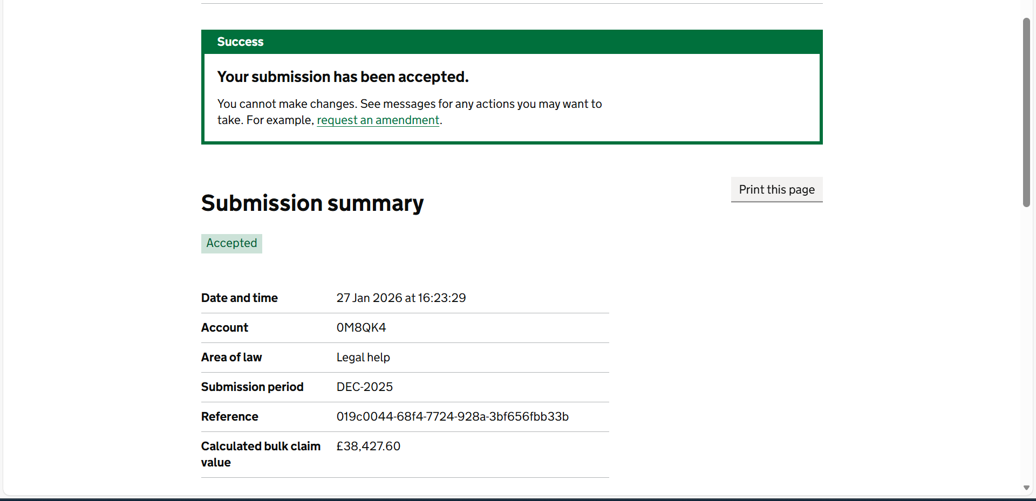
A message on that screen will tell you if any Warnings apply to any of the claims in your submission file. You will not be able to make any changes to your submission at this stage using Submit a Bulk Claim. If you need any amendments to be made to your submission, you can request a claim amendment. The screen will contain 3 separate tabs:

Claims tab
Here, you will see a table containing all claim lines in your submission. The information in each table varies according to submission area of law, details are outlined below, but the table has a ‘Claim’ column containing the word ‘View’ with a link to where you can see how the claim value for that claim was calculated and any Warning messages applicable to that claim.
For a Civil submission, the table will contain columns with the following sortable headings:
- Client surname
- Client forename
- UFN
- UCN
- Fee code
- Calculated Value (as calculated by the Submit a Bulk Claim application)
- Escape case flag
- Messages

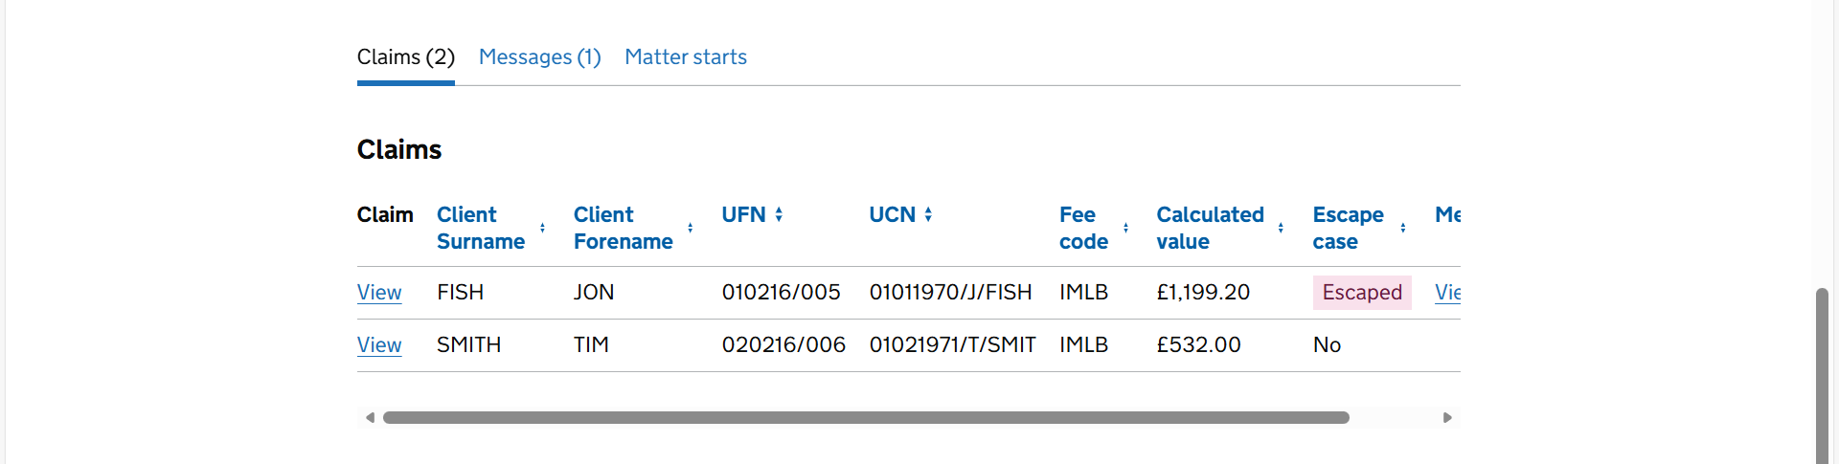
For a Mediation submission, the table will contain columns with the following sortable headings:
- Client 1 surname
- Client 1 forename
- Client 1 UCN
- Client 2 surname (if there isn’t a second client, this field will be blank)
- Client 2 forename (if there isn’t a second client, this field will be blank)
- Client 2 UCN (if there isn’t a second client, this field will be blank)
- Fee code
- Calculated Value (as calculated by the Submit a Bulk Claim application)
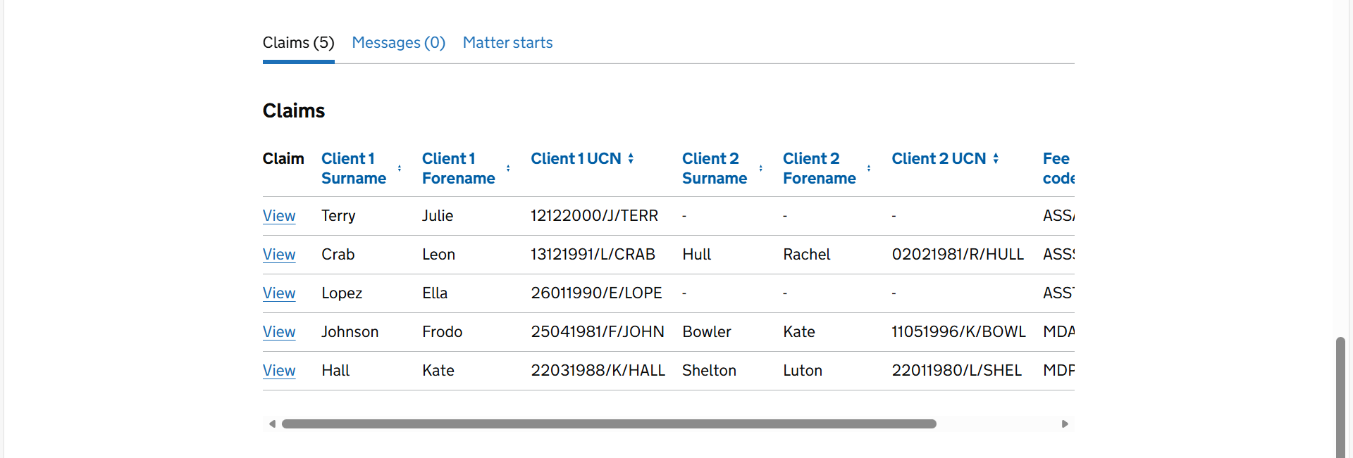
For a Crime submission, the table will contain columns with the following sortable headings:
- Client surname (for claims with the PROD fee code, this field will be blank)
- Client initial (for claims with the PROD fee code, this field will be blank)
- UFN (for claims with the PROD fee code, this field will be blank)
- Fee code
- Date work concluded
- Calculated Value (as calculated by the Submit a Bulk Claim application)
- Escape case flag
- Messages
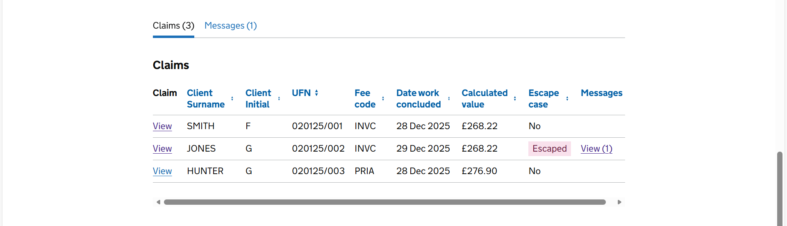

Messages tab
Here, you will see any Warning messages that apply to any of the claims in your submission file. This will be for Civil or Crime Lower submissions only. No Warnings are generated for Mediation submissions.

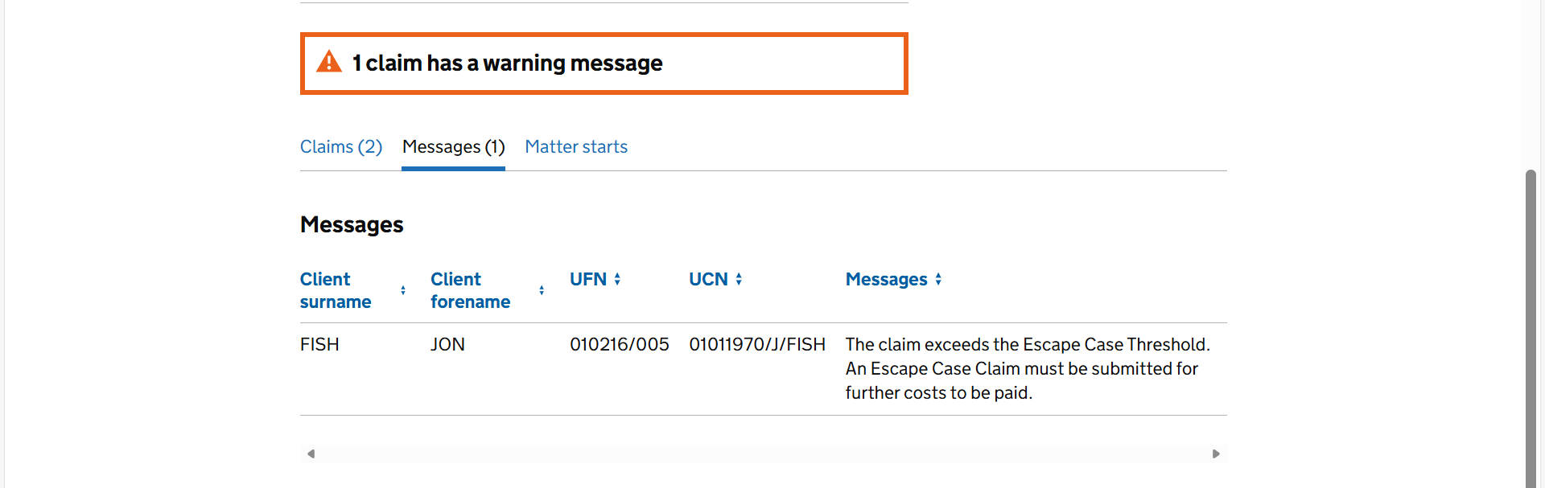

Matter Starts tab
You can also view any matter starts information that you included in your Civil or Mediation submission file on the Matter Starts tab. You will be able to see a breakdown of the matter starts figure included in your claim by category of law.

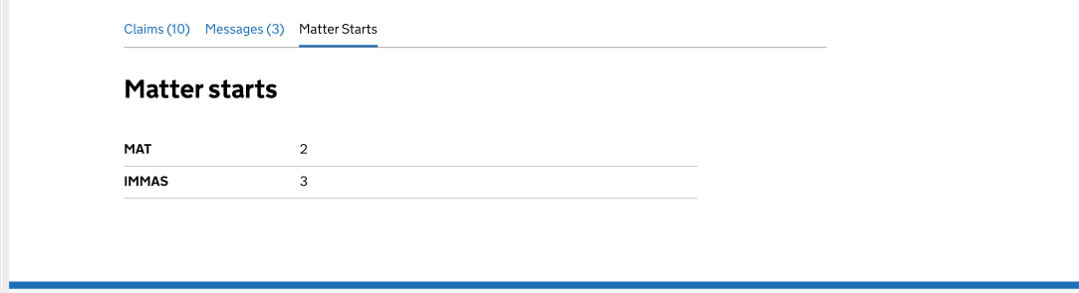

Fee Calculation screen
If you click View on any of the claim lines in the table on the Claims tab, you will be taken to another screen showing a table with 3 columns containing:
- the calculated value of that claim with a breakdown of that value by cost type to enable you to see how it was calculated (Calculated Claim Value column)
- any costs that were entered in the submission file for that claim to enable comparison with the calculated value (Entered Value column)
- information on which fields in the table are only applicable to certain areas of law or Civil matter types. These are indicated in the Area of Law column in the table (Area of Law column)
You can see a screenshot below:
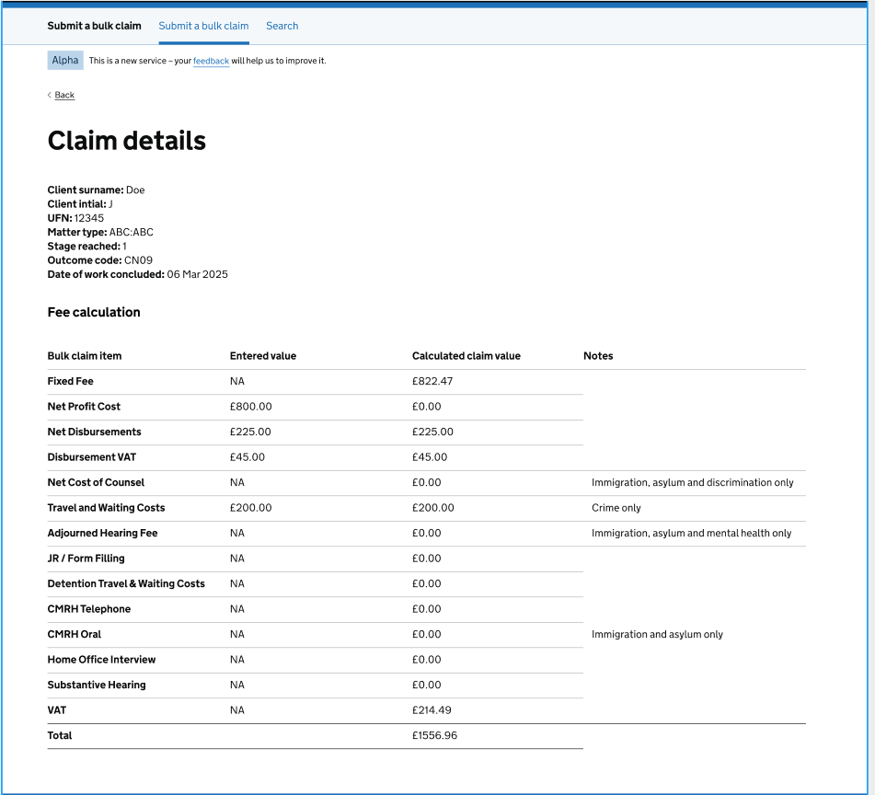
You will not currently be able to export any claim information from Submit a Bulk Claim into a CSV file but this functionality will be available at a later date.

Unsuccessful Submissions
If at least one error is found in any of your claims, the submission file will not have been accepted and you will see a ‘Rejected’ banner on the Submission Summary screen along with an error message at the top of the screen informing you how many claims contain errors. You will need to fix all of the errors found before re-uploading the file.
Errors can relate to the submission as a whole, for example if the submission is a ‘duplicate’ i.e. has the same monthly period, office account number and category of law as a file that has already been successfully submitted, or if the monthly period is before April 2025, or they can relate to an individual claim line within the submission.
If there are errors relating to the submission, you will not see any errors relating to any individual claims as Submit a Bulk Claim will not check any claim information. Once the submission errors are corrected and the file is reuploaded, the system will check each claim and will find any claim-related errors then.
You will see a table containing all errors found. For submission-related errors, you will just see the error message(s). For claim-specific errors, you will see which claim the error relates to and the Error Description field in the table will contain the specific error messages. If a claim or submission has more than one error, each error will be displayed on a new line.

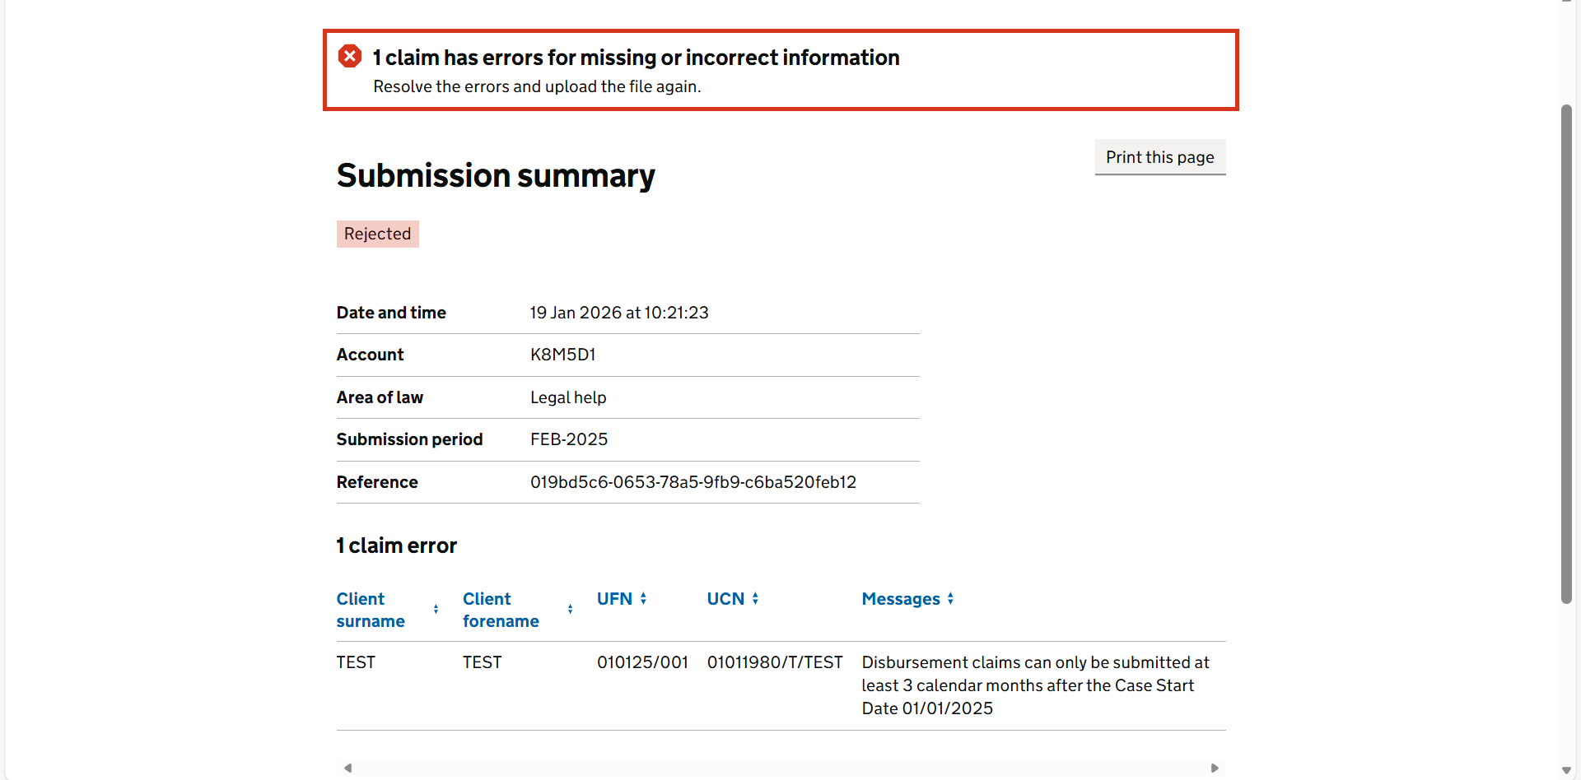
From this page, you can navigate back to the beginning of the journey to upload another submission or search for an existing submission that was previously uploaded.

Warnings
Warnings are indicated on the Submission Summary screen for successful submissions. If your submission has attracted a warning, it has still been uploaded successfully, and priced but Submit a Bulk Claim is making you aware of any specific pricing rules that mean that the calculated claim value for a claim line does not match the costs reported for that claim. The system will flag a warning for any claims where:
- A cost limit has been exceeded
- A claim is an ‘Escape’ claim i.e. the net profit and Counsel costs (if applicable) exceed the escape threshold for that claim

- In some Civil Immigration & Asylum matters:
  - certain reported costs have been capped due to cost limit validation rules that exist within the relevant Civil legal aid contract. For example, case costs exceed a threshold but a prior authority number has not been reported to demonstrate the entitlement to report costs above an initial limit
  - some Additional Costs have been entered separately instead of being combined with net profit costs

- In some Crime matters:
  - costs have been incorrectly entered when they cannot be claimed
As mentioned previously, navigating to the Messages tab or clicking on the hyperlinks in the Messages column allows you to view all Warnings for a submission file. A warning will not prevent a submission from being accepted by Submit a Bulk Claim.

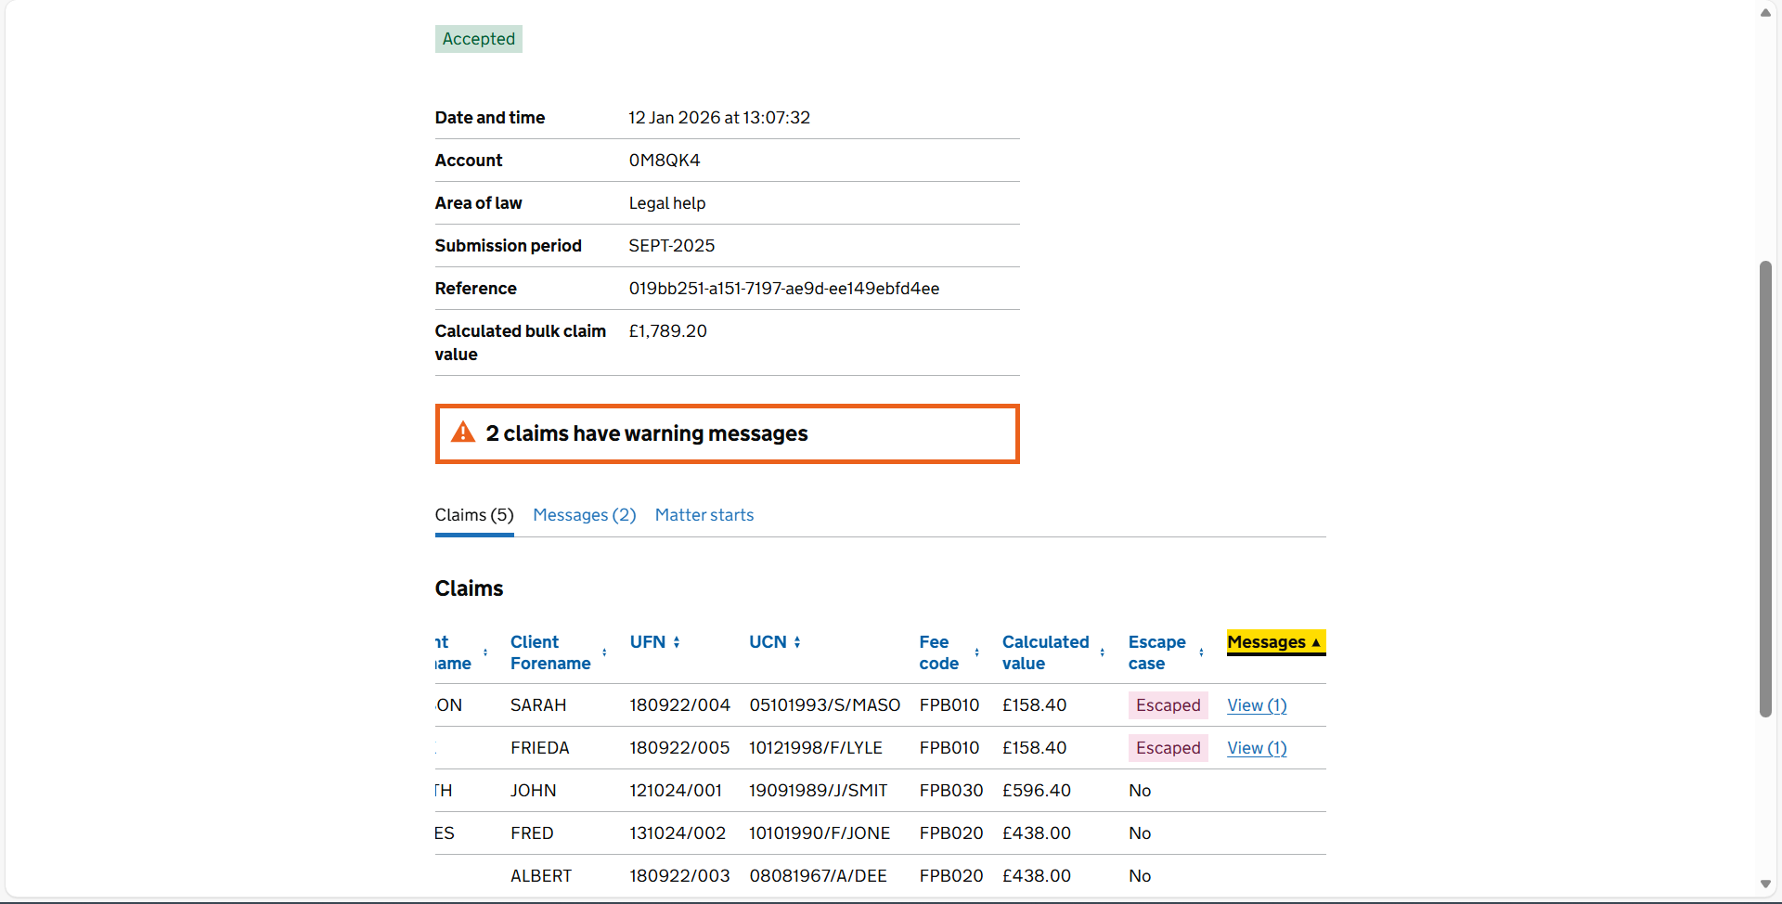

Searching for a previous submission
You will be able to navigate to a screen, called ‘Search for a submission’, where you can search for all submissions for any provider office attached to your profile that have previously been uploaded to Submit a Bulk Claim, including rejected submissions.
You will be able to search using:
- ‘From’ and ‘To’ dates to search for all submissions uploaded during a specific time period
- Submission Reference

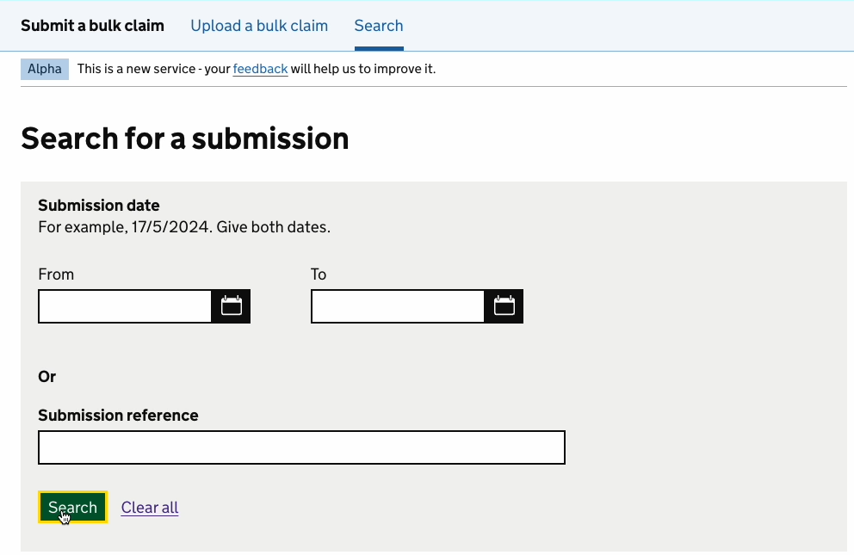
To define a search period, you will need to enter both ‘From’ and ‘To’ dates. You do not need to enter a Submission Reference if you have entered dates and you do not need to enter dates if you have entered a Submission Reference however you can populate all fields if you wish to.
Once you have completed your search, you will be able to navigate to a particular submission from the Search for a submission screen.
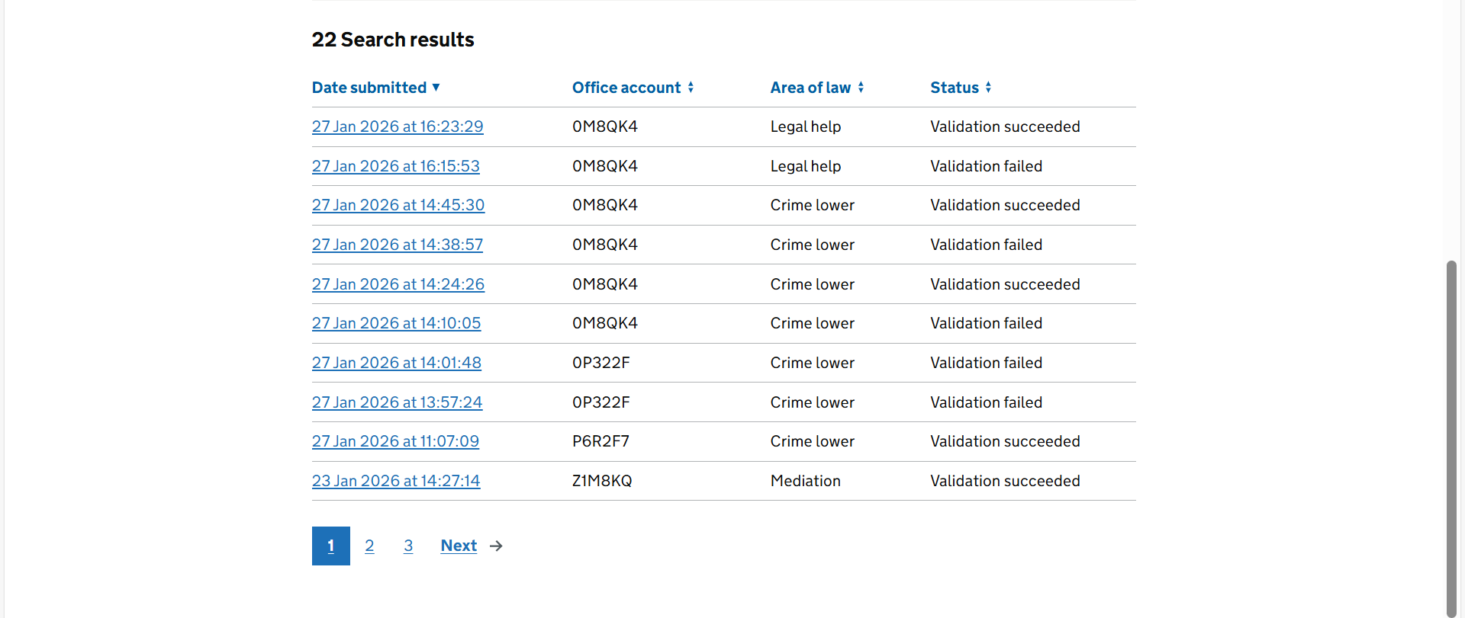
There are plans to add further search criteria options over the coming months.

Useful Links
Submit a Bulk Claim guidance page: Submit a Bulk Claim (SaBC) - GOV.UK
Information on how to submit Escape cases: Escape cases electronic handbook - GOV.UK
Information on Escape fee case claim forms:
EC-CLAIM 1: escape fee case claim form - GOV.UK (Civil)
CRM18: escape fee case claim form (crime) - GOV.UK (Crime excluding Prison Law)
CRM18A: escape fee case claim form (crime prison law) - GOV.UK
Information on Criminal Bill Assessments:
Legal aid guidance - GOV.UK

Further help and support
If you require any further help or support with using this application, you can contact the Legal Aid Agency Online Support team via the following methods:
Email: online-support@justice.gov.uk
Telephone: 0300 200 2020

