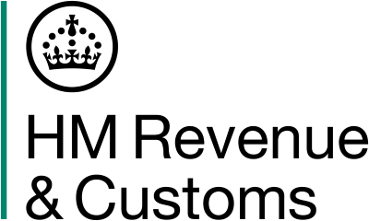

Gov.uk Minutes
Taxpayers Data Standards Forum
10 July 2025: 11:00 – 16:45

General HMRC Update
HMRC service performance is showing signs of improvement, particularly with a significant reduction in average call waiting times.

In other news:
Spending Review 2025 - Additional funding has been allocated to improve customer service and performance. HMRC Transformation Roadmap outlines how spending review funds will modernise services.
Cybersecurity emphasis - strong warnings against phishing and poor cyber hygiene. Businesses are urged to maintain robust cybersecurity practices.
Legislation Day (L Day) – On 21/07/25 - will introduce new consultations and legislative updates.
A stakeholder conference is planned for mid-September; invitations are currently being sent out. HMRC aims to ensure large employers are well represented.
Strategic updates
The NINO Verification Service was temporarily withdrawn on the 3 February 2025 therefore; employers can no longer request or verify NINOs on behalf of employees.
HMRC encourages the use of the Find My NINO digital service on GOV.UK which allows users to instantly view and download their National Insurance number if fully verified (e.g. with a passport or driving licence),or request a letter to their home address if full verification is not possible.
Next meeting
The next forum will be held on 6 November 2025.

