IA Calculator Supplementary information
Inputs
- The first step is to ensure the green table in the inputs tab is filled in correctly for each option and select the appropriate discount rate (the default of 3.5% should be used in most cases). The information in this tab tells the calculator which price year you are using and when the policy starts.
  - Appraisal period is the total length that the policy is expected to have costs and benefits for.
  - Price base year reflects the year that prices used to calculate costs and benefits are taken from. For instance, if a policy requires businesses to purchase a new machine every year and the price of a machine in 2022 is used then the price base year is 2022 and all other prices for this policy should be taken from 2022.
  - Present value base year reflects the year that costs or benefits commence for a policy option. By definition this must be after the current year. The calculator uses the discount rates set out in HMTs Green Book (3.5%) to discount figures to a 202 present value for the impact assessment template. This reflects the social time preference value of money.
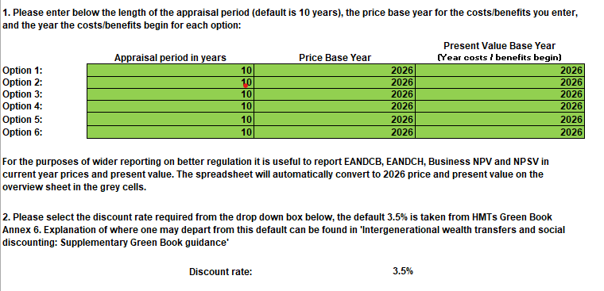
- In the event of a fixed cost or benefit being entered (eg a fixed charge which doesn’t increase with inflation) then a suitably deflated series should be entered to reflect the real cost over time.
- The calculator will use GDP deflator figures to present figures in 2026 prices for use in the impact assessment template (copy from the grey cells on the IA calculator outputs tab). This reflects adjustment for inflation.
- Now that the relevant parts of the SBEE (2015) Act relating to the Business Impact Target have been repealed, there is no requirement to present regulatory measures across government on a comparable basis. Impact assessments can be provided on a basis which is convenient to the department, provided this is made clear. However, our recommendation is to use the current year for both prices and present value, as shown in the grey boxes on the right-hand side of the Overview tab.

Options
- For each option tab, costs and benefits should be entered in millions, so £1,500,000 should be entered as 1.5. Please round final values for EANDCB and EANDCH to the nearest £0.1m.
- Each year should be the 12-month period from when the policy starts, so this may not fit with a calendar year. If a policy has costs and benefits starting in different years, please remember to stagger them when entering the figures into the calculator. For measures which are in place for less than 1 year enter the total cost for the measure in the relevant year. There is no need to ‘annualise up’ the costs for measures lasting less than a year.
- An error message will appear if the drop-down boxes for type of impact and direct business/household impacts are not completed. Please select from ‘BUSINESS’, ‘HOUSEHOLD’, OR ‘OTHER’ for type of impact, and ‘YES’ or ‘NO’ for whether this is a direct impact on businesses or households. The information on direct impacts is not needed for impacts listed as ‘OTHER’.
- The + buttons in the margins can extend the number of years up to 100 and give the option for 5 different transition costs or benefits and 15 different annual costs or benefits. The same selection can be chosen via the 1 and 2 buttons in the top left hand corner of the worksheet.
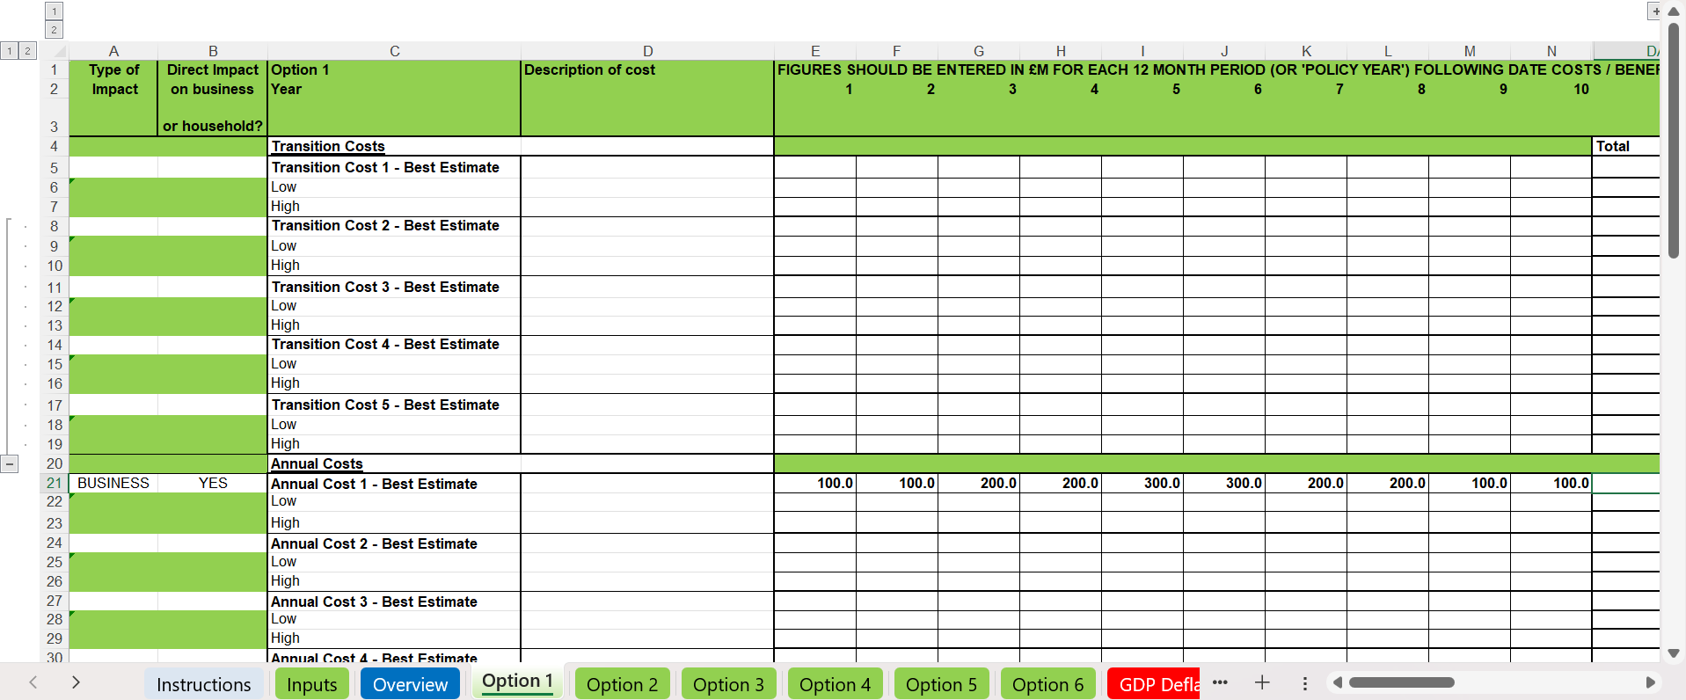
Outputs
- The overview sheet contains outputs relevant to the impact assessment, the grey boxes on the right hand side gives figures in current year for prices and present value. Note, we do not require figures to be comparable across government as there is no longer a requirement for Business Impact Target reporting. Generally, we recommend reporting in current year terms for ease of understanding to a wider audience and information in the grey boxes provide that automatically.
- As a default, the figures in the white box on the left hand side, are for information and are output in the price and present value base years that are specified in the input tab. This explains differences between the figures in the grey box. There is an option to have all the figures output in the current 2026 price year and present value year; simply select YES from the dropdown at the top of the overview sheet.
- If you are including impacts which have happened in the past it is best not to submit information from the grey boxes on the overview tab. These will always be in 2026 present value and would show the past impacts reverse discounted, which may be confusing. Instead use figures from the white cells on the LHS and select NO from the drop down box at the top of the sheet.
- Please note, the calculator is a simple tool which creates a notional output range by combining the highest benefit/lowest cost to give one end of the range, and the lowest benefit/highest cost for the other end of the range. There may be situations where the ‘high’ scenario requires taking both the highest benefits and costs, and the ‘low’ scenario would happen with the lowest benefits and costs, or some other combination. The current set-up is the most common but is not prescriptive. Users should feel free to amend the calculations as they see fit, but are advised to explain what they have done and why in their impact assessments.

Concepts
- The concept of present value takes into account that a set sum of money is not as valuable to us at some point in the future as it would be today, reflecting in part time preference and in part an assumption that as the economy is expected to grow over time, the marginal utility of each additional pound diminishes in the future. Future costs and benefits therefore must be discounted in order to be comparable with today's costs and benefits. The net present social value (NPSV) of a policy is the present value of benefits minus the present value costs, and so demonstrates the overall current monetary value of a policy option. A positive NPSV means the benefits outweight the costs.
- The calculator uses all the costs/benefits that have been assigned as impacts on business to compute the Business NPV (bNPV).
- It also uses the direct impacts on business to compute Equivalent Annual Net Direct Cost to Business (EANDCB) and the direct impact on households to compute the equivalent Equivalent Annual Net Direct Cost to Households (EANDCH) for each option. These metrics are both calculated in exactly the same way and the EANDCB/H calculator is embedded in the spreadsheet. The EANDCB/H only uses the direct impacts on business/households, but an IA will often also include indirect costs as well. Please select "YES" only for those impacts on business or households which are direct. As these metrics are defined as costs, a positive EANDCB/H means the costs outweigh the benefits.
- The present value of each cost and benefit, for each option, is computed by the calculator. The results are converted into the 'Overview' tab and split into transition, average annual and total costs/benefits as is required in the Impact Assessment.
- EANDCB/H formulae are identical. The EANDCB formula is shown on following page.

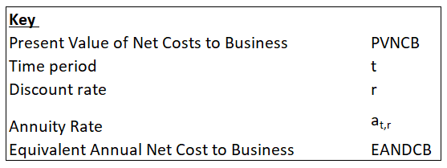
EANDCB Formulae



