Application Decision
Site Visit conducted on 26 November 2025
by Rory Cridland, Solicitor, LLM
an Inspector appointed by the Secretary of State for Environment, Food and Rural Affairs
Decision date: 23 January 2026

Application Ref: COM/3353423
Mardale Common
Register Unit No: CL86
Commons Registration Authority: Westmorland and Furness Council

- The application, dated 27 September 2024, is made under section 38 of the Commons Act 2006 for consent to erect temporary fencing on Mardale Common.
- The application is made by the Royal Society for the Protection of Birds (RSPB)
- The application seeks consent to fence parts of the common for a period of 20 years.

Decision
- Temporary consent (for a period of 20 years) to fence parts of Mardale Common (Register Unit CL86) is granted in accordance with the application dated 27 September 2024 (as amended) subject to the following conditions:
      - The works hereby permitted shall commence no later than 3 years from the date of this decision.
      - The fencing hereby permitted shall be removed no later than 20 years from the date of this decision.
      - Any gates installed as part of the works hereby permitted shall comply with the British Standards for Gates 5709:2018.
  - For the purposes of identification only, the location of the works are shown on the plans attached at Schedules 1 and 2.

Preliminary Matters
  - Following discussions between the applicant and other interested parties, the proposed enclosure at Woof Cragg was removed from the application. In addition, the line of the fencing at the proposed Hopgill Beck enclosure was altered to be more y-shaped and further details were provided on the location of the proposed gates. I have considered the application on that basis, taking account of the amendments proposed by the applicant during the determination process.

The Proposed Works
  - The application seeks consent to erect fencing to create 3 wooded enclosures intended to support tree scrub and willow planting at Hophill Beck, Woodfell Gill and Gatescarth Beck, It would enclose an area of around 30ha in total and involve the erection of around 4.75km of 1.8m high fencing. Gates would be installed to enable continued access to these areas.
  - In addition, consent is sought to erect a further 6 areas of fencing on the northeastern part of the common to create 6 experimental blocks near to Powley’s Hill. The applicant explains that each block would consist of five areas, three of which would be enclosed by 1.8m high deer fencing to form a single fenced compartment. The total area to be enclosed would be approximately 17.5 hectares (ha). Gates would be installed to enable continued access to those areas.
  - These experimental plots are part of a project to better understand the biodiversity and ecoservice benefits of two commonplace upland habitat restoration approaches: grazing reduction and tree planting. The applicant explains that the experiment has been designed as a platform to fill some essential knowledge gaps and to help further understanding of how upland habitat restoration can deliver multiple biodiversity and ecosystem service benefits.
  - A screening decision under the Environmental Impact Assessment (Agriculture) (England) (No. 2) Regulations 2006 was issued by Natural England dated 16 October 2025. I have had regard to this decision in my determination of the application.

Main Issues
  - Section 38 of the Commons Act 2006 (“the 2006 Act”) provides that a person may apply for consent to carry out restricted works on land registered as common land, including fencing.
  - In determining such an application, s.39 of the 2006 Act requires me to have regard to the following:

a. the interests of those occupying or having rights over the land (and in particular, persons exercising rights of common over it);

b. the interests of the neighbourhood;

c. the public interest; and

d. any other matter considered to be relevant.
  - Section 39(2) of the 2006 Act provides that the ‘public interest’ includes the public interest in:

a. nature conservation;

b. the conservation of the landscape;

c. the protection of public rights of access to any area of land; and

d. the protection of archaeological remains and features of historic interest.
  - I have also had regard to Defra’s Common Land Consents Policy (November 2015).

Reasons

The interests of those occupying or having rights over the land
  - Mardale Common is a large area of upland common consisting of around 1353 ha. It is owned and managed by United Utilities and has a total of 3 rights holders. The applicant owns the majority of the rights associated with Naddle Farm and Swindale Farm. The rights associated with Thornthwaite Hall are also managed by the applicant under a separate agreement with the rights holder.
  - I consider the effect on the interests of those having access rights over the land below. However, there is nothing which would indicate that the erection of the proposed fences would adversely affect the interests of either the owner of the common or those having grazing rights over the land. Consequently, I find no harm in relation to these interests.

The interests of the neighbourhood
  - The interests of the neighbourhood relate to the way the common is used by local people and its role in providing open air, exercise and and recreation to those living nearby. It also extends to any potential impacts on nature conservation, heritage assets, its location within a National Park and as part of a World Heritage Site. These are matters that are considered in greater detail below as part of the wider public interest. Where relevant, they also take into account the interests of the neighbourhood.

The public interest

Nature conservation
  - Mardale common is currently in poor ecological condition. The applicant explains that it contains some of the most important sites for high altitude arctic-alpine plant communities in England and that improving its condition is a key component of its overall recovery objectives.
  - Natural England has advised that there is the potential for significant levels of nature conservation benefits to be achieved from the proposed works. In particular, it notes that they would create the conditions whereby the habitats and species that exist within the designated protected areas are able to expand into the surrounding areas and that the proposed experimental enclosures would generate useful data on ecosystem services and habitat recovery from different grazing regimes. These could potentially contribute to informing future policies and management recommendations for sustainable grazing systems. As the government’s statutory advisor on these matters, I give NE’s views considerable weight.
  - Accordingly, I am satisfied that proposed fencing would not adversely impact on the public interest in nature conservation and would not adversely affect the interests of the neighbourhood in this respect.

Conservation of the landscape
  - Turning then to landscape impacts, in its screening decision dated 16 October 2025, NE concluded that the proposed fencing is unlikely to have significant effects on the environment. In reaching its decision, it took into account various factors including that the applicant has incorporated a number of mitigation measures intended to limit the impact of the proposed fencing on public access, the wider landscape and this important World Heritage Site. Furthermore, it notes that the applicant has designed the proposed planting to be low density and naturalistic to maintain the landscape’s sense of openness, has positioned fencing to follow landforms and not impede skyline views, and committed to significant monitoring of the project.
  - It is clear that the impact of the fences on this sensitive and internationally important landscape were a key aspect of the EIA screening process. However, while I agree with NE’s overall assessment that there will not be significant adverse effects on the environment, the proposal would nevertheless result in a number of non-significant, localised, adverse impacts on the landscape. These include localised impacts on walkers using Old Corpse Road and Gatescarth Pass due to the close proximity of the wooded enclosures and their resultant impacts on visual amenity. While this would be experienced for only short sections of these routes, they are well used by both those living and working nearby and visitors to the area. This would adversely impact on the interests of the neighbourhood.
  - However, I accept that at around 50 trees per hectare, the proposed wooded enclosures would not appear materially at odds with the wider landscape and their impact would be gradual due to the considerable amount of time it would take for them to mature at these elevations.
  - Likewise, while I acknowledge that the rectangular appearance of the proposed fencing at the experimental plots would appear somewhat alien in that part of the common, I accept that it would not be widely visible in the surrounding landscape, would be located in a little used area and is unlikely to have a material impact on users of the common.
  - Consequently, while I acknowledge there would be some minor landscape and visual harm, I do not consider the proposed fencing would cause unacceptable harm to landscape character or visual amenity. Similarly, I do not consider it would adversely impact on or erode the key characteristics of the World Heritage Site.
  - Overall, I am satisfied that, while there would be some minor adverse impacts on the interests of the neighbourhood, the addition of the proposed fencing would not materially harm the public interest in the conservation of this internationally important landscape.

The protection of public rights of access
  - Mardale Common is subject to public access rights under section 193 of the Law of Property Act 1925. My attention has also been drawn to section 43 of the Manchester Corporation Act 1919 which provides for public rights for air, exercise and recreation. There are also a number of established public rights of way (PRoW), including a Byway Open to All Traffic on Gatesgarth Pass, a bridleway from the reservoir up to Nan Bield Pass, a footpath across the top of Harter Fell linking Gatesgarth and Nan Bield Passes, and a bridleway linking Mardale with Swindale (Old Corpse Road). None of the sites proposed for fencing directly cross PRoW or significant paths or tracks.
  - The erection of fencing on the common will inevitably result in some diminution in public access. However, I am mindful that this would only affect a small percentage of the common and would be mostly located in areas which are less well used. Furthermore, in order to limit the impact, gates would be installed at various points to enable access to continue to be available over all parts of the common. This would significantly limit the impact of the proposed works on public access and ensure that the public interest in maintaining it would not be materially affected.
  - Accordingly, while I acknowledge there would be some adverse impacts on public access, I am satisfied that the degree to which access would be restricted would not affect the public’s enjoyment of the common as a whole or of the public rights of way which cross it.

Archaeological remains and features of historic interest
  - The lake district national park is a World Heritage Site cultural landscape with its Outstanding Universal Value (OUV) based on a combination of attributes including its exceptional beauty, which has inspired artistic and literary movements and generated ideas about landscapes that have had global influence and left their physical mark. It is also recognised as a catalyst for key developments in the national and international protection of landscapes.
  - Historic England have confirmed that no listed buildings, registered parks and gardens or scheduled ancient monuments would be affected by the proposal. Likewise, it does not raise any concerns that any non-designated nationally important archaeological sites would be affected. While it notes the works involve the introduction of six rectangular fenced enclosures which differ in character to the limited areas of woodland within the otherwise open landscape, it notes that the documentation supporting the application indicates that the enclosures would not be widely visible and would be unlikely to have any significant impact on the OUV of the World Heritage Site. I have no reason to conclude otherwise.
  - Furthermore, I note that suitable buffers are proposed to ensure that areas of archaeological interest are not affected.
  - Consequently, I find the proposal would not adversely affect the public interest in the protection of archaeological remains and features of historic interest nor would it adversely affect the interests of the neighbourhood in this respect.

Other Matters
  - I have noted the various concerns expressed regarding the cumulative effect of fencing on the common. However, I am satisfied that the location of the enclosures at gills and steep slopes, and their intervening distances, would ensure that there would be limited intervisibility. I do not, therefore, consider there would be any significant cumulative effects.
  - I have also given consideration as to whether a shorter period than 20 years would be appropriate. However, I accept that this period is required to protect trees and shrubs from the impact of livestock, particularly given their slow growth rate in these upland areas.
  - While I note the alternative approaches to fencing suggested by interested parties, I am not persuaded that they would be as successful in preventing deer from entering the enclosures.

Conditions
  - I consider a condition requiring the works to be carried out within a reasonable timescale and one securing their removal after 20 years is necessary to provide certainty.
  - Likewise, I consider a condition requiring any gates installed to comply with the relevant British Standard is necessary to ensure suitable public access is maintained for all users. While I note the applicant has suggested following the horse society guidance for deer gates, I consider the British Standard a more appropriate mechanism to ensure that any gates installed are functionally appropriate.

Overall Conclusions
  - I have found above that the proposed works would not harm the interests of those occupying or having rights over the land and would not be detrimental to the public interest in the protection of archaeological remains and features of historic interest.
  - However, I have also found that there would be some localised landscape and visual harm. While this would adversely impact on the interests of the neighbourhood, it would not cause unacceptable harm to landscape character or to the visual amenity of those using the common. Nor would it have any material effect on the wider landscape or the OUV of this important World Heritage Site.
  - Likewise, I have found that while there would be some restrictions on public access. While this would adversely affect the interests of both the neighbourhood and the wider public, I consider the installation of gates at the locations proposed by the applicant would significantly limit this impact and ensure that degree to which access would be restricted would not affect the public’s enjoyment of the common as a whole or of the public rights of way which cross it.
  - In contrast, the proposed fencing has the potential to deliver considerable positive benefits to the public interest in nature conservation and provide useful information on upland habitat restoration. While I acknowledge the limited landscape, visual and access effects and their impacts on both the interests of the neighbourhood and the wider public interest, I consider the positive benefits which would result outweigh them.
  - Accordingly, for the reasons set out above, and having had regard to all other matters raised, I conclude that consent should be granted for a 20-year period, subject to the conditions set out in the Decision above.

Rory Cridland

Inspector

Schedule 1

Location of proposed fencing (for illustrative purposes only).
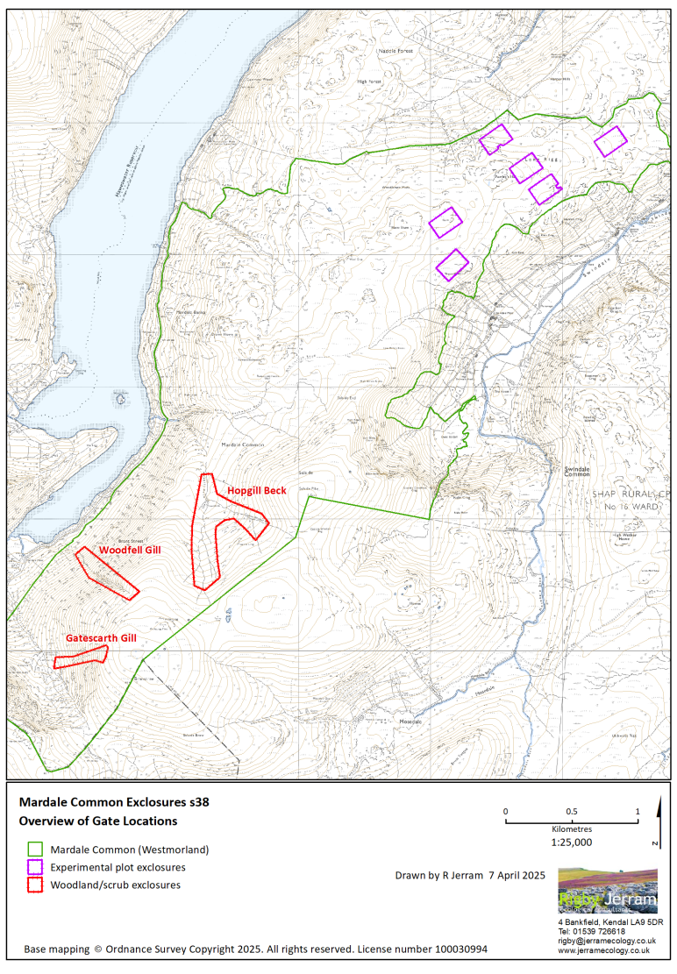
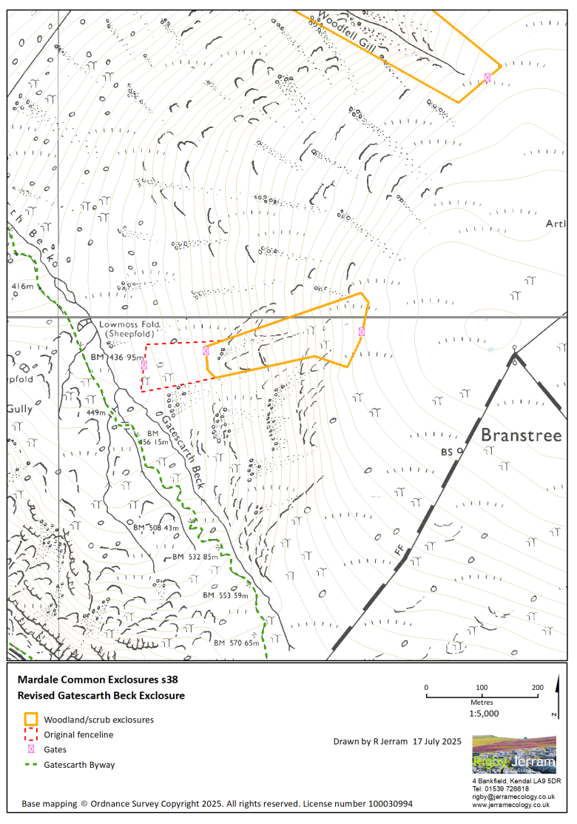

Schedule 2

Gate Locations
