NOTICE OF ORDER

Highways Act 1980, Section 118A and Section 120(3A)
NETWORK RAIL
Unrecorded footpath parish of Grange-over-Sands Rail Crossing Extinguishment Order 2025

Notice is hereby given that the above referenced Order has been proposed by the Secretary of State for Environment, Food and Rural Affair. An Inspector will be appointed by the Secretary of State to determine whether the Order should be made.

The start date for the above Order is 9 January 2026.

Consideration of the Order will take the form of a public local inquiry.

The Inquiry will be held at Victoria Hall, Main Street Grange-over-Sands, Cumbria, LA11 6DP on 30 June 2026 at 10.00am.

The effect of the Order, without modifications, will be to make an order to: Extinguish the whole width and length of unrecorded footpath situated at Bailey Lane in the parish of Grange-over-Sands from grid reference 340800 477786 (point A) southwards for about 9 metres, at a maximum
width of 5 metres, to grid reference 340803 477778 (point B).

Any queries relating to this Order should be referred to Zoe McPhail by email: zoe.mcphail@planninginspectorate.gov.uk quoting reference number ROW/3337872 on all correspondence. Alternatively, queries may be sent in writing to the Planning Inspectorate, Rights of Way Section, c/o QUADIENT, 69 Buckingham Avenue, Slough, SL1 4PN. Telephone: 0303 444 5481.

Any person wishing to view the statements of case and other documents relating to this Order may do so by appointment at Grange-over-Sands Library, Grange Fell Road, Grange-over-Sands, LA11 6BQ Monday to Friday: 10am to 5pm and Saturday: 10am to 1pm.

Timetable for sending in statements of case and proofs of evidence

Within 8 weeks of the start date by [by 6 March 2026]

The Order Making Authority, or where the Order Making Authority is taking a neutral stance and the applicant or other party are taking the case forward in support of the order, must ensure their statement of case is received by the Secretary of State. As soon as possible after the deadline, the Secretary of State will send a copy (excluding copies of any supporting documents - these will be available to view at the Authority’s offices) to everyone who has made an objection or representation and the applicant and any other person who has written to us in respect of the Order.

Within 14 weeks of the start date [by 17 April 2026]

Everyone who has made an objection or representation and anyone who wishes to give evidence at the Inquiry must ensure their statement of case is received by the Secretary of State. As soon as possible after the deadline, the Secretary of State will send full copies to the Authority. Copies will also be sent to the applicant, every person who has made an objection or representation and any other person who has written to us in respect of the Order (excluding copies of any supporting documents - these will be available to view at the Authority’s offices).

Within the same period the applicant (if applicable) must ensure their statement of case is received by the Secretary of State. As soon as possible after the deadline, the Secretary of State will send a full copy to the Authority. Copies will also be sent to everyone who has made an objection or representation and any other person who has written to us in respect of the Order (excluding copies of any supporting documents - these will be available to view at the Authority’s offices).

4 weeks before the date of the inquiry [by 2 June 2026]

The Authority, everyone who has made an objection or representation, the applicant (if applicable) and anyone who wishes to give evidence at the Inquiry must ensure their proof of evidence (together with any summary) is received by the Secretary of State. As soon as possible after the deadline, the Secretary of State will send copies of:

- the Authority’s proof of evidence to everyone who has made an objection or representation, the applicant and anyone who has submitted a statement of case (including copies of any supporting documents – although none should be submitted with a proof of evidence);

- the applicant’s proof of evidence to the Authority, everyone who has made an objection or representation and anyone else who has submitted a statement of case (including copies of any supporting documents – although none should be submitted with a proof of evidence); and

- all other proofs of evidence to the Authority, the applicant, everyone who has made an objection or representation and anyone else who has submitted a statement of case (including copies of any supporting documents – although none should not be submitted with a proof of evidence).

All parties must keep to the timetable set out above and ensure that statements of case and proofs of evidence are received by the Secretary of State on time. Late documents will be returned.

We cannot accept any inflammatory, discriminatory or abusive comments. Any documents containing such comments will be returned.

If you use Artificial Intelligence (AI) to create or alter any part of your documents, information or data, you should tell us that you have done this when you provide the material to us. See the detailed guidance for further information.

Notice of order for inquiry

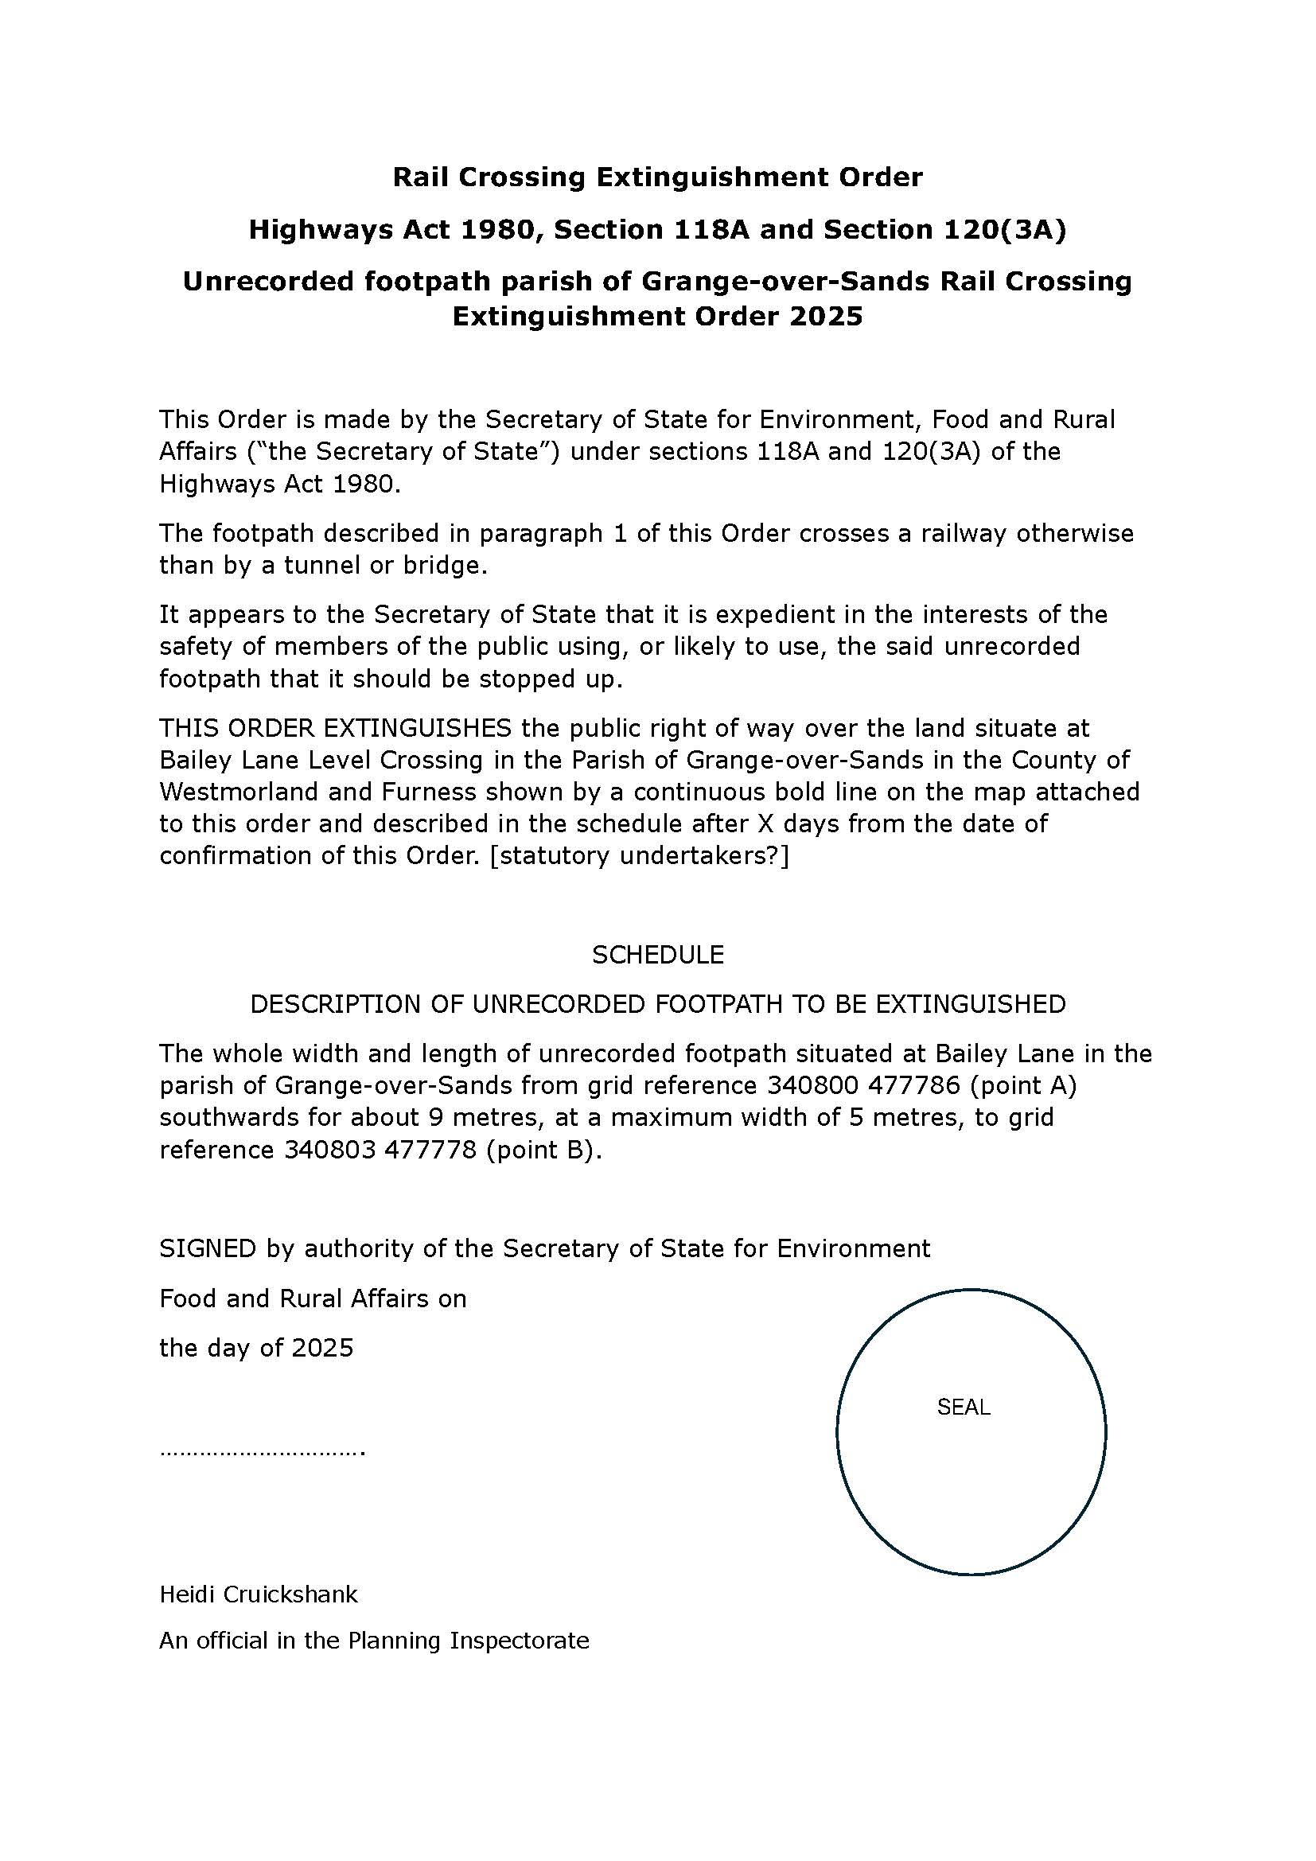
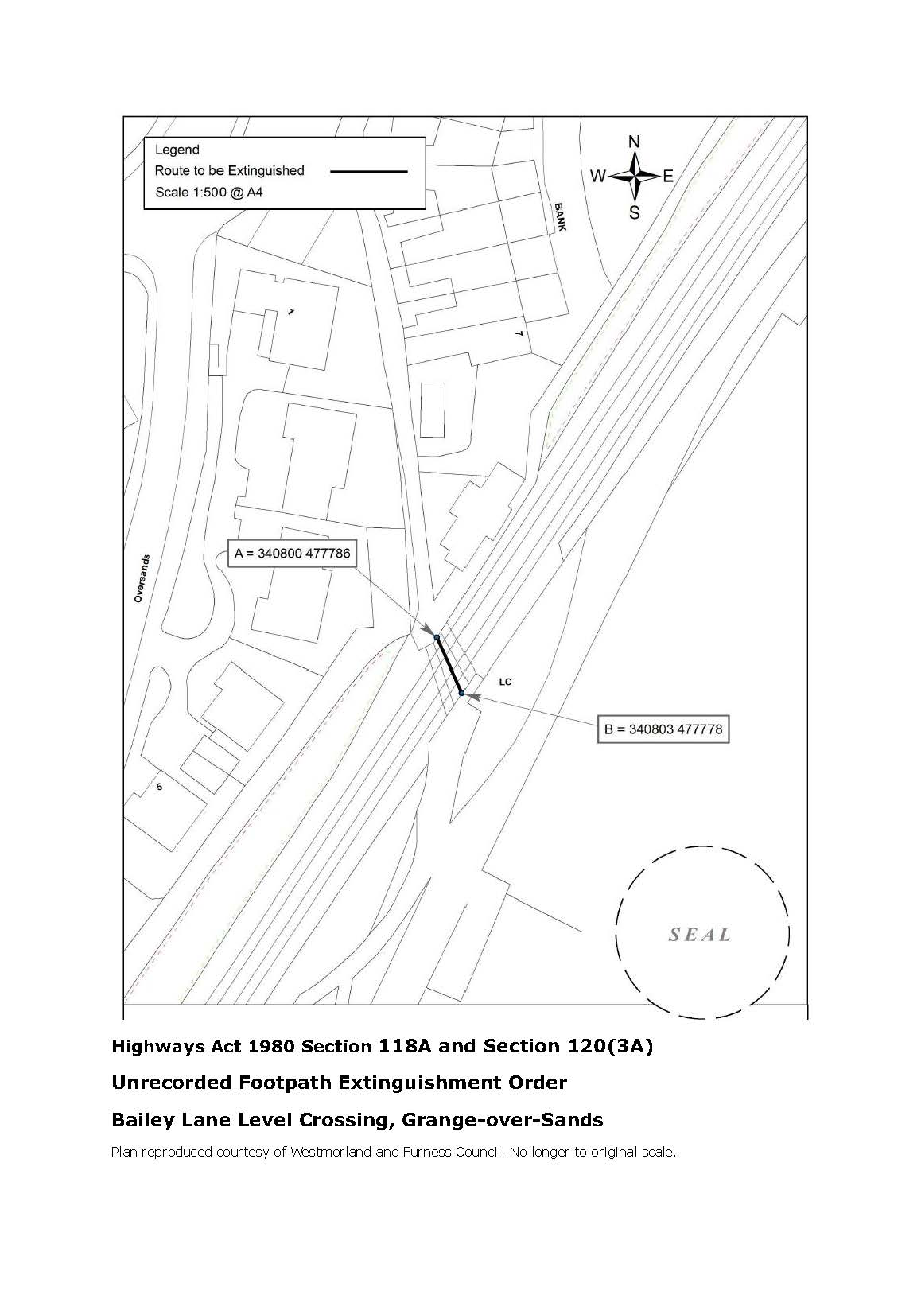

If you wish to make a legal submission, this should be submitted at the same time as your statement of case. Otherwise legal submissions will have to be submitted in writing on the day of the inquiry.

