NOTICE OF ORDER

Wildlife and Countryside Act 1981
Lancashire County Council

THE LANCASHIRE COUNTY COUNCIL (THWAITE BROW LANE, BOLTON-LE-SANDS) DEFINITIVE MAP MODIFICATION ORDER 2018

Notice is hereby given that the above referenced Order has been submitted to the Secretary of State for Environment, Food and Rural Affairs for determination. An Inspector will be appointed by the Secretary of State to determine the Order.

The start date for the above Order is 10 February 2026.

Consideration of the Order will take the form of exchanges of statements of case and comments on statements of case.

The effect of the Order, if confirmed without modifications, will be to modify the Definitive Map and Statement of Public Rights for the area by adding to them a Byway Open to All Traffic (commonly known as Thwaite Brow Lane) from the junction with Mount Pleasant Lane and Highfield Lane at SD 4906 6864 (point A on the Order Map) generally west along a bounded track passing through Crawstone Wood to SD 4879 6866 (point B), then north on an unbounded track through Thwaite Brow Woods to the junction of Whin Grove and Thwaite Brow Lane (U3529) at SD 4880 6884 (point C), shown on the Order Map as a continuous brown line marked A-B-C.
Any queries relating to this Order should be referred to Paul Scrivener by email: paul.scrivener@planninginspectorate.gov.uk quoting reference number ROW/3357221 on all correspondence. Alternatively, queries may be sent in writing to The Planning Inspectorate, Rights of Way Section, c/o QUADIENT, 69 Buckingham Avenue, Slough, SL1 4PN. Telephone: 0303 444 5000.

Any person wishing to view the statements of case and other documents relating to this Order may do so by appointment at County Hall, Fishergate, Preston, PR1 0LD, for further information please contact Ansar Sadiq at ansar.sadiq@lancashire.gov.uk or on 01772 532435.

Documents have also been made available online. To access the documents, please use the following URL address: http://www.lancashire.gov.uk/council/transparency/dmmos/thwaite-brow-lane-2018/

Timetable for sending in statements of case and comments
Within 2 weeks of the start date by 24 February 2026
The Order Making Authority, or where the Order Making Authority is taking a neutral stance and the applicant or other party are taking the case forward in support of the order, must ensure their statement of case is received by the Secretary of State. As soon as possible after the deadline, the Secretary of State will send a copy (excluding copies of any supporting documents - these will be available to view at the Authority’s
offices) to everyone who has made an objection or representation, the applicant and any other person who has written to us in respect of the Order.

Within 8 weeks of the start date by 7 April 2026.
Everyone who has made an objection or representation or any other written representation or any other person wishing to make representations in writing must ensure their statement of case is received by the Secretary of State. As soon as possible after the deadline, the Secretary of State will send full copies to the Authority. Copies (excluding copies of any supporting documents - these will be available to view at the Authority’s offices) will also be sent to the applicant, every person who has made an objection or representation and any other person who has written to us in respect of the Order.
Within the same period the applicant (if applicable) must ensure their statement of case is received by the Secretary of State. As soon as possible after the deadline, Secretary of State will send a full copy to the Authority. Copies will also be sent to everyone who has made an objection or representation and any other person who has written to us in respect of the Order (excluding copies of any supporting documents - these will be available to view at the Authority’s offices).

Within 14 weeks of the start date by 19 May 2026.
Everyone who has made an objection or representation, the Authority, the applicant (if applicable) and anyone who has written to us in respect of the Order must ensure that their comments on any or every other statement of case is received by the Secretary of State. As soon as possible after the deadline, the Secretary of State will send copies of these comments to everyone else.
In fairness to the other parties everyone should keep to the timetable to ensure that statements of case and comments are received on time. Late documents will be returned.

We cannot accept any inflammatory, discriminatory or abusive comments. Any documents containing such comments will be returned.
If you use Artificial Intelligence (AI) to create or alter any part of your documents, information or data, you should tell us that you have done this when you provide the material to us. See the detailed guidance for further information.

Notice of order for w/r
WILDLIFE AND COUNTRYSIDE ACT 1981

THE DE)FJNITIVE MAP AND STATEMENT OF PUBLIC RiJGHTS OF WAY FOR THE
I
COUNTY OF LANCASHIRE \

THE LANCASHIRE COUNTY COUNCIL (THWAITE BROW LANE, BOLTON-LE-SANDS) DEFINITIVE MAP MODIFICATION ORDER 2018
This Order is made by Lancashire County Council ("the Authority") under Section 53(2){b) of the Wildlife and Countryside Act, 1981 ("the Act") because it appears to that authority that The Definitive Map and Statement of Public Rights of Way for the County of Lancashire require modification in consequence of the occurrence of an event specified in Section 53(3)(c)(i) of the Act, namely the discovery by the authority of evidence which (when considered with all other relevant evidence available to them) shows that a right of way which is not shown in the map and statement subsists or is reasonably alleged to subsist over land in the area to which the map relates, namely a byway open to all traffic.
The authority have consulted with every local authority whose area includes the land to
which the order relates. Lancashire County Council hereby order that:

- For the purposes of this order, the "relevant date" is 4th July 2018.

- The Definitive Map and Statement of Public Rights of Way for the County of Lancashire shall be modified as described in Part I and Part II of the Schedule and shown on the map attached to the Order.

- This order shall take effect on the date it is confirmed and may be cited as The Lancashire County Council (Thwaite Brow Lane, Bolton-le-Sands) Definitive Map Modification Order 2018.

Dated this 4th day of July 2018.

THE COMMON SEAL of the )
Lancashire Cou11ty Council )
\l\1as hereunto affo:ed in the prescmce of )

AuthorisEd Signatory � (A�

SCHEDULE
i

PAFtU

MODIFICATION OF THE DEFINITIVE MAP

DESCRIPTION QF PATH OR WAY TO BE ADDED
Byway Open to All Traffic (commonly known as Thwaite Brow Lane) from the junction with Mount Pleasant Lane and Highfield Lane (point A on the Order Map) generally west along a bounded track passing through Crawstone Wood then north on an unbounded track through Thwaite Brow Woods to a junction of Whin Grove and Thwaite Brow Lane (U3529) (point C); a total distance of approximately 480 metres and at a width varying between 2.5 and 4 metres, shown on the Order Map as a continuous brown line marked A-B-C.

PART II

M_ODIFICATION OF DEFINlTIVE Sl"_ATEMENT YARIATION OF PARTICULARS OF PATH OR WAY
Entry to be added to read as follows:

"Byway open to all traffic commencing from the cross roads of Mount Pleasant Lane, Highfield Lane and Thwaite Brow Lane at SD 4906 6864 and running in a generally westerly direction along a bounded track passing through Crawstone Wood to SD 4879 6866 from where it enters Thwaite Brow Woods and continues as an unbounded track in a generally northerly direction to the junction of Whin Grove and Thwaite Brow Lane (U3529) at SD 4880 6884.11

Width:
SD 4906 6864 to SD 4879 6866: Varies between 3 and 4 metres as shown on Ordnance Survey 25 inch sheets XXIV.11 and XXIV.12 both surveyed 1889 and published 1891.

SD 4879 6866 to SD 4880 6884: Varies between 2.5 and 4 metres as shown on Ordnance Survey 25 inch sheets XXIV.11 and XXIV.12 both surveyed 1889 and published 1891.

Length: "0.48 l<m" Other particulars:
Lin iitaiions:

r=rold gate: SD 4879 6866
348800 348900 349000
.
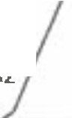
,,: ',.,I
�"'
-�ti,.,,.. Q
... ,,',
�
11------l .
�I
�,,-,�-::G�_
,
:, /;/ G.
: ,' C) Q
�/,(i - 0
�/ S'G_-
, C'
,: Go�e�
C,
�c,Q
,,;.,:G_q,c,
�.,o
;i
'Q�! �,
- �rt o'
G.G_�
Wa ,,
I 1i
Q •
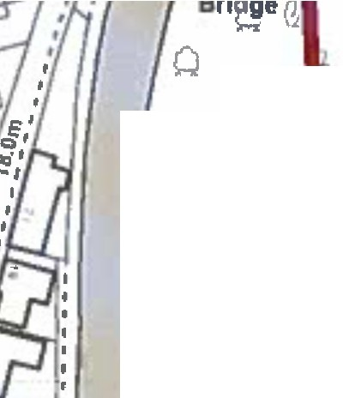
Q
G
Q G.
QQ QQ (1
G. ol:
(1 Q�
G. 111

G_ Q Q
- ll (.) G.
(1 Q
- j
Q (1 Q Q Gc�stone woQ. Q G. G.- I
11
(i G. Q G_
il'ri\l
laQ tzi ' G. QG. G. G. w12� \ l��
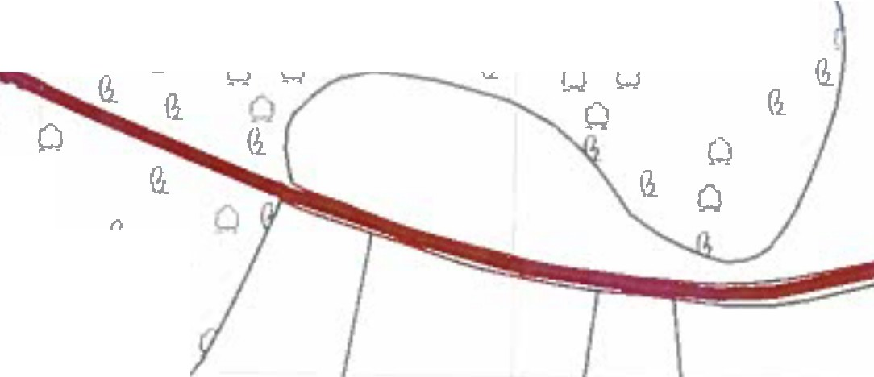
�.J Q
Q Q Q
(1 Q Cl
G. CJ
(i
G. G.
Q G. (1 G.
[.:) 0 G. G.
Q
QQ (1 Q c..iO G. Q
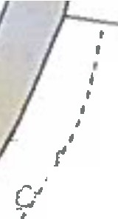
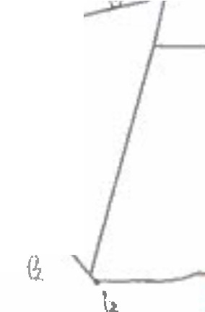
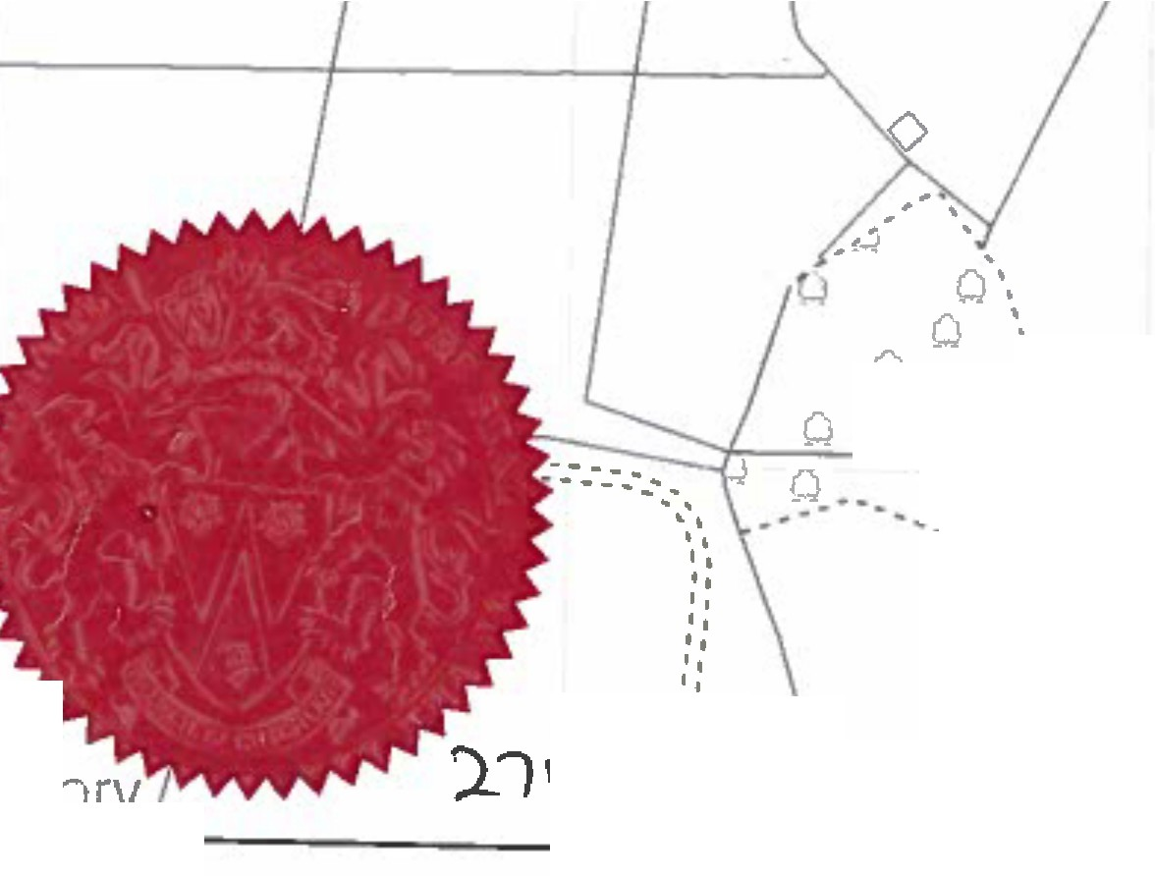



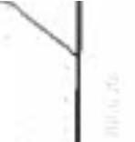
if// i�:--0r,� I I \ \ \\ 11

C, t
,,,

I
,j
,'
I
,I'
0
.
I
Q -' - - - Public Footpath I\_
r!
•
I'
=u·
ICll)
,'

h, .
Q Q ri•\ Order route
! ' G. Q
G_
\
Q G.:
I
(]
a:
.,

- • • • • • Parish boundary
Ill IO
Q cy•··
·-�9•-Al�. .�.
,',•
,,
80 Meters
I
0 20 40
,,
- .
h
tuhorized �',ion.Jtory
7 \ '6.4f I
348800 348900 349000
��♦·
'
1111dlgidttd fllgllb or way Information shouldbe u1td for guidance only 11 Its accuracy cannot� guaranlHd.Rlel\U of WI)' Information must b1 _,.,in1don th• cumnt Dlfinlllv, llap bllortbtlng1u1111lltd or used lor anrpu111011.
This Map11rlJlrodueed lrDm Drdn•ct Surv111 malaial with thep1rml11lon ol Otllnanc■Sur,ey anbehalf of lh■canllDler alHer llaj11t)"1 SlltiDnllfY Offica !ClCmwn Copyrigh1 Unauthorised rwpn,duct!Dll lnf!lllg11Cnlww Copyri9ht andmay Ind ID l'nlstcutiol\ a, civilp111caedillgs.Lancnlll111 Cllunty Coundl Uctnca No. 1G002ll20
1:2,000
Wlldllle affll Countryside Act 1981
AddlUan or part or Thwalte Brow Lana, Bolton le SInd1,
In th• District or Llncaater u I Byway Optn to All Traffic

Andtew Mulla11ey
Head al Planning and Environment
Leaounn,cy asle
Can;ol

