
Integrated Environmental Design Report
Project code: [SRP/FS/FE code]
Project name: [Name of school/college]
[Month] 20[XX]
Contents
Table of figures 3
Summary 4
Review date 4
Who this publication is for? 4
Document history 5
Template 5
Project specific 5
Overview 6
Report structure 6
Integrated environmental design report 7
Section 1 - Integrated environmental design approach 7
Section 2 - A summary of the integrated design proposals 8
Healthy and productive spaces 8
Reducing emissions 9
Nature-based solutions 10
Section 3 - Completed reports required 12
Required reports 12

Table of figures
Figure 1: Elements of environmental design 7

Summary
The Department for Education (DfE) Integrated Environmental Design Report template sets the report structure that the Contractor shall follow to demonstrate their coordinated design response to the Integrated Environmental Design requirements outlined in the DfE’s Technical Manual.

Advisory note
This document contains a series of advisory notes that should be deleted once addressed by the Contractor, including this one.

Review date
This document shall normally be reviewed at 12-month intervals however, DfE reserve the right to update it at any time.

Who this publication is for?
This document shall be used by contractors as part of the DfE Construction Framework 2025 (CF25). It may also be used for other procurement routes using DfE’s design and construction standards and guidance.

Document history
This table lists the key changes in each update.

Template
Revision code | Status code | Date | Amendment
C01 | A | 2026-01-12 | GOV.UK publication

Project specific
Revision code | Status code | Date | Amendment
Pnn | Sn | 20YY-MM-DD | Contractor to add amendments made to document here and rename file to make project specific

The DfE and its agents and advisers accept no liability whatsoever for any expense, liability, loss, claim or proceedings arising from reliance placed upon this resource.

Overview
As part of the design development process, the Contractor shall produce an Integrated Environmental Design Report using this template, for submission in accordance with the information exchanges outlined in the Detailed Exchange Information Requirements (DEIR).
The report shall demonstrate how the indoor and outdoor design solutions have been coordinated in response to the site specific climatic, environmental, topographical and ecological conditions, and the requirements outlined in the Project Brief, Technical Manual and Pattern Book.
This process will ensure environmental design strategies are appropriately established from the outset, so that they can be developed and tested throughout the design process and then integrated into the final design.
Schemes shall be designed in accordance with the following environmental principles as outlined in the Technical Manual:
- Healthy and productive spaces - provide indoor and outdoor learning environments with good air quality, and thermal, acoustic and visual comfort

- Reducing emissions - reduce direct and indirect emissions considering both operational and whole life carbon impacts

- Nature-based solutions - implement nature-based solutions that offer educational and health benefits to users, whilst supporting biodiversity and enhancing ecological resilience

Report structure
The report, using this template, shall be made up of three sections:
- Section 1 - Integrated environmental design approach

- Section 2 - A summary of the integrated design proposals under a series of defined headings and prompts

- Section 3 - Completed operational energy, thermal comfort and internal environment, and daylighting analysis reports that capture the proposed design in full, and with reference to other reports and surveys

The Integrated Environmental Design Report shall be produced in A3 landscape format with the exception of the annexes which may be in A4 portrait or A3 landscape format. All text shall be in 12-point Arial font.
Each section shall be clearly identified and demonstrate a consistent style of writing and illustration/graphic layout.

Integrated environmental design report

Section 1 - Integrated environmental design approach
This section shall provide an overall description of the project’s integrated environmental design approach based on the headings in the matrix outlined within Figure 1 below.
The response shall recognise the challenges of a fully coordinated project specific solution and include how the influences of the site and the Project Brief have impacted the design of the landscape, buildings and engineering systems.
The response shall demonstrate how the proposed project design has been appropriately coordinated between the all the design disciplines involved.

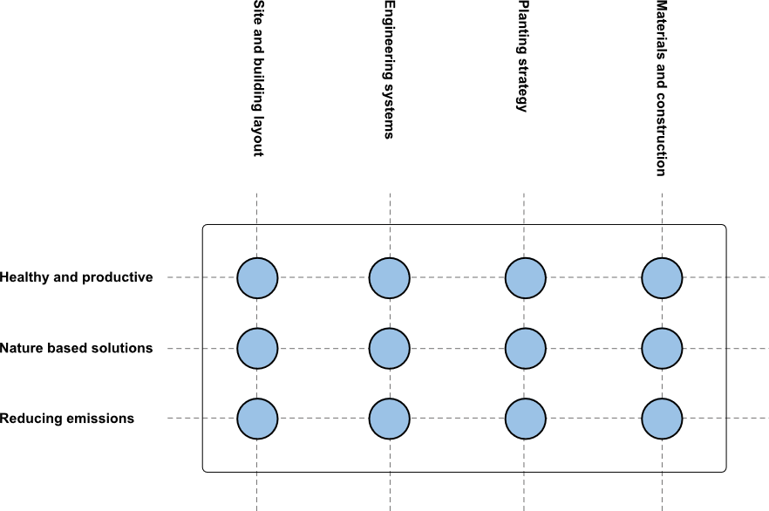
Figure 1: Elements of environmental design
Deliverables: A written and illustrated summary
Minimum word count: 2000 Maximum word count: 2500

Section 2 - A summary of the integrated design proposals

Healthy and productive spaces

Heating and cooling loads
Provide a summary of how the project’s proposed integrated environmental design reduces the overall heating demand and cooling load, including a summary of results from associated modelling and analysis.
The response shall include, but not be limited to, the following:
- how the building orientation, layout and form have been designed to minimise heating demand and cooling load
- how solar shading has been incorporated to reduce peak solar gains and how this has been coordinated with the daylighting strategy
- performance of the proposed building fabric (including glazing) and thermal mass
- a summary of the heating, cooling and ventilation design strategy
- how planting and external surfaces have been incorporated to reduce solar gains
- a summary of the proposed heating capacity of the main plant, based on dynamic thermal simulation modelling
Deliverables: Drawings, diagrams and a written summary
Minimum word count: 800 Maximum word count: 1200

Thermal comfort and indoor air quality
Provide a summary of how the project’s proposed integrated environmental design provides thermal comfort throughout the summer and winter, and how the proposed design will provide good air quality.
The response shall include, but not be limited to, the following:
- solar shading (including planting)
- building materials (minimising VOCs and internal pollutants)
- thermal mass and nighttime cooling strategy
- building occupancy
- daylighting strategy
- ventilation strategy and the use of natural ventilation
- controls strategy (including the parameters used within calculations, and variations between winter and summer assumptions as relevant)
Deliverables: Drawings, diagrams and a written summary
Minimum word count: 800 Maximum word count: 1200

Daylighting
Provide a summary of how the project’s proposed integrated design ensures the daylighting requirements have been maximised, including a summary of the results from associated modelling and analysis.
The analysis must include all the shading measures that have been included within the proposed design.
The response shall include, but not be limited to, the following:
- inclusion of natural surface materials
- the strategy for ensuring direct access to daylight where required
Deliverables: Drawings, diagrams and a written summary
Minimum word count: 800 Maximum word count: 1200

Reducing emissions

Operational energy
Provide a summary of how the project’s proposed integrated environmental design reduces the overall operational energy demand, including a summary of the results from associated modelling and analysis, and a record of the design decisions made to reduce the overall energy demand.
Examples of what should be covered in the response include, but not limited to, the following:
- daylighting strategy
- ventilation strategy
- BMS integration
- small power / IT / kitchen usage
- lighting controls (internal and external)
Deliverables: Drawings, diagrams and a written summary
Minimum word count: 800 Maximum word count: 1200

Materials and carbon
Describe the project’s approach to embodied and whole life carbon, identifying:
- where this has informed product, material and finish selection
- reductions in up-front carbon (A1-A5) to improve whole life carbon outcomes
- strategy for achieving sequestered biogenic carbon target
- strategy for achieving recycled content target
- any assumed data presented in the project’s Carbon Report, with explanation regarding why some project specific data is not available and how any perceived risks have been mitigated accordingly
Describe the project’s approach to materials and construction including, but not limited to, the following:
- a summary of the pre-demolition audit and approach to the demolition of existing structures, including direction of waste streams
- potential opportunities for materials to be retained and reused on site
- measures to reduce site waste and improving material recovery
- key approaches to future deconstruction of building elements for replacement and demolition
- a robust solution minimising the replacement of materials and building components
Deliverables: Drawings, diagrams and a written summary
Minimum word count: 800 Maximum word count: 1200

Nature-based solutions

Nature based integrated design
Provide a summary of how the integrated landscape design coordinates with the buildings, site and overall context to deliver:
- a Sense of Place (e.g., a welcoming, site specific design that responds to its natural landscape character)
- interaction with nature (e.g., to enhance eco-literacy, create a sense of stewardship and provide restorative courtyard gardens)
- outdoor learning and play (e.g., a thermally comfortable, educational and variable outdoor learning and play offer)
- climate resilience through delivery of ecosystem services (e.g., improved acoustic, air quality and flood resilience)
The summary shall incorporate, but not be limited to, the following:
- site and context opportunities and constraints
- the proposed integrated landscape strategic approach, including integration with the building(s) and internal spaces improving views of and access to nature
- the proposed approach to maximising learning opportunities with nature-based solutions
- the proposed management of acoustics and air quality on site
- the proposed approach to indoor and outdoor thermal heat reduction
- what sustainable soil and ecological approach has been undertaken
- the proposed approach to prioritising green infrastructure solutions in the boundaries and fencing strategy
- the strategic approach to maintenance and management, including the planting plan and handover strategy to ensure delivery of 30-year habitat establishment
Deliverables: Drawings, diagrams and a written summary
Minimum word count: 800 Maximum word count: 1200

Section 3 - Completed reports required

Required reports
The following reports shall be attached to the Integrated Environmental Design Report:
- completed operational energy report
- thermal comfort and internal environment report, and
- daylighting analysis report

These shall capture the proposed design in full.

Note 1: Reports provided for sample spaces only shall not be accepted.
Note 2: Other project reports and surveys used to generate this report shall be listed in this section.

© Crown copyright 2026
This publication is licensed under the terms of the Open Government Licence v3.0, except where otherwise stated. To view this licence, visit nationalarchives.gov.uk/doc/open-government-licence/version/3.

Where we have identified any third-party copyright information, you will need to obtain permission from the copyright holders concerned.

About this publication:

enquiries https://www.gov.uk/contact-dfe
download www.gov.uk/government/publications
Follow us on X: @educationgovuk
Connect with us on Facebook: facebook.com/educationgovuk

When not using the DfE Construction Framework 2025, seek appropriate advice on how the DfE’s Employer’s Requirements can be incorporated into the relevant Contract(s).

