ADDENDUM 1 TO BUSINESS CASE Publication version November 2024

SUMMARY INFORMATION

Project Name | JUST ENERGY TRANSITION PARTNERSHIP SUPPORT
Country or region targeted | SOUTH AFRICA
Type of cost extension (if applicable) | Additional cost
Original project budget | £5m
Original project start and end dates | 15 March 2022 – 15 March 2025 (extended to March 2026)
Cost extension value (if applicable) | £14.98m RDEL (of which, up to £9m CDEL)
New project end date (if applicable) | 15 March 2029 -with review point in March 2027
Original Business Case location on Devtracker | https://iati.fcdo.gov.uk/iati_documents/D0004749.odt

What is the project’s purpose?
Strategic case - Context and problem statement

- South Africa (SA) is the 15th largest emitter of Greenhouse Gases (GHGs) globally. Coal comprises approximately 70% of the country’s energy supply and 80% of the country’s electricity mix. Supporting South Africa’s energy transition is critical to limit global temperature increases and reach net zero by 2050.

- At COP26, the Just Energy Transition Partnership (JETP) was announced as part of a Political Declaration between South Africa, the UK, Germany, France, USA and the EU (the International Partners Group or IPG). The JETP supports South Africa’s Just Energy Transition (JET) – enabling it to move away from fossil fuels and achieve the decarbonisation commitments in its Nationally Determined Contribution (NDC) addressing the global risks of climate change, while creating jobs (especially in the coal areas) and driving more rapid and inclusive economic growth. SA has estimated the cost of the JET at $98bn via its 2022 JET Investment Plan.

- The IPG, now with the Netherlands and Denmark having joined, have pledged up to $9.3bn, mostly in the form of loan finance (with about $720m being grant). Other funders have also joined the broader JET.

- The UK financial contribution consists of $1.8bn:-
- $1.3bn via two guarantee facilities to African Development Bank to increase its sovereign lending (dedicated JETP Guarantee – see Business case on Devtracker – Addendum no 1 ) and $300m from Room to Run Guarantee see here DevTracker Programme GB-GOV-1-400013 Documents (fcdo.gov.uk)
- $500m BII and PIDG investments; and DevTracker Programme GB-GOV-1-301523 Documents (fcdo.gov.uk)
- over $34m of technical assistance grant (increased from the original $10m). This comprises a range of DESNZ and FCDO programmes, including UKPACT work on technical areas in energy and SME/job creation programmes such as Commercial Agriculture and clean tech SME support. The original JETP Business Case accounts for £5m of this grant.

- South Africa’s JETP was the first of several JETPs and the only one chaired by the UK on its own. It is important that it succeeds. Success of the JETP is also a goal within the SA Country Plan which is here.

- SA has faced the challenges of loadshedding (power cuts) damaging both the economy and households and social disquiet about job losses in regions reliant on coal and combustion engine vehicle production where unemployment is 42% and there is low national GDP growth. Despite this the JET is proving resilient. SA President and Ministers have endorsed the JET again as recently as 26 August 2024 in a JET public conference. They place emphasis on energy security, affordability of energy and frontloading the “Just” element of the transition with not just jobs but also respecting restorative, distributive and procedural justice.

JETP and the JETP programme
- The JETP comprises both diplomatic engagement and ODA and non-ODA spend from different sources. The theory of change and logframe were set to measure the impact of our programming spend on its own and the collective impact of all of these elements (not just the £5m JETP business case and the $1bn guarantee business case, the $300m from the general Room to Run guarantee but also BII/PIDG $500m, UK’s influencing and grant CMPs).

- The original JETP programme has two focus areas:

- Development of project pipeline for the UK investment pledges AfDB/BII/PIDG;
This has to date comprised work on scoping out investment options in municipalities, especially in the coal mining region and then work on potential initial financial and procurement structures, although this is not finalised.
2. Transformational change to help achieve the JETP, but especially the NDC (SA’s emissions commitment).
Work under this has included evidence on the health implications of coal via primary research with a control trial, support to energy sector emissions modelling and work on policy changes such as supporting an industry sponsored Energy Transition Roadmap for 2025 to 2035 (which SA Presidency is likely to endorse).
What is the objective of the cost extension or other changes?
- The cost extension would finance:-

- continued technical assistance for the investment project pipeline – with the aim of taking the shortlisted projects to AfDB and SA Government approval and potentially build stage
- additional transformational change work (not confined to investment)
- potential CDEL – for the Just side of the transition – primarily for blending
- a programme funded adviser.

The opportunity is also being taken to update the Business case to reflect the areas of focus as the original Business case was written before the SA Government published its investment and implementation plans and before deconflicting with other development partner work.

- If the additional funding is not provided then:-

a) in practice it would not be viable to continue the project pipeline work for the AfDB loans to approval and build stage. The work to date would need to end with the studies and analysis. This would affect the pace and ability to spend UK pledges under the JETP, given the limited other options being put forward by AfDB. In particular there has been pressure by AfDB to spend on policy loans which do not of themselves qualify clearly as JET spending as they go to the general budget and do not deliver GHG emissions or jobs under the JET Investment Plan. While the policy loans or budget loans are favoured by National Treasury, they are not regarded positively by the JET PMU. So without this addendum the AfDB projects would be less impactful. This would impact on the JETP success and reputation, especially given the UK is the only IPG member working on infrastructure projects and trying to find a solution to lending for municipalities.

b) Work by the Centrally Managed Programme, Growth Gateway on SMEs to date would be less impactful as less of the identified SMEs would receive funding.

c) The UK offer on Just and jobs in the JETP would be weaker. DESNZ/CMPs do not tend to focus on the Just area or project pipeline preparation.

What is the additional and total support the UK will provide?
- The proposal is for an up £15m extension to the existing £5m, bringing the Business Case total to £19.8m. Estimates:-

- £7m could be CDEL for blended finance – if CDEL is available from spare country budget or the centre. This would be disbursed over a period – exact annual allocations could vary.

- £12.8m would be RDEL for project preparation and ad hoc transformational projects:-

- £10.4m for project pipeline preparation
- £1.6m for transformational change projects
- £500k for a programme funded adviser

- Flexibility would be needed to shift between components (working within RDEL and CDEL constraints) so as to achieve best value for money and results. For example more funds or less funds might be needed for project preparation or less if that area hit political or practical issues. Funds would not be spent in the transformational change projects area if nothing sufficiently good arose. On the other hand a good opportunity might arise to maximise CDEL results.

Table 1 - Figures in £ for total programme support including cost extension

Funding shown below in 23-24 is spent and most of 24-25 committed (given notice periods). There is no CDEL or PF adviser in the initial Business Case so this Business Case would cover that in early 2025 and project prep and transformational projects from 25-26 onwards.

 | 23-24 | 24-25 | 25-26 | 26-27 | 27-28 | 28-29 | 29-30 | Total
Ad hoc transformational projects | 522,800 | 650,000 | 220,000 | 210,000 | 200,000 | 150,000 | 150,000 | 2,102,800
Project Preparation | 108,000 | 1,800,000 | 2,190,000 | 2,200,000 | 2,200,000 | 900,000 | 800,000 | 10,198,000
Blended finance CDEL- locally |  | 1,000,000 |  |  |  |  |  | 1,000,000
Spare central CDEL (if exists e.g ECED) |  | 6,000,000 |  |  |  |  |  | 6,000,000
Programme funded adviser |  | 29,465 | 80,000 | 90,000 | 100,000 | 100,000 | 100,000 | 499,465
Envelope total | 630,535 | 9,479,465 | 2,490,000 | 2,500,000 | 2,500,000 | 1,150,000 | 1,050,000 | 19,800,000

- This funding would also depend ultimately on country allocations and available CDEL. There is some flexibility to scale down (with reductions on the results below) but ultimately a minimum amount of funding for project preparation work of around £1.5m a year for at least 4 years will be needed to actually viably deliver even a single AfDB loan project of $100m (their minimum loan size) due to the volume of preparation activities needed and the minimum process times within SA institutions and AfDB. Early termination or scale down below this is likely to lead to extremely poor value for money. The CDEL and the programme funded adviser pieces are more severable but there are significant economies of scale and economies of scale/value for money gains with scale ups.

What are the expected results?
- The results align with UK International Climate Finance KPIs but also with the SA Government JET KPIs – we have worked closely with the JET PMU on these. Their key indicators are 1) GHG 2) Jobs 3) Enhanced capital e.g. improved local services and local and national capacity.

Impact Level

Green house gas reductions and better climate resilience achieved from the programme’s interventions.

Reduced unemployment rate differences between coal province and rest of South Africa

Outcome Level

Transformational Change ICF KPI - Improved national and subnational capacity for project preparation – with at least 4 municipalities following best practice of cost benefit analyses, gantt charts, project preparation and other templates introduced by the programme.

Climate Finance mobilised ICF KPI $200m concretely mobilised by 2027, with $500m of additional private finance tentatively committed/envisaged – via the ODA work (the log frame also measures finance via non ODA work)

Jobs created/incomes increased – at least 2000 direct and indirect jobs (30% for women) – including in municipal infrastructure construction (short-term) and 3000 via the CDEL component. Long term direct jobs will be more limited from this programme but infrastructure is vital for business, including agriculture and industry which are reliant on the infrastructure from this programme.

Improved infrastructure and services (community capital) including for at least 20,000 people in the coal mining areas.

Outputs

At least 10 additional projects identified for the JETP (including 9 in the Just/coal mining areas) by 2027, with 4 main projects progressing to financial close.

Opportunities created for UK business e.g. supply of smart meters, supply of software or as bidders for turnaround management or distribution concession projects.

What is the approach to implementation?
- Project Pipeline development for the investment pledges

- The original Business Case was written and approved a few months after the COP 26 decision in November 2021 when the JETP was largely conceptual. The SA Government produced a JET Investment Plan (JET IP) setting out areas for focus in November 2022 and a JET implementation plan in November 2023. While these give indications of general sectors for investment e.g. energy grids, municipal infrastructure e.g. water or energy in Mpumalanga province (the coal area), electrified public transport and road to rail, the SA Government documents do not include a clear pipeline of projects where the loans and DFI funds (including the $1.5bn of the UK pledge) could be deployed. In common with many other countries, SA has a limited pipeline of investable projects and limited central but especially local capacity to deliver the projects. SA’s under-investment in infrastructure is holding back economic growth. The World Bank and growth economist Ricardo Hausmann have identified infrastructure and government capacity to deliver it as a key growth constraint

- The decision was therefore taken to use the UK JETP Business Case funding to develop investable projects for the UK (and to lesser degree IPG) funding, especially pipeline in the Just area where the SA Government had asked us to frontload funding to create the social acceptance for coal plant closures. No other development partners were really working on this area and the JET Project Management Unit encouraged our approach.

- In mid-2023 using the existing Business case funding the UK appointed consultants at the time identified a long list of investment projects in the coal province and then a Steering Committee of FCDO, AfDB and SA’s National Treasury selected two initial buckets of projects to focus on – energy and water (comprising both non-revenue water and bulk water supply), with the plan to develop more projects in the long-term, perhaps in other areas such as job-supporting infrastructure. Some individual projects from the list were also referred to BII. Some initial work on financial structures and procurement and cost benefit analyses has been done. This is of value but not enough to get the projects to approval stage.

- The selection of the project areas for the project preparation reflects SA Government priorities and our analysis of best likely impact. SA has serious problems with both technical and commercial losses (theft and non-payment) in the energy and water distribution networks. SA, but especially the coal mining province, is water-stressed but 50% of water is lost and in many municipalities over 40% of finance for water and energy is not billed and/or if billed is not collected (collectively referred to as “non-revenue water/energy”). Municipalities carry out the role of energy and water distributors and source their energy largely from Eskom (the public energy supplier). The municipalities owe Eskom and water boards over £15bn and the debt is increasing in scale year on year, presenting a threat to SA’s fiscal stability. Eskom then in turn struggles to invest and required a government central bail out in 2022. In turn, the SA sovereign must give guarantees to private suppliers of energy services or grid services to Eskom and its subsidiaries, exacerbating fiscal pressure. Municipalities struggle with receiving adequate revenue to maintain and make investments in their energy and water infrastructure and outages result. These outages further hamper business, discourage payment and a vicious circle of poor services and poor payment ensues.

- A combination of investment in infrastructure upgrades and repair, coupled with a private sector Contractor paid only based on their results (a Performance Based Contractor) to increase billing and collections, could break this circle. Evidence from the World Bank shows that Performance Based Contractors (PBCs) can increase water revenue collection by 68% versus technical assistance without PBCs. In the energy sector there are examples of success using turn around contractors and smart metering in states in Nigeria and Georgia and some evidence that private sector involvement can increase billing, collection and delivery performance, although the area is poorly studied

- The expenditure of the business case in this area is on the consultants who will do financial and legal structuring advice, cost benefit analysis, financial model and engineering baseline assessments and support to procurement of equipment and the performance based contracts as well as then supervising the infrastructure build.

- Transformational change ad hoc work

- A second area, much smaller area of focus for the Business case is on niche areas where we think other programmes and donors are not stepping in or would be too slow to do so but which we think will trigger transformational change. This is largely in the policy area. The first test here is always to see if there is another programme that could undertake the work in a reasonable timeframe. For administrative and value for money reasons we would like to keep this ad hoc work to a minimum but we feel it is valuable to reserve the option to do this work under the Business case. Examples to date are below.

Recipient of support and value | Issue/Area of focus | Why others could not step in | Next steps
Medical Research Council | Inadequate evidence existed of the impact of coal plants on the communities’ health.  MRC is gathering raw data to produce a peer reviewed study of health issues (not just morbidity but also respiratory and cardiovascular) around coal plants vs a control area (with similar socio-economic characteristics). | UKPACT could not move fast enough and unable to do direct grants | Publication of article  Peer reviewed evidence  Event to promote the findings and raise awareness of clean air implications.  Should provide evidence for future hearings on clean air and decisions on coal plant closure
Energy Council | Energy Council was a new business association with a dynamic management and 38 members across generators and key buyers. It has a vision of key actions which its members could finance in the Presidency.  Delivery of an Energy Transition Roadmap of actions for the new Government’s Energy reform unit within the Presidency.  Work on implementation including pricing implications and structuring of capacity market. | As above. The due diligence and accountable grant were concluded within 2 months to enable rapid work. | EC is partly funded by its members but other development partners are also likely to fund EC in the future, especially now it has proven its worth.  The Plan is being used for actions which other donors and businesses will fund.
Loughborough University/University of Cape Town | Need for more capacity in SA on modelling energy systems  Open source energy modelling | As above. | Other donors e.g. US, Germany have now stepped into this area but will aim for a smooth end.
National Treasury – in the end didn’t go ahead as they decided not to proceed | Lack of incentives for EV manufacturing and roll out, meaning a loss of jobs and higher GHG emissions |  | Hoping this BC or other UK programmes (e.g. SA Treasury support programmes) can step into this area again.

- Blended finance for Just projects - CDEL

- A third area for the programme is to provide CDEL for development capital grants (not returnable to FCDO) for Just projects, such as grants to investment funds investing in equity or debt in JET-related SMEs. Blended finance is a now common way of addressing the challenges of risk and transaction costs, especially for developing country investments. Convergence, a specialist blended finance research firm, identified over 2110 blended finance arrangements in 2024 with $123bn of investment5. There is evidence (see paragraph 31) that supporting SMEs with additional finance will lead to growth and jobs.

A key element of the JET is creating alternative jobs to fossil fuel industries, especially alternatives to coal jobs in Mpumalanga province where unemployment is over 42%. Most alternative industry employers are in the SME category.

- Work undertaken by the UK’s centrally managed programmes which operate in South Africa - Growth Gateway and the CASA identified that by focussing on some high growth potential SMEs (as opposed to absolute start-ups), 4000 to 10,000 long-term sustainable jobs could be created in Mpumalanga within the next 4 years. The Growth Gateway programme identified an investment pipeline of 200 SMEs in Mpumalanga and over 400 firms in total (if green growth firms outside of Mpumalanga were included). Technoserve interviewed over 50 farms and found a pipeline of 15 and 4-5 firms for viable near term investments Mpumalanga. CASA also interviewed 80 financial intermediaries to assess challenges and Growth Gateway about 20 financial firms. Growth Gateway found that over 65-75% of the demand for finance for SMEs in Mpumalanga was unmet. See their slides below.

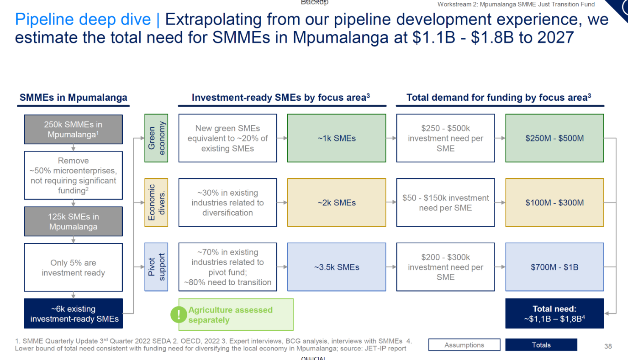

- While consultants from both sets of programmes have sought to match investors with the SMEs, the ticket size and early-stage risk makes it hard to find either equity investors or debt providers necessary for the expansion of the firms. Other development partners (e.g. IDC, JETP) can provide small grants of up to £100,000 but then companies do not have the access to capital to grow beyond that – they are stuck in the so-called valley of death which is where philanthropic capital or blended finance can help.

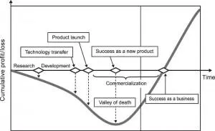

Image credit- forbes.com
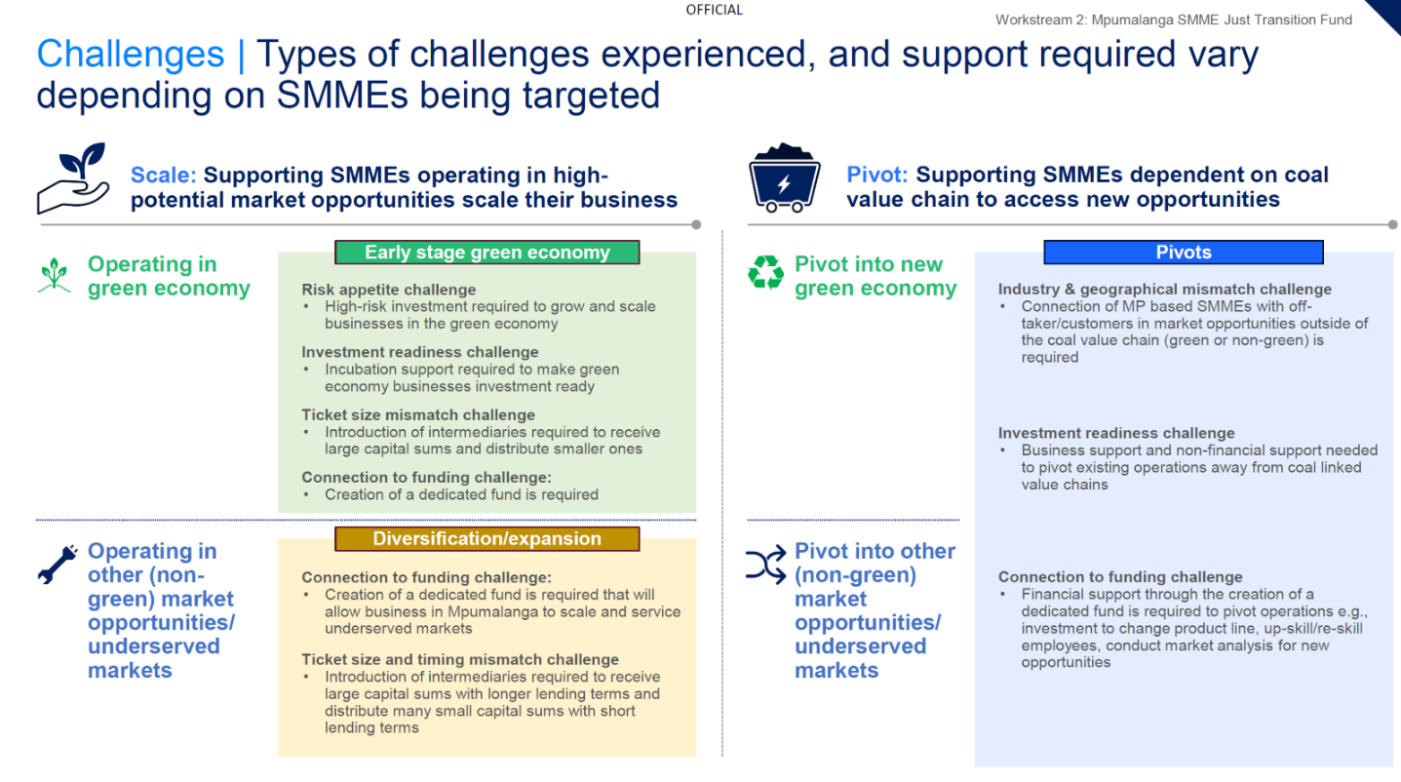

- Growth Gateway has been working with South African investment firms to see if they can move into Mpumalanga to support these SMEs– including by using grant finance to subsidise the extra transaction costs e.g. of hosting a representative in Mpumalanga and by offering a first loss tranche (either within the fund structure or as a side car mechanism drawn down as necessary) for those transactions which are higher risk and so which wouldn’t otherwise occur. It has modelled the size of fund/s necessary to support the anticipated pipeline and then the first loss or transaction support capital necessary. For debt the ratio of first loss to core capital could be about 1:4 but this could reduce over time.

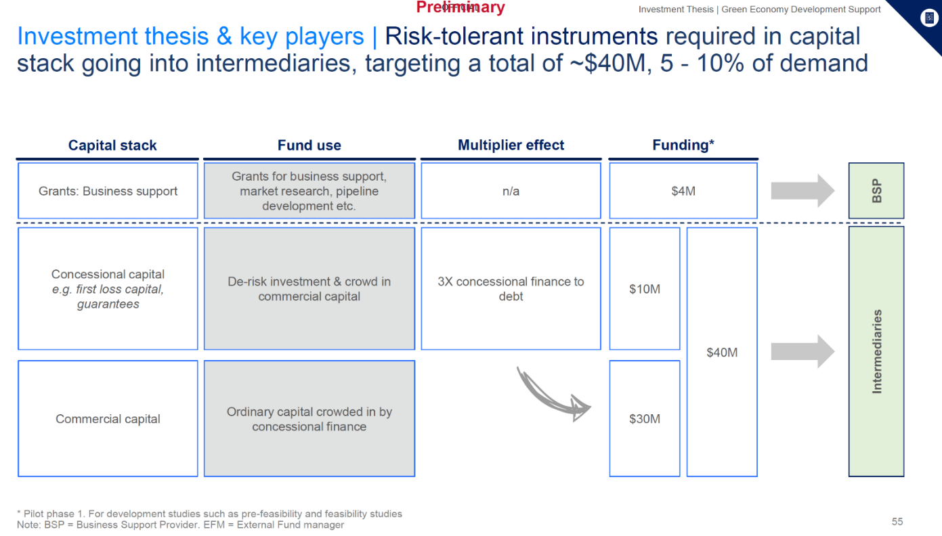

Playing to UK strengths and avoiding overlap with other development partners and UK programmes

- The JET development partners (IPG and beyond) have mapped their development assistance including in a published grant register and coordinate through Technical Working Groups and thematic donor coordination groups e.g. energy, “Just”, green hydrogen, transport etc.

- Other partners are strong/have large budgets in areas such as green hydrogen, skills (where the developmental evidence is quite negative), they have material energy technical assistance programmes (US Power Africa and National Energy Research Labs, GIZ and the Danish Energy Agency) and the EU has a Euro25m grant for road to rail.

- The UK identified (i) creation of long-term sustainable jobs through longer term/larger investments SMEs in the main coal province, and (ii) developing investment pipeline for Just/energy as key areas, along with a few niche areas (see above). Some of the SME work is taking place through other programmes e.g. the SA’s economic growth team or central agricultural (CASA) or SME programming (Growth Gateway).

Evidence Base

- The evidence base on what works/doesn’t with project pipeline preparation projects or municipal capacity building is very limited. There is some evidence that financing alone does not work but needs to be combined with technical assistance and of the importance of donor coordination on policy (something which is at the heart of the JETP donor coordination committees, including a specific one on energy distribution) and of the need for a long term programme. There has been limited success with PPP capacity building in developing countries– largely due to a turnover of staff in institutions. Given this and the budget, the spend and ambition on capacity building will be limited and confined to “learning by doing”, avoiding training and workshop sessions where evidence of long term impact is limited and the plan is to focus on institutions with stability and most likely to use the knowledge – especially National Treasury, rather than small municipalities. South Africa has tried PPP advisory work through Infrastructure SA (which was trained by Infrastructure UK) and GTAC but both bodies have provided more analysis and actual delivery of projects to financial close and build stage is limited. SA and the World Bank are therefore revisiting the architecture of SA institutions to centralise the scattered PPP work and hopefully focus more on delivery. The UK has funded InfraCo Africa to undertake some project preparation but this tends to focus on slightly more advanced phases of projects and does not deliver institutional capacity building.

- In terms of the evidence on the types of investment projects, climate mitigation and adaptation investments and changes to utility ownership and structuring are classed as high potential in FCDO’s Best Buys, reflecting again the very limited availability of evidence. Some repository of information on this is the World Bank’s PPIAF site which has good evidence on the success of Non Revenue water projects (see the Economic appraisal section below), especially when using Performance Based contracting in the water sector but less around similar approaches to turnaround of underperforming energy distribution sectors. There are clear, poorly documented lessons from other countries’ energy sectors, including work with Nigeria’s distribution companies (including via the UK’s (UK)NIAF programming across the years), USAID’s energy distribution “turnaround management” work in Georgia and recent success with deployment of smart meters in Nigeria, Mozambique and elsewhere resulting in increased revenue.

- One World Bank literature synthesis finds that of the several studies monitoring private sector involvement in energy four showed significant decreases in technical and commercial losses and others showed significant bill collection improvement (although it could be transitory) and improvement in quality of services e.g. one showed a significant reduction in outages.

- What is very clear from the evidence review is the need to work politically on power sector reforms and this has been a key focus of the FCDO JETP approach and the implementer’s work (see below) includes political economy analysis (PEA) of the municipalities before short-list/selection and there will need to be a regular PEA of the investment PPPs as they progress.

- Investment in businesses is classified as a Good buy in the FCDO Best Buys. There is some evidence that SMEs backed by venture capital funds or similar can succeed, especially if they are slightly larger and more robust. Start ups remain risky.

Options and Economic Appraisal

As explained above, if the Business Case is not expanded then our funding to date would deliver some studies and analysis. There’s a chance others may pick these up, but also a risk they don’t as SA’s track record in concluding infrastructure projects is weak.

Core options

 | Extra Jobs created | Improved services | GHG emission reductions
A Not expand Business case | Nil to minimal – some other development partners might invest in SMEs or do project preparation | Based on situation to date very unlikely | None (again there’s some potential that others might invest but the track record to date is poor)
B Project Preparation work but not CDEL | Yes Circa 2000 jobs, but mostly construction jobs in initially envisaged projects | Yes | Yes from reduced or solar pumping of water and removing wasted energy and maybe from ad hoc projects
C Do both Project Prep and CDEL | Yes. Circa 5000 jobs, including additionally from from SME investees | Yes | Yes.  Additional GHG savings from some of the investee companies.

More detailed economic appraisal

- This economic appraisal looks at two elements of the programme: (i) project preparation work (for projects to be financed by UK-backed AfDB loans) and (ii) grant finance to SMEs in Mpumalanga.

- The general approach is to assess costs (FCDO + others) and benefits (jobs and GHG emissions avoided), make projections for these costs and benefits out over a 20-year time horizon, and – using a social preference discount rate – calculate the Net Present Value (NPV) and Benefit-Cost Ratio (BCR) of these investments.

Project preparation

- Paragraphs 18 to 20 set out the strong arguments for investing in non-revenue energy and water projects, given the huge amounts of waste currently seen. Paragraph 17 describes the work done by UK consultants (PWC) in analysing some initial investments in these areas which is continuing in more detail with the long term consultants. These projects would aim to address issues of municipal water/energy losses, which are substantial in Mpumalanga (as elsewhere). This is the kind of work (and in the first few years the emphasis work) which can be supported through the project preparation element in order to reach the point of investment. Whilst not yet fully defined, there would be a variety of interventions, including infrastructure repair, maintenance and upgrades, smart grid interventions (improving billing processes, etc.), smart metering, tariff adjustments, improving energy efficiency (e.g., installing solar powered pumps), and performance improvement contracts and some social interventions e.g. solar street lighting, new connections or energy acccess or waste water treatment upgrades

- PWC designed a cost-benefit analysis (CBA) approach which captures a wide range of benefits for the non-revenue water and energy projects. These include increased tariff recovery (from improving the billing system), reduced commercial losses (e.g., from smart metering systems), limited physical losses (from infrastructure improvements, behaviour change, and contract incentives), improved energy efficiency, and social benefits and externalities (e.g., public space lighting).

- PWC ran these CBAs based on dummy and genuine data based on similar projects from the Western Cape. Doing so produced positive NPVs (R310m and R280m for electricity and water respectively) and Benefit Cost Ratios (BCRs) above one (1.2 and 2.5 for electricity and water respectively).

- More generally, looking at similar projects elsewhere in the world is useful. A review of non-revenue water projects by the Netherlands Enterprise Agency examined non-revenue water (NRW) investments between 2012 and 2019. It found that the “calculated Return on Investment (RoI) [is] typically between 2 and 4 years” and that this “confirms the cost-effectiveness of the capital investment(s) in NRW-reduction”.

- In their analysis of performance-based contracts for reducing non-revenue water the World Bank’s Public-Private Infrastructure Advisory Facility (PPIAF) document BCRs for a range of non-revenue water projects. The BCRs in this analysis never fall below two and are shown to rise to very high levels (+30). The analysis shows variability in BCRs dependent on (i) the initial level of non-revenue water and (ii) the cost of water production. Even when non-revenue water is low/medium and water production is cheap, BCRs are greater than two. That is, there is consistent, widespread evidence from similar projects in multiple contexts that this is a sound economic investment. This evidence base, in combination with the initial PWC cost-benefit analyses outlined above, gives confidence that the non-revenue water and electricity projects into which FCDO project preparation (and UK-backed loans) will be channelled will deliver substantial positive economic returns.

Mpumalanga SME investments

- The current plan is to channel FCDO grant money through an existing fund (operated by one of SA’s largest) which will invest in SMEs. The details and assumptions for this element of the economic appraisal are:
- Grant funding will be matched in a ratio of 1:4 by other investment funds (e.g., $5m of grant funds are matched by $20m investment funds, allowing for $25m of investment).
- The average size of individual SME investments by the fund would be $1.66m.
- Each investment would be repaid, and recycled into the fund for further reinvestment, after five years (on average).
- Discount rate used is 10%.
- A twenty year lifetime is assumed.
- As is good practice in a CBA all costs are included. These are the both the FCDO grant element, and the leveraged investment funds.
- Similarly on the benefits side, all benefits are included. There is therefore no need for a calculation to assess attribution or contribution of FCDO funds in a larger pot of investment funding. The BCR is valid without this.
- Benefits are defined as direct jobs created and GHG emissions avoided. For each of these, analysis was conducted (by BCG) of six SMEs in Mpumalanga from the potential project pipeline for these investments. The averages were used as the basis for benefits for the whole set of SME investments under this programme element.
- The size of the investments sought differed among SMEs, investments were scaled to the average likely size of an investment from the fund ($1.66m), the implicit assumption here being that benefits are scalable (up and down) in a linear way.
- The direct jobs created by the investments comes from the BCG analysis and is an average from the six SMEs studied. Jobs are created in the ten years following the investment and assumed to be permanent thereafter.
- However, jobs are not entirely additional (i.e., the labour employed is not currently earning zero return). The assumption is that it increases earnings equivalent to moving from a job in the retail trade sector (64% of national average earnings) to a job in the manufacturing sector (87% of national average earnings).
- The other benefit is GHG emission reductions. Again, this comes from the BCG analysis and is the average of the six SME studied. An additional (conservative) assumption is that not all the SME investments will be able to deliver substantial GHG emission reductions: we assume that half of SME investments are in firms that deliver GHG emission reduction benefits.
- The GHG benefits are monetised using the market carbon values to be used for modelling purposes, from the Department of Energy Security and Net Zero.

- There will likely be other benefits. Households and businesses will benefit from additional choice and improved services. They may benefit from lower prices. There will likely be wider impacts through indirect job creation. These benefits are hard to quantify, and harder to attach a monetary value to. They have not been included in the numeric analysis but will almost certainly bring added value from these investments.

- Running this analysis, using say £9.6m of FCDO grants (and associated matching funds), and only considering benefits from job creation and GHG emission reduction gives the following results.

Costs – Present Value | £37m
Benefits – Jobs – Present Value | £126m
Benefits – GHG – Present Value | £60m

 | Jobs | GHG | Jobs + GHG
NPV | £89m | £23m | £149m
BCR | 3.4 | 1.6 | 5.0

All options give a positive NPV and a BCR above one. The main result, which includes benefits from direct job creation and GHG emission reduction has a NPV of £149m and a BCR of 5. This suggests that investing in SMEs in this way is a positive economic investment.

Commercial and Management Case

- Given the planned focus a tender under the Global Delivery Frameworks was run for a long-term implementation partner – a contractor who could take projects from concept to full build and operation and which had experience in municipal and central government project design and implementation, structuring PPPs and Multilateral development projects as well as energy and water engineering. A 3 year contract (with scope to extend to 5 years) with the implementing consortium partner was signed in August 2024. Given the need for long duration involvement and continuity in developing infrastructure projects, this length of time was seen as vital. The contract includes break clauses (before the next spending review and in 2027) and uses adaptive programming –Task Orders with review points and break/scale up and scale down elements in them to manage the political risk of dealing with municipalities in particular.

- Projects with not-for-profits such as Loughborough, Medical Research Council and Energy Council can on the other hand be done through Accountable Grants, although we are keen to keep the number of these to a minimum to keep FCDO programme management costs down.

- The CDEL commitments would be delivered through an investment agreement between FCDO and the investment fund which would set out the investment policy e.g. areas of clean tech funding and/or Mpumalanga, where financing is allowed for additionality, rules around money laundering, UK sanctions, impact reporting and governance arrangements. There are precedents to follow from other programmes e.g. UKNIAF InfraCredit Nigeria CDEL. An alternative would be to use an intermediary such as USAID (who is also considering investing) or FSDA but this will reduce FCDO control and add another layer of potential admin/cost.

- The PROF guide on DevCap would be followed. In particular – care would be taken to ensure funds would not be returnable to FCDO (implying an asset for FCDO to value for its balance sheet or potential negative ODA) while also avoiding over subsidy or wastage. Involvement of the PSD adviser to verify need and reduce market distortion will be key and there will be strict criteria around the usage. If the investment house can keep reusing the funds it has an incentive not to waste them.

Review point

- March 2027 is proposed as a potential major review point for the programme. This would align with the Annual Review and the results for the first 4 years of the programme and the proposed initial period of the JETP. Based on a review the:-
(i) the main implementer contract could be terminated in August 2027;
(ii) if the SA broader climate and JETP situation is appropriate there could be a scale up beyond the proposed current period
(ii) arrangements could be continued as currently envisaged.

Long term sustainability

- The SME investment is sustainable in the sense that once SME investments are made, we do not need to keep engaged and do not create a dependency. It should have some demonstration effect and creation of evidence around the viability of early stage climate investing and investing in Mpumalanga. We know early stage companies fail and are risky and the evidence may be that there is always going to be some need for first loss funds in the early stage area (in line with the approach to the UK’s start ups which have been supported by HMG funds decades)

- In an ideal world the project preparation intervention would be time limited and capacity would be built in the SA Government such that future grant is not needed, however, we need to be realistic on this based on both the volume of funding and evidence elsewhere.

- The budget and the timing is tight to deliver all the financial, legal and engineering work required to get several $100m of AfDB loans to signature and build stage. There are a lot of hoops to jump through and a lot of SA entities to engage with – National Treasury, Development Bank of South Africa, Local Government Ministry, Ministry of Electricity and Energy, Department of Water and Sanitation, Water Partnership Office, Municipal Infrastructure Support Agency, Government Technical Advisory Centre, JET PMU, JET Municipal Council, Infrastructure SA, Water Boards, Water Catchment Authority and Municipalities (including their councils). We have deliberately not modelled workshops and training into the consultancy - this would have needed at least £500k more budget a year and risked slowing down the project and the evidence is that where as in South Africa the responsibility for PPPs is scattered among so many agencies, capacity building is ineffective due to heavy staff turnover. The hope is that some entities, especially National Treasury, but even some municipalities, will use processes and template contracts and tender packs, gantt charts and cost benefit models from the project and there will be some capacity built. In practice even in the UK, councils and central government do rely on transaction advisers for PPPs – the key is to build some basic understanding of the concepts and how to manage planning, tenders and contracts.

Value for Money and Monitoring and Evaluation

- Economy - The central framework provides good economy on input costs for the consultants but the key will be close management to ensure they are set stretching timelines in task orders.

- Efficiency – Key will be ascertaining how many projects are delivered to scoping stage and then full financial close and build versus the funding provided. As flagged above, there are clear economies of scale here – if funding is reduced then the project becomes quite inefficient.

- Effectiveness – We should develop some metrics around £ of grant per job created or GHG emission reduced once the SME investments are made. Growth Gateway estimated costs at about £500k investment per job for green economy firms, 150k for transition firms and £300k for pivot firms. Assessing the effectiveness of the project preparation in terms of increased revenue in the municipalities will only be possible probably after the programme – the aim is to build this evaluation element into the AfDB loan funding – so as to build up an evidence case around these types of utility projects for wider use by AfDB across Africa and by SA.

Gender and disability and terrorism financing

- Given the funding will flow through the commercial implementing partners selected through an FCDO framework, the terrorism financing and corruption risks would be from accountable grants. The careful selection of limited partners and due diligence should minimise that risk.

- Our work on the health implications of coal plants will highlight the impact on women and girls specifically. Otherwise most gender impacts will be indirect as women and girls are unlikely to be employed in construction jobs for water and energy infrastructure. Women and girls are those most likely to suffer from the delivery of poor basic services (as they need water and energy for their chores) and a decline in jobs in coal areas has been linked to gender based violence. The impact criterion in the investment agreements for the CDEL will emphasise the importance of those benefitting women through their employment or SMEs producing products which benefit women.

Describe any key changes to the original business case including the theory of change or new evidence from ongoing monitoring, evaluation or learning work?

UK International Climate Finance Results: methodologies and reports - GOV.UK (www.gov.uk)
Growth Through Inclusion in South Africa (harvard.edu) and South Africa Overview: Development news, research, data | World Bank
PPIAF | Developing Good Performance Based Contract Practices for Non-Revenue Water Management
Taking Stock of the Impact of Power Utility Reform in Developing Countries Robert Bacon 2018 World Bank Document
Taking Stock of the Impact of Power Utility Reform in Developing Countries Robert Bacon 2018 World Bank Document
6 From Blueprint to Scale - FSG The case for philanthropy in impact investing Harvey Koh 2014 and Beyond the Pioneer: Getting Inclusive Industries to Scale | Marketlinks
World Bank Document – David McKenzie - How effective are active labor market policies in developing countries? Link here
Why Tackling Energy Governance in Developing Countries Needs a New Approach (chemonics.com) 2021 Neil McCollough
Rethinking Power Sector Reform - World Bank Document
Why Tackling Energy Governance in Developing Countries Needs a New Approach (chemonics.com)
Improving SMEs’ Access to Finance Through Capital Markets and Innovative Financing Instruments: Some Evidence from Developing Countries (ids.ac.uk)
“Lessons Learned in NRW-Reduction from 8 RVO-Sustainable Water Fund Co-Financed Interventions with 19 Water Operators”. NRW-Practice-Note-VEI-RVO-Jan-2021-short-version.pdf (gwopa.org)
“Using Performance-Based Contracts to Reduce Non-Revenue Water.” Table 2. PPIAF_NRW_PBC.pdf
All earnings data, including an allowance for differential between Mpumalanga and national averages, is taken from Stats SA (statssa.gov.za) employment statistics publications.
https://www.gov.uk/government/publications/traded-carbon-values-used-for-modelling-purposes-2023/traded-carbon-values-used-for-modelling-purposes-2023
BCG analysis modelled indirect job creation, but it wasn’t included here as quantifying benefits of indirect jobs is difficult.
PV of benefits minus PV of costs.
PV of benefits divided by PV of costs.

